**23NS065_Hoàng Nữ Bảo Ngọc**

FireStore Databa

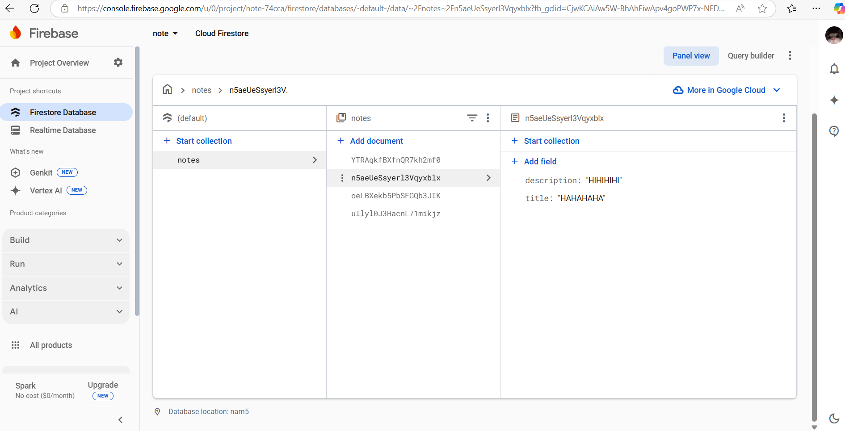

Video demo Note App

https://drive.google.com/drive/folders/1-Hh1M5BCdVym14P1Fw9ZjultyJiuPyWu?usp=drive_link