BRICKED-UP
Implementation Master Guide
A LEGO brick scanner, inventory & build-idea webapp
Temasek Polytechnic — School of Informatics & IT
Diploma in Applied Artificial Intelligence — Cloud Technologies for AI (CAI2C09)
AY2026/2027 April Semester
Prepared as a personal companion guide — not an official school document.
Always defer to your tutor and the official Project Specifications where they differ from this guide.

Contents

1. How to Use This Guide
This guide turns your BRICKED-UP concept — the LEGO brick scanner, personal inventory and build-idea webapp you sketched out — into a week-by-week build plan that lines up against the CAI2C09 Project Specifications and marking rubrics. It assumes no prior AWS experience and explains every step, including the reasoning behind each technical decision so you can defend it confidently in your report and demo.
The guide is organised so you can work through it top to bottom, but three parts are meant to be read first, before you write any code:
- Section 3 – Feasibility Research Findings, which confirms your dataset choice, your Rekognition approach, and the constraints of the AWS Academy Learner Lab environment.
- Section 4 – Critical Dates & Realistic Timeline, because Deliverable 1 is due in 7 days from today and the schedule below is built around that reality.
- Section 7 – Design System & Panel Workspace Specification, which translates your two notebook sketches into concrete measurements, colours and interaction rules.

After that, Section 8 is the actual build — broken into six phases, each with a goal, steps, and a self-check. A companion prompt (a separate file, “BRICKED-UP Agent Build Prompt.md”) is written so you can hand it directly to a coding agent (e.g. Claude Code) to scaffold the frontend in Phase 1; it references this guide's design system and data model so the two stay in sync.
A note on originality
The rubric explicitly penalises websites that are “minor modifications of the lab codes.” Everything in this guide is written around your own concept and your own sketches — the panel-snap workspace, the LEGO-stud grid, the docking action bar — specifically because that originality is what separates an A from a C on the Deliverable 1 and 2 rubrics. Keep the fun, personal details from your sketches; they are your strongest asset here.

2. Rubric-to-Feature Alignment Snapshot
Use this table as your north star. Every requirement in the Project Specifications is mapped to the exact BRICKED-UP feature that satisfies it, and the section of this guide where it is built.
Spec requirement | BRICKED-UP feature | Guide section
Serverless deployment to S3 | React/Vite production build deployed to a private S3 bucket, served through CloudFront | §8.6
Cloud database (RDS-MySQL or DynamoDB) | Amazon RDS for MySQL: users, inventory, parts_catalog, builds, build_parts | §6, §8.3
≥2 CRUD ops, ≥1 SELECT + ≥1 INSERT | Full CRUD on inventory (scan→INSERT, view→SELECT, edit qty→UPDATE, remove→DELETE) + SELECT on builds | §8.5, Appendix A
Basic cloud security | Cognito auth, API Gateway authorizer, private S3 + CloudFront OAC, no hard-coded secrets (SSM Parameter Store) | §9
Image recognition via AWS Rekognition | Rekognition Custom Labels model classifying a photographed brick against your trained part classes (single-piece baseline; optional multi-brick batch mode if §3.6's test succeeds) | §3.2, §3.6, §8.4
≥ 1 meaningful additional AWS service | Amazon Cognito (auth) + Amazon CloudFront (HTTPS/CDN) as the two justified additions; SNS as an optional third | §8.6, §9
Visually appealing, original UI | Panel-based “baseplate” workspace with LEGO-stud grid, drag/resize/snap panels, edge-docking action bar | §7
Individual, non-lab-code project | Custom panel engine, custom brick classifier, curated build-idea dataset — nothing lifted from lab material | throughout

Keep this table open while you build — whenever you finish a feature, tick its row mentally and move to Section 10’s longer self-grading checklist before each submission.

3. Feasibility Research Findings
Before locking in the technical plan, four open questions from your brief were checked against current documentation: is the Kaggle dataset actually usable for Rekognition, should the model classify or detect, what does the AWS Academy Learner Lab actually allow, and is a frontend framework like React permitted for an S3-hosted “serverless” site. Findings below.

3.1 Is “LEGO Classification 10k” suitable for training?
Yes — it is a strong match, with one adjustment recommended. The dataset (also published as the “B200C LEGO Classification Dataset”) contains roughly 50 photographs per class across the 200 most popular LEGO parts — studio-style images, one part per photo, plain background, multiple angles. That is exactly the shape of data Amazon Rekognition Custom Labels expects for an image classification project (one whole-image label per photo), and it comfortably clears AWS’s own guidance of “a few hundred images or less per class” and a hard minimum of 1 image per label.
Recommended adjustment: narrow to ~15–25 classes
Training on all 200 classes is technically possible but risky for a time-boxed individual project: many LEGO plates and bricks are visually near-identical (a 1x2 plate vs a 1x2 tile, for instance), so a 200-way classifier needs careful tuning to reach a usable F1 score, and every training run is billed by the hour. Curate a subset of 15–25 visually distinct, common parts (e.g. 2x4 brick, 2x2 brick, 1x1 plate, 2x4 plate, 45° slope, round 2x2 brick, minifigure head, wheel). This keeps training fast, keeps accuracy high enough for a convincing demo, and keeps your inventory/build-ideas features meaningful. Mention this scoping decision explicitly in your report — it reads as deliberate engineering judgement, not corner-cutting.

3.2 Classification, not detection — and why that matches your sketch
Rekognition Custom Labels supports two project types: image classification (one label for the whole photo) and object localisation (bounding boxes for multiple objects in one photo). Detection needs bounding-box-annotated training data, which this dataset does not provide. Conveniently, your own “Scanner Panel” sketch already shows a single-piece viewfinder with one result (“Pieces found: 1”) rather than a messy multi-brick pile — so the classification model is not a compromise, it is the correct fit for the UX you already designed. The workflow becomes: user photographs one piece → model classifies it → user confirms → piece is added to inventory. Users add multiple pieces by scanning again, which is quick and also gives you a natural “confirm before saving” moment for the cloud-security marking criterion (human-in-the-loop before a database write).

3.3 AWS Academy Learner Lab — what it allows and what it restricts
Temasek’s “learner environment” note in the spec strongly suggests an AWS Academy Learner Lab account. Three constraints matter for your architecture:
- Region lock: all services must be built in us-east-1 (N. Virginia) or us-west-2 (Oregon). Pick one region and use it everywhere — S3, RDS, Rekognition, Cognito must all match, or services will silently fail to see each other.
- IAM is heavily restricted: you generally cannot create new IAM roles or users. Lambda functions must run under the pre-provisioned LabRole. This is fine functionally, but it means you cannot demonstrate hand-crafted least-privilege policies the way a production account would — say so plainly in your report’s security section rather than pretending otherwise; graders in an AWS Academy course expect this and it is an honest, credible thing to note.
- Confirmed available in Learner Lab: S3, RDS, Lambda, API Gateway, Amazon Cognito, Amazon CloudFront, Amazon DynamoDB, Amazon SNS, Systems Manager Parameter Store. Rekognition is not explicitly listed in third-party summaries of the Foundational Services catalogue, so treat it as the single biggest risk item and validate it in Week 0 (see the callout below).
Do this on day 1, not week 3
Log into your Learner Lab, open the Rekognition console, switch to “Custom Labels”, and click through to creating a test project (you can delete it right after). This confirms the console can auto-provision the service resources it needs. If it fails with a permissions error, message your tutor immediately — this is a mandatory graded requirement (§5 of the Project Scope) and any access issue needs the longest possible runway to resolve.

3.4 Is a frontend framework (React) allowed for an S3-hosted site?
Yes. “Serverless deployment to S3” refers to the hosting model (static files served directly from a storage bucket, no web server to manage) — not to how those files are produced. A React (or Vue/Svelte) app built with a bundler like Vite compiles down to plain index.html, CSS and JS files, which is exactly what an S3 static website expects. This is the standard, widely-documented pattern for deploying single-page apps to S3, and it is what makes the drag/resize/snap panel system in your sketches practical to build — hand-rolling that interaction model in raw DOM APIs is far more error-prone than using React state to track panel position and size. Confirm this reading with your tutor once, then build with confidence.

3.5 Rebrickable data — using it without breaching its terms
Rebrickable is the right source for your parts catalogue and build/set reference data, but its Terms of Service explicitly say Rebrickable content may not be used to train AI models. That is not a problem for you — you are training on the Kaggle dataset, not Rebrickable images — but keep the two uses cleanly separated:
- Training the Rekognition model: use only the Kaggle “LEGO Classification 10k” images.
- Populating your catalogue (parts_catalog, builds, build_parts tables): use Rebrickable’s downloadable CSV dumps (parts.csv, sets.csv, inventories.csv, inventory_parts.csv) from their Downloads page — free to use for any purpose, updated daily, no rate limit because you download once and import locally. Avoid the live API for this (it is rate-limited to ≈ 1 request/second and meant for on-demand lookups, not bulk import) and never scrape the site with automation, which Rebrickable’s terms explicitly prohibit.
- Reference thumbnails in your UI: Rebrickable’s part/set images may be hot-linked or used in an external app per their terms, so they are safe to show as “what this part/build looks like” thumbnails in your Inventory and Build Ideas panels.

3.6 Should the Scanner batch-detect multiple bricks in one photo?
A natural follow-up question once 3.1–3.2 rule out training a true bounding-box object-detection model: can you still scan a whole handful of bricks at once, the way your original sketch implies, without annotating your own bounding-box dataset? Yes, via a well-known cascade pattern — detect generic regions first, then classify each region with the model you already have:
Step | What it does | Verdict
1. Locate | Amazon Rekognition’s pretrained DetectLabels finds candidate regions in one wide photo of scattered bricks and returns a bounding box per region, without knowing what a “LEGO brick” specifically is | ⚠ Real risk — see below
2. Crop | A Lambda function (Pillow) slices each returned box out of the original photo and pads/resizes it to match your training images’ aspect | Solid, low-risk
3. Classify | Each crop is fed individually into your trained Rekognition Custom Labels model to get an exact part ID | Solid — this is exactly the classifier you’re already building in §8.4
4. Store | Lambda batch-inserts all identified parts into the inventory table in one pass | Solid, straightforward SQL

Steps 2, 3 and 4 are sound and require no changes to the architecture already in this guide — Step 3 is precisely the fn: scan-brick classifier from Section 8.5, just called once per crop instead of once per photo. Step 1 is the genuine open question. AWS’s own documentation is explicit that DetectLabels only reliably returns per-instance bounding boxes for a set of “common object” categories — it repeatedly names people, cars, furniture, apparel and pets as the flagship examples — and that “bounding box information isn’t returned for less common object labels.” Scattered LEGO bricks are small, visually similar to one another, often touching or close together, and not one of those headline categories, so there is a real chance DetectLabels either merges several bricks into one region, misses some entirely, or returns only a whole-image label (e.g. “Toy”) with no per-instance boxes at all.
Recommended path: test Step 1 in isolation, early, before committing the UX to it
Spend one spare hour in Phase 0 or early Phase 3 (§8.1/§8.4) photographing your own 10–15 bricks spread out (not touching) on a plain, high-contrast mat, and call DetectLabels on that single photo to see what actually comes back in the Instances array. Two honest outcomes: (a) If it reliably returns one box per brick — build the full 4-step batch pipeline; it is a strictly more impressive result that matches your sketch exactly, and it is worth the extra Lambda logic. (b) If it merges, misses pieces, or returns no instances — swap Step 1 for a short classical computer-vision pass instead (Pillow/OpenCV contour or connected-component detection against your plain mat background, which is a well-understood, reliable way to isolate rigid, high-contrast objects on a simple background). Steps 2–4 stay completely unchanged, and the spec’s Rekognition requirement is still fully met because Step 3’s classification is the AI-driven recognition; Step 1 becomes ordinary image pre-processing, which is a normal, honestly-documentable engineering trade-off to describe in your report. Either way, keep the single-piece-at-a-time Scanner flow (§3.2, §7.5) working first and treat batch scanning as additive polish layered on top — never let it become a blocking dependency for a graded deliverable given the timeline in Section 4.

4. Critical Dates & Realistic Timeline
Today is Friday, 10 July 2026. Deliverable 1 is due in exactly 7 days (Friday 17 July, 1700h). That is tight but achievable, because Deliverable 1 is UI-only — no live AWS backend is required, only JavaScript functions that call your future API URLs and return hard-coded/simulated results. The schedule below is built backwards from your four hard deadlines.
Deliverable | Weight | Due
Deliverable 1 — static/mocked frontend | 10% | Fri 17 Jul 2026, 1700h
Deliverable 2 — fully deployed, AWS-integrated site | 30% | Fri 14 Aug 2026, 1700h
Report (.docx) | 20% | Mon 17 Aug 2026, 0900h
Presentation slides (.pptx) + video link | 10% | Mon 17 Aug 2026, 0900h (submitted with report)
Live presentation & demo | (same 10%) | Week of Mon 17 Aug 2026 (Week 18)

Phase plan
Phase | Dates | Goal | Guide §
0 – Kickoff | 10–11 Jul | Confirm Learner Lab access, Rekognition console check, repo + tooling scaffold | 8.1
1 – Deliverable 1 sprint | 11–17 Jul | Panel engine, design system, all screens working on mock data | 8.2
2 – AWS foundations | 17–24 Jul | S3 buckets, RDS schema + seed data, Cognito user pool | 8.3
3 – Train the model | 24–31 Jul | Curate dataset subset, train + evaluate Rekognition Custom Labels model | 8.4
4 – Backend wiring | 31 Jul – 7 Aug | Lambda functions, API Gateway, replace mocks with real calls, full CRUD | 8.5
5 – Harden & ship | 7–14 Aug | CloudFront + security pass, cross-device testing, submit Deliverable 2 | 8.6
6 – Tell the story | 14–17 Aug | Report, slides, demo video, rehearsal | 8.7

Deliverable 1 day-by-day (the next 7 days)
Because this week is the tightest, here is a concrete daily breakdown. Treat each day as a checkpoint — if you slip by more than a day, cut the SNS/DynamoDB stretch ideas from Section 8.6 first, never the core panel/scan/inventory flow.
Day | Focus
Fri 10 Jul | Scaffold project (Vite + React), install dependencies, set up design tokens (colours, fonts, grid unit) from Section 7
Sat 11 Jul | Build the workspace shell: LEGO-stud dot-grid background, base Panel component (header, border, close/collapse)
Sun 12 Jul | Make panels draggable, then resizable; implement the grid-snap math for both
Mon 13 Jul | Build the action bar component with edge-docking snap logic (top/bottom/left/right)
Tue 14 Jul | Scanner Panel UI: upload/camera capture, mock “scanning…” state, mock result + confirm/add flow
Wed 15 Jul | Inventory Panel (grid of owned pieces, mock data) + Build Ideas Panel (progress ring, mock data)
Thu 16 Jul | Auth screens (sign in/up UI only), responsive pass, empty/error/loading states, cross-browser check
Fri 17 Jul | Final polish, zip per the naming convention in §11, submit by 1700h with hours to spare

5. System Architecture
The diagram below is the target architecture for Deliverable 2. Build it up incrementally through Phases 2–5 (Section 8) — you do not need all of this running to submit Deliverable 1.
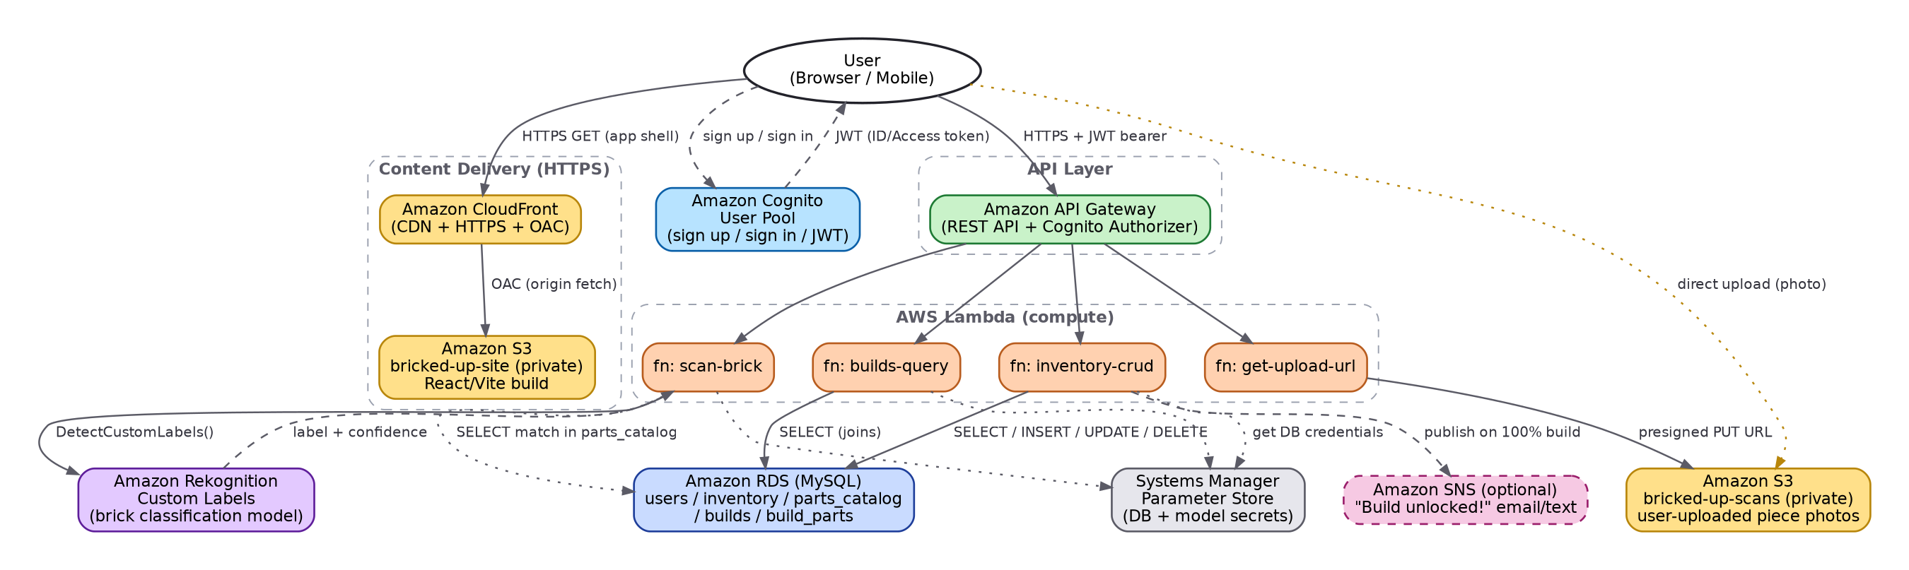
Figure 1. BRICKED-UP target AWS architecture.

How a scan actually flows through the system
- 1. The browser asks API Gateway (via fn: get-upload-url) for a pre-signed S3 PUT URL, authenticated with the user’s Cognito JWT.
- 2. The browser uploads the photo directly to the private bricked-up-scans S3 bucket using that URL — the image bytes never pass through Lambda, keeping the function fast and cheap.
- 3. The browser calls fn: scan-brick with the S3 key. This Lambda calls Rekognition’s DetectCustomLabels on that image and gets back a label (e.g. “2x4_brick”) and a confidence score.
- 4. fn: scan-brick looks up that label in parts_catalog (RDS) and returns a friendly match (part name, image, confidence) to the browser for the user to confirm — nothing is saved yet.
- 5. On confirmation, the browser calls fn: inventory-crud with an INSERT action, writing a new row into the inventory table tied to the user’s Cognito user_id.
- 6. fn: builds-query periodically (or on-demand, when the Build Ideas panel opens) joins inventory against build_parts to compute “% of parts owned” per build — this is where the metrics in your sketch come from.

Why this shape, and where each layer earns its keep
Layer | Service | Why
Delivery | CloudFront + S3 (private) | S3 alone can’t serve HTTPS on its own domain; CloudFront adds HTTPS, caching and a clean way to keep the bucket fully private via Origin Access Control — directly targets the rubric’s “HTTPS enforced” and “correct bucket policies” criteria.
Auth | Cognito | Gives every user their own private inventory, issues the JWTs that API Gateway checks on every request — satisfies “proper user authentication” and doubles as your justified additional service.
API | API Gateway | Single, versioned, CORS-controlled entry point in front of all Lambda functions; Cognito authorizer rejects unauthenticated requests before they ever reach your code.
Compute | Lambda | No servers to patch or pay for when idle — the whole backend is only “on” while handling a request, which suits a student budget.
AI | Rekognition Custom Labels | The mandatory image-recognition requirement; a purpose-trained classifier on your curated LEGO part classes.
Data | RDS (MySQL) | Inventory, catalogue and build data are naturally relational (a build needs many parts, a part appears in many builds) — a clean fit for SQL joins, which is exactly what powers the “% of parts owned” metric.
Secrets | SSM Parameter Store | DB credentials and the Rekognition project ARN are read at runtime instead of being hard-coded into Lambda source — a concrete, demonstrable “secure handling of data” talking point for your report.

6. Database Design
Five tables cover everything the spec and your sketches need: per-user accounts, a master parts catalogue, what each user owns, a curated list of buildable ideas, and which parts each build needs.
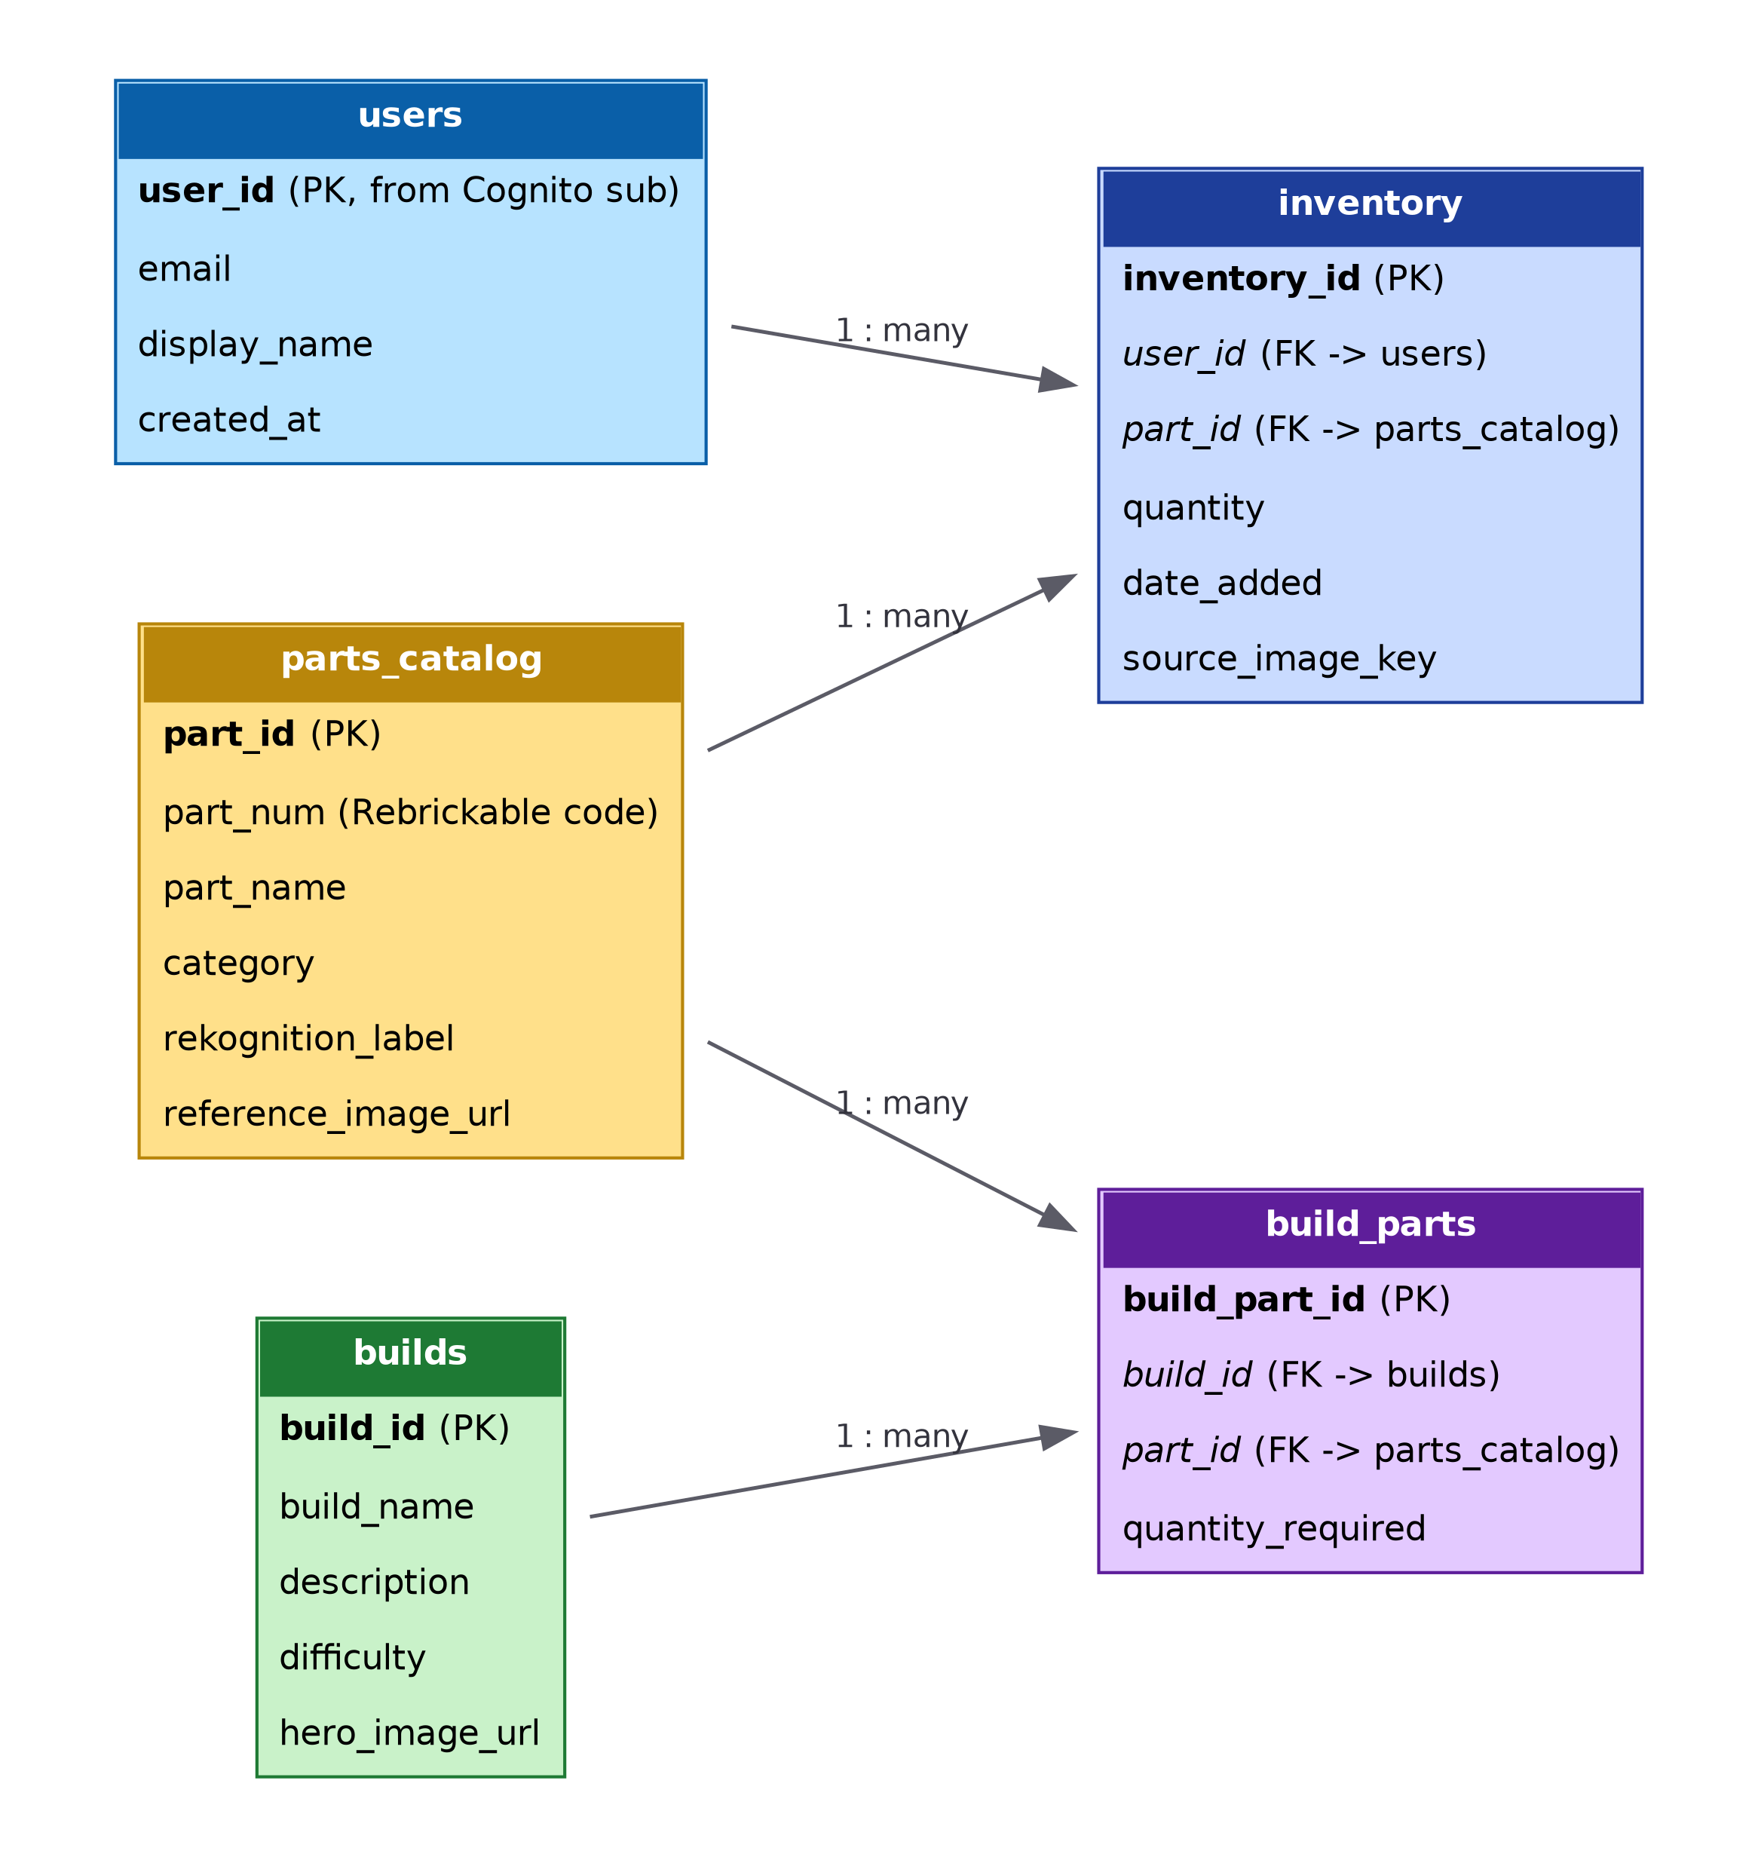
Figure 2. Entity-relationship diagram.

Schema notes
- users.user_id is the Cognito “sub” claim from the verified JWT — never trust a user_id sent in a request body; always read it from the authenticated token inside the Lambda.
- parts_catalog.rekognition_label is the exact label string your Custom Labels model was trained to output (e.g. “2x4_brick_red”) — this is the join key between what the AI returns and what your database understands.
- inventory.source_image_key keeps a pointer back to the original scan photo in S3, which is a nice touch for the Inventory Panel (“see the photo you scanned this from”) and shows deliberate data modelling in your report.
- build_parts is the many-to-many bridge table that makes the “% of parts owned” computation a single SQL join+aggregate rather than application-side looping — worth showing in your report as evidence of proper relational design.

Seed data plan
Populate parts_catalog with your 15–25 curated classes (Section 3.1), cross-referenced against Rebrickable’s parts.csv for the official part number and name. Hand-curate 8–12 small build ideas (e.g. “mini windmill”, “desk pen holder”) built only from parts inside your trained class list, and populate build_parts accordingly — this guarantees every demo build is actually achievable with pieces your model can recognise, which matters far more for a convincing live demo than a large but disconnected catalogue.

7. Design System & Panel Workspace Specification
This translates your two notebook pages — the panel layout sketch and the naming/pattern/border notes — into exact values a coding agent (or you) can implement without guessing. It resolves the three open questions you flagged: dot shape, panel border style, and the LEGO-brick snap feel.
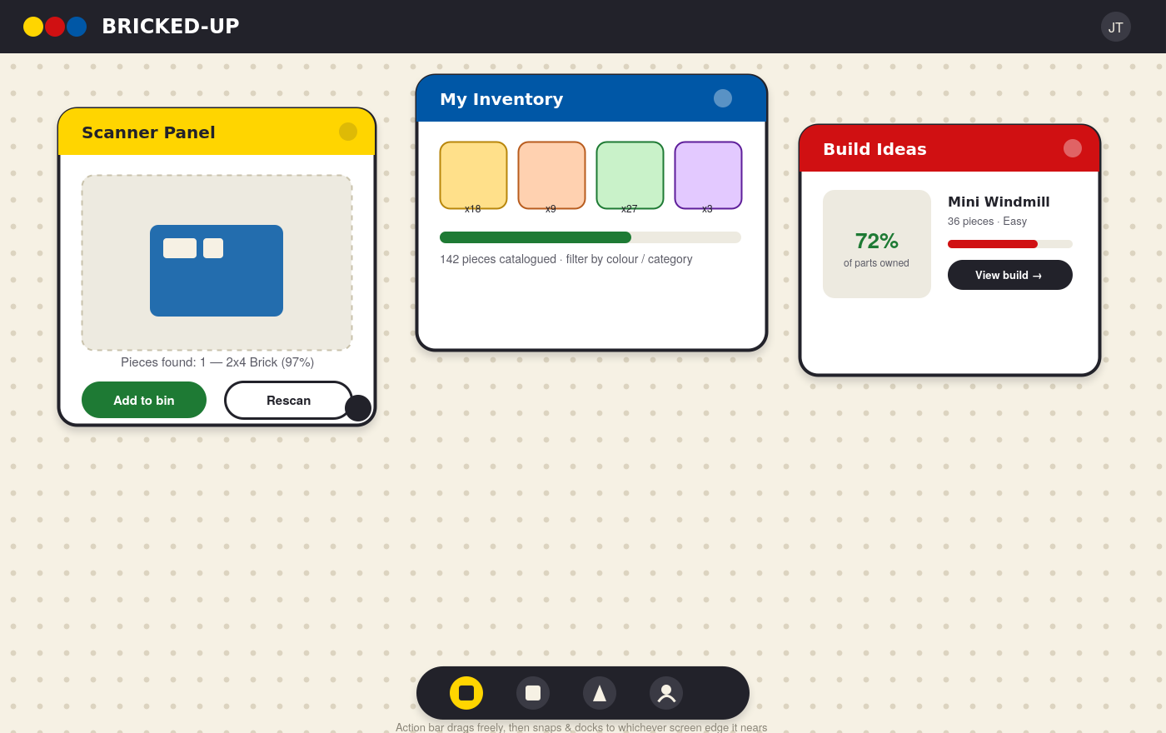
Figure 3. Direction mock-up: dot-grid workspace, floating panels, edge-docked action bar. Treat colours/copy as indicative, not final pixels.

7.1 Resolving your open design questions
Your question | Recommendation | Why
Circular dot (LEGO stud) vs rounded-square grid guide | Circular dot, 3–4px radius, low-contrast tone (≈ 10% darker than the base fill) | It is the more literal, more recognisable LEGO reference, reinforces the “BRICKED-UP” name, and is cheaper to render as a single repeating CSS pattern than a rounded-square tile.
Panel border: thin minimalist / rounded / thicc LEGO border | “Thicc” border (3–4px), rounded 16–22px corners, flat colour (no gradient/bevel), paired with a soft drop shadow | Chunky + flat reads as “modern toy” rather than dated skeuomorphism — matches your brief of “modern design and pure fun design ideas” without tipping into kitsch.
Name | BRICKED-UP (confirmed) | Reads well both as a LEGO pun and as a literal description of what the app does (get your bricks “bricked up” / catalogued).

7.2 Design tokens

Colour palette
Token | Hex | Use
ink-900 (base dark) | #22222A | Top bar, panel borders, primary text, docked action bar
cream-100 (base light) | #F6F1E4 | Workspace background
dot-grid | #DCD4C0 | Background stud pattern (low contrast on cream-100)
brick-red | #D01012 | Primary accent — destructive/important actions, Scanner Panel header
brick-yellow | #FFD500 | Highlight accent — logo mark, active/selected states
brick-blue | #0057A6 | Inventory Panel header, informational accents
brick-green | #1E7A34 | Success states, “add to bin” confirm, progress fills
brick-purple | #5E1E9A | Build Ideas accent (secondary), tags/badges
neutral-grey | #5B5B66 | Secondary/help text

Type & spacing
- Typeface: a rounded, friendly sans (Nunito or Baloo 2) for headings/UI chrome; a plain, highly legible sans (Inter or system-ui) for dense text like inventory lists — mixing the two keeps it “fun” without sacrificing readability at small sizes.
- Base grid unit: 8px. Dot-grid spacing: 32px (i.e. every 4th grid line gets a visible stud) so the background reads as a guide, not visual noise.
- Panel snap increment: 32px on both axes for position and size — matching the dot spacing is what makes the snap feel “click into place” rather than arbitrary.
- Corner radius scale: 22px panels, 14px inner cards, 999px (pill) for buttons and the action bar.

7.3 Panel behaviour specification
Behaviour | Spec
Drag | Grab anywhere on the panel header (not the body, so content inside stays interactive). Position follows the pointer 1:1 while dragging; on release, animate (150–200ms ease-out) to the nearest 32px grid intersection.
Resize | Drag handles on the bottom-right corner (and optionally all 4 edges). Width/height snap to the nearest 32px increment on release; enforce a sensible min-size (e.g. 280×220px) so panel content never collapses unusably.
Snap feedback | While dragging, show a faint ghost/outline at the target snap position (a common “magnetic” affordance) so the snap feels intentional rather than jumpy.
Z-order | Clicking/dragging a panel brings it to front (highest z-index) so overlapping panels behave the way physical bricks would — the one you’re touching is “on top”.
Collapse / close | Header includes a collapse (minimise to title bar) and a close (send back to the action bar) control — matches the ‘X’ marks in your sketch.
Persistence (nice-to-have) | Store each user’s last panel layout (position/size per panel id) — can start as browser state for Deliverable 1 and move to a small JSON column in RDS, or localStorage-equivalent server value, once the backend exists.

7.4 Action bar behaviour specification
- Default position: docked to the bottom edge, horizontally centred, pill-shaped, containing icon buttons for Scan / Inventory / Build Ideas / Profile (matches your sketch).
- Drag-to-dock: the bar can be dragged anywhere; on release, it snaps to whichever of the 4 screen edges the pointer is nearest to (simple nearest-edge distance check), and its internal layout rotates from a horizontal row (top/bottom edges) to a vertical column (left/right edges).
- Tapping an icon: opens the corresponding panel at a sensible default position/size if it isn’t already open, or brings it to front if it is.

7.5 Panel inventory (what to actually build)
Panel | Core content | Deliverable 1 (mocked) | Deliverable 2 (live)
Scanner | Camera/upload capture area, detected-piece result card, confirm/rescan actions | Simulated “scanning…” delay, then a hard-coded result JSON | Real presigned upload + DetectCustomLabels result
Inventory | Grid/list of owned pieces with quantity badges, search/filter | Hard-coded array of pieces | Live SELECT from inventory joined to parts_catalog
Build Ideas | Cards showing % of parts owned per build, click-through to detail | Hard-coded percentages | Live join across inventory + build_parts
Build Detail (optional) | Full parts list for one build, owned vs needed per part | Hard-coded | Live per-build query
Auth | Sign in / sign up forms | UI only, fake “logged in” state | Real Cognito Hosted UI or SDK flow

Optional: design the Scanner result card to support “1 or many” from day one
Even before you know whether the multi-brick batch pipeline from §3.6 will work, build the Scanner Panel’s result state as a list of 1+ candidate cards rather than a single card. That way, single-piece mode ships a list of length 1, and if the batch pipeline proves reliable later, the same UI already supports it with zero rework — only the mock/real data source changes.

8. Step-by-Step Build Guide

8.1 Phase 0 — Environment & Tooling Setup (Day 1)
Goal: everything you need is installed and verified before you write a single line of app code.
- Log into your AWS Academy Learner Lab. Note which region it defaults to (us-east-1 or us-west-2) and use that region consistently for every service from here on.
- Open the Rekognition console → Custom Labels → Get started, and walk through creating a throwaway test project to confirm the console can provision its own S3 console-bucket and service role in your account. Delete the test project once confirmed (see the Section 3.3 callout).
- Install Node.js LTS, and confirm with node -v and npm -v.
- Install the AWS CLI v2 and run aws configure (or aws configure sso if your Learner Lab provides temporary keys — Learner Lab typically gives you an access key/secret/session token pair from the “AWS Details” panel; paste these into your CLI credentials/config, noting that they expire and need refreshing each session).
- Create a project folder, e.g. bricked-up/, with two subfolders: frontend/ and infra/ (for SQL scripts, Lambda source, and notes).
- Scaffold the frontend: npm create vite@latest frontend -- --template react, then cd frontend && npm install.
- Install the panel/drag library and a couple of small helpers: npm install react-rnd clsx (react-rnd gives you draggable+resizable primitives; you will wrap it with the custom 32px snap math from §7.3 rather than using its defaults).
- Initialise git in the project root and make your first commit. Commit early and often — your report’s “development process” section is much easier to write with a clean commit history to point to.
Keep the agent build prompt handy
The companion file “BRICKED-UP Agent Build Prompt.md” is written to be pasted into a coding agent to scaffold the Phase 1 frontend in one go, using the exact design tokens and panel spec from Section 7. Treat its output as a strong first draft — review, run, and adjust it rather than shipping it unread; you still need to be able to explain every part of it in your presentation and Q&A.

8.2 Phase 1 (Week 0) — Deliverable 1: Static / Mocked Frontend
Goal: a visually complete, fully interactive single-page app where every screen works, but all data comes from local mock JSON and every “API call” is a JavaScript function that returns a Promise resolving to hard-coded data after a short simulated delay. This satisfies the spec’s explicit instruction to include the calling functions without needing working URLs yet.

Build order (mirrors the daily plan in §4)
- Workspace shell: full-bleed background component rendering the dot-grid pattern (CSS repeating-radial-gradient or a tiny inline SVG tile is enough — no need for a library).
- Base Panel component: header bar (title + collapse/close), bordered card body, accepts children so each feature panel can plug its own content in.
- Wrap react-rnd per panel instance; on onDragStop/onResizeStop, round the returned x/y/width/height to the nearest 32px before committing to state — this is the entire “snap” mechanic.
- Action bar component: fixed-position pill, icon buttons that open/focus panels; implement the nearest-edge dock logic described in §7.4 (compare distance from the bar’s drop point to each of the 4 edges, pick the minimum, set a docked orientation + position).
- Scanner Panel: file input + (optionally) getUserMedia camera capture, a mock scanBrick(imageFile) function that awaits a 1–2 second timeout then resolves to a fixed result object ({ label: "2x4_brick", confidence: 0.97, partName: "2x4 Brick" }), a result card UI, and Add to bin / Rescan buttons.
- Inventory Panel: a mockGetInventory() returning an array of ~10 fixed pieces with quantities; render as a responsive card/grid that reflows based on the panel’s current width (this is the “internal layout should be responsive to panel size” requirement from your brief — use CSS Grid with auto-fill/minmax rather than fixed columns).
- Build Ideas Panel: a mockGetBuilds() returning 3–4 builds with a percentOwned field; render progress rings/bars and a “View build” action that opens a Build Detail view or panel.
- Auth screens: sign-in/sign-up forms with client-side validation only; store a fake “logged in” flag in React state (no real persistence needed yet).
- Pass over every panel at a very narrow width and a very wide width to confirm the internal layout actually reflows rather than overflowing or leaving dead space.
- Add loading, empty and error states to every panel — these are cheap to add now and are exactly what markers mean by “no visible bugs, polish beyond classroom examples.”
What “mocked” should look like in code
Keep every mock function in its own api/ folder (e.g. api/scanner.js, api/inventory.js, api/builds.js) with the same function names and return shapes you intend the real API to have later (Section 8.5). In Phase 4 you delete the mock body and replace it with a real fetch() call — nothing else in the UI needs to change. This one habit is what makes Deliverable 2 mostly a backend task rather than a UI rewrite.

8.3 Phase 2 (Week 1) — AWS Foundations
Goal: the database, storage buckets and authentication layer exist and are reachable, before any Lambda logic is written against them.

S3 buckets
- Create bricked-up-site-<yourname> (website hosting bucket) and bricked-up-scans-<yourname> (user photo uploads). Keep “Block all public access” ON for both — neither bucket will be public directly; the site bucket is fronted by CloudFront (Phase 5) and the scans bucket is only reachable via short-lived pre-signed URLs.
- Enable default server-side encryption (SSE-S3) on both buckets — a one-click setting that is a genuine, reportable “data protection” measure.
- On bricked-up-scans, add a lifecycle rule to expire objects after, say, 30 days — you don’t need to keep raw scan photos forever, and it is a nice, easy-to-explain cost/security touch for your report.

RDS (MySQL)
- RDS console → Create database → Standard create → MySQL → Free-tier template → db.t3.micro (or the smallest available in Learner Lab).
- Set a master username/password you will store in Parameter Store, never in code. Enable public access = No; you will only reach it from Lambda (in the same VPC) and, temporarily, from your own IP for setup via a security group inbound rule.
- Security group: allow inbound MySQL/Aurora (port 3306) from your current IP (for setup with MySQL Workbench / DBeaver / mysql CLI) and, later, from the Lambda functions’ security group.
- Once available, connect and run the schema script from Appendix B to create the five tables from Section 6.
- Import your curated parts_catalog and builds/build_parts seed data (Section 6, “Seed data plan”) using LOAD DATA or simple INSERT statements generated from the Rebrickable CSVs.

Cognito
- Cognito console → User pools → Create user pool. Use email as the sign-in alias, default password policy is fine for a student project.
- Create an App client (public client, no secret — required for browser-based apps) and note the User Pool ID and App Client ID.
- Test sign-up/sign-in once via the console’s built-in test tools before wiring it into the frontend, so you know the pool itself works before debugging your own code on top of it.

Secrets
- Systems Manager → Parameter Store → create SecureString parameters for the DB host/user/password and (later) the Rekognition model ARN. Lambda will read these at runtime via the SSM SDK rather than environment variables containing plaintext secrets.
Networking note: how will Lambda actually reach RDS?
This trips up almost every student, so decide it now, not while debugging Phase 4. Lambda functions that also call Rekognition/SSM (public AWS API endpoints) need internet access; RDS, by default, sits in your VPC and is not reachable from the public internet. Two workable options: Option A (recommended for a time-boxed project) — keep Lambda un-attached to any VPC (its default state), make the RDS instance “Publicly accessible = Yes”, but lock its security group to only accept inbound 3306 from your own IP for setup, enforce SSL/TLS on the MySQL connection, and use a strong password from Parameter Store. Document this trade-off honestly in your report as a deliberate scope decision for a short project. Option B (more production-correct, more setup) — attach your Lambda functions to the same VPC/subnets as RDS and allow inbound 3306 from the Lambda security group; this then requires a NAT Gateway (small hourly cost — remember to delete it after grading) or VPC endpoints so those same functions can still reach Rekognition and SSM over the internet. Either is defensible; just pick one deliberately and be ready to explain the trade-off if asked.

8.4 Phase 3 (Week 2) — Train the Rekognition Custom Labels Model
Goal: a working brick classifier you can call from Lambda. Budget a few days of slack here — training itself only takes about an hour, but curating data and iterating on accuracy takes longer.
- Download the “LEGO Classification 10k” dataset from Kaggle. Select your 15–25 curated classes (Section 3.1) and discard the rest — fewer, cleaner classes beat all 200 for a first model.
- Organise images into one folder per class, named exactly what you want the Rekognition label to be (this name is what ends up in parts_catalog.rekognition_label, so pick something SQL- and code-friendly, e.g. 2x4_brick, not “2x4 Brick!”).
- Upload the folders to a new S3 prefix, e.g. s3://bricked-up-scans-<yourname>/training-data/<class_name>/*.jpg.
- Rekognition console → Custom Labels → Projects → Create project (e.g. bricked-up-classifier).
- Create a dataset: choose “Import images from S3 bucket” and point at your training-data/ prefix with the “auto-label based on folder name” option — this reads each subfolder name as the class label automatically, saving you from hand-labelling.
- Split off roughly 15–20% of images per class into a separate test dataset (or let the console auto-split from your training set if you don’t have a separate test folder).
- Click Train model. This is billed per training hour — typically completes within an hour for a dataset this size.
- Once training completes, open the evaluation results: check the overall F1 score and, per class, precision/recall. Classes with poor recall are usually visually similar to another class in your set (e.g. two plates that differ only by one stud) — either merge them, add more/varied images, or drop the weaker one.
- Retrain if needed. It is normal to iterate 2–3 times before you’re happy.
- Note the trained model’s ARN and save it into Parameter Store (Phase 2’s secrets step).
- If you’re pursuing the optional multi-brick batch pipeline (§3.6), run the DetectLabels isolation test now, while you’re already deep in the Rekognition console — decide whether Step 1 uses Rekognition or classical CV before you start Phase 4’s Lambda work.
This is the single biggest cost/budget risk — read this
A Custom Labels model is billed hourly while it is in the STARTED/RUNNING state — including idle time between your tests. Always press “Stop model” in the console the moment you’re done testing for the session, and only start it again right before you need it (including, critically, 10–15 minutes before your live presentation — build that into your presentation-day checklist in §11).

8.5 Phase 4 (Week 3) — Backend: Lambda + API Gateway
Goal: every mocked function from Phase 1 gets a real Lambda + API Gateway route behind it, and the frontend switches from mock data to live fetch() calls one function at a time.

Lambda functions to build
Function | Trigger route | What it does
get-upload-url | POST /uploads | Generates and returns a pre-signed S3 PUT URL for bricked-up-scans/{userId}/{uuid}.jpg
scan-brick | POST /scans | Calls Rekognition DetectCustomLabels on the given S3 key, matches the top label against parts_catalog, returns a candidate match + confidence
inventory-crud | GET/POST/PUT/DELETE /inventory | SELECT (list owned pieces), INSERT (confirm a scan), UPDATE (edit quantity), DELETE (remove a piece) — all scoped to the caller’s Cognito user_id
builds-query | GET /builds and GET /builds/{id} | SELECT builds joined against build_parts and the caller’s inventory to compute % owned per build, and per-part owned-vs-needed for a build’s detail view
scan-batch (optional) | POST /scans/batch | Section 3.6 stretch path: locate multiple bricks in one wide photo, crop each, classify each with the same model as scan-brick, return all candidates at once

- Write each Lambda in Python or Node.js (whichever you’re more comfortable with — the project spec does not mandate a language). Use the LabRole execution role (Section 3.3) since custom roles generally cannot be created in Learner Lab.
- Each Lambda reads DB credentials from Parameter Store at cold start (cache them in memory across warm invocations to avoid re-fetching on every call) and connects to RDS using a standard MySQL client library (e.g. mysql2 for Node, or PyMySQL for Python).
- API Gateway: create a REST API, one resource per route above, methods wired to the matching Lambda via Lambda proxy integration.
- Add a Cognito authorizer to the API and attach it to every route except perhaps a public health-check — API Gateway will reject requests without a valid JWT before your Lambda code even runs.
- Enable CORS on every method (this trips up almost everyone the first time — remember both the OPTIONS preflight response and the actual method response need the right Access-Control-Allow-Origin headers).
- In the frontend, replace each mock function body with a real fetch() call to the matching API Gateway URL, attaching the current user’s ID token as an Authorization: Bearer <token> header. Because your function names and return shapes already match (Phase 1 discipline), this should be a small, mechanical change per function.
- Test each route independently with a REST client (e.g. Postman or curl) before wiring it into the UI — isolates whether a bug is in the backend or the frontend.

8.6 Phase 5 (Week 4) — Harden, Deploy & Ship Deliverable 2

CloudFront + S3 (production hosting)
- Build the production frontend bundle: npm run build inside frontend/ (Vite outputs to dist/).
- Upload the contents of dist/ to bricked-up-site-<yourname>.
- Create a CloudFront distribution with the S3 bucket as its origin, using Origin Access Control (OAC) so CloudFront can read the bucket while the bucket itself stays fully private — this is what lets you tick both “correct bucket policies” and “HTTPS enforced” in one move (CloudFront’s default *.cloudfront.net domain is HTTPS by default).
- Set the default root object to index.html, and add a custom error response mapping 403/404 → 200 with /index.html — required for a single-page app’s client-side routing to survive a hard page refresh.
- Re-deploy workflow going forward: rebuild → sync to S3 → create a CloudFront invalidation for /* so viewers see the latest build instead of a cached old one.

Second justified additional AWS service
Cognito (auth) and CloudFront (delivery/HTTPS) together already satisfy “additional AWS services” with a clear, defensible justification for each. If time allows, a nice third addition: Amazon SNS to email/text the user when a build’s % owned hits 100% (“you can build the Mini Windmill now!”) — publish from inventory-crud after an INSERT/UPDATE recalculates a build’s completion. This is genuinely delightful, ties back to your “fun” design brief, and is a small, low-risk addition if you have spare time in this phase; skip it without guilt if you don’t.

End-to-end pass
- Walk through the entire user journey for real: sign up → sign in → scan a physical (or printed/photographed) brick → confirm → see it in Inventory → see a Build Idea’s % owned update.
- Test on at least one narrow (mobile-width) and one wide (desktop) viewport — confirm panels remain usable and the action bar still docks correctly at each edge.
- Re-check every item in Section 9 (Security Checklist) and Section 10 (Testing Checklist) before zipping up.
- Submit Deliverable 2 per the naming and packaging rules in Section 11.

8.7 Phase 6 — Report, Slides, Video & Presentation
Goal: communicate the work you’ve already done clearly — this phase should not involve new building, only documenting, screenshotting and rehearsing.

Report (use the official Report Template)
- Introduction of website: restate your problem statement, the site name/URL, embed the YouTube demo link, and screenshot every panel in a real, populated state (not empty placeholders).
- Development process — AWS Rekognition: document the class-curation decision (Section 3.1), the dataset-to-S3 upload, project/dataset creation, training run(s), the evaluation metrics you got, and any retrain you did and why — this is exactly what the rubric’s “thoroughly documents… including custom configurations, handling data inputs/outputs” line is looking for.
- Development process — additional services: one subsection per additional AWS service (Cognito, CloudFront, and SNS if used), each explaining what it does and why it adds value, matching the report template’s repeatable “[Development of XXX service]” section.
- Deployment process: step-by-step S3 + CloudFront deployment exactly as you did it (Section 8.6), including your invalidation workflow.
- Setup guide: a service-by-service configuration reference (Rekognition, Lambda, S3, RDS, API Gateway, Cognito) explaining how each is configured and how they interact — Section 8 of this guide, condensed into your own words, is most of this section already written.
- Be candid about the Learner Lab IAM limitation (Section 3.3) in your security discussion — explain what you would tighten in a production AWS account (custom least-privilege Lambda execution roles, scoped RDS IAM auth, etc.) even though the Learner Lab didn’t allow you to implement it directly. This reads as maturity, not a weakness.

Slides (≤15 slides, excluding cover/references/appendices)
- Suggested outline: (1) Cover, (2) Problem & concept, (3) Architecture diagram, (4) Data model, (5) Design system / panel workspace, (6–8) Live feature walkthrough screenshots (Scan → Inventory → Build Ideas), (9) Rekognition training & evaluation results, (10) Additional AWS services + justification, (11) Security measures, (12) Challenges & how you solved them, (13) What you’d improve with more time, (14) Demo video link, (15) References.
- Keep slides visual and light on paragraphs — the rubric explicitly rewards “not cluttered, easy to read” over dense text.

Demo video (≤5 minutes)
- Record in MS Teams Presenter mode so your face is visible per the spec. Script a tight path: sign in → scan a real brick → confirm → show it land in Inventory → open Build Ideas and show a % change → briefly show the AWS console for Rekognition/RDS/Lambda to prove it’s real, not mocked.
- Upload to YouTube as Unlisted, and paste the link into your slides as required.

Live presentation checklist
- 10–15 minutes before your slot: start the Rekognition Custom Labels model (it needs a moment to reach RUNNING) — do not skip this, it’s the easiest live-demo failure to prevent.
- Have the recorded video cued up as a fallback if the live cloud demo has connectivity issues on presentation day, exactly as the spec recommends.
- Rehearse explaining why each additional AWS service was chosen — markers explicitly probe this in the “Ability to Answer Questions” rubric line.

9. Security Checklist (mapped to the A-tier rubric wording)
The Deliverable [2] rubric’s top band for Cloud Security reads: “Robust data protection practices implemented (e.g., correct bucket policies, HTTPS enforced, and principle of least privilege applied).” Each row below is a concrete, checkable implementation of that sentence.
Rubric phrase | What you implement | Done?
Correct bucket policies | Both S3 buckets keep “Block all public access” ON; the site bucket is only reachable through CloudFront via Origin Access Control, the scans bucket only via short-lived pre-signed URLs | ☐
HTTPS enforced | CloudFront distribution (default *.cloudfront.net domain is HTTPS-only); API Gateway endpoints are HTTPS by default | ☐
Principle of least privilege | Lambda uses LabRole (Learner Lab constraint, documented honestly in the report); RDS security group scoped to a single known source rather than 0.0.0.0/0; Cognito authorizer rejects unauthenticated API calls before Lambda executes | ☐
Secure handling of data | DB credentials and the Rekognition model ARN read from SSM Parameter Store, never hard-coded; SSE-S3 encryption enabled on both buckets; scan photos auto-expire via a lifecycle rule | ☐
Proper access rights | Every inventory/builds query filters by the caller’s Cognito user_id read from the verified JWT — never from a client-supplied field — so one user cannot read or edit another user’s inventory | ☐
Proper user authentication | Amazon Cognito user pool; API Gateway Cognito authorizer on every protected route | ☐

10. Testing & Self-Grading Checklist
Run this checklist against your own build before every submission — it mirrors the rubric’s own language so a “yes” to every row is a strong signal you’re in the A/B band.

Deliverable 1 (UI & Interactivity)
Check | Yes/No
Aesthetically consistent, responsive, no visible bugs across at least two viewport widths | ☐
All panels drag, resize and snap to the grid as specified in §7.3 | ☐
Action bar docks correctly to all 4 edges and reflows orientation | ☐
Every screen has working loading / empty / error states, even on mock data | ☐
Mock JS functions exist for every planned API call (uploads, scan, inventory CRUD, builds) | ☐
No leftover lab-code boilerplate or unmodified starter templates | ☐

Deliverable 2 (Cloud Security / Database / Deployment / Rekognition / Additional services)
Check | Yes/No
All 4 CRUD operations implemented on inventory and wired to real UI actions | ☐
Rekognition returns real, non-hard-coded classifications tied to your trained model | ☐
Site loads over HTTPS via CloudFront with no mixed-content warnings | ☐
Signing in as two different test users shows two separate, non-overlapping inventories | ☐
At least one additional AWS service (Cognito/CloudFront at minimum) is clearly justified in-app and in documentation | ☐
Rekognition Custom Labels model is stopped when not actively being tested (cost control) | ☐
Full journey (sign up → scan → confirm → inventory → build ideas) works end-to-end from a clean browser session | ☐

Report & Presentation
Check | Yes/No
Report follows the official template section order exactly | ☐
Screenshots included for every panel, in a populated (not empty) state | ☐
Rekognition development section documents class curation, training and evaluation results | ☐
Deployment and setup guide sections are step-by-step, not a summary paragraph | ☐
Slides ≤15 (excl. cover/references/appendices), visual, not text-dense | ☐
Demo video ≤5 minutes, face visible, uploaded Unlisted, link on slides | ☐
You can explain, unscripted, why each additional AWS service was chosen | ☐

11. Submission Checklists

Deliverable 1 — due Fri 17 Jul 2026, 1700h
- Contents: your frontend source (HTML/CSS/JS or the full React/Vite project including package.json) with mocked API-calling functions.
- Filename: <matric number>_<name>.zip (e.g. 2300000A_TanChuChu.zip) — exact format, submitted under Project on TPLMS.
- Keep a backup copy locally before uploading.

Deliverable 2 — due Fri 14 Aug 2026, 1700h
- Contents: entire web application code, fully deployed and functional on S3/CloudFront with all integrated AWS services. Copy each Lambda function into its own separate .txt file as the spec requires.
- Filename: <matric number>_<name>.zip, same convention.
- Keep a backup copy locally before uploading.

Report + Slides — due Mon 17 Aug 2026, 0900h
- Report file type: Microsoft Word .docx only — the spec explicitly says do not submit PDF.
- Report filename: <matric number>_<name>.docx.
- Slides: .pptx, ≤15 slides excluding cover/references/appendices, submitted alongside the report.
- Keep backup copies of both files locally before uploading.

Presentation & Demo — Week 18 (week starting Mon 17 Aug 2026)
- 10 minutes total, live demo plus Q&A.
- Start the Rekognition Custom Labels model 10–15 minutes before your slot.
- Have the backup demo video cued up in case of connectivity issues.
Late penalty, verbatim from the spec
Less than 1 day late: –10% of the absolute mark. 1–2 days late: –20%. 2+ days late: 0 marks. “Day” includes weekends and public holidays, and general MC/LOA is not accepted as a reason for extension — build in buffer time rather than aiming to finish exactly at the deadline.

12. Risk Register & Common Pitfalls
Risk | Mitigation
Rekognition Custom Labels not accessible in the Learner Lab | Validate on Day 1 (§8.1). If blocked, escalate to your tutor immediately — this is a mandatory graded requirement with no workaround inside AWS.
Custom Labels model left running racks up hidden cost | Always “Stop model” after each test session (§8.4); only start it again right before a demo or grading session.
Lambda can’t reach RDS (timeouts on every DB call) | Almost always a networking/security-group issue — revisit the callout in §8.3 and confirm which of Option A/B you chose and that its security group rules match.
CORS errors in the browser console | Every API Gateway method needs both an OPTIONS mock/mock-integration response and the real method response to include Access-Control-Allow-Origin — easy to add one and forget the other.
Learner Lab session expiring mid-work, losing temporary credentials | Learner Lab sessions time out; re-open the lab and re-run aws configure with fresh temporary keys if the CLI starts failing with expired-token errors.
200-class model trains slowly / low accuracy | Curate down to 15–25 visually distinct classes as recommended in §3.1 — revisit this early, not after a failed training run eats your week.
SPA routes 404 on refresh once deployed | Confirm the CloudFront custom error response mapping (403/404 → 200 → /index.html) from §8.6 is in place.
Running out of time in the final week | Cut stretch scope first (SNS notifications, DynamoDB extras, build-detail deep dives) — never the core scan → confirm → inventory → builds journey, which is what every rubric row ultimately checks.

Appendix A: Lambda Function Reference (pseudocode)
Not literal deployable code — a structural reference to keep each function’s responsibility tight and testable, matching the routes defined in §8.5.

get-upload-url
Read the caller’s user_id from the verified Cognito claims → generate a UUID → build key = `${userId}/${uuid}.jpg` → call S3 getSignedUrl("putObject", { Bucket: scansBucket, Key: key, Expires: 60 }) → return { uploadUrl, key }.

scan-brick
Accept { key } → call Rekognition detectCustomLabels({ Image: { S3Object: { Bucket, Name: key } }, ProjectVersionArn, MinConfidence: 70 }) → take the top label → SELECT * FROM parts_catalog WHERE rekognition_label = ? → return { label, confidence, part } to the client for confirmation (no DB write here).

inventory-crud
Branch on HTTP method. GET → SELECT i.*, p.part_name, p.reference_image_url FROM inventory i JOIN parts_catalog p ON i.part_id = p.part_id WHERE i.user_id = ?. POST → INSERT INTO inventory (user_id, part_id, quantity, source_image_key) VALUES (?,?,?,?). PUT → UPDATE inventory SET quantity = ? WHERE inventory_id = ? AND user_id = ?. DELETE → DELETE FROM inventory WHERE inventory_id = ? AND user_id = ?. Always include the user_id from the JWT in the WHERE clause, never trust a client-supplied one.

builds-query
List view → for each build, SELECT b.*, SUM(CASE WHEN i.quantity >= bp.quantity_required THEN 1 ELSE 0 END) / COUNT(*) AS pct_owned FROM builds b JOIN build_parts bp ON b.build_id = bp.build_id LEFT JOIN inventory i ON i.part_id = bp.part_id AND i.user_id = ? GROUP BY b.build_id. Detail view → same join without aggregation, returning owned-vs-needed per part for one build_id.

scan-batch (optional — Section 3.6 stretch path)
Accept { key } for one wide photo → call Rekognition detectLabels({ Image: { S3Object: { Bucket, Name: key } }, MinConfidence: 55 }) → collect every label’s Instances[].BoundingBox → for each box: convert the ratio-based Left/Top/Width/Height into pixel coordinates against the original image dimensions, crop with Pillow, pad to square → call the same detectCustomLabels(...) used by scan-brick on each crop → return an array of { boxIndex, label, confidence, part } candidates for the user to confirm in bulk. If Instances comes back empty or clearly wrong (per the §3.6 test), fall back to a classical-CV localisation pass (Pillow/OpenCV contours on a plain background) in place of the detectLabels call — everything downstream of “we have a list of boxes” stays identical.

Appendix B: SQL Schema Script
Run against your RDS MySQL instance once it is reachable (§8.3). Adjust types/lengths as needed.
CREATE TABLE users (
user_id VARCHAR(64) PRIMARY KEY, -- Cognito 'sub'
email VARCHAR(255) NOT NULL,
display_name VARCHAR(100),
created_at TIMESTAMP DEFAULT CURRENT_TIMESTAMP
);

CREATE TABLE parts_catalog (
part_id INT AUTO_INCREMENT PRIMARY KEY,
part_num VARCHAR(20), -- Rebrickable part number
part_name VARCHAR(150) NOT NULL,
category VARCHAR(80),
rekognition_label VARCHAR(80) NOT NULL UNIQUE,
reference_image_url VARCHAR(500)
);

CREATE TABLE inventory (
inventory_id INT AUTO_INCREMENT PRIMARY KEY,
user_id VARCHAR(64) NOT NULL,
part_id INT NOT NULL,
quantity INT NOT NULL DEFAULT 1,
date_added TIMESTAMP DEFAULT CURRENT_TIMESTAMP,
source_image_key VARCHAR(300),
FOREIGN KEY (user_id) REFERENCES users(user_id),
FOREIGN KEY (part_id) REFERENCES parts_catalog(part_id)
);

CREATE TABLE builds (
build_id INT AUTO_INCREMENT PRIMARY KEY,
build_name VARCHAR(150) NOT NULL,
description TEXT,
difficulty VARCHAR(20),
hero_image_url VARCHAR(500)
);

CREATE TABLE build_parts (
build_part_id INT AUTO_INCREMENT PRIMARY KEY,
build_id INT NOT NULL,
part_id INT NOT NULL,
quantity_required INT NOT NULL DEFAULT 1,
FOREIGN KEY (build_id) REFERENCES builds(build_id),
FOREIGN KEY (part_id) REFERENCES parts_catalog(part_id)
);

Appendix C: Your Original Sketches
Kept here for reference so this guide stays traceable back to your own concept.
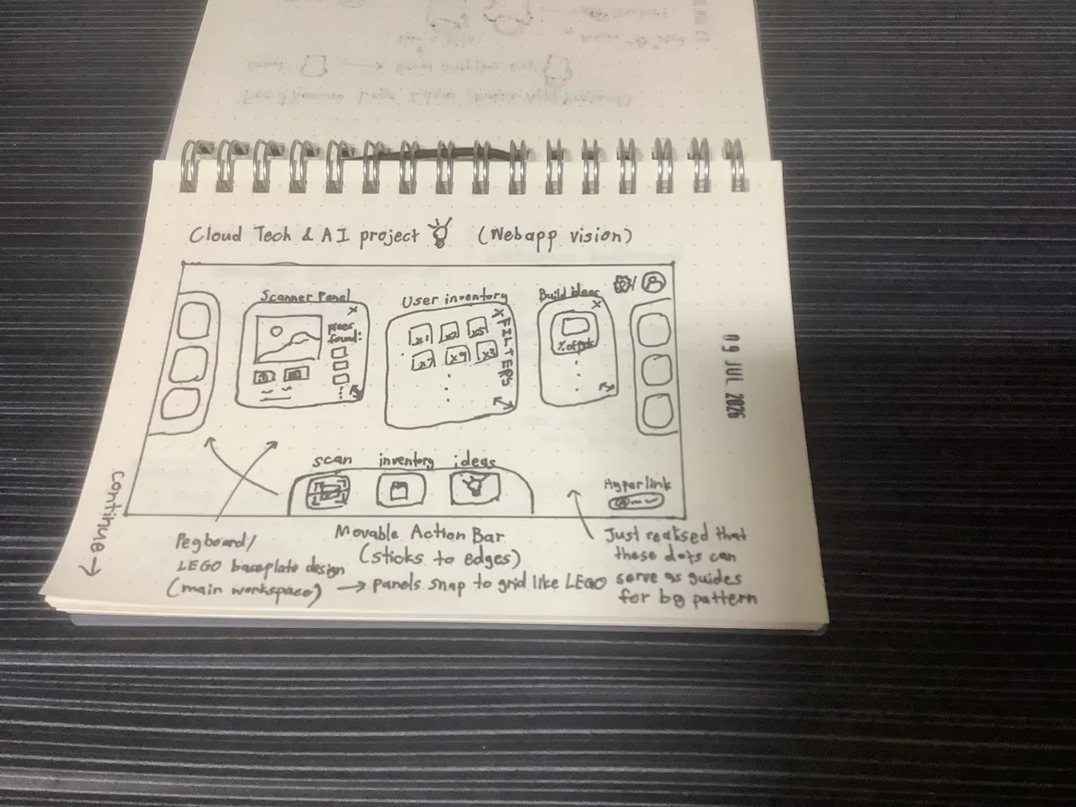
Sketch 1 — panel layout vision, movable action bar, pegboard/LEGO baseplate workspace concept.
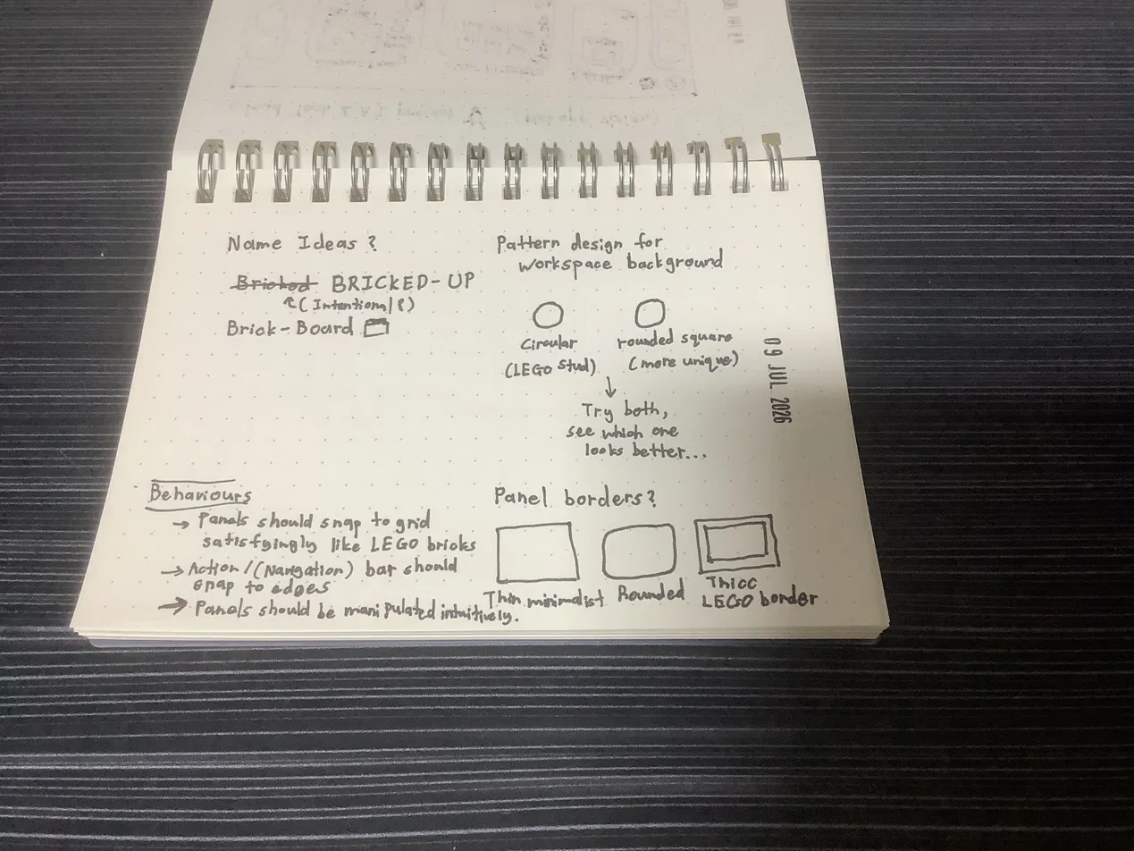
Sketch 2 — naming ideas, background pattern options, panel border options, behaviour notes.

Appendix D: Reference Links
- AWS Rekognition Custom Labels guide: docs.aws.amazon.com/rekognition/latest/customlabels-dg/
- AWS Academy Learner Lab foundational services restrictions: check the “AWS Details” panel in your own lab for the current authoritative list
- Rebrickable downloads (parts/sets/inventories CSVs): rebrickable.com/downloads
- Rebrickable API docs (for later/optional live lookups): rebrickable.com/api/
- Rebrickable Terms of Service (note the AI-training restriction covered in §3.5): rebrickable.com/terms/
- Kaggle “LEGO Classification 10k” dataset: kaggle.com/datasets/ronanpickell/lego-classification-10k
- Vite + React getting started: vitejs.dev
- react-rnd (drag/resize primitives used in §7.3/§8.2): www.npmjs.com/package/react-rnd

End of BRICKED-UP Implementation Master Guide.

