Model Manager

*(Updated 2014-02-05 by Jinsol Kim)*

*For HOK buildingSMART Managers only*

## Overview

The Model Manager will operate in two modes, “Project Replication” and “Model Builder”, and commands of each mode will be accessible by two separate push buttons located in the HOK tab. “Project Replication” mode will be enabled for all general users, whereas “Model Builder” will be restricted to only certain HOK staffs or buildingSMART Managers.

*** Project Replication*** mode - The tool will allow users to duplicate elements or transfer data across opened Revit models, not from external resources or non-work shared Revit project files.

*** Model Builder*** mode - on top of the all features from the Project Replication mode, the tool will allow users to set resources not only from the opened Revit models, but also from external files. In addition, it will provide UI for users to manage the source locations and linked items.

While the Model Manager duplicates Revit elements, as a background process all the record of synchronized items will be stored in Google spreadsheet which will not be exposed to end users.

*By the limitation of the Revit API, the Model Manager will only be available in 2014 version*.

## Terminology

* ***Source Model*** will be a Revit model from which Revit elements will be copied
* ***Recipient Model*** will be a Revit model in which copied Revit elements will be pasted
* ***Linked Items*** in this documentation will refer to the map between the source item and the copied item in the recipient model

Contents

Overview 1

Terminology 1

***1.*** ***Installation*** 4

***2.*** ***Project Replication*** 5

2.1 Drafting Views 5

2.1.1 User Interface 5

2.1.2 Duplicating Drafting Views 6

2.1.3 Diagrams 11

2.2 Legends 11

2.3 Schedules 11

***3.*** ***Model Builder*** 11

3.1 Drafting Views 11

3.2 Legends 11

3.3 Schedules 11

3.4 Resource Manager 11

***4.*** ***Data Storage*** 12

4.1 Google Doc 12

4.1.1 HOK Users 12

4.1.2 External Users 12

4.1.3 Spreadsheet Contents 13

4.2 Registry Keys 14

4.3 Log Images 14

# ***Installation***

*By HOK Navigator*



Select the check box named HOK Addins to run HOK Addins Installer.

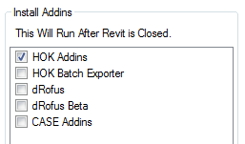

The latest version of the Model Manager will be found under beta files. Select the option to include beta files and make sure the Model Manager is checked before preceding the installation.

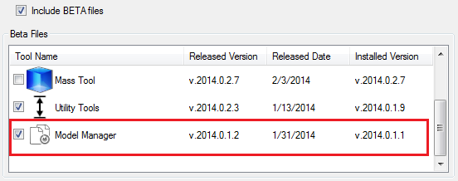

After the installation, you will see the Project Replication button on the Customizations panel in the HOK tab.

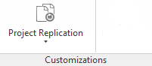

# ***Project Replication***

In this mode, users can duplicate three different categories of elements like Drafting Views, Legends, and Schedules across opened Revit models based on the recorded linked data.

## 2.1 Drafting Views

### 2.1.1 User Interface

- ***Model Selection***: both of combo boxes for Source and Recipient Model will display options of all opened Revit project files in the current Revit Session, excluding Family files.

- ***Sorting Views By***: Source and Recipient items can be sorted by Sheets or View types.

- ***Manage Links***: If any missing items in linked items exist from one side either source or recipient, the links can be restored or created new links through the UI.

- ***Lists of Source Items***: selected source items from this view will be duplicated to the recipient model.

- ***List of Recipient Items***: existing items in the recipient model will be displayed in this view

- ***Linked Views Selection***: check/uncheck all linked items

- ***Sheet Mirroring Option***: based on this option, associated sheets will be created or not.

- ***Update Views Command***: users will be entered to preview windows before making a final decision.

- ***Save Settings***: users will be able to save the current state of the settings.

### 2.1.2 Duplicating Drafting Views

In order to duplicate drafting views, following options may need to be considered.

**1. Model Selection**

Select a source model that contains drafting views to be copied, and a recipient model in which the copied elements will be pasted. Identical model selection between source and recipient will not be allowed.



1. **Sorting Views**

The drafting views can be sorted by either sheets, or view types under the tree view structure.

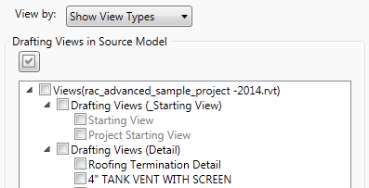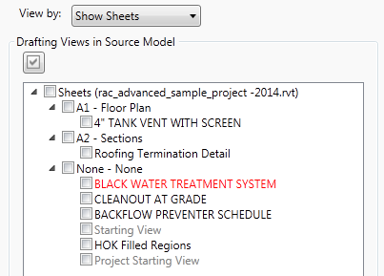

If a sheet node or a view type node is selected among the source items, the recipient view ill be displayed with corresponding drafting views that belongs to the specific group. To get back to the full list, select the root nodes, Sheets or Views.

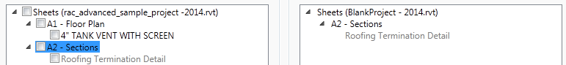

1. **Selecting Source Items**

Linked status will be distinguished by three different colors of the text and tool tips.

Text Colors: Black (new item), Gray (linked items), Red (broken links)

These are how the tool tips will look like

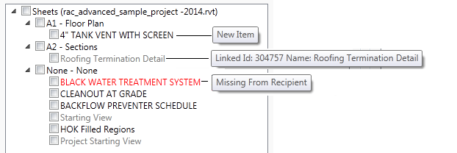

By selecting the check box named “Select All Linked Views” on the left bottom corner, it will check or uncheck only linked items.



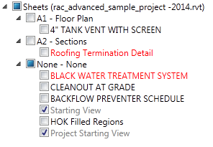

1. **Enforcing Sheet Mirroring**

If a drafting view in the source model is placed on a certain sheet as a view port, this option will determine whether creating the corresponding sheet in the recipient model or not.



If the option is selected, this tool will create the same name of sheet with duplicated title blocks and transfer all parameter values from the source sheet. The selected drafting view will be placed in the equivalent position as the source view placed.

1. **Managing Links**

In order to fix or create new links, click the button, on the right top corner.

Select an item from the source view and an item from the recipient view before adding the link by the right arrows button , or select an item in the list of liked drafting views and click the left arrows button to remove the link.

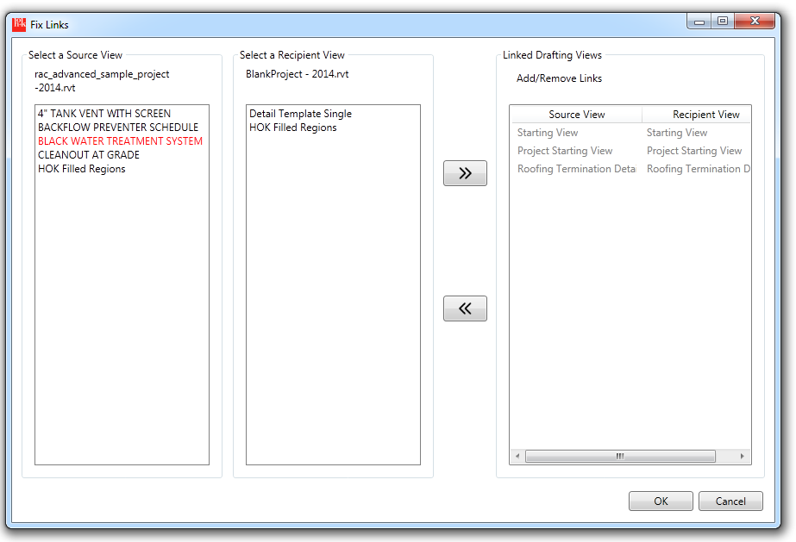

1. **Updating Views**

Make selections of drafting views in the source tree view, and click the button on the bottom right corner. This will open the window titled “Confirm Views to Sync” to be able to preview of the current state of source views and the recipient views if ever synchronized before.

The source view displayed on the left can be panned or zoomed in/out by scrolling the mouse wheel up or down.

Select the option, , to skip the current view.

If any changes were made on the linked recipient view, click the refresh button on the top right corner.

At the end of page, the Update Views button  will be enabled.

Users can also instantly update views without review 

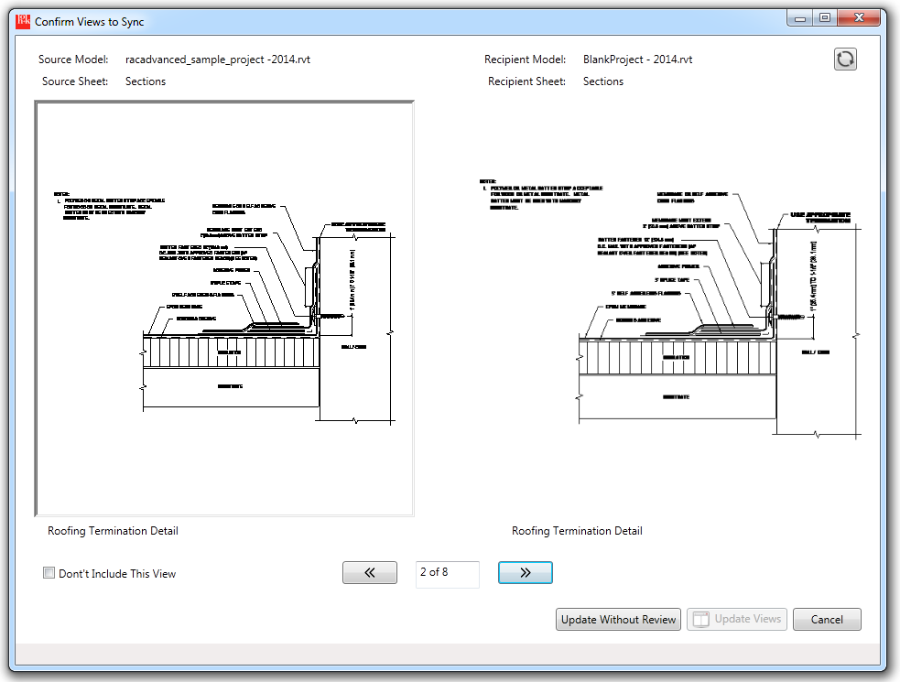

### 2.1.3 Diagrams

[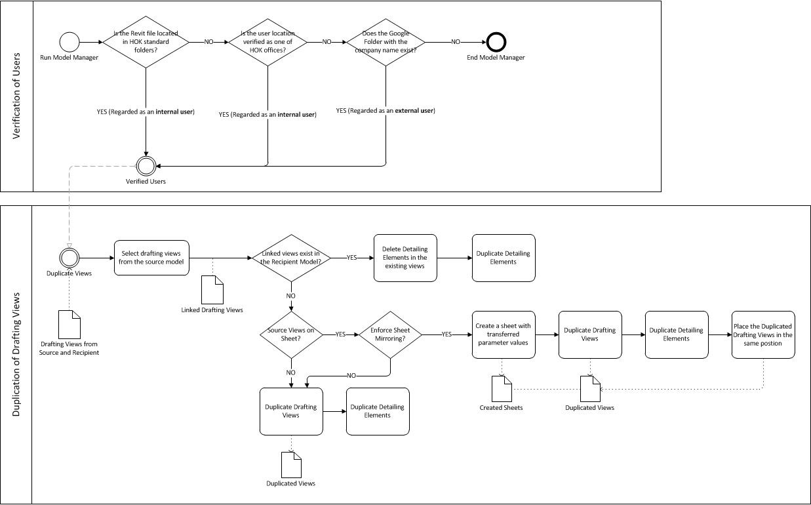](DuplicateViews.jpg)

## 2.2 Legends

## 2.3 Schedules

# ***Model Builder***

## 3.1 Drafting Views

## 3.2 Legends

## 3.3 Schedules

## 3.4 Resource Manager

# ***Data Storage***

## 4.1 Google Doc

Based upon duplicating items by this tool, one Google spreadsheet per a recipient model will be created or associated.

### 4.1.1 HOK Users

The corresponding Google spreadsheet will be found under the following folder structure.

AppData >> HOK Model Manager >> Project Replication >> HOK Offices >> *[Office Location]*

>> *[Project Number + Project Name]* >> *[Recipient Model Title]*

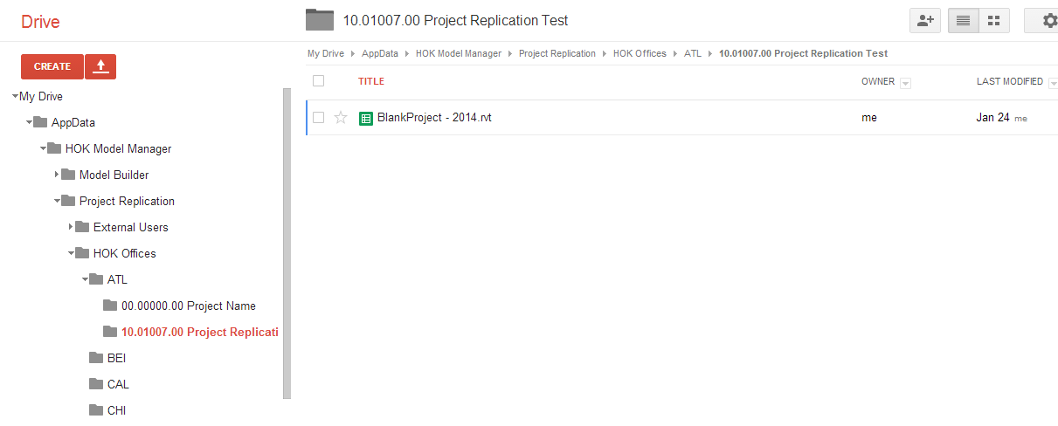

### 4.1.2 External Users

The tool will create 17-digits of the unique identifier of the Revit file which will be consistent after renaming or moving the file to another location.

The Google spreadsheet will be stored under the following folder structure.

AppData >> HOK Model Manager >> ProjectReplication >> External Users >> *[Company Name]*  >> *[Identifier of Recipient Model]*

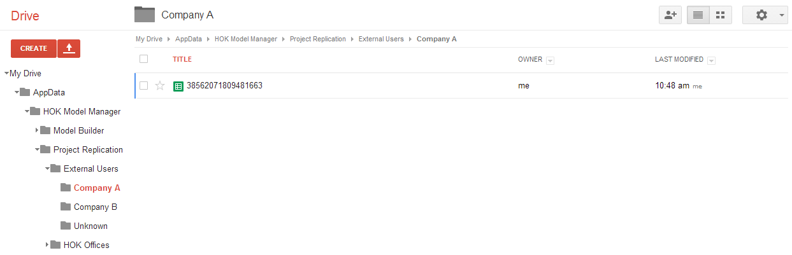

*\*\* only the company names matched to one in Google folders will be approved to use HOK Model Manager.*

### 4.1.3 Spreadsheet Contents

- ***ItemType***: possible types of linked items could be “DraftingView”, “Legend”, or “Schedule”

- ***SourceName***: the name of the source model

- ***SourcePath***: the file path of the source model

- ***DestinationPath***: the file path of the recipient model

- ***ItemSourceID***: the element Id of the source item

- ***ItemSourceName***: the name of the source element

- ***ItemDestinationID***: the element Id of the recipient item

- ***ItemDestinationName***: the name of the recipient element

- ***ItemDestinationImage1***: the older image of the drafting view before overriding the view

-***ItemDestinationImage2***: the current image of the drafting view after overriding the view

- ***LinkModified***: the date and time at which the link is modified.

- ***LinkModifiedBy***: the user name by which the link is modified

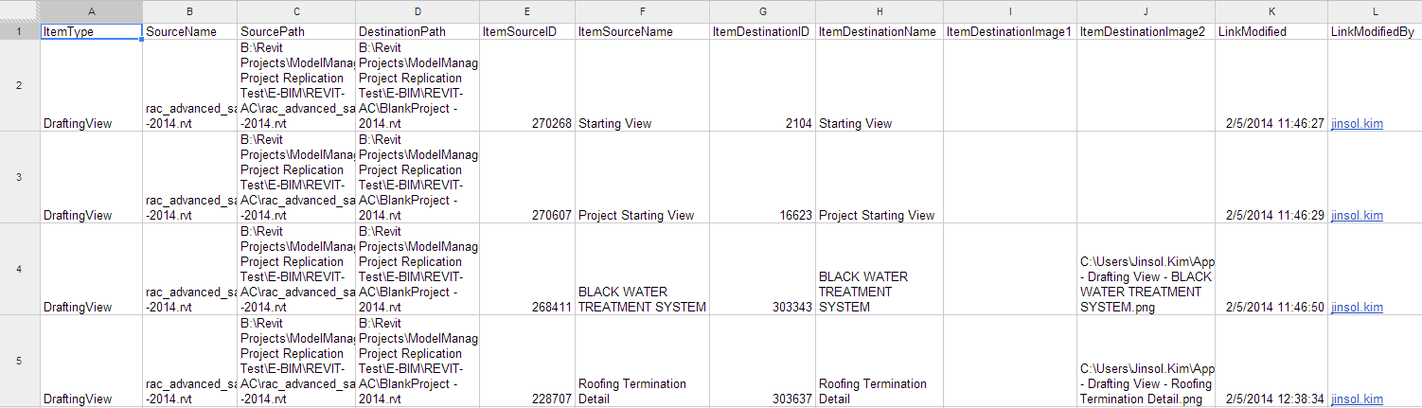

## 4.2 Registry Keys

Two registry keys will be involved in the Model Manager.

“CompanyName” will be used to verify the approved external users

“ModelBuilderActivated” will define whether the Model Manager will include the Model Builder mode or not.

## 4.3 Log Images

At the event of duplicating drafting views, the tool will export the views as image files and save them in the temp folder named ModelManager. Those saved image files will be referenced for the display of recipient drafting views in the preview window, Confirm Views to Sync.

C:\Users*\[user name]*AppData\Local\Temp\ModelManager