HOK Solibri Batch Manager

*(Updated 2016-11-04 by Jinsol Kim)*

## **Overview**

The HOK Solibri Batch Manager is designed to facilitate the use of [Autorun](https://www.solibri.com/solibri-autorun-released/) feature in Solibri Model Checker(SMC) with the graphical user interface. This tool will help users create an xml configuration file and a bat file for batching process of models in an assigned directory of a remote machine.

## **Requirements**

* Solibri Model Checker v.9.5 **
* Solibri Model Checker v.9.6
* Solibri Model Checker v.9.7

**Some of newly released task types like “updatemodel” and “updatepresentation” are only available in version 9.6.10 or newer.

Contents

**Overview** 1

**Requirements** 1

1. Task Types 3

2. Batch Process 6

2.1 Converting to SMC Models 6

2.2 Creating Presentation 7

2.3 Creating Reports 7

Report from Checking View 8

Report form Presentation View 8

BCF Report 8

Coordination Report 8

2.4 Updating Models and Presentation 9

3. Settings 10

3.1 Batch Options 10

3.2 Classification and Rulesets 11

3.3 Reports 11

3.4 Saving Solibri Model 12

3.5 Default Settings 12

# 1. Task Types

**openmodel** opens a model with defined parameters.

|  |  |
| --- | --- |
| Parameters | |
| file | the path to a file with the following extensions .smc, .ifc, .ifczip, .zip, .dwg, |
| discipline | discipline of the model |
| shortname | short name for the model |

**openruleset** opens a ruleset file with defined parameters.

|  |  |
| --- | --- |
| Parameters | |
| file | the path of a ruleset file |
| provider |  |
| resource |  |

**openclassification** opens a classification file with defined parameters.

|  |  |
| --- | --- |
| Parameters | |
| file | the path of classification file |
| provider |  |
| resource |  |

**check** checks the currently opened models with opened rulesets.

**autocomment** adds description to the issues in the checking result

|  |  |
| --- | --- |
| Parameters | |
| zoom | TRUE or FALSE |
| maxsnapshotsincategory | if the category has more issues than the limit, the snapshots are added to the category level. |

**writereport** generates reports from the checking view.

|  |  |
| --- | --- |
| Parameters | |
| pdffile | the path of a pdf file to be saved |
| rtffile | the path of rtf file to be saved |
| major | inclusion of the results with major severity |
| normal | inclusion of the results with normal severity |
| minor | inclusion of the results with minor severity |
| rejected | inclusion of the results with rejected status |
| accepted | inclusion of the results with accepted status |

**createpresentation** generates presentation slides from the checking results.

**generalreport** generates reports from the presentation view.

|  |  |
| --- | --- |
| Parameters | |
| pdffile | the path of a pdf file to be saved |
| rtffile | the path of rtf file to be saved |
| major | inclusion of the results with major severity |
| normal | inclusion of the results with normal severity |
| minor | inclusion of the results with minor severity |
| rejected | inclusion of the results with rejected status |
| accepted | inclusion of the results with accepted status |

**bcfreport** generates BCF reports from the presentation view.

|  |  |
| --- | --- |
| Parameters | |
| file | the path of a bcf file to be saved |
| version | 1 or 2(default) |

**coordinationreport** generates coordination reports from the presentation view in Excel format.

|  |  |
| --- | --- |
| Parameters | |
| file | the path of a coordination report to be saved as .xls or xlsx formats |
| templatefile | the path of a template file with extensions .xls or .xlsx |

**savemodel** saves the model as a SMC file.

|  |  |
| --- | --- |
| Parameters | |
| file | the path of a smc file to be saved |

**closemodel** closes the opened models in the current session.

**updatemodel** updates ifc models in the smc model with new models**.**

|  |  |
| --- | --- |
| Parameters | |
| file | the path of an ifc file already opened |
| with | the path of a new ifc file to be replaced with |

**updatepresentation** updates presentation after updating models

**exit** exits Solibri Model Checker.

# 2. Batch Process

The HOK Solibri Batch Processor will help create a configuration file (.xml) containing all task types in sequences and a batch file (.bat) to execute Solibri Model Checker following the configuration file.

To start, create a task by clicking (+) button on the bottom left corner of the Tasks section.

## 2.1 Converting to SMC Models

Create a task with a name and a directory for the task.

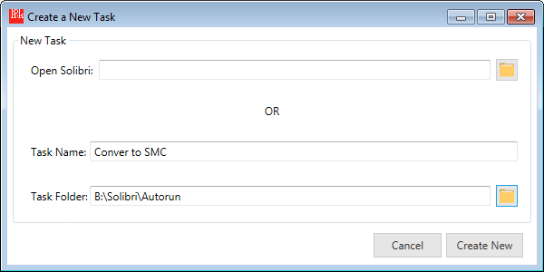

Add models among .ifc, .ifczip, .dwg, .zip formats to be combined in a Solibri model.

Specify an abbreviation for the model under Short Name column, and select a discipline among the drop-down list.

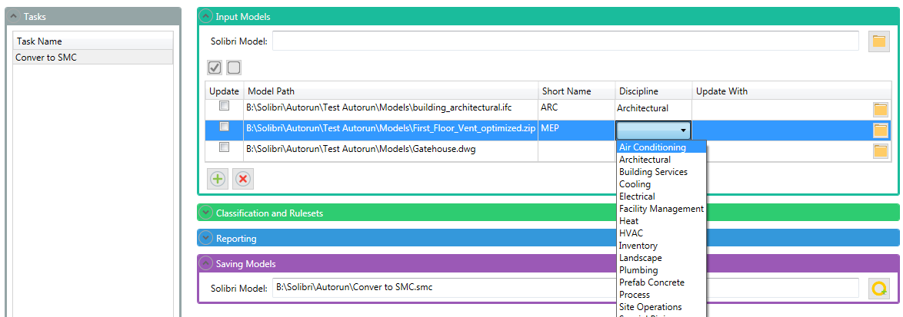

You can either specify the path of Solibri model to save, or just use the default path assigned by the tool.

## 2.2 Creating Presentation

Create a task and open models following the section above 2.1 Converting to SMC Models

Expand “Clasification and Rulesets” panel and add ruleset files to check.

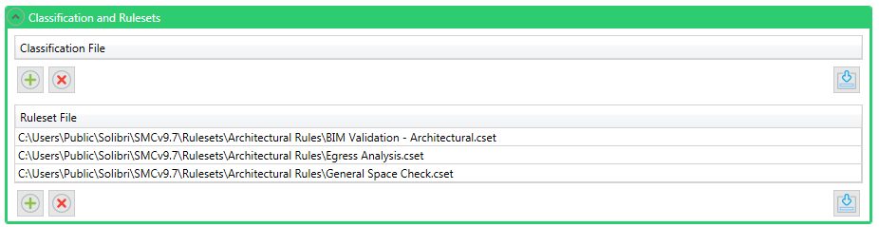If you want to import commonly used ruleset files from the settings, press down arrow button on the bottom-right corner.  (See 3.2 Classifications and Rulesets for more detail)

Under “Reporting” panel, turn on the toggle button to make the checking mode on and check the Create Presentation option.

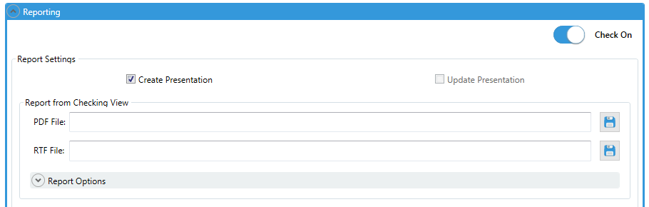

## 2.3 Creating Reports

In order to create reports, follow the steps above to create a task, and to add input models and rulesets 2.1 Converting to SMC Models, and 2.2 Creating Presentation.

### Report from Checking View

Specify a report path for pdf or rtf file. Select severity and checking decision options to include in the report.

*Create Presentation is optional.

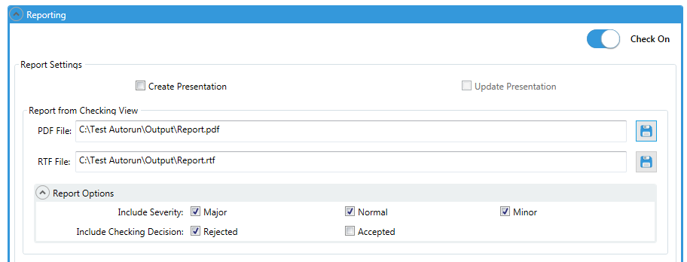

### Report form Presentation View

Specify a report path for pdf or rtf file.

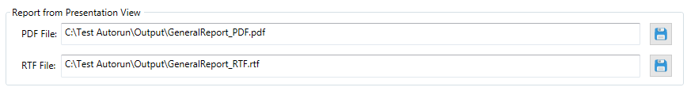

### BCF Report

Select the version of BCF format (1.0 or 2.0) and specify the path for the bcf report.

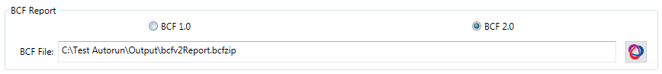

### Coordination Report

Specify a path for the coordination report and assign a template file to be used to create the report.

**The type of Excel should be matched between the report and the template file. If the template is “xls”, the report should be “xls”. On the other hand, “xlsx” template should assign with “xlsx” report.

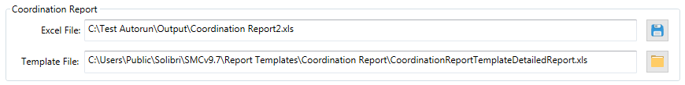

## 2.4 Updating Models and Presentation

When models contained in a smc file are externally updated, you can reload the same model into the Solibri model or replace with the updated model.

Simply select the check box under the Update column and it will fill the “Update With” column with the same path as Model Path to reload. Otherwise, specify the updated model path through the button for opening folder in Update With column to replace.

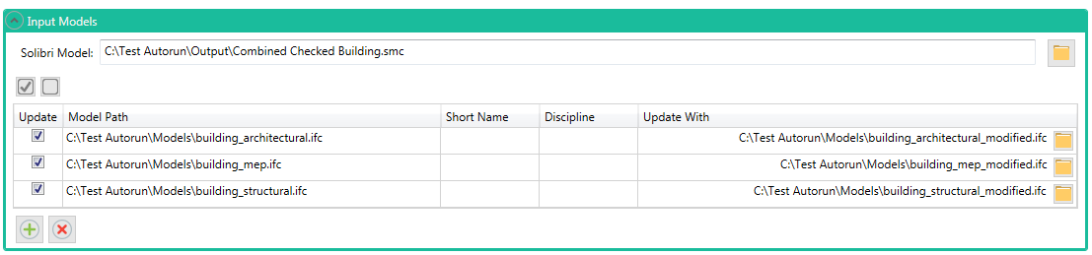If at least one model is selected for update, the option for Update Presentation will be automatically selected in the Reporting panel.

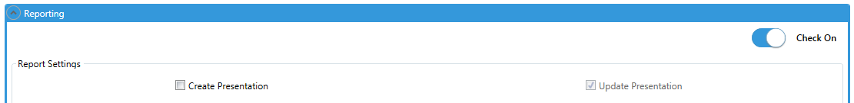

You can create reports with the updated presentation following the steps above. (See 2.3 Creating Reports)

# 3. Settings

The Solibri Batch Manager will store application settings to help assign the path of output files with predefined rules or import commonly used rulesets or classification files into the task as an automatic process.

Press the Settings button on the upper-right corner to open the Settings window.

## 3.1 Batch Options

Select a version for Solibri to run the tasks created and a directory of a remote computer in which the configuration file (.xml) will be saved.

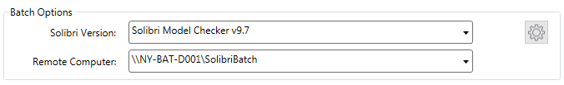

In order to customize items for Solibri Version or Remote Computer, press the gear icon button on the upper-right corner.

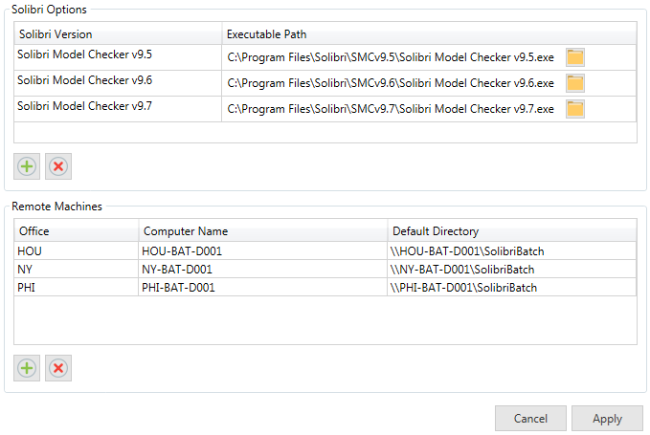

You can add/edit/delete items and apply to the current session. The options you created will be stored as an xml file in users’ profile.

e.g. C:\Users\[user name]\AppData\Roaming\Solibri Batch Manager\BatchOptions.xml

## 3.2 Classifications and Rulesets

You can define presets of classification and ruleset files commonly used project-wide so that they can be loaded at once by the import button in the main window.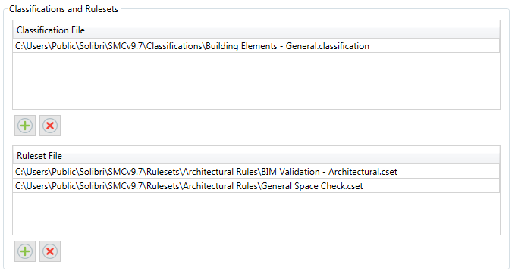

## 3.3 Reports

Select types of reports to apply the saving rules for the path of output files. When you create a task, the tool will automatically set the path of the selected reports following the predefined rules.

* Save In Place : this will save the selected reports in the same directory with the same file name as the opening Solibri model or the task name.
* Save In Folder: this will save the selected reports in the assigned directory as the name of the opening Solibri model or the task name.
* Append Date in File Names: this will append a suffix of a date format i.e. yyyy-mm-dd into the file names of selected reports
* Coordination Template: default template for the coordination report.

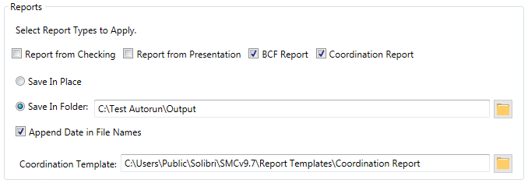

With the pre-selected reports and settings, you will see the applied results like below when you create a task.

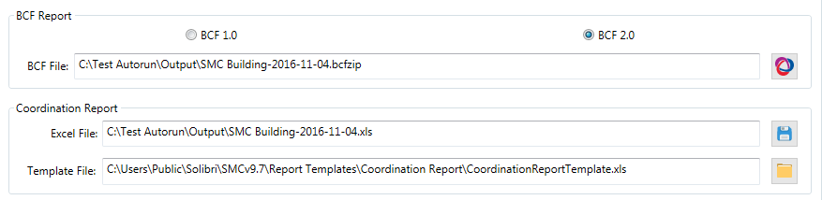

## 3.4 Saving Solibri Model

Similar to the settings for reports, you can select Save In Place or specify an output folder for the path of each Solibri model to be saved.

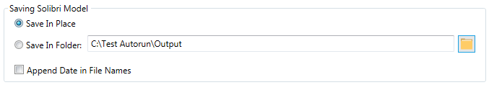

## 3.5 Default Settings

You can restore back to the default setting by the Set Default button on the bottom left corner.

