 | 

Faculty of Technology and Engineering
Chandubhai S. Patel Institute of Technology (CSPIT) Department of Computer Science & Engineering
Date: / /
Laboratory Manul

Academic Year | : | 2026-27 | Semester | : | 3rd
Course code | : | ITUE203 | Course name | : | WEB DEVELOPMENT FRAMEWORKS

Practical – 13
PROBLEM STATEMENT :

Create simple PHP JSON API endpoints for events or students and consume them using Fetch API. Perform list, add, update, and delete
operations asynchronously without full page reload.

Objective :

To develop a PHP JSON API integrated with a MySQL database and use JavaScript Fetch API to perform Create, Read, Update, and Delete (CRUD) operations asynchronously without reloading the webpage.

Code :

Api.php

const API_URL = 'api.php';

const form = document.getElementById('eventForm');
const messageBox = document.getElementById('message');
const loadingBox = document.getElementById('loading');
const eventsBody = document.getElementById('eventsBody');
const eventId = document.getElementById('eventId');
const titleInput = document.getElementById('title');
const categoryInput = document.getElementById('category');
const dateInput = document.getElementById('eventDate');
const venueInput = document.getElementById('venue');
const saveButton = document.getElementById('saveButton');
const cancelButton = document.getElementById('cancelButton');
const formTitle = document.getElementById('formTitle');

function showMessage(text, type = 'success') {
messageBox.textContent = text;
messageBox.className = type;
}

function setLoading(isLoading) {
loadingBox.classList.toggle('hidden', !isLoading);
saveButton.disabled = isLoading;
document.getElementById('refreshButton').disabled = isLoading;
}

async function apiRequest(action, payload = null) {
const options = {
headers: {}
};

let url = `${API_URL}?action=${encodeURIComponent(action)}`;

if (payload !== null) {
options.method = 'POST';
options.headers['Content-Type'] = 'application/json';
options.body = JSON.stringify(payload);
}

const response = await fetch(url, options);
const result = await response.json();

if (!response.ok || result.status !== 'success') {
throw new Error(result.message || `HTTP error ${response.status}`);
}

return result;
}

async function loadEvents() {
setLoading(true);

try {
const result = await apiRequest('list');
eventsBody.replaceChildren();

if (!result.data || result.data.length === 0) {
const row = document.createElement('tr');
const cell = document.createElement('td');
cell.colSpan = 6;
cell.textContent = 'No events found.';
row.appendChild(cell);
eventsBody.appendChild(row);
} else {
result.data.forEach(event => {
const row = document.createElement('tr');

[
event.id,
event.title,
event.category,
event.event_date,
event.venue
].forEach(value => {
const cell = document.createElement('td');
cell.textContent = value;
row.appendChild(cell);
});

const actions = document.createElement('td');

const editButton = document.createElement('button');
editButton.textContent = 'Edit';
editButton.className = 'edit';
editButton.type = 'button';
editButton.addEventListener('click', () => startEdit(event));

const deleteButton = document.createElement('button');
deleteButton.textContent = 'Delete';
deleteButton.className = 'danger';
deleteButton.type = 'button';
deleteButton.addEventListener('click', () => deleteEvent(event.id));

actions.append(editButton, deleteButton);
row.appendChild(actions);
eventsBody.appendChild(row);
});
}

showMessage('Event list loaded successfully.');
} catch (error) {
showMessage(`Unable to load events: ${error.message}`, 'error');
eventsBody.replaceChildren();

const row = document.createElement('tr');
const cell = document.createElement('td');
cell.colSpan = 6;
cell.textContent = 'Unable to load data. Please try again.';
row.appendChild(cell);
eventsBody.appendChild(row);
} finally {
setLoading(false);
}
}

function startEdit(event) {
eventId.value = event.id;
titleInput.value = event.title;
categoryInput.value = event.category;
dateInput.value = event.event_date;
venueInput.value = event.venue;

formTitle.textContent = 'Edit Event';
saveButton.textContent = 'Update Event';
cancelButton.classList.remove('hidden');
titleInput.focus();
}

function resetForm() {
form.reset();
eventId.value = '';
formTitle.textContent = 'Add Event';
saveButton.textContent = 'Add Event';
cancelButton.classList.add('hidden');
}

form.addEventListener('submit', async event => {
event.preventDefault();

const payload = {
title: titleInput.value.trim(),
category: categoryInput.value.trim(),
event_date: dateInput.value,
venue: venueInput.value.trim()
};

const action = eventId.value ? 'update' : 'create';

if (action === 'update') {
payload.id = Number(eventId.value);
}

setLoading(true);

try {
const result = await apiRequest(action, payload);
showMessage(result.message || 'Operation completed successfully.');
resetForm();
await loadEvents();
} catch (error) {
showMessage(`Operation failed: ${error.message}`, 'error');
} finally {
setLoading(false);
}
});

async function deleteEvent(id) {
if (!confirm('Are you sure you want to delete this event?')) {
return;
}

setLoading(true);

try {
const result = await apiRequest('delete', { id: Number(id) });
showMessage(result.message);
await loadEvents();
} catch (error) {
showMessage(`Delete failed: ${error.message}`, 'error');
} finally {
setLoading(false);
}
}

cancelButton.addEventListener('click', resetForm);
document.getElementById('refreshButton').addEventListener('click', loadEvents);

const API_URL = 'api.php';

const form = document.getElementById('eventForm');
const messageBox = document.getElementById('message');
const loadingBox = document.getElementById('loading');
const eventsBody = document.getElementById('eventsBody');
const eventId = document.getElementById('eventId');
const titleInput = document.getElementById('title');
const categoryInput = document.getElementById('category');
const dateInput = document.getElementById('eventDate');
const venueInput = document.getElementById('venue');
const saveButton = document.getElementById('saveButton');
const cancelButton = document.getElementById('cancelButton');
const formTitle = document.getElementById('formTitle');

function showMessage(text, type = 'success') {
messageBox.textContent = text;
messageBox.className = type;
}

function setLoading(isLoading) {
loadingBox.classList.toggle('hidden', !isLoading);
saveButton.disabled = isLoading;
document.getElementById('refreshButton').disabled = isLoading;
}

async function apiRequest(action, payload = null) {
const options = {
headers: {}
};

let url = `${API_URL}?action=${encodeURIComponent(action)}`;

if (payload !== null) {
options.method = 'POST';
options.headers['Content-Type'] = 'application/json';
options.body = JSON.stringify(payload);
}

const response = await fetch(url, options);
const result = await response.json();

if (!response.ok || result.status !== 'success') {
throw new Error(result.message || `HTTP error ${response.status}`);
}

return result;
}

async function loadEvents() {
setLoading(true);

try {
const result = await apiRequest('list');
eventsBody.replaceChildren();

if (!result.data || result.data.length === 0) {
const row = document.createElement('tr');
const cell = document.createElement('td');
cell.colSpan = 6;
cell.textContent = 'No events found.';
row.appendChild(cell);
eventsBody.appendChild(row);
} else {
result.data.forEach(event => {
const row = document.createElement('tr');

[
event.id,
event.title,
event.category,
event.event_date,
event.venue
].forEach(value => {
const cell = document.createElement('td');
cell.textContent = value;
row.appendChild(cell);
});

const actions = document.createElement('td');

const editButton = document.createElement('button');
editButton.textContent = 'Edit';
editButton.className = 'edit';
editButton.type = 'button';
editButton.addEventListener('click', () => startEdit(event));

const deleteButton = document.createElement('button');
deleteButton.textContent = 'Delete';
deleteButton.className = 'danger';
deleteButton.type = 'button';
deleteButton.addEventListener('click', () => deleteEvent(event.id));

actions.append(editButton, deleteButton);
row.appendChild(actions);
eventsBody.appendChild(row);
});
}

showMessage('Event list loaded successfully.');
} catch (error) {
showMessage(`Unable to load events: ${error.message}`, 'error');
eventsBody.replaceChildren();

const row = document.createElement('tr');
const cell = document.createElement('td');
cell.colSpan = 6;
cell.textContent = 'Unable to load data. Please try again.';
row.appendChild(cell);
eventsBody.appendChild(row);
} finally {
setLoading(false);
}
}

function startEdit(event) {
eventId.value = event.id;
titleInput.value = event.title;
categoryInput.value = event.category;
dateInput.value = event.event_date;
venueInput.value = event.venue;

formTitle.textContent = 'Edit Event';
saveButton.textContent = 'Update Event';
cancelButton.classList.remove('hidden');
titleInput.focus();
}

function resetForm() {
form.reset();
eventId.value = '';
formTitle.textContent = 'Add Event';
saveButton.textContent = 'Add Event';
cancelButton.classList.add('hidden');
}

form.addEventListener('submit', async event => {
event.preventDefault();

const payload = {
title: titleInput.value.trim(),
category: categoryInput.value.trim(),
event_date: dateInput.value,
venue: venueInput.value.trim()
};

const action = eventId.value ? 'update' : 'create';

if (action === 'update') {
payload.id = Number(eventId.value);
}

setLoading(true);

try {
const result = await apiRequest(action, payload);
showMessage(result.message || 'Operation completed successfully.');
resetForm();
await loadEvents();
} catch (error) {
showMessage(`Operation failed: ${error.message}`, 'error');
} finally {
setLoading(false);
}
});

async function deleteEvent(id) {
if (!confirm('Are you sure you want to delete this event?')) {
return;
}

setLoading(true);

try {
const result = await apiRequest('delete', { id: Number(id) });
showMessage(result.message);
await loadEvents();
} catch (error) {
showMessage(`Delete failed: ${error.message}`, 'error');
} finally {
setLoading(false);
}
}

cancelButton.addEventListener('click', resetForm);
document.getElementById('refreshButton').addEventListener('click', loadEvents);

loadEvents();

header('Content-Type: application/json; charset=UTF-8');
header('Cache-Control: no-store');

require_once 'db.php';

function respond($status, $message = '', $data = null, $code = 200) {
http_response_code($code);
$result = ['status' => $status];

if ($message !== '') {
$result['message'] = $message;
}

if ($data !== null) {
$result['data'] = $data;
}

echo json_encode($result);
exit;
}

function readInput() {
$raw = file_get_contents('php://input');
$data = json_decode($raw, true);

if (!is_array($data)) {
respond('error', 'Invalid JSON request.', null, 400);
}

return $data;
}

function validId($id) {
return filter_var($id, FILTER_VALIDATE_INT, [
'options' => ['min_range' => 1]
]) !== false;
}

function validDate($date) {
if (!is_string($date)) {
return false;
}

$d = DateTime::createFromFormat('!Y-m-d', $date);
return $d && $d->format('Y-m-d') === $date;
}

$action = $_GET['action'] ?? '';

try {
switch ($action) {
case 'list':
$stmt = $pdo->query(
'SELECT id, title, category, event_date, venue
FROM events ORDER BY id DESC'
);
respond('success', 'Events loaded.', $stmt->fetchAll());

case 'create':
if ($_SERVER['REQUEST_METHOD'] !== 'POST') {
respond('error', 'POST required.', null, 405);
}

$input = readInput();
$title = trim($input['title'] ?? '');
$category = trim($input['category'] ?? '');
$date = $input['event_date'] ?? '';
$venue = trim($input['venue'] ?? '');

if ($title === '' || $category === '' ||
$venue === '' || !validDate($date)) {
respond('error', 'Enter all valid event details.', null, 422);
}

if (mb_strlen($title) > 100 ||
mb_strlen($category) > 50 ||
mb_strlen($venue) > 100) {
respond('error', 'One or more fields are too long.', null, 422);
}

$stmt = $pdo->prepare(
'INSERT INTO events (title, category, event_date, venue)
VALUES (?, ?, ?, ?)'
);
$stmt->execute([$title, $category, $date, $venue]);

respond('success', 'Event added successfully.', [
'id' => (int)$pdo->lastInsertId()
], 201);

case 'update':
if ($_SERVER['REQUEST_METHOD'] !== 'POST') {
respond('error', 'POST required.', null, 405);
}

$input = readInput();
$id = $input['id'] ?? null;
$title = trim($input['title'] ?? '');
$category = trim($input['category'] ?? '');
$date = $input['event_date'] ?? '';
$venue = trim($input['venue'] ?? '');

if (!validId($id) || $title === '' || $category === '' ||
$venue === '' || !validDate($date)) {
respond('error', 'Enter all valid event details.', null, 422);
}

if (mb_strlen($title) > 100 ||
mb_strlen($category) > 50 ||
mb_strlen($venue) > 100) {
respond('error', 'One or more fields are too long.', null, 422);
}

$stmt = $pdo->prepare(
'UPDATE events SET title=?, category=?, event_date=?, venue=?
WHERE id=?'
);
$stmt->execute([$title, $category, $date, $venue, $id]);

if ($stmt->rowCount() === 0) {
$check = $pdo->prepare('SELECT id FROM events WHERE id=?');
$check->execute([$id]);

if (!$check->fetch()) {
respond('error', 'Event not found.', null, 404);
}
}

respond('success', 'Event updated successfully.');

case 'delete':
if ($_SERVER['REQUEST_METHOD'] !== 'POST') {
respond('error', 'POST required.', null, 405);
}

$input = readInput();
$id = $input['id'] ?? null;

if (!validId($id)) {
respond('error', 'Valid event ID required.', null, 422);
}

$stmt = $pdo->prepare('DELETE FROM events WHERE id=?');
$stmt->execute([$id]);

if ($stmt->rowCount() === 0) {
respond('error', 'Event not found.', null, 404);
}

respond('success', 'Event deleted successfully.');

default:
respond('error', 'Invalid API action.', null, 400);
}
} catch (Throwable $e) {
respond('error', 'Server error while processing request.', null, 500);
}
?>

Db.php

<?php
header('Content-Type: application/json; charset=UTF-8');

$host = 'localhost';
$db = 'dashboard_db';
$user = 'root';
$pass = '';

try {
$pdo = new PDO(
"mysql:host=$host;dbname=$db;charset=utf8mb4",
$user,
$pass,
[
PDO::ATTR_ERRMODE => PDO::ERRMODE_EXCEPTION,
PDO::ATTR_DEFAULT_FETCH_MODE => PDO::FETCH_ASSOC
]
);
} catch (PDOException $e) {
http_response_code(500);
echo json_encode([
'status' => 'error',
'message' => 'Database connection failed.'
]);
exit;
}
?>

Index.php

<!DOCTYPE html>
<html lang="en">
<head>
<meta charset="UTF-8">
<meta name="viewport" content="width=device-width, initial-scale=1">
<title>Practical 13 - Event CRUD</title>
<style>
body {
font-family: Arial, sans-serif;
margin: 25px;
background: #f4f6f9;
color: #222;
}
h1 { color: #174a7e; }
.panel {
background: white;
padding: 20px;
margin-bottom: 20px;
border-radius: 8px;
box-shadow: 0 2px 6px #ddd;
}
input, button {
padding: 10px;
margin: 5px 0;
box-sizing: border-box;
}
input { width: 100%; }
button {
cursor: pointer;
border: 0;
border-radius: 4px;
background: #1769aa;
color: white;
}
.danger { background: #c62828; }
.edit { background: #e5a000; color: black; }
.secondary { background: #666; }
table {
width: 100%;
border-collapse: collapse;
background: white;
}
th, td {
border: 1px solid #ddd;
padding: 10px;
text-align: left;
}
th { background: #174a7e; color: white; }
#message { padding: 12px; margin: 10px 0; }
.success { background: #d9f5df; }
.error { background: #ffe0e0; }
.hidden { display: none; }
.actions button { margin-right: 5px; }
</style>
<script src="script.js" defer></script>
</head>
<body>
<h1>Practical 13: Event Management</h1>
<p>PHP JSON API and Fetch-Based CRUD Without Page Reload</p>

<div id="message" role="status" aria-live="polite" class="hidden"></div>
<p id="loading" class="hidden">Loading, please wait...</p>

<section class="panel">
<h2 id="formTitle">Add Event</h2>

<form id="eventForm">
<input type="hidden" id="eventId">

<label for="title">Event Title</label>
<input id="title" maxlength="100" required>

<label for="category">Category</label>
<input id="category" maxlength="50" required>

<label for="eventDate">Event Date</label>
<input type="date" id="eventDate" required>

<label for="venue">Venue</label>
<input id="venue" maxlength="100" required>

<button type="submit" id="saveButton">Add Event</button>
<button type="button" id="cancelButton" class="secondary hidden">
Cancel Edit
</button>
</form>
</section>

<section class="panel">
<h2>Event List</h2>
<button type="button" id="refreshButton">Refresh List</button>

<div style="overflow-x:auto">
<table>
<thead>
<tr>
<th>ID</th>
<th>Title</th>
<th>Category</th>
<th>Date</th>
<th>Venue</th>
<th>Actions</th>
</tr>
</thead>
<tbody id="eventsBody">
<tr><td colspan="6">Events will appear here.</td></tr>
</tbody>
</table>
</div>
</section>
</body>
</html>

Schema.sql

CREATE DATABASE IF NOT EXISTS dashboard_db;
USE dashboard_db;

CREATE TABLE IF NOT EXISTS events (
id INT AUTO_INCREMENT PRIMARY KEY,
title VARCHAR(100) NOT NULL,
category VARCHAR(50) NOT NULL,
event_date DATE NOT NULL,
venue VARCHAR(100) NOT NULL,
created_at TIMESTAMP DEFAULT CURRENT_TIMESTAMP
);

INSERT INTO events (title, category, event_date, venue)
VALUES
('Tech Fest', 'Technology', '2026-11-15', 'CHARUSAT Campus'),
('Workshop', 'Education', '2026-11-20', 'CSPIT'),
('Cultural Night', 'Cultural', '2026-12-01', 'University Auditorium');

Script.js

const API_URL = 'api.php';

const form = document.getElementById('eventForm');
const messageBox = document.getElementById('message');
const loadingBox = document.getElementById('loading');
const eventsBody = document.getElementById('eventsBody');
const eventId = document.getElementById('eventId');
const titleInput = document.getElementById('title');
const categoryInput = document.getElementById('category');
const dateInput = document.getElementById('eventDate');
const venueInput = document.getElementById('venue');
const saveButton = document.getElementById('saveButton');
const cancelButton = document.getElementById('cancelButton');
const formTitle = document.getElementById('formTitle');

function showMessage(text, type = 'success') {
messageBox.textContent = text;
messageBox.className = type;
}

function setLoading(isLoading) {
loadingBox.classList.toggle('hidden', !isLoading);
saveButton.disabled = isLoading;
document.getElementById('refreshButton').disabled = isLoading;
}

async function apiRequest(action, payload = null) {
const options = {
headers: {}
};

let url = `${API_URL}?action=${encodeURIComponent(action)}`;

if (payload !== null) {
options.method = 'POST';
options.headers['Content-Type'] = 'application/json';
options.body = JSON.stringify(payload);
}

const response = await fetch(url, options);
const result = await response.json();

if (!response.ok || result.status !== 'success') {
throw new Error(result.message || `HTTP error ${response.status}`);
}

return result;
}

async function loadEvents() {
setLoading(true);

try {
const result = await apiRequest('list');
eventsBody.replaceChildren();

if (!result.data || result.data.length === 0) {
const row = document.createElement('tr');
const cell = document.createElement('td');
cell.colSpan = 6;
cell.textContent = 'No events found.';
row.appendChild(cell);
eventsBody.appendChild(row);
} else {
result.data.forEach(event => {
const row = document.createElement('tr');

[
event.id,
event.title,
event.category,
event.event_date,
event.venue
].forEach(value => {
const cell = document.createElement('td');
cell.textContent = value;
row.appendChild(cell);
});

const actions = document.createElement('td');

const editButton = document.createElement('button');
editButton.textContent = 'Edit';
editButton.className = 'edit';
editButton.type = 'button';
editButton.addEventListener('click', () => startEdit(event));

const deleteButton = document.createElement('button');
deleteButton.textContent = 'Delete';
deleteButton.className = 'danger';
deleteButton.type = 'button';
deleteButton.addEventListener('click', () => deleteEvent(event.id));

actions.append(editButton, deleteButton);
row.appendChild(actions);
eventsBody.appendChild(row);
});
}

showMessage('Event list loaded successfully.');
} catch (error) {
showMessage(`Unable to load events: ${error.message}`, 'error');
eventsBody.replaceChildren();

const row = document.createElement('tr');
const cell = document.createElement('td');
cell.colSpan = 6;
cell.textContent = 'Unable to load data. Please try again.';
row.appendChild(cell);
eventsBody.appendChild(row);
} finally {
setLoading(false);
}
}

function startEdit(event) {
eventId.value = event.id;
titleInput.value = event.title;
categoryInput.value = event.category;
dateInput.value = event.event_date;
venueInput.value = event.venue;

formTitle.textContent = 'Edit Event';
saveButton.textContent = 'Update Event';
cancelButton.classList.remove('hidden');
titleInput.focus();
}

function resetForm() {
form.reset();
eventId.value = '';
formTitle.textContent = 'Add Event';
saveButton.textContent = 'Add Event';
cancelButton.classList.add('hidden');
}

form.addEventListener('submit', async event => {
event.preventDefault();

const payload = {
title: titleInput.value.trim(),
category: categoryInput.value.trim(),
event_date: dateInput.value,
venue: venueInput.value.trim()
};

const action = eventId.value ? 'update' : 'create';

if (action === 'update') {
payload.id = Number(eventId.value);
}

setLoading(true);

try {
const result = await apiRequest(action, payload);
showMessage(result.message || 'Operation completed successfully.');
resetForm();
await loadEvents();
} catch (error) {
showMessage(`Operation failed: ${error.message}`, 'error');
} finally {
setLoading(false);
}
});

async function deleteEvent(id) {
if (!confirm('Are you sure you want to delete this event?')) {
return;
}

setLoading(true);

try {
const result = await apiRequest('delete', { id: Number(id) });
showMessage(result.message);
await loadEvents();
} catch (error) {
showMessage(`Delete failed: ${error.message}`, 'error');
} finally {
setLoading(false);
}
}

cancelButton.addEventListener('click', resetForm);
document.getElementById('refreshButton').addEventListener('click', loadEvents);

loadEvents();

Screenshot :

Database and Events Table Created

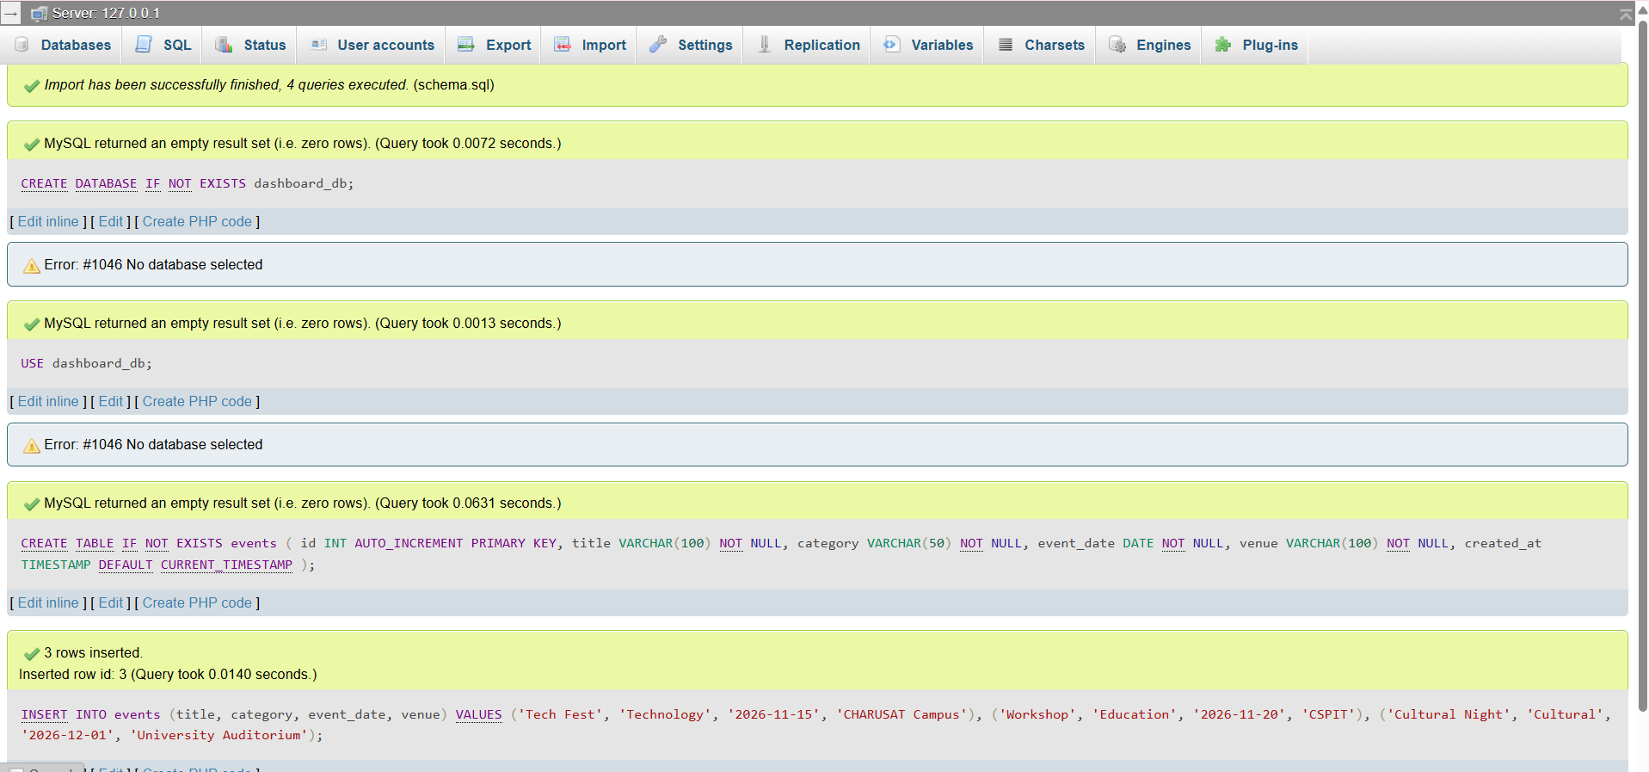

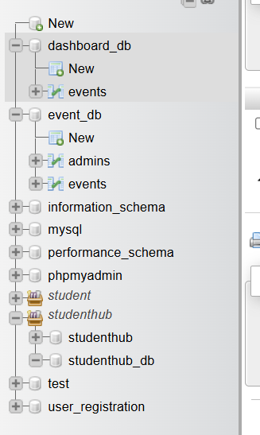

Event List Loaded Successfully

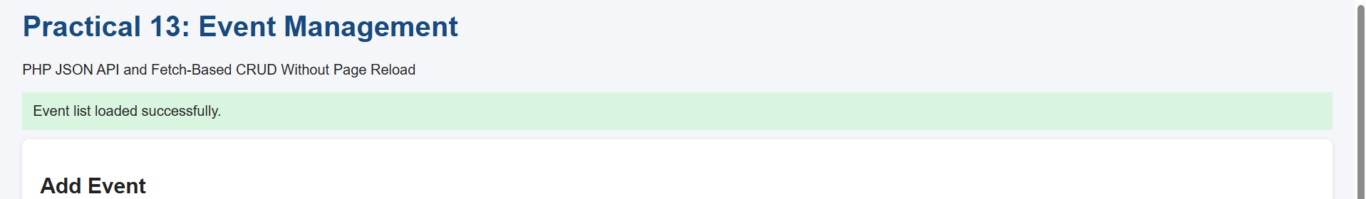

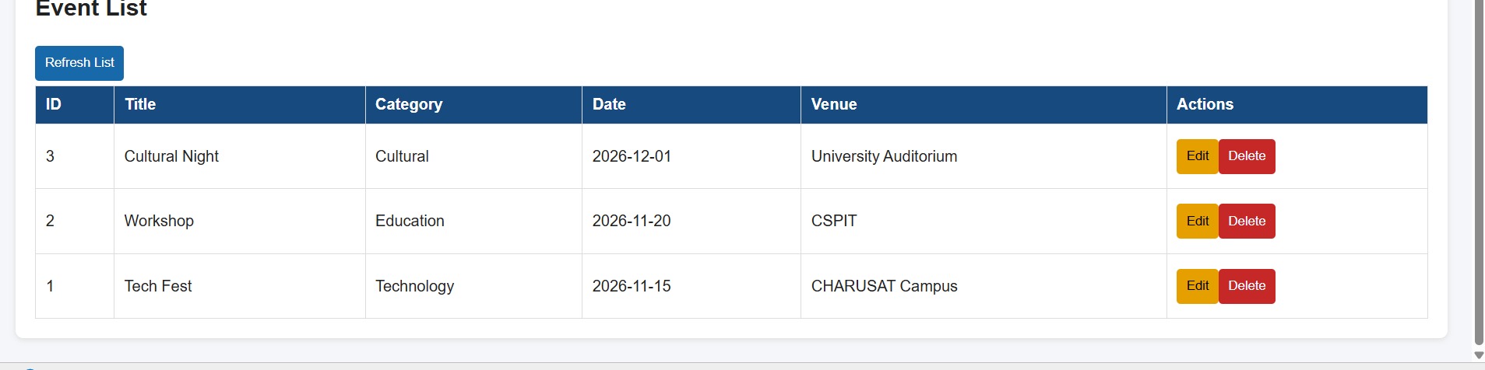

Add Event Using Fetch API Without Page Reload

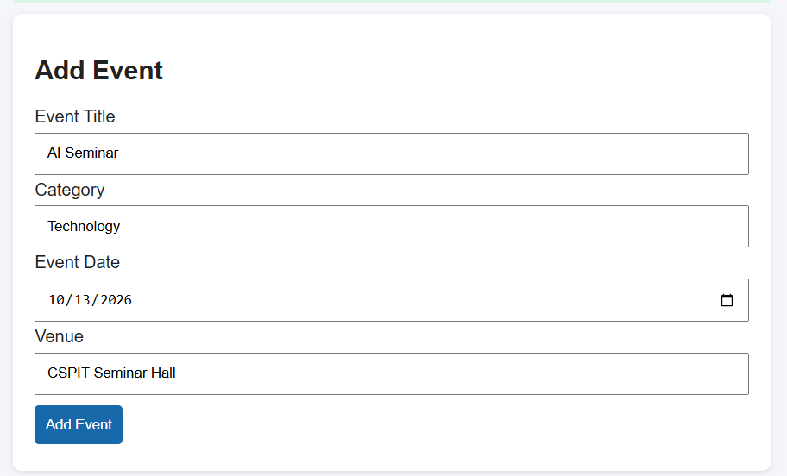

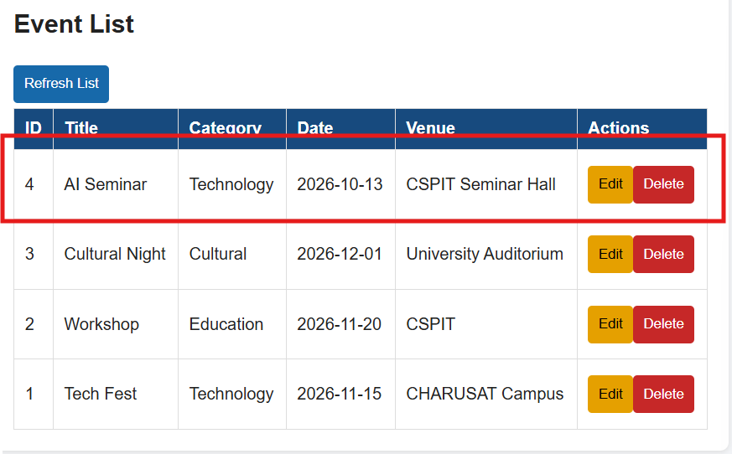

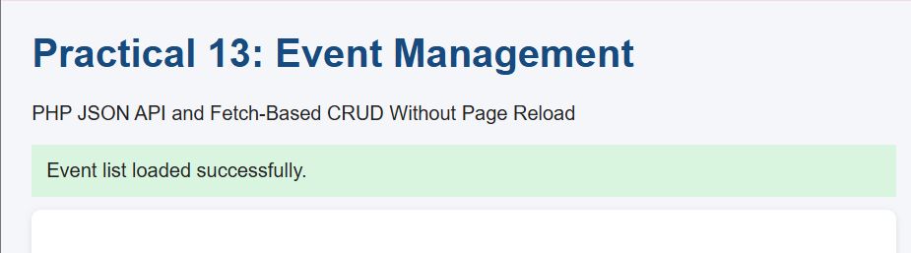

Edit Event Successfully Without Page Reload
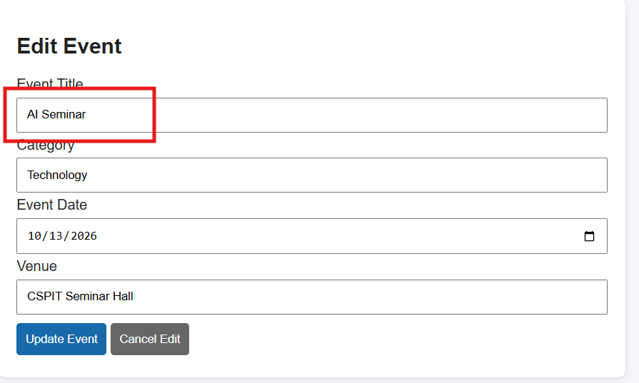

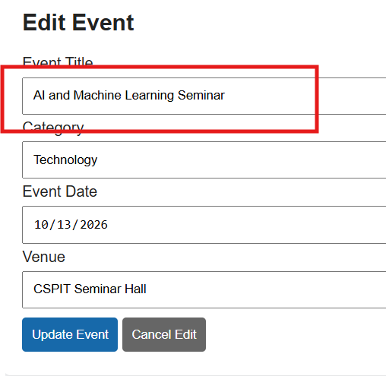

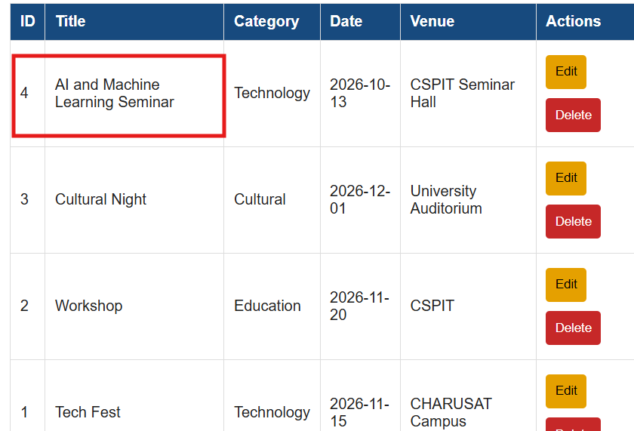

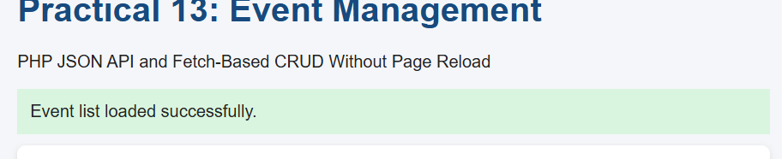

Delete Event Using Asynchronous Fetch Request

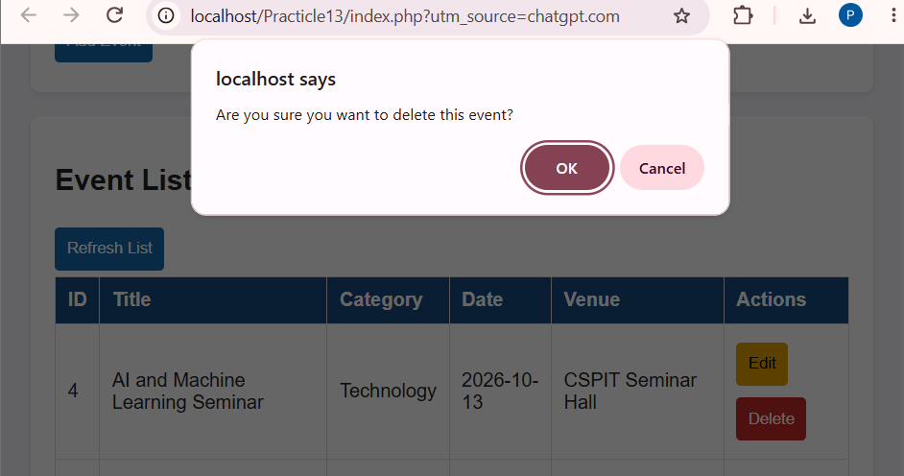

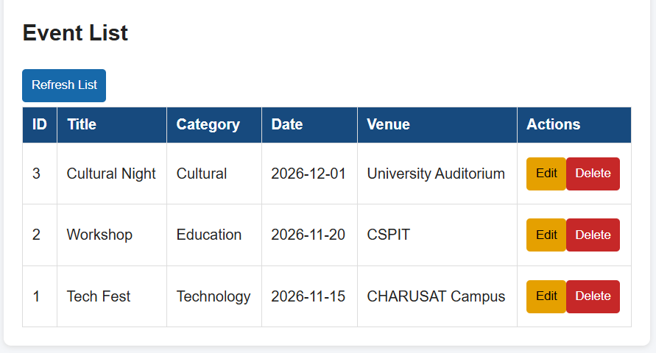

API Error Handling and JSON Response

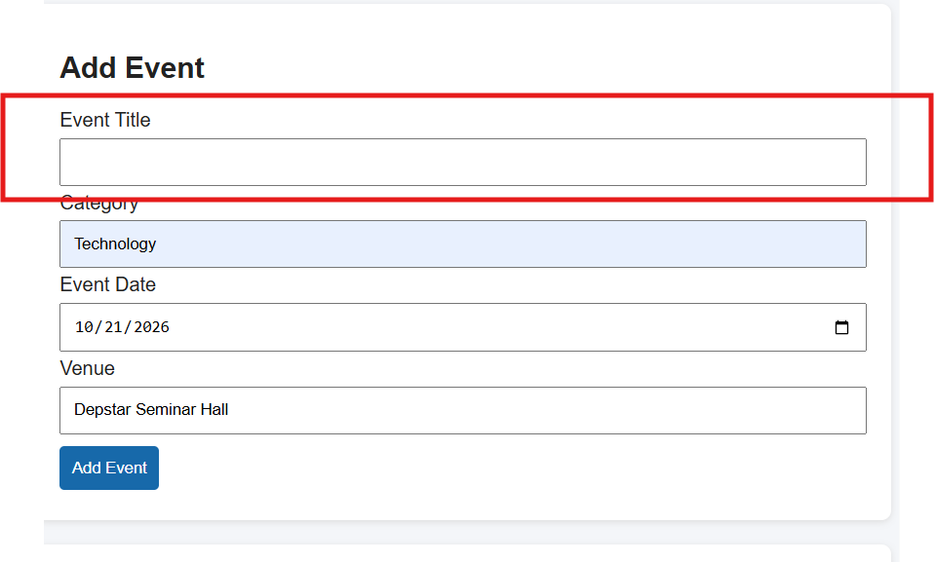

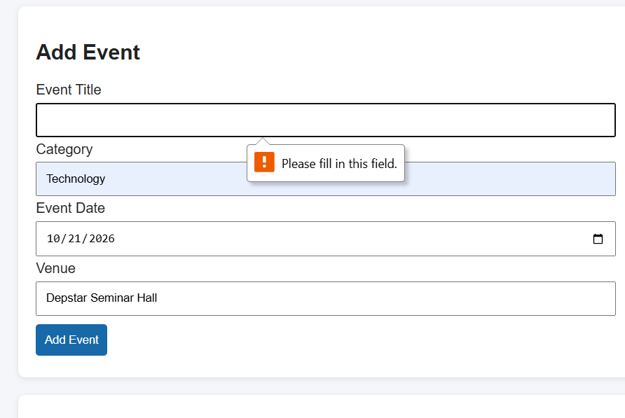

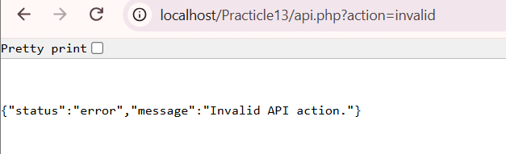

Fetch API GET Request with HTTP 200 OK

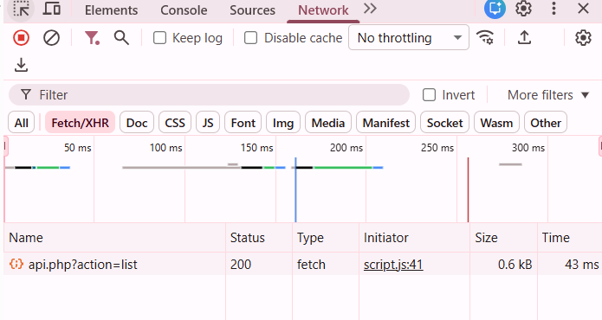

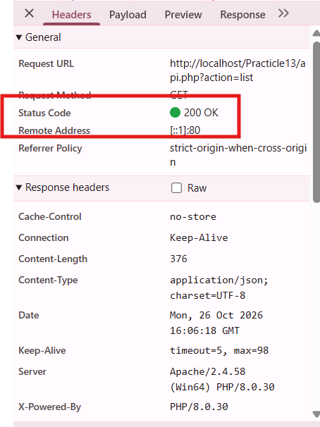

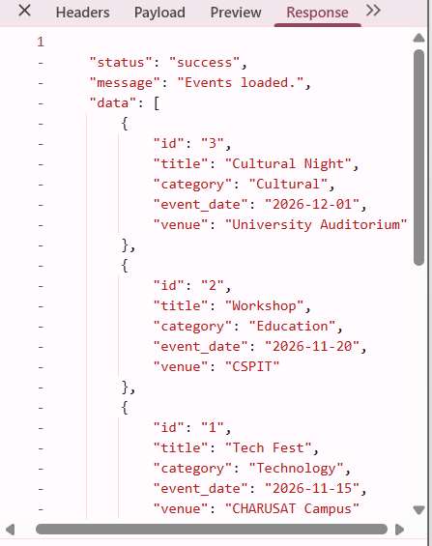

Fetch API POST Request and JSON Response

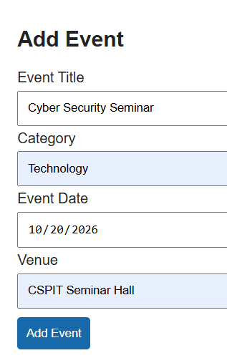

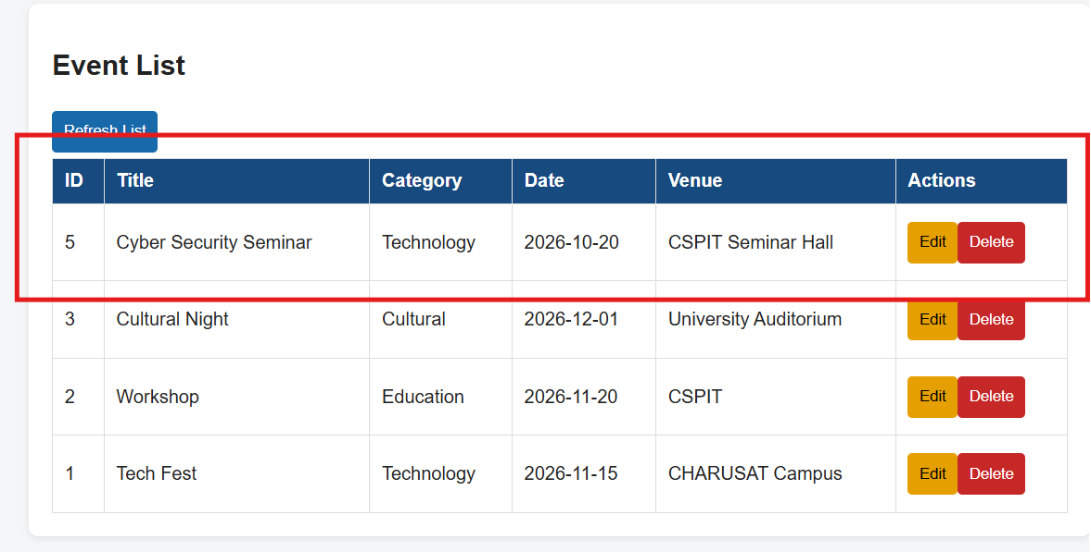

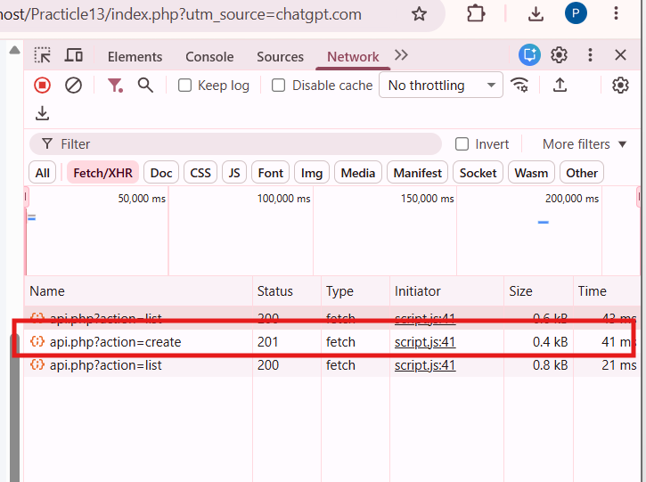

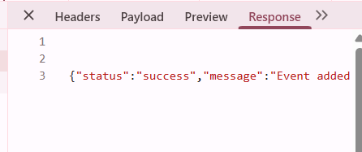

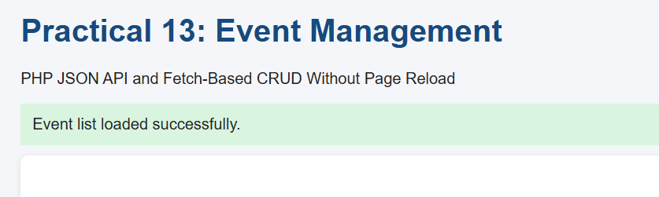

MySQL Database Records After AJAX CRUD Operations

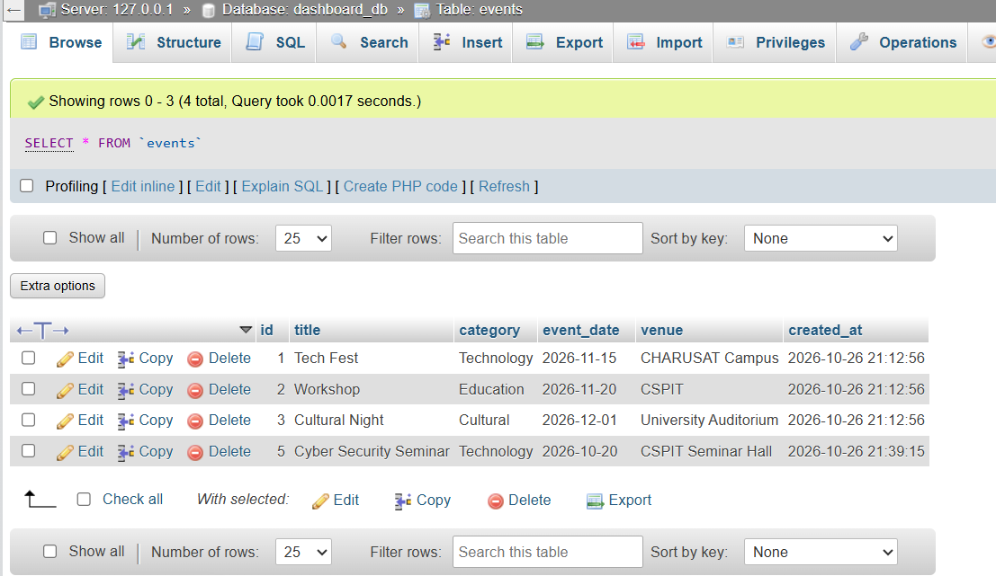

Output :

Learning outcome :

I learned how to connect PHP with a MySQL database, create JSON API endpoints, and use JavaScript Fetch API to perform asynchronous CRUD operations. I also learned to handle JSON requests and responses, validate user input, display success and error messages, and inspect HTTP status codes and API responses using the browser's Network tab.

GitHub link:

