 | 

Faculty of Technology and Engineering
Chandubhai S. Patel Institute of Technology (CSPIT) Department of Computer Science & Engineering
Date: / /
Laboratory Manul

Academic Year | : | 2026-27 | Semester | : | 3rd
Course code | : | ITUE203 | Course name | : | WEB DEVELOPMENT FRAMEWORKS

Practical – 1
PROBLEM STATEMENT :

Design the database for StudentHub with students, events and
registrations. Create PHP database connection using MYSQL statements.

Objective :

To design and implement a normalized MySQL database for StudentHub and establish a secure PHP database connection using PDO and Prepared Statements.

Code :

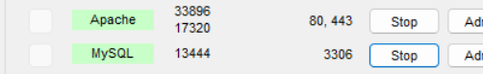

schema.sql
CREATE DATABASE IF NOT EXISTS studenthub_db;
USE studenthub_db;

CREATE TABLE students (
student_id INT AUTO_INCREMENT PRIMARY KEY,
name VARCHAR(100) NOT NULL,
enrollment_no VARCHAR(20) NOT NULL UNIQUE,
email VARCHAR(100) NOT NULL UNIQUE,
mobile VARCHAR(15) NOT NULL
);

CREATE TABLE events (
event_id INT AUTO_INCREMENT PRIMARY KEY,
event_name VARCHAR(100) NOT NULL,
event_date DATE NOT NULL,
venue VARCHAR(100) NOT NULL
);

CREATE TABLE registrations (
registration_id INT AUTO_INCREMENT PRIMARY KEY,
student_id INT NOT NULL,
event_id INT NOT NULL,
registration_date TIMESTAMP DEFAULT CURRENT_TIMESTAMP,

FOREIGN KEY (student_id)
REFERENCES students(student_id),

FOREIGN KEY (event_id)
REFERENCES events(event_id)
);

Test.connection.php
INSERT INTO students
(name, enrollment_no, email, mobile)
VALUES
('Test Student', '25CS063', 'teststudent@gmail.com', '9876543210');

INSERT INTO events
(event_name, event_date, venue)
VALUES
('Test Fest', '2026-10-20', 'CHARUSAT Campus'),
('Tech Fest', '2026-10-20', 'CHARUSAT Campus');

INSERT INTO registrations
(student_id, event_id)
VALUES
(1, 1);

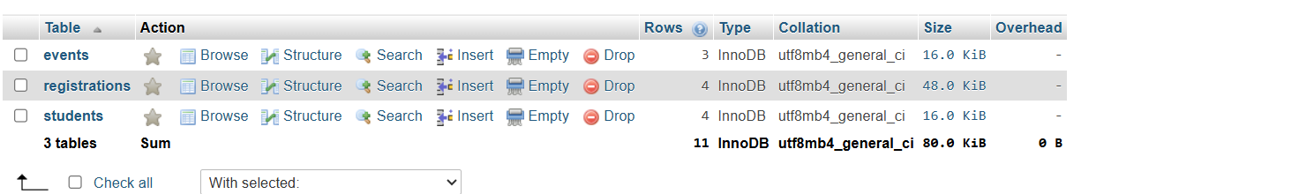

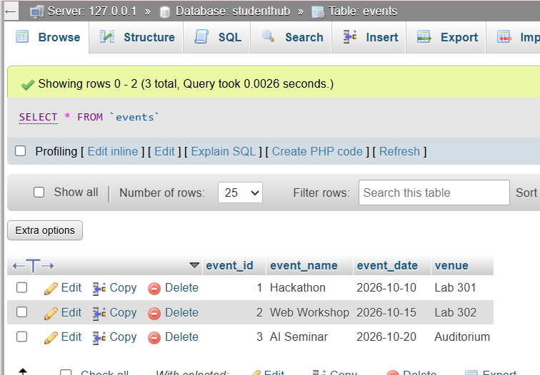

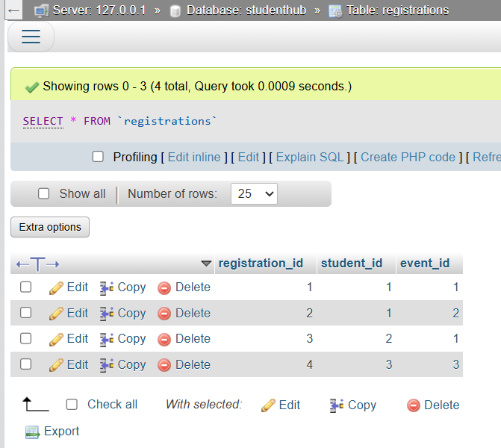

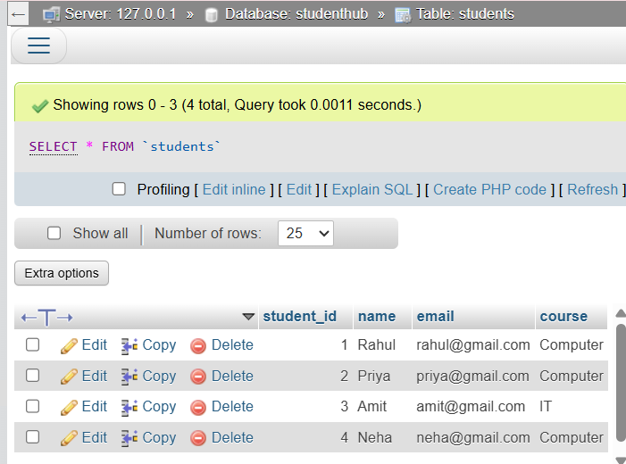

Db.php
<?php

$host = "localhost";
$dbname = "studenthub_db";
$username = "root";
$password = "";

try {

$pdo = new PDO(
"mysql:host=$host;dbname=$dbname;charset=utf8mb4",
$username,
$password
);

$pdo->setAttribute(PDO::ATTR_ERRMODE, PDO::ERRMODE_EXCEPTION);

} catch (PDOException $e) {

die("Database connection failed: " . $e->getMessage());

}

?>

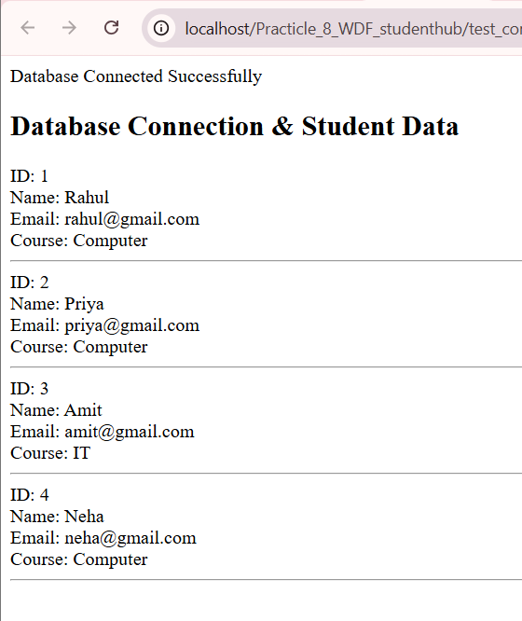

Test_connection.php
<?php

require_once "db.php";

$stmt = $pdo->prepare("SELECT * FROM students");
$stmt->execute();

$students = $stmt->fetchAll(PDO::FETCH_ASSOC);

echo "<h2>Database Connected Successfully!</h2>";

echo "<table border='1' cellpadding='10'>";

echo "<tr>
<th>ID</th>
<th>Name</th>
<th>Enrollment No</th>
<th>Email</th>
<th>Mobile</th>
</tr>";

foreach ($students as $student) {

echo "<tr>";

echo "<td>" . $student['student_id'] . "</td>";
echo "<td>" . $student['name'] . "</td>";
echo "<td>" . $student['enrollment_no'] . "</td>";
echo "<td>" . $student['email'] . "</td>";
echo "<td>" . $student['mobile'] . "</td>";

echo "</tr>";
}

echo "</table>";

?>

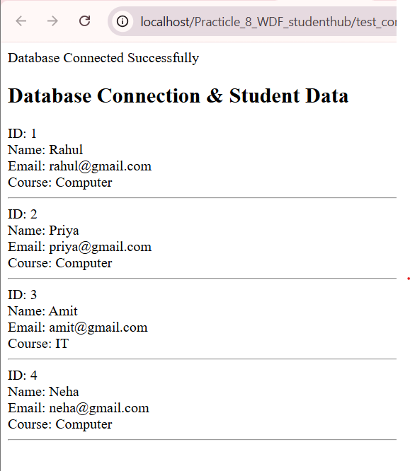

Screenshot :

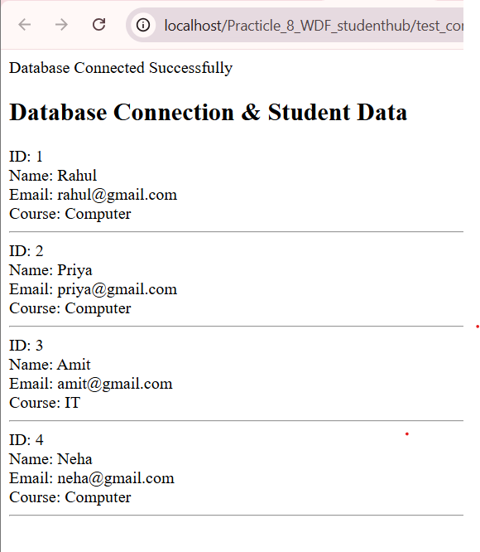

Learning outcome :

Students will be able to design a normalized MySQL database with proper primary and foreign keys, create and manage database tables using phpMyAdmin, and securely connect the database with PHP using PDO and Prepared Statements with proper error handling.

Github link

https://github.com/HONEY2218/STUDENTHUB/tree/main/Practicle_8_WDF_studenthub

