 | 

Faculty of Technology and Engineering
Chandubhai S. Patel Institute of Technology (CSPIT) Department of Computer Science & Engineering
Date: / /
Laboratory Manul

Academic Year | : | 2026-27 | Semester | : | 3rd
Course code | : | ITUE203 | Course name | : | WEB DEVELOPMENT FRAMEWORKS

Practical – 1
PROBLEM STATEMENT :
Design responsive layouts for Home, About, Registration, Dashboard, and Events pages using CSS Grid and Flexbox. Optional to use CSS framework such as Bootstrap or Tailwind. Ensure mobile-first
responsiveness.

Code :

Home.html

<!DOCTYPE html>
<html lang="en">
<head>
<meta charset="UTF-8">
<meta name="viewport" content="width=device-width, initial-scale=1.0">
<title>StudentHub | Home</title>

<!-- [BOOTSTRAP]: External CSS Framework -->
<link href="https://cdn.jsdelivr.net/npm/bootstrap@5.3.3/dist/css/bootstrap.min.css" rel="stylesheet">

<!-- Custom Stylesheet -->
<link rel="stylesheet" href="style4.css">
</head>
<body>

<!-- Header Section -->
<header class="py-4 shadow-sm">
<div class="container">
<!-- [FLEXBOX]: 'd-flex', 'align-items-center' અને 'gap-3' નો ઉપયોગ Logo અને Text ને ફ્લેક્સ રો (Horizontal alignment) માં ગોઠવવા કર્યો છે -->
<div class="d-flex align-items-center logo gap-3">
<!-- [BOOTSTRAP UTILITY]: 'rounded-circle' ઈમેજને ગોળાકાર કરવા માટે -->
<img src="image.jpg" alt="StudentHub Logo" class="rounded-circle">
<div>
<h1 class="m-0 text-white fw-bold">StudentHub</h1>
<h3 class="m-0 text-light fw-light fs-4">Student Management Portal</h3>
</div>
</div>
</div>
</header>

<!-- Navigation Section ([BOOTSTRAP COMPONENT]: Navbar) -->
<nav class="navbar navbar-expand-lg nav-section sticky-top">
<div class="container">
<!-- [BOOTSTRAP COMPONENT]: Mobile Menu Toggle Button -->
<button class="navbar-toggler text-white bg-light my-2" type="button" data-bs-toggle="collapse" data-bs-target="#navbarNav" aria-controls="navbarNav" aria-expanded="false" aria-label="Toggle navigation">
<span class="navbar-toggler-icon"></span>
</button>
<div class="collapse navbar-collapse justify-content-center" id="navbarNav">
<!-- [FLEXBOX]: 'd-flex', 'flex-wrap', 'justify-content-center' અને 'gap-1' નો ઉપયોગ નેવિગેશન લીંક સેન્ટરમાં ગોઠવવા માટે થયો છે -->
<ul class="navbar-nav d-flex flex-wrap justify-content-center gap-1">
<li class="nav-item"><a class="nav-link text-white fw-bold px-3 py-2 rounded" href="home.html">Home</a></li>
<li class="nav-item"><a class="nav-link text-white fw-bold px-3 py-2 rounded" href="about.html">About</a></li>
<li class="nav-item"><a class="nav-link text-white fw-bold px-3 py-2 rounded" href="register.html">Register</a></li>
<li class="nav-item"><a class="nav-link text-white fw-bold px-3 py-2 rounded" href="login.html">Login</a></li>
<li class="nav-item"><a class="nav-link text-white fw-bold px-3 py-2 rounded" href="dashboard.html">Dashboard</a></li>
<li class="nav-item"><a class="nav-link text-white fw-bold px-3 py-2 rounded" href="profile.html">Profile</a></li>
<li class="nav-item"><a class="nav-link text-white fw-bold px-3 py-2 rounded" href="event.html">Events</a></li>
<li class="nav-item"><a class="nav-link text-white fw-bold px-3 py-2 rounded" href="fees.html">Fees</a></li>
<li class="nav-item"><a class="nav-link text-white fw-bold px-3 py-2 rounded" href="result.html">Result</a></li>
<li class="nav-item"><a class="nav-link text-white fw-bold px-3 py-2 rounded" href="FAQ.html">FAQ</a></li>
<li class="nav-item"><a class="nav-link text-white fw-bold px-3 py-2 rounded" href="logout.html">Logout</a></li>
</ul>
</div>
</div>
</nav>

<!-- Main Content Section -->
<main class="container my-5">

<!-- [BOOTSTRAP COMPONENT]: Carousel / Image Slider Component -->
<div id="homeCarousel" class="carousel slide custom-slider mb-5 shadow rounded overflow-hidden" data-bs-ride="carousel" data-bs-interval="3000">
<div class="carousel-indicators">
<button type="button" data-bs-target="#homeCarousel" data-bs-slide-to="0" class="active" aria-current="true" aria-label="Slide 1"></button>
<button type="button" data-bs-target="#homeCarousel" data-bs-slide-to="1" aria-label="Slide 2"></button>
</div>

<div class="carousel-inner">
<div class="carousel-item active">
<img src="swipeimage6.jpg" class="slider-img" alt="Campus View 1">
</div>
<div class="carousel-item">
<img src="swipeimage1.jpg" class="slider-img" alt="Campus View 2">
</div>
</div>

<button class="carousel-control-prev" type="button" data-bs-target="#homeCarousel" data-bs-slide="prev">
<span class="carousel-control-prev-icon bg-dark rounded-circle p-2" aria-hidden="true"></span>
<span class="visually-hidden">Previous</span>
</button>
<button class="carousel-control-next" type="button" data-bs-target="#homeCarousel" data-bs-slide="next">
<span class="carousel-control-next-icon bg-dark rounded-circle p-2" aria-hidden="true"></span>
<span class="visually-hidden">Next</span>
</button>
</div>

<!-- [BOOTSTRAP COMPONENT]: Card Structure -->
<div class="card mb-4 shadow-sm">
<h2 class="card-header text-white fs-4 py-3" style="background-color: #2098D1;">Welcome to StudentHub</h2>
<div class="card-body p-4">
<p class="card-text fs-5 text-dark m-0">
StudentHub is an online portal designed to help students manage their academic activities. Students can register, log in, view their profile, check fees, access results, and stay updated with university events and notices.
</p>
</div>
</div>

<!-- Student Services -->
<div class="card mb-4 shadow-sm">
<h2 class="card-header text-white fs-4 py-3" style="background-color: #2098D1;">Student Services</h2>
<div class="card-body p-4">
<!-- [GRID SYSTEM]: 'row' એ Bootstrap Grid ની શરૂઆત દર્શાવે છે -->
<div class="row g-4">
<!-- [GRID SYSTEM]: 'col-12 col-md-4' મોબાઈલમાં 12 કૉલમ (Full width) અને મેડિયમ સ્ક્રીનમાં 4 કૉલમ (એટલે કે 1 લાઈનમાં 3 કાર્ડ્સ) ગોઠવે છે -->
<div class="col-12 col-md-4">
<div class="p-3 border rounded h-100 bg-light">
<h3 style="color: #1F3B73;" class="h5 fw-bold mb-2">Student Registration</h3>
<p class="m-0 text-secondary fs-6">Create a new student account and complete your registration online.</p>
</div>
</div>
<div class="col-12 col-md-4">
<div class="p-3 border rounded h-100 bg-light">
<h3 style="color: #1F3B73;" class="h5 fw-bold mb-2">Student Profile</h3>
<p class="m-0 text-secondary fs-6">View and update your personal and academic information.</p>
</div>
</div>
<div class="col-12 col-md-4">
<div class="p-3 border rounded h-100 bg-light">
<h3 style="color: #1F3B73;" class="h5 fw-bold mb-2">Fees Details</h3>
<p class="m-0 text-secondary fs-6">Check semester fee status and download payment receipts.</p>
</div>
</div>
<div class="col-12 col-md-4">
<div class="p-3 border rounded h-100 bg-light">
<h3 style="color: #1F3B73;" class="h5 fw-bold mb-2">Results</h3>
<p class="m-0 text-secondary fs-6">View semester examination results quickly and securely.</p>
</div>
</div>
<div class="col-12 col-md-4">
<div class="p-3 border rounded h-100 bg-light">
<h3 style="color: #1F3B73;" class="h5 fw-bold mb-2">Events</h3>
<p class="m-0 text-secondary fs-6">Stay updated with workshops, seminars and campus activities.</p>
</div>
</div>
<div class="col-12 col-md-4">
<div class="p-3 border rounded h-100 bg-light">
<h3 style="color: #1F3B73;" class="h5 fw-bold mb-2">Dashboard</h3>
<p class="m-0 text-secondary fs-6">Access all student services from one convenient dashboard.</p>
</div>
</div>
</div>
</div>
</div>

<!-- Notice Board & Latest News Section -->
<!-- [GRID SYSTEM]: 'row' દ્વારા બે વિભાગ વહેંચવામાં આવ્યા છે -->
<div class="row g-4 mb-4">
<!-- [GRID SYSTEM]: 'col-12 col-md-6' મોટી સ્ક્રીન પર 50%-50% (6-6 કૉલમ) જગ્યા રોકે છે -->
<div class="col-12 col-md-6">
<div class="card shadow-sm h-100">
<h2 class="card-header text-white fs-4 py-3" style="background-color: #2098D1;">Notice Board</h2>
<div class="card-body p-4">
<!-- [BOOTSTRAP COMPONENT]: List Group -->
<ul class="list-group list-group-flush fs-6">
<li class="list-group-item">Admissions Open for Academic Year 2026-27</li>
<li class="list-group-item">Semester Examination Schedule Released</li>
<li class="list-group-item">Hackathon Registration Starts Next Week</li>
<li class="list-group-item">Library Timings Updated</li>
<li class="list-group-item">Sports Week Registration is Now Open</li>
</ul>
</div>
</div>
</div>

<div class="col-12 col-md-6">
<div class="card shadow-sm h-100">
<h2 class="card-header text-white fs-4 py-3" style="background-color: #2098D1;">Latest News</h2>
<div class="card-body p-4">
<!-- [BOOTSTRAP COMPONENT]: List Group -->
<ul class="list-group list-group-flush fs-6">
<li class="list-group-item">Online Student Registration Portal is Now Live.</li>
<li class="list-group-item">Web Development Workshop on Friday.</li>
<li class="list-group-item">Mid-Sem Examination Dates Announced.</li>
<li class="list-group-item">Scholarship Applications are Open.</li>
<li class="list-group-item">Placement Training Begins Next Month.</li>
</ul>
</div>
</div>
</div>
</div>

<!-- Contact Section ([BOOTSTRAP COMPONENT]: Card) -->
<div class="card contact-card shadow-sm mb-4">
<h2 class="card-header text-white fs-4 py-3" style="background-color: #2098D1;">Contact Us</h2>
<div class="card-body contact-info p-4">
<h3 class="fs-5 fw-bold" style="color: #1F3B73;">StudentHub Portal</h3>
<p class="mb-1">📧 Email : studenthub@gmail.com</p>
<p class="mb-1">📞 Phone : +91 9876543210</p>
<p class="mb-0">📍 Address : CHARUSAT Campus, Changa, Gujarat 388421</p>
</div>
</div>

</main>

<!-- Footer Section -->
<footer class="text-white py-5 mt-5">
<div class="container text-center">
<div class="footer-content">
<h2 class="fs-3 fw-bold mb-2">StudentHub Portal</h2>
<p class="mb-2">Empowering Students Through Technology</p>
<p class="email mb-3">Email : studenthub@gmail.com</p>
<p class="copyright small text-light m-0">&copy; 2026 StudentHub. All Rights Reserved.</p>
</div>
</div>
</footer>

<!-- [BOOTSTRAP COMPONENT]: JavaScript Bundle for Interactive Components (Carousel, Dropdowns, etc.) -->
<script src="https://cdn.jsdelivr.net/npm/bootstrap@5.3.3/dist/js/bootstrap.bundle.min.js"></script>

</body>
</html>

Myscript.js

/* ======================================
NOTIFICATION BANNER CLOSE
====================================== */
// [DOM SELECTION]:
const banner = document.getElementById("banner");
const closeBanner = document.getElementById("closeBanner");

if (closeBanner && banner) {
// [EVENT LISTENER]:
closeBanner.addEventListener("click", function () {
banner.style.display = "none";
});
}

/* ======================================
IMAGE / CONTENT SLIDER
====================================== */
const slider = document.getElementById("slider");

// [ARRAY]:
const slides = [
"📖 Welcome to StudentHub FAQ Center",
"🎓 Student Registration Made Easy",
"📢 Check Latest Events & Announcements",
"💳 View Fees & Payment Details",
"🏆 Access Your Semester Results"
];

let current = 0;

if (slider) {
// [TIMER / SETINTERVAL]:
setInterval(function () {
current++;
if (current >= slides.length) {
current = 0;
}
slider.innerHTML = slides[current];
}, 3000);
}

/* ======================================
FAQ COLLAPSIBLE (ONE OPEN AT A TIME)
====================================== */
// [DOM SELECTION]:
const faqButtons = document.querySelectorAll(".faq-btn");

// [ARRAY ITERATION]:
faqButtons.forEach(function(button){
button.addEventListener("click", function(){
// [DOM TRAVERSAL]:
const answer = this.nextElementSibling;
const icon = this.querySelector("span");

document.querySelectorAll(".faq-answer").forEach(function(item){
if(item !== answer){
item.style.display = "none";
}
});

document.querySelectorAll(".faq-btn span").forEach(function(item){
if(item !== icon && item){
item.innerHTML = "+";
}
});

// [CONDITIONAL TOGGLE]:
if(answer && answer.style.display === "block"){
answer.style.display = "none";
if(icon) icon.innerHTML = "+";
} else if(answer) {
answer.style.display = "block";
if(icon) icon.innerHTML = "−";
}
});
});

/* ======================================
MODAL POPUP (CONTACT SUPPORT)
====================================== */
const modal = document.getElementById("supportModal");
const openModal = document.getElementById("openModal");
const closeModal = document.getElementById("closeModal");

if(openModal && modal){
openModal.addEventListener("click", function(){
modal.style.display = "block";
});
}

if(closeModal && modal){
closeModal.addEventListener("click", function(){
modal.style.display = "none";
});
}

// [GLOBAL WINDOW EVENT]:
window.addEventListener("click", function(event){
if(event.target === modal){
modal.style.display = "none";
}
});

/* ======================================
DARK / LIGHT THEME
====================================== */
const themeBtn = document.getElementById("themeBtn");

// [LOCAL STORAGE READ]:
if (localStorage.getItem("theme") === "dark") {
document.body.classList.add("dark");
if (themeBtn) {
themeBtn.innerHTML = "☀ Light Mode";
}
}

if (themeBtn) {
themeBtn.addEventListener("click", function () {
// [CLASS TOGGLE]:
document.body.classList.toggle("dark");

// [LOCAL STORAGE WRITE]:
if (document.body.classList.contains("dark")) {
themeBtn.innerHTML = "☀ Light Mode";
localStorage.setItem("theme", "dark");
} else {
themeBtn.innerHTML = "🌙 Dark Mode";
localStorage.setItem("theme", "light");
}
});
}

/* ======================================
HAMBURGER MENU
====================================== */
const menuBtn = document.getElementById("menuBtn");
const navbar = document.getElementById("navbar");

// [STYLE MANIPULATION]:
if(menuBtn && navbar){
menuBtn.addEventListener("click", function(){
if(navbar.style.display === "flex"){
navbar.style.display = "none";
} else {
navbar.style.display = "flex";
navbar.style.flexDirection = "column";
navbar.style.alignItems = "center";
}
});
}

/* ======================================
REGISTER FORM VALIDATION
====================================== */
const registerForm = document.getElementById("registerForm");

if (registerForm) {
// [FORM SUBMIT EVENT]:
registerForm.addEventListener("submit", function (event) {
const mobileInput = document.getElementById("mobile");
const passwordInput = document.getElementById("password");
const confirmInput = document.getElementById("confirm");

const mobileValue = mobileInput ? mobileInput.value.trim() : "";
const passwordValue = passwordInput ? passwordInput.value : "";
const confirmValue = confirmInput ? confirmInput.value : "";

// [REGULAR EXPRESSION / REGEX]:
const mobileRegex = /^[0-9]{10}$/;
if (mobileInput && !mobileRegex.test(mobileValue)) {
alert("Please enter a valid 10-digit mobile number");
mobileInput.focus();
// [PREVENT DEFAULT]:
event.preventDefault();
return false;
}

// [VALUE COMPARISON]:
if (passwordInput && confirmInput && passwordValue !== confirmValue) {
alert("Password and Confirm Password do not match");
confirmInput.focus();
event.preventDefault();
return false;
}
});
}

/* ======================================
AUTOMATIC IMAGE CAROUSEL
====================================== */
// [EVENT]:
document.addEventListener("DOMContentLoaded", function () {
const carouselElement = document.querySelector('#campusCarousel');
if (carouselElement) {
// [BOOTSTRAP JS API]:
new bootstrap.Carousel(carouselElement, {
interval: 3000, /
ride: 'carousel'
});
}
});

Style.css
/*==================================================
STUDENTHUB THEME (PRACTICAL 3)
==================================================*/

*{
margin:0;
padding:0;
box-sizing:border-box;
}

html{
scroll-behavior:smooth;
}

body{
font-family:'Segoe UI',Tahoma,sans-serif;
background:#F4F6F9;
color:#333;
}

/*==================== CONTAINER ====================*/

/* [BOOTSTRAP OVERRIDE]: Customizing Bootstrap's standard .container width and max-width */
.container{
width:92%;
max-width:1400px;
margin:auto;
}

/*==================================================
HEADER - FLEXBOX
==================================================*/

/* [FLEXBOX]: Header layout uses Flexbox for vertical centering */
header {
background: linear-gradient(135deg, #182E5A, #1F3B73);
min-height: 220px;
display: flex;
align-items: center;
padding: 30px 0;
box-shadow: 0 6px 20px rgba(0, 0, 0, .25);
border-bottom: 4px solid #2098D1;
position: relative;
}

/*==================== TOP FLEXBOX ====================*/

/* [FLEXBOX]: Spreads child elements across the horizontal space */
.top {
display: flex;
justify-content: space-between;
align-items: center;
width: 100%;
}

/*==================== LOGO & MAIN TITLE FLEXBOX ====================*/

/* [FLEXBOX]: Aligns logo image and title text inline with defined spacing */
.logo {
display: flex;
align-items: center;
gap: 20px;
}

.logo img {
width: 130px;
height: 130px;
border-radius: 50%;
background: white;
padding: 8px;
margin-right: 25px;
box-shadow: 0 8px 20px rgba(0, 0, 0, .30);
border: 3px solid #2098D1;
transition: transform .35s ease;
}

.logo img:hover {
transform: scale(1.05);
}

.logo h1 {
font-size: 68px;
color: #FFFFFF;
font-weight: 800;
letter-spacing: 1.5px;
text-shadow: 0 3px 10px rgba(0, 0, 0, .35);
line-height: 1.1;
}

.logo h3 {
margin-top: 10px;
color: #E0E9F8;
font-size: 28px;
font-weight: 500;
letter-spacing: 0.8px;
}

/*==================================================
NAVIGATION - FLEXBOX
==================================================*/

.nav-section{
background:#294B8A;
box-shadow:0 3px 10px rgba(0,0,0,.15);
}

/* [FLEXBOX]: Centers menu items with wrapping enabled for smaller screens */
nav{
width:100%;
display:flex;
justify-content:center;
align-items:center;
gap:10px;
padding:15px 0;
flex-wrap:wrap;
}

nav a{
color:white;
text-decoration:none;
padding:10px 16px;
font-size:16px;
font-weight:600;
border-radius:5px;
transition:.3s;
}

nav a:hover{
background:#3F79D6;
}

/*==================================================
MAIN • CARDS • TITLES • CONTENT
==================================================*/

main{
width:92%;
max-width:1400px;
margin:35px auto;
}

/*==================== FULL WIDTH SLIDER ====================*/

/* [BOOTSTRAP CAROUSEL STYLING]: Customizing Bootstrap Carousel component dimensions */
.custom-slider {
width: 100% !important;
max-width: 100% !important;
margin-left: 0 !important;
margin-right: 0 !important;
}

.carousel-item {
height: 420px;
background-color: #e0e0e0;
}

.slider-img {
width: 100%;
height: 100%;
object-fit: cover;
object-position: center;
display: block;
}

/*==================== CARD ====================*/

/* [BOOTSTRAP CARD OVERRIDE]: Custom styling for Bootstrap Card component */
.card{
background:white;
border-radius:10px;
margin-bottom:30px;
overflow:hidden;
box-shadow:0 4px 12px rgba(0,0,0,.12);
border:1px solid #E3E8EF;
}

.card h2{
background:#2098D1;
color:white;
font-size:28px;
font-weight:600;
padding:18px 25px;
margin:0;
border:none;
}

.card p,
.card address,
.card ul,
.card ol{
padding:25px;
font-size:18px;
line-height:1.8;
color:#1d1a1a;
}

/*==================== CONTACT CARD ====================*/

.contact-card {
padding: 0 !important;
overflow: hidden;
}

.contact-card h2 {
margin: 0 !important;
padding: 8px 15px !important;
font-size: 18px !important;
}

.contact-info {
padding: 10px 15px !important;
}

.contact-info h3 {
margin: 0 0 4px 0 !important;
padding: 0 !important;
font-size: 16px !important;
color: #1F3B73 !important;
}

.contact-info p {
margin: 2px 0 !important;
padding: 0 !important;
font-size: 14px !important;
color: #333 !important;
line-height: 1.2 !important;
}

/*==================== WELCOME SECTION ====================*/

.welcome-box{
background:white;
border-left:6px solid #2098D1;
padding:35px;
border-radius:10px;
margin-bottom:30px;
box-shadow:0 4px 12px rgba(0,0,0,.10);
}

.welcome-box h2{
color:#1F3B73;
background:none;
padding:0;
font-size:42px;
margin-bottom:18px;
}

.welcome-box p{
padding:0;
font-size:20px;
color:#555;
}

/*==================================================
ROW - FLEXBOX (GRID LAYOUT)
==================================================*/

/* [BOOTSTRAP GRID / FLEXBOX]: Re-defining Bootstrap .row to use Flexbox as a flexible Grid system */
.row{
display: flex;
gap: 20px;
flex-wrap: wrap;
}

/* [FLEXBOX GRID COLUMNS]: Flex-grow creates automatic responsive grid columns (Min width 300px) */
.row .card{
flex: 1;
min-width: 300px;
}

/*==================== SECTION SPACING ====================*/

section{
margin-bottom:35px;
}

h3{
color:#1F3B73;
margin-bottom:15px;
}

hr{
border:none;
border-top:1px solid #D8DEE8;
margin:30px 0;
}

a{
transition:.3s;
}

a:hover{
text-decoration:none;
}

address{
font-style:normal;
line-height:2;
}

/*==================== BUTTONS ====================*/

/* [BOOTSTRAP BUTTON OVERRIDE]: Custom styles for Bootstrap button classes */
button{
font-family:'Segoe UI',sans-serif;
cursor:pointer;
transition:.3s;
border:none;
outline:none;
}

.btn{
background:#2098D1;
color:white;
padding:12px 25px;
border-radius:6px;
display:inline-block;
text-decoration:none;
transition:.3s;
}

.btn:hover{
background:#1B7FB0;
}

/*==================================================
FORMS • INPUTS • LOGIN • REGISTER
==================================================*/

form {
width: 100%;
padding: 25px;
}

label{
display:block;
margin-top:18px;
margin-bottom:8px;
font-size:16px;
font-weight:600;
color:#1F3B73;
}

input[type=text],
input[type=email],
input[type=password],
input[type=number],
input[type=date],
input[type=tel],
input[type=file],
select,
textarea{
width:100%;
padding:14px 16px;
border:1px solid #C8D3E0;
border-radius:6px;
font-size:16px;
background:white;
transition:.3s;
}

input:focus,
select:focus,
textarea:focus{
outline:none;
border-color:#2098D1;
box-shadow:0 0 8px rgba(32,152,209,.25);
}

textarea{
resize:vertical;
min-height:120px;
}

::placeholder{
color:#999;
}

input[type=radio],
input[type=checkbox]{
margin-right:8px;
transform:scale(1.15);
accent-color:#2098D1;
}

input[type=submit],
input[type=reset]{
background:#2098D1;
color:white;
border:none;
padding:14px 30px;
border-radius:6px;
font-size:17px;
font-weight:600;
cursor:pointer;
margin-top:25px;
margin-right:10px;
transition:.3s;
}

input[type=submit]:hover,
input[type=reset]:hover{
background:#1B7FB0;
transform:translateY(-2px);
box-shadow:0 5px 12px rgba(0,0,0,.15);
}

/*==================================================
TABLES • RESULT • FEES
==================================================*/

/* [BOOTSTRAP TABLE STYLING]: Customizing data tables for responsive web views */
table{
width:100%;
border-collapse:collapse;
margin-top:25px;
background:white;
box-shadow:0 5px 15px rgba(0,0,0,.12);
border-radius:8px;
overflow:hidden;
}

th{
background:#1F3B73;
color:white;
padding:16px;
font-size:16px;
font-weight:600;
text-align:center;
border-bottom:1px solid rgba(255, 255, 255, 0.2);
}

td{
padding:14px;
border-bottom:1px solid #E2E8F0;
text-align:center;
font-size:15px;
}

tr:nth-child(even){
background:#F7FAFC;
}

tr:hover{
background:#E8F4FF;
}

.table-container{
overflow-x:auto;
}

/*==================================================
FOOTER-FLEXBOX
==================================================*/

footer {
background: #182E5A;
color: #FFFFFF;
text-align: center;
padding: 45px 20px;
margin-top: 50px;
width: 100%;
box-shadow: 0 -4px 15px rgba(0, 0, 0, 0.15);
}

/* [FLEXBOX]: Centers footer content vertically using column direction */
.footer-content {
max-width: 1200px;
margin: 0 auto;
display: flex;
flex-direction: column;
align-items: center;
justify-content: center;
}

.footer-content h2 {
font-size: 26px;
font-weight: 700;
margin-bottom: 10px;
color: #FFFFFF;
letter-spacing: 0.5px;
}

.footer-content p {
font-size: 16px;
color: #D8E2F2;
margin: 4px 0;
}

.footer-content .email {
margin-top: 15px;
margin-bottom: 20px;
font-size: 15px;
color: #E0E9F8;
}

.footer-content .copyright {
font-size: 14px;
color: #A0B2D6;
}

/*==================================================
RESPONSIVE MEDIA QUERIES (FLEXBOX ADAPTATION)
==================================================*/

/* [FLEXBOX RESPONSIVE]: Changes flex directions to column for smaller screen sizes */
@media (max-width:992px){
.top{ flex-direction:column; text-align:center; }
.logo{ justify-content:center; margin-bottom:20px; }
.logo img{ margin-right:0; margin-bottom:10px; }
nav{ flex-wrap:wrap; justify-content:center; }
nav a{ font-size:15px; padding:8px 12px; }
}

@media (max-width:768px){
header { padding: 25px 0; }
.logo h1{ font-size:38px; }
.logo h3{ font-size:18px; }
.logo img{ width:85px; height:85px; }
.card{ margin-bottom:20px; }
.card h2{ font-size:22px; }
.carousel-item { height: 260px; }
}

@media (max-width:480px){
.container{ width:96%; }
.logo h1{ font-size:28px; }
.logo h3{ font-size:16px; }
.card{ padding:18px; }
.card h2{ font-size:20px; }
.carousel-item { height: 200px; }
}

Screenshot :

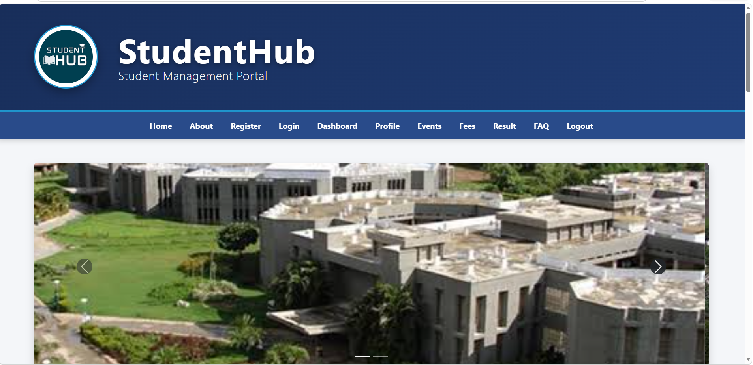

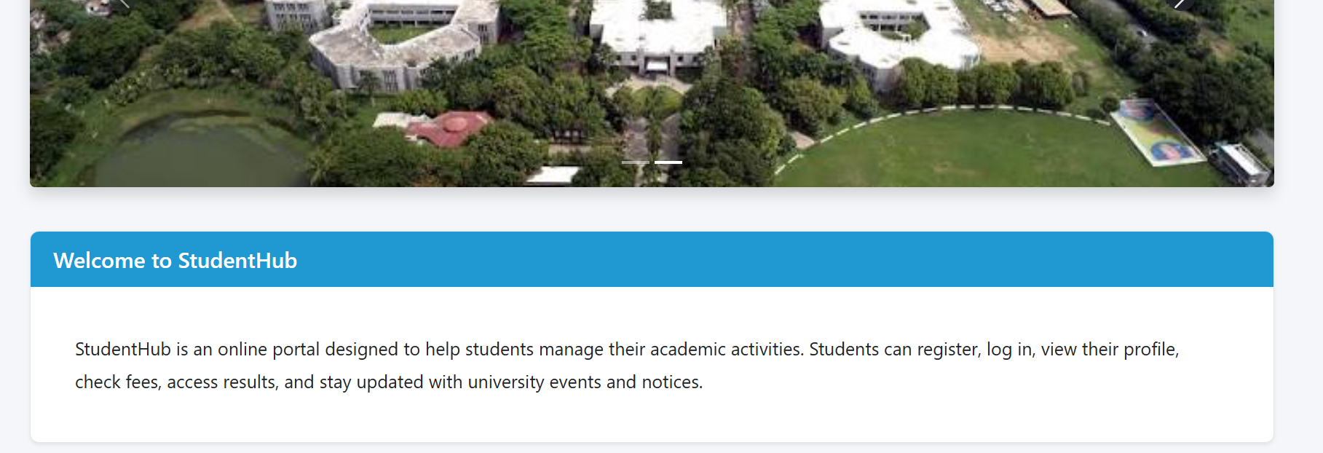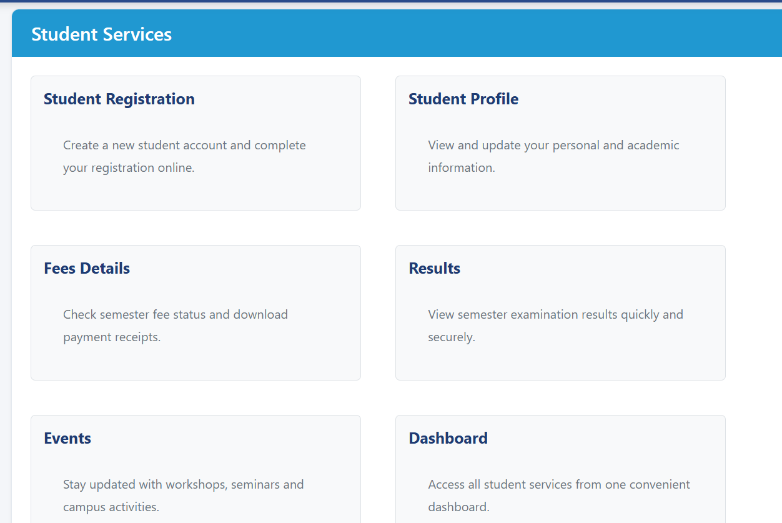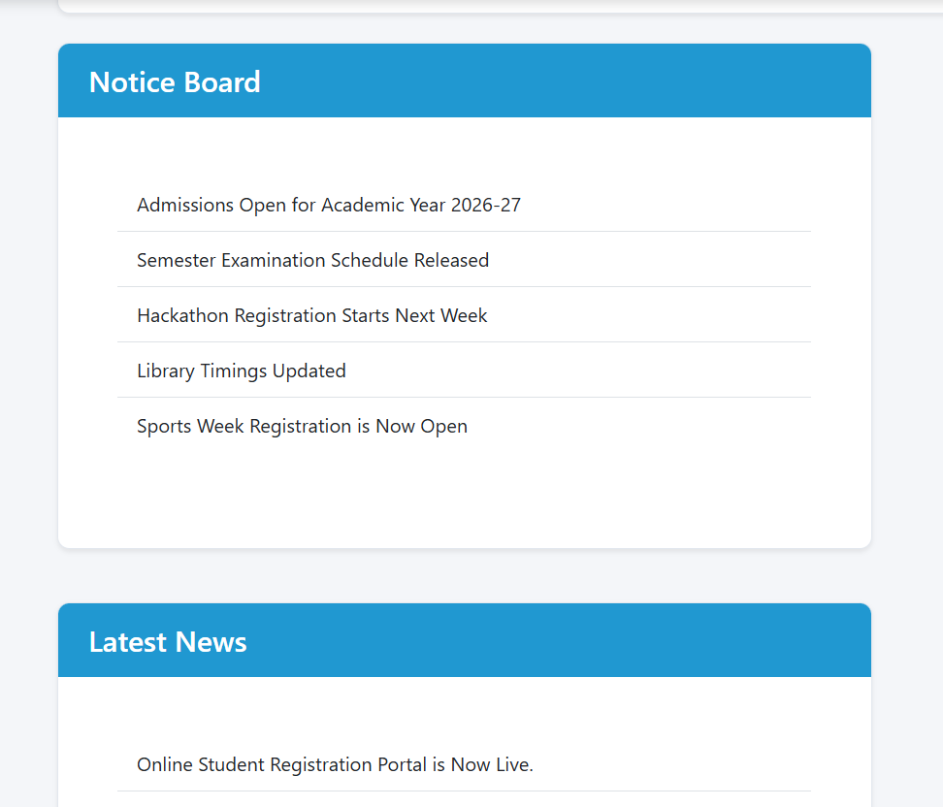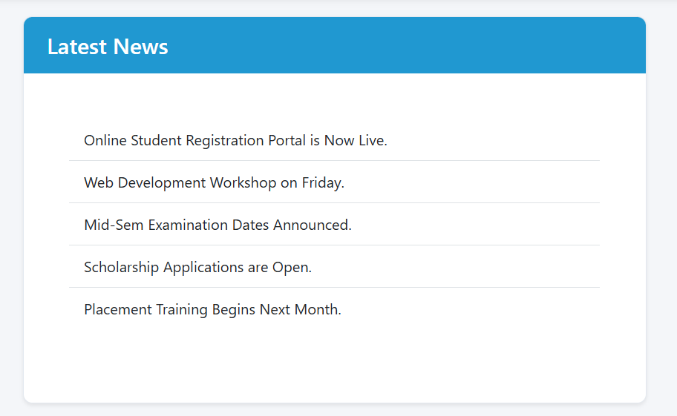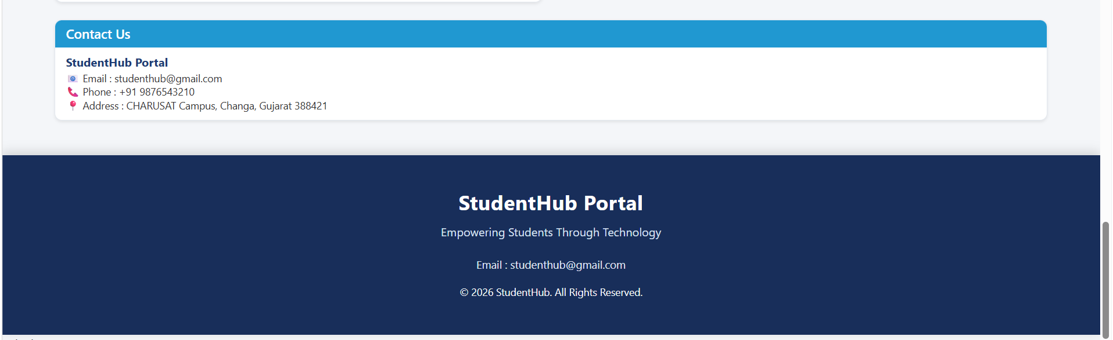

Learning outcome :

• HTML Structure & Form Building:
- Learned to construct complex, user-friendly HTML forms using diverse input types (text, password, email, tel, radio, checkbox) for registration, login, FAQ, and contact sections.
• Flexbox Layout Management:
- Mastered CSS Flexbox properties (display: flex, justify-content, align-items, flex-wrap) to dynamically align and space header elements, navigation bars, cards, and footers.
• Responsive Web Design & Media Queries:
- Implemented CSS Media Queries (@media) to ensure seamless responsiveness and visual hierarchy across desktop, tablet, and mobile viewport sizes.
• DOM Manipulation with JavaScript:
- Gained hands-on experience selecting and manipulating HTML elements dynamically using JavaScript methods like getElementById and querySelectorAll (e.g., banner closing, collapsible FAQ accordions, mobile hamburger menu).
• Event Handling & Client-Side Form Validation:
- Applied addEventListener to intercept form submissions and validate user input prior to sending data, ensuring strict rules like 10-digit mobile number Regex checks and password matching.
• Local Storage & State Management:
- Utilized Browser localStorage to save user preferences across sessions, enabling persistent Dark Mode / Light Mode toggles and interactive Modal popups.

