 | 

Faculty of Technology and Engineering
Chandubhai S. Patel Institute of Technology (CSPIT) Department of Computer Science & Engineering
Date: / /
Laboratory Manul

Academic Year | : | 2026-27 | Semester | : | 3rd
Course code | : | ITUE203 | Course name | : | WEB DEVELOPMENT FRAMEWORKS

Practical – 11
PROBLEM STATEMENT :

Create a student management module to add, view, edit, delete, search and filter student records. All database operations must use MYSQLi
statements and clear success/failure messages.

Objective :

To develop a Student Management System using PHP and MySQL to perform CRUD operations (Create, Read, Update, and Delete) with search, course filtering, and CSV export functionality.

Code :

Db.php

<?php
$host = "localhost";
$user = "root";
$pass = "";
$db = "student_db";

$conn = mysqli_connect($host, $user, $pass, $db);

if (!$conn) {
die("Database connection failed: " . mysqli_connect_error());
}
?>

Edit.php

<?php
include 'db.php';

$id = isset($_GET['id']) ? (int)$_GET['id'] : 0;

$result = mysqli_query(
$conn,
"SELECT * FROM students WHERE id=$id AND status='active'"
);

$student = $result ? mysqli_fetch_assoc($result) : null;

if (!$student) {
die("Student record not found or inactive.");
}

$message = "";

if (isset($_POST['update_student'])) {
$name = mysqli_real_escape_string($conn, trim($_POST['name']));
$email = mysqli_real_escape_string($conn, trim($_POST['email']));
$course = mysqli_real_escape_string($conn, $_POST['course']);
$gender = mysqli_real_escape_string($conn, $_POST['gender']);

if ($name === "" || !filter_var($email, FILTER_VALIDATE_EMAIL)) {
$message = "Please enter valid details.";
} else {
$sql = "UPDATE students SET
name='$name',
email='$email',
course='$course',
gender='$gender'
WHERE id=$id AND status='active'";

if (mysqli_query($conn, $sql)) {
header("Location: index.php?msg=updated");
exit;
} else {
$message = "Update failed: " . mysqli_error($conn);
}
}
}
?>
<!DOCTYPE html>
<html lang="en">
<head>
<meta charset="UTF-8">
<meta name="viewport" content="width=device-width, initial-scale=1">
<title>Edit Student</title>
<style>
body { font-family: Arial; margin: 30px; background: #f4f7fb; }
form { background: white; padding: 20px; max-width: 450px; }
input, select, button { display: block; margin: 12px 0; padding: 10px; width: 95%; }
button { background: #203864; color: white; border: 0; cursor: pointer; }
</style>
</head>
<body>
<h1>Edit Student Details</h1>

<?php if ($message !== ""): ?>
<p><?= htmlspecialchars($message) ?></p>
<?php endif; ?>

<form method="POST">
<label>Full Name</label>
<input type="text" name="name"
value="<?= htmlspecialchars($student['name']) ?>" required>

<label>Email</label>
<input type="email" name="email"
value="<?= htmlspecialchars($student['email']) ?>" required>

<label>Course</label>
<select name="course" required>
<?php foreach (['Computer Science','Web Development','Data Science'] as $c): ?>
<option value="<?= htmlspecialchars($c) ?>"
<?= $student['course'] === $c ? 'selected' : '' ?>>
<?= htmlspecialchars($c) ?>
</option>
<?php endforeach; ?>
</select>

<label>Gender</label>
<select name="gender" required>
<?php foreach (['Male','Female','Other'] as $g): ?>
<option value="<?= htmlspecialchars($g) ?>"
<?= $student['gender'] === $g ? 'selected' : '' ?>>
<?= htmlspecialchars($g) ?>
</option>
<?php endforeach; ?>
</select>

<button type="submit" name="update_student">Update Student</button>
<a href="index.php">Back to Student List</a>
</form>
</body>
</html>

Export.php

<?php
include 'db.php';

header('Content-Type: text/csv; charset=utf-8');
header('Content-Disposition: attachment; filename=students.csv');

$output = fopen('php://output', 'w');

fputcsv($output, ['ID', 'Name', 'Email', 'Course', 'Gender', 'Status']);

$sql = "SELECT id, name, email, course, gender, status
FROM students
ORDER BY id ASC";

$result = mysqli_query($conn, $sql);

if (!$result) {
exit("Database query failed.");
}

while ($row = mysqli_fetch_assoc($result)) {
fputcsv($output, [
$row['id'],
$row['name'],
$row['email'],
$row['course'],
$row['gender'],
$row['status']
]);
}

fclose($output);
exit;
?>

Index.php

<?php
include 'db.php';

if (isset($_POST['add_student'])) {
$name = mysqli_real_escape_string($conn, trim($_POST['name']));
$email = mysqli_real_escape_string($conn, trim($_POST['email']));
$course = mysqli_real_escape_string($conn, $_POST['course']);
$gender = mysqli_real_escape_string($conn, $_POST['gender']);

if ($name === '' || !filter_var($email, FILTER_VALIDATE_EMAIL)) {
header('Location: index.php?msg=invalid');
exit;
}

$sql = "INSERT INTO students (name, email, course, gender)
VALUES ('$name', '$email', '$course', '$gender')";

header('Location: index.php?msg=' .
(mysqli_query($conn, $sql) ? 'added' : 'error'));
exit;
}

if (isset($_POST['update_student'])) {
$id = (int)$_POST['id'];
$name = mysqli_real_escape_string($conn, trim($_POST['name']));
$email = mysqli_real_escape_string($conn, trim($_POST['email']));
$course = mysqli_real_escape_string($conn, $_POST['course']);
$gender = mysqli_real_escape_string($conn, $_POST['gender']);

if ($id > 0 && $name !== '' &&
filter_var($email, FILTER_VALIDATE_EMAIL)) {
$sql = "UPDATE students
SET name='$name', email='$email',
course='$course', gender='$gender'
WHERE id=$id AND status='active'";

header('Location: index.php?msg=' .
(mysqli_query($conn, $sql) ? 'updated' : 'error'));
} else {
header('Location: index.php?msg=invalid');
}
exit;
}

if (isset($_POST['delete_student'])) {
$id = (int)$_POST['id'];
$sql = "UPDATE students SET status='inactive'
WHERE id=$id AND status='active'";

header('Location: index.php?msg=' .
(mysqli_query($conn, $sql) ? 'deleted' : 'error'));
exit;
}

$messages = [
'added' => 'Student added successfully.',
'updated' => 'Student updated successfully.',
'deleted' => 'Student soft-deleted successfully.',
'invalid' => 'Please enter valid student details.',
'error' => 'Operation failed.'
];

$msg = $_GET['msg'] ?? '';
$search = mysqli_real_escape_string($conn, trim($_GET['search'] ?? ''));
$courseFilter = $_GET['course_filter'] ?? '';

$allowedCourses = [
'Computer Science',
'Web Development',
'Data Science'
];

$where = ["status='active'"];

if ($search !== '') {
$where[] = "(name LIKE '%$search%' OR email LIKE '%$search%')";
}

if (in_array($courseFilter, $allowedCourses, true)) {
$safeCourse = mysqli_real_escape_string($conn, $courseFilter);
$where[] = "course='$safeCourse'";
}

$sql = "SELECT * FROM students WHERE " .
implode(' AND ', $where) . " ORDER BY id DESC";
$result = mysqli_query($conn, $sql);
?>
<!DOCTYPE html>
<html lang="en">
<head>
<meta charset="UTF-8">
<meta name="viewport" content="width=device-width, initial-scale=1">
<title>Student Management System</title>
<style>
body { font-family: Arial, sans-serif; margin: 25px; background: #f4f7fb; }
h1, h2 { color: #203864; }
.card { background: white; padding: 20px; margin-bottom: 20px; border-radius: 8px; }
input, select, button, .button { padding: 10px; margin: 5px 3px; }
button, .button { background: #203864; color: white; border: 0; cursor: pointer; text-decoration: none; border-radius: 4px; display: inline-block; }
table { width: 100%; border-collapse: collapse; background: white; margin-top: 15px; }
th, td { border: 1px solid #ddd; padding: 10px; text-align: left; }
th { background: #d9e5f6; }
.message { padding: 12px; margin-bottom: 15px; background: #d9f2df; }
.actions form { display: inline; }
</style>
</head>
<body>

<h1>Student Management System</h1>

<?php if (isset($messages[$msg])): ?>
<div class="message"><?= htmlspecialchars($messages[$msg]) ?></div>
<?php endif; ?>

<div class="card">
<h2>Add New Student</h2>
<form method="POST">
<input type="text" name="name" placeholder="Full Name" required>
<input type="email" name="email" placeholder="Email" required>

<select name="course" required>
<option value="">Select Course</option>
<?php foreach ($allowedCourses as $c): ?>
<option value="<?= htmlspecialchars($c) ?>"><?= htmlspecialchars($c) ?></option>
<?php endforeach; ?>
</select>

<select name="gender" required>
<option value="">Select Gender</option>
<option>Male</option>
<option>Female</option>
<option>Other</option>
</select>

<button type="submit" name="add_student">Add Student</button>
</form>
</div>

<div class="card">
<h2>Search and Filter Students</h2>
<form method="GET" action="index.php">
<input type="text" name="search" placeholder="Search by name or email"
value="<?= htmlspecialchars($_GET['search'] ?? '') ?>">

<select name="course_filter">
<option value="">All Courses</option>
<?php foreach ($allowedCourses as $c): ?>
<option value="<?= htmlspecialchars($c) ?>"
<?= $courseFilter === $c ? 'selected' : '' ?>>
<?= htmlspecialchars($c) ?>
</option>
<?php endforeach; ?>
</select>

<button type="submit">Search / Filter</button>
<a class="button" href="index.php">Reset</a>
<a class="button" href="export.php">Export CSV</a>
</form>
</div>

<div class="card">
<h2>Student Records</h2>
<table>
<thead>
<tr>
<th>ID</th><th>Name</th><th>Email</th>
<th>Course</th><th>Gender</th><th>Actions</th>
</tr>
</thead>
<tbody>
<?php if ($result && mysqli_num_rows($result) > 0): ?>
<?php while ($row = mysqli_fetch_assoc($result)): ?>
<tr>
<td><?= (int)$row['id'] ?></td>
<td><?= htmlspecialchars($row['name']) ?></td>
<td><?= htmlspecialchars($row['email']) ?></td>
<td><?= htmlspecialchars($row['course']) ?></td>
<td><?= htmlspecialchars($row['gender']) ?></td>
<td class="actions">
<a class="button" href="edit.php?id=<?= (int)$row['id'] ?>">Edit</a>
<form method="POST" onsubmit="return confirm('Are you sure you want to deactivate this student?');">
<input type="hidden" name="id" value="<?= (int)$row['id'] ?>">
<button type="submit" name="delete_student">Delete</button>
</form>
</td>
</tr>
<?php endwhile; ?>
<?php else: ?>
<tr><td colspan="6">No active student records found.</td></tr>
<?php endif; ?>
</tbody>
</table>
</div>

</body>
</html>

Schema.php

CREATE DATABASE IF NOT EXISTS student_db;
USE student_db;

CREATE TABLE IF NOT EXISTS students (
id INT AUTO_INCREMENT PRIMARY KEY,
name VARCHAR(100) NOT NULL,
email VARCHAR(100) NOT NULL,
course VARCHAR(50) NOT NULL,
gender VARCHAR(10) NOT NULL,
status ENUM('active', 'inactive') DEFAULT 'active',
created_at TIMESTAMP DEFAULT CURRENT_TIMESTAMP
);

Screenshot :

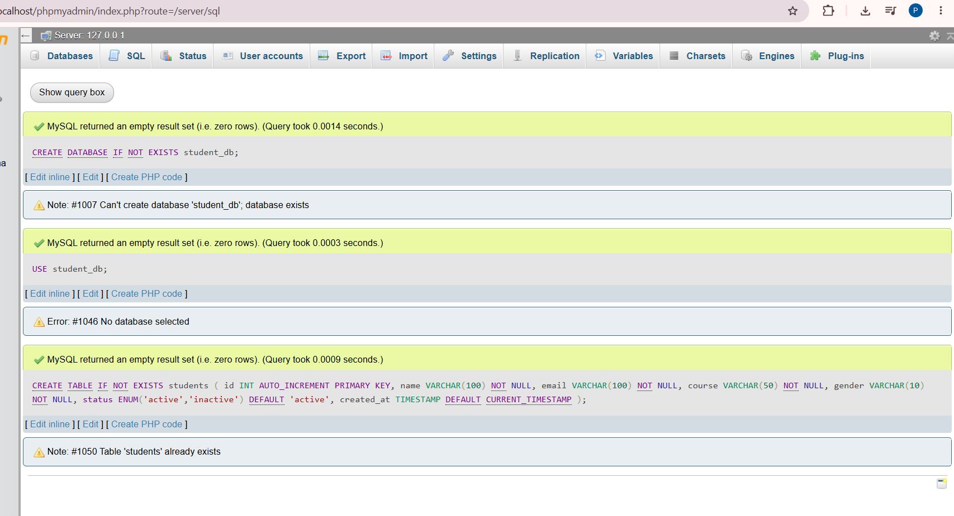

Student Database and Table Structure

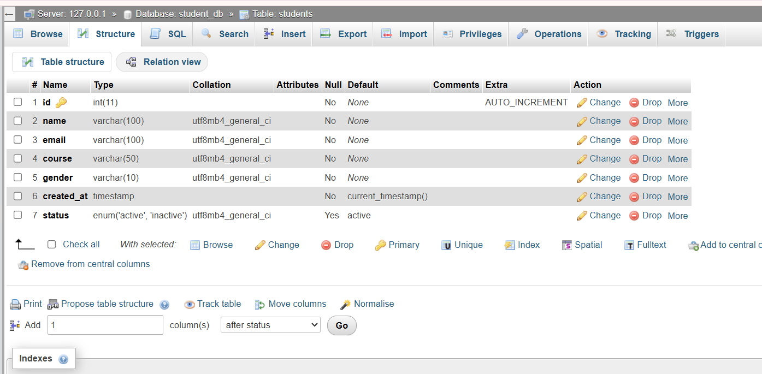

Sample Student Records in Database

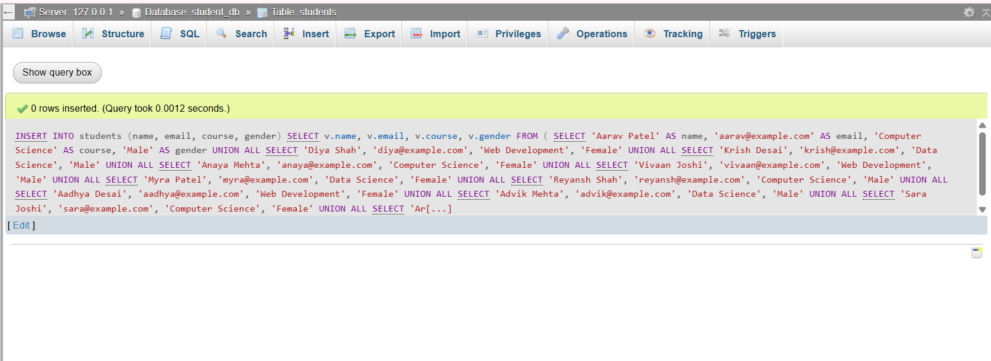

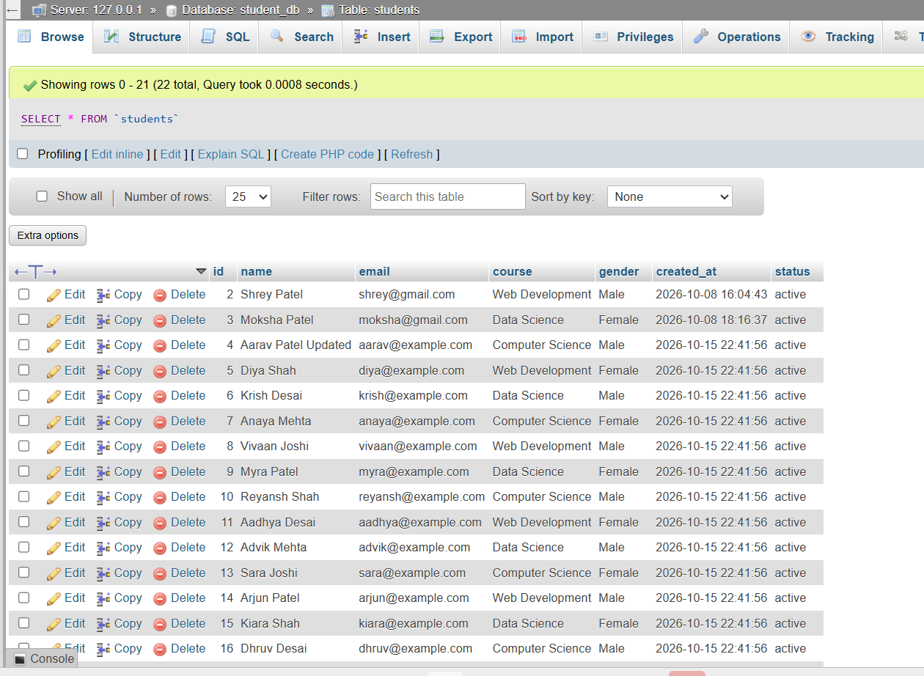

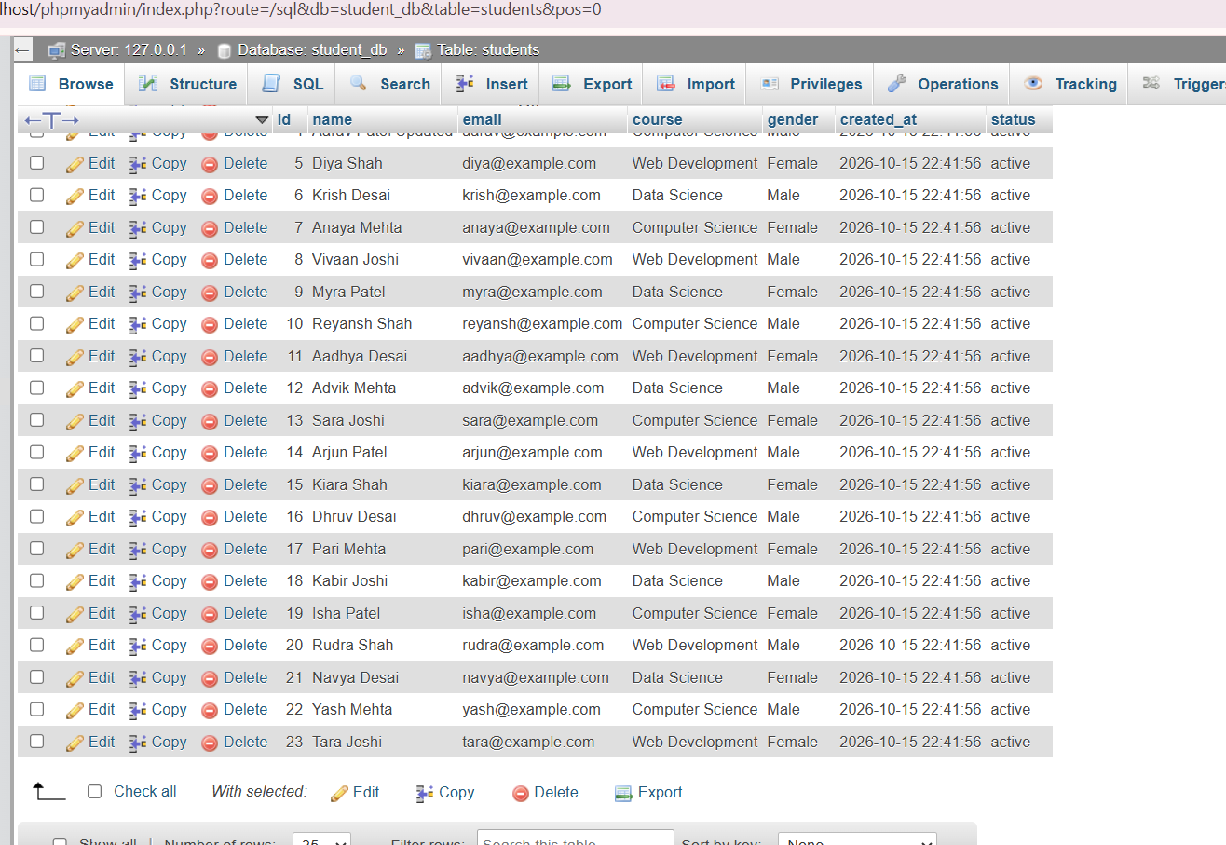

Student Management Dashboard

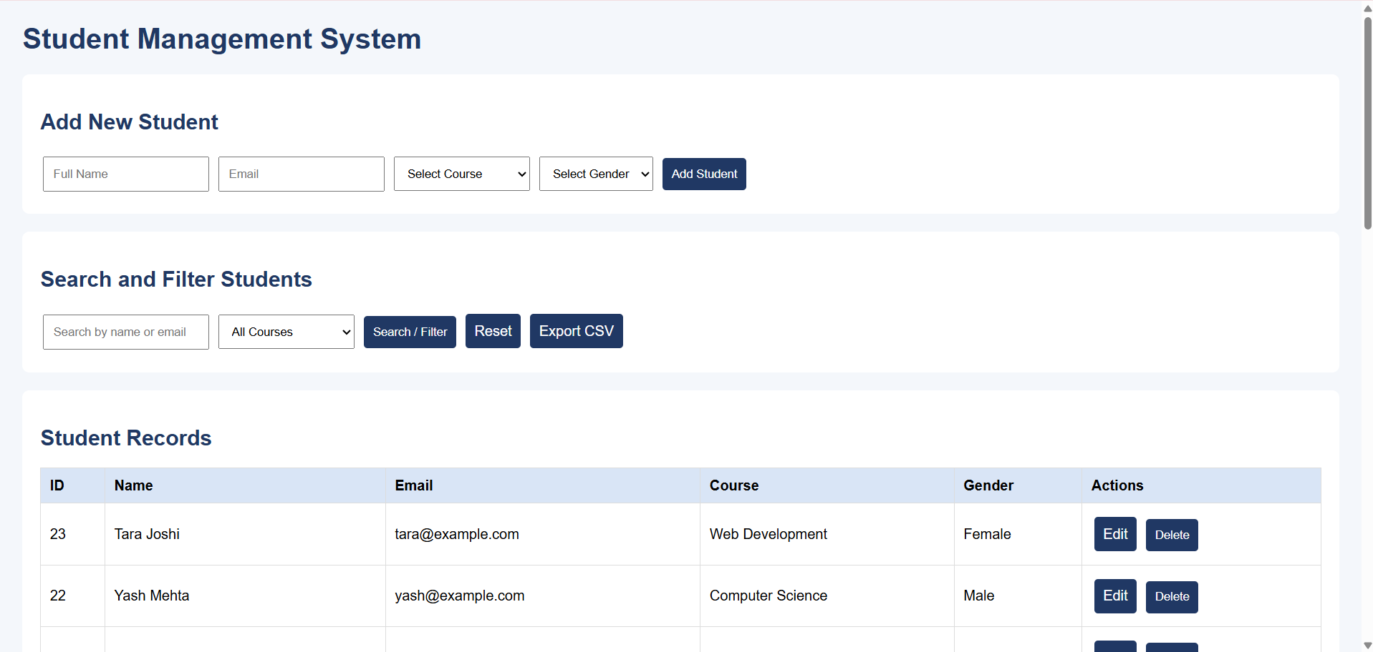

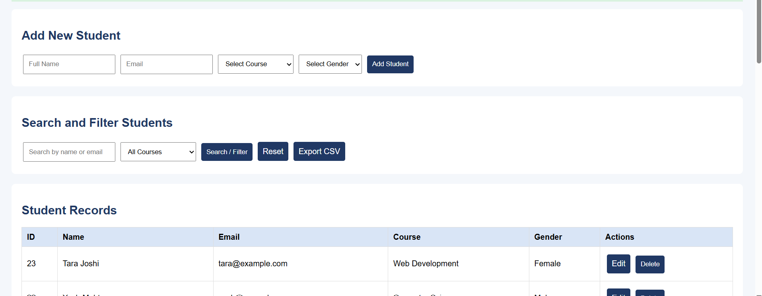

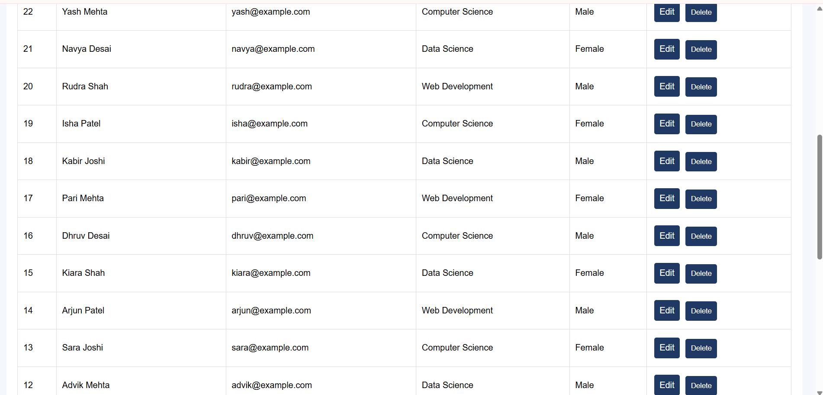

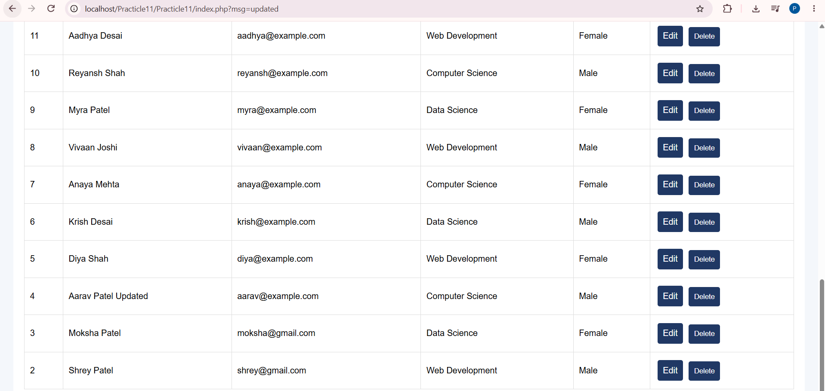

Database Connection Test

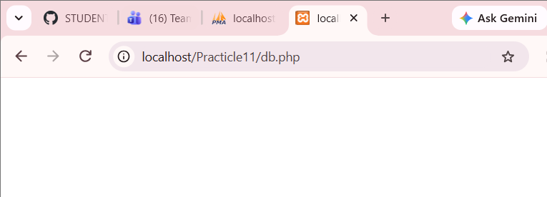

Edit Student Form

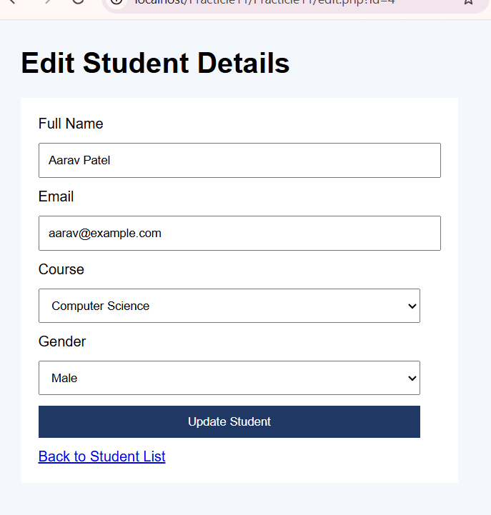

Successful Student Update
After update

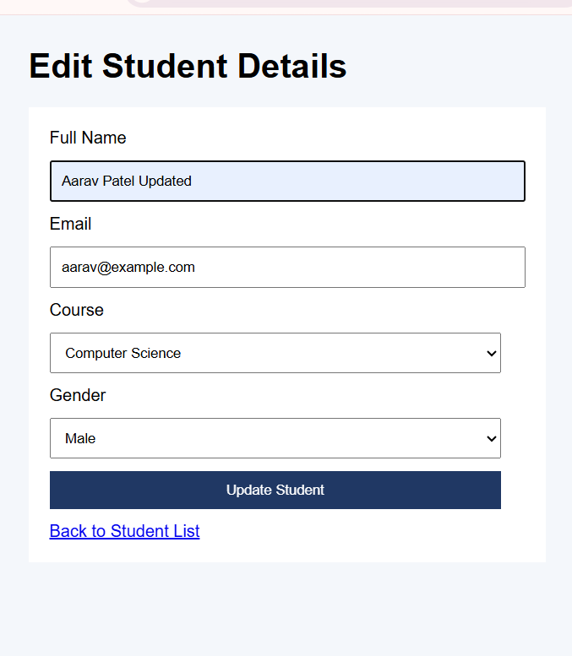

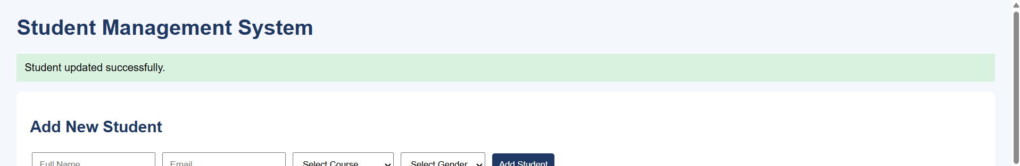

Student Management Dashboard

CSV Exported Successfully

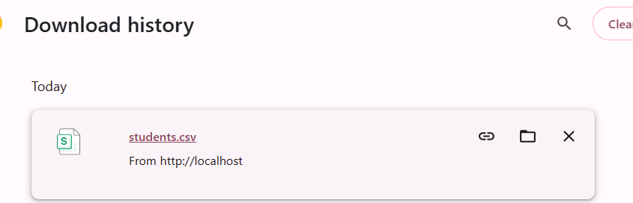

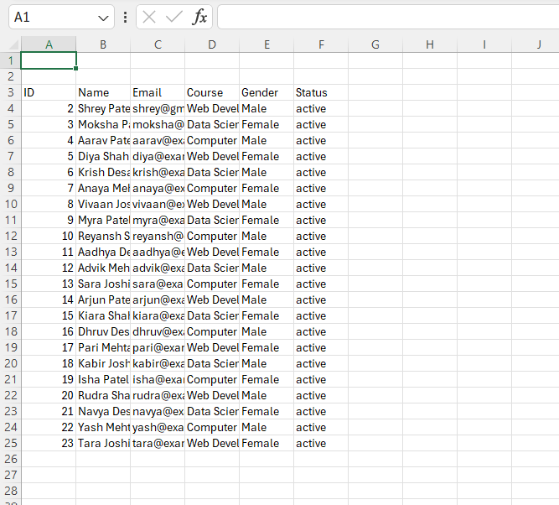

Student Search Functionality

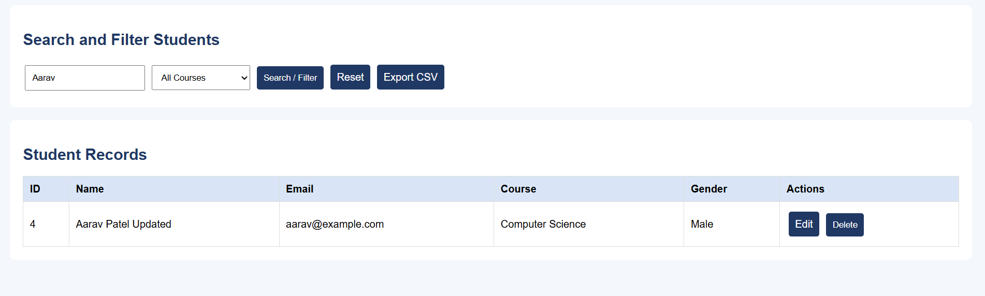

Course Filter Functionality

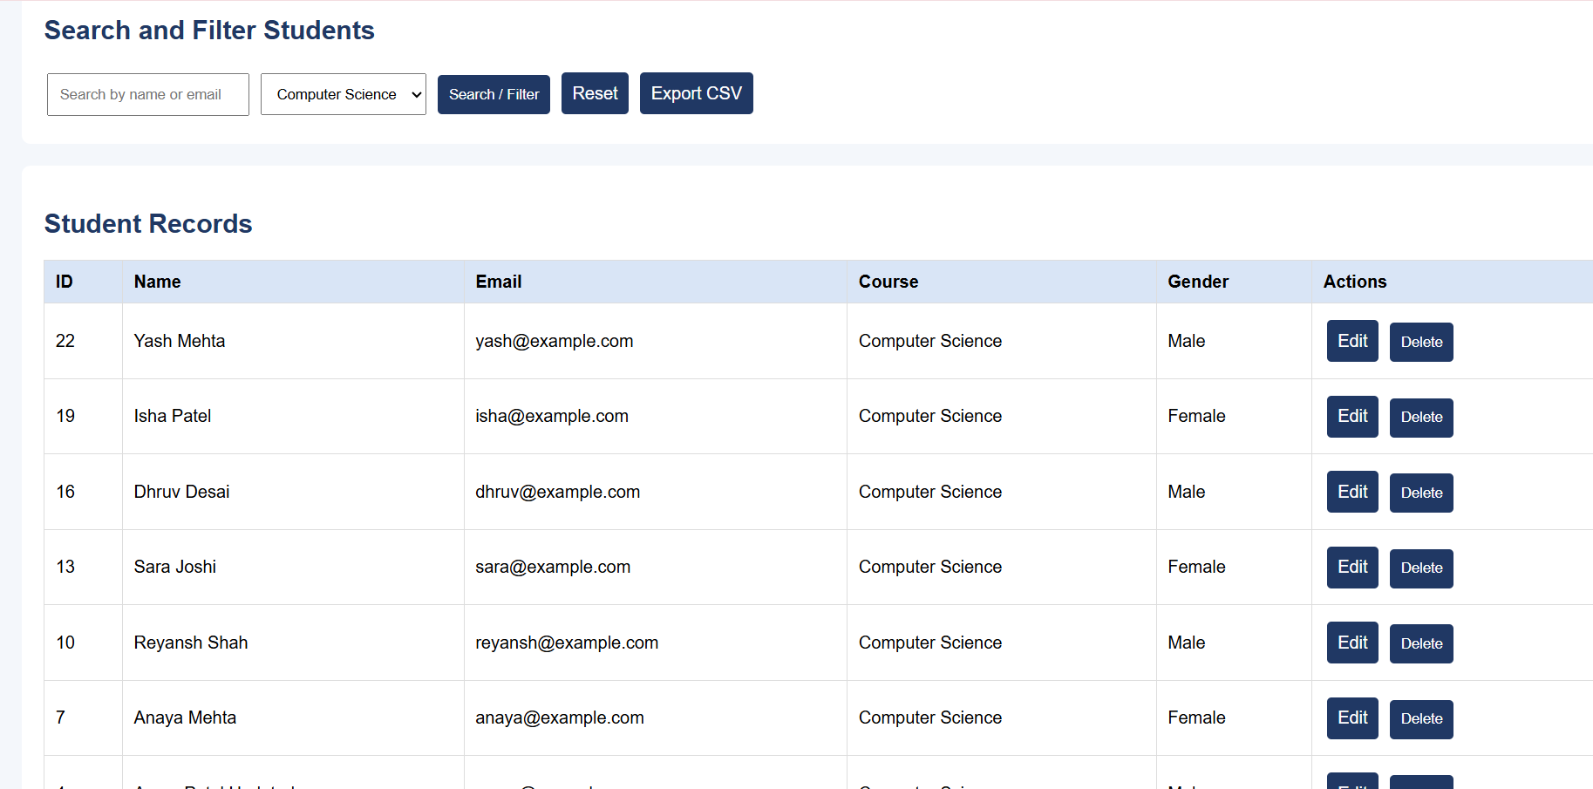

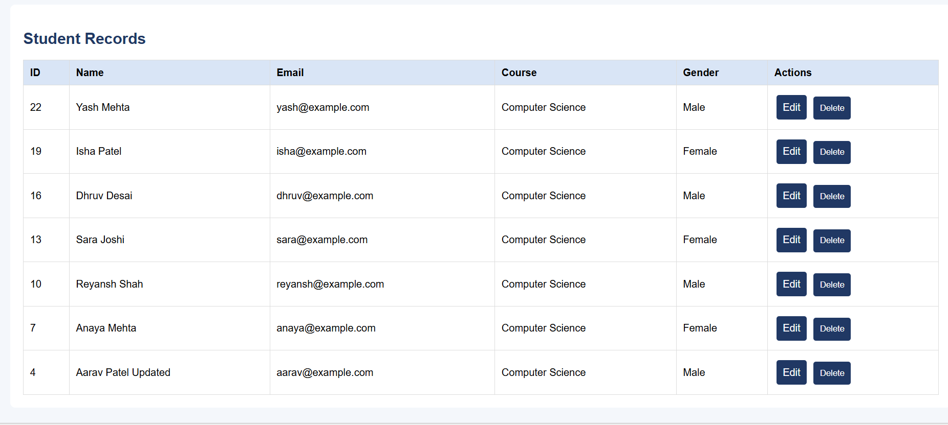

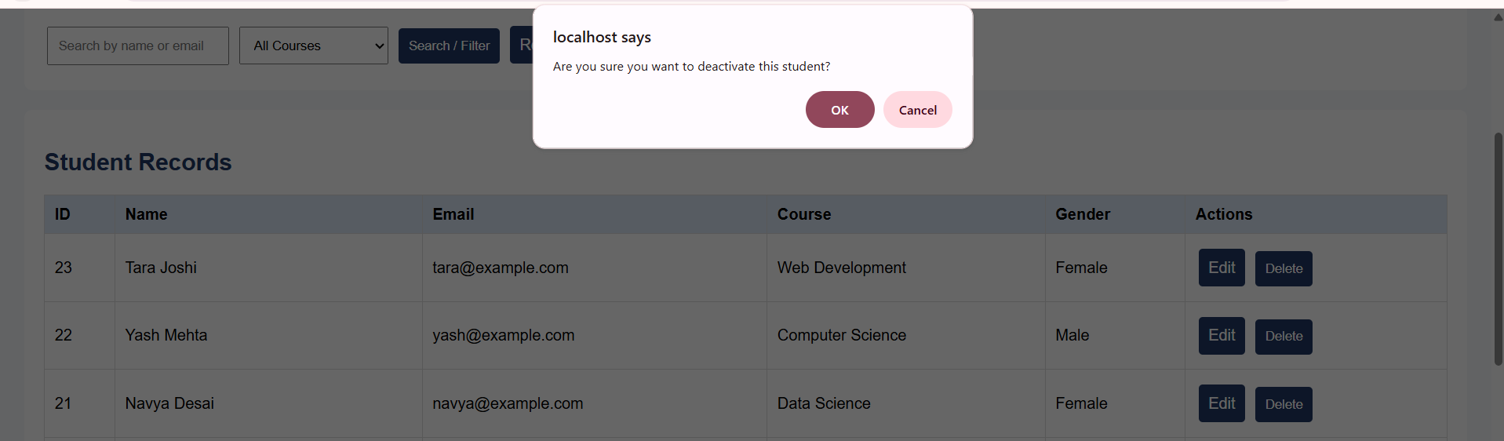

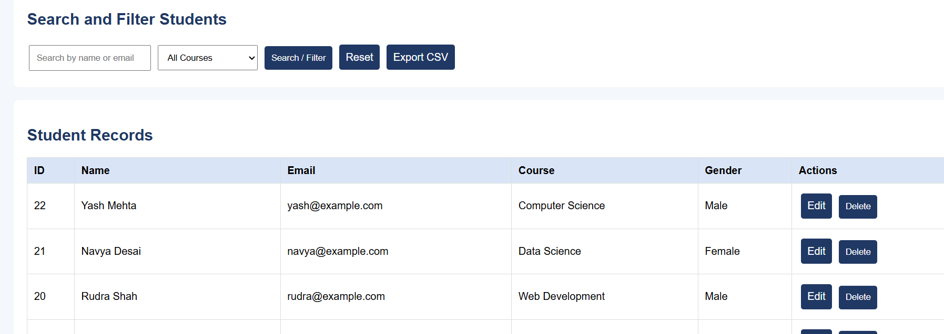

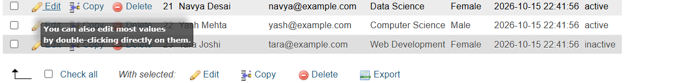

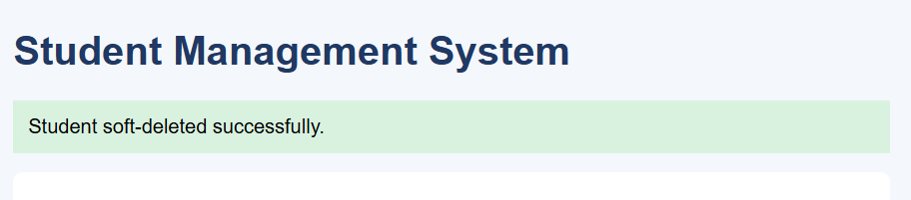

Successful Student Registration

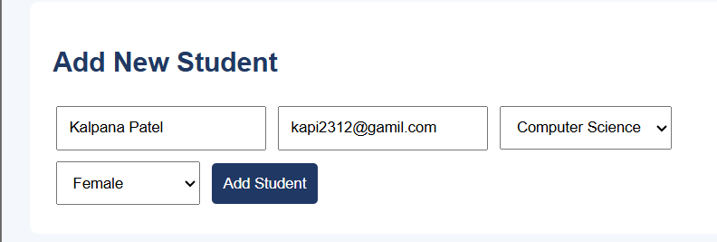

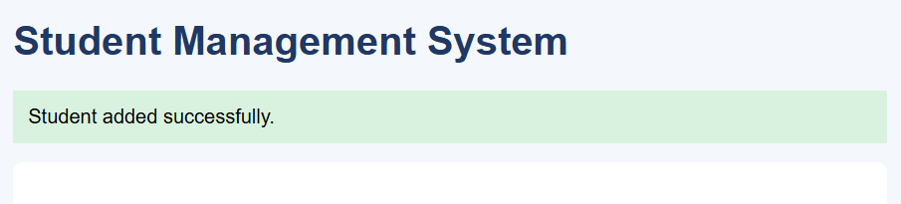

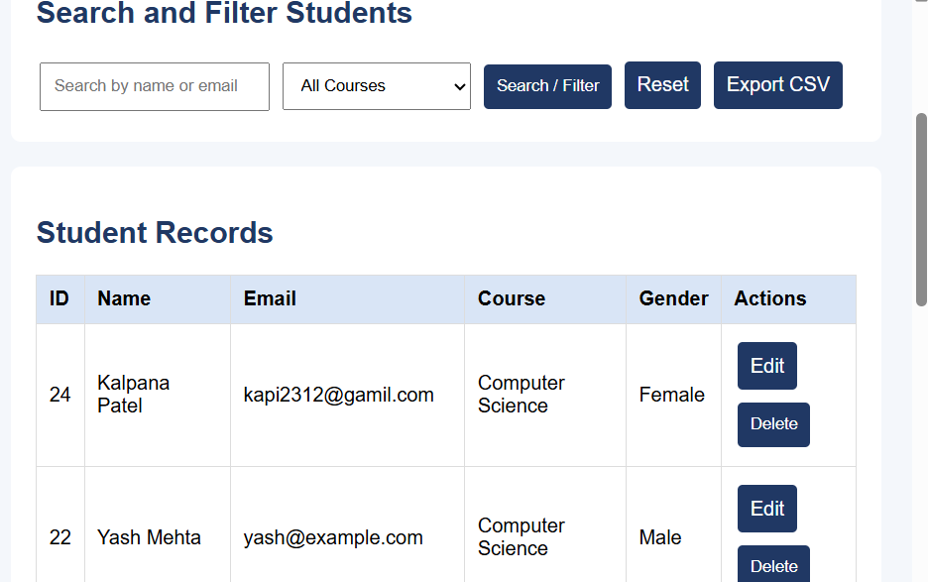

Student Database Records

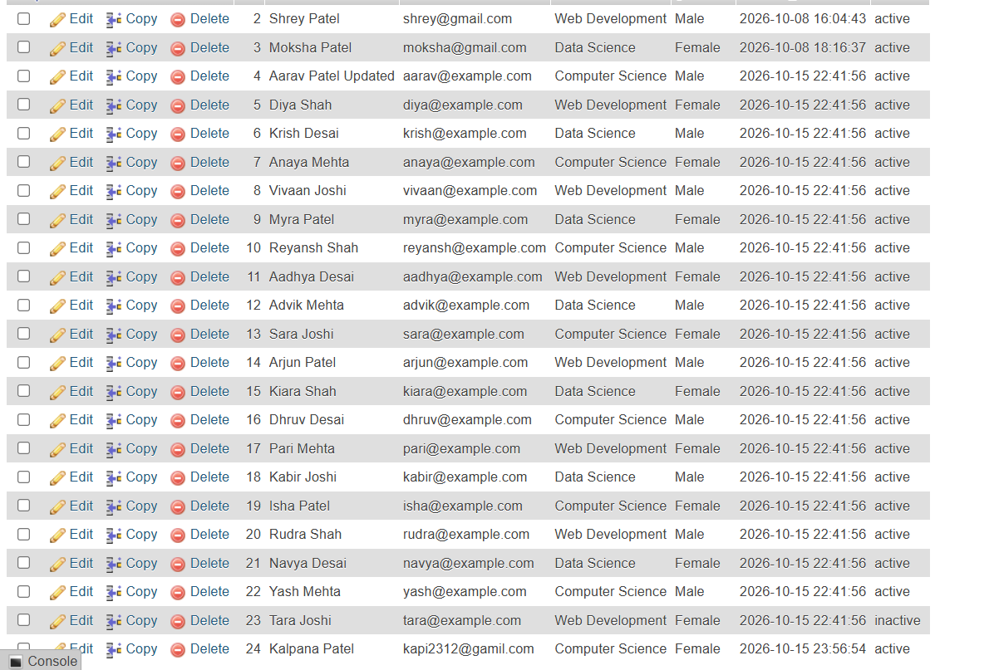

Output :

Learning outcome :

To develop a Student Management System using PHP and MySQL to perform CRUD operations (Create, Read, Update, and Delete) with search, course filtering, and CSV export functionality.
Learning Outcomes
- To understand the basics of PHP and MySQL database connectivity.
- To implement CRUD operations for managing student records.
- To perform searching and filtering of student records based on name, email, and course.
- To implement soft delete functionality to deactivate student records without permanently deleting them.
- To export student records into a CSV file for data management and reporting.

