 | 

Faculty of Technology and Engineering
Chandubhai S. Patel Institute of Technology (CSPIT) Department of Computer Science & Engineering
Date: / /
Laboratory Manul

Academic Year | : | 2026-27 | Semester | : | 3rd
Course code | : | ITUE203 | Course name | : | WEB DEVELOPMENT FRAMEWORKS

Practical – 14
dashboard_db_for_p14

PROBLEM STATEMENT :

Develop an admin dashboard that displays user statistics, student count,
event count and latest registrations. Restrict access to admin users only and show dynamic menu options based on role.

Objective :

To develop an admin dashboard using PHP, MySQL, and Bootstrap that displays dynamic user, student, event, and registration statistics. To implement Role-Based Access Control (RBAC), dynamic navigation menus, restrict unauthorized access, and maintain audit logs of administrative activities.

Code :

Audit_logs.php

<?php
require_once 'auth.php';
requireAdmin();
require_once 'db.php';

$stmt = $pdo->query(
"SELECT a.id, a.action, a.details, a.ip_address,
a.created_at, u.username
FROM audit_logs a
LEFT JOIN users u ON a.user_id = u.id
ORDER BY a.id DESC
LIMIT 100"
);

$logs = $stmt->fetchAll();
?>
<!DOCTYPE html>
<html lang="en">
<head>
<meta charset="UTF-8">
<meta name="viewport" content="width=device-width, initial-scale=1">
<title>Practical 14 - Audit Logs</title>
<link href="https://cdn.jsdelivr.net/npm/bootstrap@5.3.3/dist/css/bootstrap.min.css"
rel="stylesheet">
</head>
<body class="bg-light">

<?php require_once 'menu.php'; ?>

<div class="container py-4">
<h2 class="mb-4">Audit Logs</h2>

<div class="card shadow-sm">
<div class="card-header bg-primary text-white">
Recent Admin Activities
</div>

<div class="card-body">
<div class="table-responsive">
<table class="table table-bordered table-striped">
<thead class="table-dark">
<tr>
<th>ID</th>
<th>User</th>
<th>Action</th>
<th>Details</th>
<th>IP Address</th>
<th>Date and Time</th>
</tr>
</thead>
<tbody>
<?php if (count($logs) > 0): ?>
<?php foreach ($logs as $log): ?>
<tr>
<td><?= (int) $log['id'] ?></td>
<td><?= htmlspecialchars($log['username'] ?? 'Deleted user', ENT_QUOTES, 'UTF-8') ?></td>
<td><?= htmlspecialchars($log['action'], ENT_QUOTES, 'UTF-8') ?></td>
<td><?= htmlspecialchars($log['details'] ?? '', ENT_QUOTES, 'UTF-8') ?></td>
<td><?= htmlspecialchars($log['ip_address'] ?? '', ENT_QUOTES, 'UTF-8') ?></td>
<td><?= htmlspecialchars($log['created_at'], ENT_QUOTES, 'UTF-8') ?></td>
</tr>
<?php endforeach; ?>
<?php else: ?>
<tr>
<td colspan="6" class="text-center">
No audit records found.
</td>
</tr>
<?php endif; ?>
</tbody>
</table>
</div>

<a href="dashboard.php" class="btn btn-secondary">
Back to Dashboard
</a>
</div>
</div>
</div>

</body>
</html>

Auth.php

<?php
if (session_status() !== PHP_SESSION_ACTIVE) {
session_start();
}

function requireLogin(): void
{
if (!isset($_SESSION['user_id'])) {
header('Location: login.php');
exit;
}
}

function requireAdmin(): void
{
requireLogin();

if (($_SESSION['role'] ?? '') !== 'admin') {
header('Location: forbidden.php');
exit;
}
}
?>

Dashboard.php

<?php
require_once 'auth.php';
requireAdmin();
require_once 'db.php';

// Record the admin dashboard visit in the audit log.
$log = $pdo->prepare(
"INSERT INTO audit_logs (user_id, action, details, ip_address)
VALUES (?, ?, ?, ?)"
);
$log->execute([
$_SESSION['user_id'],
'VIEW_DASHBOARD',
'Admin opened the dashboard',
$_SERVER['REMOTE_ADDR'] ?? null
]);

// Load dashboard statistics dynamically.
$totalUsers = (int) $pdo->query(
"SELECT COUNT(*) FROM users"
)->fetchColumn();

$totalStudents = (int) $pdo->query(
"SELECT COUNT(*) FROM students"
)->fetchColumn();

$totalEvents = (int) $pdo->query(
"SELECT COUNT(*) FROM events"
)->fetchColumn();

$totalRegistrations = (int) $pdo->query(
"SELECT COUNT(*) FROM registrations"
)->fetchColumn();

// Get the latest registrations.
$stmt = $pdo->query(
"SELECT r.id, s.name AS student_name,
s.email, e.title AS event_title, r.registered_at
FROM registrations r
INNER JOIN students s ON r.student_id = s.id
INNER JOIN events e ON r.event_id = e.id
ORDER BY r.registered_at DESC, r.id DESC
LIMIT 10"
);
$registrations = $stmt->fetchAll();
?>
<!DOCTYPE html>
<html lang="en">
<head>
<meta charset="UTF-8">
<meta name="viewport" content="width=device-width, initial-scale=1">
<title>Practical 14 - Admin Dashboard</title>
<link href="https://cdn.jsdelivr.net/npm/bootstrap@5.3.3/dist/css/bootstrap.min.css"
rel="stylesheet">
</head>
<body class="bg-light">

<?php require_once 'menu.php'; ?>

<main class="container py-4">
<h2 class="mb-4">Dashboard Overview</h2>

<div class="row g-3 mb-4">
<div class="col-12 col-sm-6 col-lg-3">
<div class="card shadow-sm border-primary h-100">
<div class="card-body">
<h6 class="text-muted">Total Users</h6>
<h2><?= $totalUsers ?></h2>
</div>
</div>
</div>

<div class="col-12 col-sm-6 col-lg-3">
<div class="card shadow-sm border-success h-100">
<div class="card-body">
<h6 class="text-muted">Total Students</h6>
<h2><?= $totalStudents ?></h2>
</div>
</div>
</div>

<div class="col-12 col-sm-6 col-lg-3">
<div class="card shadow-sm border-warning h-100">
<div class="card-body">
<h6 class="text-muted">Total Events</h6>
<h2><?= $totalEvents ?></h2>
</div>
</div>
</div>

<div class="col-12 col-sm-6 col-lg-3">
<div class="card shadow-sm border-info h-100">
<div class="card-body">
<h6 class="text-muted">Total Registrations</h6>
<h2><?= $totalRegistrations ?></h2>
</div>
</div>
</div>
</div>

<div class="card shadow-sm">
<div class="card-header bg-primary text-white">
Latest Registrations
</div>
<div class="card-body">
<div class="table-responsive">
<table class="table table-striped table-bordered align-middle">
<thead class="table-dark">
<tr>
<th>ID</th>
<th>Student Name</th>
<th>Email</th>
<th>Event</th>
<th>Registration Date</th>
</tr>
</thead>
<tbody>
<?php if (count($registrations) > 0): ?>
<?php foreach ($registrations as $row): ?>
<tr>
<td><?= (int) $row['id'] ?></td>
<td><?= htmlspecialchars($row['student_name'], ENT_QUOTES, 'UTF-8') ?></td>
<td><?= htmlspecialchars($row['email'], ENT_QUOTES, 'UTF-8') ?></td>
<td><?= htmlspecialchars($row['event_title'], ENT_QUOTES, 'UTF-8') ?></td>
<td><?= htmlspecialchars($row['registered_at'], ENT_QUOTES, 'UTF-8') ?></td>
</tr>
<?php endforeach; ?>
<?php else: ?>
<tr>
<td colspan="5" class="text-center">
No registrations found.
</td>
</tr>
<?php endif; ?>
</tbody>
</table>
</div>
</div>
</div>

<p class="text-muted mt-3">
Dashboard statistics are loaded dynamically from the MySQL database.
</p>
</main>

</body>
</html>

Db.php

<?php
$host = 'localhost';
$dbname = 'dashboard_db_for_p14';
$username = 'root';
$password = '';

try {
$pdo = new PDO(
"mysql:host=$host;dbname=$dbname;charset=utf8mb4",
$username,
$password,
[
PDO::ATTR_ERRMODE => PDO::ERRMODE_EXCEPTION,
PDO::ATTR_DEFAULT_FETCH_MODE => PDO::FETCH_ASSOC
]
);
} catch (PDOException $e) {
error_log($e->getMessage());
http_response_code(500);
exit('Database connection failed. Check db.php settings.');
}
?>

Events.php

<?php
require_once 'auth.php';
requireLogin();
require_once 'db.php';

// Only editor and admin can access Event Management.
$role = $_SESSION['role'] ?? 'user';

if (!in_array($role, ['editor', 'admin'], true)) {
require_once 'forbidden.php';
exit;
}

// Fetch event records from the database.
$stmt = $pdo->query(
"SELECT id, title, event_date, created_at
FROM events
ORDER BY event_date ASC"
);

$events = $stmt->fetchAll();
?>
<!DOCTYPE html>
<html lang="en">
<head>
<meta charset="UTF-8">
<meta name="viewport" content="width=device-width, initial-scale=1">
<title>Practical 14 - Event Management</title>

<link
href="https://cdn.jsdelivr.net/npm/bootstrap@5.3.3/dist/css/bootstrap.min.css"
rel="stylesheet"
>
</head>
<body class="bg-light">

<?php require_once 'menu.php'; ?>

<main class="container py-4">
<h2 class="mb-4">Event Management</h2>

<div class="card shadow-sm">
<div class="card-header bg-primary text-white">
Event Records
</div>

<div class="card-body">
<div class="table-responsive">
<table class="table table-striped table-bordered align-middle">
<thead class="table-dark">
<tr>
<th>ID</th>
<th>Event Title</th>
<th>Event Date</th>
<th>Created At</th>
</tr>
</thead>

<tbody>
<?php if (count($events) > 0): ?>
<?php foreach ($events as $event): ?>
<tr>
<td><?= (int) $event['id'] ?></td>
<td><?= htmlspecialchars($event['title'], ENT_QUOTES, 'UTF-8') ?></td>
<td><?= htmlspecialchars($event['event_date'], ENT_QUOTES, 'UTF-8') ?></td>
<td><?= htmlspecialchars($event['created_at'], ENT_QUOTES, 'UTF-8') ?></td>
</tr>
<?php endforeach; ?>
<?php else: ?>
<tr>
<td colspan="4" class="text-center">
No events found.
</td>
</tr>
<?php endif; ?>
</tbody>
</table>
</div>

<a href="menu_test.php" class="btn btn-secondary">
Back
</a>
</div>
</div>
</main>

</body>
</html>

Forbidden.php

<?php
http_response_code(403);
?>
<!DOCTYPE html>
<html lang="en">
<head>
<meta charset="UTF-8">
<meta name="viewport" content="width=device-width, initial-scale=1">
<title>403 Forbidden</title>
<link href="https://cdn.jsdelivr.net/npm/bootstrap@5.3.3/dist/css/bootstrap.min.css"
rel="stylesheet">
</head>
<body class="bg-light">
<div class="container mt-5">
<div class="alert alert-danger shadow">
<h1>403 - Forbidden</h1>
<p>You do not have permission to access this page.</p>
<a href="dashboard.php" class="btn btn-secondary">
Back to Dashboard
</a>
<a href="logout.php" class="btn btn-danger">
Logout
</a>
</div>
</div>
</body>
</html>

Login.php

<?php
session_start();
require_once 'db.php';

if (isset($_SESSION['user_id'])) {
if (($_SESSION['role'] ?? '') === 'admin') {
header('Location: dashboard.php');
} else {
header('Location: menu_test.php');
}
exit;
}

$error = '';

if ($_SERVER['REQUEST_METHOD'] === 'POST') {
$username = trim($_POST['username'] ?? '');
$password = $_POST['password'] ?? '';

$stmt = $pdo->prepare(
"SELECT id, username, password, role, status
FROM users
WHERE username = ?
LIMIT 1"
);

$stmt->execute([$username]);
$user = $stmt->fetch();

if (
$user &&
password_verify($password, $user['password']) &&
$user['status'] === 'active'
) {
session_regenerate_id(true);

$_SESSION['user_id'] = $user['id'];
$_SESSION['username'] = $user['username'];
$_SESSION['role'] = $user['role'];

if ($user['role'] === 'admin') {
header('Location: dashboard.php');
} else {
header('Location: menu_test.php');
}

exit;
}

$error = 'Invalid username or password, or account inactive.';
}
?>
<!DOCTYPE html>
<html lang="en">
<head>
<meta charset="UTF-8">
<meta name="viewport" content="width=device-width, initial-scale=1">

<title>Practical 14 - Login</title>

<link
href="https://cdn.jsdelivr.net/npm/bootstrap@5.3.3/dist/css/bootstrap.min.css"
rel="stylesheet"
>
</head>

<body class="bg-light">

<div class="container mt-5">
<div class="card shadow mx-auto" style="max-width: 420px;">

<div class="card-body p-4">

<h2 class="text-center mb-4">
Admin Dashboard Login
</h2>

<?php if ($error !== ''): ?>
<div class="alert alert-danger">
<?= htmlspecialchars(
$error,
ENT_QUOTES,
'UTF-8'
) ?>
</div>
<?php endif; ?>

<form method="POST" action="login.php">

<div class="mb-3">
<label class="form-label">Username</label>

<input
type="text"
name="username"
class="form-control"
autocomplete="username"
required
>
</div>

<div class="mb-3">
<label class="form-label">Password</label>

<input
type="password"
name="password"
class="form-control"
autocomplete="current-password"
required
>
</div>

<button
type="submit"
class="btn btn-primary w-100"
>
Login
</button>

</form>

</div>
</div>
</div>

</body>
</html>

Logout.php

<?php
session_start();

$_SESSION = [];
session_regenerate_id(true);
session_destroy();

header('Location: login.php');
exit;
?>

Menu_test.php

<?php
require_once 'auth.php';
requireLogin();
?>
<!DOCTYPE html>
<html lang="en">
<head>
<meta charset="UTF-8">
<meta name="viewport" content="width=device-width, initial-scale=1">
<title>Practical 14 - Role Menu Test</title>
<link href="https://cdn.jsdelivr.net/npm/bootstrap@5.3.3/dist/css/bootstrap.min.css"
rel="stylesheet">
</head>
<body class="bg-light">

<?php require_once 'menu.php'; ?>

<div class="container py-5">
<div class="card shadow-sm">
<div class="card-body">
<h2>Dynamic Role-Based Menu</h2>
<p>
Logged-in user:
<strong><?= htmlspecialchars($_SESSION['username'], ENT_QUOTES, 'UTF-8') ?></strong>
</p>
<p>
Current role:
<strong><?= htmlspecialchars($_SESSION['role'], ENT_QUOTES, 'UTF-8') ?></strong>
</p>
<p>
The navigation menu above is displayed according to
the user's role.
</p>
</div>
</div>
</div>

</body>
</html>

Menu.php

<?php
require_once 'auth.php';
requireLogin();
require_once 'db.php';

$role = $_SESSION['role'] ?? 'user';

$roleLevels = [
'user' => 1,
'editor' => 2,
'admin' => 3
];

$currentLevel = $roleLevels[$role] ?? 0;

$stmt = $pdo->query(
"SELECT title, link, min_role
FROM menu_items
ORDER BY id ASC"
);

$menuItems = $stmt->fetchAll();
?>

<nav class="navbar navbar-expand-lg navbar-dark bg-dark">
<div class="container-fluid">
<a class="navbar-brand"
href="<?= $role === 'admin' ? 'dashboard.php' : 'menu_test.php' ?>">
Practical 14
</a>

<button class="navbar-toggler" type="button"
data-bs-toggle="collapse"
data-bs-target="#mainMenu"
aria-controls="mainMenu"
aria-expanded="false"
aria-label="Toggle navigation">
<span class="navbar-toggler-icon"></span>
</button>

<div class="collapse navbar-collapse show" id="mainMenu">
<ul class="navbar-nav me-auto mb-2 mb-lg-0">
<?php foreach ($menuItems as $item): ?>
<?php
$requiredLevel =
$roleLevels[$item['min_role']] ?? 99;
?>

<?php if ($currentLevel >= $requiredLevel): ?>
<li class="nav-item">
<a class="nav-link"
href="<?= htmlspecialchars(
$item['link'],
ENT_QUOTES,
'UTF-8'
) ?>">
<?= htmlspecialchars(
$item['title'],
ENT_QUOTES,
'UTF-8'
) ?>
</a>
</li>
<?php endif; ?>
<?php endforeach; ?>
</ul>

<span class="navbar-text text-white me-3">
<?= htmlspecialchars(
$_SESSION['username'],
ENT_QUOTES,
'UTF-8'
) ?>
(<?= htmlspecialchars($role, ENT_QUOTES, 'UTF-8') ?>)
</span>

<a class="btn btn-danger btn-sm" href="logout.php">
Logout
</a>
</div>
</div>
</nav>

Schema.sql

CREATE DATABASE IF NOT EXISTS dashboard_db_for_p14;
USE dashboard_db_for_p14;

CREATE TABLE IF NOT EXISTS users (
id INT AUTO_INCREMENT PRIMARY KEY,
username VARCHAR(100) NOT NULL UNIQUE,
password VARCHAR(255) NOT NULL,
role ENUM('user', 'editor', 'admin')
NOT NULL DEFAULT 'user',
status ENUM('active', 'inactive')
NOT NULL DEFAULT 'active',
created_at TIMESTAMP DEFAULT CURRENT_TIMESTAMP
);

CREATE TABLE IF NOT EXISTS students (
id INT AUTO_INCREMENT PRIMARY KEY,
name VARCHAR(100) NOT NULL,
email VARCHAR(150) NOT NULL UNIQUE,
course VARCHAR(100) NOT NULL,
created_at TIMESTAMP DEFAULT CURRENT_TIMESTAMP
);

CREATE TABLE IF NOT EXISTS events (
id INT AUTO_INCREMENT PRIMARY KEY,
title VARCHAR(150) NOT NULL,
event_date DATE NOT NULL,
created_at TIMESTAMP DEFAULT CURRENT_TIMESTAMP
);

CREATE TABLE IF NOT EXISTS registrations (
id INT AUTO_INCREMENT PRIMARY KEY,
student_id INT NOT NULL,
event_id INT NOT NULL,
registered_at TIMESTAMP DEFAULT CURRENT_TIMESTAMP,
FOREIGN KEY (student_id) REFERENCES students(id),
FOREIGN KEY (event_id) REFERENCES events(id)
);

CREATE TABLE IF NOT EXISTS menu_items (
id INT AUTO_INCREMENT PRIMARY KEY,
title VARCHAR(100) NOT NULL,
link VARCHAR(255) NOT NULL,
min_role ENUM('user', 'editor', 'admin')
NOT NULL DEFAULT 'user'
);

CREATE TABLE IF NOT EXISTS audit_logs (
id INT AUTO_INCREMENT PRIMARY KEY,
user_id INT NULL,
action VARCHAR(100) NOT NULL,
details TEXT,
ip_address VARCHAR(45),
created_at TIMESTAMP DEFAULT CURRENT_TIMESTAMP,
FOREIGN KEY (user_id) REFERENCES users(id)
ON DELETE SET NULL
);

Students.php

<?php
require_once 'auth.php';
requireLogin();
require_once 'db.php';

// Only editor and admin can access this page.
$role = $_SESSION['role'] ?? 'user';

if (!in_array($role, ['editor', 'admin'], true)) {
require_once 'forbidden.php';
exit;
}

// Load student records from the database.
$stmt = $pdo->query(
"SELECT id, name, email, course, created_at
FROM students
ORDER BY id DESC"
);

$students = $stmt->fetchAll();
?>
<!DOCTYPE html>
<html lang="en">
<head>
<meta charset="UTF-8">
<meta name="viewport" content="width=device-width, initial-scale=1">
<title>Practical 14 - Students</title>

<link
href="https://cdn.jsdelivr.net/npm/bootstrap@5.3.3/dist/css/bootstrap.min.css"
rel="stylesheet"
>
</head>
<body class="bg-light">

<?php require_once 'menu.php'; ?>

<main class="container py-4">
<h2 class="mb-4">Students Management</h2>

<div class="card shadow-sm">
<div class="card-header bg-primary text-white">
Student Records
</div>

<div class="card-body">
<div class="table-responsive">
<table class="table table-striped table-bordered align-middle">
<thead class="table-dark">
<tr>
<th>ID</th>
<th>Name</th>
<th>Email</th>
<th>Course</th>
<th>Created At</th>
</tr>
</thead>

<tbody>
<?php if (count($students) > 0): ?>
<?php foreach ($students as $student): ?>
<tr>
<td><?= (int) $student['id'] ?></td>
<td><?= htmlspecialchars($student['name'], ENT_QUOTES, 'UTF-8') ?></td>
<td><?= htmlspecialchars($student['email'], ENT_QUOTES, 'UTF-8') ?></td>
<td><?= htmlspecialchars($student['course'], ENT_QUOTES, 'UTF-8') ?></td>
<td><?= htmlspecialchars($student['created_at'], ENT_QUOTES, 'UTF-8') ?></td>
</tr>
<?php endforeach; ?>
<?php else: ?>
<tr>
<td colspan="5" class="text-center">
No students found.
</td>
</tr>
<?php endif; ?>
</tbody>
</table>
</div>

<a href="menu_test.php" class="btn btn-secondary">
Back
</a>
</div>
</div>
</main>

</body>
</html>

Test_db.php

<?php
require_once 'db.php';

echo "Database connection successful!";
?>

Users.php

<?php
require_once 'auth.php';
requireAdmin();
require_once 'db.php';

// Fetch all user accounts.
$stmt = $pdo->query(
"SELECT id, username, role, status, created_at
FROM users
ORDER BY id ASC"
);

$users = $stmt->fetchAll();
?>
<!DOCTYPE html>
<html lang="en">
<head>
<meta charset="UTF-8">
<meta name="viewport" content="width=device-width, initial-scale=1">
<title>Practical 14 - User Management</title>

<link
href="https://cdn.jsdelivr.net/npm/bootstrap@5.3.3/dist/css/bootstrap.min.css"
rel="stylesheet"
>
</head>
<body class="bg-light">

<?php require_once 'menu.php'; ?>

<main class="container py-4">
<h2 class="mb-4">User Management</h2>

<div class="card shadow-sm">
<div class="card-header bg-primary text-white">
Registered Users
</div>

<div class="card-body">
<div class="table-responsive">
<table class="table table-striped table-bordered align-middle">
<thead class="table-dark">
<tr>
<th>ID</th>
<th>Username</th>
<th>Role</th>
<th>Status</th>
<th>Created At</th>
</tr>
</thead>

<tbody>
<?php if (count($users) > 0): ?>
<?php foreach ($users as $user): ?>
<tr>
<td><?= (int) $user['id'] ?></td>
<td><?= htmlspecialchars($user['username'], ENT_QUOTES, 'UTF-8') ?></td>
<td><?= htmlspecialchars($user['role'], ENT_QUOTES, 'UTF-8') ?></td>
<td>
<?php if ($user['status'] === 'active'): ?>
<span class="badge bg-success">Active</span>
<?php else: ?>
<span class="badge bg-secondary">Inactive</span>
<?php endif; ?>
</td>
<td><?= htmlspecialchars($user['created_at'], ENT_QUOTES, 'UTF-8') ?></td>
</tr>
<?php endforeach; ?>
<?php else: ?>
<tr>
<td colspan="5" class="text-center">
No users found.
</td>
</tr>
<?php endif; ?>
</tbody>
</table>
</div>

<a href="dashboard.php" class="btn btn-secondary">
Back to Dashboard
</a>
</div>
</div>
</main>

</body>
</html>

Screenshort:

Practical 14 – Database Schema and Tables

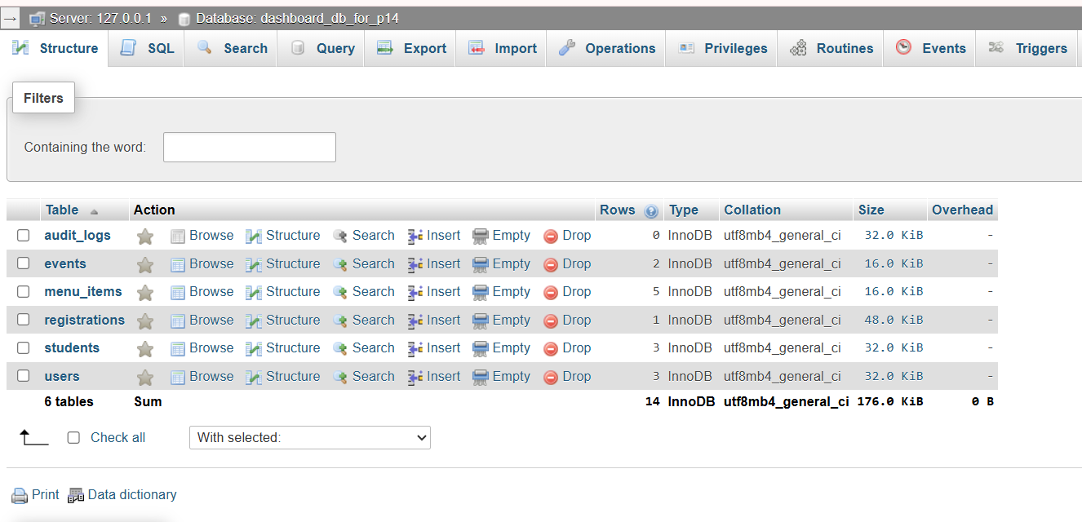

Successful PHP and MySQL Database Connection

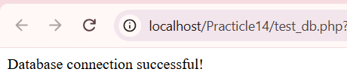

Dashboard Statistics and Latest Registrations

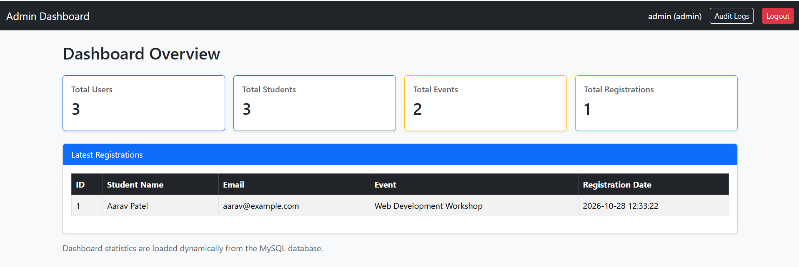

Audit Log Records of Admin Activities

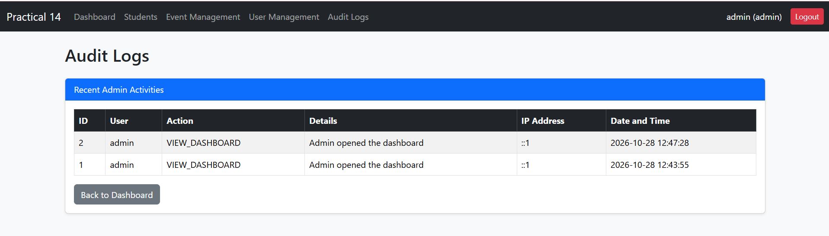

RBAC Security Test: Non-Admin Access Denied (403 Forbidden)

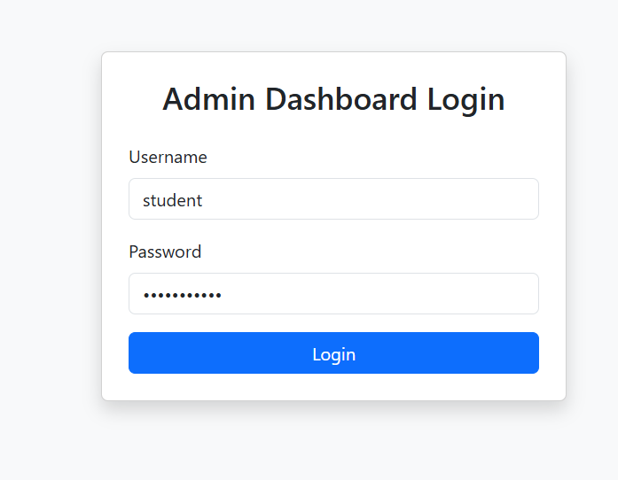

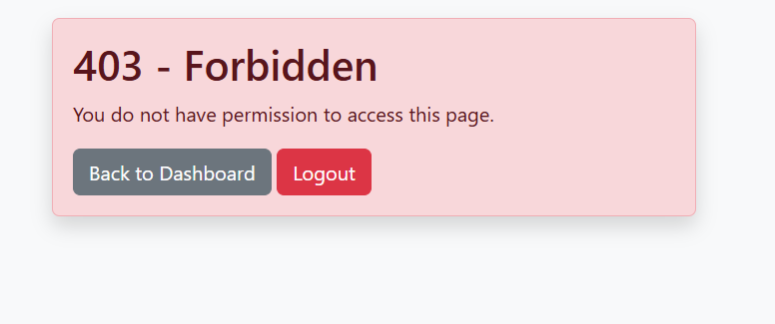

Dynamic Navigation Menu for Admin Role

Dynamic Menu for Admin Role

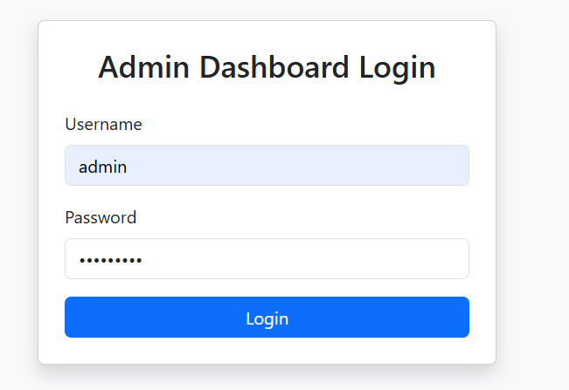

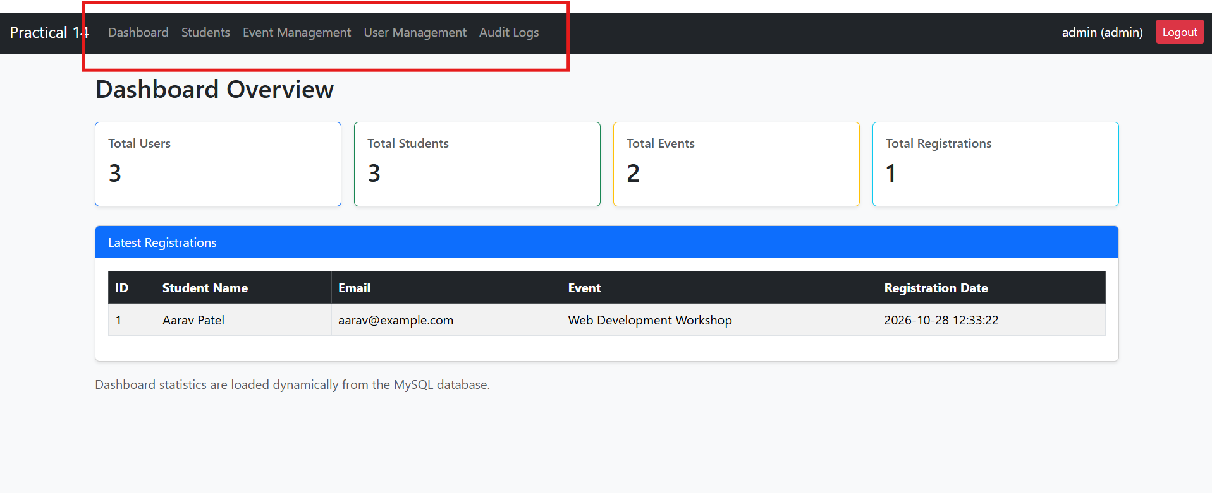

Dynamic Menu for Editor Role

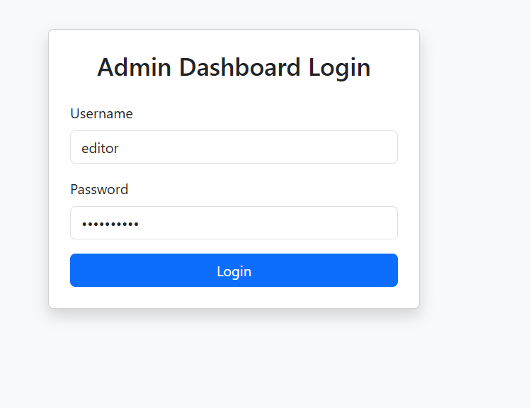

Dynamic Menu for User Role

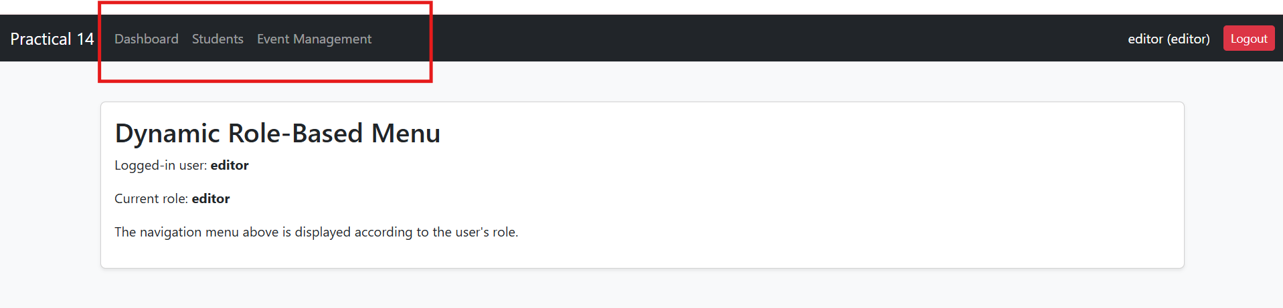

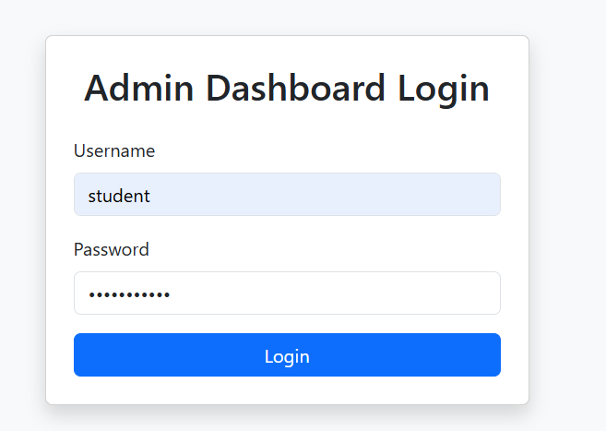

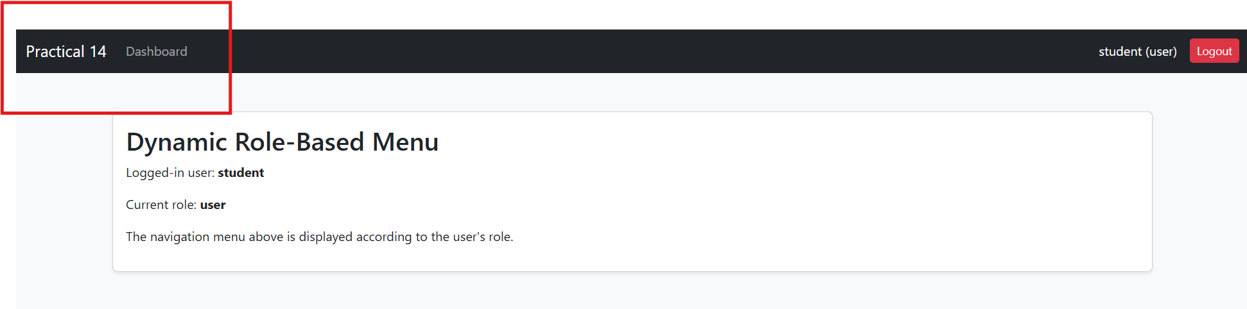

Students Management and Database Records

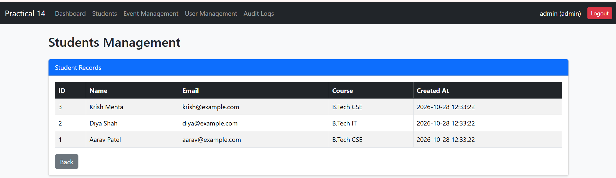

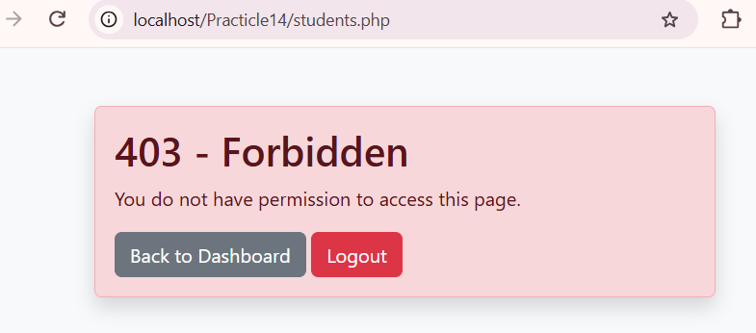

Students Management: Editor Access Granted

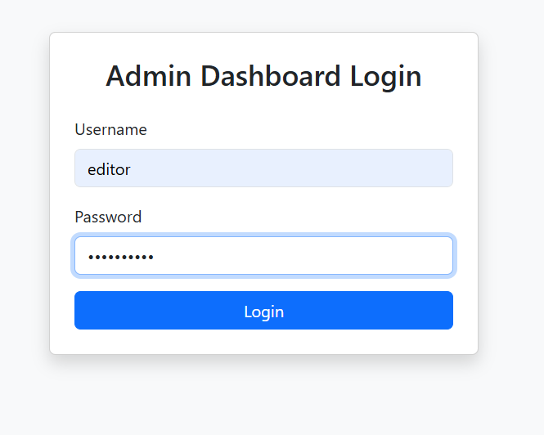

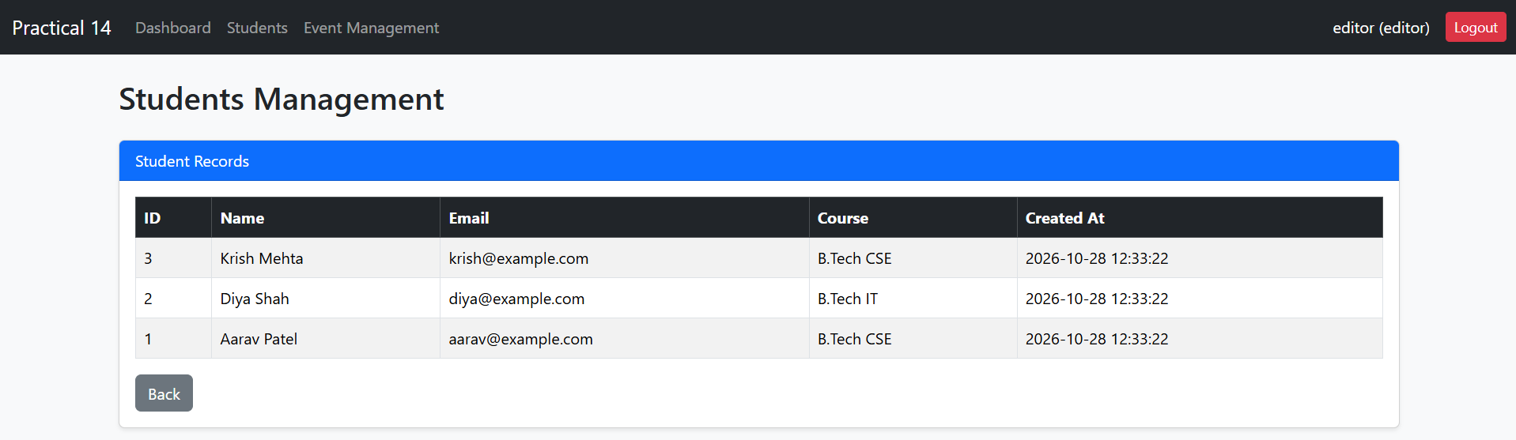

Event Management and Database Records

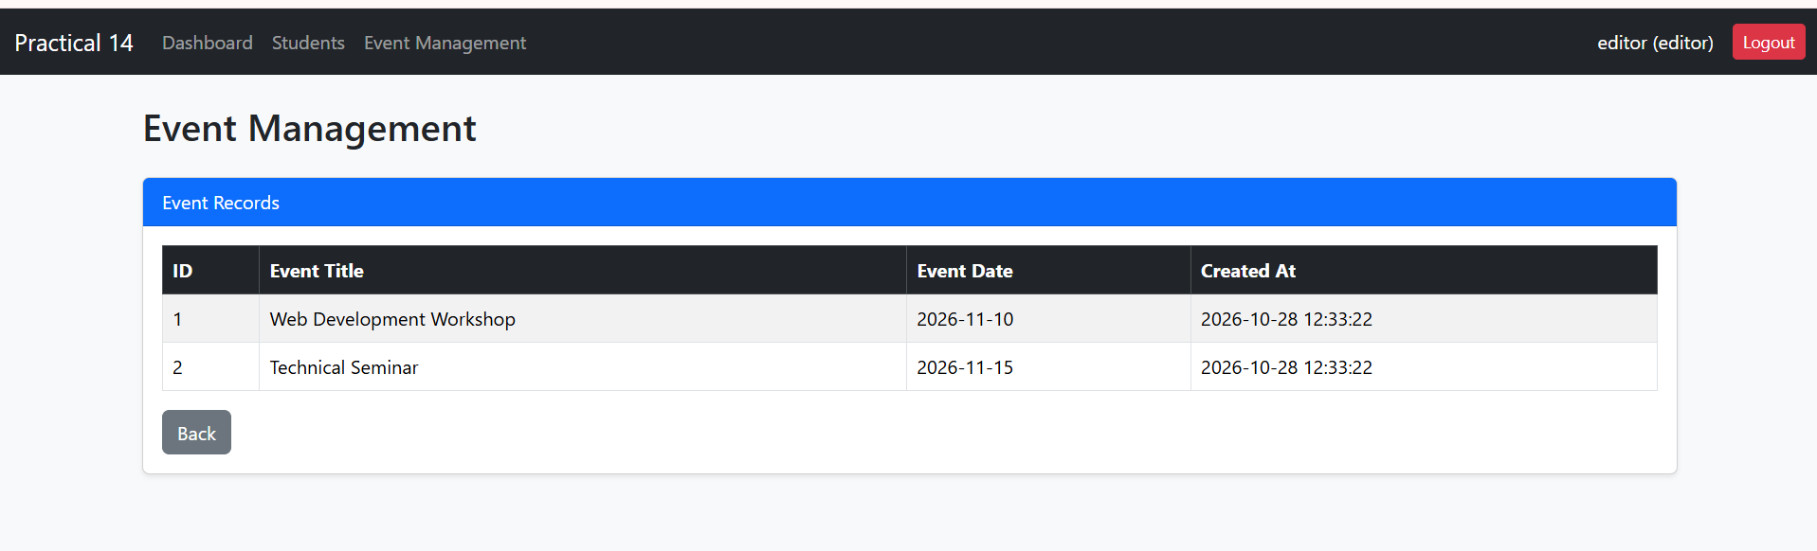

User Management with Role and Account Status

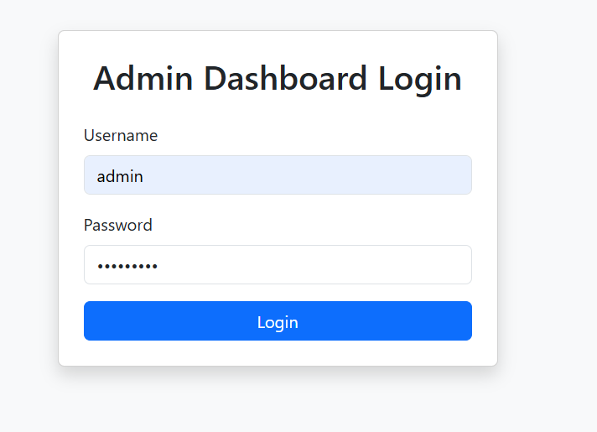

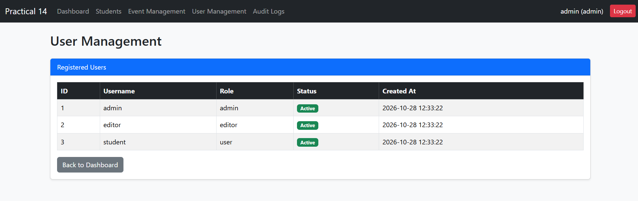

User Management Restricted to Admin

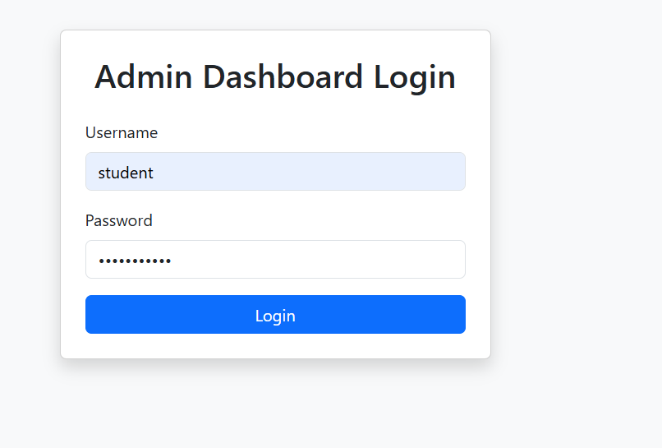

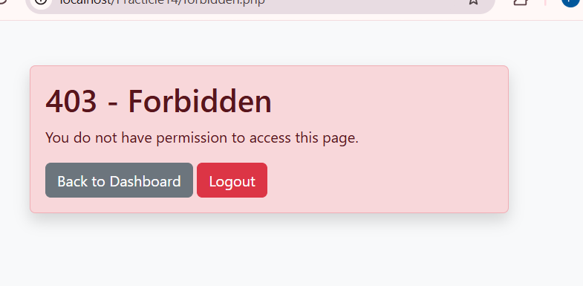

Audit Log Proof: Recorded Admin Actions

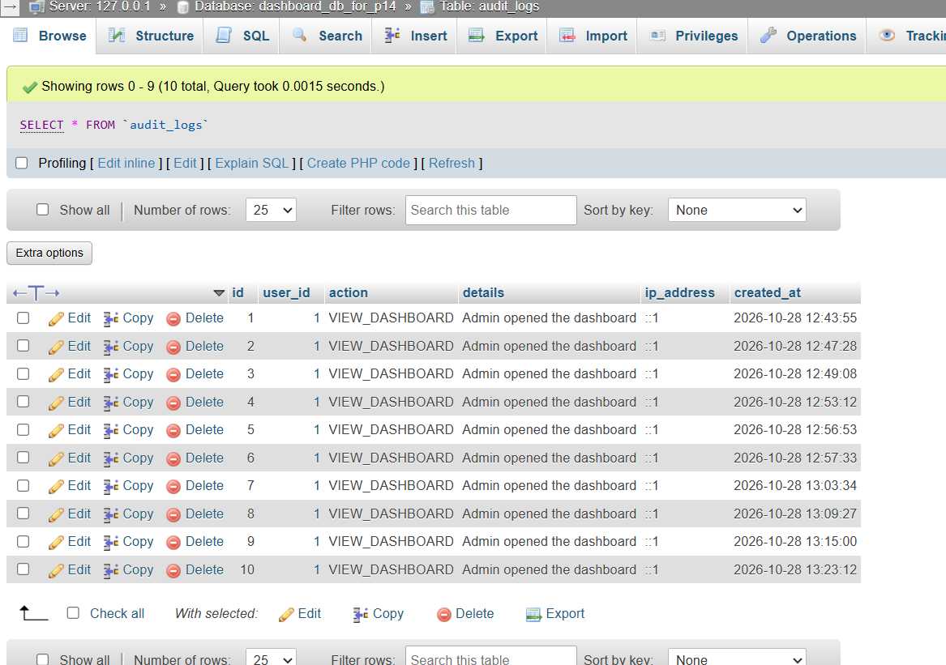

Output :
A responsive admin dashboard was developed using PHP, MySQL, and Bootstrap. It displays total users, total students, total events, total registrations, and the latest registration records dynamically from the database. Role-based navigation menus are displayed according to admin, editor, and user roles. Unauthorized users are restricted from accessing protected pages through a 403 Forbidden page. Administrative activities, such as dashboard visits, are recorded and displayed in the audit_logs table.

Learning outcome :

After completing this practical, I learned how to develop a database-driven admin dashboard using PHP and MySQL. I learned to retrieve and display statistics using SQL queries, implement role-based access control, generate dynamic menus according to user roles, restrict unauthorized users using a 403 Forbidden page, and record administrative activities in an audit log for monitoring and traceability.

GitHub Link

