 | 

Faculty of Technology and Engineering
Chandubhai S. Patel Institute of Technology (CSPIT) Department of Computer Science & Engineering
Date: / /
Laboratory Manul

Academic Year | : | 2026-27 | Semester | : | 3rd
Course code | : | ITUE203 | Course name | : | WEB DEVELOPMENT FRAMEWORKS

Practical – 15
PROBLEM STATEMENT :

Objective :

Code :

Screenshot :

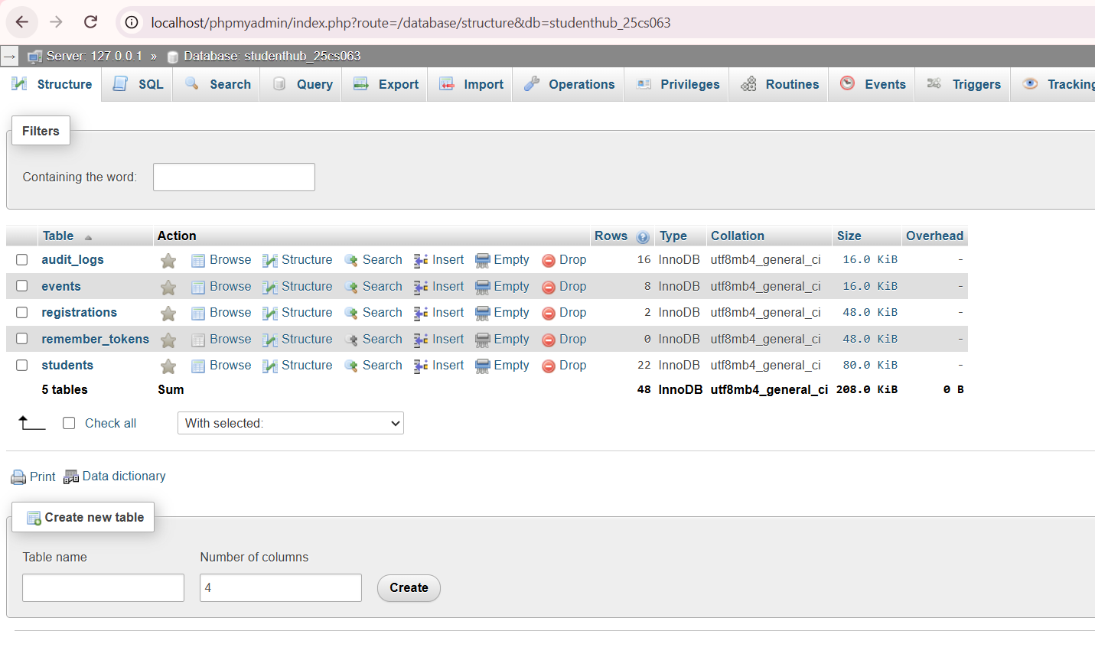
Database Structure and Student Records

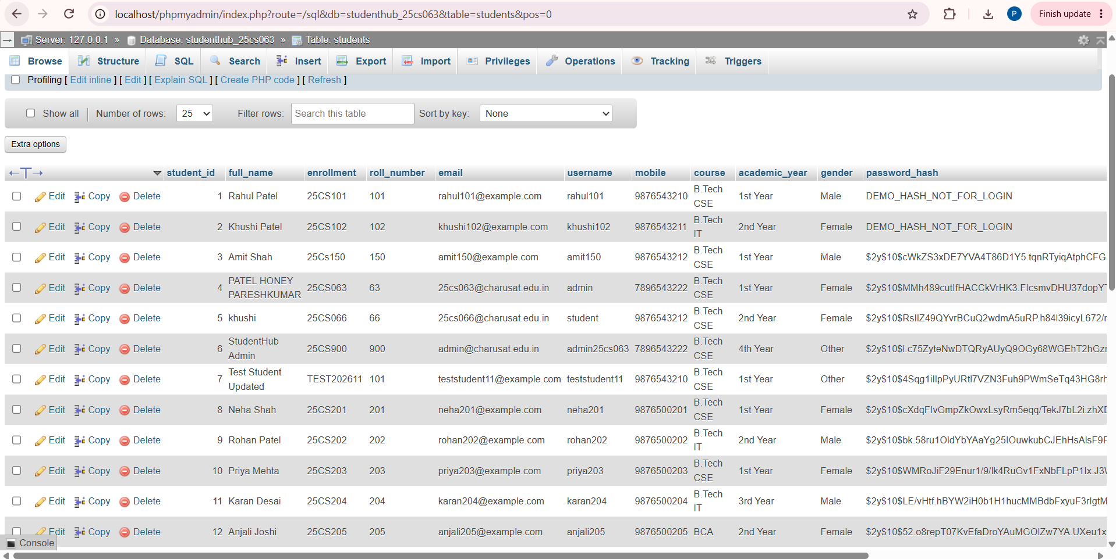

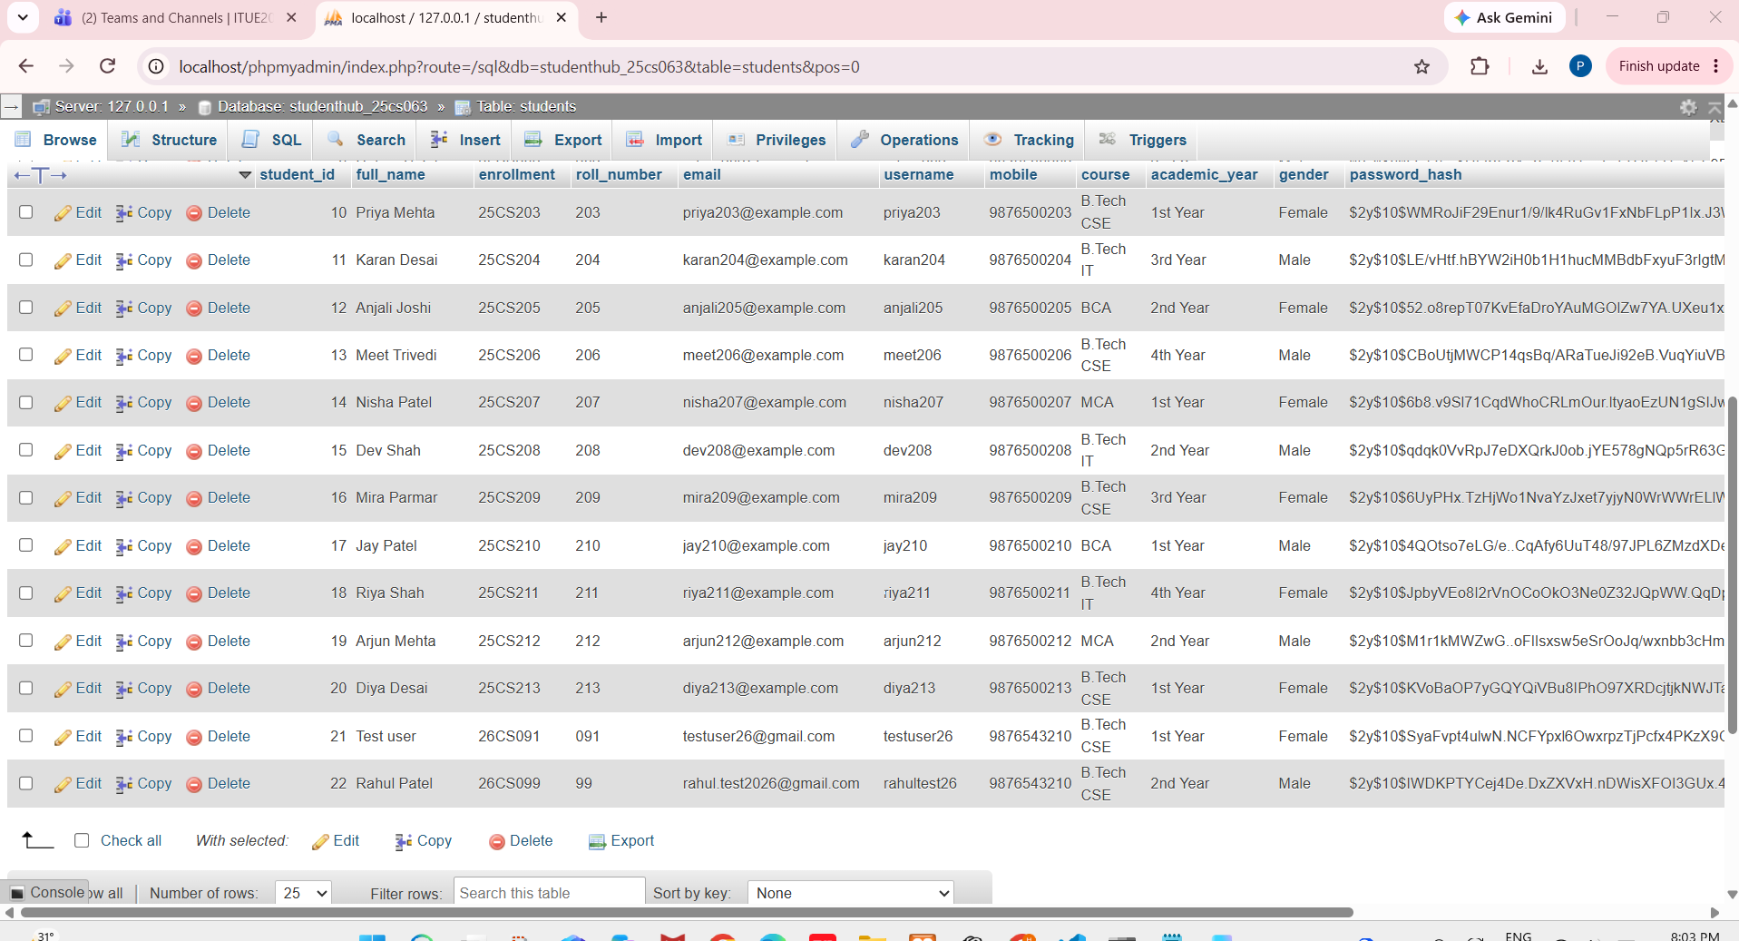

Events Table and Stored Event Records

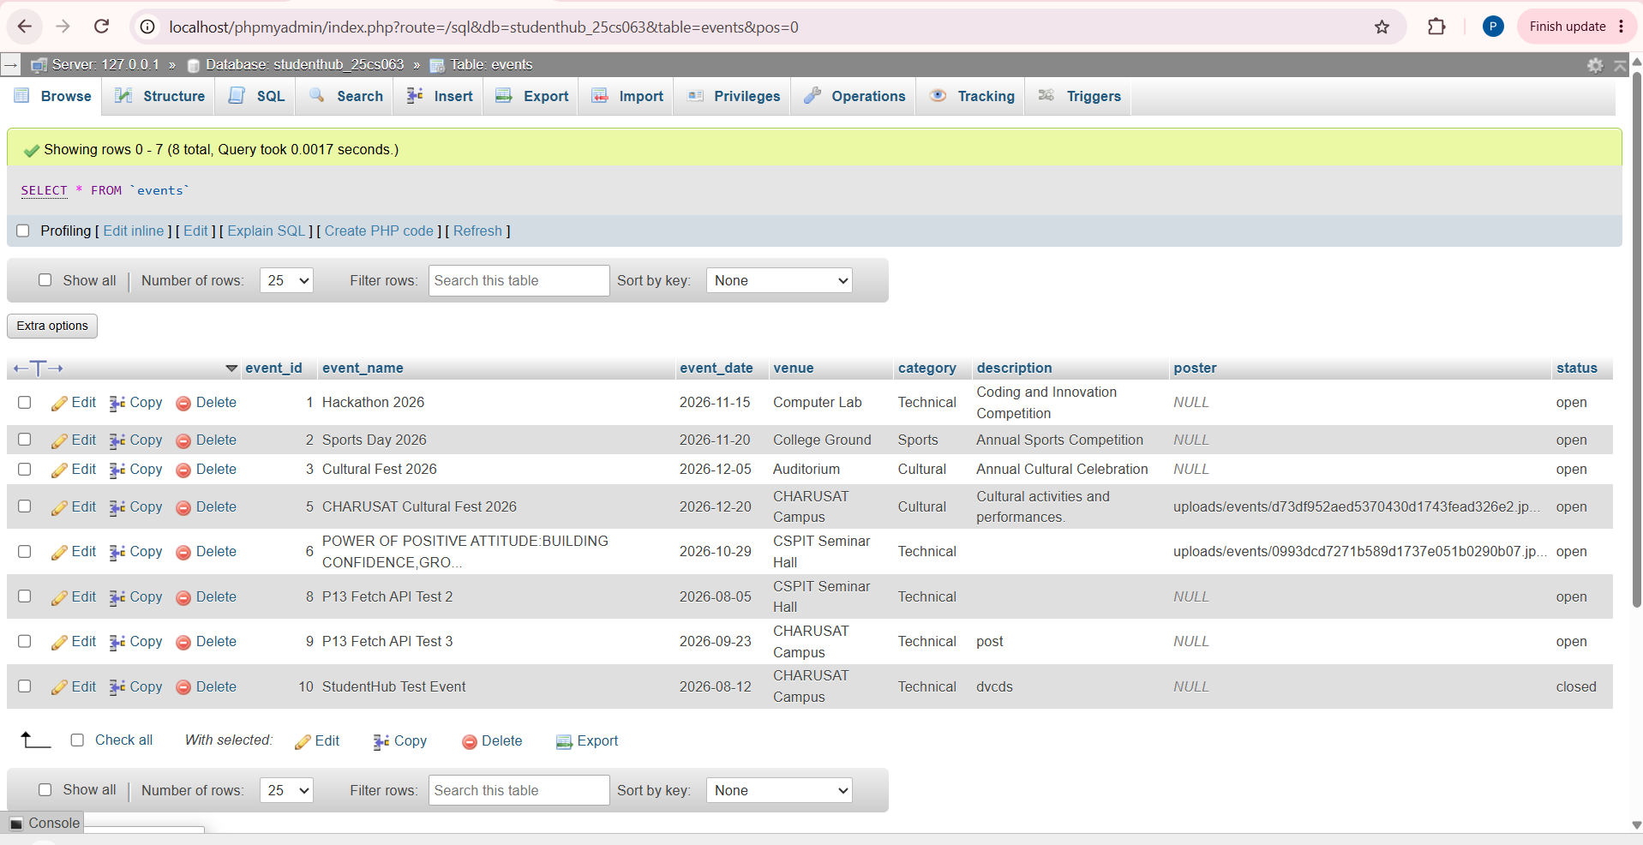

Event Registration Table and Stored Records

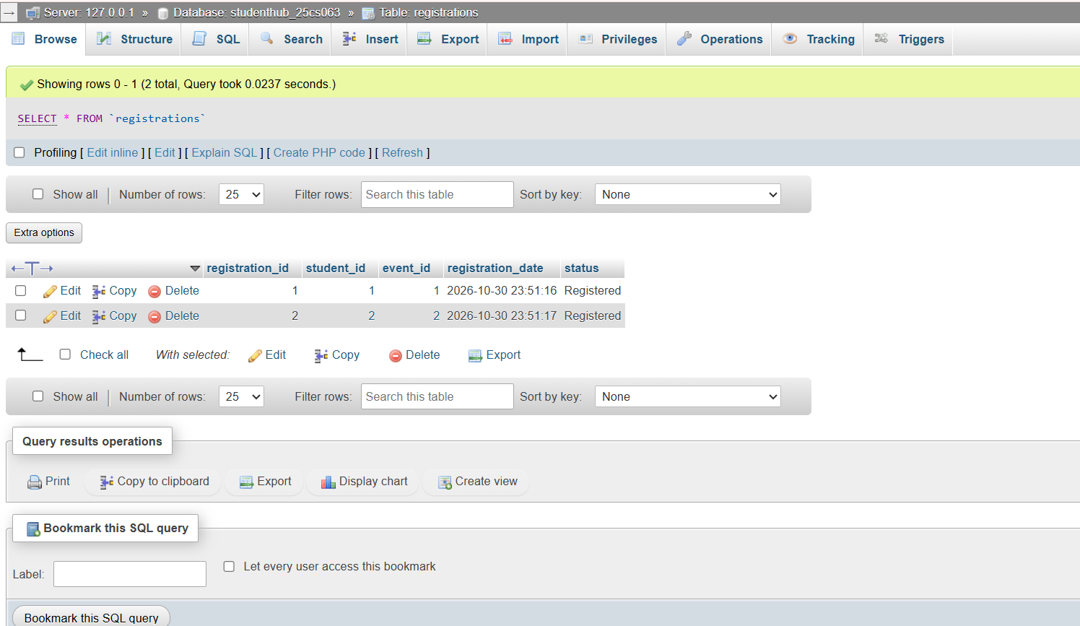

Audit Logs Table and Activity Records

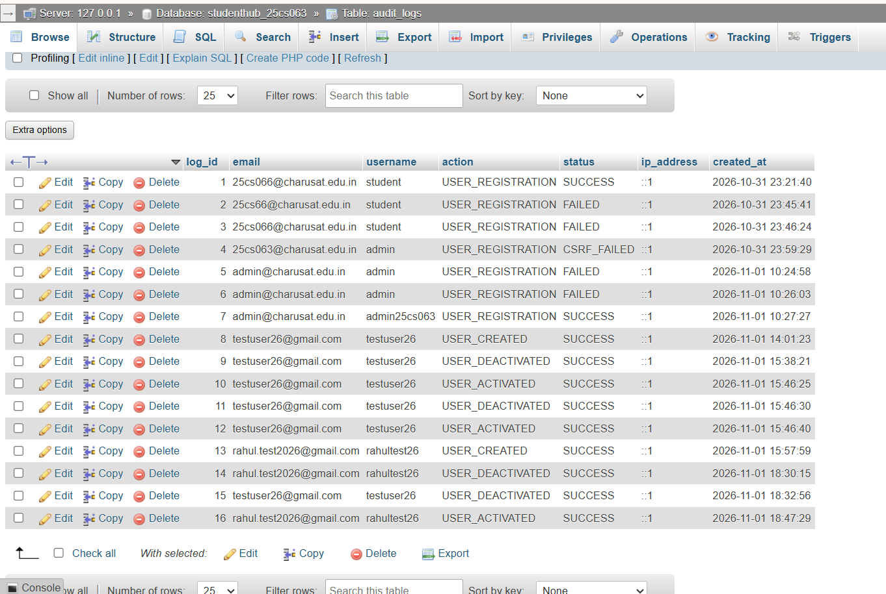

Remember Me Tokens Table and Session Persistence Data

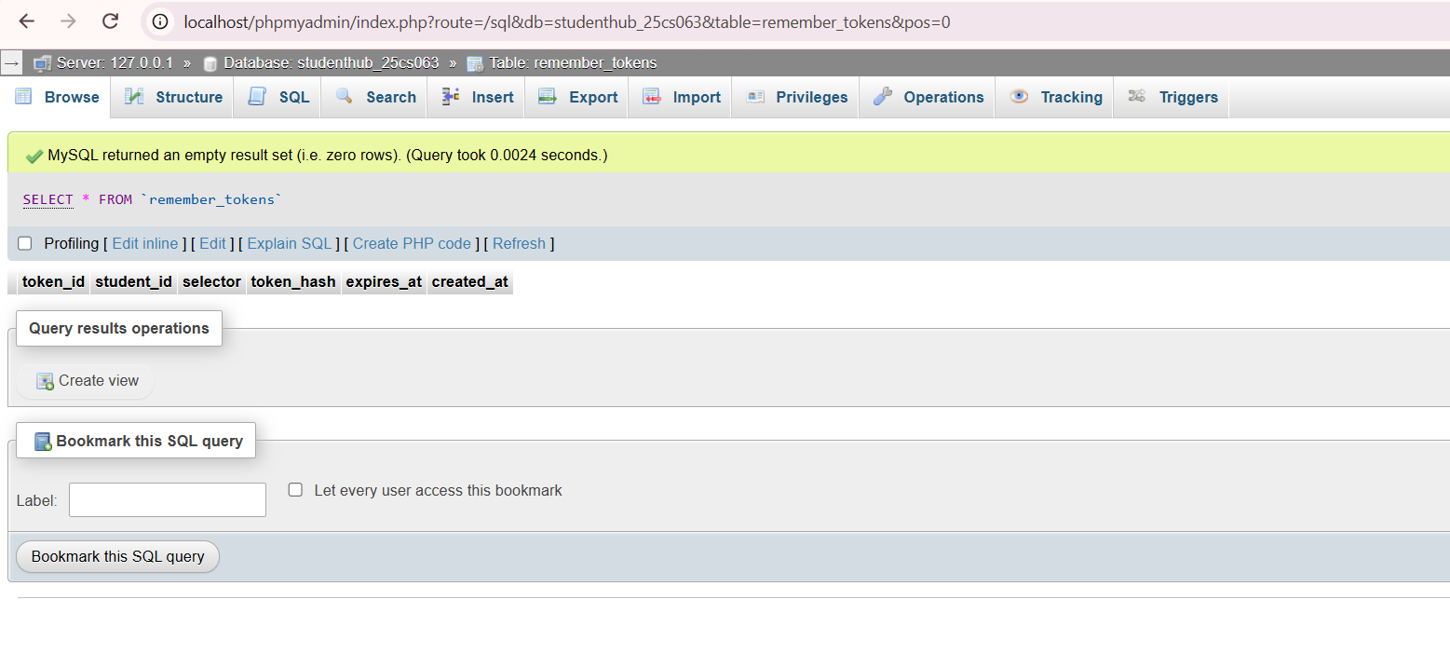

StudentHub Database SQL Export

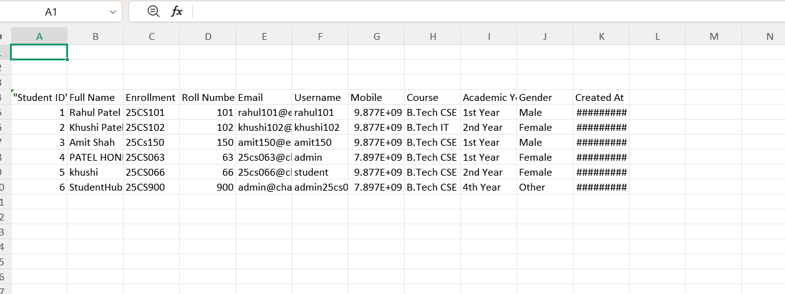

-- phpMyAdmin SQL Dump
-- version 5.2.1
-- https://www.phpmyadmin.net/
--
-- Host: 127.0.0.1
-- Generation Time: Nov 01, 2026 at 03:38 PM
-- Server version: 10.4.32-MariaDB
-- PHP Version: 8.0.30

SET SQL_MODE = "NO_AUTO_VALUE_ON_ZERO";
START TRANSACTION;
SET time_zone = "+00:00";

/*!40101 SET @OLD_CHARACTER_SET_CLIENT=@@CHARACTER_SET_CLIENT */;
/*!40101 SET @OLD_CHARACTER_SET_RESULTS=@@CHARACTER_SET_RESULTS */;
/*!40101 SET @OLD_COLLATION_CONNECTION=@@COLLATION_CONNECTION */;
/*!40101 SET NAMES utf8mb4 */;

--
-- Database: `studenthub_25cs063`
--

-- --------------------------------------------------------

--
-- Table structure for table `audit_logs`
--

CREATE TABLE `audit_logs` (
`log_id` int(11) NOT NULL,
`email` varchar(100) DEFAULT NULL,
`username` varchar(50) DEFAULT NULL,
`action` varchar(50) NOT NULL,
`status` varchar(20) NOT NULL,
`ip_address` varchar(45) DEFAULT NULL,
`created_at` timestamp NOT NULL DEFAULT current_timestamp()
) ENGINE=InnoDB DEFAULT CHARSET=utf8mb4 COLLATE=utf8mb4_general_ci;

--
-- Dumping data for table `audit_logs`
--

INSERT INTO `audit_logs` (`log_id`, `email`, `username`, `action`, `status`, `ip_address`, `created_at`) VALUES
(1, '25cs066@charusat.edu.in', 'student', 'USER_REGISTRATION', 'SUCCESS', '::1', '2026-10-31 17:51:40'),
(2, '25cs66@charusat.edu.in', 'student', 'USER_REGISTRATION', 'FAILED', '::1', '2026-10-31 18:15:41'),
(3, '25cs066@charusat.edu.in', 'student', 'USER_REGISTRATION', 'FAILED', '::1', '2026-10-31 18:16:24'),
(4, '25cs063@charusat.edu.in', 'admin', 'USER_REGISTRATION', 'CSRF_FAILED', '::1', '2026-10-31 18:29:29'),
(5, 'admin@charusat.edu.in', 'admin', 'USER_REGISTRATION', 'FAILED', '::1', '2026-11-01 04:54:58'),
(6, 'admin@charusat.edu.in', 'admin', 'USER_REGISTRATION', 'FAILED', '::1', '2026-11-01 04:56:03'),
(7, 'admin@charusat.edu.in', 'admin25cs063', 'USER_REGISTRATION', 'SUCCESS', '::1', '2026-11-01 04:57:27'),
(8, 'testuser26@gmail.com', 'testuser26', 'USER_CREATED', 'SUCCESS', '::1', '2026-11-01 08:31:23'),
(9, 'testuser26@gmail.com', 'testuser26', 'USER_DEACTIVATED', 'SUCCESS', '::1', '2026-11-01 10:08:21'),
(10, 'testuser26@gmail.com', 'testuser26', 'USER_ACTIVATED', 'SUCCESS', '::1', '2026-11-01 10:16:25'),
(11, 'testuser26@gmail.com', 'testuser26', 'USER_DEACTIVATED', 'SUCCESS', '::1', '2026-11-01 10:16:30'),
(12, 'testuser26@gmail.com', 'testuser26', 'USER_ACTIVATED', 'SUCCESS', '::1', '2026-11-01 10:16:40'),
(13, 'rahul.test2026@gmail.com', 'rahultest26', 'USER_CREATED', 'SUCCESS', '::1', '2026-11-01 10:27:59'),
(14, 'rahul.test2026@gmail.com', 'rahultest26', 'USER_DEACTIVATED', 'SUCCESS', '::1', '2026-11-01 13:00:15'),
(15, 'testuser26@gmail.com', 'testuser26', 'USER_DEACTIVATED', 'SUCCESS', '::1', '2026-11-01 13:02:56'),
(16, 'rahul.test2026@gmail.com', 'rahultest26', 'USER_ACTIVATED', 'SUCCESS', '::1', '2026-11-01 13:17:29');

-- --------------------------------------------------------

--
-- Table structure for table `events`
--

CREATE TABLE `events` (
`event_id` int(11) NOT NULL,
`event_name` varchar(150) NOT NULL,
`event_date` date NOT NULL,
`venue` varchar(150) NOT NULL,
`category` varchar(50) NOT NULL,
`description` text DEFAULT NULL,
`poster` varchar(255) DEFAULT NULL,
`status` enum('open','closed') NOT NULL DEFAULT 'open'
) ENGINE=InnoDB DEFAULT CHARSET=utf8mb4 COLLATE=utf8mb4_general_ci;

--
-- Dumping data for table `events`
--

INSERT INTO `events` (`event_id`, `event_name`, `event_date`, `venue`, `category`, `description`, `poster`, `status`) VALUES
(1, 'Hackathon 2026', '2026-11-15', 'Computer Lab', 'Technical', 'Coding and Innovation Competition', NULL, 'open'),
(2, 'Sports Day 2026', '2026-11-20', 'College Ground', 'Sports', 'Annual Sports Competition', NULL, 'open'),
(3, 'Cultural Fest 2026', '2026-12-05', 'Auditorium', 'Cultural', 'Annual Cultural Celebration', NULL, 'open'),
(5, 'CHARUSAT Cultural Fest 2026', '2026-12-20', 'CHARUSAT Campus', 'Cultural', 'Cultural activities and performances.', 'uploads/events/d73df952aed5370430d1743fead326e2.jpg', 'open'),
(6, 'POWER OF POSITIVE ATTITUDE:BUILDING CONFIDENCE,GROWTH AND SUCCESS', '2026-10-29', 'CSPIT Seminar Hall', 'Technical', '', 'uploads/events/0993dcd7271b589d1737e051b0290b07.jpg', 'open'),
(8, 'P13 Fetch API Test 2', '2026-08-05', 'CSPIT Seminar Hall', 'Technical', '', NULL, 'open'),
(9, 'P13 Fetch API Test 3', '2026-09-23', 'CHARUSAT Campus', 'Technical', 'post', NULL, 'open'),
(10, 'StudentHub Test Event', '2026-08-12', 'CHARUSAT Campus', 'Technical', 'dvcds', NULL, 'closed');

-- --------------------------------------------------------

--
-- Table structure for table `registrations`
--

CREATE TABLE `registrations` (
`registration_id` int(11) NOT NULL,
`student_id` int(11) NOT NULL,
`event_id` int(11) NOT NULL,
`registration_date` timestamp NOT NULL DEFAULT current_timestamp(),
`status` varchar(20) DEFAULT 'Registered'
) ENGINE=InnoDB DEFAULT CHARSET=utf8mb4 COLLATE=utf8mb4_general_ci;

--
-- Dumping data for table `registrations`
--

INSERT INTO `registrations` (`registration_id`, `student_id`, `event_id`, `registration_date`, `status`) VALUES
(1, 1, 1, '2026-10-30 18:21:16', 'Registered'),
(2, 2, 2, '2026-10-30 18:21:17', 'Registered');

-- --------------------------------------------------------

--
-- Table structure for table `remember_tokens`
--

CREATE TABLE `remember_tokens` (
`token_id` int(11) NOT NULL,
`student_id` int(11) NOT NULL,
`selector` char(32) NOT NULL,
`token_hash` char(64) NOT NULL,
`expires_at` datetime NOT NULL,
`created_at` timestamp NOT NULL DEFAULT current_timestamp()
) ENGINE=InnoDB DEFAULT CHARSET=utf8mb4 COLLATE=utf8mb4_general_ci;

-- --------------------------------------------------------

--
-- Table structure for table `students`
--

CREATE TABLE `students` (
`student_id` int(11) NOT NULL,
`full_name` varchar(100) NOT NULL,
`enrollment` varchar(20) NOT NULL,
`roll_number` varchar(10) NOT NULL,
`email` varchar(100) NOT NULL,
`username` varchar(50) NOT NULL,
`mobile` varchar(15) NOT NULL,
`course` varchar(50) NOT NULL,
`academic_year` varchar(20) NOT NULL,
`gender` varchar(10) NOT NULL,
`password_hash` varchar(255) NOT NULL,
`created_at` timestamp NOT NULL DEFAULT current_timestamp(),
`role` enum('admin','student','user') NOT NULL DEFAULT 'student',
`status` enum('active','inactive') NOT NULL DEFAULT 'active',
`last_login` datetime DEFAULT NULL
) ENGINE=InnoDB DEFAULT CHARSET=utf8mb4 COLLATE=utf8mb4_general_ci;

--
-- Dumping data for table `students`
--

INSERT INTO `students` (`student_id`, `full_name`, `enrollment`, `roll_number`, `email`, `username`, `mobile`, `course`, `academic_year`, `gender`, `password_hash`, `created_at`, `role`, `status`, `last_login`) VALUES
(1, 'Rahul Patel', '25CS101', '101', 'rahul101@example.com', 'rahul101', '9876543210', 'B.Tech CSE', '1st Year', 'Male', 'DEMO_HASH_NOT_FOR_LOGIN', '2026-10-30 18:20:38', 'student', 'active', NULL),
(2, 'Khushi Patel', '25CS102', '102', 'khushi102@example.com', 'khushi102', '9876543211', 'B.Tech IT', '2nd Year', 'Female', 'DEMO_HASH_NOT_FOR_LOGIN', '2026-10-30 18:20:38', 'student', 'active', NULL),
(3, 'Amit Shah', '25Cs150', '150', 'amit150@example.com', 'amit150', '9876543212', 'B.Tech CSE', '1st Year', 'Male', '$2y$10$cWkZS3xDE7YVA4T86D1Y5.tqnRTyiqAtphCFGLLtFbDAAhK.5mshO', '2026-10-30 18:32:37', 'student', 'active', NULL),
(4, 'PATEL HONEY PARESHKUMAR', '25CS063', '63', '25cs063@charusat.edu.in', 'admin', '7896543222', 'B.Tech CSE', '1st Year', 'Female', '$2y$10$MMh489cutIfHACCkVrHK3.FIcsmvDHU37dopYTXsVeqPYeglXHzJ2', '2026-10-31 17:43:27', 'student', 'active', '2026-11-01 19:16:08'),
(5, 'khushi', '25CS066', '66', '25cs066@charusat.edu.in', 'student', '9876543212', 'B.Tech CSE', '2nd Year', 'Female', '$2y$10$RsIlZ49QYvrBCuQ2wdmA5uRP.h84l39icyL672/mahBBJ6u8jOE02', '2026-10-31 17:51:40', 'student', 'active', NULL),
(6, 'StudentHub Admin', '25CS900', '900', 'admin@charusat.edu.in', 'admin25cs063', '7896543222', 'B.Tech CSE', '4th Year', 'Other', '$2y$10$l.c75ZyteNwDTQRyAUyQ9OGy68WGEhT2hGzr7OvNg2v3Ra0ZUfLSW', '2026-11-01 04:57:27', 'admin', 'active', '2026-11-01 19:14:18'),
(7, 'Test Student Updated', 'TEST202611', '101', 'teststudent11@example.com', 'teststudent11', '9876543210', 'B.Tech CSE', '1st Year', 'Other', '$2y$10$4Sqg1iIlpPyURtl7VZN3Fuh9PWmSeTq43HG8rhr2W9sx3bFxNBW..', '2026-11-01 06:11:00', 'student', 'inactive', NULL),
(8, 'Neha Shah', '25CS201', '201', 'neha201@example.com', 'neha201', '9876500201', 'B.Tech CSE', '1st Year', 'Female', '$2y$10$cXdqFIvGmpZkOwxLsyRm5eqq/TekJ7bL2i.zhXDiTBfznK7wgRXce', '2026-11-01 06:25:31', 'student', 'active', NULL),
(9, 'Rohan Patel', '25CS202', '202', 'rohan202@example.com', 'rohan202', '9876500202', 'B.Tech IT', '2nd Year', 'Male', '$2y$10$bk.58ru1OldYbYAaYg25IOuwkubCJEhHsAlsF9F1RpY5hsE0V046.', '2026-11-01 06:25:32', 'student', 'active', NULL),
(10, 'Priya Mehta', '25CS203', '203', 'priya203@example.com', 'priya203', '9876500203', 'B.Tech CSE', '1st Year', 'Female', '$2y$10$WMRoJiF29Enur1/9/lk4RuGv1FxNbFLpP1Ix.J3WufTV4zgJNXxFC', '2026-11-01 06:25:32', 'student', 'active', NULL),
(11, 'Karan Desai', '25CS204', '204', 'karan204@example.com', 'karan204', '9876500204', 'B.Tech IT', '3rd Year', 'Male', '$2y$10$LE/vHtf.hBYW2iH0b1H1hucMMBdbFxyuF3rIgtM0zhc6r60/oyhma', '2026-11-01 06:25:32', 'student', 'active', NULL),
(12, 'Anjali Joshi', '25CS205', '205', 'anjali205@example.com', 'anjali205', '9876500205', 'BCA', '2nd Year', 'Female', '$2y$10$52.o8repT07KvEfaDroYAuMGOlZw7YA.UXeu1x/kfSUinZlL/frs6', '2026-11-01 06:25:32', 'student', 'active', NULL),
(13, 'Meet Trivedi', '25CS206', '206', 'meet206@example.com', 'meet206', '9876500206', 'B.Tech CSE', '4th Year', 'Male', '$2y$10$CBoUtjMWCP14qsBq/ARaTueJi92eB.VuqYiuVBiXU80jfbGzYI94a', '2026-11-01 06:25:32', 'student', 'active', NULL),
(14, 'Nisha Patel', '25CS207', '207', 'nisha207@example.com', 'nisha207', '9876500207', 'MCA', '1st Year', 'Female', '$2y$10$6b8.v9Sl71CqdWhoCRLmOur.ltyaoEzUN1gSIJwZihFNCUE8qSJKy', '2026-11-01 06:25:32', 'student', 'active', NULL),
(15, 'Dev Shah', '25CS208', '208', 'dev208@example.com', 'dev208', '9876500208', 'B.Tech IT', '2nd Year', 'Male', '$2y$10$qdqk0VvRpJ7eDXQrkJ0ob.jYE578gNQp5rR63GKsart99bm278yqW', '2026-11-01 06:25:32', 'student', 'active', NULL),
(16, 'Mira Parmar', '25CS209', '209', 'mira209@example.com', 'mira209', '9876500209', 'B.Tech CSE', '3rd Year', 'Female', '$2y$10$6UyPHx.TzHjWo1NvaYzJxet7yjyN0WrWWrELlWFycId9vQRJ45FBe', '2026-11-01 06:25:33', 'student', 'active', NULL),
(17, 'Jay Patel', '25CS210', '210', 'jay210@example.com', 'jay210', '9876500210', 'BCA', '1st Year', 'Male', '$2y$10$4QOtso7eLG/e..CqAfy6UuT48/97JPL6ZMzdXDeeO9XXeZRfXvaMy', '2026-11-01 06:25:33', 'student', 'active', NULL),
(18, 'Riya Shah', '25CS211', '211', 'riya211@example.com', 'riya211', '9876500211', 'B.Tech IT', '4th Year', 'Female', '$2y$10$JpbyVEo8I2rVnOCoOkO3Ne0Z32JQpWW.QqDprtjsYG2uBLjtzZXFi', '2026-11-01 06:25:33', 'student', 'active', NULL),
(19, 'Arjun Mehta', '25CS212', '212', 'arjun212@example.com', 'arjun212', '9876500212', 'MCA', '2nd Year', 'Male', '$2y$10$M1r1kMWZwG..oFlIsxsw5eSrOoJq/wxnbb3cHmfHiI0B3s0Mbq9mW', '2026-11-01 06:25:33', 'student', 'active', NULL),
(20, 'Diya Desai', '25CS213', '213', 'diya213@example.com', 'diya213', '9876500213', 'B.Tech CSE', '1st Year', 'Female', '$2y$10$KVoBaOP7yGQYQiVBu8IPhO97XRDcjtjkNWJTajW31YFvPNacL6JDe', '2026-11-01 06:25:33', 'student', 'active', NULL),
(21, 'Test user', '26CS091', '091', 'testuser26@gmail.com', 'testuser26', '9876543210', 'B.Tech CSE', '1st Year', 'Female', '$2y$10$SyaFvpt4ulwN.NCFYpxl6OwxrpzTjPcfx4PKzX9OWvFkYvvWJ0b62\r\n', '2026-11-01 08:31:23', 'user', 'inactive', '2026-11-01 14:03:26'),
(22, 'Rahul Patel', '26CS099', '99', 'rahul.test2026@gmail.com', 'rahultest26', '9876543210', 'B.Tech CSE', '2nd Year', 'Male', '$2y$10$IWDKPTYCej4De.DxZXVxH.nDWisXFOI3GUx.4QvISUtYbuaU6mFqS', '2026-11-01 10:27:59', 'user', 'active', '2026-11-01 19:12:30');

--
-- Indexes for dumped tables
--

--
-- Indexes for table `audit_logs`
--
ALTER TABLE `audit_logs`
ADD PRIMARY KEY (`log_id`);

--
-- Indexes for table `events`
--
ALTER TABLE `events`
ADD PRIMARY KEY (`event_id`);

--
-- Indexes for table `registrations`
--
ALTER TABLE `registrations`
ADD PRIMARY KEY (`registration_id`),
ADD UNIQUE KEY `unique_student_event` (`student_id`,`event_id`),
ADD KEY `fk_event` (`event_id`);

--
-- Indexes for table `remember_tokens`
--
ALTER TABLE `remember_tokens`
ADD PRIMARY KEY (`token_id`),
ADD UNIQUE KEY `selector` (`selector`),
ADD KEY `fk_remember_student` (`student_id`);

--
-- Indexes for table `students`
--
ALTER TABLE `students`
ADD PRIMARY KEY (`student_id`),
ADD UNIQUE KEY `enrollment` (`enrollment`),
ADD UNIQUE KEY `email` (`email`),
ADD UNIQUE KEY `unique_username` (`username`);

--
-- AUTO_INCREMENT for dumped tables
--

--
-- AUTO_INCREMENT for table `audit_logs`
--
ALTER TABLE `audit_logs`
MODIFY `log_id` int(11) NOT NULL AUTO_INCREMENT, AUTO_INCREMENT=17;

--
-- AUTO_INCREMENT for table `events`
--
ALTER TABLE `events`
MODIFY `event_id` int(11) NOT NULL AUTO_INCREMENT, AUTO_INCREMENT=11;

--
-- AUTO_INCREMENT for table `registrations`
--
ALTER TABLE `registrations`
MODIFY `registration_id` int(11) NOT NULL AUTO_INCREMENT, AUTO_INCREMENT=3;

--
-- AUTO_INCREMENT for table `remember_tokens`
--
ALTER TABLE `remember_tokens`
MODIFY `token_id` int(11) NOT NULL AUTO_INCREMENT, AUTO_INCREMENT=5;

--
-- AUTO_INCREMENT for table `students`
--
ALTER TABLE `students`
MODIFY `student_id` int(11) NOT NULL AUTO_INCREMENT, AUTO_INCREMENT=23;

--
-- Constraints for dumped tables
--

--
-- Constraints for table `registrations`
--
ALTER TABLE `registrations`
ADD CONSTRAINT `fk_event` FOREIGN KEY (`event_id`) REFERENCES `events` (`event_id`) ON DELETE CASCADE,
ADD CONSTRAINT `fk_student` FOREIGN KEY (`student_id`) REFERENCES `students` (`student_id`) ON DELETE CASCADE;

--
-- Constraints for table `remember_tokens`
--
ALTER TABLE `remember_tokens`
ADD CONSTRAINT `fk_remember_student` FOREIGN KEY (`student_id`) REFERENCES `students` (`student_id`) ON DELETE CASCADE;
COMMIT;

/*!40101 SET CHARACTER_SET_CLIENT=@OLD_CHARACTER_SET_CLIENT */;
/*!40101 SET CHARACTER_SET_RESULTS=@OLD_CHARACTER_SET_RESULTS */;
/*!40101 SET COLLATION_CONNECTION=@OLD_COLLATION_CONNECTION */;

Mobile Home Page

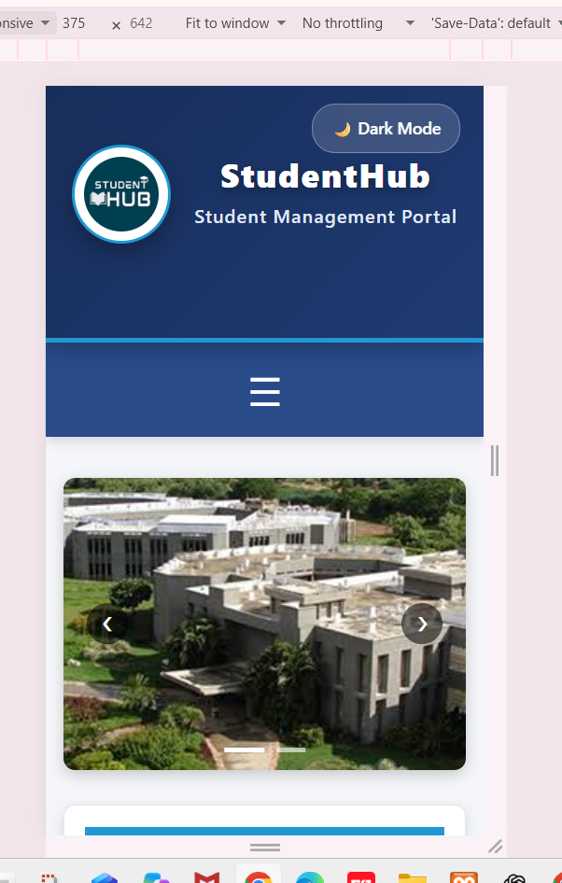

Tablet Home Page

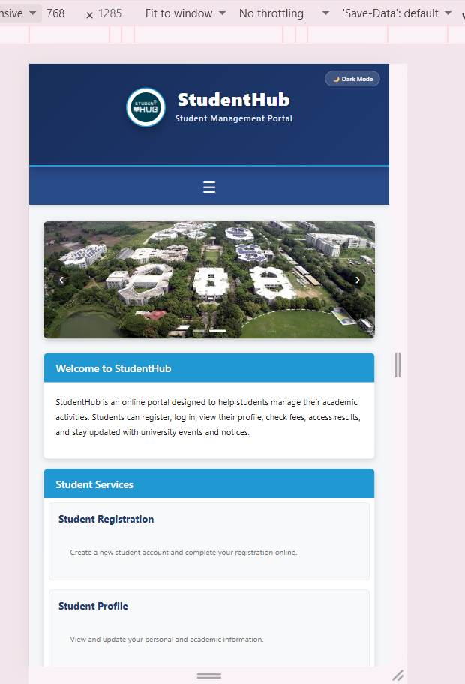

Desktop Home Page

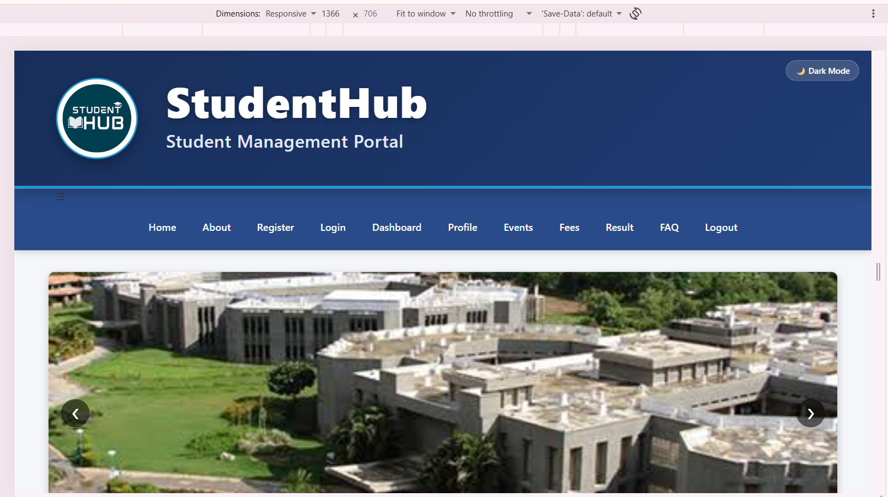

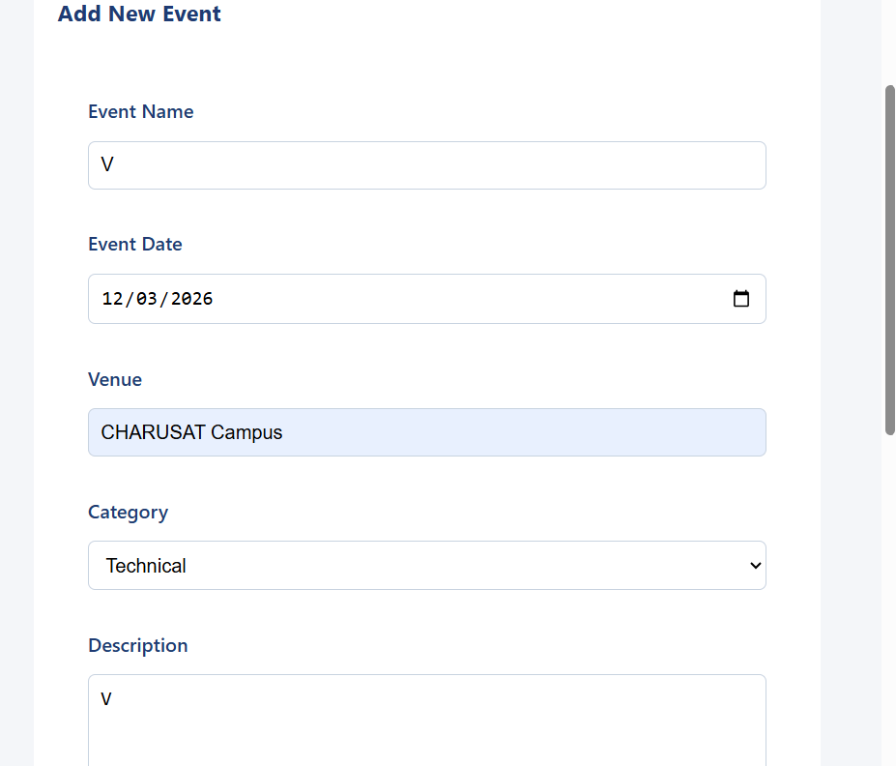

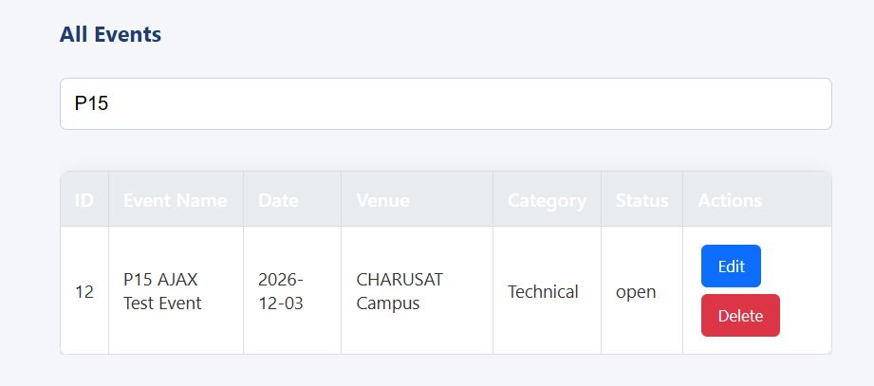

After delete P15 AJAx Test Event

Database Verification

Not showing here P15 AJAx Test Event
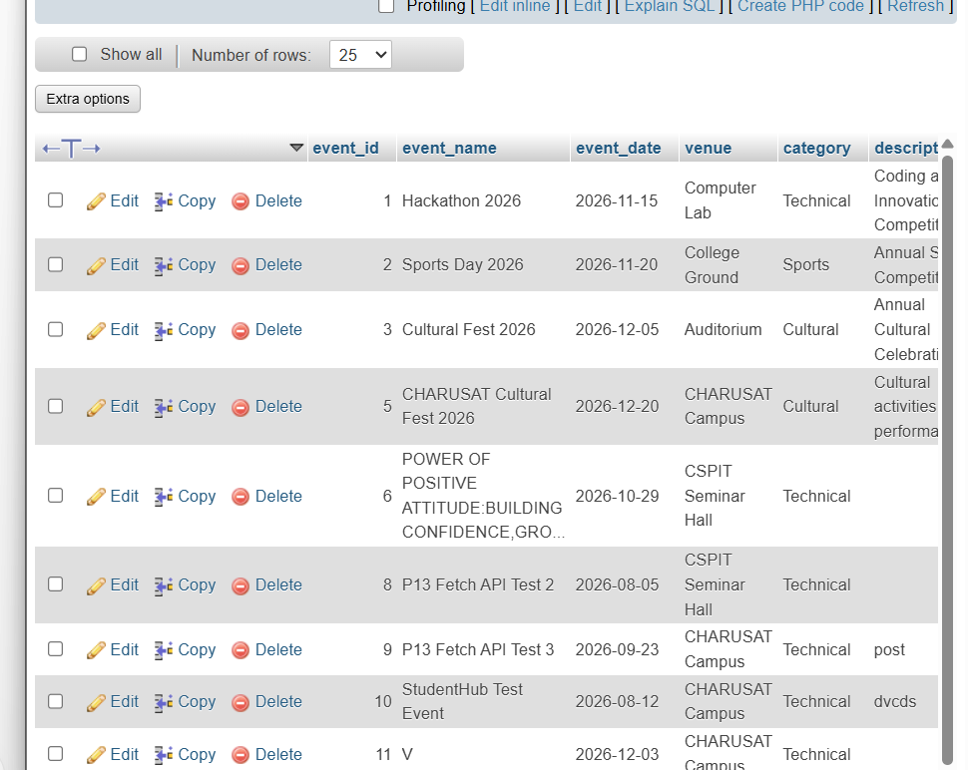

SQL Injection Testing

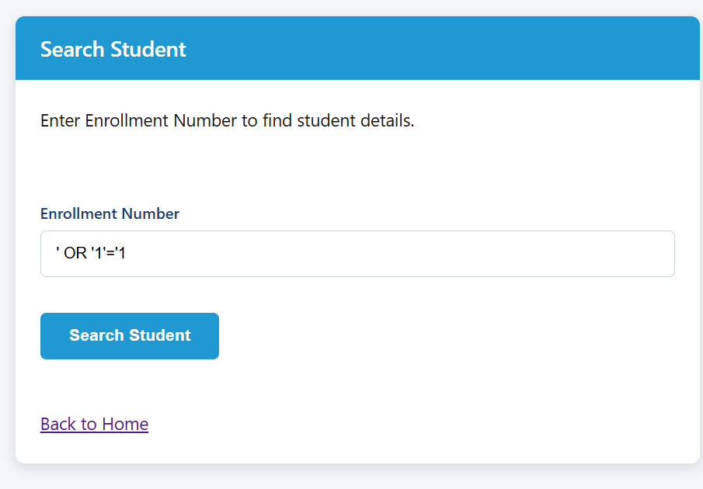

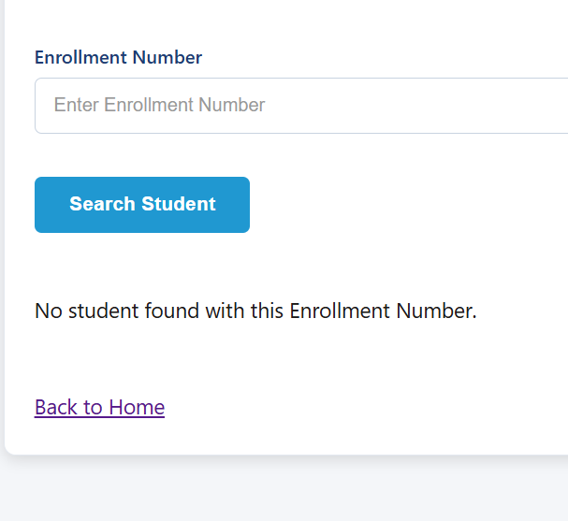

XSS (Cross-Site Scripting) Testing

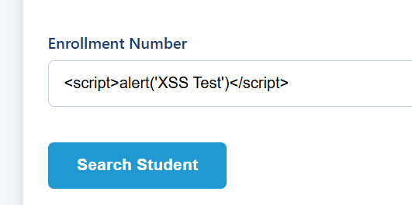

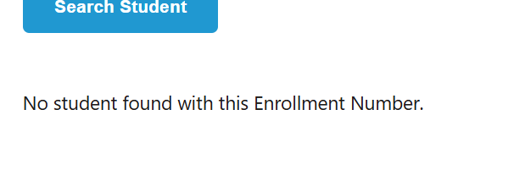

Accessibility Testing – Keyboard Navigation

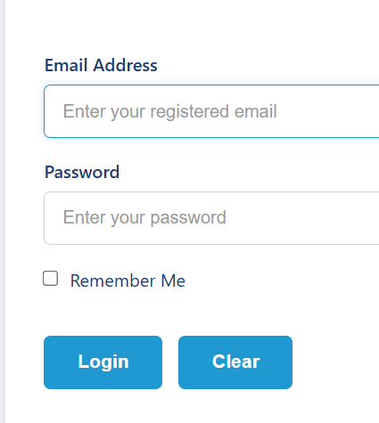

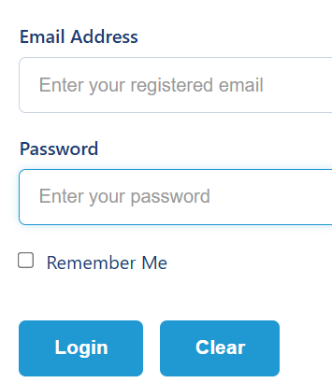

Page Zoom Testing



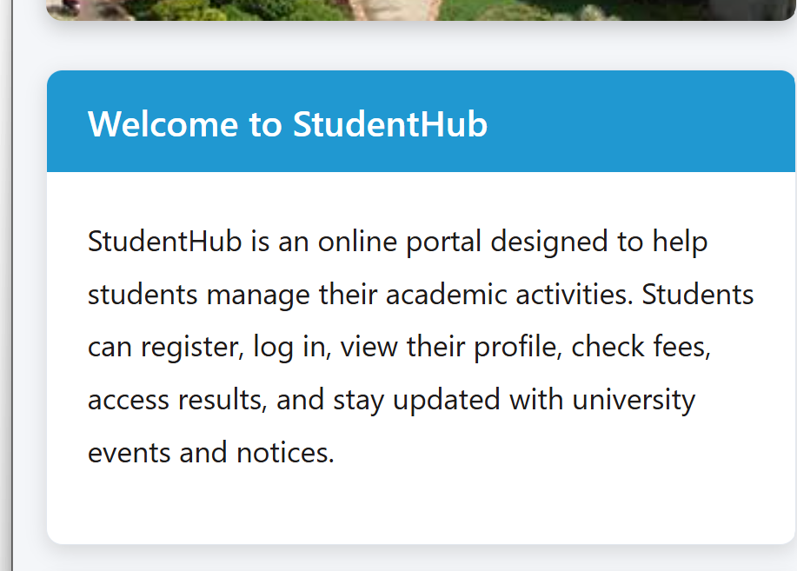
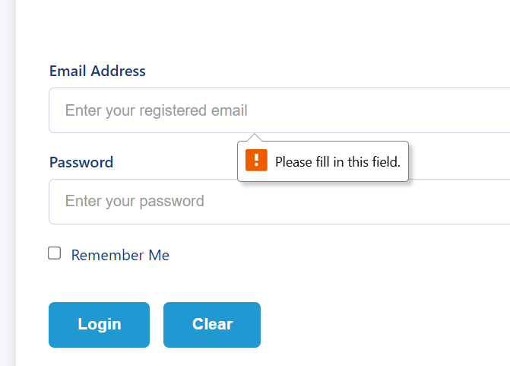

Session Security Testing

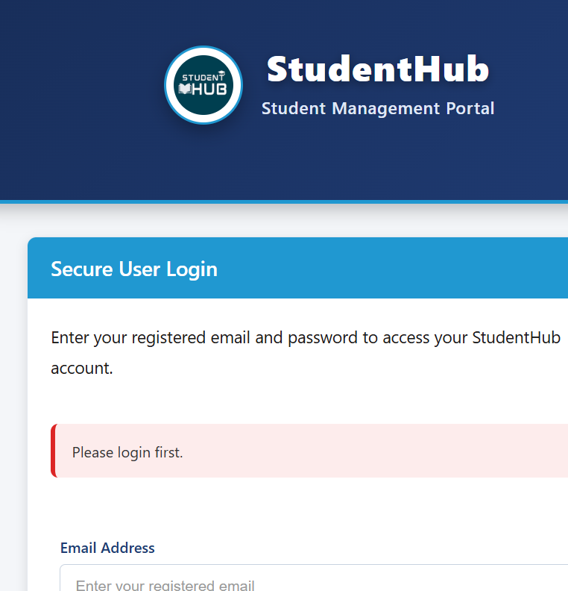

CSRF Protection Verification

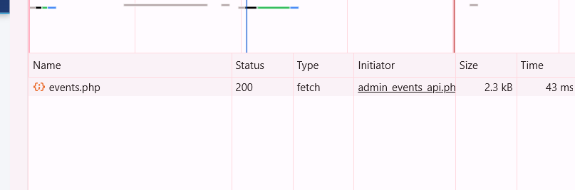

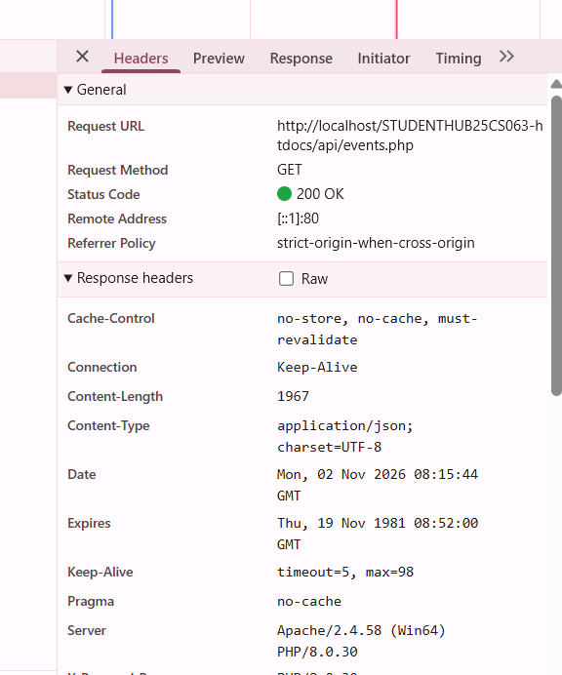

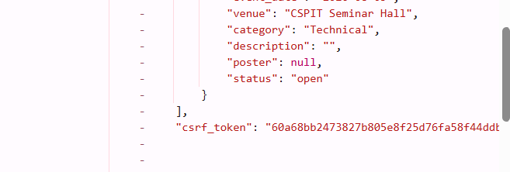

Password Hashing Verification

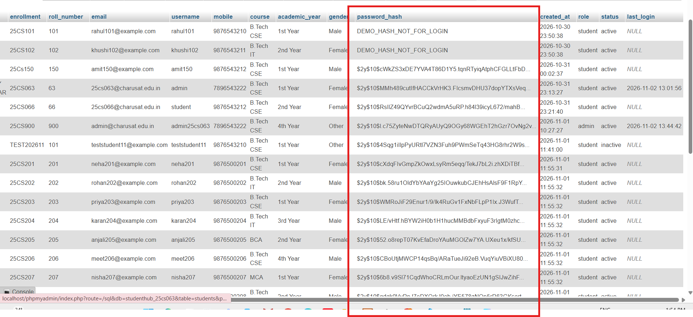

XSS Testing – Result Confirm

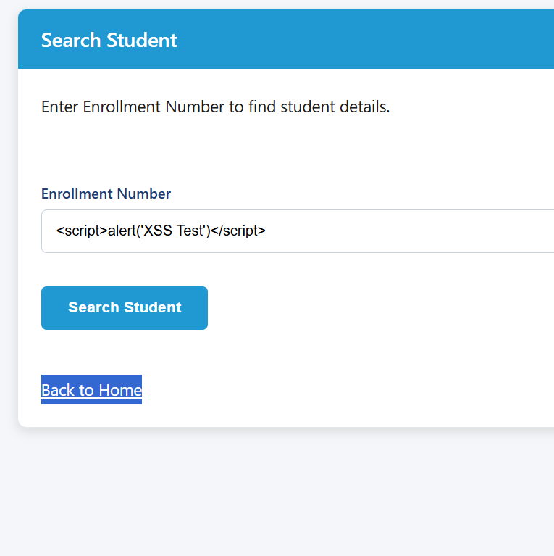

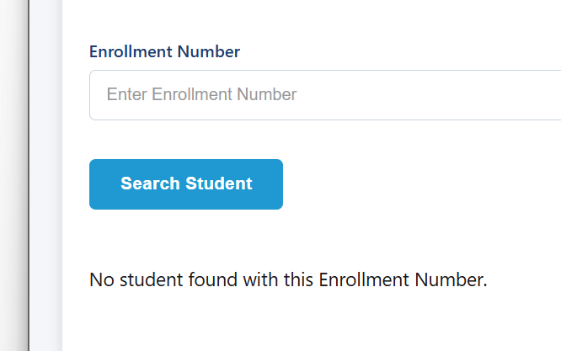

Output :

Learning outcome :

