 | 

Faculty of Technology and Engineering
Chandubhai S. Patel Institute of Technology (CSPIT) Department of Computer Science & Engineering
Date: / /
Laboratory Manul

Academic Year | : | 2026-27 | Semester | : | 3rd
Course code | : | ITUE203 | Course name | : | WEB DEVELOPMENT FRAMEWORKS

Practical – 1
PROBLEM STATEMENT :

Implement secure user registration by inserting user details into MySQL using MYSQLi. Validate input on frontend and backend, check duplicate email/username, hash passwords using password_hash(), and display
appropriate messages.

Objective :

To implement a secure user registration system using PHP and MySQL with frontend and backend validation, duplicate username/email checking, password hashing, and secure database insertion.

Code :

Db.php

<?php

$host = "localhost";
$username = "root";
$password = "";
$database = "user_registration";

$conn = new mysqli($host, $username, $password, $database);

if ($conn->connect_error) {
die("Database connection failed: " . $conn->connect_error);
}

$conn->set_charset("utf8mb4");

?>

Register.php

<!DOCTYPE html>
<html>

<head>

<title>User Registration</title>

<link rel="stylesheet" href="style.css">

</head>

<body>

<div class="container">

<h2>User Registration</h2>

<form action="process_registration.php" method="POST">

<label>Username:</label>

<input
type="text"
name="username"
required
minlength="3"
maxlength="50"
>

<label>Email:</label>

<input
type="email"
name="email"
required
>

<label>Password:</label>

<input
type="password"
name="password"
required
minlength="6"
>

<label>Confirm Password:</label>

<input
type="password"
name="confirm_password"
required
minlength="6"
>

<button type="submit">Register</button>

</form>

</div>

</body>

</html>

Process_registration.php
<?php

require_once "db.php";

if ($_SERVER["REQUEST_METHOD"] !== "POST") {
die("Invalid request.");
}

// Get form data
$username = trim($_POST["username"] ?? "");
$email = trim($_POST["email"] ?? "");
$password = $_POST["password"] ?? "";
$confirm_password = $_POST["confirm_password"] ?? "";

// Backend validation
if ($username === "" || $email === "" || $password === "" || $confirm_password === "") {
die("All fields are required.");
}

// Validate username
if (!preg_match("/^[a-zA-Z0-9_]{3,50}$/", $username)) {
die("Username must contain only letters, numbers, and underscore.");
}

// Validate email
if (!filter_var($email, FILTER_VALIDATE_EMAIL)) {
die("Please enter a valid email address.");
}

// Validate password length
if (strlen($password) < 6) {
die("Password must contain at least 6 characters.");
}

// Confirm password
if ($password !== $confirm_password) {
die("Passwords do not match.");
}

// Check duplicate username/email
$check = $conn->prepare(
"SELECT id FROM users WHERE username = ? OR email = ?"
);

$check->bind_param("ss", $username, $email);
$check->execute();
$check->store_result();

if ($check->num_rows > 0) {
$check->close();
$conn->close();
die("Username or email already exists.");
}

$check->close();

// Hash password
$hashed_password = password_hash($password, PASSWORD_DEFAULT);

// Insert user
$stmt = $conn->prepare(
"INSERT INTO users (username, email, password) VALUES (?, ?, ?)"
);

$stmt->bind_param(
"sss",
$username,
$email,
$hashed_password
);

if ($stmt->execute()) {

echo "<h2>Registration Successful!</h2>";
echo "<p>User registered successfully.</p>";

} else {

echo "<h2>Registration Failed</h2>";
echo "<p>Unable to register user.</p>";
}

$stmt->close();
$conn->close();

?>

Style.css

body {
font-family: Arial, sans-serif;
background-color: #f2f2f2;
}

.container {
width: 400px;
margin: 50px auto;
background: white;
padding: 25px;
border-radius: 8px;
}

h2 {
text-align: center;
}

label {
display: block;
margin-top: 12px;
}

input {
width: 100%;
padding: 10px;
margin-top: 5px;
box-sizing: border-box;
}

button {
width: 100%;
padding: 10px;
margin-top: 20px;
cursor: pointer;
}

Screenshot :

Registration Form

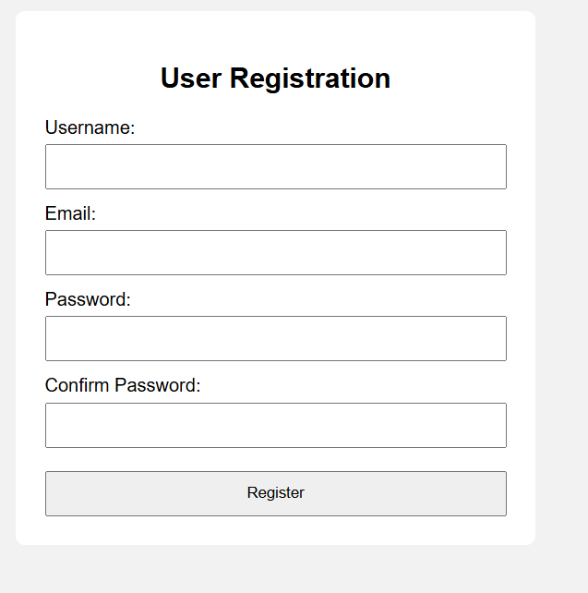

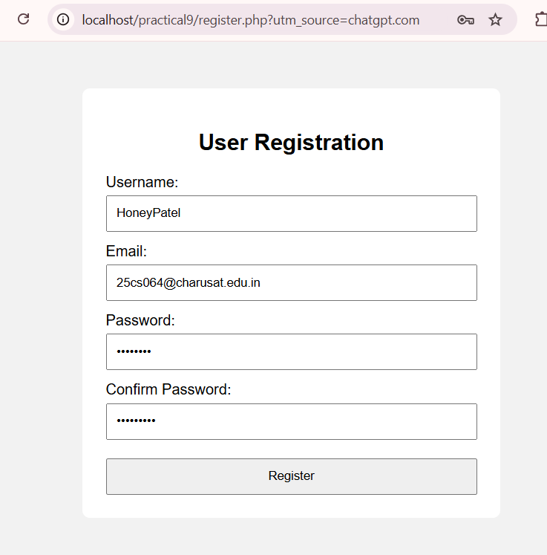

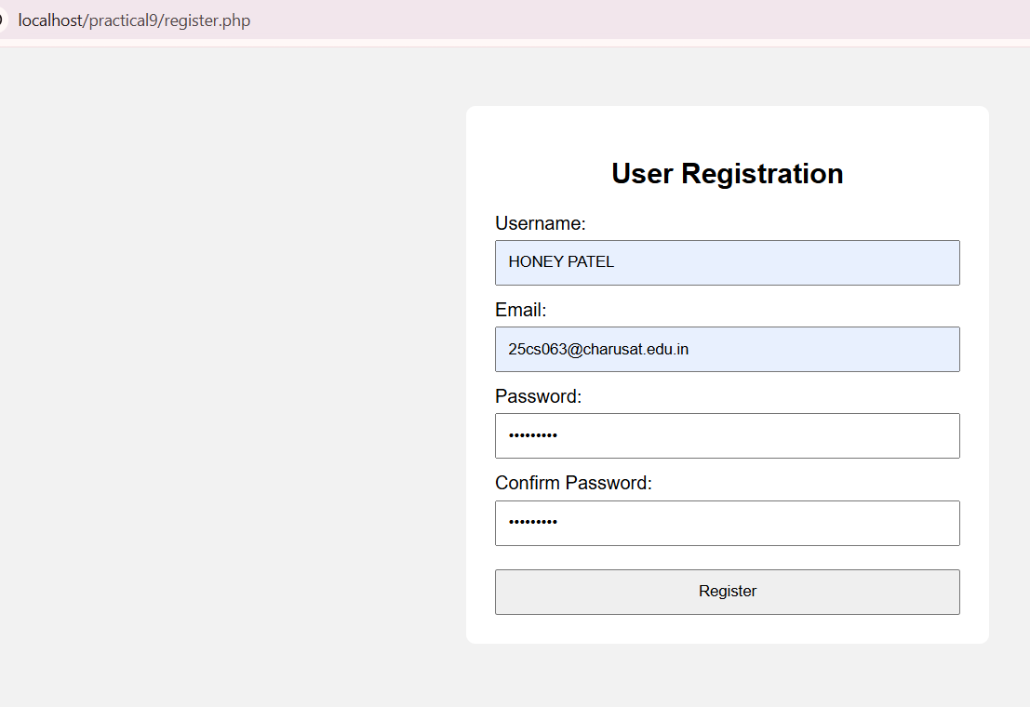

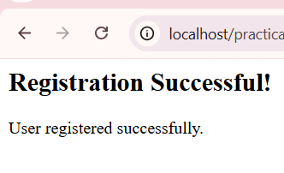

Successful Registration

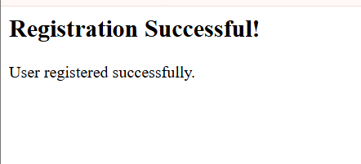

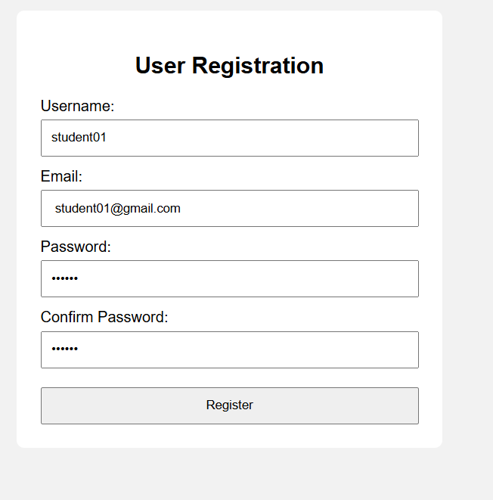

Test Case 2: Duplicate Email Check.

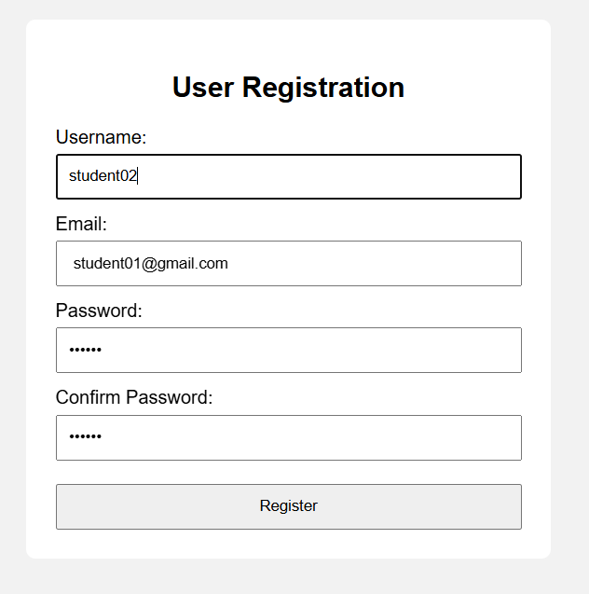

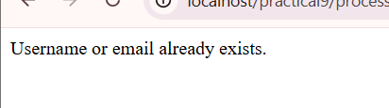

Test Case 3: Duplicate Username Check.

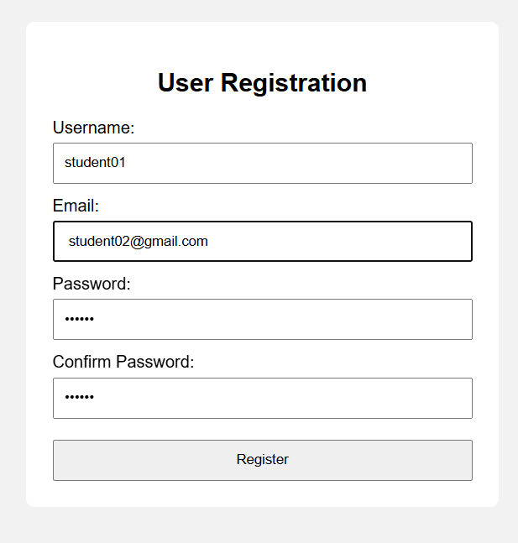

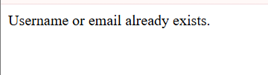

Test Case 4: Invalid Email.

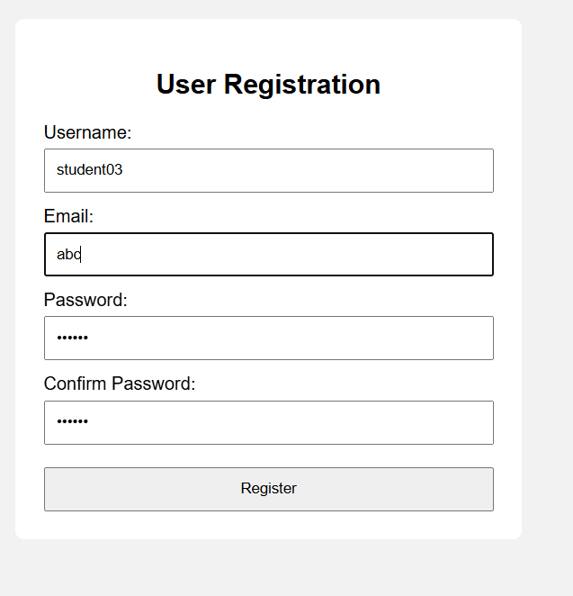

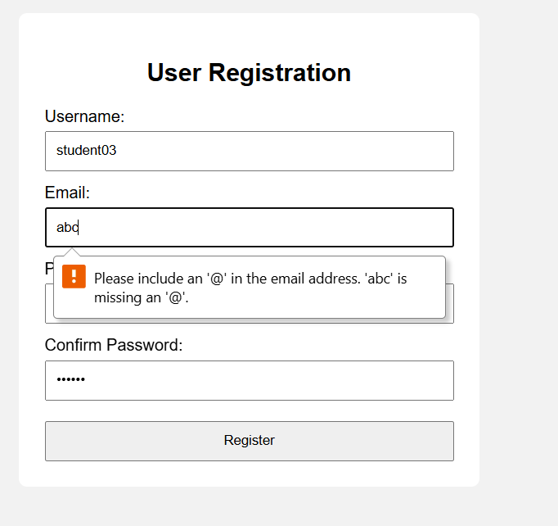

Test Case 5: Password Mismatch.

Username: student04
Email: student04@gmail.com
Password: 123456
Confirm Password: 123457

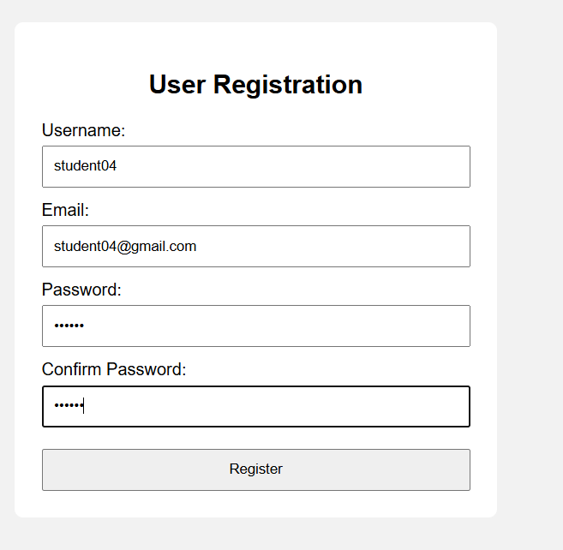



Test Case 6: Short Password.

Username: student05
Email: student05@gmail.com
Password: 123
Confirm Password: 123

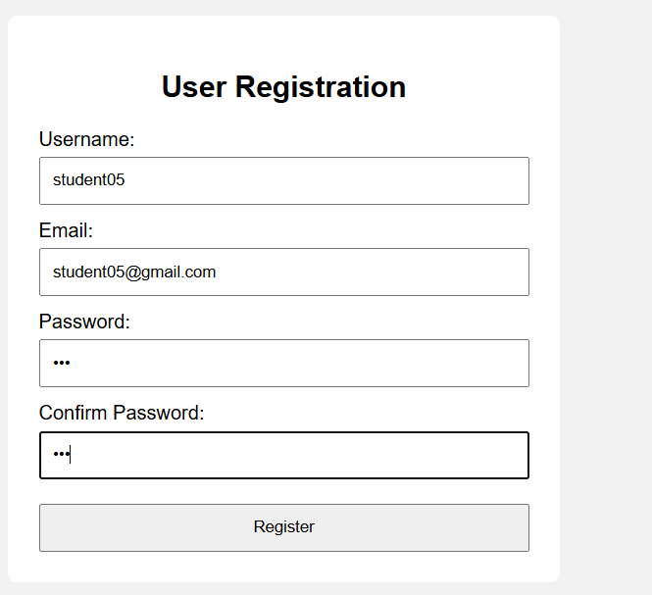

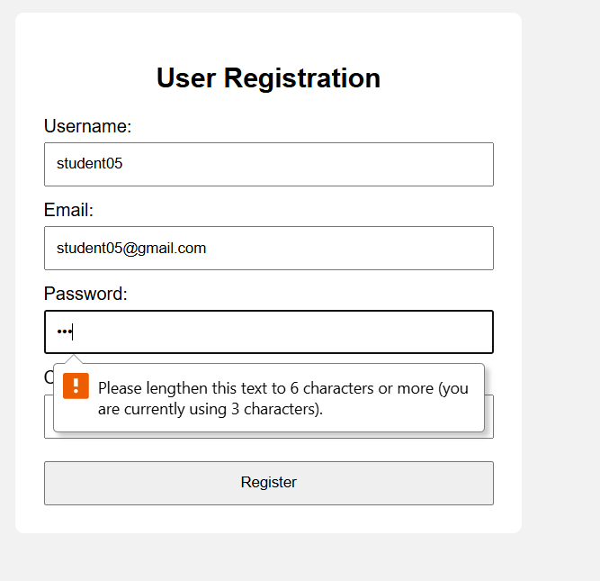

Test Case 7: Empty Fields.

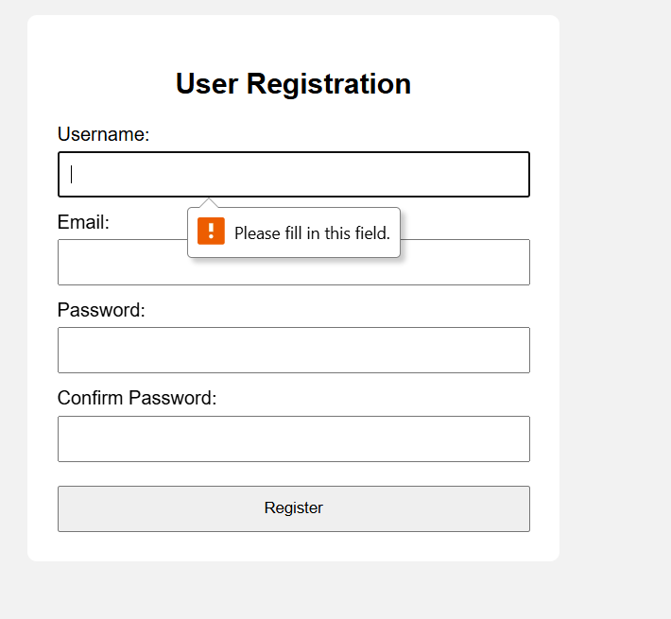

Test Case 8: Invalid Username.

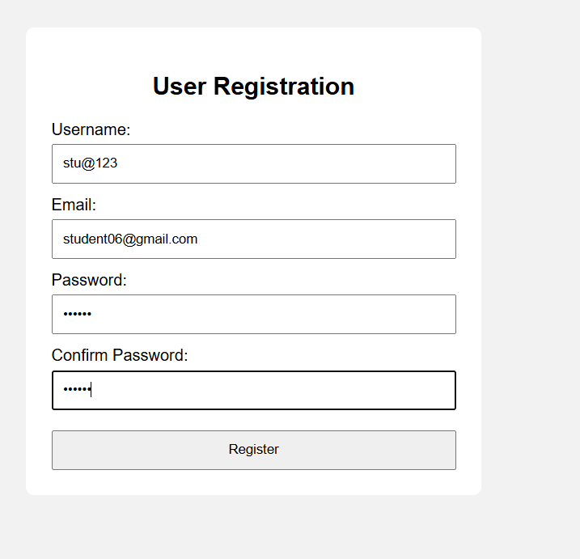

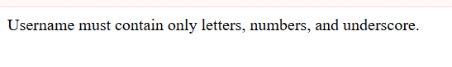

MySQL Users Table + Hashed Password

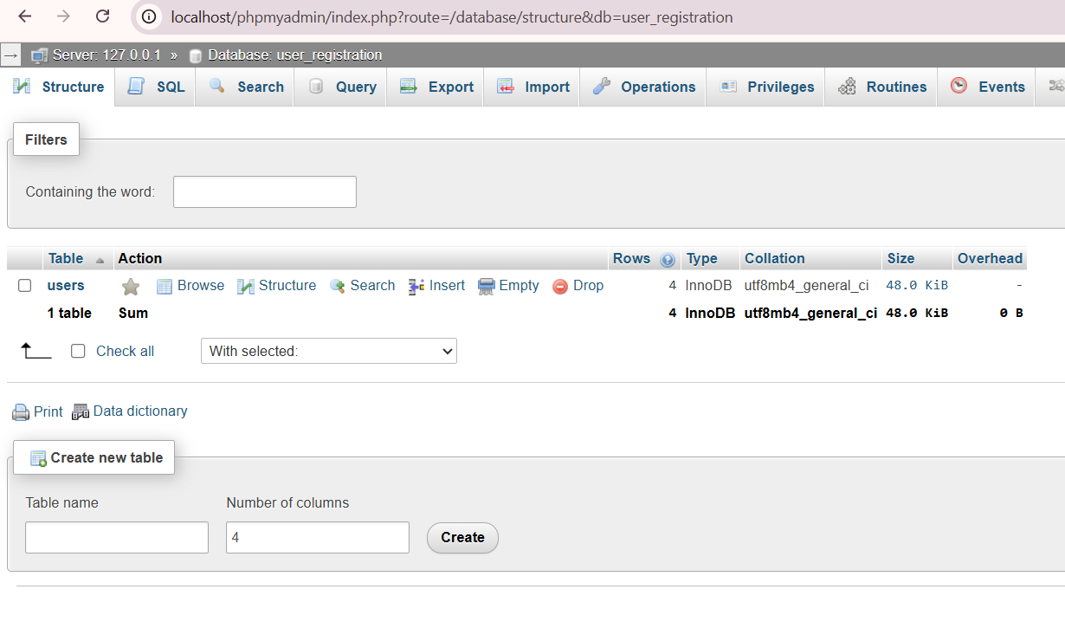

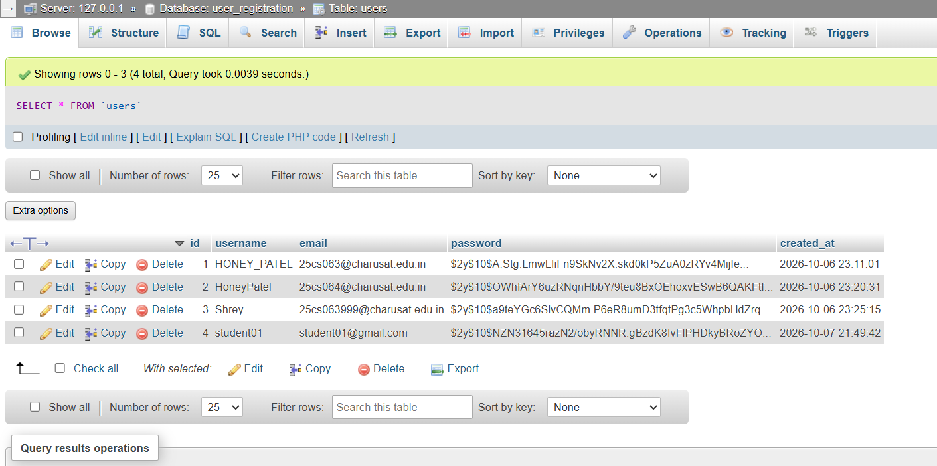

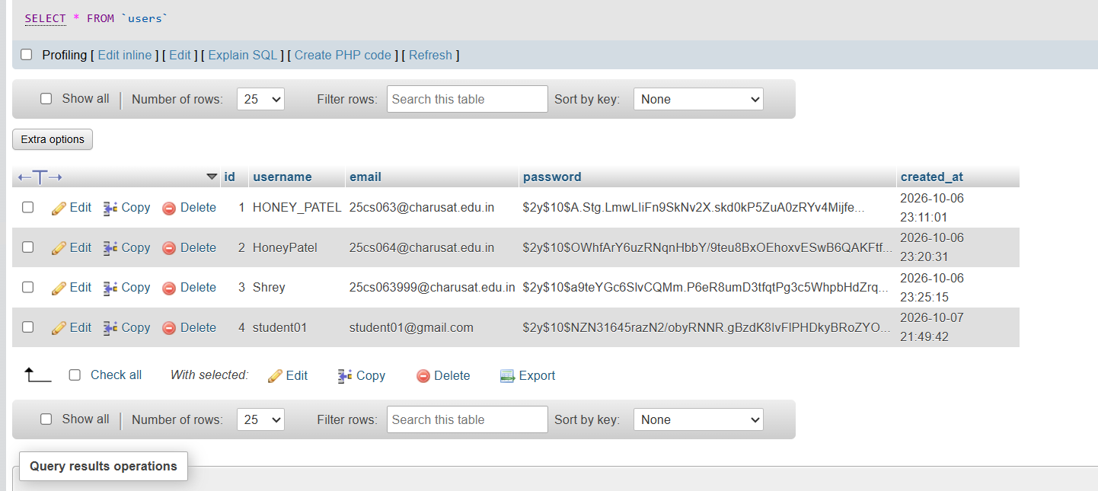

Test Report

Test Case | Input / Condition | Expected Result | Actual Result | Status
Valid Registration | Valid username, email and password | Registration successful | Registration successful | PASS
Duplicate Email | Existing email | Duplicate email error | Duplicate email error | PASS
Duplicate Username | Existing username | Duplicate username error | Duplicate username error | PASS
Invalid Email | abc | Invalid email error | Invalid email error | PASS
Password Mismatch | Different passwords | Password mismatch error | Password mismatch error | PASS
Short Password | Password less than 6 characters | Short password error | Short password error | PASS
Empty Fields | Fields left empty | Required field validation | Required field validation | PASS
Invalid Username | stu@123 | Invalid username error | Invalid username error | PASS
All test cases passed successfully.

Output :

Learning outcome :

To implement a secure user registration system using PHP and MySQL with frontend and backend validation, duplicate username/email checking, password hashing, and secure database insertion.

GitHub Link

