 | 

Faculty of Technology and Engineering
Chandubhai S. Patel Institute of Technology (CSPIT) Department of Computer Science & Engineering
Date: / /
Laboratory Manul

Academic Year | : | 2026-27 | Semester | : | 3rd
Course code | : | ITUE203 | Course name | : | WEB DEVELOPMENT FRAMEWORKS

Practical – 11
PROBLEM STATEMENT :

Create a student management module to add, view, edit, delete, search and filter student records. All database operations must use MYSQLi
statements and clear success/failure messages.

Objective :

To develop a Student Management System using PHP and MySQL that performs CRUD operations (Create, Read, Update, Delete) with search and filter functionality.

Code :

Edit.php

<?php

ob_start();

include 'db.php';

$id = isset($_GET['id']) ? (int)$_GET['id'] : 0;

if ($id <= 0) {
die("Invalid record ID.");
}

// Fetch existing record
$select_sql = "SELECT * FROM students WHERE id = $id";

$fetch_result = mysqli_query($conn, $select_sql);

if (!$fetch_result || mysqli_num_rows($fetch_result) == 0) {
die("Student record not found.");
}

$student = mysqli_fetch_assoc($fetch_result);

// Handle Form Update
if (isset($_POST['update_student'])) {

$name = mysqli_real_escape_string($conn, $_POST['name']);
$email = mysqli_real_escape_string($conn, $_POST['email']);
$course = mysqli_real_escape_string($conn, $_POST['course']);
$gender = mysqli_real_escape_string($conn, $_POST['gender']);

$update_sql = "UPDATE students
SET name = '$name',
email = '$email',
course = '$course',
gender = '$gender'
WHERE id = $id";

if (mysqli_query($conn, $update_sql)) {

header("Location: index.php");
exit();

} else {

die("Update Error: " . mysqli_error($conn));

}
}

?>

<!DOCTYPE html>

<html lang="en">

<head>

<meta charset="UTF-8">

<title>Edit Student</title>

</head>

<body>

<h2>Edit Student Details</h2>

<form method="POST" action="edit.php?id=<?php echo $id; ?>">

<div>

<label>Name:</label>
<br>

<input
type="text"
name="name"
value="<?php echo htmlspecialchars($student['name']); ?>"
required
>

</div>

<br>

<div>

<label>Email:</label>
<br>

<input
type="email"
name="email"
value="<?php echo htmlspecialchars($student['email']); ?>"
required
>

</div>

<br>

<div>

<label>Course:</label>
<br>

<select name="course" required>

<option value="Computer Science"
<?php
if ($student['course'] == 'Computer Science')
echo 'selected';
?>>
Computer Science
</option>

<option value="Web Development"
<?php
if ($student['course'] == 'Web Development')
echo 'selected';
?>>
Web Development
</option>

<option value="Data Science"
<?php
if ($student['course'] == 'Data Science')
echo 'selected';
?>>
Data Science
</option>

</select>

</div>

<br>

<div>

<label>Gender:</label>
<br>

<select name="gender" required>

<option value="Male"
<?php
if ($student['gender'] == 'Male')
echo 'selected';
?>>
Male
</option>

<option value="Female"
<?php
if ($student['gender'] == 'Female')
echo 'selected';
?>>
Female
</option>

</select>

</div>

<br>

<button type="submit" name="update_student">
Update
</button>

<a href="index.php">
Cancel
</a>

</form>

</body>

</html>

Db.php

<?php

$host = "localhost";
$user = "root";
$pass = "";
$db = "student_db";

$conn = mysqli_connect($host, $user, $pass, $db);

if (!$conn) {
die("Connection failed: " . mysqli_connect_error());
}

?>

Index.php

<?php

ob_start();

include 'db.php';

// Handle Student Creation
if (isset($_POST['add_student'])) {

$name = mysqli_real_escape_string($conn, $_POST['name']);
$email = mysqli_real_escape_string($conn, $_POST['email']);
$course = mysqli_real_escape_string($conn, $_POST['course']);
$gender = mysqli_real_escape_string($conn, $_POST['gender']);

$insert_sql = "INSERT INTO students (name, email, course, gender)
VALUES ('$name', '$email', '$course', '$gender')";

if (mysqli_query($conn, $insert_sql)) {
header("Location: index.php");
exit();
} else {
die("Insert Error: " . mysqli_error($conn));
}
}

// Handle Student Deletion
if (isset($_GET['delete'])) {

$id = (int)$_GET['delete'];

if ($id > 0) {

$delete_sql = "DELETE FROM students WHERE id = $id";

if (mysqli_query($conn, $delete_sql)) {
header("Location: index.php");
exit();
} else {
die("Delete Error: " . mysqli_error($conn));
}

} else {
die("Invalid ID for deletion.");
}
}

// Search and Filter
$search = isset($_GET['search'])
? mysqli_real_escape_string($conn, $_GET['search'])
: '';

$course_filter = isset($_GET['course_filter'])
? mysqli_real_escape_string($conn, $_GET['course_filter'])
: '';

$conditions = [];

if (!empty($search)) {
$conditions[] = "(name LIKE '%$search%' OR email LIKE '%$search%')";
}

if (!empty($course_filter)) {
$conditions[] = "course = '$course_filter'";
}

$query_sql = "SELECT * FROM students";

if (count($conditions) > 0) {
$query_sql .= " WHERE " . implode(' AND ', $conditions);
}

$query_sql .= " ORDER BY id DESC";

$result = mysqli_query($conn, $query_sql);

if (!$result) {
die("Query Failed: " . mysqli_error($conn));
}

?>

<!DOCTYPE html>
<html lang="en">

<head>

<meta charset="UTF-8">

<title>Student Management System</title>

<style>

body {
font-family: Arial, sans-serif;
margin: 20px;
}

table {
width: 100%;
border-collapse: collapse;
margin-top: 20px;
}

th,
td {
border: 1px solid #ddd;
padding: 8px;
text-align: left;
}

th {
background-color: #f2f2f2;
}

.form-group {
margin-bottom: 10px;
}

.form-inline {
display: flex;
gap: 10px;
margin-bottom: 20px;
}

.btn-delete {
color: red;
}

</style>

</head>

<body>

<h2>Add New Student</h2>

<form method="POST" action="index.php">

<div class="form-group">

<input
type="text"
name="name"
placeholder="Full Name"
required
>

<input
type="email"
name="email"
placeholder="Email"
required
>

<select name="course" required>

<option value="">Select Course</option>

<option value="Computer Science">
Computer Science
</option>

<option value="Web Development">
Web Development
</option>

<option value="Data Science">
Data Science
</option>

</select>

<select name="gender" required>

<option value="">Select Gender</option>

<option value="Male">Male</option>

<option value="Female">Female</option>

</select>

<button type="submit" name="add_student">
Add Student
</button>

</div>

</form>

<hr>

<h2>Student List</h2>

<form method="GET" action="index.php" class="form-inline">

<input
type="text"
name="search"
placeholder="Search by name or email"
value="<?php echo htmlspecialchars($search); ?>"
>

<select name="course_filter">

<option value="">All Courses</option>

<option value="Computer Science"
<?php
if ($course_filter == 'Computer Science')
echo 'selected';
?>>
Computer Science
</option>

<option value="Web Development"
<?php
if ($course_filter == 'Web Development')
echo 'selected';
?>>
Web Development
</option>

<option value="Data Science"
<?php
if ($course_filter == 'Data Science')
echo 'selected';
?>>
Data Science
</option>

</select>

<button type="submit">
Filter
</button>

<a href="index.php">
<button type="button">
Reset
</button>
</a>

</form>

<table>

<thead>

<tr>

<th>ID</th>
<th>Name</th>
<th>Email</th>
<th>Course</th>
<th>Gender</th>
<th>Actions</th>

</tr>

</thead>

<tbody>

<?php if (mysqli_num_rows($result) > 0): ?>

<?php while ($row = mysqli_fetch_assoc($result)): ?>

<tr>

<td>
<?php echo $row['id']; ?>
</td>

<td>
<?php echo htmlspecialchars($row['name']); ?>
</td>

<td>
<?php echo htmlspecialchars($row['email']); ?>
</td>

<td>
<?php echo htmlspecialchars($row['course']); ?>
</td>

<td>
<?php echo htmlspecialchars($row['gender']); ?>
</td>

<td>

<a href="edit.php?id=<?php echo $row['id']; ?>">
Edit
</a>

|

<a
href="index.php?delete=<?php echo $row['id']; ?>"
class="btn-delete"
onclick="return confirm('Are you sure you want to delete this record?');"
>
Delete
</a>

</td>

</tr>

<?php endwhile; ?>

<?php else: ?>

<tr>

<td colspan="6">
No records found.
</td>

</tr>

<?php endif; ?>

</tbody>

</table>

</body>

</html>

Screenshot :

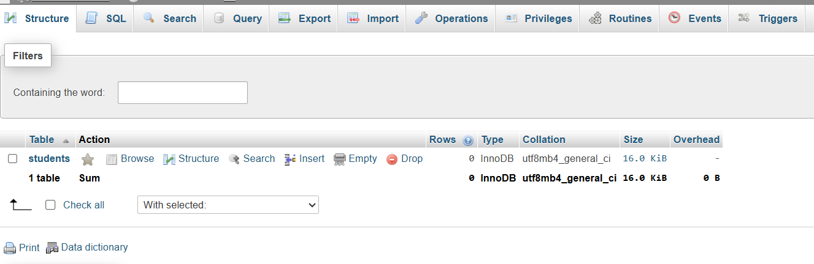

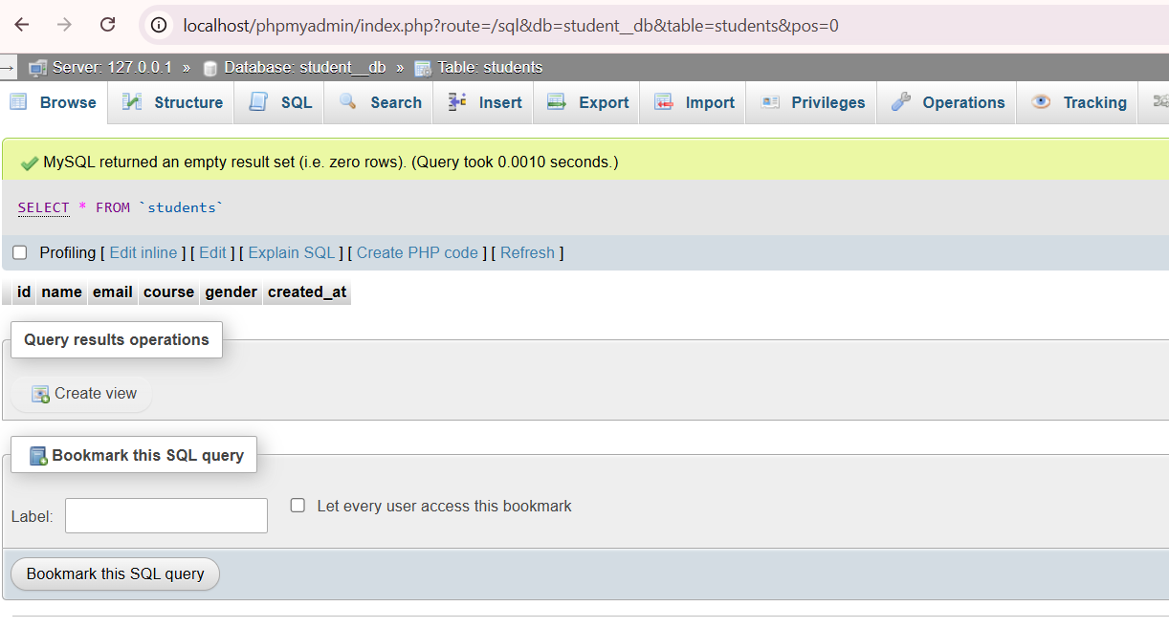

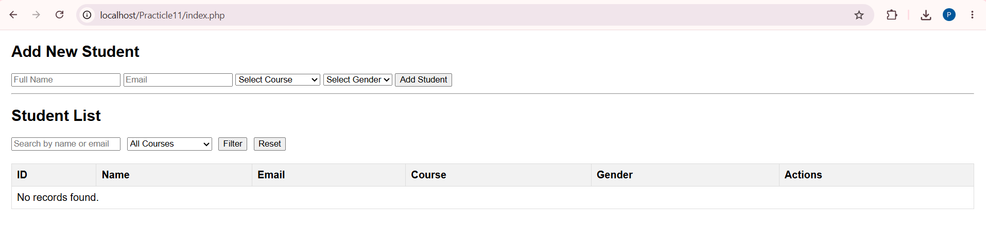

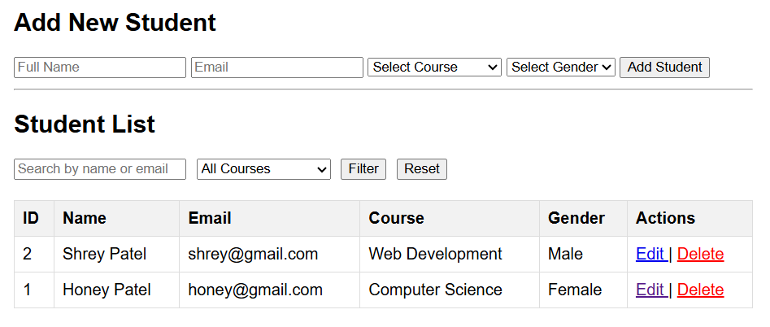

Search Operation
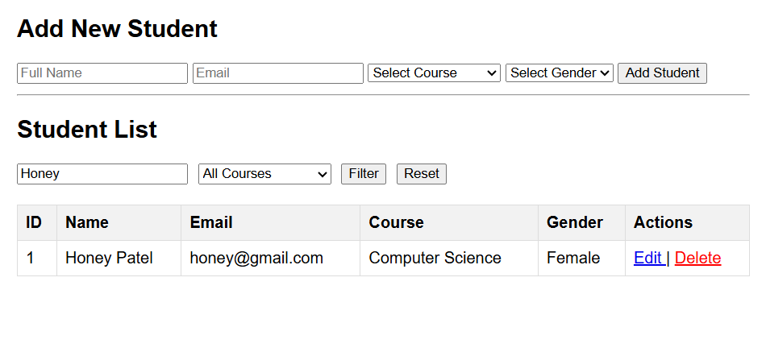

Course Filter Operation

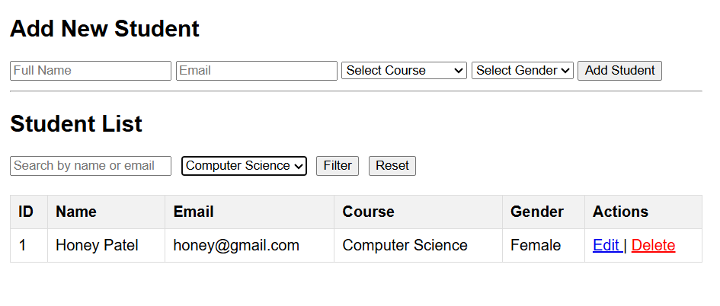

Update/Edit Operation
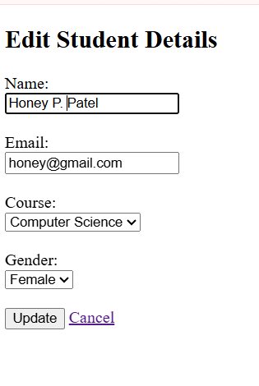

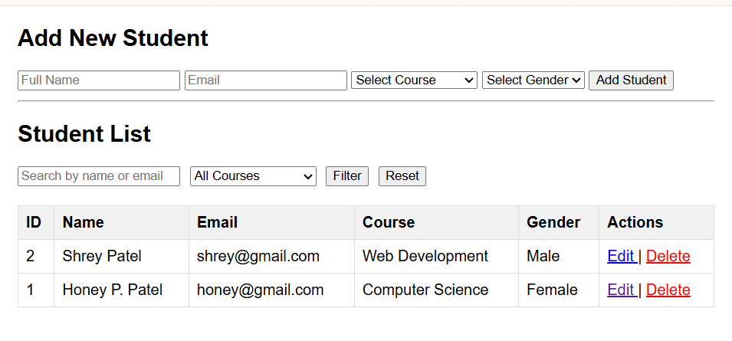

Delete Operation

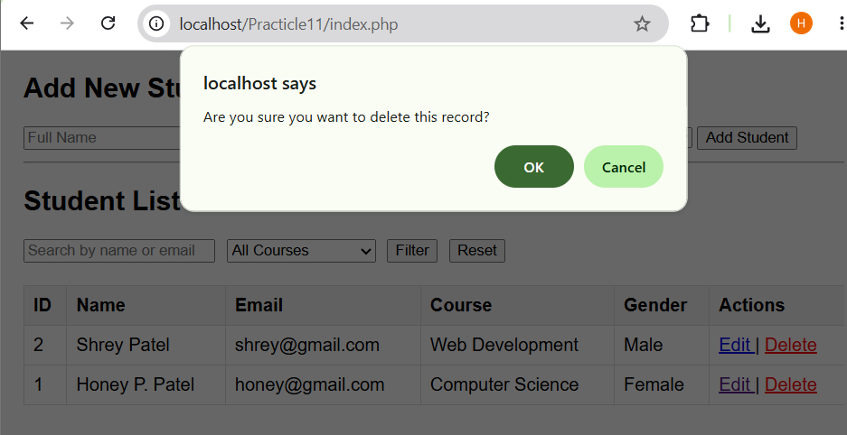

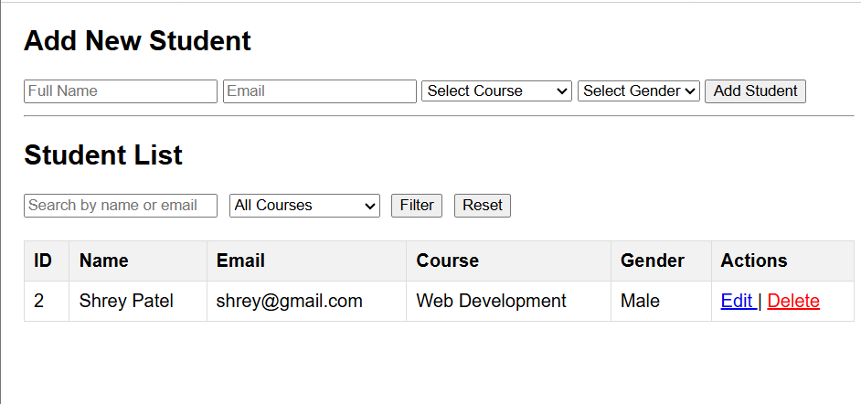

Reset Operation

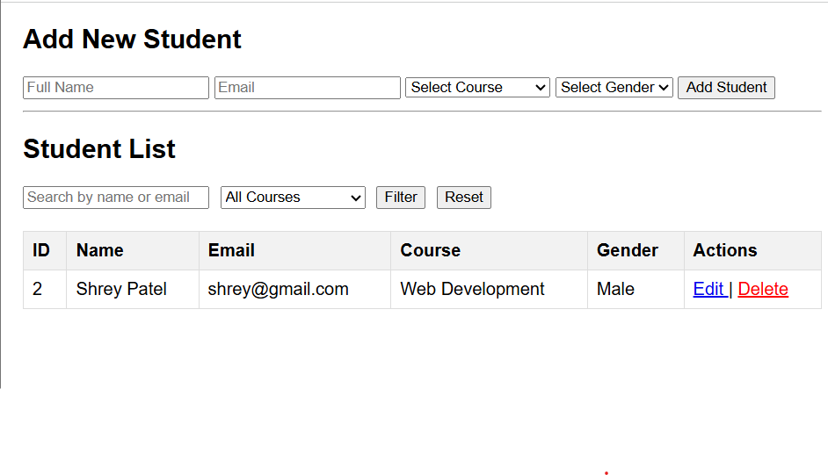

Database Records

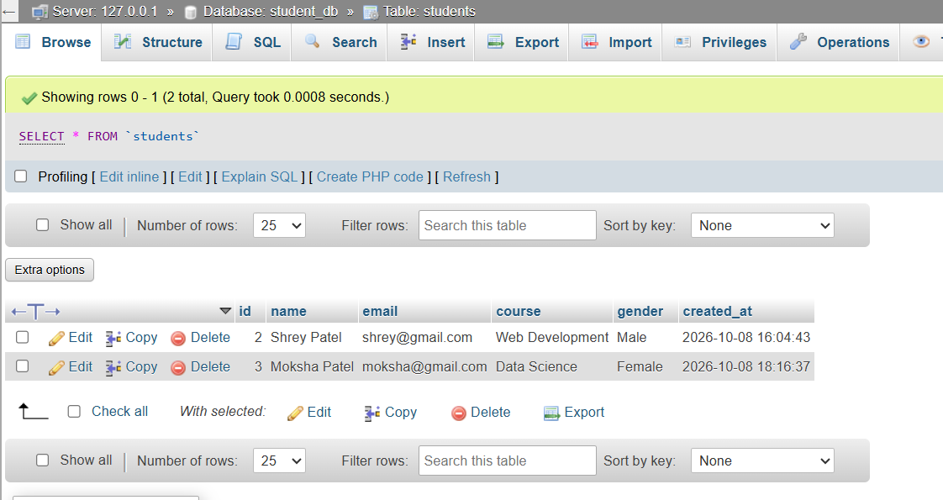

Edit Student Page

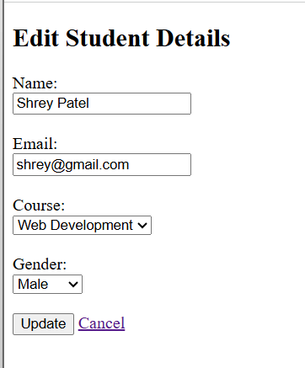

Output :

Learning outcome :
After completing this practical, I learned how to develop a Student Management System using PHP and MySQL. I learned how to perform CRUD operations such as creating, reading, updating, and deleting student records. I also learned how to implement search and course-filter functionality to manage and find student records easily.

