 | 

Faculty of Technology and Engineering
Chandubhai S. Patel Institute of Technology (CSPIT) Department of Computer Science & Engineering
Date: / /
Laboratory Manul

Academic Year | : | 2026-27 | Semester | : | 3rd
Course code | : | ITUE203 | Course name | : | WEB DEVELOPMENT FRAMEWORKS

Practical – 10
PROBLEM STATEMENT :

Develop secure login and logout functionality using PHP sessions. Verify password using password_verify(), regenerate session ID after login, restrict dashboard access, implement role-based redirection, session
timeout, and optional secure remember-me token.

Objective :

To implement a secure login and logout system using PHP sessions, password verification, role-based access control, session timeout, and session ID regeneration.

Code :
Admin_dashboard.php

<?php
session_start();

if (!isset($_SESSION["user_id"])) {
header("Location: login.php?error=Please login first.");
exit;
}

if ($_SESSION["role"] !== "admin") {
http_response_code(403);
die("Unauthorized Access: Admins only.");
}
?>

<!DOCTYPE html>
<html>
<head>
<title>Admin Dashboard - StudentHub</title>
<link rel="stylesheet" href="style.css">
</head>
<body>

<div class="container">

<h2>Admin Dashboard</h2>

<p>
Welcome Admin,
<?= htmlspecialchars($_SESSION["username"]) ?>!
</p>

<p>
You have administrator access.
</p>

<p>
<a href="dashboard.php">Back to Dashboard</a>
</p>

<p>
<a href="logout.php">Logout</a>
</p>

</div>

</body>
</html>
Authenticate.php

<?php
session_start();

if (!isset($_SESSION["user_id"])) {
header("Location: login.php?error=Please login first.");
exit;
}

if ($_SESSION["role"] !== "admin") {
http_response_code(403);
die("Unauthorized Access: Admins only.");
}
?>

<!DOCTYPE html>
<html>
<head>
<title>Admin Dashboard - StudentHub</title>
<link rel="stylesheet" href="style.css">
</head>
<body>

<div class="container">

<h2>Admin Dashboard</h2>

<p>
Welcome Admin,
<?= htmlspecialchars($_SESSION["username"]) ?>!
</p>

<p>
You have administrator access.
</p>

<p>
<a href="dashboard.php">Back to Dashboard</a>
</p>

<p>
<a href="logout.php">Logout</a>
</p>

</div>

</body>
</html>
Dashboard.php
<?php
session_start();

$timeout = 300; // 5 minutes

if (!isset($_SESSION["user_id"])) {
header("Location: login.php?error=Please login first.");
exit;
}

if (isset($_SESSION["last_activity"]) &&
(time() - $_SESSION["last_activity"]) > $timeout) {

$_SESSION = [];
session_destroy();

header("Location: login.php?error=Session expired. Please login again.");
exit;
}

$_SESSION["last_activity"] = time();
?>

<!DOCTYPE html>
<html>
<head>
<title>Dashboard - StudentHub</title>
<link rel="stylesheet" href="style.css">
</head>
<body>

<div class="container">

<h2>Welcome, <?= htmlspecialchars($_SESSION["username"]) ?>!</h2>

<p>
<strong>Email:</strong>
<?= htmlspecialchars($_SESSION["email"]) ?>
</p>

<p>
<strong>Role:</strong>
<?= htmlspecialchars($_SESSION["role"]) ?>
</p>

<?php if ($_SESSION["role"] === "admin"): ?>

<p>
<a href="admin_dashboard.php">
Go to Admin Dashboard
</a>
</p>

<?php elseif ($_SESSION["role"] === "student"): ?>

<p>
<a href="student_dashboard.php">
Go to Student Dashboard
</a>
</p>

<?php endif; ?>

<p>
<a href="logout.php">Logout</a>
</p>

</div>

</body>
</html>

Db.php
<?php
$host = "localhost";
$username = "root";
$password = "";
$database = "user_registration";

$conn = new mysqli($host, $username, $password, $database);

if ($conn->connect_error) {
die("Database connection failed: " . $conn->connect_error);
}

$conn->set_charset("utf8mb4");
?>

Login.php
<?php
session_start();

if (isset($_SESSION['user_id'])) {
header("Location: dashboard.php");
exit;
}

$error = $_GET['error'] ?? '';
$message = $_GET['message'] ?? '';
?>

<!DOCTYPE html>
<html>
<head>
<title>Login - StudentHub</title>
<link rel="stylesheet" href="style.css">
</head>
<body>

<div class="container">

<h2>StudentHub Login</h2>

<?php if ($error): ?>
<p class="error">
<?= htmlspecialchars($error) ?>
</p>
<?php endif; ?>

<?php if ($message): ?>
<p class="success">
<?= htmlspecialchars($message) ?>
</p>
<?php endif; ?>

<form action="authenticate.php" method="POST">

<label>Email:</label>
<input type="email" name="email" required>

<label>Password:</label>
<input type="password" name="password" required>

<button type="submit">Login</button>

</form>

</div>

</body>
</html>

Logout.php
<?php
session_start();

$_SESSION = [];

if (ini_get("session.use_cookies")) {
$params = session_get_cookie_params();

setcookie(
session_name(),
'',
time() - 42000,
$params["path"],
$params["domain"],
$params["secure"],
$params["httponly"]
);
}

session_destroy();

header("Location: login.php?message=You have been logged out successfully.");
exit;
?>

Student_dashboard.php
<?php
session_start();

if (!isset($_SESSION["user_id"])) {
header("Location: login.php?error=Please login first.");
exit;
}

if ($_SESSION["role"] !== "student") {
http_response_code(403);
die("Unauthorized Access: Students only.");
}
?>

<!DOCTYPE html>
<html>
<head>
<title>Student Dashboard - StudentHub</title>
<link rel="stylesheet" href="style.css">
</head>
<body>

<div class="container">

<h2>Student Dashboard</h2>

<p>
Welcome Student,
<?= htmlspecialchars($_SESSION["username"]) ?>!
</p>

<p>
You have student access.
</p>

<p>
<a href="dashboard.php">Back to Dashboard</a>
</p>

<p>
<a href="logout.php">Logout</a>
</p>

</div>

</body>
</html>

Style.css
body {
font-family: Arial, sans-serif;
background: #f4f6f8;
margin: 0;
padding: 40px;
}

.container {
width: 400px;
margin: auto;
background: white;
padding: 25px;
border-radius: 10px;
box-shadow: 0 0 10px rgba(0,0,0,0.1);
}

h2 {
text-align: center;
}

label {
display: block;
margin-top: 15px;
}

input {
width: 100%;
padding: 10px;
margin-top: 5px;
box-sizing: border-box;
}

button {
width: 100%;
padding: 10px;
margin-top: 20px;
cursor: pointer;
}

.error {
color: red;
}

.success {
color: green;
}

Timeout.php
<?php
session_start();

if (!isset($_SESSION["user_id"])) {
header("Location: login.php?error=Please login first.");
exit;
}

$timeout = 300; // 5 minutes

if (isset($_SESSION["last_activity"]) &&
(time() - $_SESSION["last_activity"]) > $timeout) {

$_SESSION = [];
session_destroy();

header("Location: login.php?error=Session expired. Please login again.");
exit;
}

$_SESSION["last_activity"] = time();

echo "Session is active.";
?>

Screenshot :

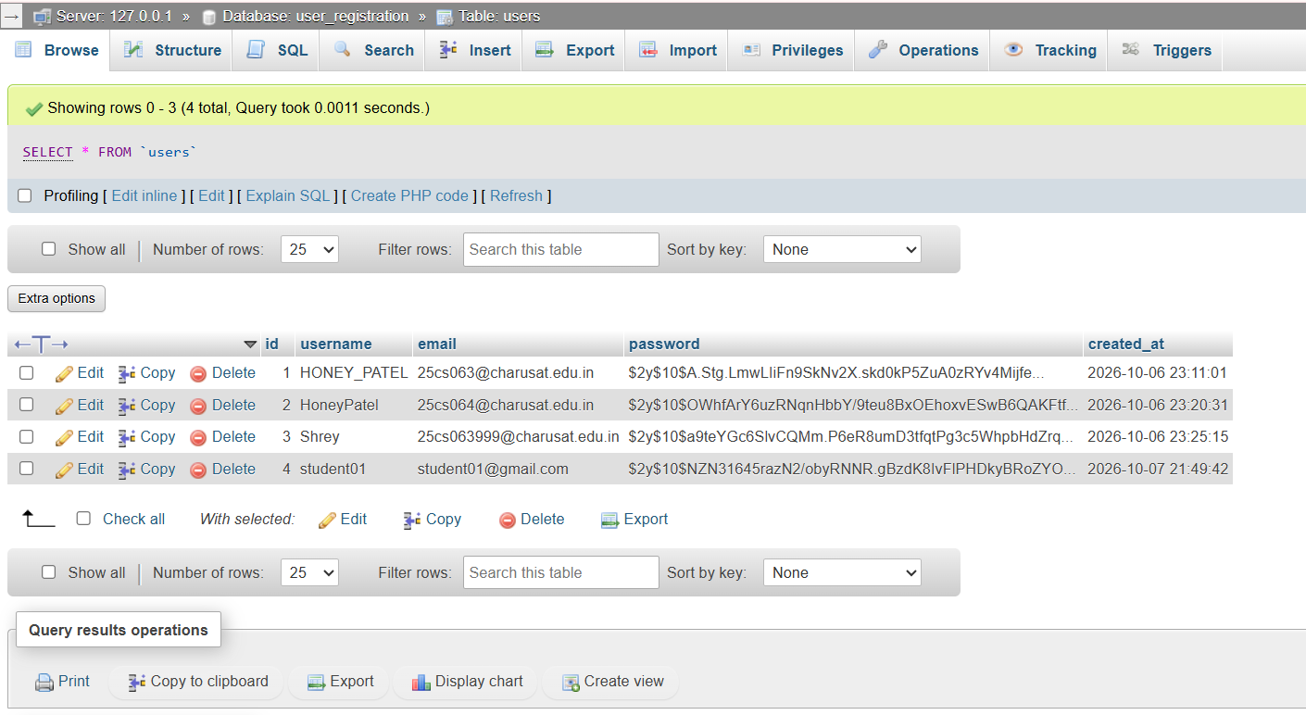

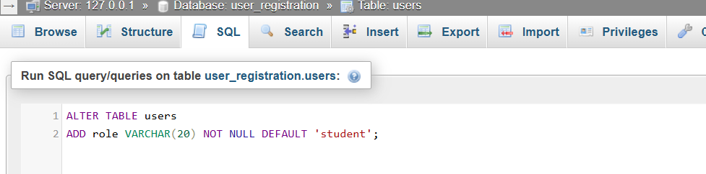

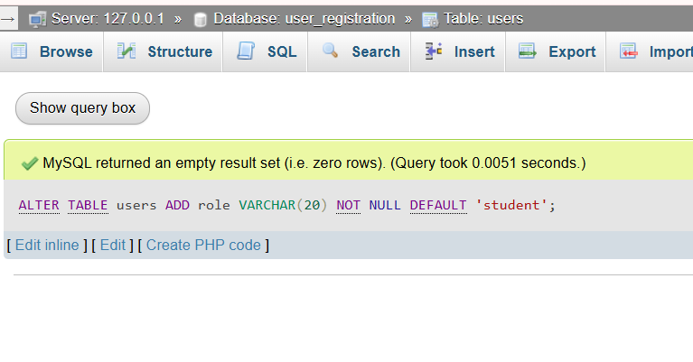

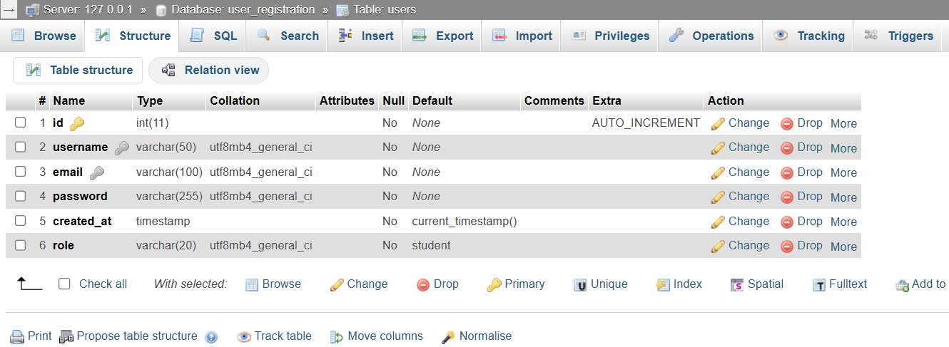

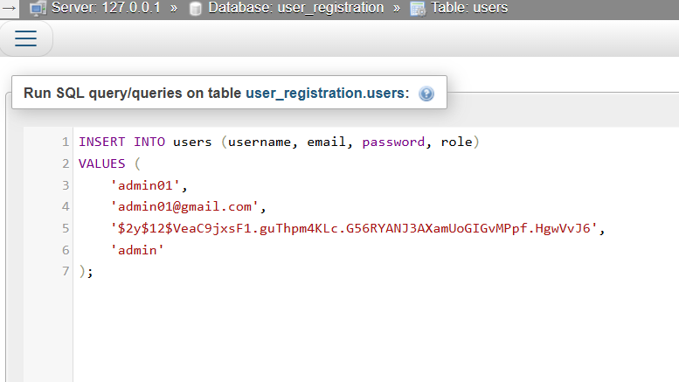

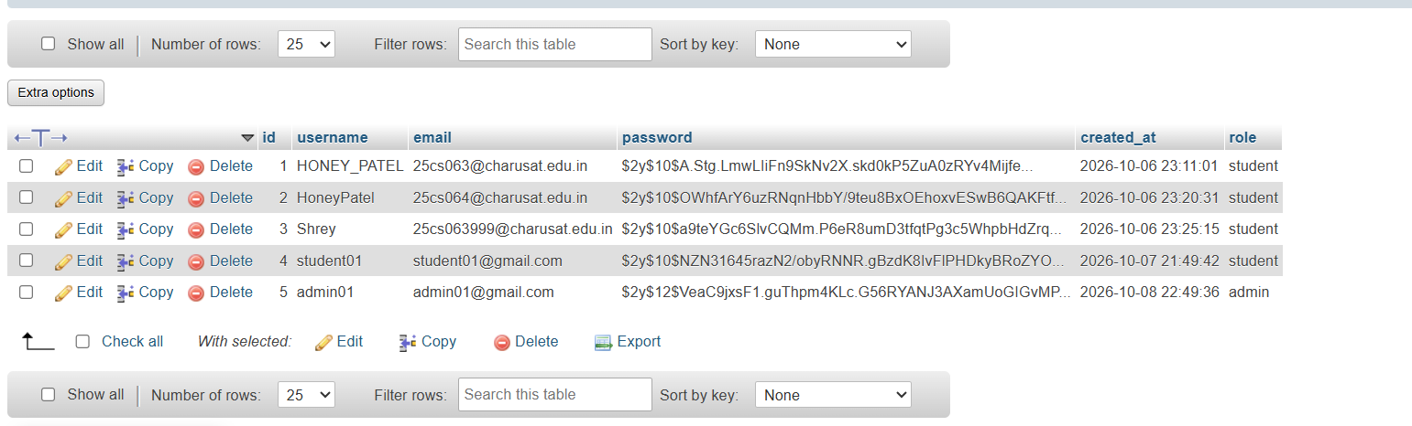

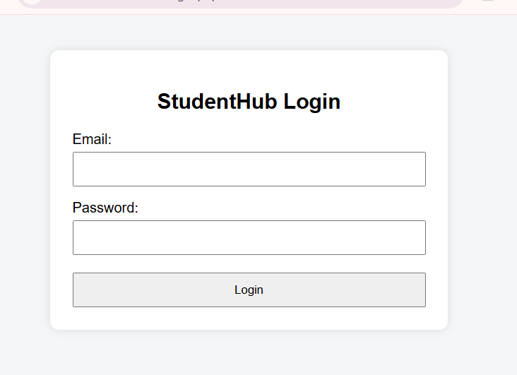

Successful student login.

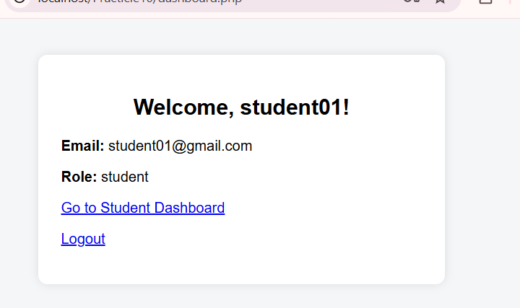

Student Dashboard

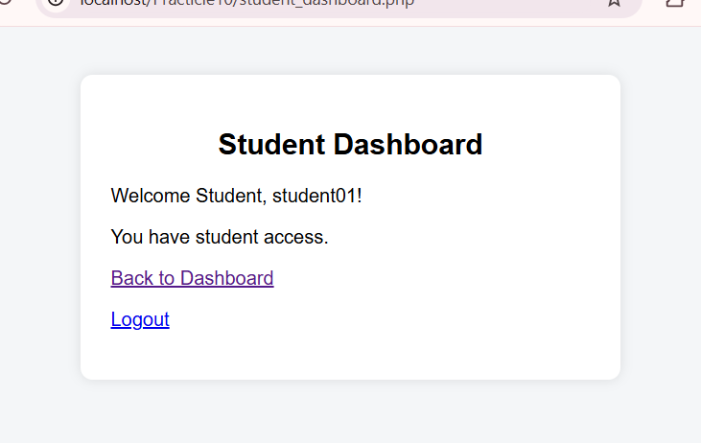

- Student attempting to access the admin dashboard (Unauthorized Access).

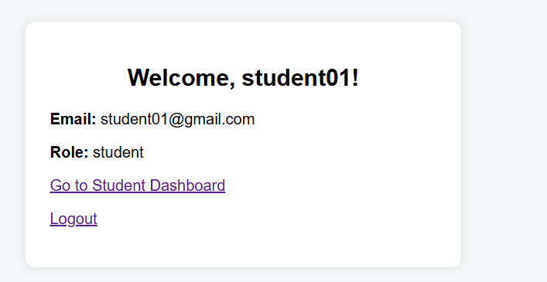

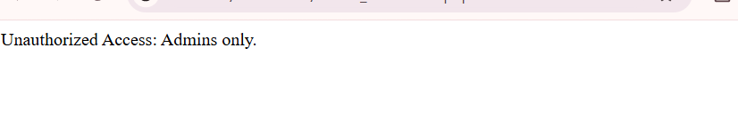

- Admin attempting to access the student dashboard (Unauthorized Access).

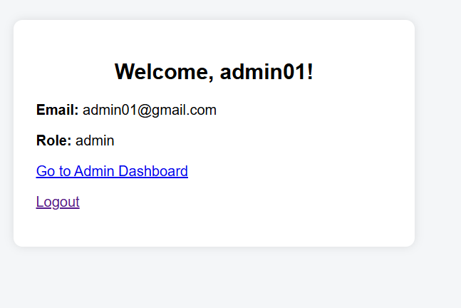

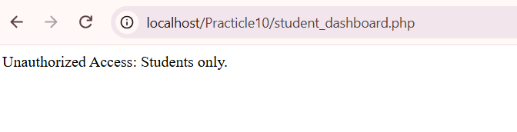

- Successful admin login.

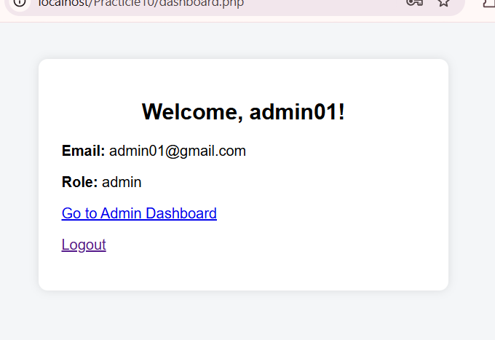

- Invalid email/password message.

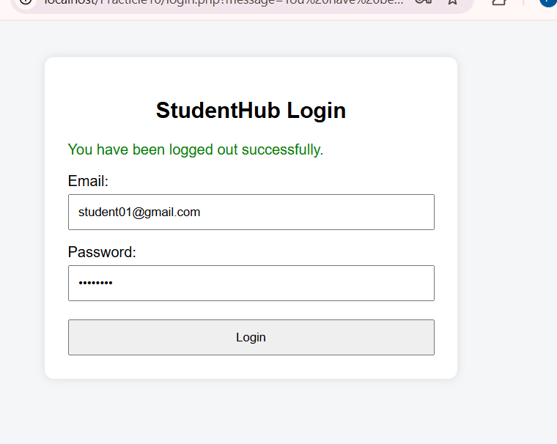

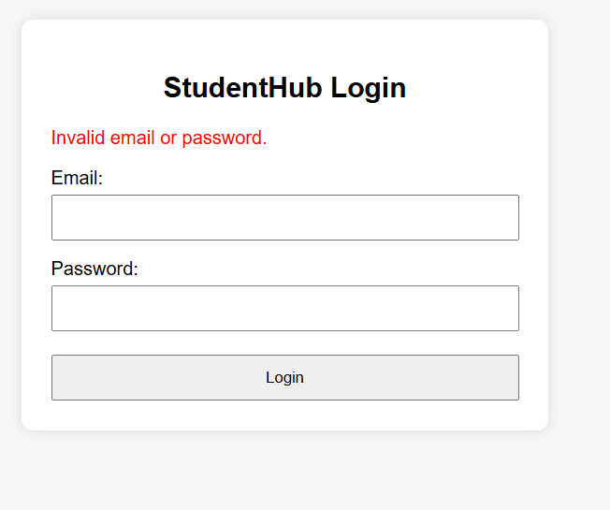

- Successful logout.

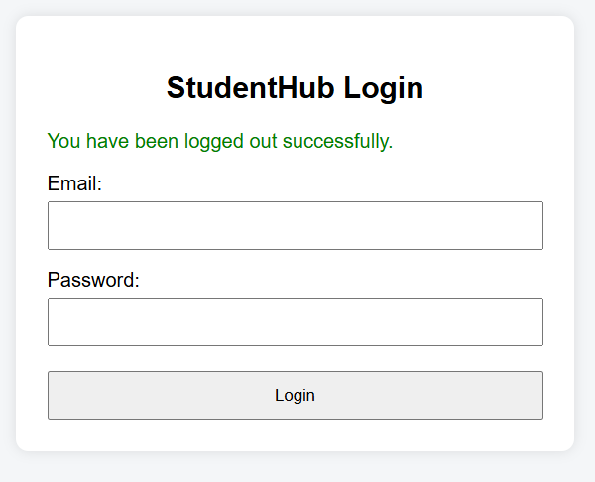

- Dashboard access denied after logout.

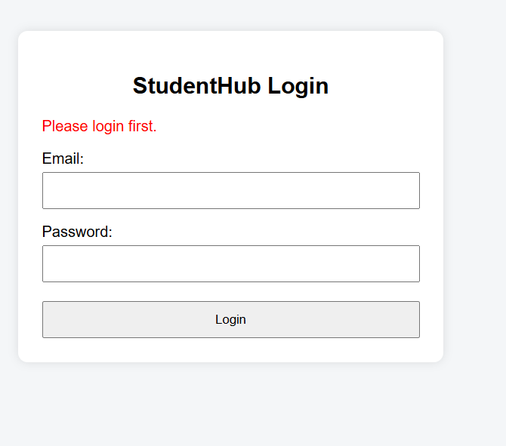

- Session timeout and redirection to login.

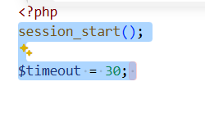

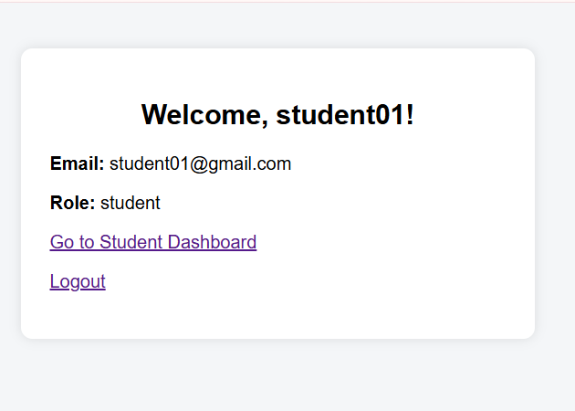

After 30 seconds

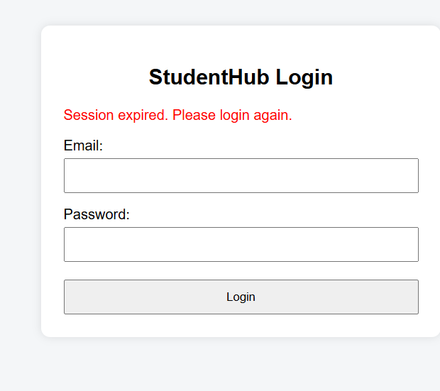

Empty Fields Test

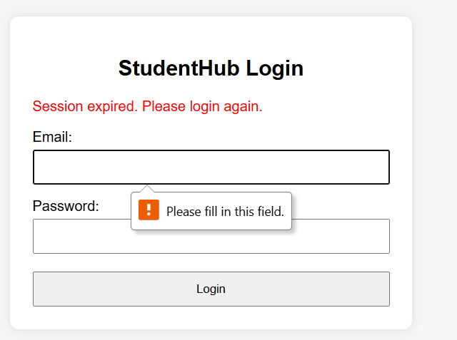

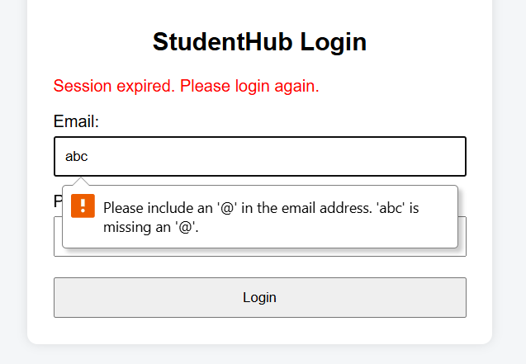

- Session ID regeneration after successful login.

Before login

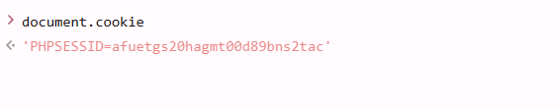

After login

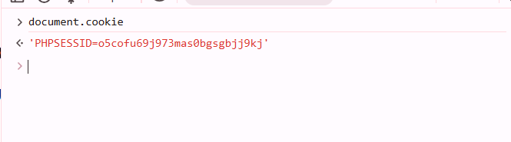
Output :

Learning outcome :

- Understand session management in PHP.
- Implement secure login using password_verify().
- Use session_regenerate_id(true) to regenerate the session ID after login.
- Implement role-based access for Admin and Student users.
- Apply session timeout and secure logout functionality.
- Prevent unauthorized access to protected pages.

