 | 

Faculty of Technology and Engineering
Chandubhai S. Patel Institute of Technology (CSPIT) Department of Computer Science & Engineering
Date: / /
Laboratory Manul

Academic Year | : | 2026-27 | Semester | : | 3rd
Course code | : | ITUE203 | Course name | : | WEB DEVELOPMENT FRAMEWORKS

Practical – 7
PROBLEM STATEMENT :

Process submitted registration/contact form data using PHP. Validate and sanitize inputs on the server side and store records in CSV or JSON file
format. Display success/error messages.

Objective :

• To develop a PHP-based registration/contact form using the POST method.
• To implement server-side validation and sanitization of user inputs.
• To store submitted form data securely in CSV/JSON format.
• To display clear success and error messages after form submission.

PHP Form

Code:
Index.php
<form
action="process.php"
method="POST"
id="registerForm"
>

<!-- Full Name -->
<input
type="text"
id="name"
name="name"
placeholder="Enter Full Name (Alphabet only)"
>

<small
class="error-msg"
id="nameError"
></small>

<!-- Enrollment Number -->
<input
type="text"
id="enrollment"
name="enrollment"
placeholder="e.g. 25CS063 or D25CS063"
>

<small
class="error-msg"
id="enrollmentError"
></small>

<!-- Roll Number -->
<input
type="text"
id="Roll-no."
name="roll_no"
placeholder="e.g. 63"
>

<small
class="error-msg"
id="rollNoError"
></small>
Screenshorts
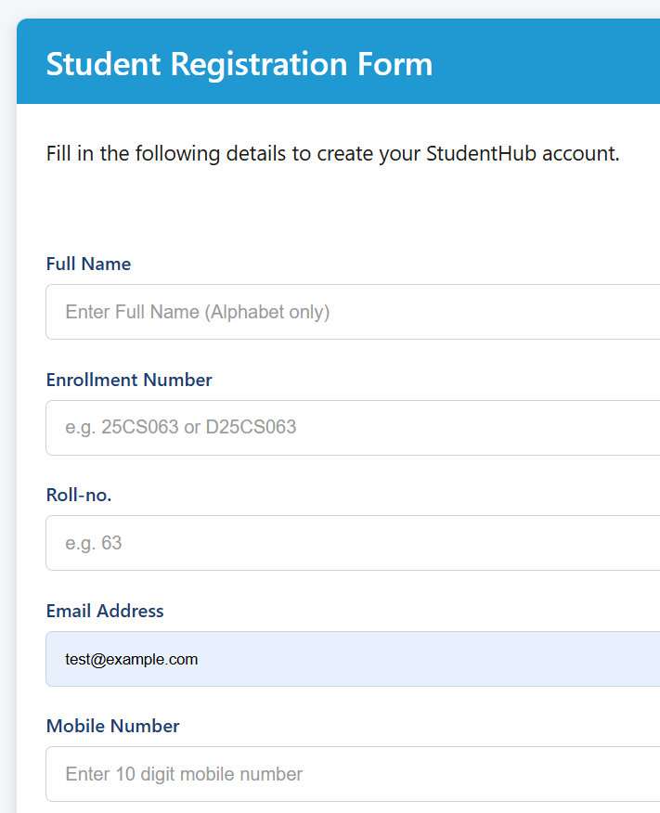

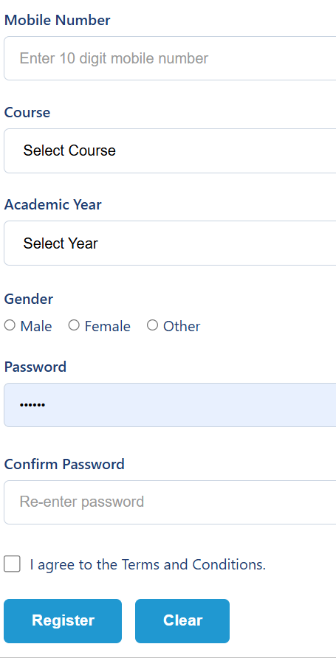

POST Method
Successful Form Submission

Code:
Index.php

<form
action="process.php"
method="POST"
id="registerForm"
>

Process.php

if ($_SERVER["REQUEST_METHOD"] !== "POST") {

die(
"Invalid Request! Please submit the registration form."
);
}

screenshort



Validation

Code:

Process.php

if ($name === "") {

$errors[] =
"Full Name is required.";

}
else if (
!preg_match(
"/^[A-Za-z\s]+$/",
$name
)
) {

$errors[] =
"Full Name must contain only alphabets.";
}

$enrollmentPattern =
"/^[Dd]?[0-9]{2}[A-Za-z]{2}[0-9]{3}$/";

if ($enrollment === "") {

$errors[] =
"Enrollment Number is required.";

}
else if (
!preg_match(
$enrollmentPattern,
$enrollment
)
) {

$errors[] =
"Invalid Enrollment Number. Example: 25CS063 or D25CS063.";
}
if ($rollNo === "") {

$errors[] =
"Roll Number is required.";

}
else if (
!preg_match(
"/^[0-9]{1,3}$/",
$rollNo
)
) {

$errors[] =
"Roll Number must contain 1 to 3 digits.";
}

Screenshorts:

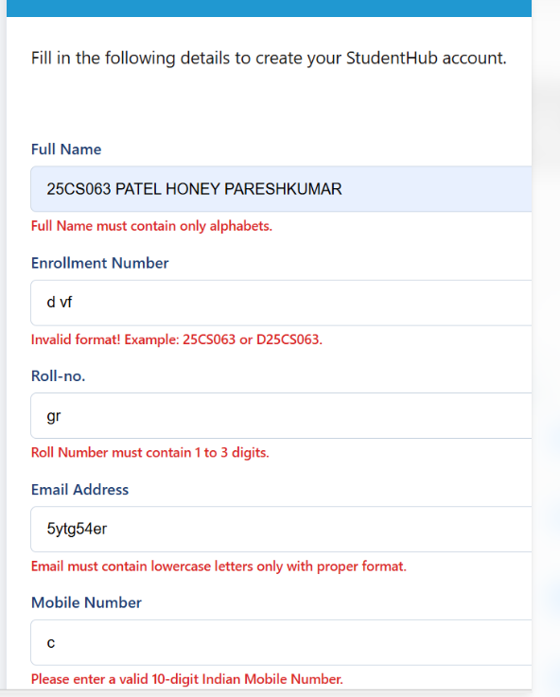

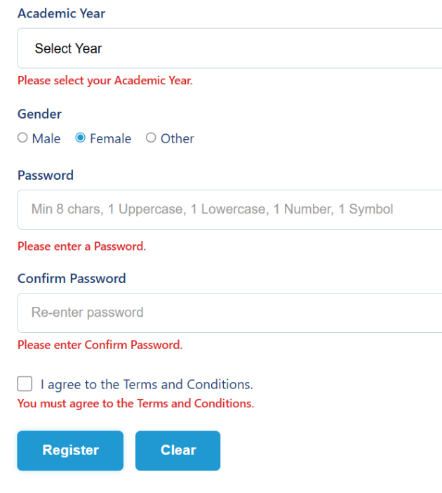

Sanitization

Code:

Process.php

$name =
htmlspecialchars(
$name,
ENT_QUOTES,
"UTF-8"
);

$enrollment =
htmlspecialchars(
$enrollment,
ENT_QUOTES,
"UTF-8"
);

$rollNo =
htmlspecialchars(
$rollNo,
ENT_QUOTES,
"UTF-8"
);

$email =
htmlspecialchars(
$email,
ENT_QUOTES,
"UTF-8"
);

$mobile =
htmlspecialchars(
$mobile,
ENT_QUOTES,
"UTF-8"
);

$course =
htmlspecialchars(
$course,
ENT_QUOTES,
"UTF-8"
);

$year =
htmlspecialchars(
$year,
ENT_QUOTES,
"UTF-8"
);

$gender =
htmlspecialchars(
$gender,
ENT_QUOTES,
"UTF-8"
);

Screenshorts:

File Storage
Data Stored in CSV File

Code:

Process.php

$hashedPassword =
password_hash(
$password,
PASSWORD_DEFAULT
);

$file =
"data.csv";

$handle =
fopen(
$file,
"a"
);
fputcsv(
$handle,
array(
"Name",
"Enrollment",
"Roll No",
"Email",
"Mobile",
"Course",
"Academic Year",
"Gender",
"Password"
)
);
fputcsv(
$handle,
array(
$name,
$enrollment,
$rollNo,
$email,
$mobile,
$course,
$year,
$gender,
$hashedPassword
)
);

fclose($handle);

Screenshorts:

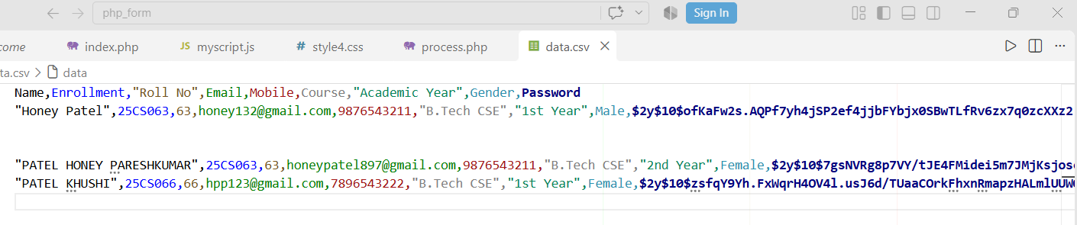

Success Message

Code:

Process.php

<div class="success-box">

<h1>
✓ Registration Completed Successfully!
</h1>

<p>
Your registration data has been stored successfully.
</p>

<a href="index.php">
Register Another Student
</a>

</div>

Screenshorts:

Validation Error Messages

Code:

Process.php

if (count($errors) > 0) {

<ul>

<?php

foreach ($errors as $error) {

echo
"<li>" .
htmlspecialchars(
$error,
ENT_QUOTES,
"UTF-8"
) .
"</li>";
}

?>

</ul>

<a href="index.php">
Go Back to Registration
</a>

Screenshorts:

Code:

Process.php

if ($name === "") {

$errors[] =
"Full Name is required.";

}
else if (
!preg_match(
"/^[A-Za-z\s]+$/",
$name
)
) {

$errors[] =
"Full Name must contain only alphabets.";
}

$enrollmentPattern =
"/^[Dd]?[0-9]{2}[A-Za-z]{2}[0-9]{3}$/";

if ($enrollment === "") {

$errors[] =
"Enrollment Number is required.";

}
else if (
!preg_match(
$enrollmentPattern,
$enrollment
)
) {

$errors[] =
"Invalid Enrollment Number. Example: 25CS063 or D25CS063.";
}
if ($rollNo === "") {

$errors[] =
"Roll Number is required.";

}
else if (
!preg_match(
"/^[0-9]{1,3}$/",
$rollNo
)
) {

$errors[] =
"Roll Number must contain 1 to 3 digits.";
}

Screenshorts:

Learning outcome :

• Understand and implement PHP form processing using POST.
• Perform server-side validation and sanitization of form inputs.
• Store form records in CSV/JSON files using safe file handling.
• Display appropriate success and error responses to users.
• Implement basic file-based storage for backend form-processing systems.

Github link

https://github.com/HONEY2218/STUDENTHUB/tree/main/php_form_PR7

