 | 

Faculty of Technology and Engineering
Chandubhai S. Patel Institute of Technology (CSPIT) Department of Computer Science & Engineering
Date: / /
Laboratory Manul

Academic Year | : | 2026-27 | Semester | : | 3rd
Course code | : | ITUE203 | Course name | : | WEB DEVELOPMENT FRAMEWORKS

Practical – 12
PROBLEM STATEMENT :

Develop event management functionality for admin users. Admin can add, view, update, delete, and upload event posters with file type and file size
validation.

Objective :

To develop an Event Management System using PHP and MySQL that allows administrators to manage events through CRUD operations, upload event posters with file validation, and control access through admin authentication.

Code :

Db.php
<?php
// Database connection (mysqli, procedural style)
$host = "localhost";
$user = "root";
$pass = "";
$db = "event_db";

mysqli_report(MYSQLI_REPORT_OFF); // we check errors ourselves
$conn = mysqli_connect($host, $user, $pass, $db);

if (!$conn) {
die("Database connection failed: " . mysqli_connect_error());
}
mysqli_set_charset($conn, "utf8mb4");

Edit.php

<?php
require 'functions.php';
require 'db.php';
require_admin();

$id = (int)($_GET['id'] ?? 0);

$stmt = mysqli_prepare($conn, "SELECT * FROM events WHERE id = ?");
mysqli_stmt_bind_param($stmt, "i", $id);
mysqli_stmt_execute($stmt);
$event = mysqli_fetch_assoc(mysqli_stmt_get_result($stmt));

if (!$event) {
flash('danger', 'Event not found.');
header('Location: index.php');
exit();
}

$errors = [];
$form = [
'title' => $event['title'], 'event_date' => $event['event_date'], 'location' => $event['location'],
'category' => $event['category'], 'status' => $event['status'],
];

/* ---------- UPDATE ---------- */
if (post_too_large()) {
$errors[] = 'The upload is too large. Maximum allowed poster size is ' . MAX_POSTER_MB . ' MB.';
}
if ($_SERVER['REQUEST_METHOD'] === 'POST' && isset($_POST['update_event'])) {
$form = event_input();
$errors = validate_event($form);

$new_poster = null;
if (!$errors) {
$up = save_poster($_FILES['poster'] ?? null);
if ($up['error']) {
$errors[] = $up['error'];
} else {
$new_poster = $up['name']; // null = keep the old poster
}
}

if (!$errors) {
$poster_final = $new_poster ?? $event['poster'];

$stmt = mysqli_prepare($conn,
"UPDATE events SET title = ?, event_date = ?, location = ?, category = ?, status = ?, poster = ? WHERE id = ?");
mysqli_stmt_bind_param($stmt, "ssssssi",
$form['title'], $form['event_date'], $form['location'], $form['category'], $form['status'], $poster_final, $id);

if (mysqli_stmt_execute($stmt)) {
if ($new_poster) {
delete_poster($event['poster']); // old file removed only AFTER the update succeeded
}
flash('success', 'Event updated successfully.');
header('Location: index.php');
exit();
}
delete_poster($new_poster); // update failed: remove the new unused file
$errors[] = 'Database error: the event could not be updated.';
}
}
?>
<!DOCTYPE html>
<html lang="en">
<head>
<meta charset="UTF-8">
<meta name="viewport" content="width=device-width, initial-scale=1">
<title>Edit Event</title>
<link href="https://cdn.jsdelivr.net/npm/bootstrap@5.3.3/dist/css/bootstrap.min.css" rel="stylesheet">
<style>.poster-preview { width: 120px; height: 160px; object-fit: cover; border-radius: 4px; }</style>
</head>
<body class="bg-light">
<div class="container py-4" style="max-width: 700px;">
<div class="card shadow-sm">
<div class="card-header fw-semibold">Edit Event #<?= (int)$event['id'] ?></div>
<div class="card-body">
<?php if ($errors): ?>
<div class="alert alert-danger">
<ul class="mb-0"><?php foreach ($errors as $err): ?><li><?= e($err) ?></li><?php endforeach; ?></ul>
</div>
<?php endif; ?>

<form method="POST" action="edit.php?id=<?= (int)$id ?>" enctype="multipart/form-data">
<div class="mb-3">
<label class="form-label" for="title">Title</label>
<input class="form-control" id="title" name="title" maxlength="150" value="<?= e($form['title']) ?>" required>
</div>
<div class="row">
<div class="col-md-6 mb-3">
<label class="form-label" for="event_date">Date</label>
<input class="form-control" type="date" id="event_date" name="event_date" value="<?= e($form['event_date']) ?>" required>
</div>
<div class="col-md-6 mb-3">
<label class="form-label" for="location">Location</label>
<input class="form-control" id="location" name="location" maxlength="150" value="<?= e($form['location']) ?>" required>
</div>
</div>
<div class="row">
<div class="col-md-6 mb-3">
<label class="form-label" for="category">Category</label>
<select class="form-select" id="category" name="category" required>
<?php foreach (CATEGORIES as $c): ?>
<option value="<?= e($c) ?>" <?= $form['category'] === $c ? 'selected' : '' ?>><?= e($c) ?></option>
<?php endforeach; ?>
</select>
</div>
<div class="col-md-6 mb-3">
<label class="form-label" for="status">Status</label>
<select class="form-select" id="status" name="status">
<?php foreach (STATUSES as $s): ?>
<option value="<?= e($s) ?>" <?= $form['status'] === $s ? 'selected' : '' ?>><?= e($s) ?></option>
<?php endforeach; ?>
</select>
</div>
</div>
<div class="mb-3">
<label class="form-label d-block">Current poster</label>
<?php if ($event['poster']): ?>
<img class="poster-preview mb-2" src="<?= UPLOAD_URL . e($event['poster']) ?>" alt="Current poster">
<?php else: ?>
<p class="text-muted">No poster uploaded.</p>
<?php endif; ?>
<label class="form-label d-block" for="poster">Change poster (optional, JPG/PNG/WEBP, max <?= MAX_POSTER_MB ?> MB)</label>
<input class="form-control" type="file" id="poster" name="poster" accept=".jpg,.jpeg,.png,.webp">
</div>
<button class="btn btn-primary" type="submit" name="update_event">Update Event</button>
<a class="btn btn-outline-secondary" href="index.php">Cancel</a>
</form>
</div>
</div>
</div>
</body>
</html>

Functions.php
<?php
// Shared helpers: session, flash messages, admin guard, validation, poster upload
session_start();

const UPLOAD_DIR = __DIR__ . '/uploads/'; // where files are saved on disk
const UPLOAD_URL = 'uploads/'; // how the browser reaches them
const MAX_POSTER_MB = 2;
const ALLOWED_EXT = ['jpg', 'jpeg', 'png', 'webp'];
const ALLOWED_MIME = ['image/jpeg', 'image/png', 'image/webp'];
const CATEGORIES = ['Music', 'Conference', 'Workshop', 'Sports'];
const STATUSES = ['Open', 'Closed'];

// Safe output (prevents XSS)
function e($value) {
return htmlspecialchars((string)$value, ENT_QUOTES, 'UTF-8');
}

// One-time success / failure message shown after a redirect
function flash($type, $message) {
$_SESSION['flash'] = ['type' => $type, 'message' => $message];
}

function show_flash() {
if (!empty($_SESSION['flash'])) {
$f = $_SESSION['flash'];
unset($_SESSION['flash']);
echo '<div class="alert alert-' . e($f['type']) . ' alert-dismissible fade show" role="alert">'
. e($f['message'])
. '<button type="button" class="btn-close" data-bs-dismiss="alert"></button></div>';
}
}

// Access restriction: only a logged-in admin may continue
function require_admin() {
if (empty($_SESSION['admin_id'])) {
flash('warning', 'Please log in as admin to continue.');
header('Location: login.php');
exit();
}
}

// Validate the text fields of the event form. Returns a list of error messages.
function validate_event(array $d) {
$errors = [];
if ($d['title'] === '' || mb_strlen($d['title']) > 150) {
$errors[] = 'Title is required (maximum 150 characters).';
}
$dt = DateTime::createFromFormat('Y-m-d', $d['event_date']);
if (!$dt || $dt->format('Y-m-d') !== $d['event_date']) {
$errors[] = 'Please enter a valid event date.';
}
if ($d['location'] === '' || mb_strlen($d['location']) > 150) {
$errors[] = 'Location is required (maximum 150 characters).';
}
if (!in_array($d['category'], CATEGORIES, true)) {
$errors[] = 'Please select a valid category.';
}
if (!in_array($d['status'], STATUSES, true)) {
$errors[] = 'Please select a valid status.';
}
return $errors;
}

/*
* Validate and save an uploaded poster.
* Returns ['name' => saved file name or null, 'error' => message or null]
* - no file chosen -> name null, error null (poster is optional)
* - invalid file -> name null, error message
* - valid file -> name = new unique file name (already moved to uploads/)
*/
function save_poster($file) {
if (!isset($file) || $file['error'] === UPLOAD_ERR_NO_FILE) {
return ['name' => null, 'error' => null];
}

if ($file['error'] !== UPLOAD_ERR_OK) {
$msg = ($file['error'] === UPLOAD_ERR_INI_SIZE || $file['error'] === UPLOAD_ERR_FORM_SIZE)
? 'Poster is too large. Maximum allowed size is ' . MAX_POSTER_MB . ' MB.'
: 'Poster upload failed (error code ' . $file['error'] . ').';
return ['name' => null, 'error' => $msg];
}

// 1. File type check by extension
$ext = strtolower(pathinfo($file['name'], PATHINFO_EXTENSION));
if (!in_array($ext, ALLOWED_EXT, true)) {
return ['name' => null, 'error' => 'Invalid file type. Only JPG, JPEG, PNG and WEBP are allowed.'];
}

// 2. File size check
if ($file['size'] > MAX_POSTER_MB * 1024 * 1024) {
return ['name' => null, 'error' => 'Poster is too large. Maximum allowed size is ' . MAX_POSTER_MB . ' MB.'];
}

// 3. Real content check (a renamed .txt or .php file is not a real image)
$finfo = finfo_open(FILEINFO_MIME_TYPE);
$mime = finfo_file($finfo, $file['tmp_name']);
finfo_close($finfo);
if (!in_array($mime, ALLOWED_MIME, true) || @getimagesize($file['tmp_name']) === false) {
return ['name' => null, 'error' => 'The file is not a valid image.'];
}

// 4. Rename (never trust the user's file name) and move
$new_name = time() . '_' . bin2hex(random_bytes(4)) . '.' . $ext;
if (!move_uploaded_file($file['tmp_name'], UPLOAD_DIR . $new_name)) {
return ['name' => null, 'error' => 'Could not save the poster. Check that the uploads folder exists and is writable.'];
}
return ['name' => $new_name, 'error' => null];
}

// Delete a poster file from disk (safe if empty or missing)
function delete_poster($file_name) {
if ($file_name) {
$path = UPLOAD_DIR . basename($file_name);
if (is_file($path)) {
unlink($path);
}
}
}

// When a file is bigger than PHP's post_max_size, PHP empties $_POST and $_FILES completely.
function post_too_large() {
return $_SERVER['REQUEST_METHOD'] === 'POST' && empty($_POST) && empty($_FILES)
&& !empty($_SERVER['CONTENT_LENGTH']);
}

// Collect the event form fields from $_POST
function event_input() {
return [
'title' => trim($_POST['title'] ?? ''),
'event_date' => trim($_POST['event_date'] ?? ''),
'location' => trim($_POST['location'] ?? ''),
'category' => trim($_POST['category'] ?? ''),
'status' => trim($_POST['status'] ?? 'Open'),
];
}

Index.php
<?php
require 'functions.php';
require 'db.php';
require_admin();

$errors = [];
$old = ['title' => '', 'event_date' => '', 'location' => '', 'category' => '', 'status' => 'Open'];

/* ---------- CREATE ---------- */
if (post_too_large()) {
$errors[] = 'The upload is too large. Maximum allowed poster size is ' . MAX_POSTER_MB . ' MB.';
}
if ($_SERVER['REQUEST_METHOD'] === 'POST' && isset($_POST['add_event'])) {
$old = event_input();
$errors = validate_event($old);

$poster_name = null;
if (!$errors) {
$up = save_poster($_FILES['poster'] ?? null);
if ($up['error']) {
$errors[] = $up['error'];
} else {
$poster_name = $up['name'];
}
}

if (!$errors) {
$stmt = mysqli_prepare($conn,
"INSERT INTO events (title, event_date, location, category, status, poster) VALUES (?, ?, ?, ?, ?, ?)");
mysqli_stmt_bind_param($stmt, "ssssss",
$old['title'], $old['event_date'], $old['location'], $old['category'], $old['status'], $poster_name);

if (mysqli_stmt_execute($stmt)) {
flash('success', 'Event "' . $old['title'] . '" was added successfully.');
header('Location: index.php');
exit();
}
delete_poster($poster_name); // DB failed: do not leave an orphan file
$errors[] = 'Database error: the event could not be saved.';
}
}

/* ---------- DELETE (POST, with confirm in the browser) ---------- */
if ($_SERVER['REQUEST_METHOD'] === 'POST' && isset($_POST['delete_event'])) {
$id = (int)($_POST['id'] ?? 0);

$stmt = mysqli_prepare($conn, "SELECT poster FROM events WHERE id = ?"); // need the file name first
mysqli_stmt_bind_param($stmt, "i", $id);
mysqli_stmt_execute($stmt);
$row = mysqli_fetch_assoc(mysqli_stmt_get_result($stmt));

if (!$row) {
flash('danger', 'Event not found.');
} else {
$stmt = mysqli_prepare($conn, "DELETE FROM events WHERE id = ?");
mysqli_stmt_bind_param($stmt, "i", $id);
if (mysqli_stmt_execute($stmt)) {
delete_poster($row['poster']); // remove the image only after the row is gone
flash('success', 'Event and its poster were deleted.');
} else {
flash('danger', 'Delete failed. Please try again.');
}
}
header('Location: index.php');
exit();
}

/* ---------- STATUS TOGGLE (Open <-> Closed) ---------- */
if ($_SERVER['REQUEST_METHOD'] === 'POST' && isset($_POST['toggle_status'])) {
$id = (int)($_POST['id'] ?? 0);
$stmt = mysqli_prepare($conn,
"UPDATE events SET status = IF(status = 'Open', 'Closed', 'Open') WHERE id = ?");
mysqli_stmt_bind_param($stmt, "i", $id);
if (mysqli_stmt_execute($stmt) && mysqli_stmt_affected_rows($stmt) > 0) {
flash('success', 'Event status updated.');
} else {
flash('danger', 'Could not update the status.');
}
header('Location: index.php?' . http_build_query(array_filter([
'search' => $_GET['search'] ?? '', 'category_filter' => $_GET['category_filter'] ?? '', 'status_filter' => $_GET['status_filter'] ?? ''])));
exit();
}

/* ---------- READ with SEARCH + FILTERS ---------- */
$search = trim($_GET['search'] ?? '');
$category_filter = trim($_GET['category_filter'] ?? '');
$status_filter = trim($_GET['status_filter'] ?? '');

$sql = "SELECT * FROM events";
$where = [];
$types = '';
$params = [];

if ($search !== '') {
$where[] = "(title LIKE ? OR location LIKE ?)";
$like = '%' . $search . '%';
$types .= 'ss';
array_push($params, $like, $like);
}
if ($category_filter !== '') {
$where[] = "category = ?";
$types .= 's';
$params[] = $category_filter;
}
if ($status_filter !== '') {
$where[] = "status = ?";
$types .= 's';
$params[] = $status_filter;
}
if ($where) {
$sql .= " WHERE " . implode(' AND ', $where);
}
$sql .= " ORDER BY event_date ASC, id DESC";

$stmt = mysqli_prepare($conn, $sql);
if ($params) {
mysqli_stmt_bind_param($stmt, $types, ...$params);
}
mysqli_stmt_execute($stmt);
$result = mysqli_stmt_get_result($stmt);
$total = mysqli_num_rows($result);
?>
<!DOCTYPE html>
<html lang="en">
<head>
<meta charset="UTF-8">
<meta name="viewport" content="width=device-width, initial-scale=1">
<title>Event Management System</title>
<link href="https://cdn.jsdelivr.net/npm/bootstrap@5.3.3/dist/css/bootstrap.min.css" rel="stylesheet">
<style>
.poster-img { width: 70px; height: 90px; object-fit: cover; border-radius: 4px; }
.no-poster { width: 70px; height: 90px; display: flex; align-items: center; justify-content: center;
background: #e9ecef; color: #6c757d; font-size: 12px; border-radius: 4px; }
</style>
</head>
<body class="bg-light">
<nav class="navbar navbar-dark bg-dark mb-4">
<div class="container">
<span class="navbar-brand">Event Management System</span>
<span class="text-white">
Logged in as <strong><?= e($_SESSION['admin_name'] ?? 'admin') ?></strong>
<a href="logout.php" class="btn btn-sm btn-outline-light ms-2">Logout</a>
</span>
</div>
</nav>

<div class="container pb-5">
<?php show_flash(); ?>

<!-- ADD EVENT -->
<div class="card shadow-sm mb-4">
<div class="card-header fw-semibold">Add New Event</div>
<div class="card-body">
<?php if ($errors): ?>
<div class="alert alert-danger mb-3">
<strong>Please fix the following:</strong>
<ul class="mb-0">
<?php foreach ($errors as $err): ?><li><?= e($err) ?></li><?php endforeach; ?>
</ul>
</div>
<?php endif; ?>
<form method="POST" action="index.php" enctype="multipart/form-data" class="row g-3">
<div class="col-md-4">
<label class="form-label" for="title">Title</label>
<input class="form-control" id="title" name="title" maxlength="150" value="<?= e($old['title']) ?>" required>
</div>
<div class="col-md-2">
<label class="form-label" for="event_date">Date</label>
<input class="form-control" type="date" id="event_date" name="event_date" value="<?= e($old['event_date']) ?>" required>
</div>
<div class="col-md-3">
<label class="form-label" for="location">Location</label>
<input class="form-control" id="location" name="location" maxlength="150" value="<?= e($old['location']) ?>" required>
</div>
<div class="col-md-3">
<label class="form-label" for="category">Category</label>
<select class="form-select" id="category" name="category" required>
<option value="">Select category</option>
<?php foreach (CATEGORIES as $c): ?>
<option value="<?= e($c) ?>" <?= $old['category'] === $c ? 'selected' : '' ?>><?= e($c) ?></option>
<?php endforeach; ?>
</select>
</div>
<div class="col-md-3">
<label class="form-label" for="status">Status</label>
<select class="form-select" id="status" name="status">
<?php foreach (STATUSES as $s): ?>
<option value="<?= e($s) ?>" <?= $old['status'] === $s ? 'selected' : '' ?>><?= e($s) ?></option>
<?php endforeach; ?>
</select>
</div>
<div class="col-md-6">
<label class="form-label" for="poster">Poster (optional, JPG/PNG/WEBP, max <?= MAX_POSTER_MB ?> MB)</label>
<input class="form-control" type="file" id="poster" name="poster" accept=".jpg,.jpeg,.png,.webp">
</div>
<div class="col-md-3 d-flex align-items-end">
<button class="btn btn-primary w-100" type="submit" name="add_event">Add Event</button>
</div>
</form>
</div>
</div>

<!-- SEARCH + FILTER -->
<form method="GET" action="index.php" class="row g-2 mb-3">
<div class="col-md-4">
<input class="form-control" name="search" placeholder="Search title or location" value="<?= e($search) ?>">
</div>
<div class="col-md-3">
<select class="form-select" name="category_filter">
<option value="">All categories</option>
<?php foreach (CATEGORIES as $c): ?>
<option value="<?= e($c) ?>" <?= $category_filter === $c ? 'selected' : '' ?>><?= e($c) ?></option>
<?php endforeach; ?>
</select>
</div>
<div class="col-md-2">
<select class="form-select" name="status_filter">
<option value="">Open + Closed</option>
<?php foreach (STATUSES as $s): ?>
<option value="<?= e($s) ?>" <?= $status_filter === $s ? 'selected' : '' ?>><?= e($s) ?></option>
<?php endforeach; ?>
</select>
</div>
<div class="col-md-3">
<button class="btn btn-secondary" type="submit">Filter</button>
<a href="index.php" class="btn btn-outline-secondary">Reset</a>
</div>
</form>

<!-- EVENT LIST -->
<div class="card shadow-sm">
<div class="card-header fw-semibold">Events (<?= $total ?>)</div>
<div class="table-responsive">
<table class="table table-hover align-middle mb-0">
<thead class="table-light">
<tr><th>ID</th><th>Poster</th><th>Title</th><th>Date</th><th>Location</th><th>Category</th><th>Status</th><th>Actions</th></tr>
</thead>
<tbody>
<?php if ($total > 0): ?>
<?php while ($row = mysqli_fetch_assoc($result)): ?>
<tr>
<td><?= (int)$row['id'] ?></td>
<td>
<?php if ($row['poster']): ?>
<img class="poster-img" src="<?= UPLOAD_URL . e($row['poster']) ?>" alt="Poster of <?= e($row['title']) ?>">
<?php else: ?>
<div class="no-poster">No poster</div>
<?php endif; ?>
</td>
<td><?= e($row['title']) ?></td>
<td><?= e($row['event_date']) ?></td>
<td><?= e($row['location']) ?></td>
<td><?= e($row['category']) ?></td>
<td>
<span class="badge <?= $row['status'] === 'Open' ? 'text-bg-success' : 'text-bg-secondary' ?>">
<?= e($row['status']) ?>
</span>
</td>
<td class="text-nowrap">
<a class="btn btn-sm btn-outline-primary" href="edit.php?id=<?= (int)$row['id'] ?>">Edit</a>
<form method="POST" action="index.php?<?= e(http_build_query(['search' => $search, 'category_filter' => $category_filter, 'status_filter' => $status_filter])) ?>" class="d-inline">
<input type="hidden" name="id" value="<?= (int)$row['id'] ?>">
<button class="btn btn-sm btn-outline-warning" name="toggle_status" type="submit">
<?= $row['status'] === 'Open' ? 'Close' : 'Reopen' ?>
</button>
</form>
<form method="POST" action="index.php" class="d-inline"
onsubmit="return confirm('Delete this event and its poster?');">
<input type="hidden" name="id" value="<?= (int)$row['id'] ?>">
<button class="btn btn-sm btn-outline-danger" name="delete_event" type="submit">Delete</button>
</form>
</td>
</tr>
<?php endwhile; ?>
<?php else: ?>
<tr><td colspan="8" class="text-center text-muted py-4">No events found.</td></tr>
<?php endif; ?>
</tbody>
</table>
</div>
</div>
</div>
<script src="https://cdn.jsdelivr.net/npm/bootstrap@5.3.3/dist/js/bootstrap.bundle.min.js"></script>
</body>
</html>

Login.php

<?php
require 'functions.php';
require 'db.php';

if (!empty($_SESSION['admin_id'])) {
header('Location: index.php');
exit();
}

$error = '';
if ($_SERVER['REQUEST_METHOD'] === 'POST') {
$username = trim($_POST['username'] ?? '');
$password = $_POST['password'] ?? '';

$stmt = mysqli_prepare($conn, "SELECT id, password_hash FROM admins WHERE username = ?");
mysqli_stmt_bind_param($stmt, "s", $username);
mysqli_stmt_execute($stmt);
$admin = mysqli_fetch_assoc(mysqli_stmt_get_result($stmt));

if ($admin && password_verify($password, $admin['password_hash'])) {
session_regenerate_id(true); // prevents session fixation
$_SESSION['admin_id'] = $admin['id'];
$_SESSION['admin_name'] = $username;
flash('success', 'Welcome, ' . $username . '!');
header('Location: index.php');
exit();
}
$error = 'Invalid username or password.';
}
?>
<!DOCTYPE html>
<html lang="en">
<head>
<meta charset="UTF-8">
<meta name="viewport" content="width=device-width, initial-scale=1">
<title>Admin Login - Event Management</title>
<link href="https://cdn.jsdelivr.net/npm/bootstrap@5.3.3/dist/css/bootstrap.min.css" rel="stylesheet">
</head>
<body class="bg-light">
<div class="container" style="max-width: 400px; margin-top: 10vh;">
<div class="card shadow-sm">
<div class="card-body p-4">
<h4 class="mb-3">Admin Login</h4>
<?php show_flash(); ?>
<?php if ($error): ?><div class="alert alert-danger"><?= e($error) ?></div><?php endif; ?>
<form method="POST" action="login.php">
<div class="mb-3">
<label class="form-label" for="username">Username</label>
<input class="form-control" id="username" name="username" required autofocus>
</div>
<div class="mb-3">
<label class="form-label" for="password">Password</label>
<input class="form-control" type="password" id="password" name="password" required>
</div>
<button class="btn btn-primary w-100" type="submit">Login</button>
</form>
</div>
</div>
</div>
</body>
</html>

Logout.php

<?php
require 'functions.php';
$_SESSION = [];
session_destroy();
session_start();
flash('info', 'You have been logged out.');
header('Location: login.php');
exit();

Schema.sql

-- Practical 12: Event Management CRUD with Poster Upload and File Validation
CREATE DATABASE IF NOT EXISTS event_db CHARACTER SET utf8mb4 COLLATE utf8mb4_unicode_ci;
USE event_db;

DROP TABLE IF EXISTS events;
DROP TABLE IF EXISTS admins;

CREATE TABLE admins (
id INT AUTO_INCREMENT PRIMARY KEY,
username VARCHAR(50) NOT NULL UNIQUE,
password_hash VARCHAR(255) NOT NULL
);

CREATE TABLE events (
id INT AUTO_INCREMENT PRIMARY KEY,
title VARCHAR(150) NOT NULL,
event_date DATE NOT NULL,
location VARCHAR(150) NOT NULL,
category VARCHAR(50) NOT NULL,
status ENUM('Open','Closed') NOT NULL DEFAULT 'Open',
poster VARCHAR(255) NULL, -- only the FILE NAME is stored; NULL = no poster
created_at TIMESTAMP DEFAULT CURRENT_TIMESTAMP
);

-- Default admin account: username admin / password admin123 (stored as a bcrypt hash)
INSERT INTO admins (username, password_hash) VALUES ('admin', '$2y$10$neDfjdlh.ZYxOKso1FNwaOyoFi.vW.n.jRLyr4tzdW6.kDD3Stxhu');

-- Sample events (posters are optional, add them through the form)
INSERT INTO events (title, event_date, location, category, status) VALUES
('Tech Summit 2026', '2026-11-15', 'Convention Center', 'Conference', 'Open'),
('Web Dev Bootcamp', '2026-11-20', 'CSE Lab 3', 'Workshop', 'Open'),
('Inter-College Cricket', '2026-12-02', 'University Ground', 'Sports', 'Open'),
('Unplugged Music Night', '2026-12-10', 'Open Air Theatre', 'Music', 'Open'),
('AI in Healthcare Talk', '2026-10-25', 'Seminar Hall A', 'Conference', 'Closed'),
('PHP Hands-on Workshop', '2026-11-05', 'CSE Lab 1', 'Workshop', 'Open'),
('Annual Sports Meet', '2026-12-18', 'Main Stadium', 'Sports', 'Open'),
('Battle of Bands', '2026-10-30', 'Auditorium', 'Music', 'Closed');

Screenshot :

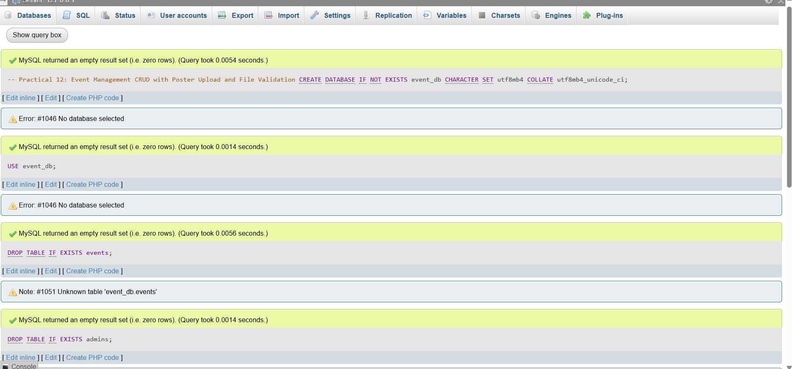

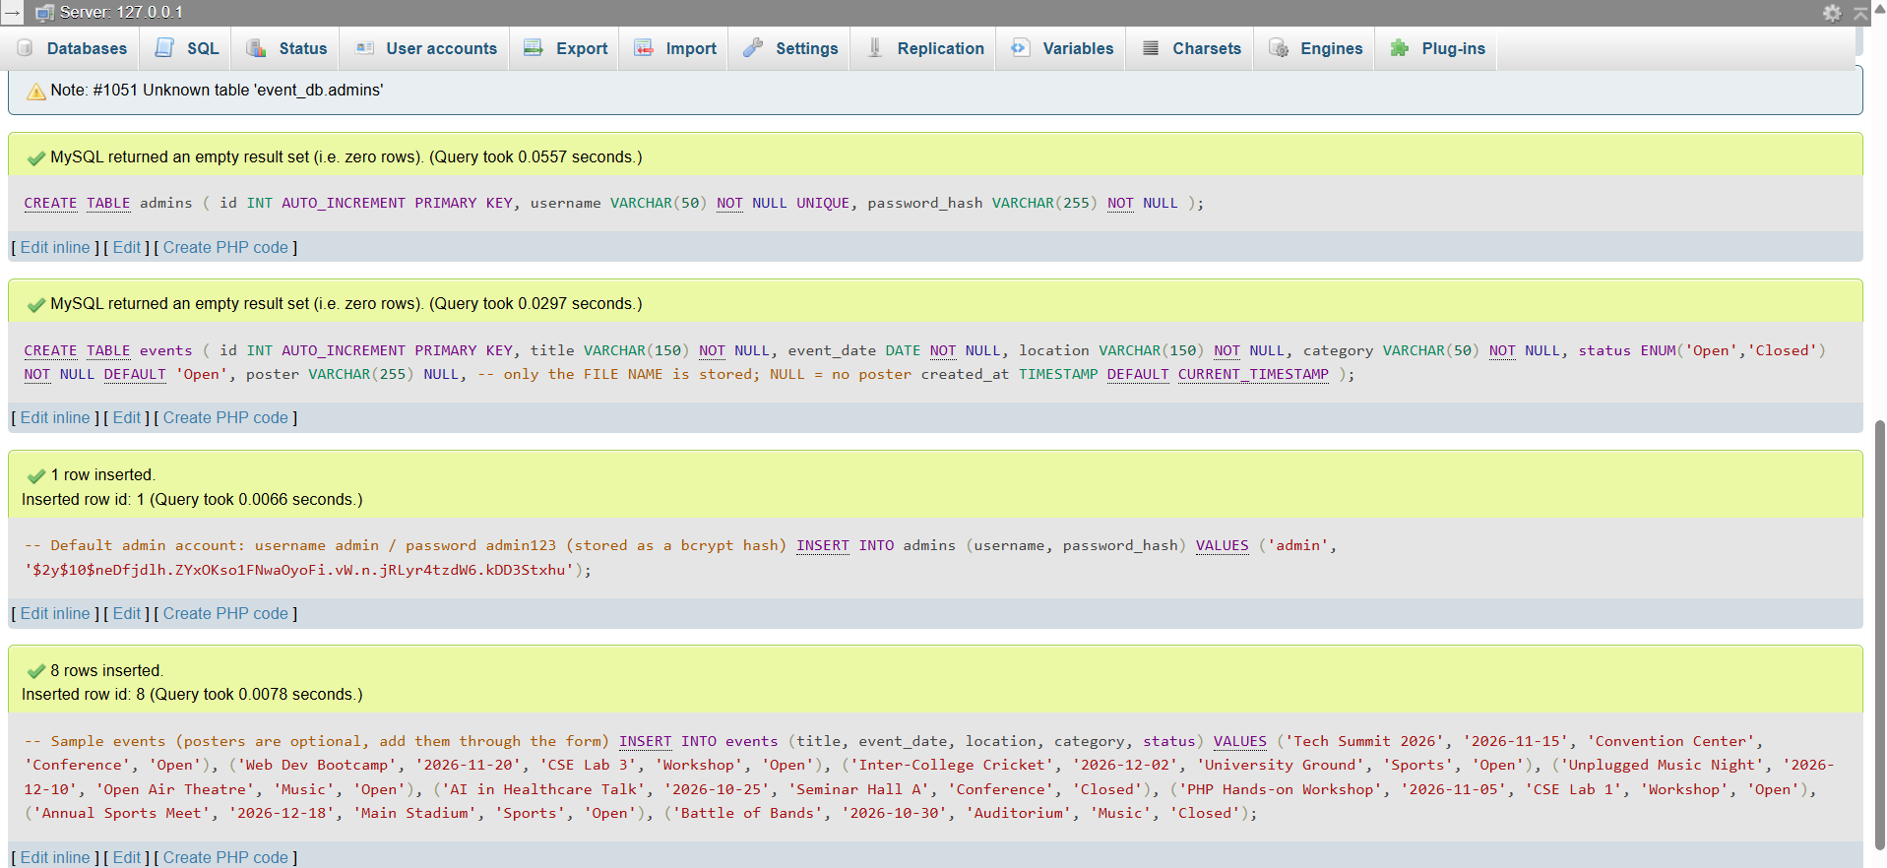

Admin Login and Dashboard
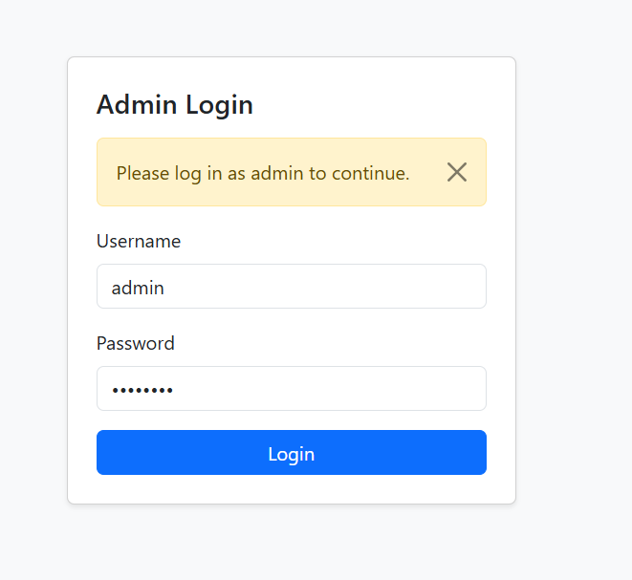

Event list with uploaded posters/
Admin Dashboard
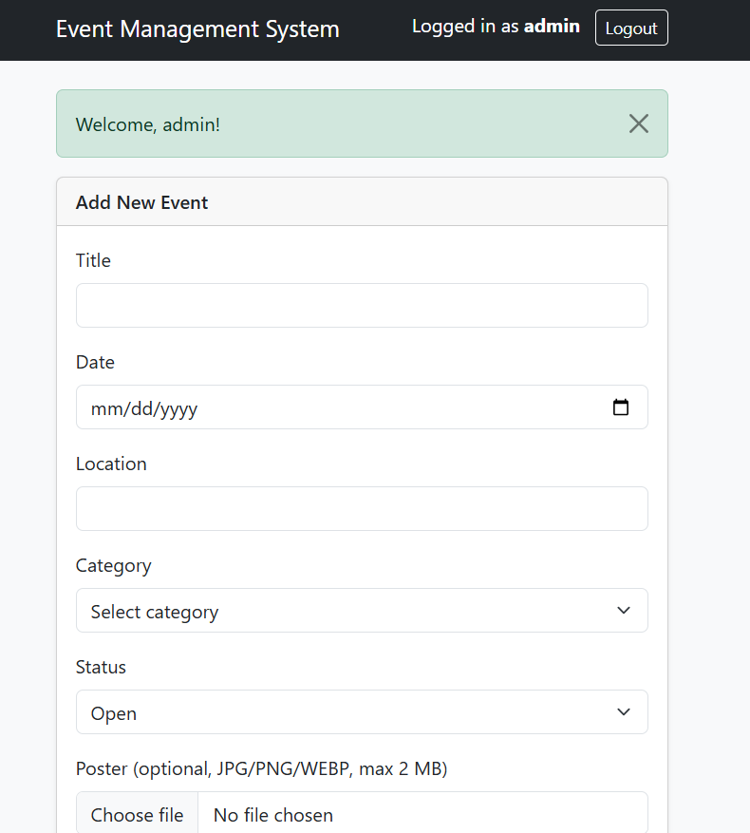

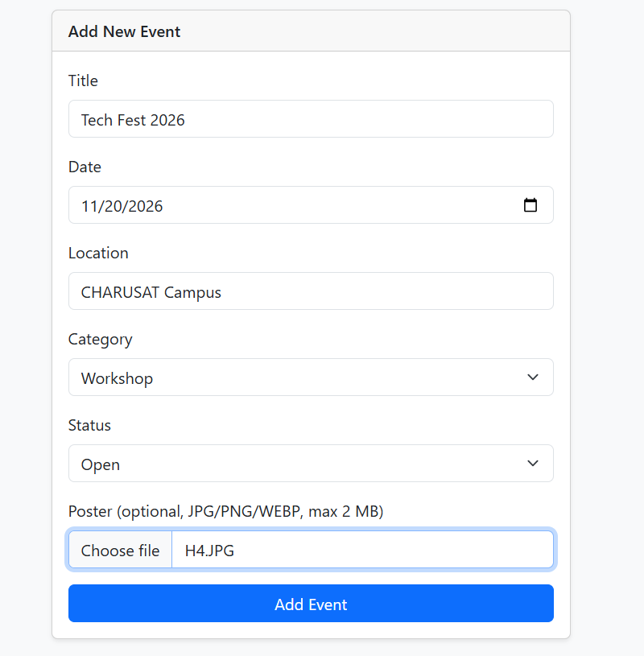

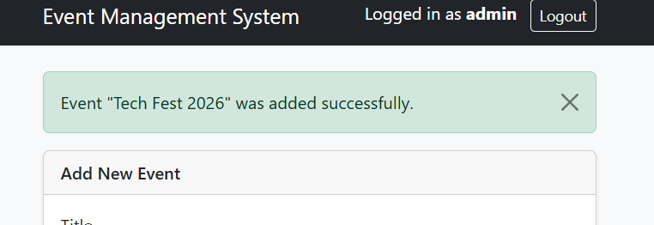

Successful event creation/Valid poster upload/
Add Event with Poster Upload

File size limit validation/
Poster File Size Validation

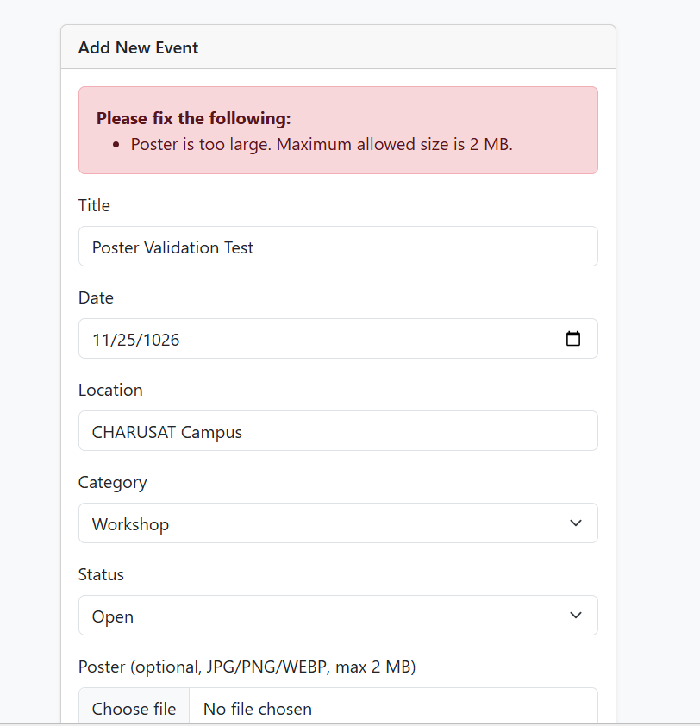

Invalid Poster File Type Validation

Only we can select jpg,png… file (not txt…)
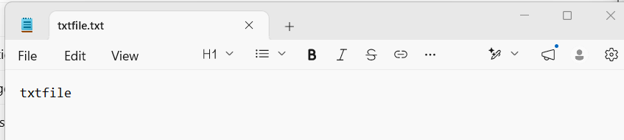

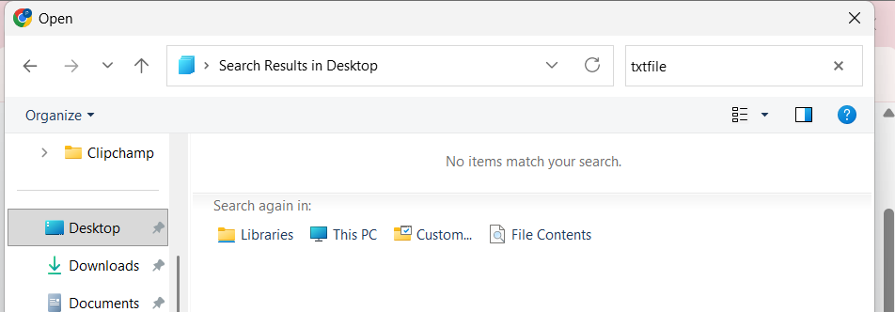

We can see only jpg.png files..

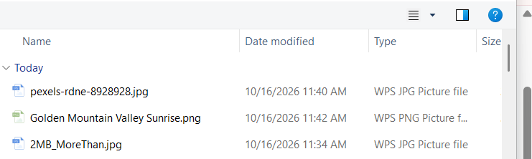

Success and error messages/
Successful Event Update

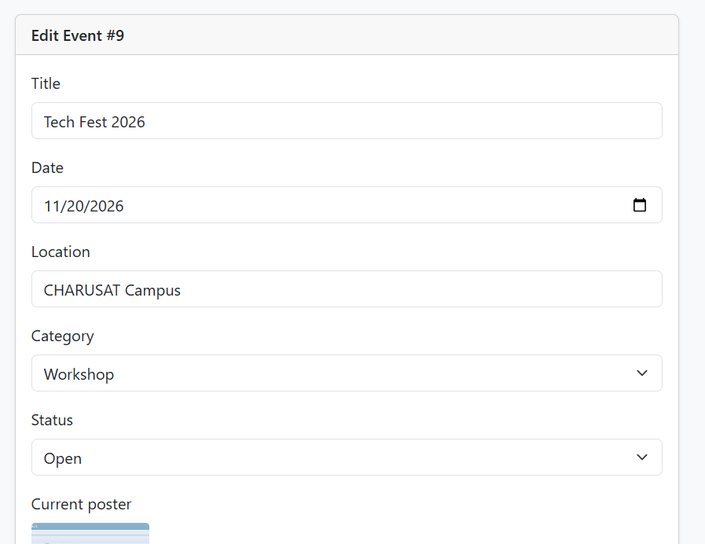

After Update..

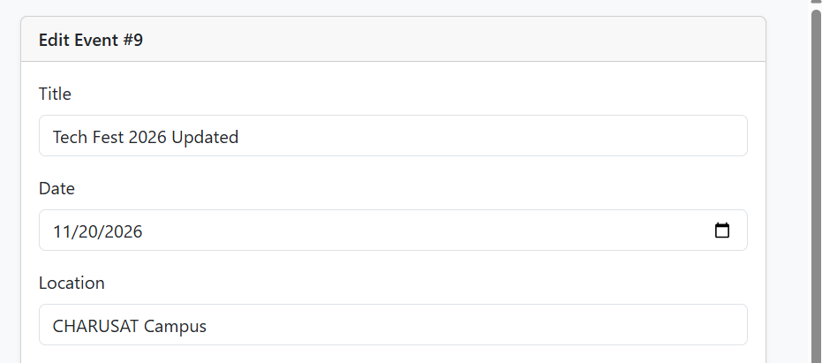

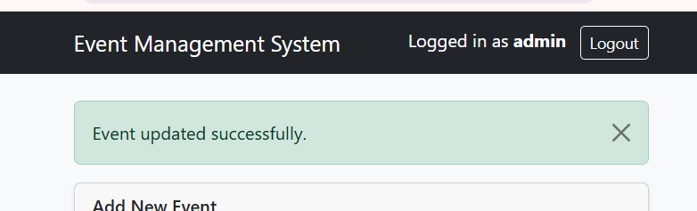

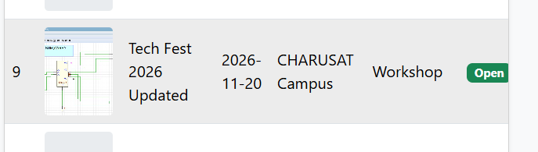

Event Delete Confirmation

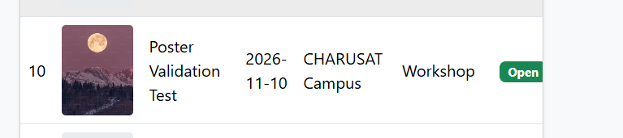

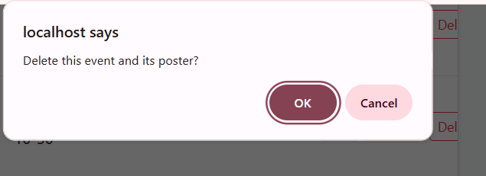

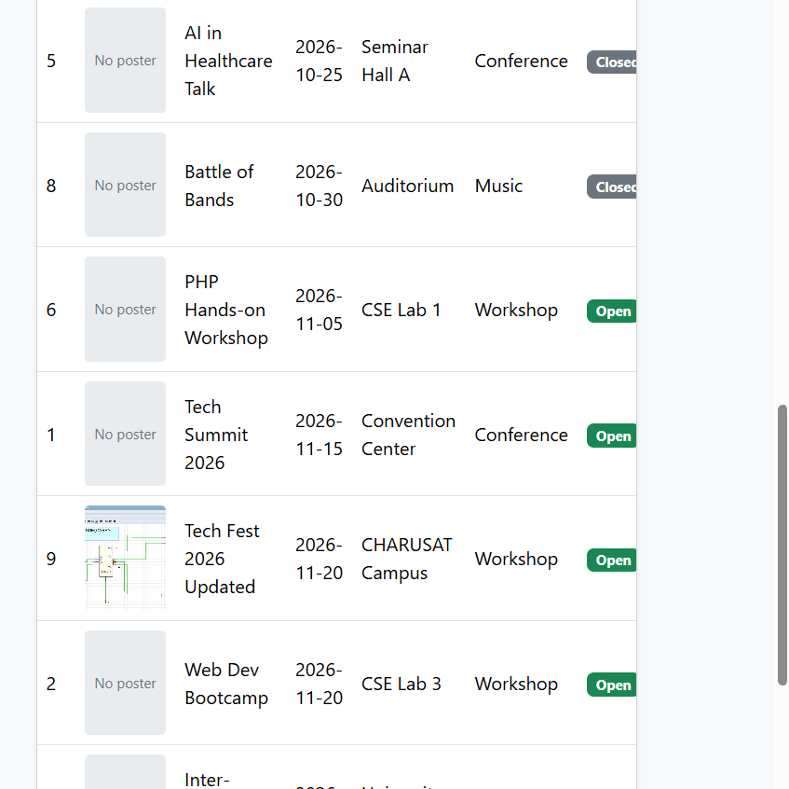

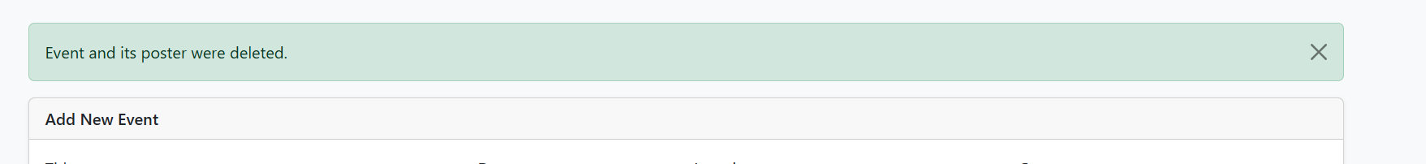

Event Search and Filter

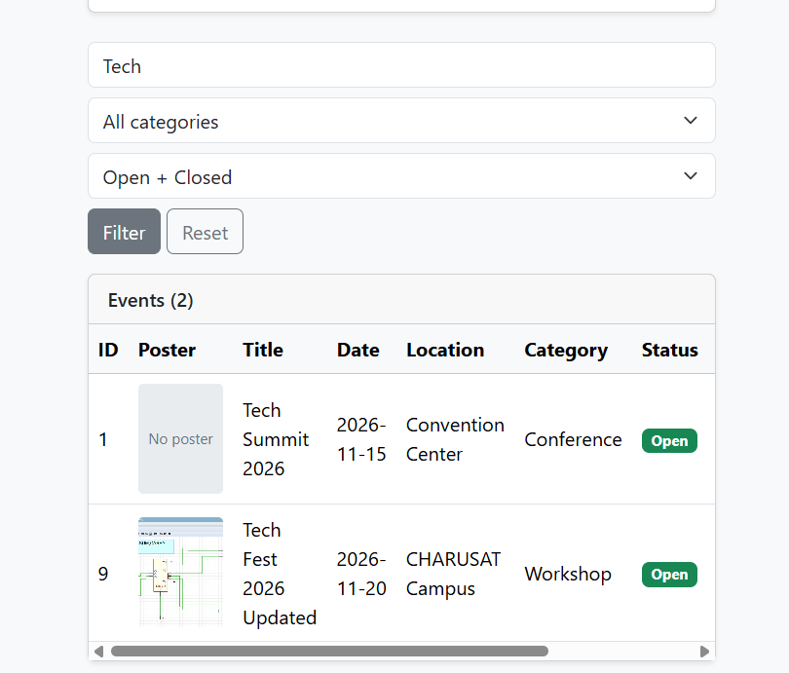

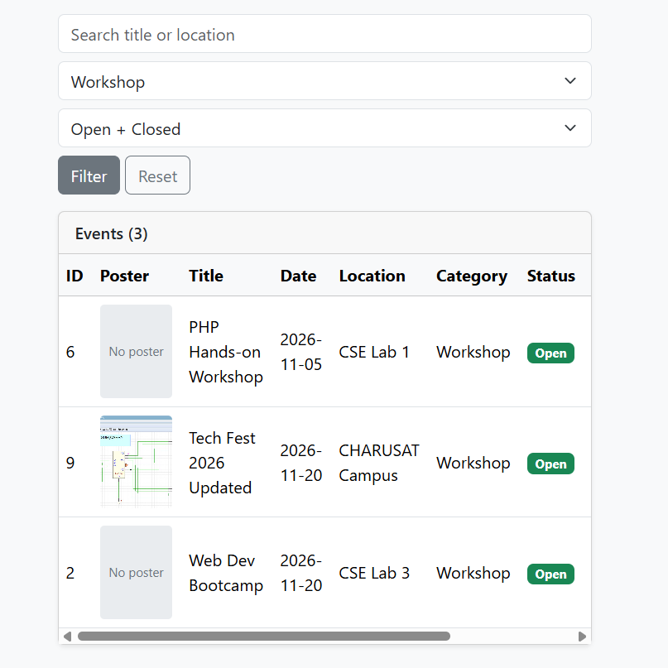

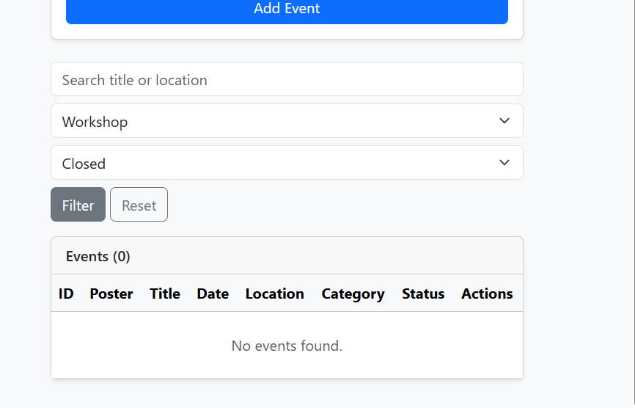

Admin Logout

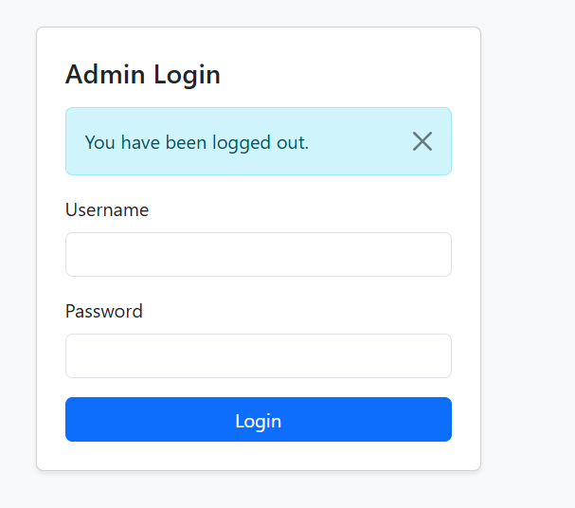

Unauthorized Access Restricted

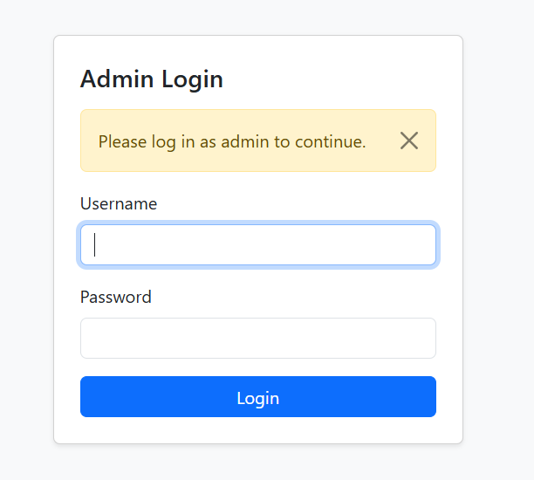

Event Status Update

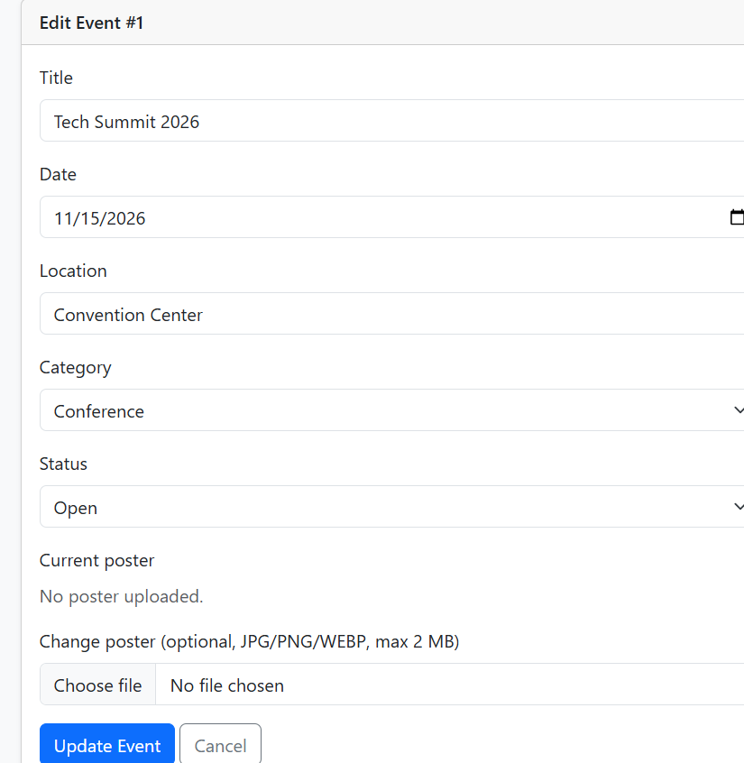

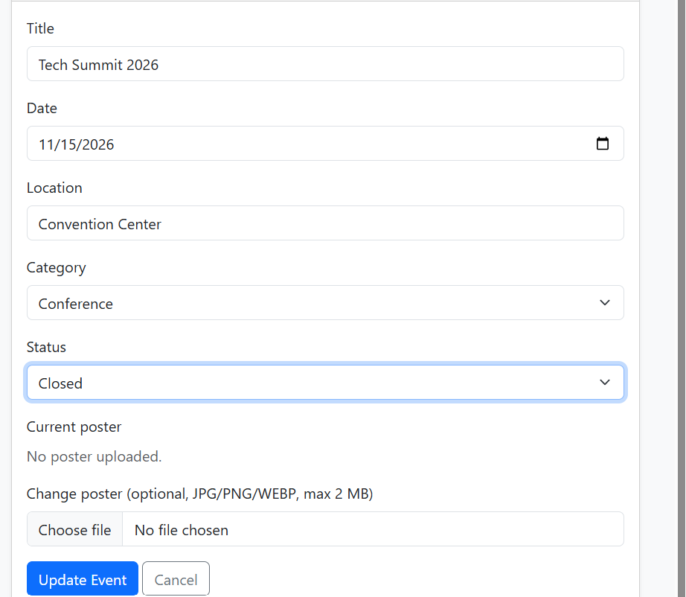

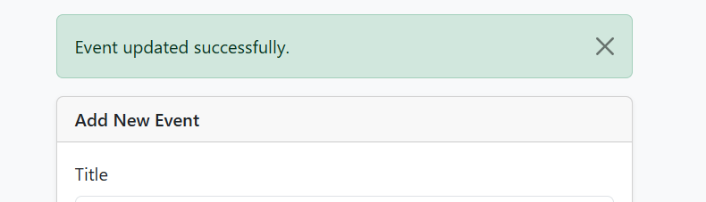

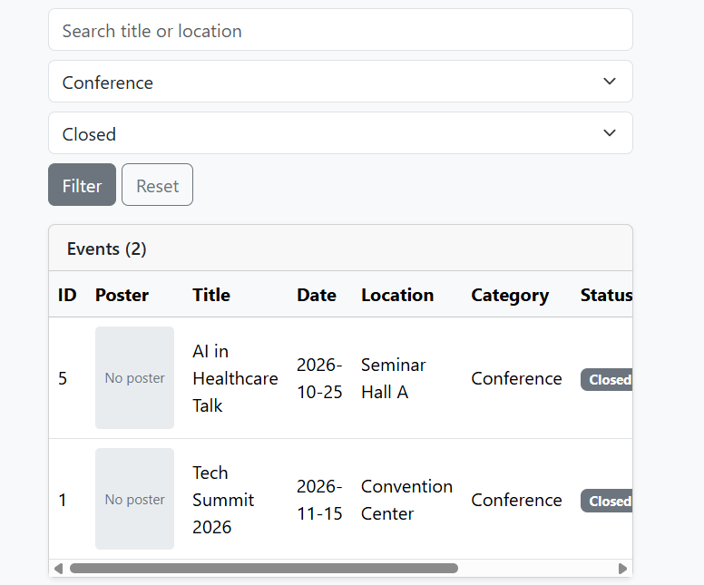

Event Database Records

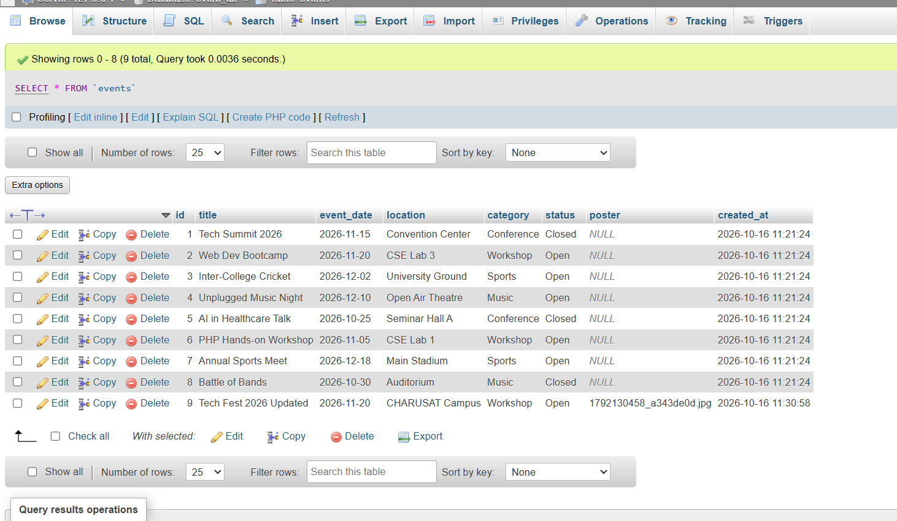

Uploaded Event Poster

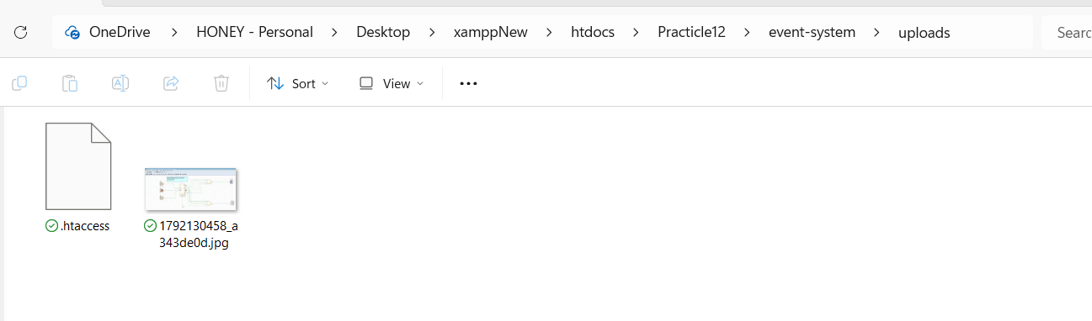

Output :

Learning outcome :

- To understand PHP and MySQL database connectivity.
- To implement CRUD operations for adding, viewing, updating, and deleting events.
- To implement admin login, logout, and unauthorized access protection.
- To upload event posters with file type and file size validation.
- To implement event search, filtering, and status management.
- To display success and error messages for different operations.

GitHub Link

