Title: Climate outweighs human effects on vegetation assemblage dynamics in the Holocene

Authors
Vivian Astrup Felde1,2*†, Ondřej Mottl1,2,3,4*†, Suzette G. A. Flantua1,2*†, Kuber P. Bhatta1, Hilary H. Birks1,2, John-Arvid Grytnes1, Henry Hooghiemstra5, Sandra Nogué6,7, Triin Reitalu8,9, Alistair W. R. Seddon1,2, Manuel J. Steinbauer10, Cajo J. F. ter Braak11, Thomas Giesecke12, Simon J. Goring13,14, Simon G. Haberle15,16, Annika V. Herbert15,16, Petr Šmilauer17, Willy Tinner18, John W. Williams13,14, Darcy Bird19,20, Jacob Freeman21,22, Eugenia Gayo23,24, Julie A. Hoggarth25, Claudio Latorre24,26, Lux Miranda27, Erick Robinson28,29,30, Xianyong Cao31, Fahu Chen31, H. John B. Birks1,2,32

Affiliations
1 Department of Biological Sciences, University of Bergen, Bergen, Norway.
2 Bjerknes Centre for Climate Research, Bergen, Norway.
3 Center for Theoretical Study, Charles University, Prague, Czech Republic.
4 Department of Botany, Faculty of Science, Charles University, Prague, Czech Republic.
5 Institute for Biodiversity and Ecosystem Dynamics, University of Amsterdam, Amsterdam, The Netherlands.
6 Department of Animal Biology, Plant Biology and Ecology, Universitat Autònoma de Barcelona; Bellaterra (Cerdanyola del Vallès), Catalonia, Spain.
7 CREAF, Campus de Bellaterra (UAB) Edifici G, Catalonia, Spain.
8 Institute of Ecology and Earth Sciences, University of Tartu, Tartu, Estonia.
9 Institute of Geology, Tallinn University of Technology, Tallinn, Estonia.
10 Bayreuth Center of Ecology and Environmental Research (BayCEER) & Bayreuth Center of Sport Science (BaySpo), University of Bayreuth, Bayreuth, Germany.
11 Biometris, Wageningen University & Research, Wageningen, The Netherlands.
12 Department of Physical Geography, Utrecht University, Utrecht, The Netherlands.
13 Department of Geography, University of Wisconsin-Madison, Madison, USA.
14 Nelson Institute Center for Climatic Research, University of Wisconsin-Madison, Madison, USA.
15 School of Culture, History and Language, ANU College of Asia and the Pacific, Australian National University, Canberra, Australian Capital Territory, Australia.
16 ARC Centre of Excellence for Indigenous and Environmental Histories and Futures, Australian National University, Canberra, Australian Capital Territory, Australia.
17 Department of Ecosystem Biology, University of South Bohemia, České Budějovice, Czech Republic.
18 Institute of Plant Sciences and Oeschger Centre for Climate Change Research, University of Bern, Bern, Switzerland.
19 Department of Anthropology, Washington State University, Pullman, USA.
20 Florida Museum of Natural History, University of Florida, Gainesville, Florida, USA.
21 Anthropology Program, Utah State University, Logan, USA.
22 The Ecology Center, Utah State University, Logan, USA.
23 Departamento de Geografía & Center for Climate and Resilence Research (CR)2, Universidad de Chile, Santiago, Chile.
24 Departamento de Ecologia, Pontificia Universidad Católica de Chile, Santiago, Chile.
25 Department of Anthropology, Baylor University, Waco, USA.
26 Institute of Ecology and Biodiversity (IEB), Pontificia Universidad Católica de Chile, Santiago, Chile.
27 Department of Information Technology, Uppsala University, Uppsala, Sweden.
28 Native Environment Solutions LLC, Boise, USA.
29 Division of Atmospheric Sciences, Desert Research Institute, USA.
30 School of Human Evolution and Social Change, Arizona State University, Tempe, USA.
31 Group of Alpine Paleoecology and Human Adaptation (ALPHA), State Key Laboratory of Tibetan Plateau Earth System, Environment and Resources (TPESER), Institute of Tibetan Plateau Research, Chinese Academy of Sciences, Beijing, China.
32 Environmental Change Research Centre, University College London, London, UK.
*Corresponding authors.
Emails: vivian.felde@uib.no; ondrej.mottl@gmail.com; s.g.a.flantua@gmail.com
†These authors contributed equally to this study.

Abstract
Although there is consensus that human impacts have shaped ecosystems and biodiversity for millennia, the relative roles of climate and human activity affecting the structure of Holocene ecosystems remain poorly understood. At present, there has been no systematic attempt to determine the relative strength of these two drivers at regional to continental scales. Here, we integrate palaeoecological, archaeological, and palaeoclimate data to quantify the relative importance of climate and human activity in shaping Holocene vegetation assemblage dynamics (8.5 – 2 ka BP). By analyzing 1262 fossil pollen sequences, we examine the responses of nine pollen assemblage properties (PAPs), serving as indirect vegetation assemblage changes and, for the first time, assess how relationships amongst these PAPs change over the study period. We then combine 150,000 radiocarbon dates from archaeological sites with palaeoclimate model output to establish that while human activities had localised impacts, climate was the predominant force influencing vegetation assemblage patterns across continental regions during this period. Whilst human impact during the mid-Holocene was present in some regions, the effects of this human impact was not uniform. Our results challenge the view that human actions were a major driver of changes in broad-scale ecological processes throughout the Holocene.

Main Text

Introduction
Human activity has transformed—and continues to transform—Earth’s terrestrial ecosystems^{1–3}. Over the last centuries, exponential growth in land-use intensity, economic growth, and consumption have had impacts on ecosystems in ways that are unprecedented in geological history^{4–6}. Before the last few hundred years, archaeological and palaeoecological evidence shows that humans have inhabited much of Earth’s land for millennia, transforming natural landscapes into anthropogenic biomes through activities such as burning, deforestation, and cultivation⁷, potentially even influencing global carbon cycling and climate change⁸. The extent of human impact has varied over time, driven by migrations, societal development, technological advancements, and increases in population densities, resulting in regionally distinct rates of vegetation transformation¹.
However, whilst the impacts of human activity on Earth’s ecosystems for the past few centuries are well established, the extent and magnitude of this human impact during earlier periods, particularly on vegetation composition and associated ecological processes, remains under exploration⁹. Lyons et al.¹⁰ presented evidence that human activity was so pervasive that underlying ecological characteristics of communities were modified in the middle Holocene (~6 ka BP), arguing that dominant patterns in taxon co-occurrence patterns shifted from facilitative to competitive interactions as a result of human activity (although see the replies by Bertelsmeier & Ollier¹¹ and Telford et al.¹²). Mottl et al.¹³ reported evidence of consistent increases in rates-of-change in pollen assemblages at continental scales since as early as 4.6 ka BP, likely the result of increased human activity and land-use change, although no attribution studies were carried out to confirm this assumption. Recent syntheses of palaeoecological and archaeological evidence have suggested that humans have likely shaped most of nature over the last 12 ka BP (i.e. Holocene), but evidence indicates that this human impact has occurred at different extents and intensities across continental regions^{7,14–16}. Thus, detection and attribution of ecological changes in relation to human activity in the Holocene remains an important area of research if we are to understand the legacy of past drivers of change on shaping present-day ecosystem patterns.
A number of processes can influence the structure and composition of an ecological community at a given point in time¹⁷. For example, in addition to land-use change and disturbance related to human activity, climate also plays a major role in structuring vegetation communities, particularly on centennial to millennial timescales^{18–21}. Environmental proxies from ice cores and deep-sea records have confirmed that climate fluctuations during the Pleistocene and the Holocene periods correspond with vegetation dynamics at regional and continental scales²². However, the relative roles of climate and human activity in shaping the structure and function of ecosystems, particularly at larger scales (e.g. regional to continental) within the Holocene period, remains poorly understood. At present, there has been no systematic attempt to disentangle the relative strength of these two drivers during such a critical period of Earth system transformation.
Here, we assembled a global dataset based on fossil pollen data, archaeological remains, and past climate variability (see Methods) to investigate the effects of both climate and human activity on vegetation assemblage dynamics —as inferred from pollen assemblages—in the Holocene. We standardised 1262 fossil pollen sequences from North America, Central and South America, Europe, Asia, and Oceania (Fig. 1; Extended Fig. 1) and converted them into nine metrics, each of which reflect different properties of past vegetation assemblage change, including composition, diversity and rates-of-change (Table 1). Since these are derived from pollen assemblages, we stress that these are indirect representations of vegetation assemblage change, hereafter defined as pollen assemblage properties²³ (PAPs, see Methods).
We then combined our fossil pollen data with archaeological evidence of past human activity based on two sources: (i) summed probability density (SPD) from over 150,000 archaeological radiocarbon dates²⁴, a validated proxy that goes beyond mere presence-absence indicators by reflecting the intensity and frequency of human activities in a given region^{25,26} (See Methods), and (ii) a series of “human-impact events”, derived from expert-based detection of patterns of anthropogenic indicator taxa in pollen diagrams (Extended Fig. 2, Methods). Note that we chose to focus on period between 8.5 – 2 ka BP, since there is a lack of radiocarbon datasets for the last two millennia in Europe and Asia²⁴ (Table 2). Finally, we used the CHELSA-TraCE21k Paleoclimate database²⁷ to extract climate predictors related to summer and winter precipitation, mean annual temperature, and minimum temperature of the coldest month.
We used this data compilation to test two hypotheses. The first hypothesis (H1) proposes that human impact was the primary driver of changes in PAPs at continental and subcontinental scales between 8.5 and 2 ka BP. We assessed the relative importance of human impact compared to climate, both spatially (by comparing fossil pollen sequences within climate zones and continents) and temporally (by examining trends across time slices). If human impact is an important driver of change in past patterns in PAPs, we expect its importance to match or exceed the importance of climate across both spatial and temporal dimensions. The second hypothesis (H2) proposes that human impact significantly altered the relationships among the different PAPs within these regions during the same time-period. If human impact was pervasive in the Holocene, we expect that they altered the covariance between the PAPs within different climate zones on continental regions.

Results

H1: Holocene human impact secondary to palaeoclimate
We used hierarchical variation partitioning (HVARPART) within a redundancy analysis (RDA)²⁸ to assess how each predictor—human activities and palaeoclimate—contributes to changes observed in the PAPs, in individual sequences (i.e. Fig. 1, Extended Fig. 3). We find that palaeoclimate has substantially greater importance than past humans in shaping the patterns of PAPs at continental and subcontinental scales (Fig. 2). Our spatial analysis shows high variation in the ratios of predictor importance of past humans and palaeoclimate across the middle to late Holocene (Fig. 2). While both have influenced the patterns in the vegetation metrics at individual sequences—with ratios of importance ranging between 0 and 1—the relative importance of climate increases with spatial scale. For example, at the climate-zone level, weighted mean ratios range from 0–0.71 for humans and 0.29–1 for palaeoclimate. At continental scales, these ratios are 0.15–0.32 for humans and 0.68–0.85 for palaeoclimate. Although palaeoclimate dominates, the impact of past humans is more pronounced in certain climate zones (not in the Polar and Cold climate zones) than its mean importance across all continents. Findings from Oceania, based on fewer than five sequences, lack robustness and should be interpreted with caution.
In addition to assessing the overall contribution of human impact and climate to the patterns in PAPs, we conducted a temporal analysis using both the summed probability densities (SPD) or human-impact events as predictors, to investigate how the importance of these two variables changed over time. Here, we find that palaeoclimate consistently emerges as the predominant factor influencing temporal variations in the spatial patterns of the PAPs across continents (Fig. 3). Trends are generally consistent among the different regions, though some exceptions exist. In Asia, the importance of humans as indicated by SPD is probably underestimated due to limited radiocarbon dates after 3.5 ka BP, whereas the human-impact events delimited by experts indicate increasing human influence. In Europe, the influence of humans is similarly underestimated after 3 ka BP, although the level of influence estimated by the human-impact events remains relatively stable after this time (Fig. 3). The weighted mean ratios comparing the influence of human population (SPD) and human-impact events to palaeoclimate are presented in Extended Table 3 and Extended Table 4.

H2: Assessing the predictor importance for changes in interrelationships between PAPs
Our second hypothesis explores the stability of relationships among PAPs, over time. Specifically, we aim to determine whether changes in these relationships can be attributed to human activity or climate changes, thereby assessing the drivers behind the observed ecological dynamics. We used principal component analysis (PCA) and symmetrical Procrustes sum-of squares (m2) to quantify the change in covariance among the PAPs between each pair of time slices within the climate zones²⁹ (Methods). This results in pairwise m2 distance matrices that are subsequently used as response variables in a second hierarchical variation partitioning (HVARPART) analysis (Methods). Mean trends of humans and climate within different continental climate zones, derived by hierarchical generalised additive modelling (HGAM)³⁰ are integrated as predictors (Extended Fig. 4, Extended Fig. 5, Extended Fig. 6, Extended Fig. 7, Extended Fig. 8). The results are summarised in Fig. 4, which show how relationships between our different PAPs evolve over time, stratified by climate zones and continents. Starting at 8.5 ka BP, one can trace the evolving relationship between PAPs for a given climate zone by assessing how its trajectory moves through the ordination space in two dimensions. A stable relationship results in a trajectory spanning regions of the ordination space closer to the origin, while trajectories that span a larger area of ordination space indicate larger directional changes in the interrelationships among one or several metrics. The direction of the arrows illustrates how temporal changes in the interrelationships among PAPs correlate with human or climatic influences, whilst the length represents the strength of these influences, with longer arrows signifying greater correlations.
Based on this analysis, we find notable differences in the importance of humans as predictor for these changes in different continents, represented by the ratios of importance bars (Fig. 4), but observe that palaeoclimate plays a stronger role in most climate zones. Notably, the coldest regions, particularly Europe and North America’s Polar, Cold, and Temperate without dry season zones, show considerably less change in the interrelationships of PAPs compared to other climate zones. This may suggest a climatic filtering effect on the PAPs, with underlying ecological processes either remaining unchanged or changing synchronously throughout the investigated period. In contrast, regions with higher environmental variation—in Cold, Temperate, Tropical, and Arid zones—show more dynamic change (i.e. time trajectories spanning larger areas of the ordination space and evolving in different directions), mainly caused by climatic variability, but also influenced in some regions by varying degrees of past human impact. Interestingly, this analysis demonstrates that past human activities correlate with different climate variables across various climate zones, as evidenced in Fig. 4. Predictor variables that point in the same direction along the gradient indicate positive correlations. We observe that the arrows representing climate variables often point in directions that are distinct from those representing the human predictor, and there are no clear patterns between the different climate zones and continents.

Discussion
Our study used palaeoecological, archaeological, and palaeoclimate data to investigate two hypotheses about the Holocene extent of human impact on past vegetation assemblage dynamics (8.5 and 2 ka BP.). Our first hypothesis proposed that human impact was the primary driver of changes in PAPs, at continental and subcontinental scales between 8.5 and 2 ka BP. Our second hypothesis proposed that the interrelationships between these PAPs were affected by human activity between 8.5 and 2 ka BP. However, while our data show that it is likely that past humans have acted as strong disturbance factors at specific sites affecting establishment, abundance, and succession of past taxon populations, their overall importance is considerably lower than that of palaeoclimate changes. We also find that the influence of human activity consistently increases with decreasing spatial scale. Taken together, we refute both hypotheses and suggest that human impact was not a significant factor in driving vegetation assemblage dynamics at continental to global scales in the study period.
This finding contrasts with a number of previous studies that have identified evidence of humans dominating vegetation and land-use change in the Holocene^{15,31–34}. One possible explanation is that, in our studied time window, prehistoric human populations were likely small and local, and therefore regional pollen rain masks any small local effects on vegetation in the landscape. Thus, although humans were most likely present across all regions, population densities and land-use type and intensity varied spatially¹, and so the timing and extent of human-impact events also varied considerably between individual sites. As a result, these local human impacts were less significant than any abiotic filtering reflected by climate, which remained the most important predictor in our analysis at continental to global scales.
We also note that, whilst other studies have focussed on land-use changes based on reconstructions of either landcover or anthropogenic biomes^{32,35}, our study goes beyond previous reconstructions of land-use by using PAPs. These PAPS reflect a broader set of vegetation assemblage processes (Table 1) and may not necessarily be correlated with land-use change typically inferred from pollen assemblage composition (e.g. changes in composition do not necessarily imply alterations in species richness). Furthermore, whilst a number of studies have assessed variations in individual PAPs across regions^{e.g. 14,23,31,36}, ours is the first to provide a more holistic perspective, using a multivariate framework to analyse all nine metrics of past vegetation assemblage changes and their interrelationships influenced by humans and climate simultaneously. Such multivariate analyses of PAPs represent a new approach in palaeoecology and more research is needed to understand how variations in these different assemblage properties are influenced by different types of human land-use and other factors.
We emphasise that our findings do not negate the effects of human activity in the Holocene. For example, our analysis indicates that whilst high impact-events, such as total forest clearance, do not show a consistently increasing pattern across regions, certain subcontinental regions do show a consistent increase in the extent of human impact during the period investigated, particularly the first impact of anthropogenic activity and the start of agriculture (Extended Fig. 9). Similarly, whilst our results did indicate that human impact on PAPs at continental scales is more pronounced after ~5 ka BP, this influence was neither spatially coherent nor consistent. For example, human importance surpassing palaeoclimate is observed in Asia (human-impact events) and Oceania (human-impact events and SPD) at 2.5 ka BP and 2.0 ka BP, respectively (Fig. 3). In contrast, for many other regions (e.g. North America, Central and South America, and Europe), palaeoclimate remains the dominant driver in PAPs throughout the Holocene, despite increasing human importance after ~2.0, 1.0, or 3.5 ka BP, respectively. Thus, our results indicate that the site-specific effect of human impact should not be generalised to a continental or global scale and emphasise the importance of climate in shaping the underlying characteristics of the ecological assemblages in the study period.
Such results have several implications for understanding the long-term interactions of humans and of both past and present ecosystems. First, a number of studies have argued that Holocene human impacts on vegetation assemblages were extensive, potentially even affecting the general rules that govern the formation of biotic assemblages through time¹⁰. If this was the case, then we would expect differences in both the drivers of the patterns in PAPs (H1) and their associations (H2). Our results do not reveal such differences. While we cannot reject the evidence of human impact locally, we emphasise that at, larger scales, climate has remained a dominant predictor of the patterns in our PAPs between 8.5 and 2 ka BP, and any human impacts that did occur were not large enough to result in widespread and universal ecosystem change. Such findings also support the idea that, whilst human impact during the mid Holocene was present in some regions, the effects of human impact are not uniform and so context dependency remains essential for understanding present-day ecosystems.
Second, our findings align with recent global assessments¹⁴ and may help to explain the absence of coherent tipping points in terrestrial ecosystems. The high heterogeneity among regions, with the spatially variable influence of climatic factors and the interactions among taxa, contributes to highly variable assemblage dynamics both temporally and spatially. Such heterogeneity complicates the detection and quantification of overarching trends at a continental or global scale, as it tends to obscure any consistent patterns.
Third, we caution against a prevailing narrative that human transformation of the terrestrial biosphere is always destructive⁷. Our results are in line with other recent studies that human impact has been present in the Holocene, but interestingly, our results support the idea that the effects of preindustrial societies on vegetation assemblage dynamics were less influential than other drivers at continental to global scales^{37–39}. Numerous studies have highlighted the positive effects of human land-use through indigenous knowledge relating to sustainable land-management^{9,40–42}. Although it is evident that some societies have caused substantial ecosystem changes and even local extinctions in the past, our results indicate that climate was the primary driver of underlying ecological processes at regional to continental scales during these times.
Fourth, whilst our results refute both hypotheses about the direct impacts of human activity on PAPs in comparison to climate, our analysis cannot refute the possibility that climate indirectly influenced ecological processes via human impact, such as the effects on harvest yields, carrying capacities, and consequently, population densities⁴³. This complexity makes it challenging to separate the impacts of human activities from those of climate. For instance, in analyses that do not account for feedback loops between humans and vegetation, such as the feedbacks among drought, fire and human activity, all change might be attributed to climate, even though human impact, such as fire management or grazing, could be equally influential if they are closely coupled to climate change⁴⁴. Our second analysis show correlations between humans and climate in different climate zones. These results may argue for a third hypothesis that human activity, particularly farming, was co-shaped by climatic change⁴⁵. These findings underscore the need for further research to fully understand these complex interdependencies.
Note that because of data limitations, our study focuses on the period between 8.5 and 2 ka BP. At present, the lack of availability of 14C dating for the last 2 millennia makes human population density reconstructions unreliable, but there is widespread evidence of human impact from other sources from this period^{46,47}. For example, Mottl et al. found continental scale increases in rates-of-change starting between 4.6 and 2 ka BP in different regions, with largest effects in the more recent times. Thus, whilst the impacts of human activity are limited in comparison with climate in our study period, we cannot evaluate the effects of preindustrial societies in the most recent millennia. In some regions, the significance of these effects may be heightened by evolving social cultures and complexities during specific archaeological periods^{7,47}. These are historically documented periods of human introduction of many new plants to different continents⁴⁸, which has been linked to increases in pollen richness estimates and compositional changes³¹. At present, there remains a crucial gap that needs to be bridged between localized effects identified in prehistoric land-use and the larger scale transformations since 1950, related to the Great Acceleration⁴⁹.
Similarly, the climate model data that we use are generally appropriate for characterising mean changes. However, there may be mismatches between these data and pollen data, which are often collected from sequences near ecotone transitions to investigate past environmental changes. Such mismatches can arise because the climate models represent broader regional conditions that may not align perfectly with the specific localities from which pollen data are gathered. Additionally, inherent biases of pollen data, such as varying taxonomic resolution and the relative abundances of pollen types influenced by pollen production and dispersal properties, can also mask changes in the PAPs. These biases are further complicated by factors like vegetation density and structure, affecting the likelihood of pollen reaching a site⁵⁰. To mitigate these issues, our data processing efforts have been designed to reduce the effect of varying taxonomical resolution, different sizes of pollen sums, and unevenly spaced temporal data points. This processing ensured that the inherent biases in the pollen data are more systematic within subcontinental regions, yielding a similar bias across sequences within the climate zones.

Conclusion
The integration of 1262 fossil pollen sequences, archaeological radiocarbon dates, and palaeoclimate data into a large database has allowed us to examine the relative influences of human activity and palaeoclimate on pollen assemblage properties, from 8.5-2.0 ka BP at the global scale. At global to sub-continental scales, our results show that regional climate variability was more important than human activity in driving major vegetation assemblage patterns. Our results caution against extrapolating localised, intense human impacts to broader spatial scales, as we do not find evidence that these reflect widespread or global trends. Our study reinforces the essential role of interdisciplinary research in disentangling the confounding effects of human and climatic influences on past ecosystems.

References
1. Ellis, E. C. et al. Used planet: A global history. Proceedings of the National Academy of Sciences 110, 7978–7985 (2013).
2. Díaz, S. et al. Pervasive human-driven decline of life on Earth points to the need for transformative change. Science 366, eaax3100 (2019).
3. Rockström, J. et al. Safe and just Earth system boundaries. Nature 619, 102–111 (2023).
4. Barnosky, A. D. Palaeontological evidence for defining the Anthropocene. Geological Society, London, Special Publications 395, 149–165 (2014).
5. Steffen, W. et al. Trajectories of the Earth System in the Anthropocene. Proceedings of the National Academy of Sciences 115, 8252–8259 (2018).
6. Albert, J. S. et al. Human impacts outpace natural processes in the Amazon. Science 379, eabo5003 (2023).
7. Ellis, E. C. et al. People have shaped most of terrestrial nature for at least 12,000 years. Proceedings of the National Academy of Sciences 118, e2023483118 (2021).
8. Ruddiman, W. F. The Anthropogenic Greenhouse Era Began Thousands of Years Ago. Climatic Change 61, 261–293 (2003).
9. Boivin, N. L. et al. Ecological consequences of human niche construction: Examining long-term anthropogenic shaping of global species distributions. Proc. Natl. Acad. Sci. U.S.A. 113, 6388–6396 (2016).
10. Lyons, S. K. et al. Holocene shifts in the assembly of plant and animal communities implicate human impacts. Nature 529, 80–83 (2016).
11. Bertelsmeier, C. & Ollier, S. Questioning Holocene community shifts. Nature 537, E4–E5 (2016).
12. Telford, R. J., Chipperfield, J. D., Birks, H. H. & Birks, H. J. B. How foreign is the past? Nature 538, E1–E2 (2016).
13. Mottl, O. et al. Global acceleration in rates of vegetation change over the past 18,000 years. Science 372, 860–864 (2021).
14. Gordon, J. D., Fagan, B., Milner, N. & Thomas, C. D. Floristic diversity and its relationships with human land use varied regionally during the Holocene. Nat Ecol Evol 1–13 (2024) doi:10.1038/s41559-024-02457-x.
15. Nogué, S. et al. The human dimension of biodiversity changes on islands. Science 372, 488–491 (2021).
16. Cao, X. et al. Human activities have reduced plant diversity in eastern China over the last two millennia. Global Change Biology 28, 4962–4976 (2022).
17. Jackson, S. T. & Blois, J. L. Community ecology in a changing environment: Perspectives from the Quaternary. Proceedings of the National Academy of Sciences 112, 4915–4921 (2015).
18. Williams, J. W., Shuman, B. N., Webb III, T., Bartlein, P. J. & Leduc, P. L. Late-Quaternary Vegetation Dynamics in North America: Scaling from Taxa to Biomes. Ecological Monographs 74, 309–334 (2004).
19. Huntley, B. European vegetation history: Palaeovegetation maps from pollen data - 13 000 yr BP to present. Journal of Quaternary Science 5, 103–122 (1990).
20. Williams, J. W., Shuman, B. N. & Webb III, T. Dissimilarity Analyses of Late-Quaternary Vegetation and Climate in Eastern North America. Ecology 82, 3346–3362 (2001).
21. Williams, J. J. W. Quaternary Vegetation Distribution. in Encyclopedia of Paleoclimatology and Ancient Environments (ed. Gornitz, V.) 856–861 (Springer Netherlands, Dordrecht, 2009). doi:10.1007/978-1-4020-4411-3_199.
22. Webb III, T. & Bartlein, P. J. Global Changes During the Last 3 Million Years: Climatic Controls and Biotic Responses. Annual Review of Ecology, Evolution and Systematics 23, 141–173 (1992).
23. Bhatta, K. P. et al. Exploring spatio-temporal patterns of palynological changes in Asia during the Holocene. Frontiers in Ecology and Evolution 11, (2023).
24. Bird, D. et al. p3k14c, a synthetic global database of archaeological radiocarbon dates. Sci Data 9, 27 (2022).
25. Zahid, H. J., Robinson, E. & Kelly, R. L. Agriculture, population growth, and statistical analysis of the radiocarbon record. Proceedings of the National Academy of Sciences 113, 931–935 (2016).
26. Robinson, E., Bocinsky, R. K., Bird, D., Freeman, J. & Kelly, R. L. Dendrochronological dates confirm a Late Prehistoric population decline in the American Southwest derived from radiocarbon dates. Philosophical Transactions of the Royal Society B: Biological Sciences 376, 20190718 (2020).
27. Karger, D. N., Nobis, M. P., Normand, S., Graham, C. H. & Zimmermann, N. E. CHELSA-TraCE21k – high-resolution (1 km) downscaled transient temperature and precipitation data since the Last Glacial Maximum. Climate of the Past 19, 439–456 (2023).
28. Lai, J., Zou, Y., Zhang, J. & Peres-Neto, P. rdacca.hp: an R package for generalizing hierarchical and variation partitioning in multiple regression and canonical analysis. 2021.03.09.434308 Preprint at https://doi.org/10.1101/2021.03.09.434308 (2021).
29. Peres-Neto, P. R. & Jackson, D. A. How well do multivariate data sets match? The advantages of a Procrustean superimposition approach over the Mantel test. Oecologia 129, 169–178 (2001).
30. Pedersen, E. J., Miller, D. L., Simpson, G. L. & Ross, N. Hierarchical generalized additive models in ecology: an introduction with mgcv. PeerJ 7, e6876 (2019).
31. Giesecke, T. et al. Postglacial change of the floristic diversity gradient in Europe. Nat Commun 10, 5422 (2019).
32. Marquer, L. et al. Quantifying the effects of land use and climate on Holocene vegetation in Europe. Quaternary Science Reviews 171, 20–37 (2017).
33. Reitalu, T. et al. Long-term drivers of forest composition in a boreonemoral region: the relative importance of climate and human impact. Journal of Biogeography 40, 1524–1534 (2013).
34. Kuosmanen, N. et al. The role of climate, forest fires and human population size in Holocene vegetation dynamics in Fennoscandia. Journal of Vegetation Science 29, 382–392 (2018).
35. Ellis, E. C. Anthropogenic transformation of the terrestrial biosphere. Philosophical Transactions of the Royal Society A: Mathematical, Physical and Engineering Sciences 369, 1010–1035 (2011).
36. Blarquez, O., Carcaillet, C., Frejaville, T. & Bergeron, Y. Disentangling the trajectories of alpha, beta and gamma plant diversity of North American boreal ecoregions since 15,500 years. Frontiers in Ecology and Evolution 2, (2014).
37. Fuller, R. J., Williamson, T., Barnes, G. & Dolman, P. M. Human activities and biodiversity opportunities in pre-industrial cultural landscapes: relevance to conservation. Journal of Applied Ecology 54, 459–469 (2017).
38. Marinova, E., Kirleis, W. & Bittmann, F. Human landscapes and climate change during the Holocene. Veget Hist Archaeobot 21, 245–248 (2012).
39. Briere, M. D. & Gajewski, K. Holocene human-environment interactions across the Northern American prairie-forest ecotone. Anthropocene 41, 100367 (2023).
40. Abrams, M. D. & Nowacki, G. J. Native Americans as active and passive promoters of mast and fruit trees in the eastern USA. The Holocene 18, 1123–1137 (2008).
41. Carter, V. A. et al. Legacies of Indigenous land use shaped past wildfire regimes in the Basin-Plateau Region, USA. Commun Earth Environ 2, 1–9 (2021).
42. Fletcher, M.-S., Hamilton, R., Dressler, W. & Palmer, L. Indigenous knowledge and the shackles of wilderness. Proceedings of the National Academy of Sciences 118, e2022218118 (2021).
43. Ljungqvist, F. C., Seim, A. & Huhtamaa, H. Climate and society in European history. WIREs Climate Change 12, e691 (2021).
44. Napier, J. D. & Chipman, M. L. Emerging palaeoecological frameworks for elucidating plant dynamics in response to fire and other disturbance. Global Ecology and Biogeography 31, 138–154 (2022).
45. Dearing, J. A. Climate-human-environment interactions: resolving our past. Climate of the Past 2, 187–203 (2006).
46. Jenny, J.-P. et al. Human and climate global-scale imprint on sediment transfer during the Holocene. Proceedings of the National Academy of Sciences 116, 22972–22976 (2019).
47. Stephens, L. et al. Archaeological assessment reveals Earth’s early transformation through land use. Science 365, 897–902 (2019).
48. Flantua, S. G. A. & Hooghiemstra, H. Anthropogenic pollen indicators: Global food plants and Latin American human indicators in the pollen record. Sci Data 10, 721 (2023).
49. Steffen, W., Broadgate, W., Deutsch, L., Gaffney, O. & Ludwig, C. The trajectory of the Anthropocene: The Great Acceleration. The Anthropocene Review 2, 81–98 (2015).
50. Odgaard, B. V. Fossil pollen as a record of past biodiversity. Journal of Biogeography 26, 7–17 (1999).

Acknowledgments
We thank Cathy Jenks for editorial help, and Beate Helle for help with figure design. We thank and acknowledge all data contributors and data curators of the open accessible databases we have used. We dedicate this manuscript to Eric C. Grimm (1951–2020), who was initially involved in the HOPE project. We express our deep gratitude for his long dedication and ground-breaking work in palaeoecological research, and his initiatives in developing the Neotoma Palaeoecology Database and Community.

Funding
European Research Council Advanced Grant Humans on Planet Earth – Long-term impacts on biosphere dynamics (HOPE) awarded to HJBB (grant no. 741413) (HJBB, VAF, OM, SGAF, KPB, MJS, AWRS, HHB, JAG)
Trond Mohn Research Foundation (TMF) Startup Grant “Past, Present, and Future of Alpine Biomes Worldwide” (grant no. TMS2022STG03) (SGAF)
University of Bergen Startup Grant “Past, Present, and Future of Alpine Biomes Worldwide” (grant no. TMS2022STG03) (SGAF)
National Natural Science Foundation of China (grant no. 41988101) (XC, FC)
Australian Research Council’s Centre of Excellence for Australian Biodiversity and Heritage (CABAH) (AVH, SGH)
Czech Science Foundation PIF grant (GN23-06386I) (OM)
Charles University Research Centre program (UNCE/24/SCI/006) (OM)
Institutional Support for Science and Research of the Ministry of Education, Youth and Sports of the Czech Republic (OM)
Estonian Research Council (PRG874, PRG1993), Estonian Ministry of Education and Research, Centre of Excellence for Sustainable Land Use (TK232) (TR)

Author contributions
Conceptualisation: HJBB
Funding acquisition: HJBB, SGAF, OM, SGH, TR, FC
Methodology – assembling and processing data: VAF, OM, SGAF, KPB
Methodology – providing fossil pollen data from Asia: XC, FC
Methodology – initial discussions and methodological development: HJBB, MJS, TR, AWRS, SN, HHB, JAG, CJFB, PŠ
Methodology – R code and workflow development: VAF, OM, SGAF, KPB
Methodology – process for human detection in Central & South America: OM, SGAF
Methodology – human-impact/presence indicators and pollen harmonisation for Central & South America: HH, SGAF
Methodology - providing data, pollen harmonisation, and detecting human-impact events for Oceania: SGH, AVH
Methodology – pollen harmonisation for Northern Hemisphere: HJBB; KPB
Methodology – detecting human-impact events for Northern Hemisphere: HJBB, HHB
Methodology – data analysis: OM, VAF
Methodology - providing code for implementing DCCA in R, and advice on data analysis and summarisation: CJFB, PŠ
Methodology - providing code, advice, and feedback on using the p3k14C radiocarbon database and the methodology to create summed probability densities: DB, JF, ER, JAH, EG, CL & LM
Visualisation: OM, VAF, SGAF
Interpretations - regional knowledge and feedback on interpretations: TG, JWW, SJG, WT
Writing – original draft: VAF, OM, SGAF, AWRS
Writing – review and editing: VAF, OM, SGAF, KPB, HHB, JAG, HH, SN, TR, AWRS, MJS, CJFB, TG, SJG, SGH, AVH, PŠ, WT, JWW, DB, JF, EG, JAH, CL, LM, ER, XC, FC, HJBB

Competing interests
The authors declare no competing interests.

Data and materials availability
The source data are deposited and available for download via Zenodo (DOI: 10.5281/zenodo.11369243; https://doi.org/10.5281/zenodo.11369243). See methods for data description. The data are under a CC BY-NC-ND licence, which requires approval from data owners before use. Please contact Xianyong Cao (xcao@itpcas.ac.cn) for use of the Asian fossil pollen data.
All R code and workflows to reproduce the data processing, filtering, data analyses, and figures are available for download via Zenodo (DOI: 10.5281/zenodo.12773214; https://doi.org/10.5281/zenodo.12773214 )

Figures
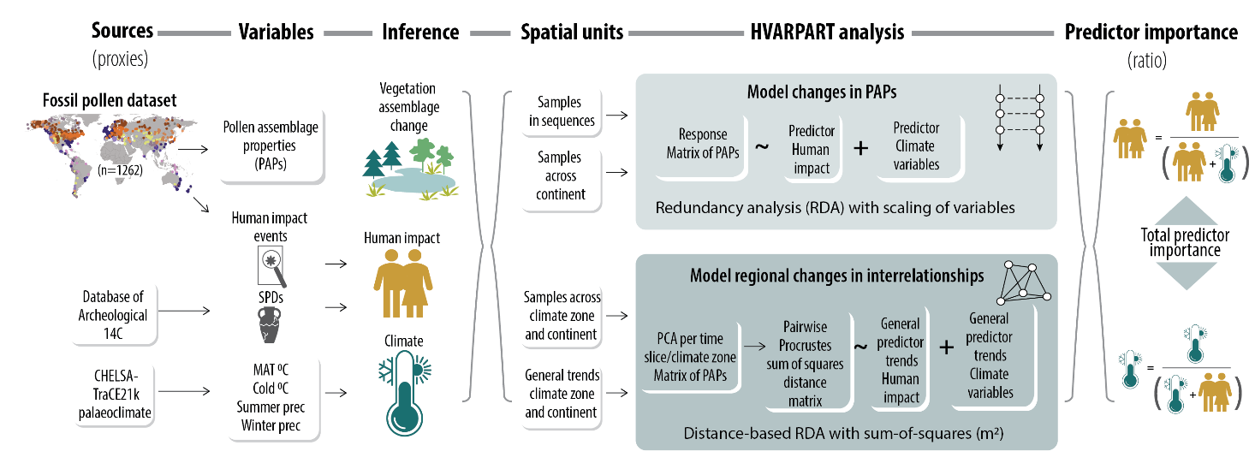
Fig. 1: Conceptual workflow figure for data preparation and quantification of the relative importance of past humans and climate on variability in PAPs at different spatial and temporal scales. From left to right, the main sources of proxy data (Sources (proxies)), what variables are derived from the data (Variables), what they can infer (Inference), data aggregation (Spatial units), the models of the hierarchical variation partitioning analyses and attribution (HVARPART analysis), and the quantification of the ratios of predictor importance between past humans and climate (Predictor importance (ratios)) are shown. See Methods for more detailed explanations. Data summaries of fossil pollen sequences, radiocarbon dates, and human-impact events are shown in Extended Fig. 1, Extended Fig. 2. Two site-based examples of quantification of predictor importance between past humans and climate combined are shown in Extended Fig. 3. The general predictor trends of past humans in different climate zones for each continental region are shown in Extended Fig. 4, and the palaeoclimate represented by mean annual temperature (MAT ℃), minimum temperature of the coldest month (Cold ℃), precipitation of warmest quarter (Summer prec), and precipitation of coldest quarter (Winter prec) for different climate zones are shown in Extended Fig. 5, Extended Fig. 6, Extended Fig. 7, Extended Fig. 8. The general trends for human-impact events in different climate zones are shown in Extended Fig. 9.

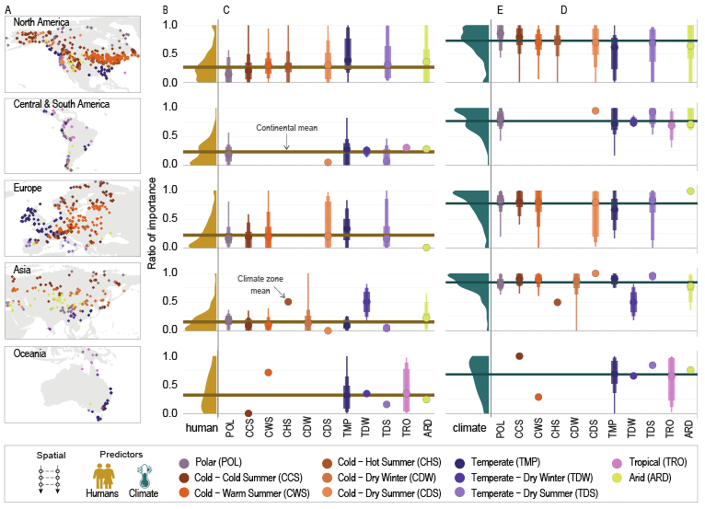
Fig. 2: Ratios of predictor importance of past humans and palaeoclimate on variability in PAPs over the period of 8.5-2 ka BP across climate zones and continents. Each row represents a continent: North America, Central and South America, Europe, Asia, and Oceania. The colours represent Köppen-Geiger climate zones³⁶. Panel A shows the spatial distribution of individual sequences represented by coloured dots on the regional maps (Number of sequences listed in Table 1; Extended Fig. 1). Note that we are only showing the parts of the map with sequences. Panel B shows the regional density curves of the distribution of human importance ratios within a continent (colour gold). Panel C shows the weighted mean ratios of importance (y-axis) of past humans summarised at the level of continents (horizontal gold line) and climate zones (circles). Panel D shows the regional density curves of the distribution of palaeoclimatic importance ratios within a continent (colour teal). Panel E shows the weighted mean ratios of importance (y-axis) of palaeoclimate (colour teal) at the level of continents (horizontal teal line) and climate zones (circles). For each climate zone, the different shading and width of the lines are the percentile ranges (50th, 75th, and 95th) of individual ratios per sequence. Only climate zones with > 2 sequences are used in this visualisation.

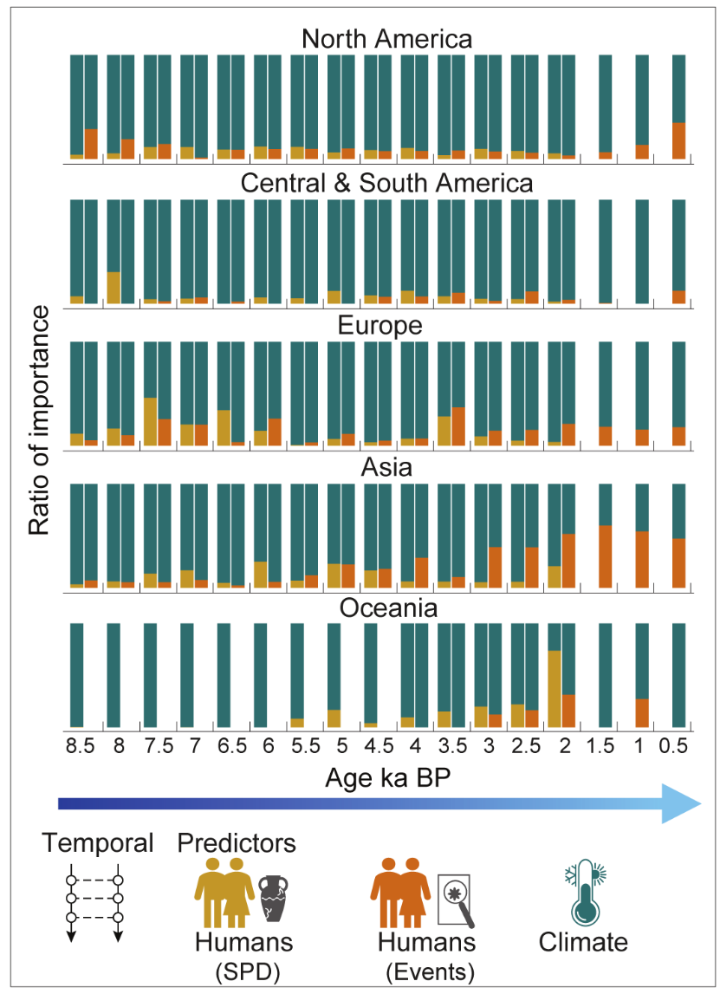
Fig. 3: Ratios of predictor importance of past humans (summed probability density (SPD) and Human-Impact Events) to palaeoclimate on variability in PAPs within time slices for each continent. The bar charts show the ratios of importance between past humans (Humans (SPD)) and palaeoclimate (Climate) as predictors (dark green and gold shaded bars), and the ratios of importance between human-impact events (Humans (Events)) and palaeoclimate (Climate) predictors (dark green and red-brown shaded bars) for the hierarchical variation partitioning (HVARPART). The human-impact events cover additional time slices from 2.0–0.5 ka BP where SPDs are lacking. The ratio of importance (y-axis) varies from 0 to 1.

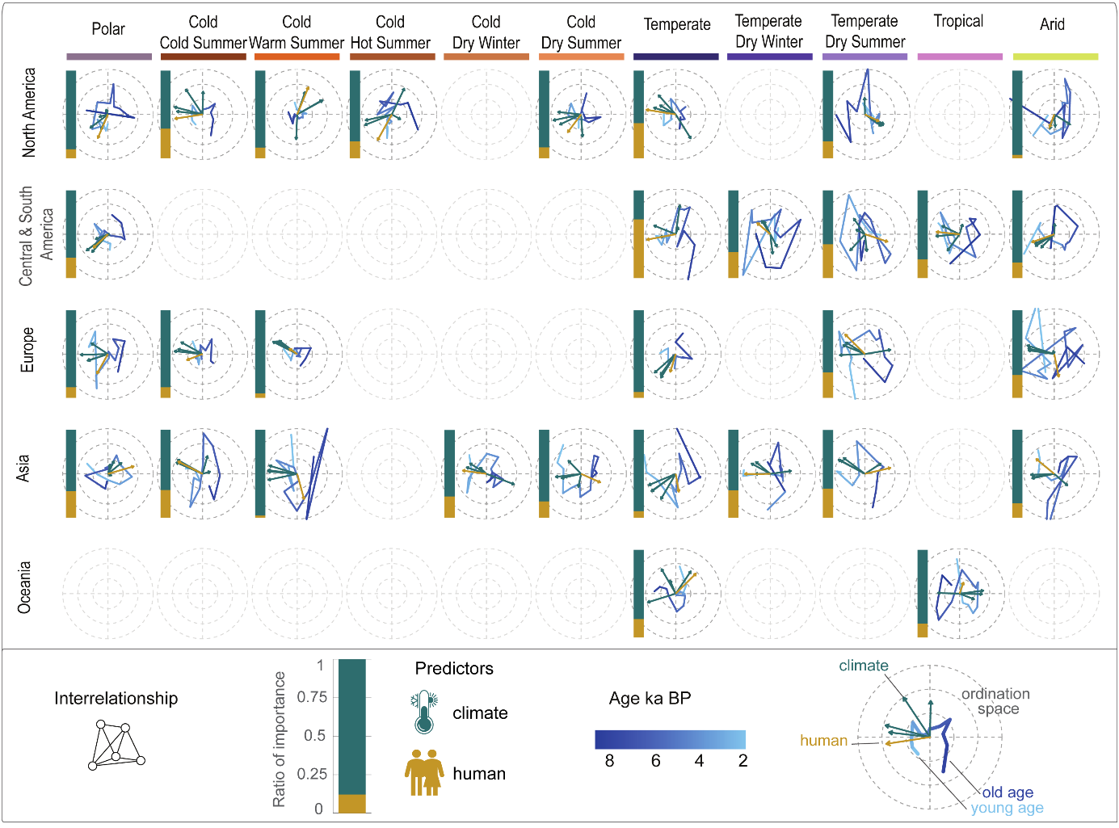
Fig. 4: Ratios of importance of past humans in relation to palaeoclimate in influencing the interrelationships among PAPs in different climate zones across the continents. Each row represents a continental region as follows: North America, Central and South America, Europe, Asia, and Oceania. The columns from left to right represent a total of 11 climate zones within the main Polar, Cold, Temperate, Tropical, and Arid zones. The left bar charts represent the ratios of predictor importance of past human presence (gold) in relation to climate (teal) for changes in the relationships among PAPs for the period 8.5–2 ka BP (y-axis on a scale 0–1). The spread in time trajectories in the ordination space (grey circles) indicates the total amount of change in the interrelationships between PAPs in different time slices, and the ordination space is scaled to similar units to allow comparison across climate zones and continents. The sample scores of the distance-based redundancy analysis (dbRDA) in hierarchical variation partitioning (HVARPART) are plotted as time trajectories (blue lines). These trajectories show the direction of change, where it starts at 8.5 ka BP (dark blue) and progresses towards 2 ka BP (light blue). Arrows, indicating past human presence (gold) and palaeoclimatic variables (teal), show the influence of each predictor over time on the interrelationship among PAPs. The direction of the arrows indicates the trend of influence, while their length quantifies the strength of association between predictors and changes in interrelationships among PAPs, with longer arrows representing stronger influences.

Tables
Table 1: Overview of metrics used to estimate PAPs.
Assemblage metrics | Description
N0 | Number of pollen types
N1 | Number of equally common pollen types
N2 | Number of equally abundant pollen types
N2/N1 | Ratio of the number of equally abundant pollen types divided by equally common pollen types
N1/N0 | Ratio of the number of equally common pollen types divided by estimated number of pollen types
DCCA1 | Compositional turnover constrained by time
RoC | Rates of compositional change
Density diversity | Density estimates of break-points in diversity variables N0, N1, N2, N2/N1, N1/N0
Density turnover | Density estimates of break-points in turnover variables estimated by multivariate regression trees (MRT), DCCA, and RoC values

Table 2: Data summary for each continental region. Number of pollen sequences included in the analyses for the assessed period of 8.5–2.0 calibrated thousand years before present (ka BP), the number of sequences with summed probability densities (SPDs) within a 250 km or 500 km radius of the site, and the number of pollen sequences with human-impact events.
Continents | Number of fossil pollen sequences | Number of sequences with SPD 250 km | Number of sequences with SPD 500 km | Number of sequences with human-impact events detected
North America | 554 | 512 | 43 | 217
Central & South America | 87 | 65 | 15 | 87
Europe | 396 | 383 | 14 | 143
Asia | 177 | 47 | 64 | 95
Oceania | 48 | 37 | 1 | 28

Methods
We created a GitHub repository to host all R scripts and custom-made functions to process data and generate outputs for this project, ensuring full transparency and reproducibility (https://github.com/HOPE-UIB-BIO/PastHumanImpact). Additionally, all data, under specific licences, have been uploaded to ZENODO. Specific links are provided under Data availability. Our full workflow encompasses all steps from data input to the final outputs, including pollen sourcing and processing, calculations of pollen assemblage properties (PAPs), and statistical analyses.

FOSSILPOL Workflow
Raw pollen datasets were curated using the R-Fossilpol package, following the guidelines in Flantua et al.⁵¹ and detailed on the FOSSILPOL project website^{52,53}. The majority of data sequences were sourced from the Neotoma Paleoecology Database⁵⁴, with additional data from private sources used to address regional gaps, particularly Asia. These additional datasets were accessed under CC BY-NC-ND 4.0 licence²³. Extended Table 1 provides an overview of the parameters employed in the FOSSILPOL workflow for compiling and processing of pollen sequences. This workflow was refined during subsequent data-processing stages, yielding a high-quality compilation of pollen sequences suitable for numerical analyses and calculations of PAPs.

Harmonisation tables
A key step in the FOSSILPOL workflow is the taxonomic and nomenclatural standardisation of pollen types to ensure dataset consistency both within and across regions. Variation in identification criteria and nomenclature among analysts from diverse backgrounds and schools may result in substantial discrepancies in pollen taxonomic levels and naming conventions, which would bias numerical comparison⁵¹. To mitigate these biases, we developed harmonisation tables all regions included in this study, encompassing Europe, Levant, Siberia, Southern Asia, Northern America, Central and South America, and the Indo-Pacific region. These harmonisation tables^{23,55}, were incorporated into the FOSSILPOL workflow.

Data filtering
To ensure the highest possible data quality and facilitate numerical comparisons across multiple pollen sequences, several filtering criteria were carefully chosen and applied:
- Removal of potentially duplicated pollen sequences.
- Sorting assemblages (samples) by chronological order (age).
- Exclusion of assemblages (samples) with a total pollen count below a specified threshold (see below).
- Exclusion of pollen sequences falling outside defined age ranges.
- Exclusion of assemblages (samples) based on the age of the last control point.
- Exclusion of assemblages (samples) beyond the specified age ranges of interest.
- Exclusion of pollen sequences if the total number of samples was fewer than 5.
These filtering procedures were systematically applied to the chronologies, raw pollen counts, harmonised pollen counts, and age uncertainties derived from the age-depth models (Bchron)^{56,57}. While the preferred minimum number of pollen grains was initially set at 150, this threshold resulted in a significant loss of pollen sequences, particularly in regions with limited data coverage. To balance data retention and quality the threshold was adjusted to 25, with the condition that less than 50% of the samples would have a low pollen sum. However, it should be noted that in such cases, the estimates of properties of pollen assemblages may exhibit reduced robustness. Regrettably, we excluded Africa as a region from our analysis because at the start of our project (2018) the coverage of pollen sequences available was too sparse. See data summaries in Extended Fig. 1. A complete description of all filtering criteria used in the FOSSILPOL workflow is provided in Extended Table 1.

Estimating Metrics of Pollen Assemblage Properties (PAPs)
We calculated different metrics, derived from community ecology and biodiversity analyses, that reflect different properties of a pollen assemblage^{e.g. 23} for each pollen sequence in our dataset compilation. These are considered proxies for changes in different components of a vegetation assemblage over time. We note that although there is not a direct relationship between a pollen assemblage and the vegetation assemblage it might represent, the association between these two concepts is fundamental to palaeoecological research⁵⁸. We used a suite of metrics that represents palynological richness, diversity, evenness, compositional change and turnover, and rate-of-change (RoC). These metrics reflect components of an ecological assemblage, caused by underlying ecological processes and interactions between past species populations and environment, which may result in taxon gains or losses (richness), changes in abundances (evenness), change in both richness and evenness (diversity), and functioning and structure of assemblages (composition), and how a pollen assemblage changes over time and space (turnover and rate-of-change).
We calculated most metrics using the newly developed R-Ecopol package⁵⁹. The base functions used in this package are derived from other packages. Examples are mvpart⁶⁰ to derive pollen zonations with multivariate regression trees, and vegan⁶¹ for other multivariate techniques and dissimilarity indices.

Pollen richness, diversity, and evenness
Palynological richness, diversity, and evenness were estimated using Hill´s effective species numbers N0, N1, and N2, and the associated evenness ratios of N2/N1 and N1/N0^{58,62}. The effective species numbers mainly differ in how rare taxa are weighted in comparison to abundant taxa depending on the parameter q in the formula⁵⁸:
$$D^{q}={(\sum_{i=1}^{T}{p_{i}^{q}})}^{1/(1−q)}$$
where D is the diversity estimate, and p is the proportion of taxon Ti. When q is 0, rare and abundant taxa have equal weight, and the number is simply the number of taxa in the sample. The equation is not defined for q = 1, but when it approaches 1, it equals the exponential of the well-known Shannon index and provides the number of equally common taxa. When q = 2, it is the same as the inverse Simpson diversity index and is the number of abundant taxa. Rare taxa receive a low weight. The advantage of using effective species numbers is that they provide easily interpretable units and contain the doubling effect⁶². To standardise pollen sample sizes, we used the rarefaction approach developed by Chao et al.⁶². These estimates were rarefied to the number of n = 150 grains, or in a few cases to a lower sum (minimum n = 25). Some pollen sequences from Asia were only available as pollen percentages; these are rarefied to the minimum sum of the percentages. The ratios (e.g. N2/N1) between any diversity numbers will be 1 if all taxa in a sample are equally abundant, hence these ratios reflect changes in evenness between rare, equally common, and abundant taxa.
Functions from iNext^{60,62,63} were modified to extract interpolated Hill numbers based on a minimum sample size and incorporated into R-Ecopol package⁵⁹.
Despite our efforts to standardise richness and diversity estimates based on a standard sample size, there remain unaccountable biases, which include variations in total pollen production and pollen representation^{50,64}.

Compositional turnover
We estimated the compositional turnover using detrended canonical correspondence analysis (DCCA) with age as the explanatory variable⁶⁵. Changes in weighted average (WA) scores (CaseR scores) are measures of compositional turnover in standard deviation (SD) units⁶⁶. The WA scores were regressed with time using a second-order polynomial (age+age^2) to allow more flexibility in the turnover pattern within a pollen sequence. The total range of CaseR scores along DCCA axis 1 is a measure of total compositional change for a sequence, whereas the pattern of individual CaseR scores along DCCA axis 1 is a measure of turnover between individual samples within the sequence⁶². The response data are pollen percentages without any transformation to maintain the chi-square distances between samples that is implicit in DCCA, whereas the ages are the median ages derived from the age-depth model for each sequence. We specifically developed R functions in the R-Ecopol package to run DCCA using Canoco 4.5⁶⁵.

Rate-of-change
To quantify the rate-of-change (RoC) of composition, we used the R-Ratepol package⁶⁷. RoC was calculated using moving windows of 500-year time bins, with five shifts for each bin where samples were randomly selected. This approach, as demonstrated by Mottl et al.⁶⁷, enhances the accurate identification of RoC peak points compared to more traditional methods. The RoC values are reported as dissimilarity per 500 years, employing the chord dissimilarity coefficient⁶⁸. Standardisation of sample size was performed within each working unit, ensuring consistency at 150 grains or the lowest number detected in each dataset.

Change-point detection and density estimations
For the calculation of change points in all the PAPs, we used conventional regression trees (RT) for single variables with Euclidean distances. An algorithm was developed to identify transitions between resulting groups or zones per variable by coding these transitions as binary variables (0/1). A change point was designated as 1, with the mean ages between two consecutive samples representing the timing of this significant change, determined individually for each pollen-assemblage property.
Compositional change was calculated using multivariate regression trees (MRT) with age as the sole constraining variable. MRT is, in general, a robust tool to explore and predict changes in multivariate datasets using external predictor variables^{68,69}. This technique has been adopted in palaeoecology to detect zones in pollen diagrams or shifts between periods of homogeneous assemblages in time⁶⁸. We used the pollen taxa in percentages without any data transformations as the response variable and the median ages derived from the age-depth model as the constraining variable. The recursive partitioning is based on chi-square distances⁷⁰ between pollen samples constrained by time. The number of cross-validations was set to 1000, and the optimal sized tree was chosen based on the 1SD rule⁶⁸.
Significant change points for richness, diversity, and evenness variables were integrated into one variable (DDC), while significant change points for compositional turnover, compositional change, and rate-of-change were combined into a second variable (DCC). The density of these two variables was computed using a Gaussian kernel and rescaled to specific age ranges for each individual pollen sequence, including minimum and maximum ages. To address boundary concerns in density estimation, the data were reflected to 0.

Equal temporal spacing of samples
We ensured equal temporal spacing of samples across all response variables, as this is crucial for temporal analyses in our stated hypotheses 1 and 2. This involves standardising samples to intervals of 500 years across time and space. Three methods of interpolation were tested: generalised additive model (GAM), hierarchical generalised additive model (HGAM), and simple linear interpolation. Linear interpolation was ultimately chosen as the preferred method, as it maintained the correlation structure between multivariate response variables closest to the original estimates, compared to GAM or HGAM. The latter models occasionally exhibited unexpected patterns in single pollen diversity estimates, which affected these correlations. Given the impracticality of individually assessing each model for every variable across all sequences (numbering over 1000), we opted for linear interpolation as the simplest approach.
After all data-processing steps, a total of 1262 sequences were available for analyses. For an overview of data coverage, see Extended Fig. 1.

Spatial units for analysis
The analyses focused on three levels of spatial units: 1) individual sequences, 2) sub-regions within continents, and 3) continental regions. While we acknowledge that any grouping will be imperfect and some specific regions might be less well represented, we used present-day Köppen-Geiger climate zones⁷¹ as a classification at the subcontinental scale. The advantage of using the Koppen-Geiger climate zones lies in its reliance solely on climate data, without making assumptions about vegetation or human influence. Additionally, these climate zones are characterized by relatively stable climates within each zone, enhancing the detectability of potential human impacts.
We used five major climate zones, namely Polar, Cold, Temperate, Arid, and Tropical for visualisation, but since the Cold and Temperate zones are so widespread across the Northern Hemisphere, we sub-divided these into Cold without Dry Season & Very Cold Summer, Cold without Dry Season & Cold Summer, Cold Dry Winter, Cold Dry Summer, Cold without Dry Season & Warm Summer, Cold without Dry Season & Hot Summer, Temperate without Dry Season, Temperate Dry Winter, and Temperate Dry Summer. This resulted in 12 climate zones used in the analyses.

Detection of past human activities
To assess the historical influence of past human activities on past vegetation (i.e., pollen-assemblages), we created two proxies of past human presence for each sequence: (1) summed probability densities (SPDs)²⁴ of archaeological radiocarbon (14C) dates to quantify past human population and their regional dynamics, and (2) human events derived from fossil pollen diagrams based on expert knowledge. We used both proxies to assess the importance of past human presence and impact across regions and continents (Extended Fig. 2). Such integration also helped to mitigate the potential issue of circularity wherein human events detected from the same pollen sequences are used to estimate ecological attributes of the pollen assemblages.

Past human presence from archaeological radiocarbon dates
We used a global dataset of archaeological radiocarbon (14C) dates from Bird et al.²⁴ to construct SPDs, which serve as validated proxies for regional human population changes²⁶. To associate radiocarbon dates with pollen sequences, a specific radius around each pollen sequence was defined. The default radius was set at 250 km to capture a reasonable density of 14C dates, with the radius increased to 500 km for sites with insufficient coverage. This approach assumes that human populations were present and potentially influencing the region within these distances
Radiocarbon dates were carefully filtered for validity, ensuring accurate geographical location (longitude and latitude), and ‘LocAccuracy’ > 0. These refined 14C dates were calibrated using the “calibrate()” function from the rcarbon package⁷². Appropriate calibration curves (“IntCal20”, “ShCal20”, “mixed”^{73,74}) were applied, with the mixed curve generated using the “rcarbon::mixCurves()” function, setting p = 0.5. Calibration curve assignment was based on geographical location, following Hua et al.⁷⁵. The estimation of SPD was performed using the “spd()” function from the rcarbon package ranging from present to 12 ka BP. Sequences with fewer than 50 radiocarbon dates were excluded to maintain robust SPD estimates. We used a moving window of 100 years to smooth the non-normal peaks.
The number of 14C dates decreases strongly toward younger material, particularly over the last 2 ka BP in Eurasia²⁴. Therefore, we focused on the time-period between 8.5 and 2 ka BP, ensuring sufficient radiocarbon data and reliable SPD reconstruction. SPD values were extracted at every 500-year interval, providing a time-resolved predictor of past humans representing the magnitude of regional changes in human populations in different regions.

Human events derived from fossil pollen sequences
We employed expert-based approach to detect periods of human activity in each pollen sequence. This binary approach identified “human events” based on anthropogenic indicator taxa, allowing us to integrate supplementary predictors of human presence and activity.

Detection of human events in North America, Europe, Asia, and Oceania
For these regions, human events were identified through examination of each pollen diagram sequence by one or more regional specialists, who recorded the age of specific events (i.e., changes in anthropogenic indicator taxa). Event types were regional-specific and may have different interpretations even if the taxon involved is distributed across continents (see Extended Table 2). A binary matrix (0/1) was created for each event type detected in each pollen diagram sequence, incorporating the average ages between levels (samples), considering that human impact may have occurred in the intervals between samples in the fossil pollen sequences. Binary values (0/1) were assigned to different event types based on their presence (i.e., detection and the event’s age). This assignment adhered to logical principles, and binary values were adjusted to compile event data for each pollen sequence. This results in a binary matrix of ages and event types for each sequence.
Note that the absence of human events in a pollen diagram sequence does not necessarily imply the absence of humans but rather indicates insufficient evidence to confirm human activity as detected in the pollen sequence.

Detection of human events in Central and South America
Due to the complex and unique use of plants in Central and South America, we performed a thorough literature review targeting pollen types associated with human presence and/or activity⁴⁸:
- Anthropogenic pollen indicators were identified from the literature as single human indicators or combined variations in a group of indicators (i.e. “human indices”).
- For each pollen sequence, the combinations of taxa recorded alongside specific indicator groups was considered. We evaluated whether the signal of a pollen indicator for human presence was weak or strong, applying a defined threshold.
- Two categories were established: “human-event indicators”, representing a single taxon associated with human activity categorised as having “weak” or “strong” impact; and “human-event indices”, comprising combinations of taxa classified similarly.
- For each pollen sequence, the human-event indicators and human-event indices were assessed for their presence at each level, with classification as “no impact”, “weak impact” or “strong impact”. Specifically, the presence of a single pollen grain of a human indicator signified “weak” impact, while the presence of more than one pollen grain of a strong impact indicator denoted “strong” impact. Additionally, the pollen type Pinus was considered a human indicator outside its native distribution, and for human-event indices (step 3), any quantity of pollen grains had to be present for the specific combination of taxa to be classified.

Palaeoclimate
Palaeoclimate from the CHELSA-TraCE21k downscaling algorithm was downloaded from the CHELSA database which is based on the Community Climate System Model version 3²⁷. The selected bioclimatic variables are bio1: annual mean temperature (℃), bio6: minimum temperature of the coldest month (℃), bio18: precipitation of warmest quarter (kg m-2 quarter-1, = mm), and bio19: precipitation of coldest quarter (kg m-2 quarter-1, = mm). The variables were selected a priori to represent subcontinental climate variability with respect to differences in temperature, moisture, or seasonality between the continental regions. The climate values were extracted for the co-ordinates for each dataset_id (pollen sequence) to retrieve the full time series for every 100 years for each climate variable. The point-based extraction of co-ordinates may provide a mismatch in elevation in areas with rough terrain. However, we assume the regional extent of the pollen signal is fairly comparable to the relevant spatial area of the climate signal per 1km spatial grid.

Numerical analysis of hypothesis 1
To calculate the relative importance of human events and climate for variability in PAPs, we used hierarchical variation partitioning (HVARPART) developed by Lai et al.²⁸. This approach calculates the importance of each predictor by partitioning the unique and shared variation for all possible combinations of predictor orders in a full model. The predictor importance is then the sum of the average unique and shared variation²⁸. To obtain an estimate of predictor importance, we used redundancy analysis (RDA) with standardised response variables as pollen assemblage properties are of mixed units. Past humans (e.g. SPD values) represent one predictor, whereas climate is represented as a group of selected variables of summer precipitation, winter precipitation, annual temperature, and winter temperature. We used the adjusted r2 total predictor importance and the average unique partitions as they correct for the number of samples and predictors in the model. To compare the predictor importance of humans and climate, we estimated the individual importance ratios for each sequence as follows:
Predictor importance ratio = predictor importance / (predictor importance human + predictor importance climate)
The analysis was run in two ways:
- to analyse the spatial changes, HVARPART was run for individual sequences. To summarise the results on broader scales within the continents, we used the Köppen-Geiger climate zones to categorise subregions and calculated the weighted mean ratios of the total predictor importance from each sequence using the sum of the predictor importance of humans and palaeoclimate as weights.
- to analyse the temporal patterns for each continent, HVARPART was run for samples within each 500-year time slice. Time slices with fewer than five samples were excluded, and some analyses failed when SPDs indicated zero human presence. Missing results in these cases were attributed to insufficient predictors. The predictor groups in each time slice consist of the SPD or group of human-detection events (Extended Table 2) together with the matrix of palaeoclimatic variables.
HVARPART analyses were run using the rdacca.hp R package²⁸. Two site-based examples to analyse spatial changes are provided in Extended Fig. 3.

Numerical analysis of hypothesis 2
To test if the interrelationships between PAPs have changed over time (H2), we performed a principal component analysis (PCA) with standardisation of the metrics within each 500-year time slice. Here samples were grouped at the subregional levels of climate zones within each continent. We performed a Procrustes sum-of-squares analysis to compare the changes in the interrelationships between PAPs between time slices²⁹. We used symmetric scaling (m2) creating distance matrices representing these changes, where 0 indicates the relationship remained constant, and 1 indicates that the relationship between one or several PAPs has changed considerably. Each climate zone is represented by the m2-distances between time slices for the period 8.5–2 ka BP. This was used as a response matrix in HVARPART.
Bayesian modelling was employed to establish overarching trends in past humans (SPD) and palaeoclimate³⁰. It is important to note that the predictions generated by these models encapsulate the prevailing trends in past human presence and palaeoclimate as relevant to the distribution of our compiled sequences and these patterns may not directly represent the broader historical human presence and palaeoclimate conditions in various climate zones; see Extended Fig. 4, Extended Fig. 5, Extended Fig. 6, Extended Fig. 7, Extended Fig. 8. Subsequently, these variables were employed as predictors in the second HVARPART, aimed at quantifying the importance of past human or palaeoclimate to the variability in the interrelationships between PAPs within climate zones. The general trends were also modelled for the human-impact events in different climate zones across the continental regions (Extended Fig. 9).

References methods
51. Flantua, S. G. A. et al. A guide to the processing and standardization of global palaeoecological data for large-scale syntheses using fossil pollen. Global Ecology and Biogeography 32, 1377–1394 (2023).
52. Flantua, S. G. A. et al. FOSSILPOL project. https:// hope-uib-bio.github.io/FOSSILPOL-website/index.html (2023).
53. Flantua, S. G. A. et al. R-package to provide tools for FOSSILPOL workflow. https://github.com/HOPE-UIB-BIO/R-Fossilpol-package (2023).
54. Williams, J. W. et al. The Neotoma Paleoecology Database, a multiproxy, international, community-curated data resource. Quaternary Research 89, 156–177 (2018).
55. Birks, H. J. B. et al. Approaches to pollen taxonomic harmonisation in Quaternary palynology. Review of Palaeobotany and Palynology 319, 104989 (2023).
56. Haslett, J. & Parnell, A. A simple monotone process with application to radiocarbon-dated depth chronologies. Journal of the Royal Statistical Society: Series C (Applied Statistics) 57, 399–418 (2008).
57. Parnell, A. C., Haslett, J., Allen, J. R. M., Buck, C. E. & Huntley, B. A flexible approach to assessing synchroneity of past events using Bayesian reconstructions of sedimentation history. Quaternary Science Reviews 27, 1872–1885 (2008).
58. Birks, H. J. B. et al. Does pollen-assemblage richness reflect floristic richness? A review of recent developments and future challenges. Review of Palaeobotany and Palynology 228, 1–25 (2016).
59. Mottl, O. REcopol: Analyse fossil pollen records. https://hope-uib-bio.github.io/R-Ecopol-package/ (2024).
60. Therneau, T. M., Atkinson, B., Ripley, B. & De’ath, G. mvpart: Multivariate partitioning. https://CRAN.R-project.org/package=mvpart (2014).
61. Oksanen, J. et al. vegan: Community Ecology Package. https://CRAN.R-project.org/package=vegan (2022).
62. Chao, A. et al. Rarefaction and extrapolation with Hill numbers: a framework for sampling and estimation in species diversity studies. Ecological Monographs 84, 45–67 (2014).
63. Hsieh, T. C., Ma, K. H. & Chao, A. iNEXT: an R package for rarefaction and extrapolation of species diversity (Hill numbers). Methods in Ecology and Evolution 7, 1451–1456 (2016).
64. Odgaard, B. V. Palaeoecological perspectives on pattern and process in plant diversity and distribution adjustments: a comment on recent developments. Diversity and Distributions 7, 197–201 (2001).
65. ter Braak, C. J. F. & Šmilauer, P. CANOCO Reference manual and CanoDraw for Windows User’s Guide: Software for Canonical Community Ordination (version 4.5). Microcomputer Power.
66. Birks, H. J. B. Estimating the amount of compositional change in late-Quaternary pollen-stratigraphical data. Veget Hist Archaeobot 16, 197–202 (2007).
67. Mottl, O. et al. Rate-of-change analysis in paleoecology revisited: A new approach. Review of Palaeobotany and Palynology 293, 104483 (2021).
68. Simpson, G. L. & Birks, H. J. B. Statistical Learning in Palaeolimnology. in Tracking Environmental Change Using Lake Sediments: Data Handling and Numerical Techniques (eds. Birks, H. J. B., Lotter, A. F., Juggins, S. & Smol, J. P.) 249–327 (Springer Netherlands, Dordrecht, 2012). doi:10.1007/978-94-007-2745-8_9.
69. De’ath, G. Multivariate Regression Trees: A New Technique for Modeling Species-Environment Relationships. Ecology 83, 1105–1117 (2002).
70. Prentice, I. C. Multidimensional scaling as a research tool in Quaternary palynology: A review of theory and methods. Review of Palaeobotany and Palynology 31, 71–104 (1980).
71. Beck, H. E. et al. Present and future Köppen-Geiger climate classification maps at 1-km resolution. Sci Data 5, 180214 (2018).
72. Crema, E. R. & Bevan, A. Inference from large sets of radiocarbon dates: Software and methods. Radiocarbon 63, 23–39 (2021).
73. Reimer, P. J. et al. The IntCal20 Northern Hemisphere Radiocarbon Age Calibration Curve (0–55 cal kBP). Radiocarbon 62, 725–757 (2020).
74. Hogg, A. G. et al. SHCal20 Southern Hemisphere Calibration, 0–55,000 Years cal BP. Radiocarbon 62, 759–778 (2020).
75. Hua, Q., Barbetti, M. & Rakowski, A. Z. Atmospheric Radiocarbon for the Period 1950–2010. Radiocarbon 55, 2059–2072 (2013).

Extended Figures
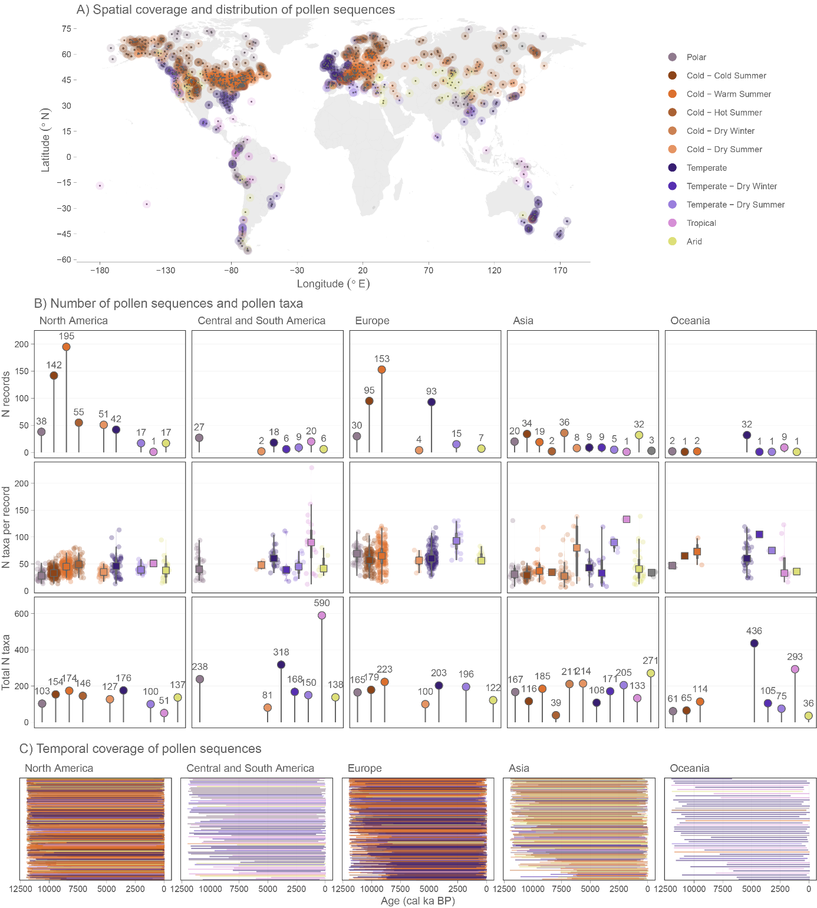
Extended Fig. 1: Overview of data coverage. (A) Spatial coverage and distribution of pollen sequences, (B) number of pollen sequences within climate zones (panels row 1), the number of taxa per sequence in each climate zone (panels row 2), and total number of taxa in each climate zone (panels row 3), and (C) temporal coverage of the pollen sequences.

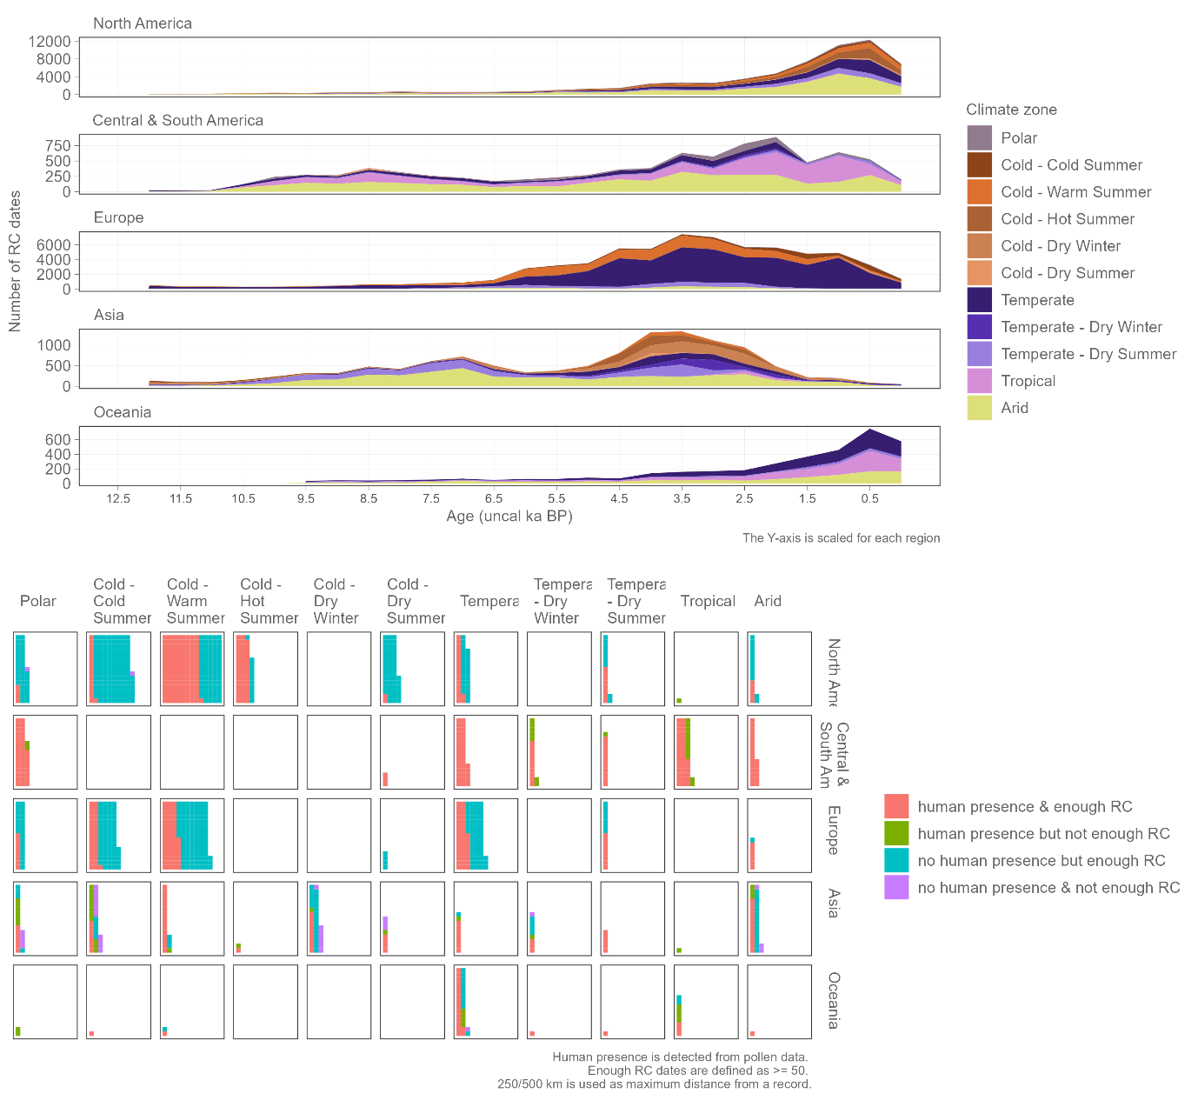
Extended Fig. 2: The top panel shows the number of uncalibrated radiocarbon (RC) dates for each climate zone in the continental regions. The y-axis, scaled for each region, is the number of RC dates. The bottom panel shows a comparison of data coverage of human presence detected from pollen diagrams and radiocarbon dates ordered by climate zones (right to left) and geographical regions (top to bottom). Am = America

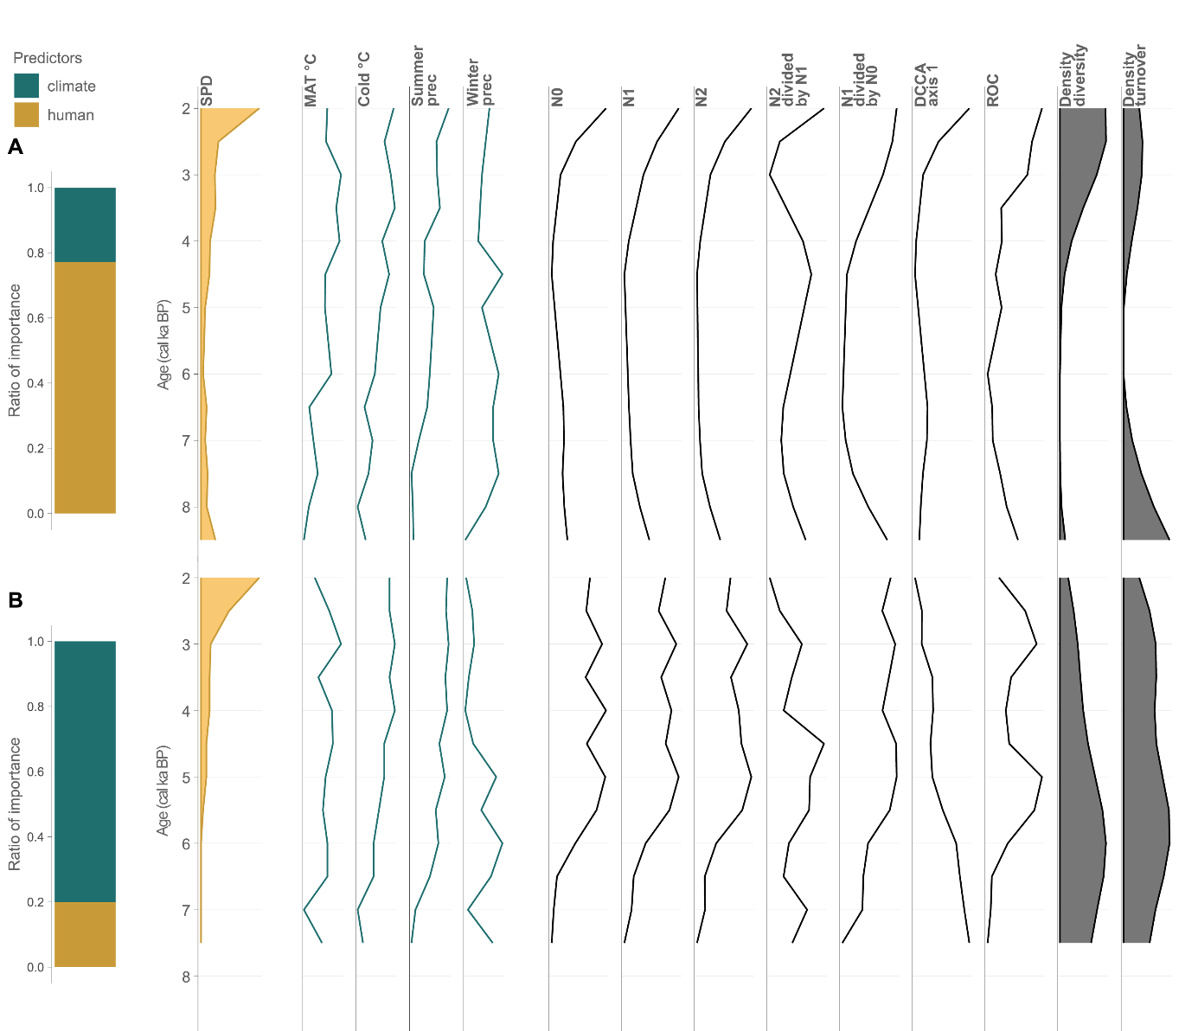
Extended Fig. 3: Two sequences and their temporal trends of PAPs and predictors (columns). The bar plots show results of the hierarchical variation partitioning. The two sequences were selected as examples of contrasting results: A) PAPs are mostly affected by trends of human population (SPD); B) PAPs are mostly explained by climate (MAT °C, Cold °C, Summer prec, Winter prec). The calculated metrics from each sequence of our full data compilation are subsequently used an input data in the analyses summarised in Fig. 2. SPD = summed probability densities, MAT °C = mean annual temperature, Cold °C = minimum temperature of the coldest month, Summer prec = mean precipitation of the warmest quarter, Winter prec = mean precipitation of the coldest quarter, N0–N2 = Hill’s diversity numbers, N2/N1 and N1/N0 = Hill’s evenness numbers, DCCA axis 1 = first axis of detrended canonical correspondence analysis, ROC = rate of compositional change, Density diversity = density of change points for diversity variables, Density turnover = density of change points of turnover variable. See Methods for more details about estimation of each variable.

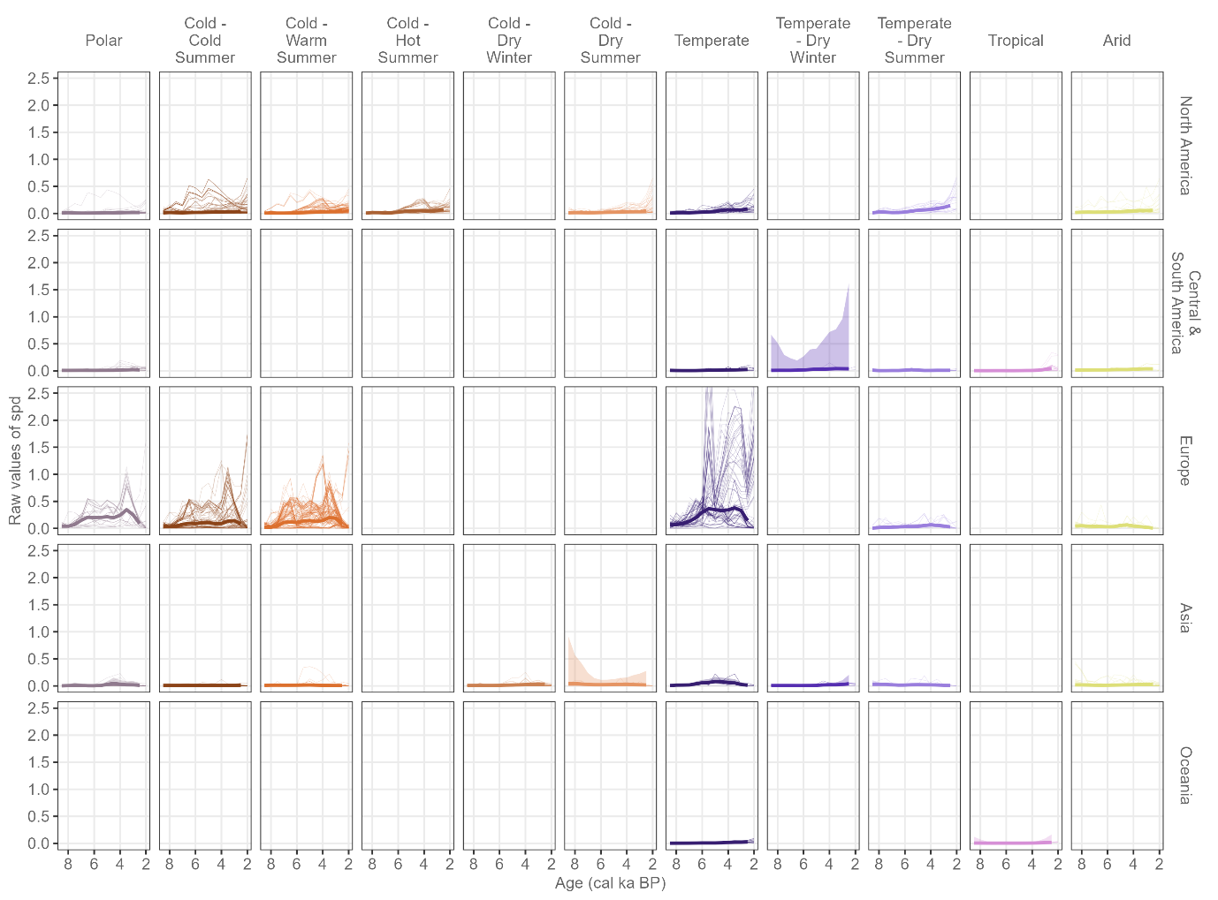
Extended Fig. 4: General patterns of the summed probability density (SPD) curves based on all sequences within each climate zone for each continent. The thin lines represent the raw data, while thick lines represent the predictions from the hierarchical generalised additive models (HGAMs). Note that values have been normalised and centralised for this visualisation.

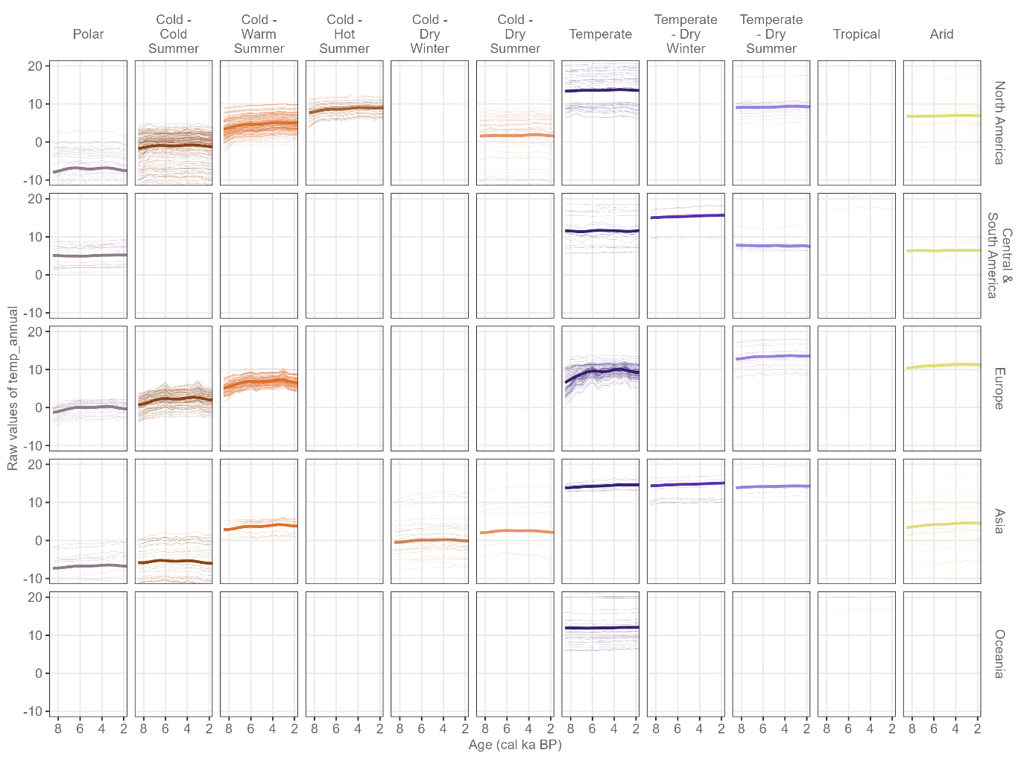
Extended Fig. 5: General patterns of mean annual temperatures ℃ (bio1) in each climate zone and continent, derived from CHELSA climate data²⁷. Thin lines represent different trends in the raw data at the sequence level. Thick lines show the general prediction from the hierarchical generalised additive models (HGAMs).

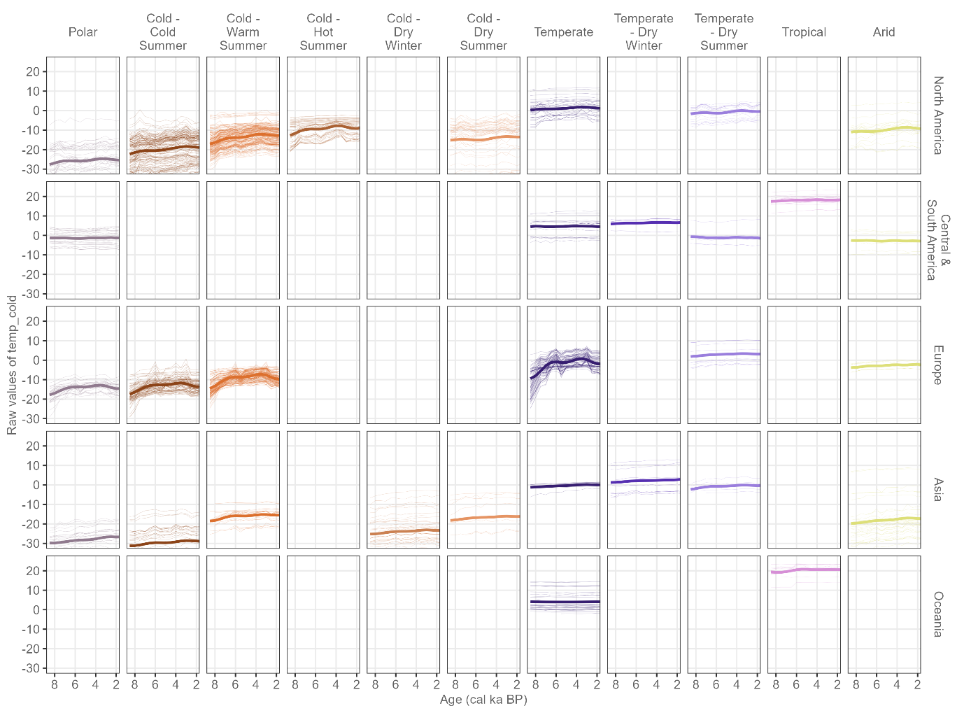
Extended Fig. 6: General patterns of minimum temperatures of the coldest month ℃ (bio6) in each climate zone and continent, derived CHELSA climate data²⁷. Thin lines represent different trends in the raw data at the sequence level. Thick lines show the general prediction from the hierarchical generalised additive models (HGAMs).

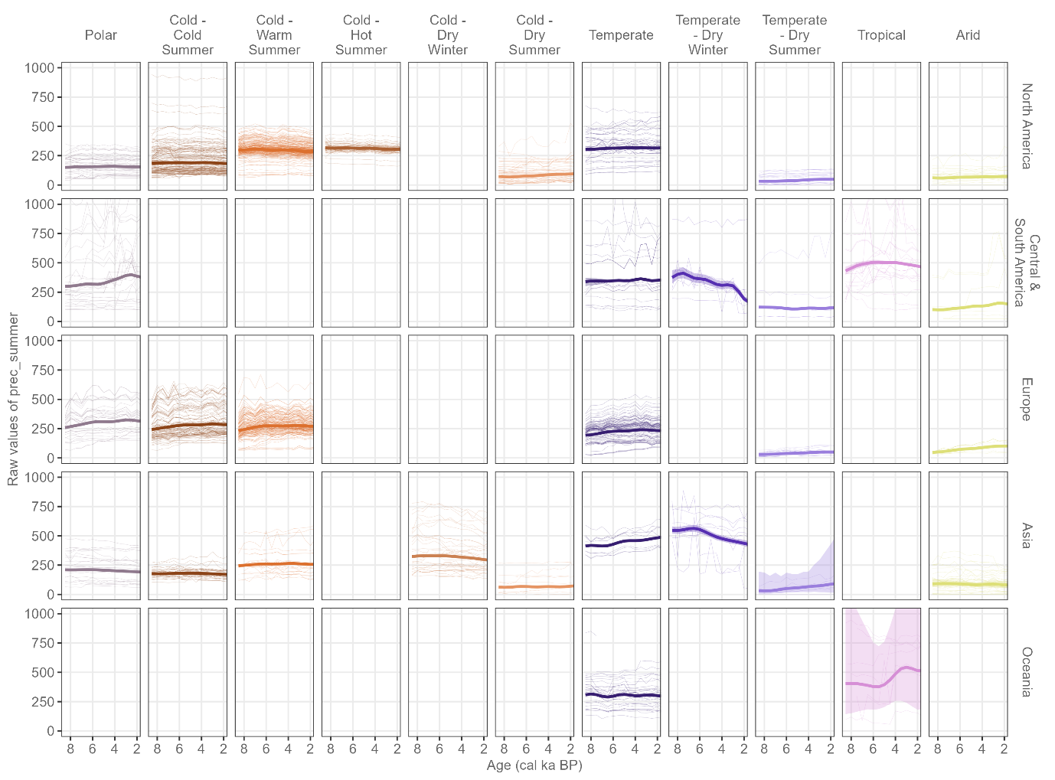
Extended Fig. 7: General patterns of precipitation of the warmest quarter (bio18) in each climate zone and continent, derived from CHELSA climate data²⁷. Thin lines represent different trends in the raw data at the sequence level. Thick lines show the general prediction from the hierarchical generalised additive models (HGAMs).

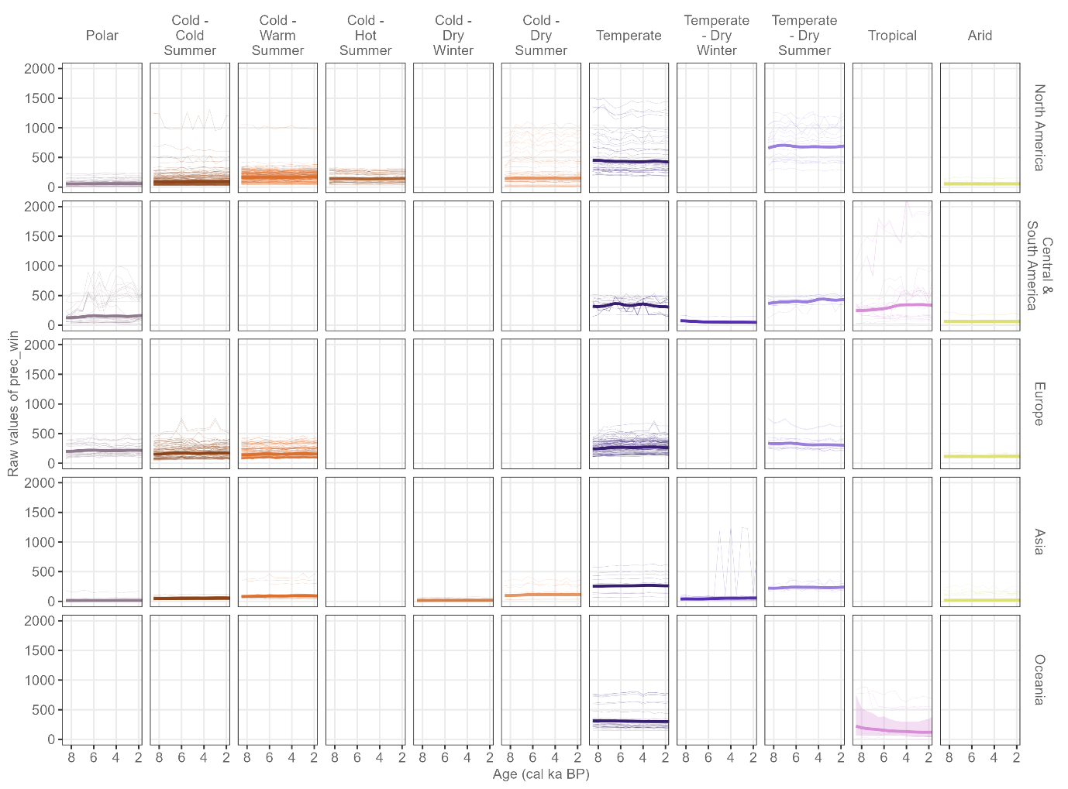
Extended Fig. 8: General patterns of precipitation of the coldest quarter (bio19) in each climate zone and continent, derived from CHELSA climate data²⁷. Thin lines represent different trends in the raw data at the sequence level. Thick lines show the general prediction from the hierarchical generalised additive models (HGAMs).

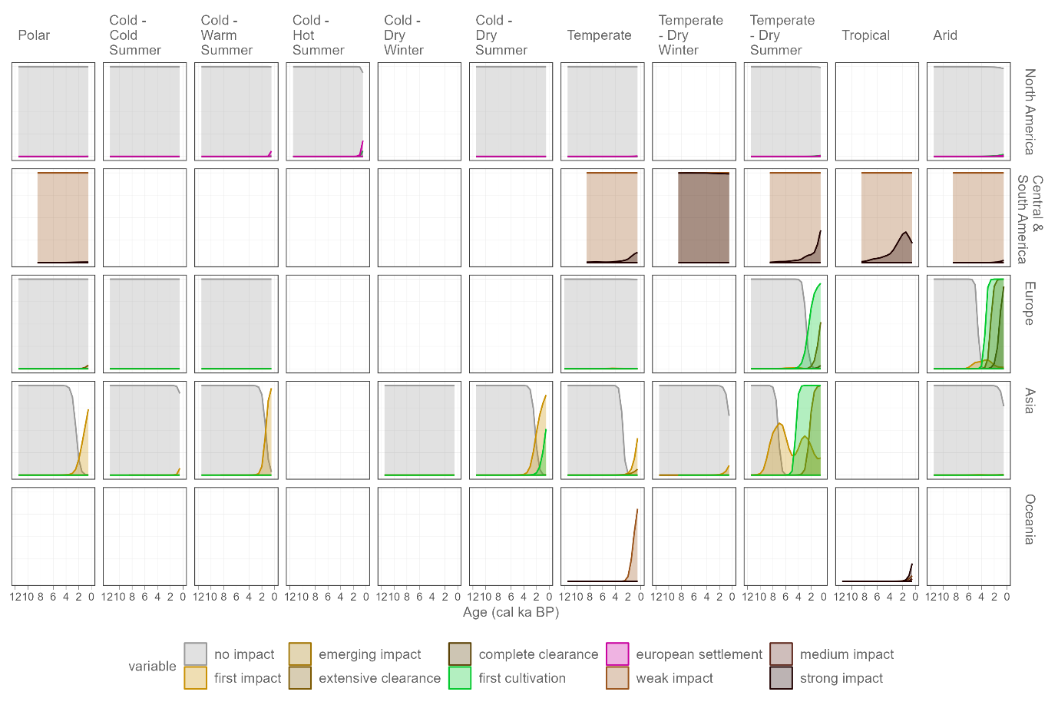
Extended Fig. 9: General pattern of hierarchical generalised additive models (HGAMs) showing the detection of different human events from pollen sequences summarised by climate zone for each geographical region. Different events are detected in different regions (see Extended Table 2).

Extended Tables
Extended Table 1
Selection of settings applied in our FOSSILPOL workflow⁵¹.

Settings | Setting type | Selection
General
 | geography_criteria | -180
 | long_max | 180
 | lat_min | -90
 | lat_max | 90
 | alt_min
 | alt_max
 | private_data | TRUE
Neotoma
 | dataset_type | pollen
 | sel_var_element | pollen
 | chron_order.type1 | Varve years BP
 | chron_order.type2 | Calibrated radiocarbon years BP
 | chron_order.type3 | Calendar years BP
 | chron_order.type4 | Radiocarbon years BP
 | chron_order.type5 | Calendar years AD/BC
 | chron_order.type6
Age-depth models
 | min_n_of_control_points | 3
 | default_thickness | TRUE
 | default_error | 100
 | max_age_error | 3000
 | guess_depth | 10
 | default_iteration | 10000
 | default_burn | 2000
 | default_thin | 8
 | iteration_multiplier | 5
Site filtering
 | pollensum.filter_by_pollen_sum | TRUE
 | pollensum.min_n_grains | 25
 | pollensum.target_n_grains | 150
 | pollensum.percentage_samples | 50
 | filter_by_age_limit | TRUE
 | extrapolation.filter_by_extrapolation | TRUE
 | extrapolation.maximum_age_extrapolation | 3000
 | extrapolation.filter_by_interest_region | TRUE
 | extrapolation.n_levels.filter_by_number_of_levels | TRUE
 | extrapolation.n_levels.min_n_levels | 5
 | extrapolation.use_age_quantiles | TRUE
 | extrapolation.use_bookend_level | TRUE
Data download: 23-05-2022

Extended Table 2
Type of human events identified in pollen sequences

Region | Human-impact event type | Detection criteria
North America | BI = No Evidence of Impact
North America | FCu = First Cultivation | First unambiguous palynological evidence for cultivation of cereals (Zea mays, Triticum, Avena, etc.) and other crop plants (e.g. Cannabis sativa).
North America | ES = European Settlement | First unambiguous indications of European settlement as shown in eastern and central US by a marked expansion of Ambrosia-type pollen, often accompanied by rises of Amaranthaceae undiff. (= Chenopodium-type), weeds such as Plantago, Salsola kali, and cultivated plants such as Zea mays, other cereals, and Cannabis sativa. In the Canadian prairie, the palynological evidence is often sustained rises of Cyclachaena xanthifolia-type (= Iva xanthifolia-type), Salsola kali, Amaranthaceae undiff., and Iva ciliata-type. In the Pacific North West, (e.g. western Washington, western Oregon, British Columbia, northern California), palynological evidence for European settlement in the mid-1800s consists of marked declines in coniferous tree pollen (e.g. Pseudotsuga (menziesii) Thuja (plicata), Tsuga (heterophylla), Abies (grandis), Picea (sitchensis), and sharp rises in pollen of Alnus (rubra) and Populus (trichocarpa).
Europe | BI = No Evidence of Impact
Europe | FI = First Indication | First unambiguous indications of human impact, as shown in northern and central Europe by the beginnings of a continuous curve for Plantago lanceolata-type pollen. In the Alps and southern Europe, the curves for P. atrata-type, P. major-type, and/or P. maritima-type pollen are, in the absence of P. lanceolata-type, good indicators as they contain species (e.g. P. major, P. serpentina) that have very similar ecologies to P. lanceolata.
Europe | FCu = First Cultivation | First unambiguous indicators of cultivation of cereals and, at some sites, Cannabis sativa.
Europe | EC = Extensive Clearance | Onset of extensive clearance (50%) of forest within the pollen-source area (PSA) of the sites. The criteria used involve a) a synthesis of work on the AP/NAP ratio; b) use of Poaceae % values (expressed as % total tree pollen) to define extensive clearance (ca. 50% of the PSA of the site being cleared of woodland); c) use of general pollen-representation factors to determine what Poaceae % values (expressed as % total pollen excluding spores and obligate aquatics) when transformed give an inferred value of 50% forestless landscape; and d) examination of pollen stratigraphies used in Sugita-type REVEALS reconstruction of past vegetation at the landscape-scale. We use 10% Poaceae or 10% Calluna pollen as the criterion for EC in this work.
Europe | CC = Complete Clearance | Onset of complete clearance of forest within the PSA. The decision of what criterion to use to recognise CC follows those used to derive values for the onset of extensive clearance. The criterion is 20% Poaceae or 20% Calluna pollen (expressed as % total pollen excluding spores and obligate aquatics).
Asia | BI = No Evidence of Impact
Asia | FI = First Indication | First unambiguous palynological indications of human impact as shown by statistically significant increases in Poaceae pollen, corresponding decreases in forest tree pollen, and the beginnings of scattered occurrences of, inter alia, Plantago, Rumex, Amaranthaceae, and Fabaceae pollen. In tropical sequences (e.g. Malayan Borneo), it is based on marked declines in pollen values of ‘primary’ forest trees and an increase in pollen of ‘secondary’ trees such as Trema.
Asia | FCu = First Cultivation | First unambiguous palynological evidence for cultivation of cereals and other crop plants (e.g. Fagopyrum, Cannabis sativa, Juglans regia).
Asia | EI = Extensive Impact | Unambiguous palynological evidence for ‘extensive impact’ in the Levant area as provided by massive deforestation and major changes in palynological composition.
Oceania | none = No Impact | No discernible evidence for human influence on vegetation change (note: In Oceania human interactions with vegetation has an antiquity of at least 50,000 years, however, this interaction is difficult to unequivocally detect in the pollen and charcoal records)
Oceania | weak = Weak Impact | Low impact on temperate vegetation is shown by minor increases in open vegetation (Poaceae), woodland disturbance (changes in dominance of fire-sensitive (e.g. Callitris, Casuarina) versus fire -adapted trees (including Eucalyptus), plus minor increases in fire events. In tropical sequences (e.g. Papua New Guinea), it is marked by minor declines in ‘primary’ forest pollen values of forest trees and minor increases in pollen of ‘secondary’ trees such as Trema and Dodonaea.
Oceania | medium = Medium Impact | Medium impact on temperate vegetation is shown by significant increases in open vegetation (Poaceae), woodland disturbance (e.g. prolonged declines in fire sensitive vegetation, such as long lived Callitris, Casuarina, and Dicksonia ferns, and an increase in fire-adapted vegetation including Eucalyptus), plus rapid changes in occurrence of fire events. In tropical sequences (e.g. Papua New Guinea), it is based on marked declines in ‘primary’ forest pollen values of forest trees and an increase in pollen of ‘secondary’ trees such as Trema and Dodonaea.
Oceania | strong = Strong Impact | Unambiguous palynological evidence for ‘strong impact’ is evidenced by a combination of massive deforestation due to clearance, by woody thickening the region due to the impact of colonisation, and a disruption of fire regimes reflected in variable fire responses. In temperate regions of Oceania (e.g. Australia) this is a result of forced cessation of Indigenous land management practices and use of fire to maintain once open landscapes at the time of colonisation around 300-240 years ago. The pollen sequences are characterised by major changes in palynological composition including introduction of weeds (e.g. Pinus and Rumex). In the tropics strong impact is evident in some sites with significant clearance of forests, increased Poaceae and the rise in Casuarina due to deliberate planting for horticultural purposes (occurs in Papua New Guinea montane sites after 2000 yr BP).

Extended Table 3
Ratio of importance of past human presence (SPD) and palaeoclimate

Age ka BP | Predictor | North America | Central & South America | Europe | Asia | Oceania
500 | climate | 0.66 | 1.00 | 0.87 | 1.00 | 0.92
500 | human | 0.34 | 0.00 | 0.13 | 0.00 | 0.08
1000 | climate | 0.90 | 1.00 | 0.95 | 0.87 | 0.67
1000 | human | 0.10 | 0.00 | 0.05 | 0.13 | 0.33
1500 | climate | 0.93 | 0.89 | 0.98 | 0.94 | 0.68
1500 | human | 0.07 | 0.11 | 0.02 | 0.06 | 0.32
2000 | climate | 0.95 | 0.98 | 0.96 | 0.79 | 0.26
2000 | human | 0.05 | 0.02 | 0.04 | 0.21 | 0.74
2500 | climate | 0.92 | 0.96 | 0.95 | 0.94 | 0.78
2500 | human | 0.08 | 0.04 | 0.05 | 0.06 | 0.22
3000 | climate | 0.90 | 0.95 | 0.91 | 0.95 | 0.80
3000 | human | 0.10 | 0.05 | 0.09 | 0.05 | 0.20
3500 | climate | 0.96 | 0.93 | 0.72 | 0.94 | 0.85
3500 | human | 0.04 | 0.07 | 0.28 | 0.06 | 0.15
4000 | climate | 0.90 | 0.88 | 0.93 | 0.94 | 0.90
4000 | human | 0.10 | 0.12 | 0.07 | 0.06 | 0.10
4500 | climate | 0.91 | 0.92 | 0.97 | 0.83 | 0.96
4500 | human | 0.09 | 0.08 | 0.03 | 0.17 | 0.04
5000 | climate | 0.94 | 0.88 | 0.93 | 0.77 | 0.83
5000 | human | 0.06 | 0.12 | 0.07 | 0.23 | 0.17
5500 | climate | 0.88 | 0.95 | 0.99 | 0.93 | 0.92
5500 | human | 0.12 | 0.05 | 0.01 | 0.07 | 0.08
6000 | climate | 0.88 | 0.94 | 0.86 | 0.75 | 1.00
6000 | human | 0.12 | 0.06 | 0.14 | 0.25 | 0.00
6500 | climate | 0.91 | 1.00 | 0.66 | 0.95 | 1.00
6500 | human | 0.09 | 0.00 | 0.34 | 0.05 | 0.00
7000 | climate | 0.89 | 0.95 | 0.80 | 0.83 | 1.00
7000 | human | 0.11 | 0.05 | 0.20 | 0.17 | 0.00
7500 | climate | 0.89 | 0.96 | 0.54 | 0.86 | 1.00
7500 | human | 0.11 | 0.04 | 0.46 | 0.14 | 0.00
8000 | climate | 0.95 | 0.70 | 0.84 | 0.94 | 1.00
8000 | human | 0.05 | 0.30 | 0.16 | 0.06 | 0.00
8500 | climate | 0.96 | 0.93 | 0.89 | 0.97 | 1.00
8500 | human | 0.04 | 0.07 | 0.11 | 0.03 | 0.00

Extended Table 4
Ratio of importance of human-impact events and palaeoclimate

Age ka BP | Predictor | North America | Central & South America | Europe | Asia | Oceania
500 | climate | 0.65 | 0.88 | 0.82 | 0.53 | 1.00
500 | human | 0.35 | 0.12 | 0.18 | 0.47 | 0.00
1000 | climate | 0.87 | 1.00 | 0.84 | 0.46 | 0.73
1000 | human | 0.13 | 0.00 | 0.16 | 0.54 | 0.27
1500 | climate | 0.94 | 0.99 | 0.82 | 0.40 | 1.00
1500 | human | 0.06 | 0.01 | 0.18 | 0.60 | 0.00
2000 | climate | 0.97 | 0.96 | 0.79 | 0.48 | 0.69
2000 | human | 0.03 | 0.04 | 0.21 | 0.52 | 0.31
2500 | climate | 0.94 | 0.88 | 0.85 | 0.61 | 0.84
2500 | human | 0.06 | 0.12 | 0.15 | 0.39 | 0.16
3000 | climate | 0.93 | 0.97 | 0.86 | 0.61 | 0.88
3000 | human | 0.07 | 0.03 | 0.14 | 0.39 | 0.12
3500 | climate | 0.92 | 0.89 | 0.63 | 0.90 | 1.00
3500 | human | 0.08 | 0.11 | 0.37 | 0.10 | 0.00
4000 | climate | 0.92 | 0.93 | 0.93 | 0.71 | 1.00
4000 | human | 0.08 | 0.07 | 0.07 | 0.29 | 0.00
4500 | climate | 0.93 | 0.94 | 0.95 | 0.82 | NA
4500 | human | 0.07 | 0.06 | 0.05 | 0.18 | NA
5000 | climate | 0.90 | 1.00 | 0.89 | 0.78 | NA
5000 | human | 0.10 | 0.00 | 0.11 | 0.22 | NA
5500 | climate | 0.90 | 1.00 | 0.97 | 0.88 | NA
5500 | human | 0.10 | 0.00 | 0.03 | 0.12 | NA
6000 | climate | 0.91 | 1.00 | 0.74 | 0.94 | NA
6000 | human | 0.09 | 0.00 | 0.26 | 0.06 | NA
6500 | climate | 0.91 | 0.98 | 0.97 | 0.98 | NA
6500 | human | 0.09 | 0.02 | 0.03 | 0.02 | NA
7000 | climate | 0.99 | 0.94 | 0.80 | 0.93 | NA
7000 | human | 0.01 | 0.06 | 0.20 | 0.07 | NA
7500 | climate | 0.86 | 0.98 | 0.75 | 0.95 | NA
7500 | human | 0.14 | 0.02 | 0.25 | 0.05 | NA
8000 | climate | 0.81 | 1.00 | 0.90 | 0.95 | NA
8000 | human | 0.19 | 0.00 | 0.10 | 0.05 | NA
8500 | climate | 0.71 | 1.00 | 0.95 | 0.93 | NA
8500 | human | 0.29 | 0.00 | 0.05 | 0.07 | NA

