The key thing is that when you run a client, the broker you pass to it is just where it’s going to go and get the metadata about brokers in the cluster from. The actual host and IP that it will connect to for reading/writing data is based on the data that the broker passes back in that initial connection—even if it’s just a single node and the broker returned is the same as the one it’s connected to.

Useful tool for debugging, diagnosing and troubleshooting kafka configurations:
kafkacat
Installation: sudo apt-get install librdkafka-dev libyajl-dev kafkacat

Troubleshooting Kafka:
You need to fix what listener is being advertised by the brokers of your kafka cluster, so that it can be actually resolved.
Assuming kafka is your dedicated kafka-server user:
In file /home/kafka/kafka/config/server.properties:
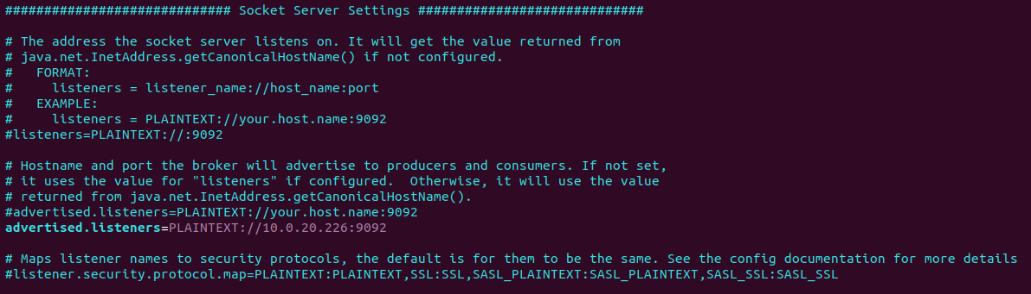
Property advertised.listeners is what the brokers (the handlers of an incoming connection from consumers or producers) broadcasts back to a client. This is the suggested listener. It follows the form of LISTENER_NAME://HOST_NAME:PORT. You need to make sure that the listener can be resolved by the incoming traffic. Here, I explicitly broadcast back the IP of the listener (which is the same as my broker – but it needs not be, especially in a distributed, multinode kafka cluster).
Find more info on brokers, listeners, distributed kafka clusters and a lot more here: https://www.confluent.io/blog/kafka-listeners-explained/
Also note in this screenshot that the security protocol for each listener is also defined in the server.properties file and, most importantly, the default security protocol option for a fresh kafka server installation is PLAINTEXT (meaning none!).

