**import** pandas **as** pd

**import** numpy **as** np

**import** matplotlib.pyplot **as** plt

**import** seaborn **as** sns

plt**.**style**.**use('dark_background')

In [4]:

df **=** pd**.**read_csv(r'C:\Users\HOSHANGI\Downloads\zomato.csv')

df**.**head()

Out[4]:

|  | **url** | **address** | **name** | **online_order** | **book_table** | **rate** | **votes** | **phone** | **location** | **rest_type** | **dish_liked** | **cuisines** | **approx_cost(for two people)** | **reviews_list** | **menu_item** | **listed_in(type)** | **listed_in(city)** |
| --- | --- | --- | --- | --- | --- | --- | --- | --- | --- | --- | --- | --- | --- | --- | --- | --- | --- |
| **0** | https://www.zomato.com/bangalore/jalsa-banasha... | 942, 21st Main Road, 2nd Stage, Banashankari, ... | Jalsa | Yes | Yes | 4.1/5 | 775 | 080 42297555\r\n+91 9743772233 | Banashankari | Casual Dining | Pasta, Lunch Buffet, Masala Papad, Paneer Laja... | North Indian, Mughlai, Chinese | 800 | [('Rated 4.0', 'RATED\n A beautiful place to ... | [] | Buffet | Banashankari |
| **1** | https://www.zomato.com/bangalore/spice-elephan... | 2nd Floor, 80 Feet Road, Near Big Bazaar, 6th ... | Spice Elephant | Yes | No | 4.1/5 | 787 | 080 41714161 | Banashankari | Casual Dining | Momos, Lunch Buffet, Chocolate Nirvana, Thai G... | Chinese, North Indian, Thai | 800 | [('Rated 4.0', 'RATED\n Had been here for din... | [] | Buffet | Banashankari |
| **2** | https://www.zomato.com/SanchurroBangalore?cont... | 1112, Next to KIMS Medical College, 17th Cross... | San Churro Cafe | Yes | No | 3.8/5 | 918 | +91 9663487993 | Banashankari | Cafe, Casual Dining | Churros, Cannelloni, Minestrone Soup, Hot Choc... | Cafe, Mexican, Italian | 800 | [('Rated 3.0', "RATED\n Ambience is not that ... | [] | Buffet | Banashankari |
| **3** | https://www.zomato.com/bangalore/addhuri-udupi... | 1st Floor, Annakuteera, 3rd Stage, Banashankar... | Addhuri Udupi Bhojana | No | No | 3.7/5 | 88 | +91 9620009302 | Banashankari | Quick Bites | Masala Dosa | South Indian, North Indian | 300 | [('Rated 4.0', "RATED\n Great food and proper... | [] | Buffet | Banashankari |
| **4** | https://www.zomato.com/bangalore/grand-village... | 10, 3rd Floor, Lakshmi Associates, Gandhi Baza... | Grand Village | No | No | 3.8/5 | 166 | +91 8026612447\r\n+91 9901210005 | Basavanagudi | Casual Dining | Panipuri, Gol Gappe | North Indian, Rajasthani | 600 | [('Rated 4.0', 'RATED\n Very good restaurant ... | [] | Buffet | Banashankari |

In [7]:

df **=** df**.**drop(['url','address','phone','menu_item','dish_liked','reviews_list'], axis **=** 1)

df**.**head()

Out[7]:

|  | **name** | **online_order** | **book_table** | **rate** | **votes** | **location** | **rest_type** | **cuisines** | **approx_cost(for two people)** | **listed_in(type)** | **listed_in(city)** |
| --- | --- | --- | --- | --- | --- | --- | --- | --- | --- | --- | --- |
| **0** | Jalsa | Yes | Yes | 4.1/5 | 775 | Banashankari | Casual Dining | North Indian, Mughlai, Chinese | 800 | Buffet | Banashankari |
| **1** | Spice Elephant | Yes | No | 4.1/5 | 787 | Banashankari | Casual Dining | Chinese, North Indian, Thai | 800 | Buffet | Banashankari |
| **2** | San Churro Cafe | Yes | No | 3.8/5 | 918 | Banashankari | Cafe, Casual Dining | Cafe, Mexican, Italian | 800 | Buffet | Banashankari |
| **3** | Addhuri Udupi Bhojana | No | No | 3.7/5 | 88 | Banashankari | Quick Bites | South Indian, North Indian | 300 | Buffet | Banashankari |
| **4** | Grand Village | No | No | 3.8/5 | 166 | Basavanagudi | Casual Dining | North Indian, Rajasthani | 600 | Buffet | Banashankari |

In [8]:

df**.**drop_duplicates(inplace **=** **True**)

df**.**shape

Out[8]:

(51609, 11)

In [9]:

**def** handlerate(value):

**if**(value**==**'NEW' **or** value**==**'-'):

**return** np**.**nan

**else**:

value **=** str(value)**.**split('/')

value **=** value[0]

**return** float(value)

df['rate'] **=** df['rate']**.**apply(handlerate)

df['rate']**.**head()

Out[9]:

0 4.1

1 4.1

2 3.8

3 3.7

4 3.8

Name: rate, dtype: float64

In [10]:

df**.**rate**.**isnull()**.**sum()

Out[10]:

10019

In [11]:

df['rate']**.**fillna(df['rate']**.**mean(),inplace **=** **True**)

df['rate']**.**isnull()**.**sum()

Out[11]:

0

In [12]:

df**.**dropna(inplace **=** **True**)

df**.**head()

Out[12]:

|  | **name** | **online_order** | **book_table** | **rate** | **votes** | **location** | **rest_type** | **cuisines** | **approx_cost(for two people)** | **listed_in(type)** | **listed_in(city)** |
| --- | --- | --- | --- | --- | --- | --- | --- | --- | --- | --- | --- |
| **0** | Jalsa | Yes | Yes | 4.1 | 775 | Banashankari | Casual Dining | North Indian, Mughlai, Chinese | 800 | Buffet | Banashankari |
| **1** | Spice Elephant | Yes | No | 4.1 | 787 | Banashankari | Casual Dining | Chinese, North Indian, Thai | 800 | Buffet | Banashankari |
| **2** | San Churro Cafe | Yes | No | 3.8 | 918 | Banashankari | Cafe, Casual Dining | Cafe, Mexican, Italian | 800 | Buffet | Banashankari |
| **3** | Addhuri Udupi Bhojana | No | No | 3.7 | 88 | Banashankari | Quick Bites | South Indian, North Indian | 300 | Buffet | Banashankari |
| **4** | Grand Village | No | No | 3.8 | 166 | Basavanagudi | Casual Dining | North Indian, Rajasthani | 600 | Buffet | Banashankari |

In [13]:

df**.**dropna(inplace **=** **True**)

df**.**head()

Out[13]:

|  | **name** | **online_order** | **book_table** | **rate** | **votes** | **location** | **rest_type** | **cuisines** | **approx_cost(for two people)** | **listed_in(type)** | **listed_in(city)** |
| --- | --- | --- | --- | --- | --- | --- | --- | --- | --- | --- | --- |
| **0** | Jalsa | Yes | Yes | 4.1 | 775 | Banashankari | Casual Dining | North Indian, Mughlai, Chinese | 800 | Buffet | Banashankari |
| **1** | Spice Elephant | Yes | No | 4.1 | 787 | Banashankari | Casual Dining | Chinese, North Indian, Thai | 800 | Buffet | Banashankari |
| **2** | San Churro Cafe | Yes | No | 3.8 | 918 | Banashankari | Cafe, Casual Dining | Cafe, Mexican, Italian | 800 | Buffet | Banashankari |
| **3** | Addhuri Udupi Bhojana | No | No | 3.7 | 88 | Banashankari | Quick Bites | South Indian, North Indian | 300 | Buffet | Banashankari |
| **4** | Grand Village | No | No | 3.8 | 166 | Basavanagudi | Casual Dining | North Indian, Rajasthani | 600 | Buffet | Banashankari |

In [14]:

df**.**rename(columns**=**{'approx_cost(for two people)': 'Cost2plate', 'listed_in(type)':'Type'}, inplace **=** **True**)

df**.**head(3)

Out[14]:

|  | **name** | **online_order** | **book_table** | **rate** | **votes** | **location** | **rest_type** | **cuisines** | **Cost2plate** | **Type** | **listed_in(city)** |
| --- | --- | --- | --- | --- | --- | --- | --- | --- | --- | --- | --- |
| **0** | Jalsa | Yes | Yes | 4.1 | 775 | Banashankari | Casual Dining | North Indian, Mughlai, Chinese | 800 | Buffet | Banashankari |
| **1** | Spice Elephant | Yes | No | 4.1 | 787 | Banashankari | Casual Dining | Chinese, North Indian, Thai | 800 | Buffet | Banashankari |
| **2** | San Churro Cafe | Yes | No | 3.8 | 918 | Banashankari | Cafe, Casual Dining | Cafe, Mexican, Italian | 800 | Buffet | Banashankari |

In [15]:

**def** handlecomma(value):

value **=** str(value)

**if** ',' **in** value:

value **=** value**.**replace(',','')

**return** float(value)

**else**:

**return** float(value)

df['Cost2plate'] **=** df['Cost2plate']**.**apply(handlecomma)

df['Cost2plate']**.**unique()

Out[15]:

array([ 800., 300., 600., 700., 550., 500., 450., 650., 400.,

900., 200., 750., 150., 850., 100., 1200., 350., 250.,

950., 1000., 1500., 1300., 199., 80., 1100., 160., 1600.,

230., 130., 50., 190., 1700., 1400., 180., 1350., 2200.,

2000., 1800., 1900., 330., 2500., 2100., 3000., 2800., 3400.,

40., 1250., 3500., 4000., 2400., 2600., 120., 1450., 469.,

70., 3200., 60., 560., 240., 360., 6000., 1050., 2300.,

4100., 5000., 3700., 1650., 2700., 4500., 140.])

In [16]:

rest_types **=** df['rest_type']**.**value_counts(ascending **=** **False**)

rest_types

Out[16]:

Quick Bites 19010

Casual Dining 10253

Cafe 3682

Delivery 2574

Dessert Parlor 2242

...

Dessert Parlor, Kiosk 2

Food Court, Beverage Shop 2

Dessert Parlor, Food Court 2

Quick Bites, Kiosk 1

Sweet Shop, Dessert Parlor 1

Name: rest_type, Length: 93, dtype: int64

In [17]:

rest_types_lessthan1000 **=** rest_types[rest_types**<**1000]

rest_types_lessthan1000

Out[17]:

Beverage Shop 863

Bar 686

Food Court 616

Sweet Shop 468

Bar, Casual Dining 411

...

Dessert Parlor, Kiosk 2

Food Court, Beverage Shop 2

Dessert Parlor, Food Court 2

Quick Bites, Kiosk 1

Sweet Shop, Dessert Parlor 1

Name: rest_type, Length: 85, dtype: int64

In [18]:

**def** handle_rest_type(value):

**if**(value **in** rest_types_lessthan1000):

**return** 'others'

**else**:

**return** value

df['rset_type'] **=** df['rest_type']**.**apply(handle_rest_type)

df['rest_type']**.**value_counts()

Out[18]:

Quick Bites 19010

Casual Dining 10253

Cafe 3682

Delivery 2574

Dessert Parlor 2242

...

Dessert Parlor, Kiosk 2

Food Court, Beverage Shop 2

Dessert Parlor, Food Court 2

Quick Bites, Kiosk 1

Sweet Shop, Dessert Parlor 1

Name: rest_type, Length: 93, dtype: int64

In [20]:

location **=** df['location']**.**value_counts(ascending **=** **False**)

location_lessthan300 **=** location[location**<**300]

**def** handle_location(value):

**if**(value **in** location_lessthan300):

**return** 'others'

**else**:

**return** value

df['location'] **=** df['location']**.**apply(handle_location)

df['location']**.**value_counts()

Out[20]:

BTM 5056

others 4954

HSR 2494

Koramangala 5th Block 2479

JP Nagar 2218

Whitefield 2105

Indiranagar 2026

Jayanagar 1916

Marathahalli 1805

Bannerghatta Road 1609

Bellandur 1268

Electronic City 1246

Koramangala 1st Block 1236

Brigade Road 1210

Koramangala 7th Block 1174

Koramangala 6th Block 1127

Sarjapur Road 1047

Koramangala 4th Block 1017

Ulsoor 1011

Banashankari 902

MG Road 893

Kalyan Nagar 841

Richmond Road 803

Malleshwaram 721

Frazer Town 714

Basavanagudi 684

Residency Road 671

Brookefield 656

New BEL Road 644

Banaswadi 640

Kammanahalli 639

Rajajinagar 591

Church Street 566

Lavelle Road 518

Shanti Nagar 508

Shivajinagar 498

Cunningham Road 490

Domlur 482

Old Airport Road 437

Ejipura 433

Commercial Street 370

St. Marks Road 343

Name: location, dtype: int64

In [21]:

cuisines **=** df['cuisines']**.**value_counts(ascending **=** **False**)

cuisines_lessthan100 **=** cuisines[cuisines**<**100]

**def** handle_cuisines(value):

**if**(value **in** cuisines_lessthan100):

**return** 'others'

**else**:

**return** value

df['cuisines'] **=** df['cuisines']**.**apply(handle_cuisines)

df['cuisines']**.**value_counts()

Out[21]:

others 26159

North Indian 2852

North Indian, Chinese 2351

South Indian 1820

Biryani 903

...

South Indian, Chinese, North Indian 105

North Indian, Mughlai, Chinese 104

South Indian, Fast Food 104

Italian, Pizza 102

North Indian, Chinese, Seafood 102

Name: cuisines, Length: 70, dtype: int64

In [22]:

plt**.**figure(figsize **=** (16,10))

ax **=** sns**.**countplot(data**=**df, x**=**'location')

plt**.**xticks(rotation **=** 90)

Out[22]:

(array([ 0, 1, 2, 3, 4, 5, 6, 7, 8, 9, 10, 11, 12, 13, 14, 15, 16,

17, 18, 19, 20, 21, 22, 23, 24, 25, 26, 27, 28, 29, 30, 31, 32, 33,

34, 35, 36, 37, 38, 39, 40, 41]),

[Text(0, 0, 'Banashankari'),

Text(1, 0, 'Basavanagudi'),

Text(2, 0, 'others'),

Text(3, 0, 'Jayanagar'),

Text(4, 0, 'JP Nagar'),

Text(5, 0, 'Bannerghatta Road'),

Text(6, 0, 'BTM'),

Text(7, 0, 'Electronic City'),

Text(8, 0, 'HSR'),

Text(9, 0, 'Marathahalli'),

Text(10, 0, 'Shanti Nagar'),

Text(11, 0, 'Koramangala 5th Block'),

Text(12, 0, 'Richmond Road'),

Text(13, 0, 'Koramangala 7th Block'),

Text(14, 0, 'Koramangala 4th Block'),

Text(15, 0, 'Bellandur'),

Text(16, 0, 'Sarjapur Road'),

Text(17, 0, 'Whitefield'),

Text(18, 0, 'Old Airport Road'),

Text(19, 0, 'Indiranagar'),

Text(20, 0, 'Koramangala 1st Block'),

Text(21, 0, 'Frazer Town'),

Text(22, 0, 'MG Road'),

Text(23, 0, 'Brigade Road'),

Text(24, 0, 'Lavelle Road'),

Text(25, 0, 'Church Street'),

Text(26, 0, 'Ulsoor'),

Text(27, 0, 'Residency Road'),

Text(28, 0, 'Shivajinagar'),

Text(29, 0, 'St. Marks Road'),

Text(30, 0, 'Cunningham Road'),

Text(31, 0, 'Commercial Street'),

Text(32, 0, 'Domlur'),

Text(33, 0, 'Ejipura'),

Text(34, 0, 'Malleshwaram'),

Text(35, 0, 'Kammanahalli'),

Text(36, 0, 'Koramangala 6th Block'),

Text(37, 0, 'Brookefield'),

Text(38, 0, 'Rajajinagar'),

Text(39, 0, 'Banaswadi'),

Text(40, 0, 'Kalyan Nagar'),

Text(41, 0, 'New BEL Road')])

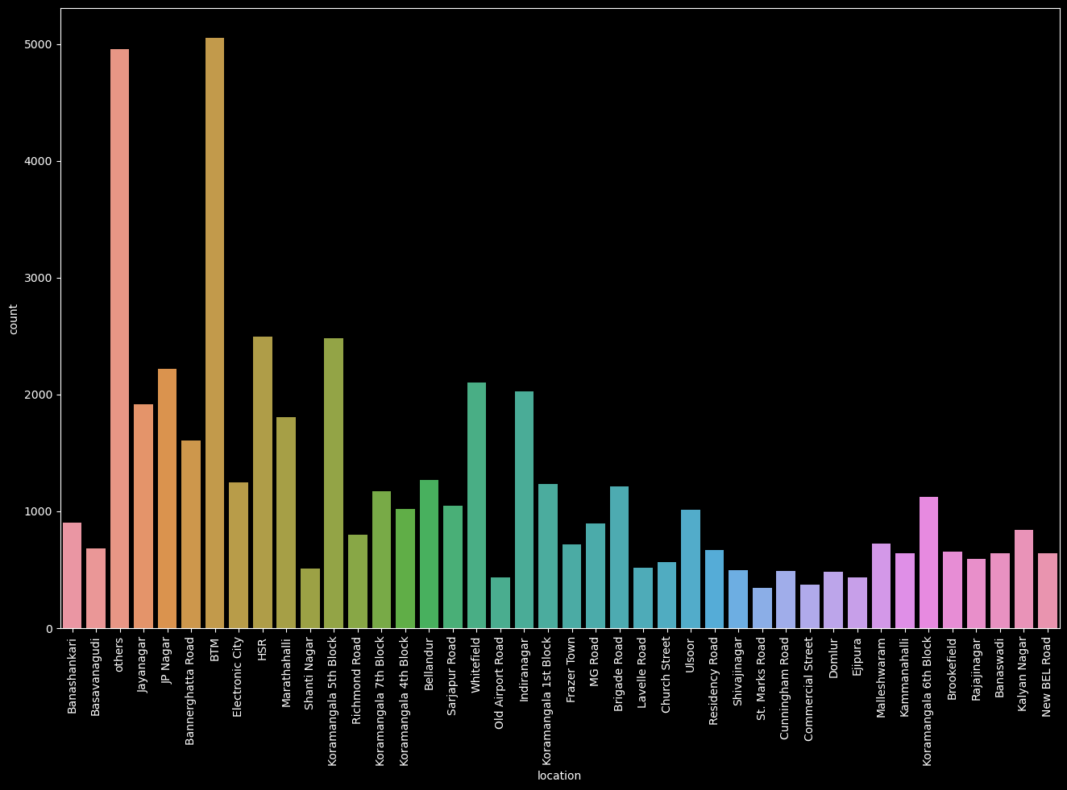In [23]:

plt**.**figure(figsize**=**(8, 6))

sns**.**countplot(data**=**df, x**=**'online_order', palette**=**'inferno')

Out[23]:

<AxesSubplot:xlabel='online_order', ylabel='count'>

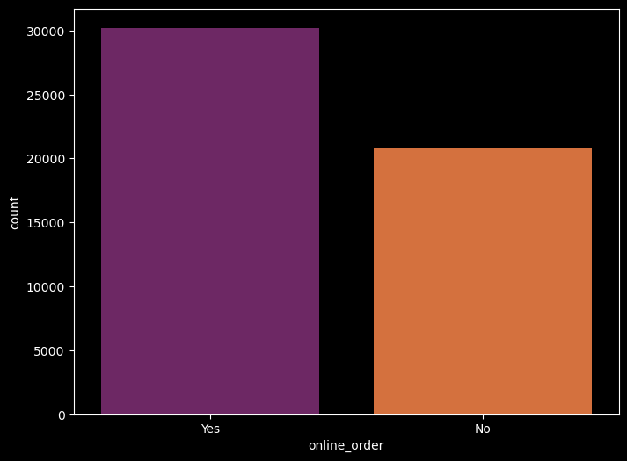In [24]:

plt**.**figure(figsize **=** (6,6))

sns**.**countplot(data **=** df, x **=**'book_table', palette **=** 'rainbow')

Out[24]:

<AxesSubplot:xlabel='book_table', ylabel='count'>

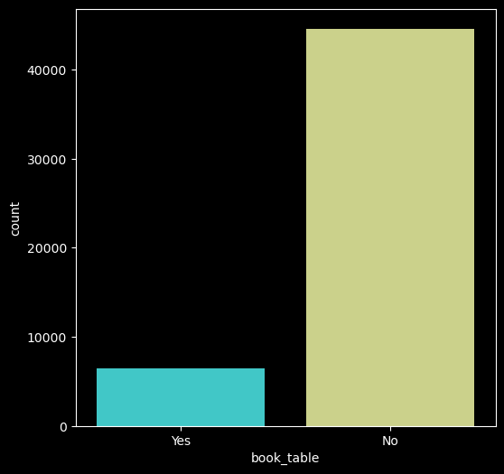In [27]:

plt**.**figure(figsize**=**(10,6))

sns**.**countplot(x**=**'online_order', hue**=**'rate', data**=**df)

Out[27]:

<AxesSubplot:xlabel='online_order', ylabel='count'>

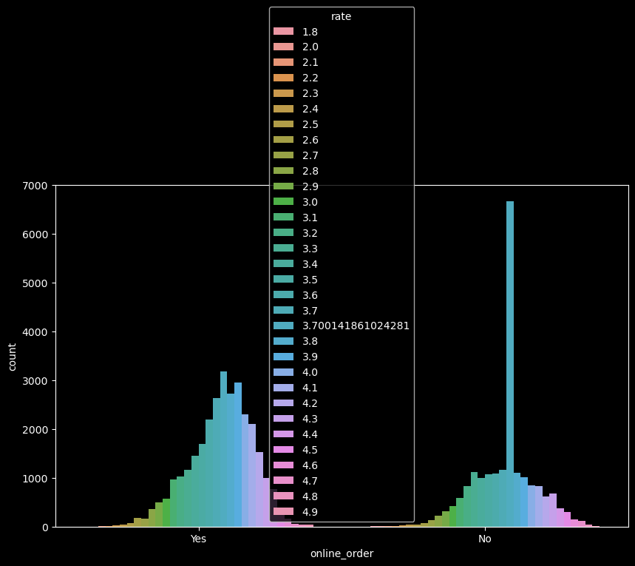In [29]:

plt**.**figure(figsize **=** (10,6))

sns**.**boxplot(x**=**'book_table',y **=** 'rate', data**=**df)

Out[29]:

<AxesSubplot:xlabel='book_table', ylabel='rate'>

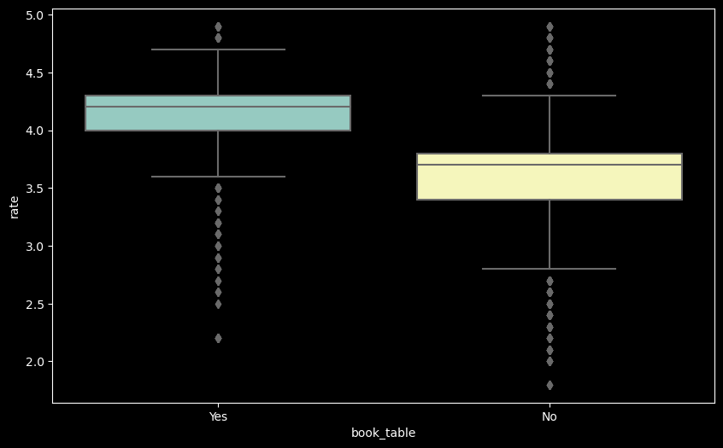In [30]:

df1 **=** df**.**groupby(['location', 'online_order'])['name']**.**count()

df1**.**to_csv('location_online.csv')

df1 **=** pd**.**read_csv('location_online.csv')

df1 **=** pd**.**pivot_table(df1, values**=None**,index **=** ['location'], columns **=** ['online_order'], fill_value **=** 0, aggfunc **=** np**.**sum)

df1

Out[30]:

|  | **name** | |
| --- | --- | --- |
| **online_order** | **No** | **Yes** |
| **location** |  |  |
| **BTM** | 1763 | 3293 |
| **Banashankari** | 397 | 505 |
| **Banaswadi** | 302 | 338 |
| **Bannerghatta Road** | 685 | 924 |
| **Basavanagudi** | 243 | 441 |
| **Bellandur** | 517 | 751 |
| **Brigade Road** | 552 | 658 |
| **Brookefield** | 239 | 417 |
| **Church Street** | 226 | 340 |
| **Commercial Street** | 228 | 142 |
| **Cunningham Road** | 168 | 322 |
| **Domlur** | 247 | 235 |
| **Ejipura** | 214 | 219 |
| **Electronic City** | 676 | 570 |
| **Frazer Town** | 287 | 427 |
| **HSR** | 584 | 1910 |
| **Indiranagar** | 697 | 1329 |
| **JP Nagar** | 911 | 1307 |
| **Jayanagar** | 552 | 1364 |
| **Kalyan Nagar** | 350 | 491 |
| **Kammanahalli** | 264 | 375 |
| **Koramangala 1st Block** | 384 | 852 |
| **Koramangala 4th Block** | 459 | 558 |
| **Koramangala 5th Block** | 866 | 1613 |
| **Koramangala 6th Block** | 445 | 682 |
| **Koramangala 7th Block** | 389 | 785 |
| **Lavelle Road** | 315 | 203 |
| **MG Road** | 520 | 373 |
| **Malleshwaram** | 309 | 412 |
| **Marathahalli** | 701 | 1104 |
| **New BEL Road** | 255 | 389 |
| **Old Airport Road** | 221 | 216 |
| **Rajajinagar** | 286 | 305 |
| **Residency Road** | 424 | 247 |
| **Richmond Road** | 557 | 246 |
| **Sarjapur Road** | 323 | 724 |
| **Shanti Nagar** | 289 | 219 |
| **Shivajinagar** | 354 | 144 |
| **St. Marks Road** | 176 | 167 |
| **Ulsoor** | 389 | 622 |
| **Whitefield** | 986 | 1119 |
| **others** | 2064 | 2890 |

In [31]:

df1**.**plot(kind **=** 'bar',figsize **=** (15,8))

Out[31]:

<AxesSubplot:xlabel='location'>

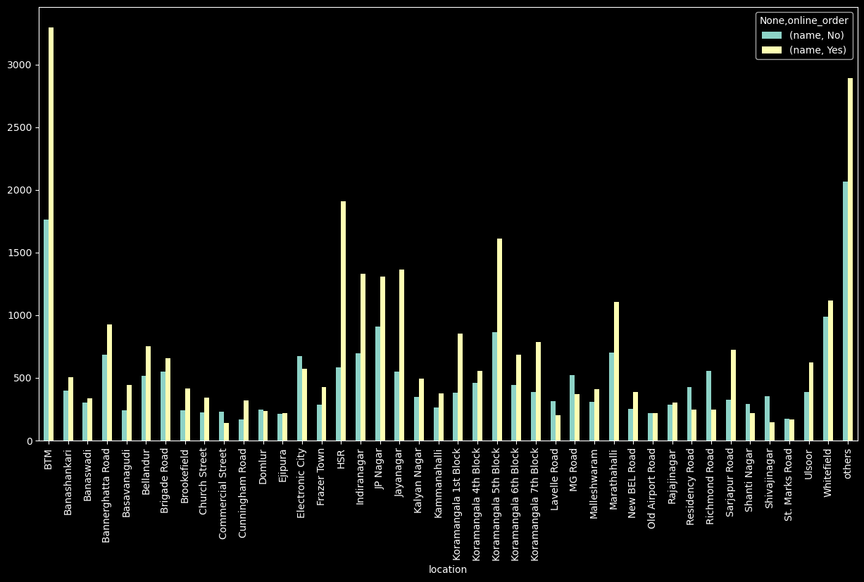In [32]:

df2 **=** df**.**groupby(['location','book_table'])['name']**.**count()

df2**.**to_csv('location_booktable.csv')

df2 **=** pd**.**read_csv('location_booktable.csv')

df2 **=** pd**.**pivot_table(df2, values **=** **None**,index **=** ['location'], columns **=** ['book_table'], fill_value**=** 0, aggfunc **=** np**.**sum)

df2

df2**.**plot(kind **=** 'bar', figsize **=** (15,8))

Out[32]:

<AxesSubplot:xlabel='location'>

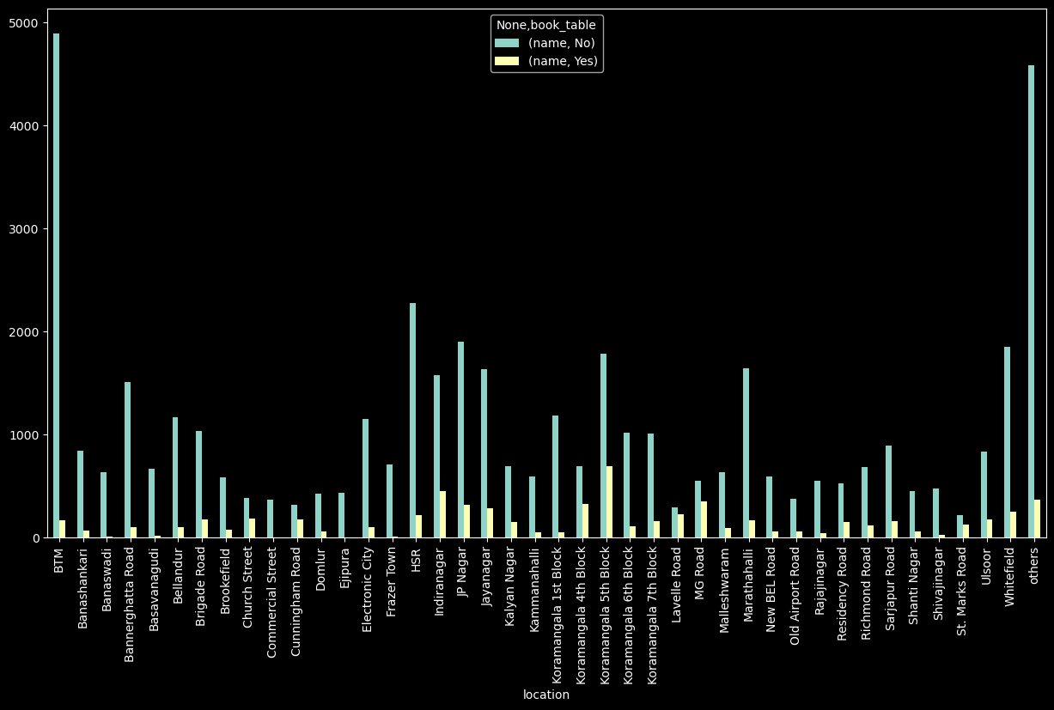In [33]:

plt**.**figure(figsize **=** (14,8))

sns**.**boxplot(x **=** 'Type', y **=** 'rate', data **=** df, palette **=** 'inferno')

Out[33]:

<AxesSubplot:xlabel='Type', ylabel='rate'>

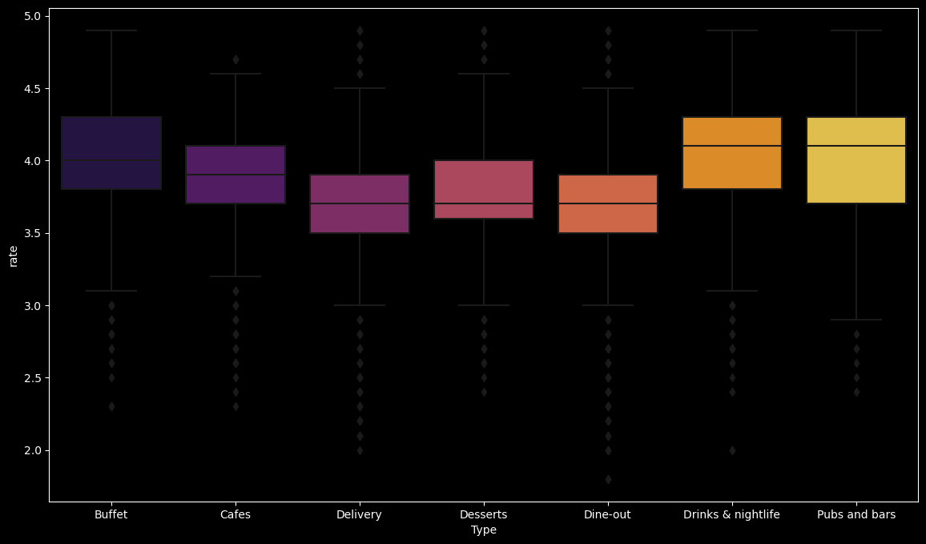In [34]:

df3 **=** df**.**groupby(['location','Type'])['name']**.**count()

df3**.**to_csv('location_Type.csv')

df3 **=** pd**.**read_csv('location_Type.csv')

df3 **=** pd**.**pivot_table(df3, values **=** **None**,index **=** ['location'], columns **=** ['Type'], fill_value**=** 0, aggfunc **=** np**.**sum)

df3

df3**.**plot(kind **=** 'bar', figsize **=** (36,8))

Out[34]:

<AxesSubplot:xlabel='location'>

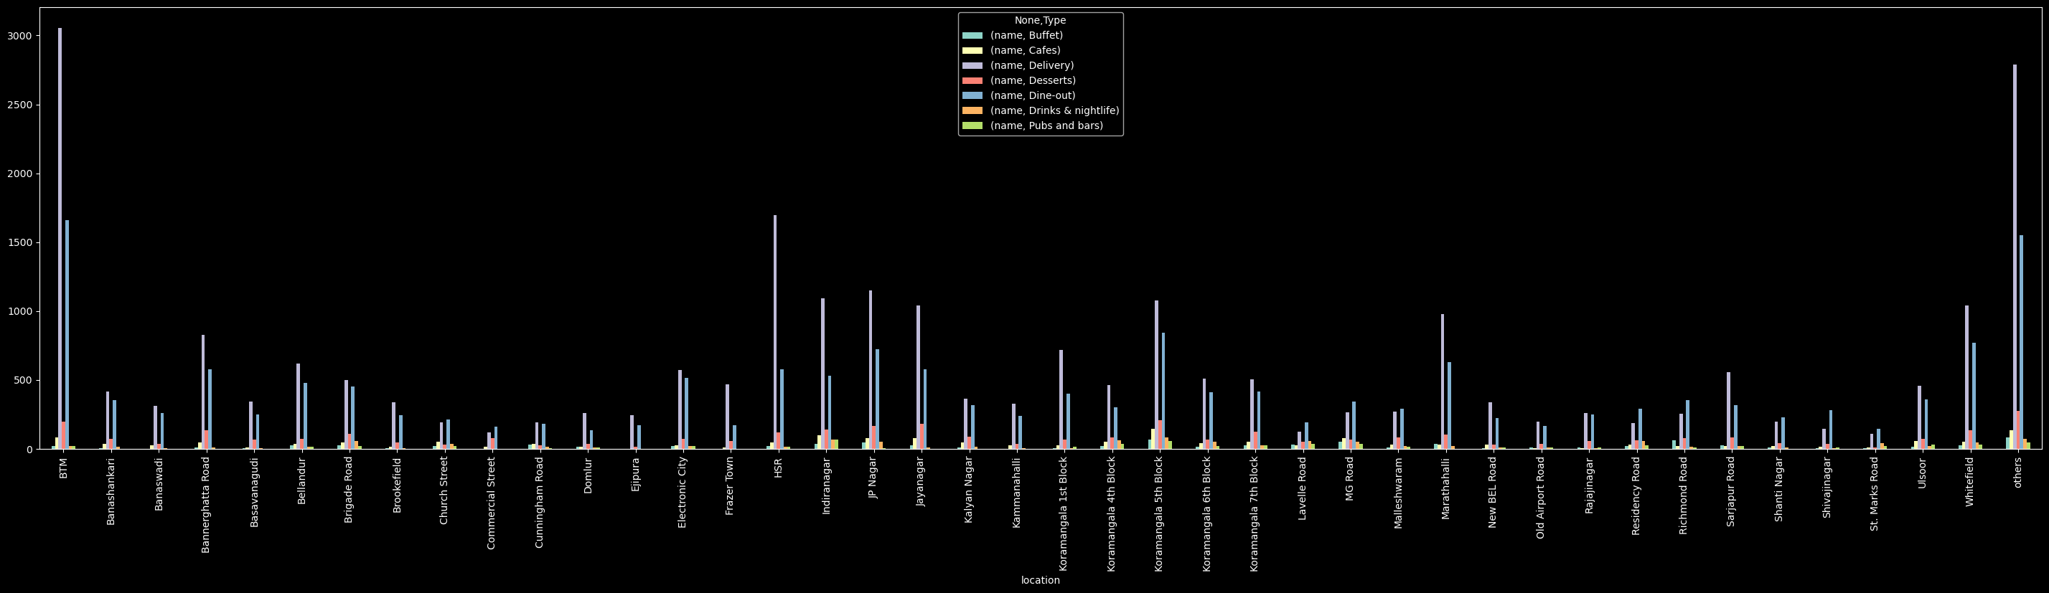In [35]:

df4 **=** df[['location','votes']]

df4**.**drop_duplicates()

df5 **=** df4**.**groupby(['location'])['votes']**.**sum()

df5 **=** df5**.**to_frame()

df5 **=** df5**.**sort_values('votes',ascending **=** **False**)

df5**.**head()

Out[35]:

|  | **votes** |
| --- | --- |
| **location** |  |
| **Koramangala 5th Block** | 2214083 |
| **Indiranagar** | 1165909 |
| **Koramangala 4th Block** | 685156 |
| **Church Street** | 590306 |
| **JP Nagar** | 586522 |

In [36]:

plt**.**figure(figsize **=** (15,8))

sns**.**barplot(df5**.**index,df5['votes'])

plt**.**xticks(rotation **=** 90)

C:\Users\HOSHANGI\anaconda3\lib\site-packages\seaborn\_decorators.py:36: FutureWarning: Pass the following variables as keyword args: x, y. From version 0.12, the only valid positional argument will be `data`, and passing other arguments without an explicit keyword will result in an error or misinterpretation.

warnings.warn(

Out[36]:

(array([ 0, 1, 2, 3, 4, 5, 6, 7, 8, 9, 10, 11, 12, 13, 14, 15, 16,

17, 18, 19, 20, 21, 22, 23, 24, 25, 26, 27, 28, 29, 30, 31, 32, 33,

34, 35, 36, 37, 38, 39, 40, 41]),

[Text(0, 0, 'Koramangala 5th Block'),

Text(1, 0, 'Indiranagar'),

Text(2, 0, 'Koramangala 4th Block'),

Text(3, 0, 'Church Street'),

Text(4, 0, 'JP Nagar'),

Text(5, 0, 'BTM'),

Text(6, 0, 'others'),

Text(7, 0, 'HSR'),

Text(8, 0, 'Lavelle Road'),

Text(9, 0, 'Koramangala 7th Block'),

Text(10, 0, 'Jayanagar'),

Text(11, 0, 'Whitefield'),

Text(12, 0, 'Koramangala 6th Block'),

Text(13, 0, 'Marathahalli'),

Text(14, 0, 'MG Road'),

Text(15, 0, 'Brigade Road'),

Text(16, 0, 'Sarjapur Road'),

Text(17, 0, 'Residency Road'),

Text(18, 0, 'Cunningham Road'),

Text(19, 0, 'St. Marks Road'),

Text(20, 0, 'Koramangala 1st Block'),

Text(21, 0, 'Malleshwaram'),

Text(22, 0, 'Bannerghatta Road'),

Text(23, 0, 'Bellandur'),

Text(24, 0, 'Ulsoor'),

Text(25, 0, 'New BEL Road'),

Text(26, 0, 'Kalyan Nagar'),

Text(27, 0, 'Banashankari'),

Text(28, 0, 'Old Airport Road'),

Text(29, 0, 'Brookefield'),

Text(30, 0, 'Richmond Road'),

Text(31, 0, 'Electronic City'),

Text(32, 0, 'Kammanahalli'),

Text(33, 0, 'Frazer Town'),

Text(34, 0, 'Domlur'),

Text(35, 0, 'Basavanagudi'),

Text(36, 0, 'Rajajinagar'),

Text(37, 0, 'Shanti Nagar'),

Text(38, 0, 'Banaswadi'),

Text(39, 0, 'Commercial Street'),

Text(40, 0, 'Ejipura'),

Text(41, 0, 'Shivajinagar')])

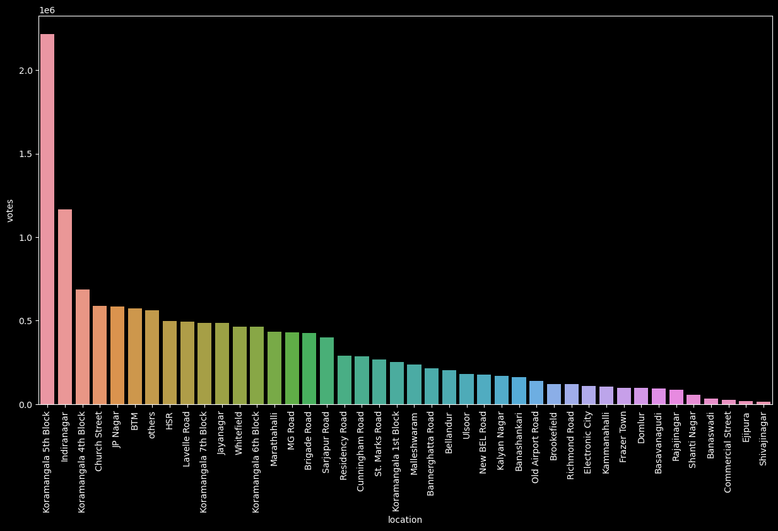In [37]:

df**.**head()

Out[37]:

|  | **name** | **online_order** | **book_table** | **rate** | **votes** | **location** | **rest_type** | **cuisines** | **Cost2plate** | **Type** | **listed_in(city)** | **rset_type** |
| --- | --- | --- | --- | --- | --- | --- | --- | --- | --- | --- | --- | --- |
| **0** | Jalsa | Yes | Yes | 4.1 | 775 | Banashankari | Casual Dining | North Indian, Mughlai, Chinese | 800.0 | Buffet | Banashankari | Casual Dining |
| **1** | Spice Elephant | Yes | No | 4.1 | 787 | Banashankari | Casual Dining | others | 800.0 | Buffet | Banashankari | Casual Dining |
| **2** | San Churro Cafe | Yes | No | 3.8 | 918 | Banashankari | Cafe, Casual Dining | others | 800.0 | Buffet | Banashankari | others |
| **3** | Addhuri Udupi Bhojana | No | No | 3.7 | 88 | Banashankari | Quick Bites | South Indian, North Indian | 300.0 | Buffet | Banashankari | Quick Bites |
| **4** | Grand Village | No | No | 3.8 | 166 | Basavanagudi | Casual Dining | others | 600.0 | Buffet | Banashankari | Casual Dining |

In [38]:

df6 **=** df[['cuisines','votes']]

df6**.**drop_duplicates()

df7 **=** df6**.**groupby(['cuisines'])['votes']**.**sum()

df7 **=** df7**.**to_frame()

df7 **=** df7**.**sort_values('votes',ascending **=** **False**)

df7**.**head()

Out[38]:

|  | **votes** |
| --- | --- |
| **cuisines** |  |
| **others** | 11542182 |
| **North Indian** | 516310 |
| **North Indian, Chinese** | 258225 |
| **South Indian** | 161975 |
| **North Indian, Mughlai** | 103706 |

In [39]:

df7 **=**df7**.**iloc[1:, :]

df7**.**head()

Out[39]:

|  | **votes** |
| --- | --- |
| **cuisines** |  |
| **North Indian** | 516310 |
| **North Indian, Chinese** | 258225 |
| **South Indian** | 161975 |
| **North Indian, Mughlai** | 103706 |
| **Chinese** | 101728 |

In [44]:

plt**.**figure(figsize **=** (15,8))

sns**.**barplot(df7**.**index, df7['votes'])

plt**.**xticks(rotation **=** 90)

C:\Users\HOSHANGI\anaconda3\lib\site-packages\seaborn\_decorators.py:36: FutureWarning: Pass the following variables as keyword args: x, y. From version 0.12, the only valid positional argument will be `data`, and passing other arguments without an explicit keyword will result in an error or misinterpretation.

warnings.warn(

Out[44]:

(array([ 0, 1, 2, 3, 4, 5, 6, 7, 8, 9, 10, 11, 12, 13, 14, 15, 16,

17, 18, 19, 20, 21, 22, 23, 24, 25, 26, 27, 28, 29, 30, 31, 32, 33,

34, 35, 36, 37, 38, 39, 40, 41, 42, 43, 44, 45, 46, 47, 48, 49, 50,

51, 52, 53, 54, 55, 56, 57, 58, 59, 60, 61, 62, 63, 64, 65, 66, 67,

68]),

[Text(0, 0, 'North Indian'),

Text(1, 0, 'North Indian, Chinese'),

Text(2, 0, 'South Indian'),

Text(3, 0, 'North Indian, Mughlai'),

Text(4, 0, 'Chinese'),

Text(5, 0, 'Cafe'),

Text(6, 0, 'North Indian, South Indian'),

Text(7, 0, 'Desserts'),

Text(8, 0, 'Chinese, Momos'),

Text(9, 0, 'Ice Cream, Desserts'),

Text(10, 0, 'Cafe, Continental'),

Text(11, 0, 'Biryani, North Indian, Chinese'),

Text(12, 0, 'Chinese, Thai, Momos'),

Text(13, 0, 'South Indian, North Indian, Chinese'),

Text(14, 0, 'Desserts, Beverages'),

Text(15, 0, 'Biryani'),

Text(16, 0, 'Finger Food'),

Text(17, 0, 'Bakery, Desserts'),

Text(18, 0, 'Burger, Fast Food'),

Text(19, 0, 'Continental'),

Text(20, 0, 'Cafe, Desserts'),

Text(21, 0, 'Andhra, Biryani'),

Text(22, 0, 'North Indian, Continental'),

Text(23, 0, 'Pizza, Fast Food'),

Text(24, 0, 'Chinese, Thai'),

Text(25, 0, 'North Indian, Chinese, Biryani'),

Text(26, 0, 'South Indian, North Indian, Chinese, Street Food'),

Text(27, 0, 'Mithai, Street Food'),

Text(28, 0, 'North Indian, South Indian, Chinese'),

Text(29, 0, 'Desserts, Ice Cream'),

Text(30, 0, 'Biryani, North Indian'),

Text(31, 0, 'North Indian, Street Food'),

Text(32, 0, 'Fast Food'),

Text(33, 0, 'North Indian, Chinese, Seafood'),

Text(34, 0, 'Chinese, North Indian'),

Text(35, 0, 'North Indian, Biryani'),

Text(36, 0, 'Biryani, Kebab'),

Text(37, 0, 'Italian, Pizza'),

Text(38, 0, 'North Indian, Chinese, Fast Food'),

Text(39, 0, 'North Indian, Chinese, Continental'),

Text(40, 0, 'Desserts, Bakery'),

Text(41, 0, 'Arabian'),

Text(42, 0, 'North Indian, Chinese, South Indian'),

Text(43, 0, 'Pizza'),

Text(44, 0, 'South Indian, North Indian'),

Text(45, 0, 'North Indian, Mughlai, Chinese'),

Text(46, 0, 'Beverages, Fast Food'),

Text(47, 0, 'South Indian, Biryani'),

Text(48, 0, 'Fast Food, Rolls'),

Text(49, 0, 'Bakery'),

Text(50, 0, 'Andhra'),

Text(51, 0, 'Street Food'),

Text(52, 0, 'Kerala'),

Text(53, 0, 'Cafe, Bakery'),

Text(54, 0, 'Biryani, Fast Food'),

Text(55, 0, 'South Indian, Fast Food'),

Text(56, 0, 'North Indian, Fast Food'),

Text(57, 0, 'Bakery, Fast Food'),

Text(58, 0, 'Fast Food, Burger'),

Text(59, 0, 'Cafe, Fast Food'),

Text(60, 0, 'South Indian, Chinese'),

Text(61, 0, 'Beverages, Desserts'),

Text(62, 0, 'Ice Cream'),

Text(63, 0, 'Beverages'),

Text(64, 0, 'Biryani, South Indian'),

Text(65, 0, 'Kerala, South Indian'),

Text(66, 0, 'Fast Food, Beverages'),

Text(67, 0, 'South Indian, Chinese, North Indian'),

Text(68, 0, 'Mithai')])

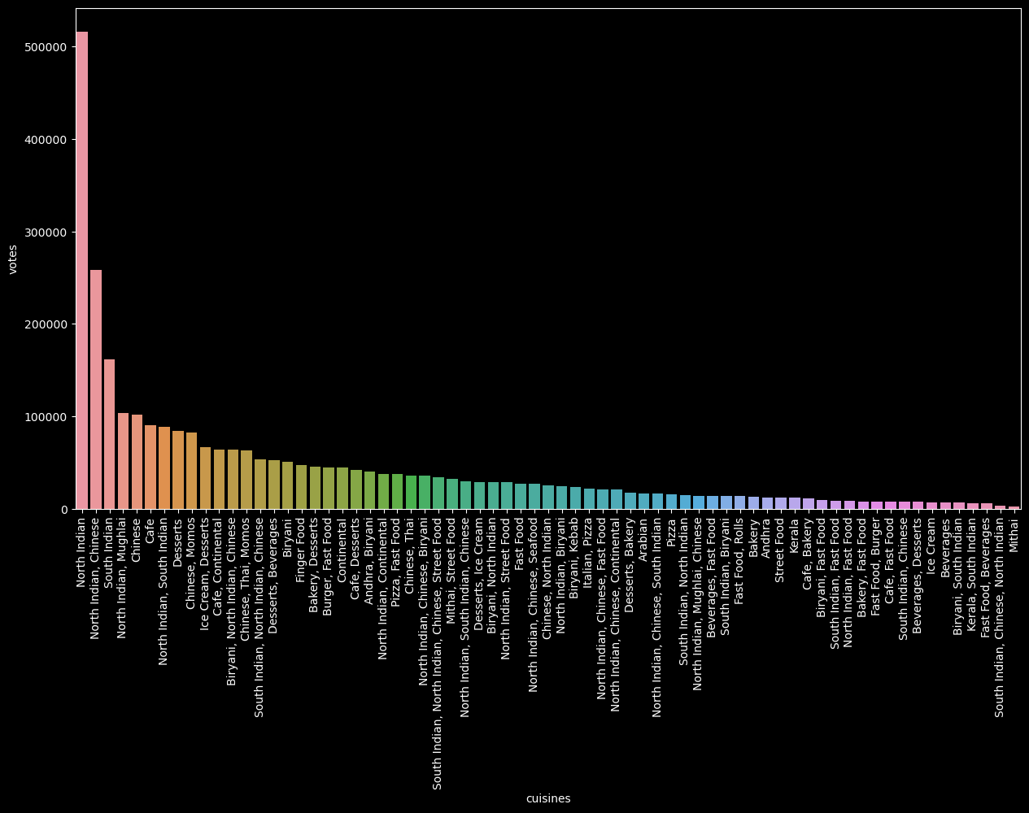In [ ]: