INTRODUCTION

TO

IMAGE PROCESSING

EEE410

HOMEWORK 7

HALİME ÖZGE KABAK

180403001

* MATLAB
* This is my graphical user interface in MATLAB.

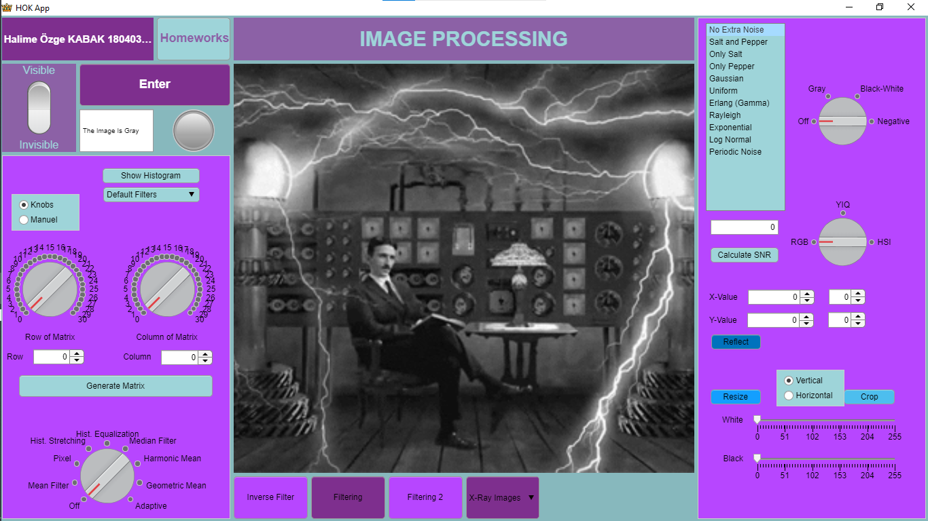

* We needed to filter the 3 pictures given in this assignment by applying inverse filtering. I completed this process in 3 images on MATLAB.

**First Image:**

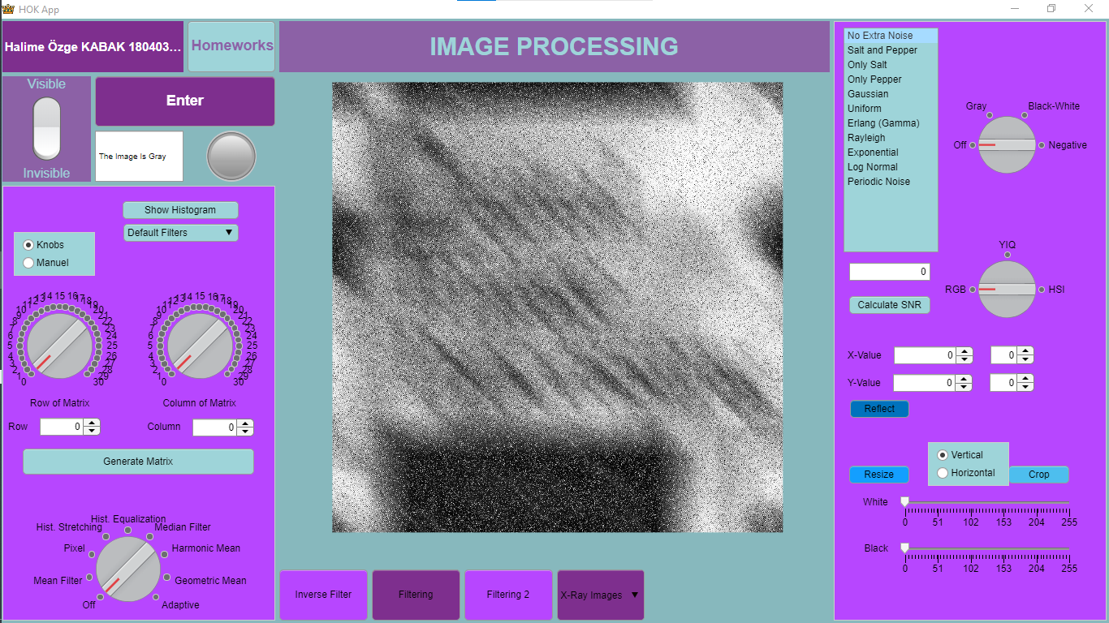

**After Inverse Filtering:**

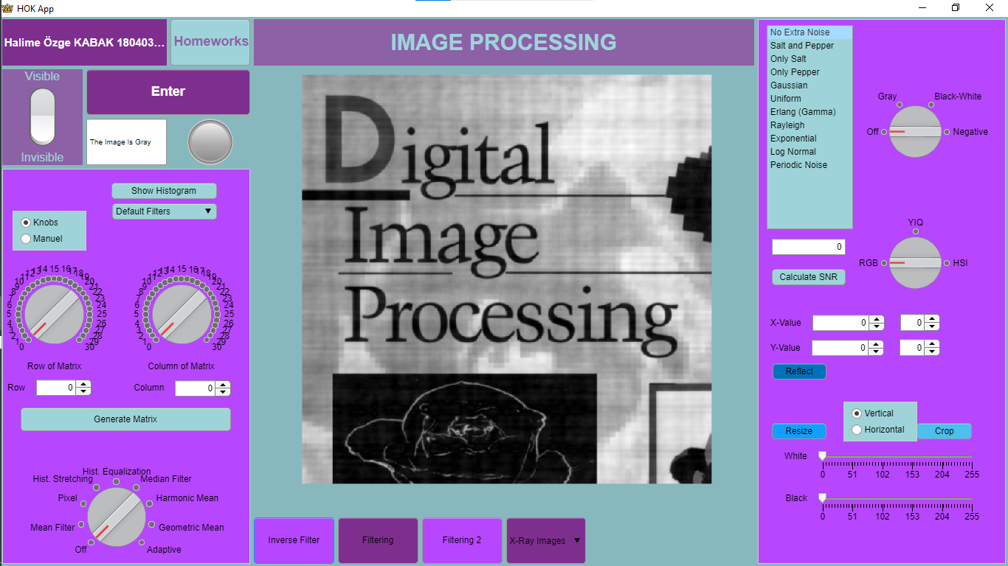

**Second Image:**

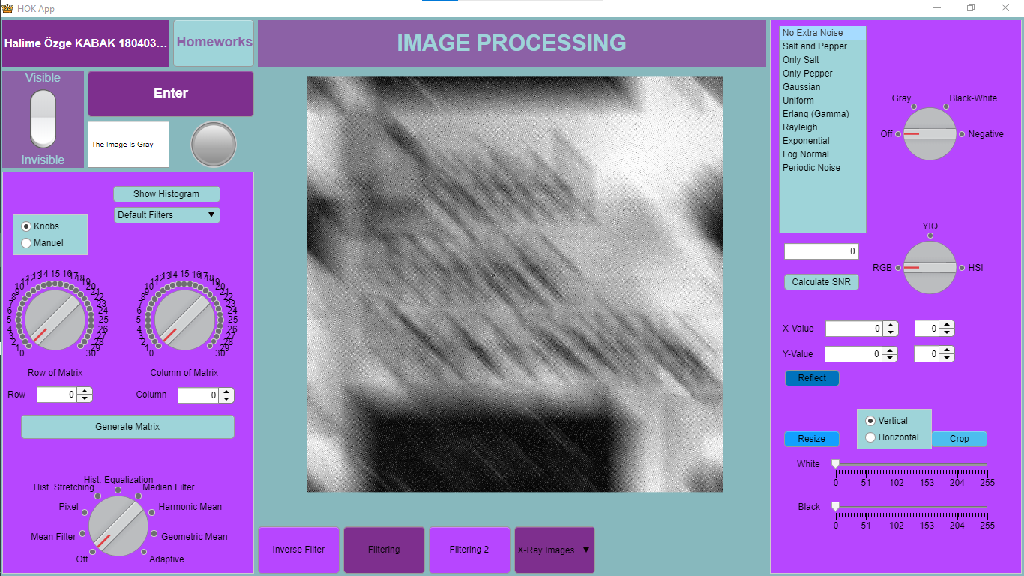

**After Inverse Filtering:**

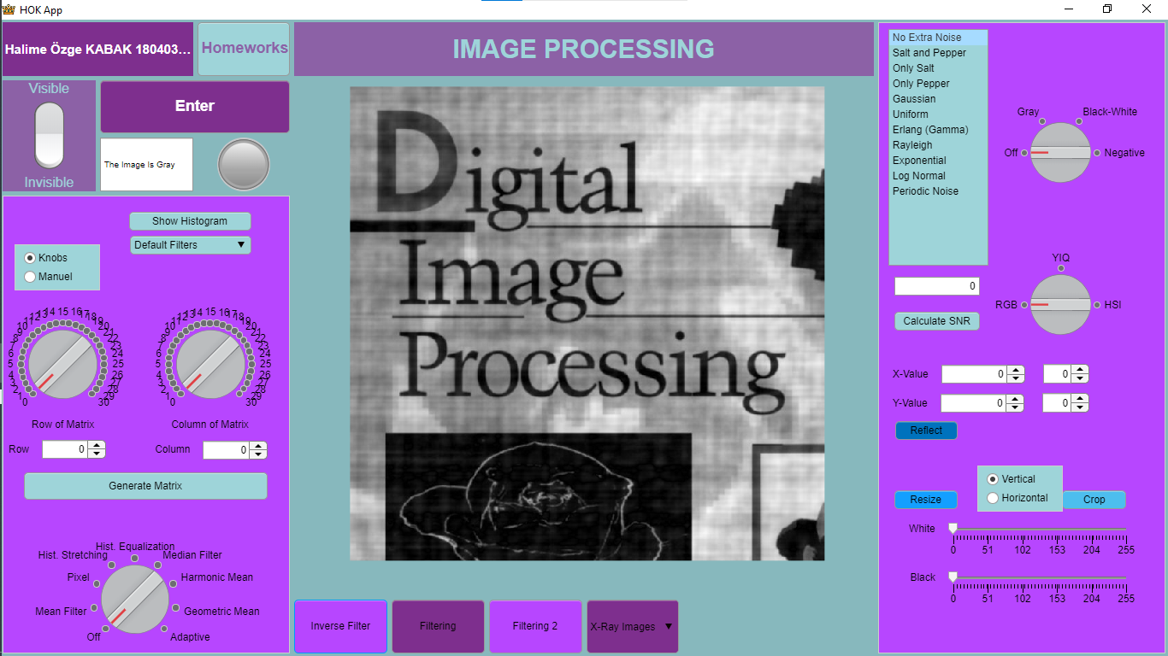

**Third Image:**

metin, ekran görüntüsü, ekran içeren bir resim

Açıklama otomatik olarak oluşturuldu

**After Inverse Filtering:**

