Name | Rama Krishna
Class | 7 B
Purpose: Skill Assessment Program - Building Strengths Beyond Academics
This report shows your child’s interests and abilities in different school activities. With your (parents) support and our guidance, these strengths can grow into useful life skills. It helps parents notice early signs of talent and areas where extra care or practice can make a big difference.
Key Insights:
The graph below shows how your child is doing in different areas. It tells us what they like more and where we can help them do even better. Blue represents your child, and red represents the class average.
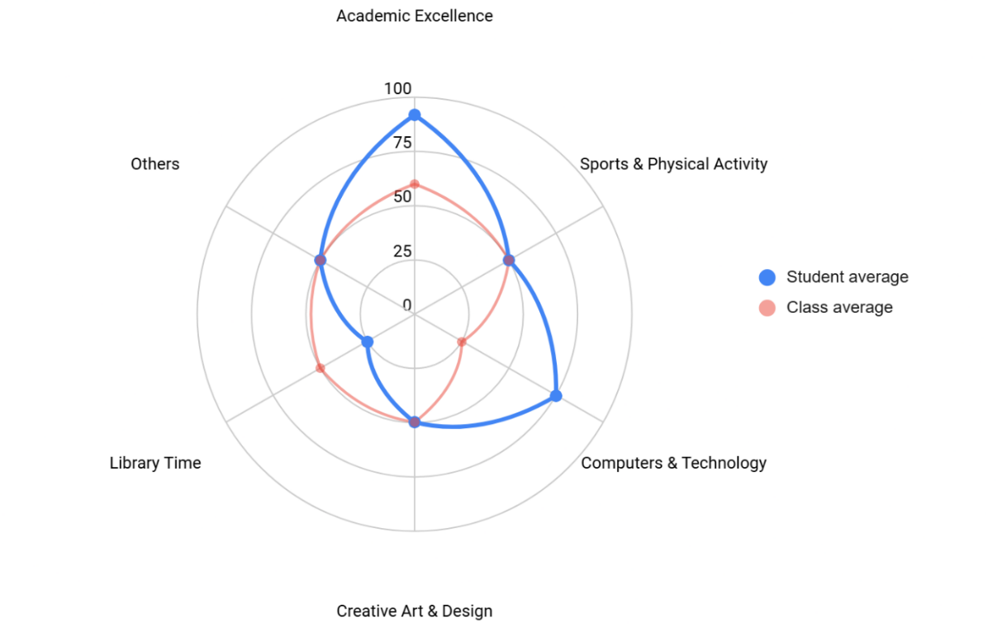

Observations:
The table gives an overview of child’s involvement and performance across co-curricular areas.
Interest Area | Engagement (%) | Interest Level | Key Observations
Academic Excellence | 92 | Interested | He is an all-rounder when it comes to exams and presentations. Based on teacher feedback, he shows strong interest in Maths and History.
Sports & Physical Activity | 50 | Positively Involved | Shows fair participation and energy in physical activities, indicating a balanced interest.
Computers & Technology | 75 | Very Curious | He is very quick with computers and loves exploring new tools and features.
Art & Design | 50 | Positively Involved | Engages in creative tasks when given, with potential to develop further with the right guidance.
Library Time | 25 | Exploring Preferences | Prefers more interactive or hands-on activities over quiet reading sessions.
Others | 50 | Positively Involved | Participates decently in other activities; shows curiosity when something new is introduced.
Recommendations & Growth Opportunities:
Here are some ways to turn your child’s interests into long-term strengths:
Strong Interest Area | Potential Careers | Simple Activities to Support
Academics (92%) | Teacher, Government Officer, Scientist, Historian | Encourage quiz games, reading books, school competitions, and storytelling
Computers & Technology (75%) | Software Creator, Cyber Safety Expert, App Developer | Let them explore child-friendly coding apps (like Scratch), logic games, or typing games
How Parents Can Help:
- Encourage Reading and Media: Provide books or educational videos on Maths, History, or Science (e.g., Khan Academy’s free Moths tutorials or History documentaries).
- Support Tech Exploration: Allocate 30 minutes weekly for learning games or coding apps like Scratch (available at scratch.mit.edu).
- Engage in Discussions: Spend 10-15 minutes weekly talking about school topics your child enjoys, asking open-ended questions to spark curiosity.
Conclusion:
Your child’s strengths in Maths, History, and technology offer exciting opportunities for growth. Focus on the recommended activities to nurture their potential. For personalized advice, contact their teacher or school counsellor.

