**Longitudinal data, trajectories and time series: how to analyze them?**

**Other examples**

***100 patients with 90 measurements***

1. ANOVA

Continuous data on CPAP adherence over time, all time points and all patients.

The p-value was 0.73, indicating no statistically significant difference in CPAP adherence across time.

1. χ ²

χ² Mantel-Haenszel, included 4 time points and all patients, using a contingency table where CPAP adherence and ESS score were treated as categorical variables. The p-value of the χ² test was 0.01 (p = 0.00617), suggesting significant difference between groups.

1. LCA

LCA using CPAP adherence as a categorical variable across 5 time points. The optimal number of clusters was determined to be 2, based on smallest AIC and BIC.

|  |  |  |  |
| --- | --- | --- | --- |
|  | **2 clusters** | **3 clusters** | **5 clusters** |
| **AIC** | 970.6 | 977.3 | 1002.1 |
| **BIC** | 1025.3 | 1060.7 | 1142.8 |

Finally, the best model was consisted of 2 clusters with a probability of, respectively, 0.37 and 0.63 to belong to the 1st and 2nd cluster.

The item-response probabilities were:

|  |  |  |  |
| --- | --- | --- | --- |
|  | **[0h; 2h[** | **[2h; 4h[** | **≥4h** |
| **T1** | | | |
| Cluster 1 | 0.28 | 0.10 | 0.61 |
| Cluster 2 | 0.03 | 0.57 | 0.40 |
| **T2** | | | |
| Cluster 1 | 0.09 | <0.01 | 0.91 |
| Cluster 2 | 0.09 | 0.55 | 0.36 |
| **T3** | | | |
| Cluster 1 | 0.16 | 0.36 | 0.49 |
| Cluster 2 | 0.07 | 0.43 | 0.51 |
| **T4** | | | |
| Cluster 1 | <0.01 | 0.47 | 0.53 |
| Cluster 2 | 0.17 | 0.33 | 0.50 |
| **T5** | | | |
| Cluster 1 | 0.05 | 0.39 | 0.56 |
| Cluster 2 | 0.14 | 0.33 | 0.53 |

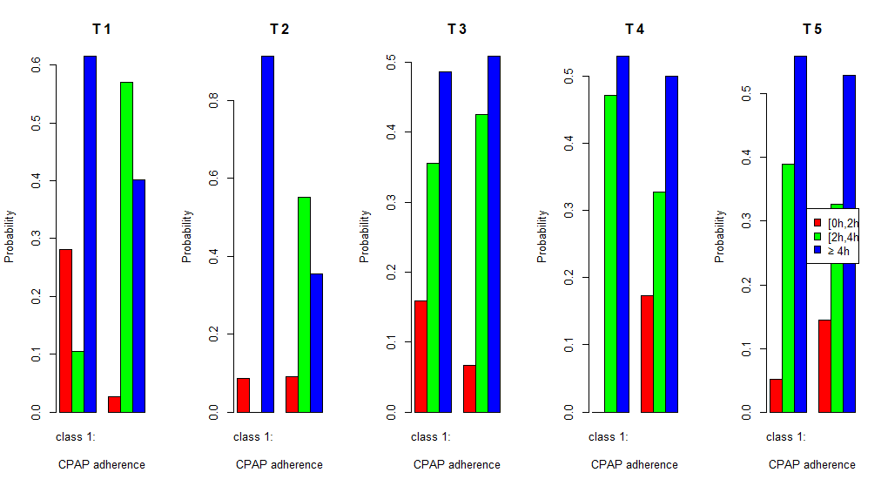

1. K-means

Numerical CPAP adherence, including all patients and 5 time points. The first step was to transform the long format data into ClusterLongData format. Then, the kml function performed the clustering. In this example, 15 redrawings for each of the clusters and a test with 2 to 6 clusters were implemented. Finally, according to the Calinski-Harabatz score, the model with 2 clusters was the best model.

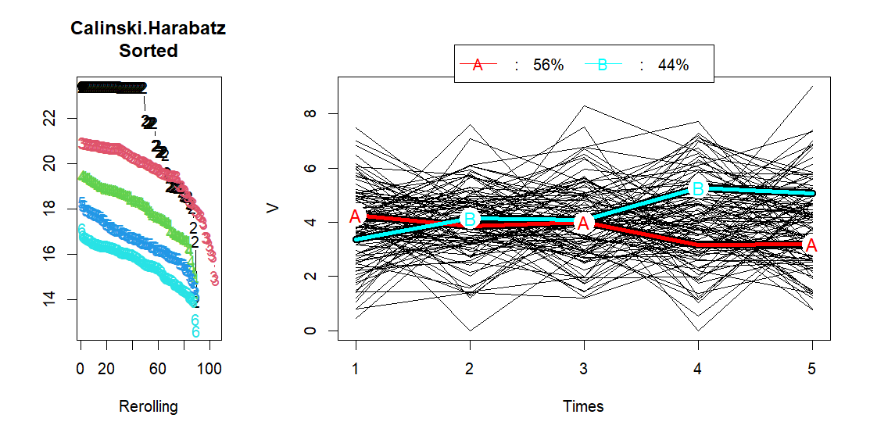

Moreover, there was a pretty equal number of individuals in each cluster: 56% in the 1st cluster and 44% in the second cluster. The first cluster remained relatively stable around 4 hours for the first 3 measuring points, then decreased to around 3 hours, while the second cluster increased after the 3 measuring point, from around 4 hours to around 5 hours.

1. LTA

Categorical CPAP adherence, all patients with all time points were included.

The model used long format data. For the reproducibility of the analysis, a seed was implemented. We test the model for 2, 3 and 4 clusters. According to the Loglikelihood and the BIC or AIC criteria, the best model created 2 clusters.

|  |  |  |  |
| --- | --- | --- | --- |
|  | **2 clusters** | **3 clusters** | **4 clusters** |
| **AIC** | 16790.1 | 16799.7 | 16813.3 |
| **BIC** | 16808.4 | 16836.1 | 16873.2 |
| **Loglikelihood** | -8388.1 | -8385.8 | -8383.7 |

The conditional response probabilities were described below.

|  |  |  |
| --- | --- | --- |
| **State**  **Category** | **1** | **2** |
| **[0h;2h[** | 0.04 | 0.20 |
| **[2h;4h[** | 0.29 | 0.62 |
| **≥4h** | 0.66 | 0.17 |

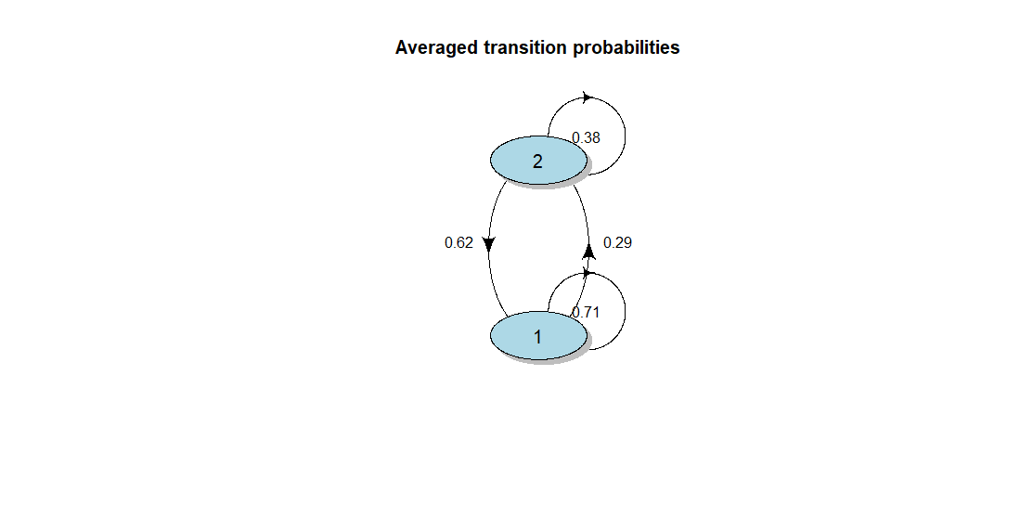

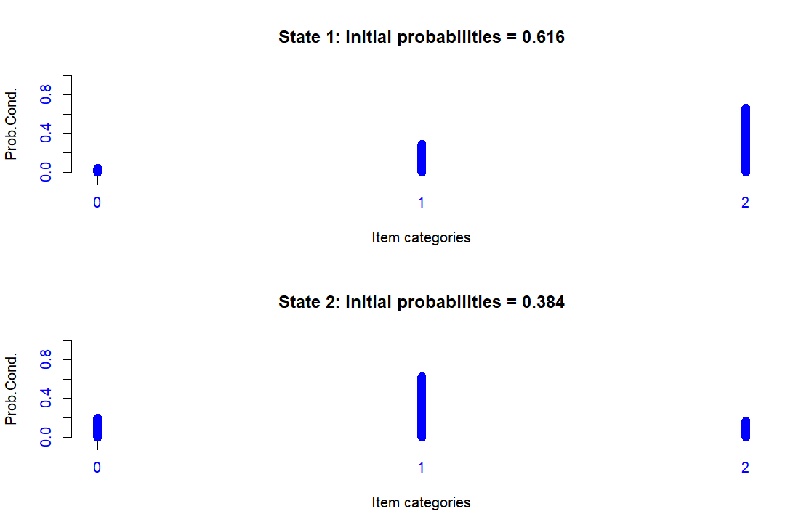

1. GBTM

Continuous CPAP adherence; 5 time points and all patients.

First, we performed GBTM method with linear curve, quadratic curve and cubic curve with 2 clusters to find the best type of curve. The chosen model was the quadratic curve, according to BIC (difference should be > 10) and loglikelihood criteria. Then, tests on number of clusters were applied with quadratic curve for 2, 3 or 4 clusters. According to BIC, Average Posterior Probability (better if ≥ 0.7) and Proportion of assignment parameters, the model with 2 clusters was the best model.

|  |  |  |  |  |  |
| --- | --- | --- | --- | --- | --- |
|  | **Linear curve – 2 clusters** | **Quadratic curve – 2 clusters** | **Cubic curve – 2 clusters** | **Quadratic curve – 3 clusters** | **Quadratic curve – 4 clusters** |
| **BIC** | 1845.0 | 1853.6 | 1862.7 | 1868.2 | 1886.1 |
| **Likelihood** | -906.4 | -906.1 | -906.0 | -901.9 | -899.3 |
| **Average Posterior Probability** |  | Cluster 1 = 0.72  Cluster 2 = 0.84 |  | Cluster 1 = 0.73  Cluster 2 = 0.85  Cluster 3 = 0.85 | Cluster 1 = 0.86  Cluster 2 = 0.70  Cluster 3 = 0.74  Cluster 4 = 0.88 |
| **Proportion of assignment** |  | Cluster 1 = 0.42  Cluster 2 = 0.58 |  | Cluster 1 = 0.47  Cluster 2 = 0.02  Cluster 3 = 0.51 | Cluster 1 = 0.02  Cluster 2 = 0.05  Cluster 3 = 0.46  Cluster 4 = 0.47 |
| **Estimate probabilities** |  | Cluster 1 = 0.40  Cluster 2 = 0.60 |  | Cluster 1 = 0.42  Cluster 2 = 0.02  Cluster 3 = 0.57 | Cluster 1 = 0.02  Cluster 2 = 0.04  Cluster 3 = 0.41  Cluster 4 = 0.54 |

The first cluster had a decreased CPAP adherence unlike the second cluster. 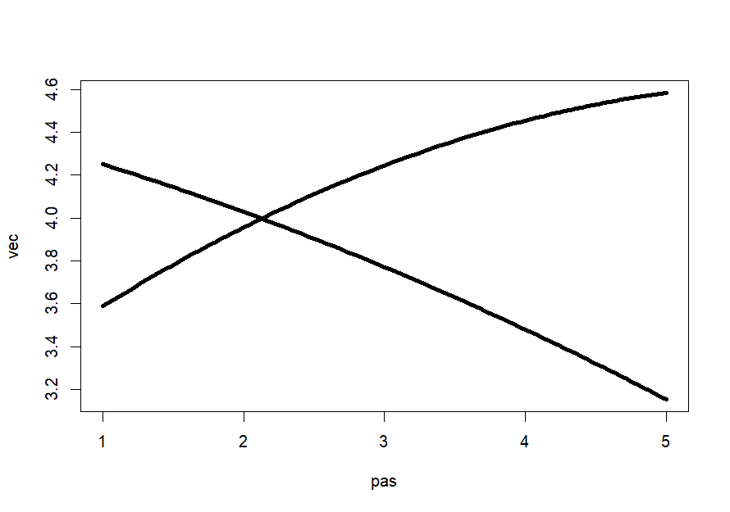

1. Mixed model

Continuous outcome while time and baseline ESS were categorical variables. All patients with all time points included. A random intercept on patient was added.

The model used long format data. The marginal R² was 0.01. All significant variables were plotted below. According to the results, CPAP adherence were positively associated with some time points and ESS baseline was not significantly associated with CPAP adherence.

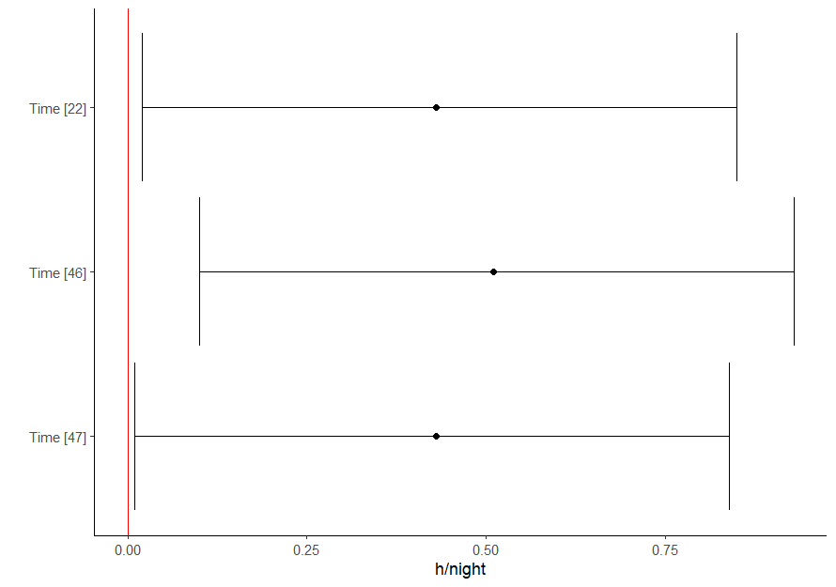

1. GMM

All patients with 5 time points were included.

The model was defined by long format data, a random intercept and slope and a mixture parameter on the time variable. A seed was implemented for the reproducibility. Four tests were performed to find the best number of clusters (1, 2, 3 or 4 clusters). According to the BIC criteria, the model with 2 clusters was the best model. Moreover, the distribution of patients in the clusters was fairly equally distributed including 58% in the 1st cluster and 42% in the 2nd cluster.

|  |  |  |  |  |  |  |
| --- | --- | --- | --- | --- | --- | --- |
|  | **Loglik** | **BIC** | **%cluster 1** | **%cluster 2** | **%cluster 3** | **%cluster 4** |
| **1 cluster** | -905.9 | 1908.5 | 100 |  |  |  |
| **2 clusters** | -894.5 | 1917.9 | 58 | 42 |  |  |
| **3 clusters** | -890.7 | 1942.7 | 5 | 57 | 38 |  |
| **4 clusters** | -885.7 | 1964.8 | 20 | 32 | 16 | 32 |

The mean of posterior probability in each cluster was, for this final model:

|  |  |  |
| --- | --- | --- |
|  | **Prob1** | **Prob2** |
| **Cluster 1** | 0.94 | 0.06 |
| **Cluster 2** | 0.06 | 0.94 |

The probability to belong to a cluster and the posterior probability above a threshold (0.7, 0.8, 0.9) were also available.

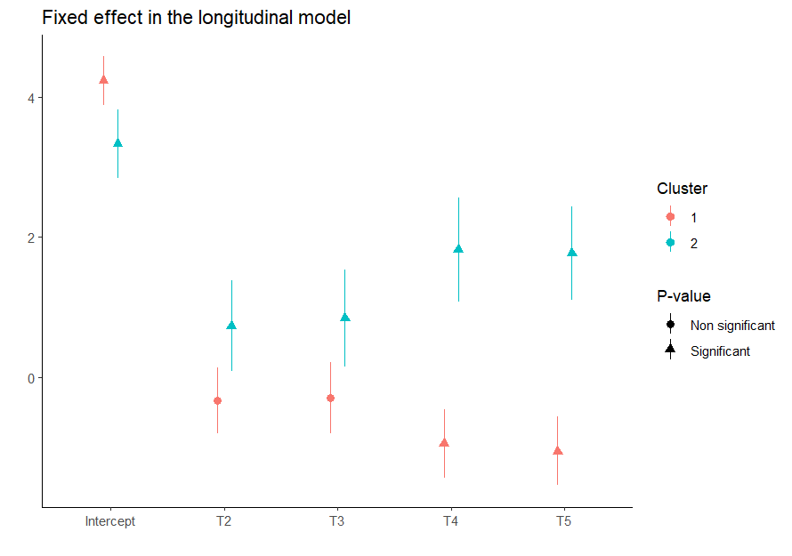

The first group tended to decrease over time, while the second group decreased between the first and second measuring points, then increased over the following three measuring points, finally stabilizing at the last measuring point.

1. ARIMA & CCF

First, the ARIMA model used numerical outcome for time series. CPAP adherence and ESS score were transformed into time series. All time points were used but only one patient was included. We can repeat the model for each patient. The frequency used was 7, for week scale. Validation of the time series:

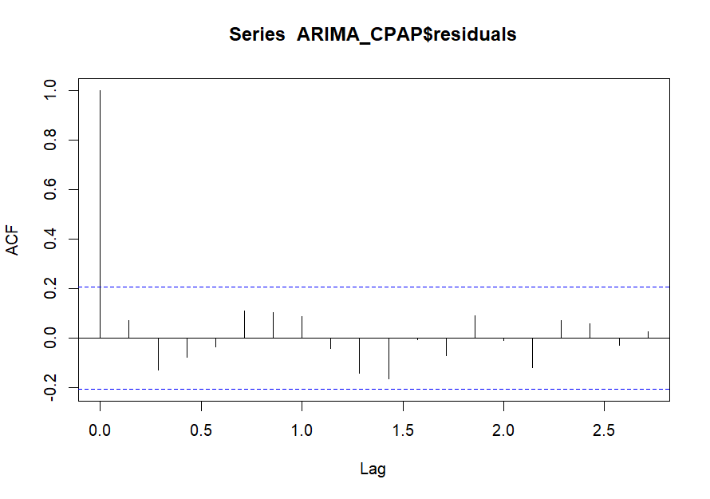For CPAP adherence validation, the p-value for Box-Ljung test were 0.49 showing that there was no pattern in the residuals.

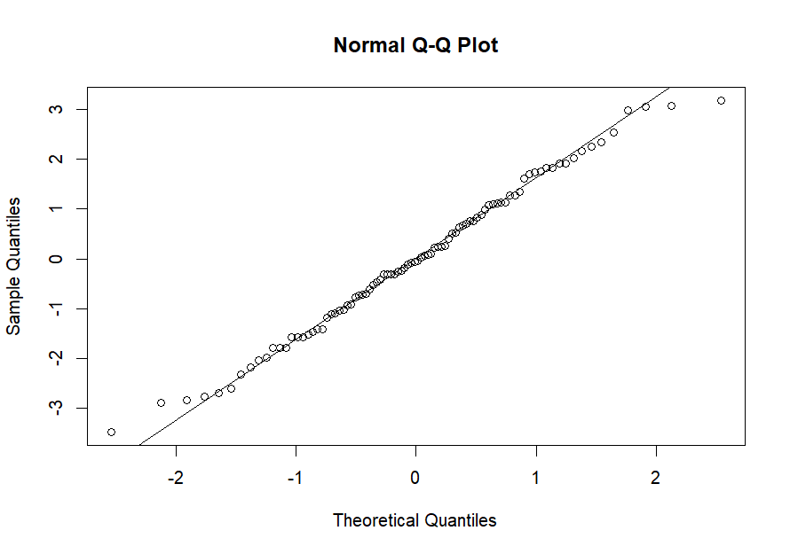

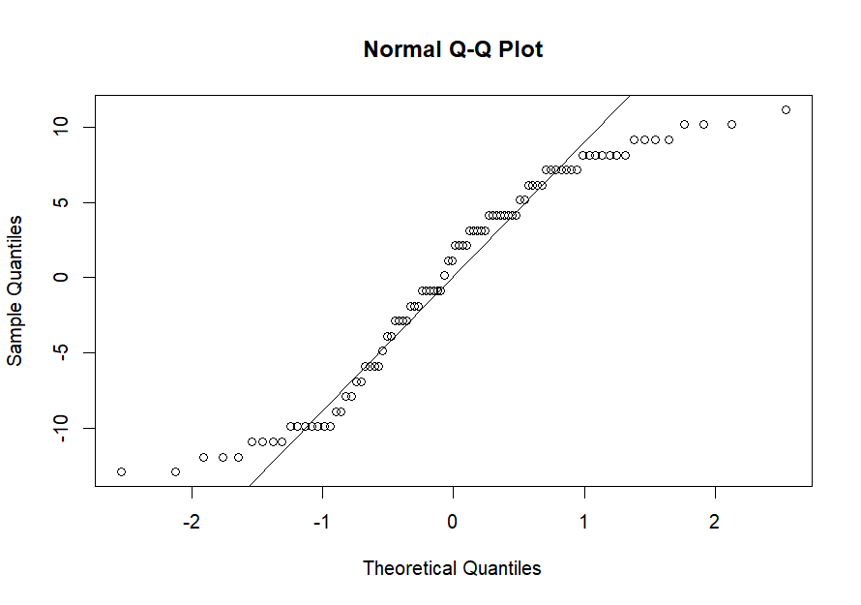For ESS score validation, the p-value for Box-Ljung test were 0.67 showing that there was no pattern in the residuals.

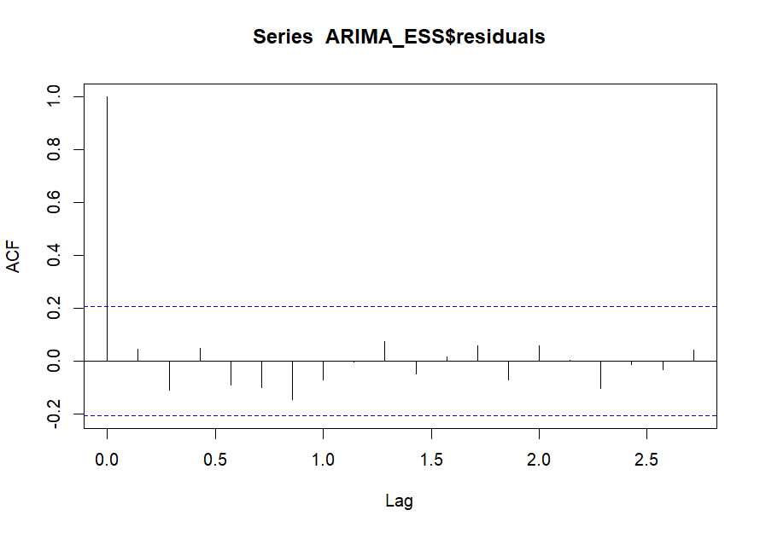For CPAP adherence and ESS score, the final model was ARIMA(0, 0, 0).

A cross-correlation function was performed to compare the correlation between these two time series (the variables detrend by the ARIMA model).

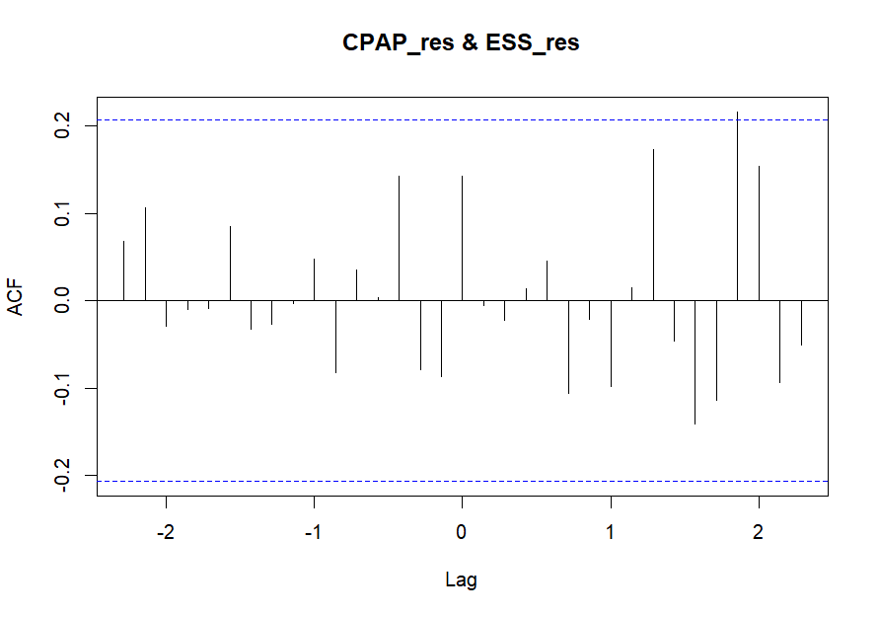

There was no correlation between ESS score and CPAP adherence with or without lag according to scatterplots; except for the 13th time points (seen on the ACF plot). Interestingly, this meant that an above value of CPAP is likely to lag to an above value of ESS score, about 13 time points after.

These lags could be implemented to a regression to study the association of the ESS score and the CPAP adherence at different lags. For the example, 3-time lags were chosen: a lag of -11, a lag of 9 and a lag of 13. The equation was:

Validation of the regression by ACF and PACF plots: residuals were correlated with a lag of 9.

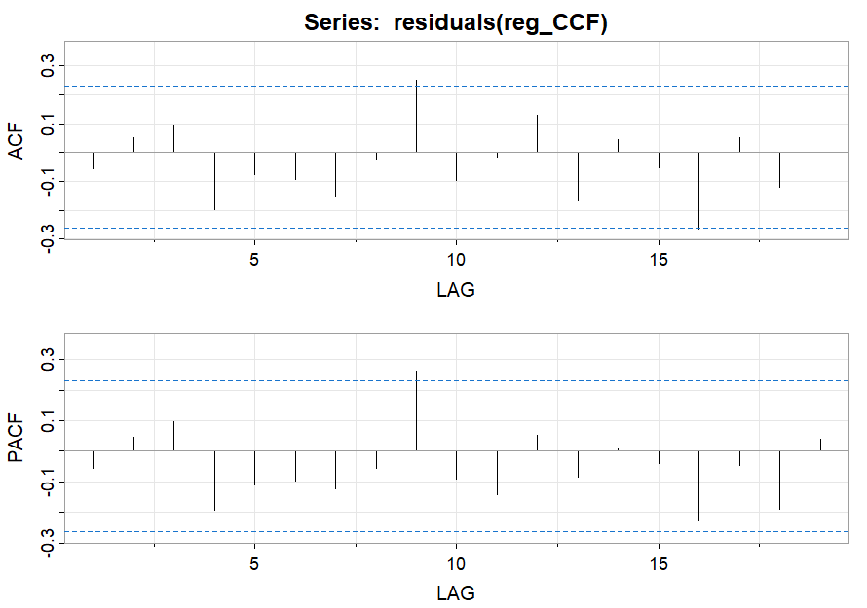

Consequently, we found the same result, i.e. the increase of CPAP adherence increase the ESS score with a lag of 13 time points, with 1.11 point for an increase of 1h of CPAP and with 1.32 point for an increase of 1h of CPAP, with a lag of 9 time points.

|  |  |  |  |
| --- | --- | --- | --- |
|  | **β** | **SE** | **P-value** |
| **CPAP lag -11** | 0.89 | 0.55 | 0.11 |
| **CPAP lag 9** | 1.32 | 0.52 | *0.01* |
| **CPAP lag 13** | 1.11 | 0.54 | *0.04* |

1. Joint model

One covariate was added to the linear mixed-effect model, the sex of the patient. This variable was a categorical random sample between Male and Female values. All patients and 7 time points were included in these analyses.

First, the mixed model was performed using continuous CPAP adherence and a random intercept and slope on patient.

A maximum of 100 iterations was used for the lme optimization algorithm and for the optimization step inside the lme optimization and the ‘optim’ value for the optimizer parameter. The model was fitted by Maximum Likelihood. The normality of the model was validated using the QQ plot.

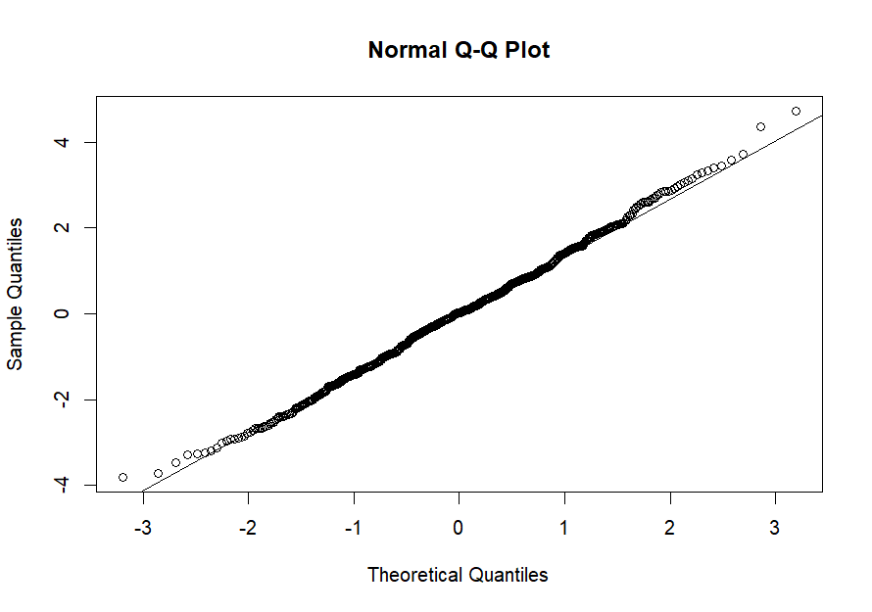

Fixed effects showed no significant association with time but negative association with sex (the CPAP adherence was smaller in men compared to women, of 0.23h).

|  |  |  |
| --- | --- | --- |
|  | **β (CI 95%)** | **P-value** |
| **Time** | 0.03 (-0.03 ; 0.09) | 0.30 |
| **Sex - Men** | -0.23 (-0.45; -0.01) | 0.04 |

The Cox model was run using the ESS score and clustered by patient. The sex variable was added as a covariate and the model was clustered by patient.

The validation of the model was measured using the relative risk proportion test. The p-value of this test was 0.23 > 0.05, consequently we can assume the proportional hazards. However, the likelihood ratio (p-value = 0.2) and score tests (p-value = 0.2), the Wald (p-value = 0.2) and robust score tests (p-value = 0.2) indicated that the model is insufficient to describe the observed data, none of the predictor variables provide any information to help estimate the hazard in the regression model. According to the results, the sex did not significantly influence the survival curve (p-value = 0.17 > 0.05).

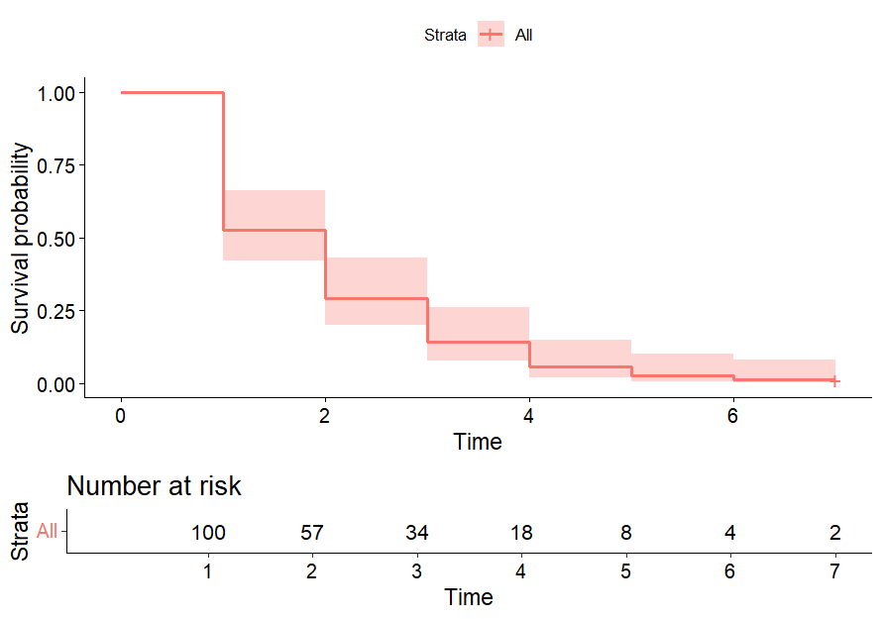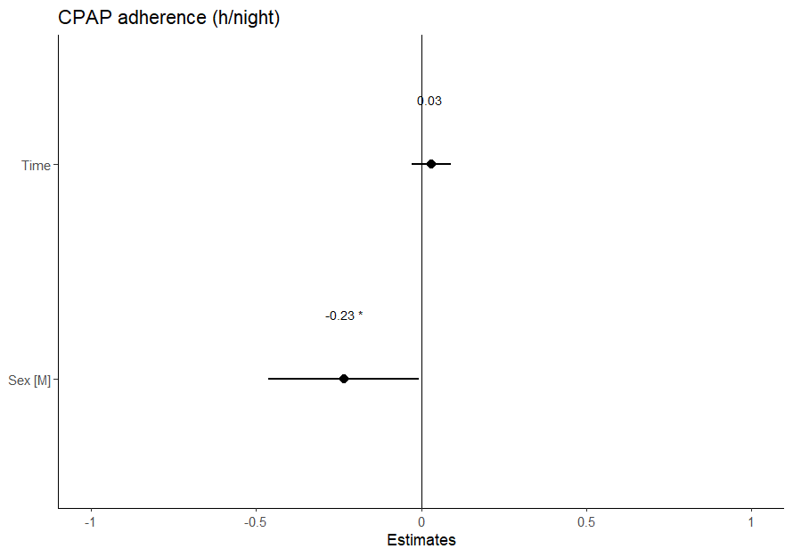

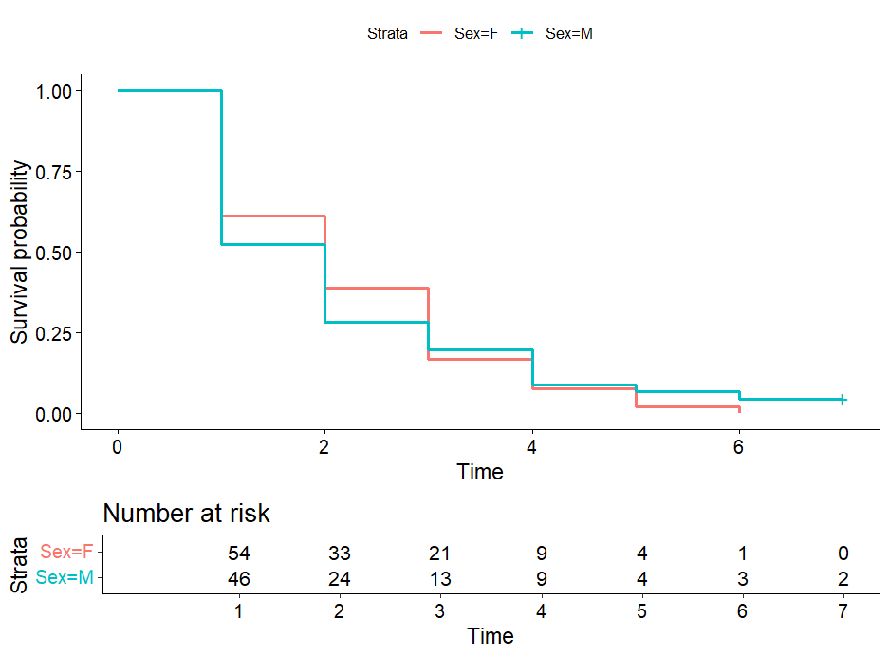

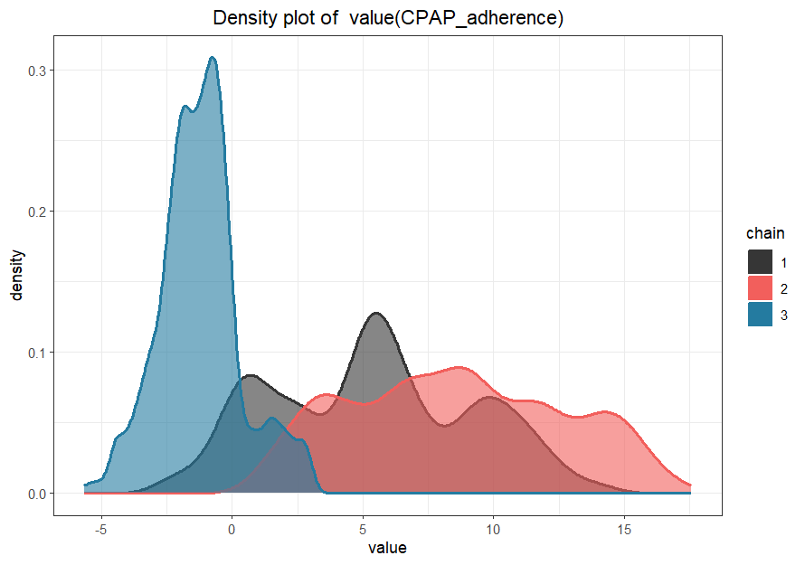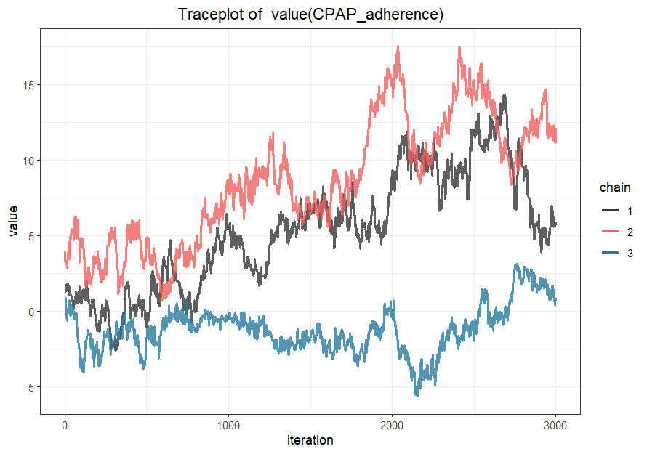The joint model only highlights significant association with sex in the longitudinal model. The joint model was validated by density, sampling behavior, mixing across chains and convergence graphs:

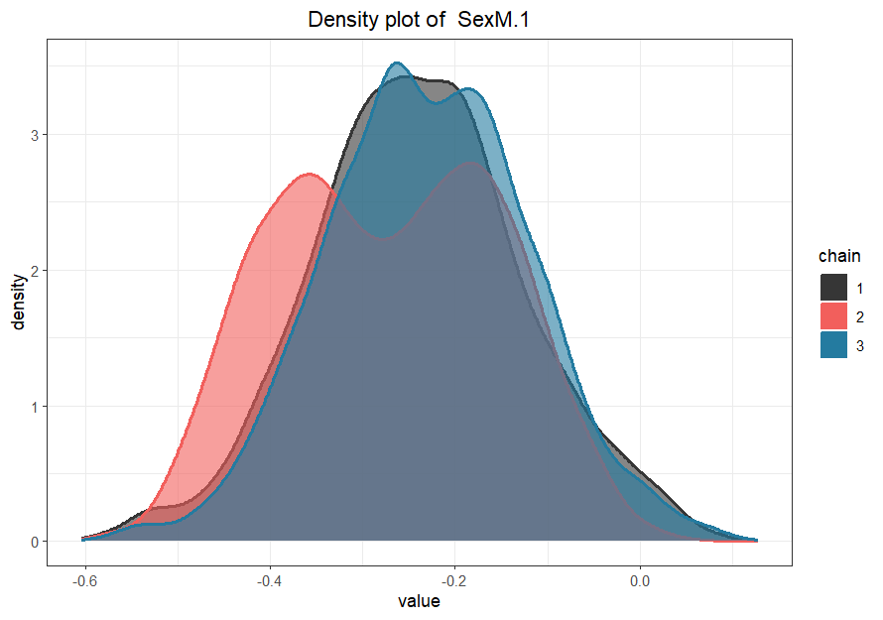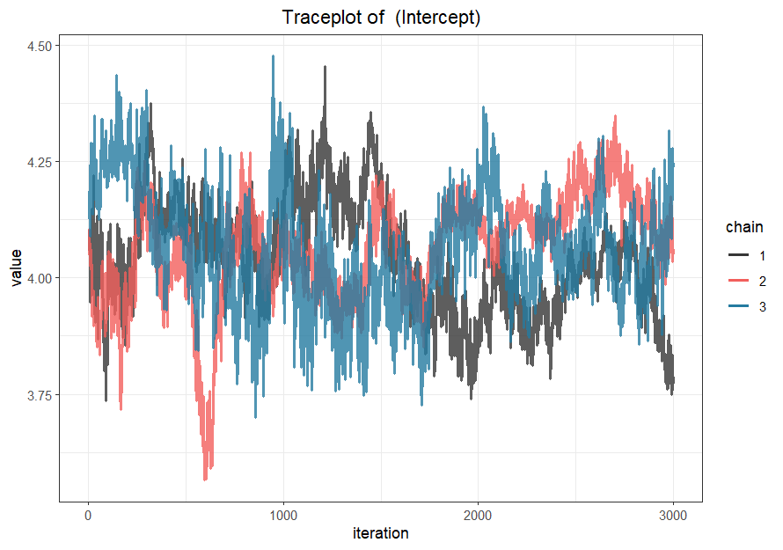

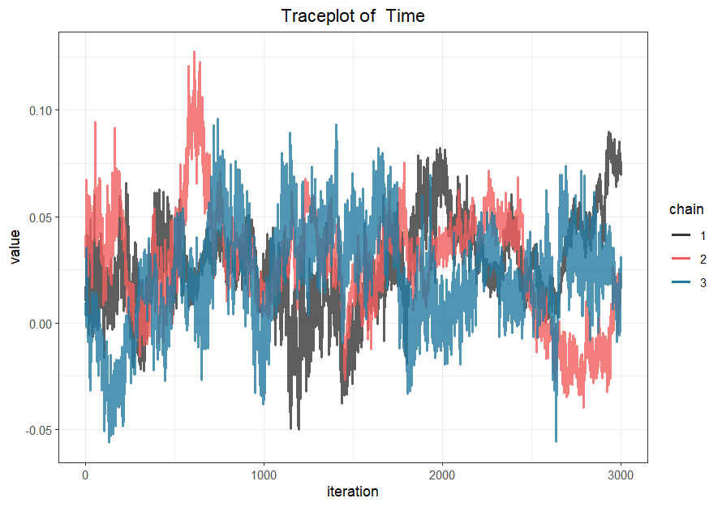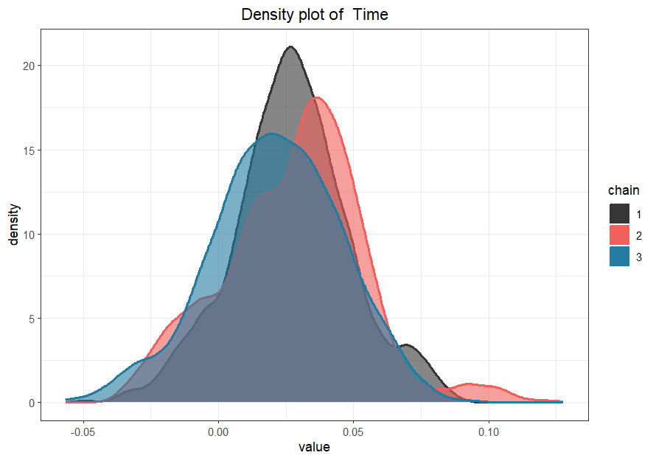

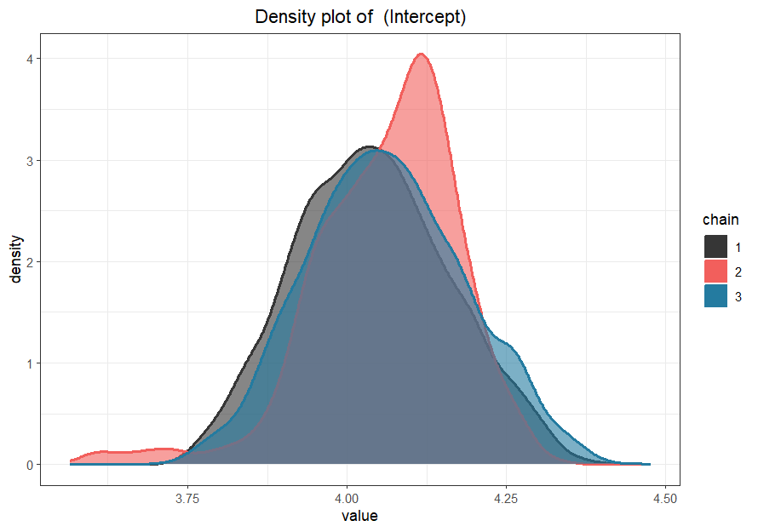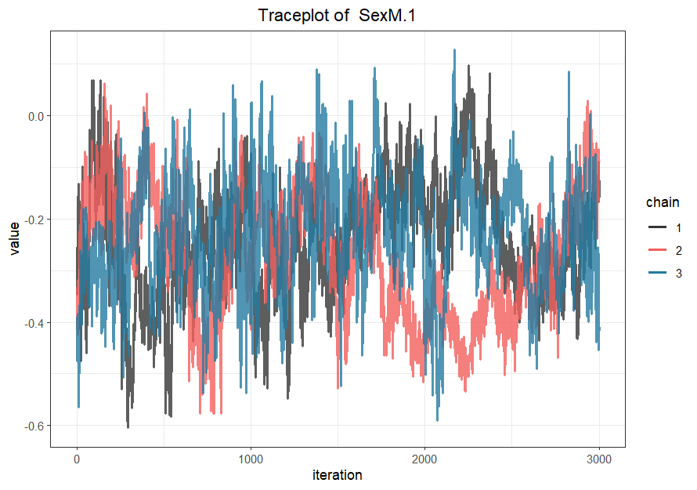

The verification of the model showed not good observations for the CPAP adherence but good observations for the other parameters.

For example, the prediction of the cumulative risk for the patient 5 increased (risk to have ESS score < 10) from the 3th time points (cumulative risk around 0.00) to the 4th time points (cumulative risk around 0.58).

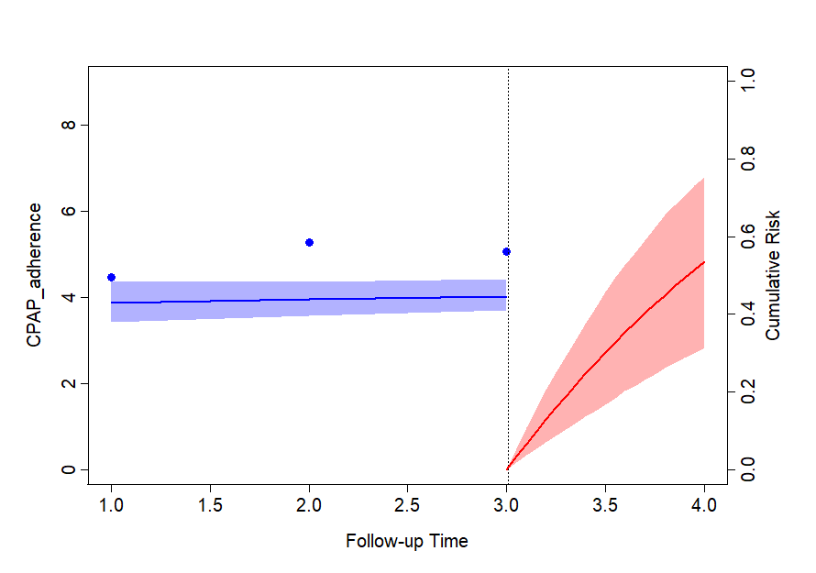

1. Hidden Markov model

One known categorical variable, e.g. in our analysis, CPAP adherence with 3 states and one hidden categorical variable with a known number of hidden states, e.g. 2 states: Adherent vs. Non-adherent were used. All time points but only one patient was included. We can repeat the model for each patient.

This model fitted EM algorithm and used the multinomial family for the categorial observations. The independence of observation variable from all covariates were added to the model. A seed was used for the reproducibility. A test for other number of hidden states can be applied and comparisons using BIC, AIC and loglikelihood criteria could be performed. However, the interpretation of hidden states must stay possible.

The initial state probabilities model was 1.0 for the 2nd state (Non-adherent). The transition probability matrix was 0.16 for the initial state of non-adherent group to the adherent group and 0.11 for the initial state of adherent to the non-adherent group. To stay in the non-adherent group, the probability was 0.84 and 0.89 to stay in the adherent group.

|  |  |  |
| --- | --- | --- |
|  | **Non-adherent** | **Adherent** |
| **Non-adherent** | 0.84 | 0.16 |
| **Adherent** | 0.11 | 0.89 |

The prediction of the patient’s state at each time point was predicted and plotted in the graph below.

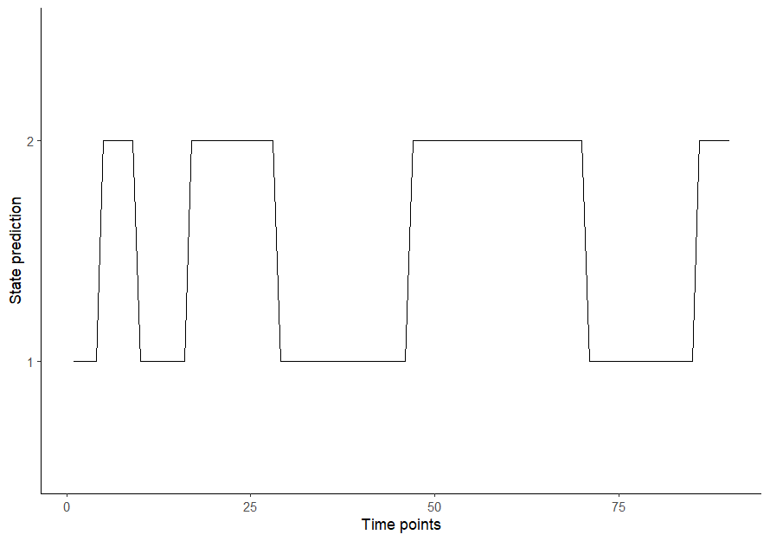

The states prediction included 48.9% of time points in the 1st state and 51.1% in the 2nd state.

***200 patients with 30 measurements***

1. ANOVA

Continuous data on CPAP adherence over time, all time points and all patients.

The p-value was 0.99, indicating no statistically significant difference in CPAP adherence across time.

1. χ ²

χ² Mantel-Haenszel, included 4 time points and all patients, using a contingency table where CPAP adherence and ESS score were treated as categorical variables. The p-value of the χ² test was 0.78, suggesting no significant difference between groups.

1. LCA

LCA using CPAP adherence as a categorical variable across 5 time points. The optimal number of clusters was determined to be 2, based on smallest AIC and BIC.

|  |  |  |  |
| --- | --- | --- | --- |
|  | **2 clusters** | **3 clusters** | **5 clusters** |
| **AIC** | 1909.8 | 1923.9 | 1943.4 |
| **BIC** | 1979.1 | 2029.4 | 2121.5 |

Finally, the best model was consisted of 2 clusters with a probability of, respectively, 0.26 and 0.74 to belong to the 1st and 2nd cluster.

The item-response probabilities were:

|  |  |  |  |
| --- | --- | --- | --- |
|  | **[0h; 2h[** | **[2h; 4h[** | **≥4h** |
| **T1** | | | |
| Cluster 1 | 0.05 | 0.32 | 0.63 |
| Cluster 2 | 0.14 | 0.39 | 0.46 |
| **T2** | | | |
| Cluster 1 | <0.01 | 0.27 | 0.73 |
| Cluster 2 | 0.11 | 0.37 | 0.51 |
| **T3** | | | |
| Cluster 1 | 0.05 | 0.41 | 0.54 |
| Cluster 2 | 0.14 | 0.39 | 0.47 |
| **T4** | | | |
| Cluster 1 | 0.06 | 0.94 | <0.01 |
| Cluster 2 | 0.13 | 0.23 | 0.63 |
| **T5** | | | |
| Cluster 1 | 0.01 | 0.61 | 0.39 |
| Cluster 2 | 0.10 | 0.36 | 0.54 |

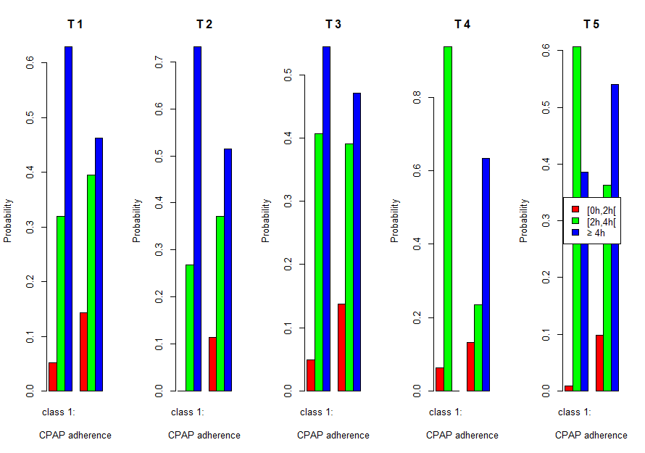

1. K-means

Numerical CPAP adherence, including all patients and 5 time points. The first step was to transform the long format data into ClusterLongData format. Then, the kml function performed the clustering. In this example, 15 redrawings for each of the clusters and a test with 2 to 6 clusters were implemented. Finally, according to the Calinski-Harabatz score, the model with 2 clusters was the best model.

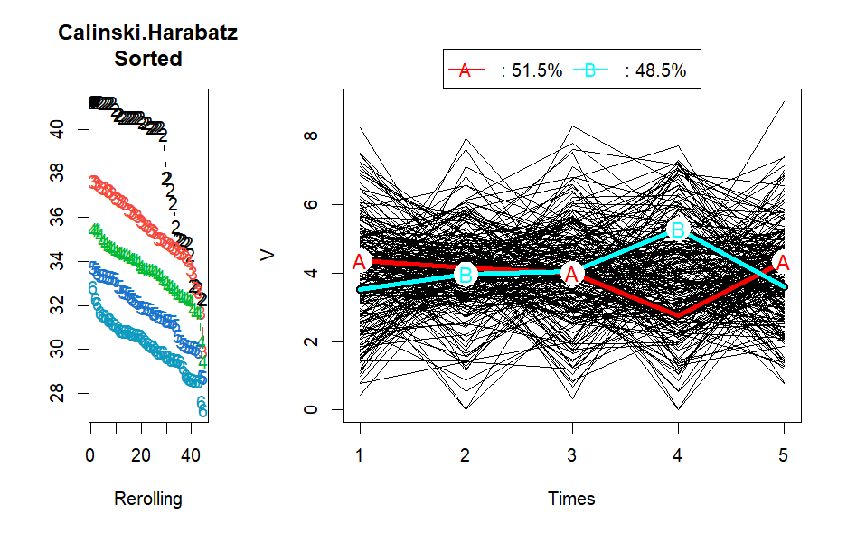

Moreover, there was a pretty equal number of individuals in each cluster: 51.5% in the 1st cluster and 48.5% in the second cluster. The first cluster remained relatively stable around 4 hours for the first 3 measuring points, then decreased to around 2h30 and finally increased to around 4h at the 5th time point, while the second cluster increased during the 3 measuring point, from around 4 hours to around 5 hours and finally decreased to around 4h at the 5th time point.

1. LTA

Categorical CPAP adherence, all patients with all time points were included.

The model used long format data. For the reproducibility of the analysis, a seed was implemented. We test the model for 2, 3 and 4 clusters. According to the Loglikelihood and the BIC or AIC criteria, the best model created 2 clusters.

|  |  |  |  |
| --- | --- | --- | --- |
|  | **2 clusters** | **3 clusters** | **4 clusters** |
| **AIC** | 11138.5 | 11147.4 | 11155.1 |
| **BIC** | 11161.6 | 11193.6 | 11230.9 |
| **Loglikelihood** | -5562.2 | -5559.7 | -5554.5 |

The conditional response probabilities were described below.

|  |  |  |
| --- | --- | --- |
| **State**  **Category** | **1** | **2** |
| **[0h;2h[** | 0.01 | 0.31 |
| **[2h;4h[** | 0.44 | 0.29 |
| **≥4h** | 0.55 | 0.40 |

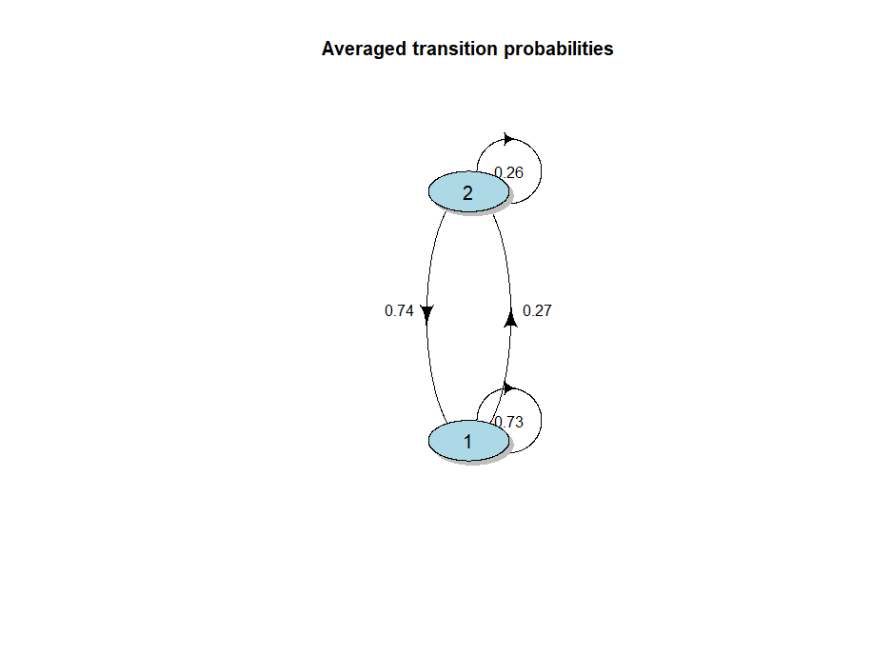

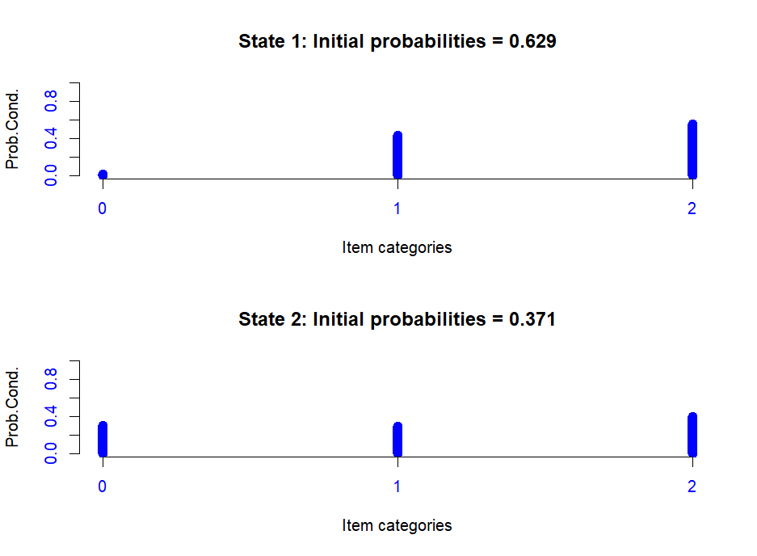

1. GBTM

Continuous CPAP adherence; 5 time points and all patients were included.

First, we performed GBTM method with linear curve, quadratic curve and cubic curve with 2 clusters to find the best type of curve. The chosen model was the linear curve, according to BIC (difference should be > 10) and loglikelihood criteria. Then, tests on number of clusters were applied with linear curve for 2, 3 or 4 clusters. According to BIC, Average Posterior Probability (better if ≥ 0.7) and Proportion of assignment parameters, the model with 2 clusters was the best model.

|  |  |  |  |  |  |
| --- | --- | --- | --- | --- | --- |
|  | **Linear curve – 2 clusters** | **Quadratic curve – 2 clusters** | **Cubic curve – 2 clusters** | **Linear curve – 3 clusters** | **Linear curve – 4 clusters** |
| **BIC** | 3677.3 | 3687.4 | 3690.5 | 3697.5 | 3718.5 |
| **Likelihood** | -1820.1 | -1819.8 | -1816.1 | -1819.6 | -1819.5 |
| **Average Posterior Probability** | Cluster 1 = 0.64  Cluster 2 = 0.98 |  |  | Cluster 1 = 0.50  Cluster 2 = 0.78  Cluster 3 = 0.54 | Cluster 1 = 0.55  Cluster 2 = 0.51  Cluster 3 = 0.46  Cluster 4 = 0.43 |
| **Proportion of assignment** | Cluster 1 = 0.03  Cluster 2 = 0.97 |  |  | Cluster 1 = 0.01  Cluster 2 = 0.96  Cluster 3 = 0.03 | Cluster 1 = 0.63  Cluster 2 = 0.04  Cluster 3 = 0.15  Cluster 4 = 0.19 |
| **Estimate probabilities** | Cluster 1 = 0.04  Cluster 2 = 0.96 |  |  | Cluster 1 = 0.21  Cluster 2 = 0.77  Cluster 3 = 0.02 | Cluster 1 = 0.46  Cluster 2 = 0.02  Cluster 3 = 0.28  Cluster 4 = 0.23 |

The first cluster had a decreased CPAP adherence unlike the second cluster which was roughly stable around 4h.

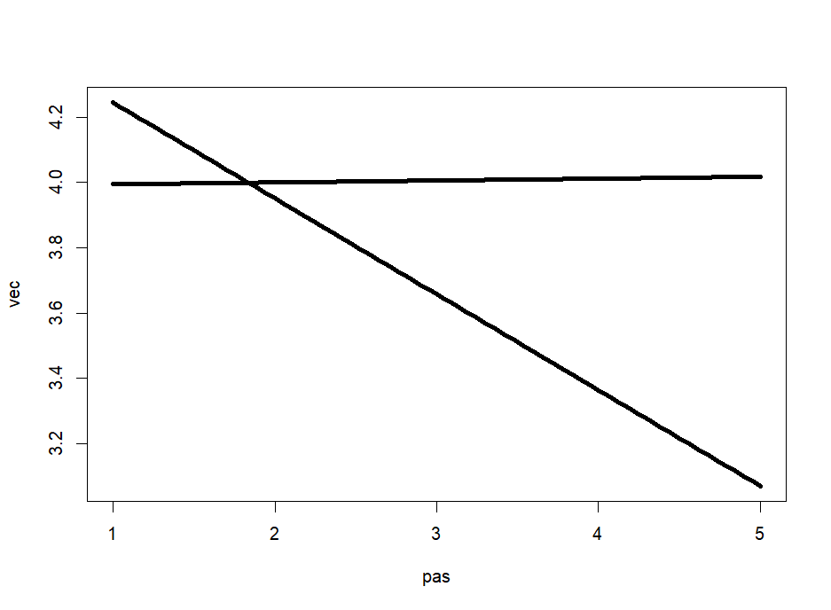

1. Mixed model

Continuous outcome while time and baseline ESS were categorical variables. All patients with all time points included. A random intercept on patient was added.

The model used long format data. The marginal R² was <0.01. Any time point or baseline ESS was significantly associated with CPAP adherence.

1. GMM

All patients with 5 time points were included.

The model was defined by long format data, a random intercept and slope and a mixture parameter on the time variable. A seed was implemented for the reproducibility. Four tests were performed to find the best number of clusters (1, 2, 3 or 4 clusters). According to the BIC criteria, the model with 2 clusters was the best model. Moreover, the distribution of patients in the clusters was fairly equally distributed including 46.5% in the 1st cluster and 53.5% in the 2nd cluster.

|  |  |  |  |  |  |  |
| --- | --- | --- | --- | --- | --- | --- |
|  | **Loglik** | **BIC** | **%cluster 1** | **%cluster 2** | **%cluster 3** | **%cluster 4** |
| **1 cluster** | -1814.2 | 3739.8 | 100 |  |  |  |
| **2 clusters** | -1806.5 | 3761.3 | 46.5 | 53.5 |  |  |
| **3 clusters** | -1800.9 | 3787.3 | 58.5 | 36.5 | 5.0 |  |
| **4 clusters** | -1798.5 | 3819.6 | 5.0 | 43.5 | 15.0 | 36.5 |

The mean of posterior probability in each cluster was, for this final model:

|  |  |  |
| --- | --- | --- |
|  | **Prob1** | **Prob2** |
| **Cluster 1** | 0.88 | 0.12 |
| **Cluster 2** | 0.11 | 0.89 |

The probability to belong to a cluster and the posterior probability above a threshold (0.7, 0.8, 0.9) were also available.

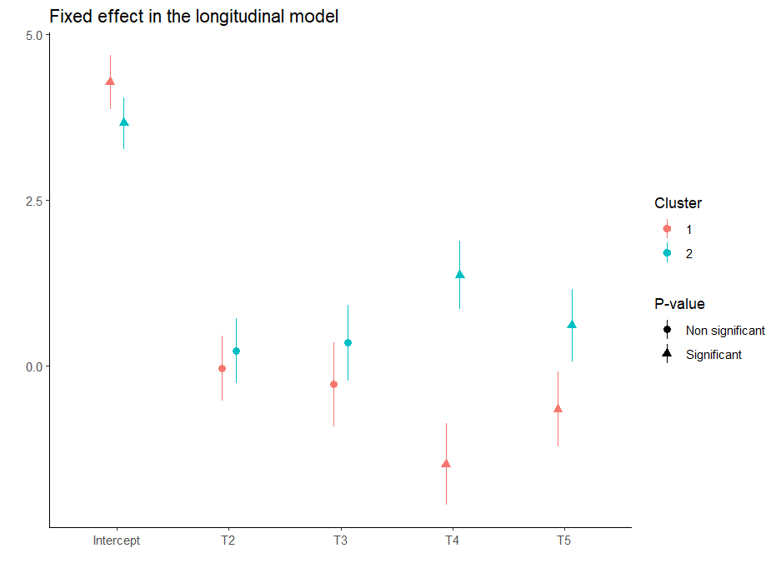

The first group tended to decrease over the first 4 time points then increased for the last time point, while the second group tended to decrease between the first and second measuring points, then tended to increase over the following 2 measuring points, finally decreased over the 2 last measuring point.

1. ARIMA & CCF

First, the ARIMA model used numerical outcome for time series. CPAP adherence and ESS score were transformed into time series. All time points were used but only one patient was included. We can repeat the model for each patient. The frequency used was 7, for week scale. Validation of the time series:

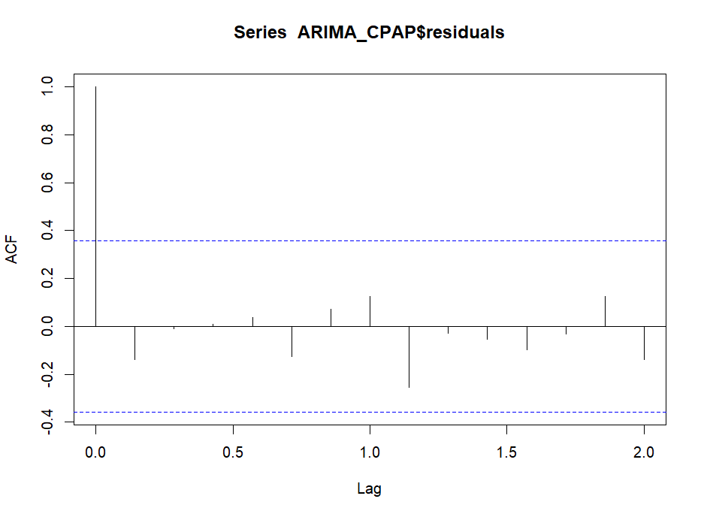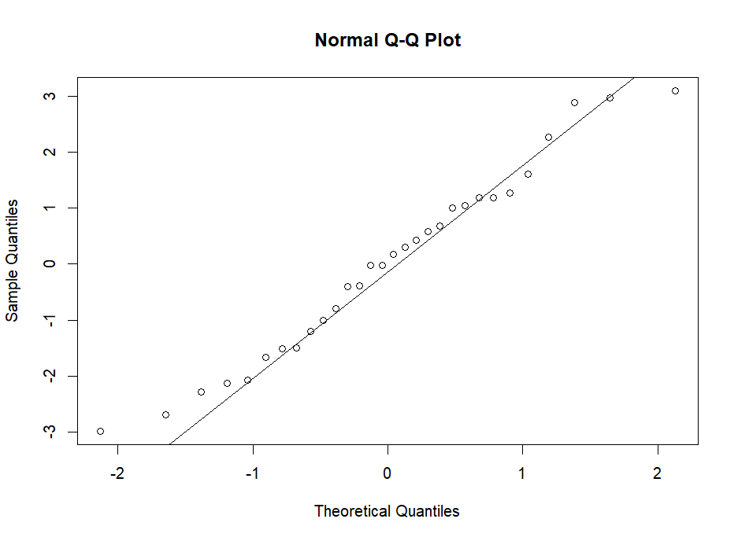For CPAP adherence validation, the p-value for Box-Ljung test were 0.42 showing that there was no pattern in the residuals.

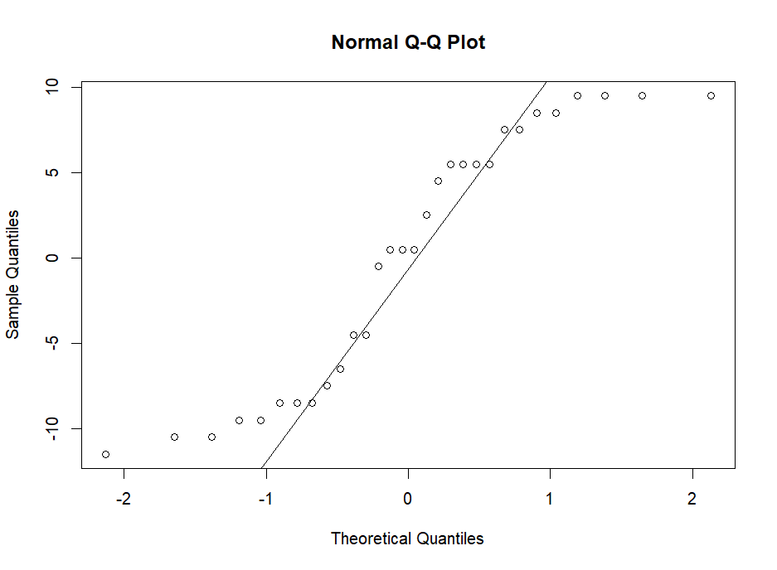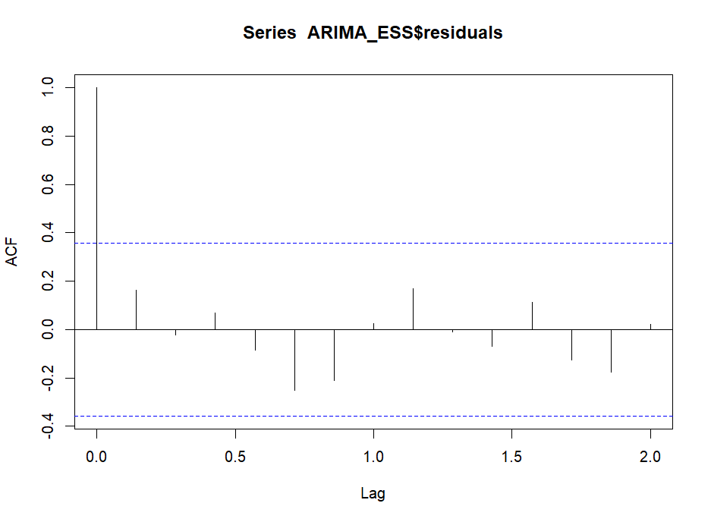For ESS score validation, the p-value for Box-Ljung test were 0.35 showing that there was no pattern in the residuals.

For CPAP adherence and ESS score, the final model was ARIMA(0, 0, 0).

A cross-correlation function was performed to compare the correlation between these two time series (the variables detrend by the ARIMA model).

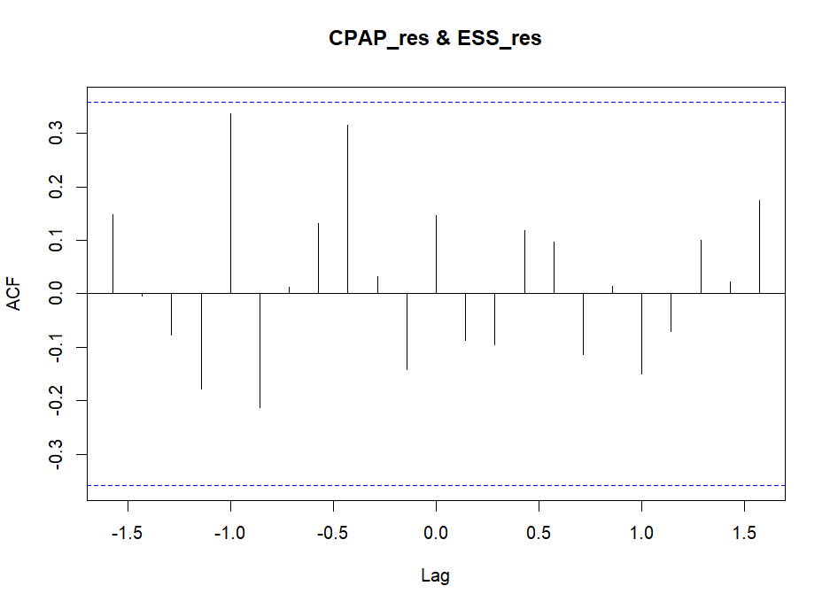

There was no correlation between ESS score and CPAP adherence with or without lag according to scatterplots and ACF plot.

These lags could be implemented to a regression to study the association of the ESS score and the CPAP adherence at different lags. For the example, 3-time lags were chosen: a lag of -11, a lag of 1 and a lag of 14. The equation was:

Validation of the regression by ACF and PACF plots: residuals were not correlated with lag.

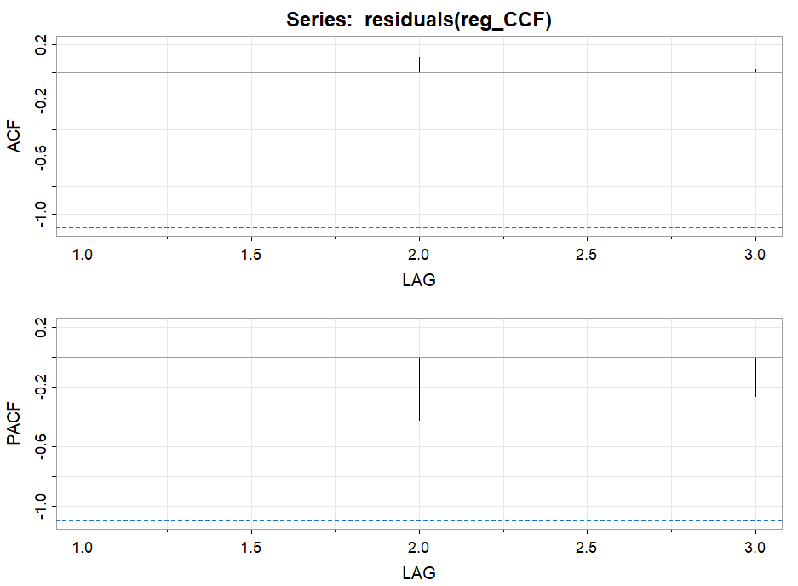

Consequently, we found the same result, i.e. no significant results.

|  |  |  |  |
| --- | --- | --- | --- |
|  | **β** | **SE** | **P-value** |
| **CPAP lag -11** | -2.25 | 3.29 | 0.62 |
| **CPAP lag 1** | -4.95 | 3.56 | 0.40 |
| **CPAP lag 14** | 0.31 | 2.23 | 0.91 |

1. Joint model

One covariate was added to the linear mixed-effect model, the sex of the patient. This variable was a categorical random sample between Male and Female values. All patients and 7 time points were included in these analyses.

First, the mixed model was performed using continuous CPAP adherence and a random intercept and slope on patient.

A maximum of 100 iterations was used for the lme optimization algorithm and for the optimization step inside the lme optimization and the ‘optim’ value for the optimizer parameter. The model was fitted by Maximum Likelihood. The normality of the model was validated using the QQ plot.

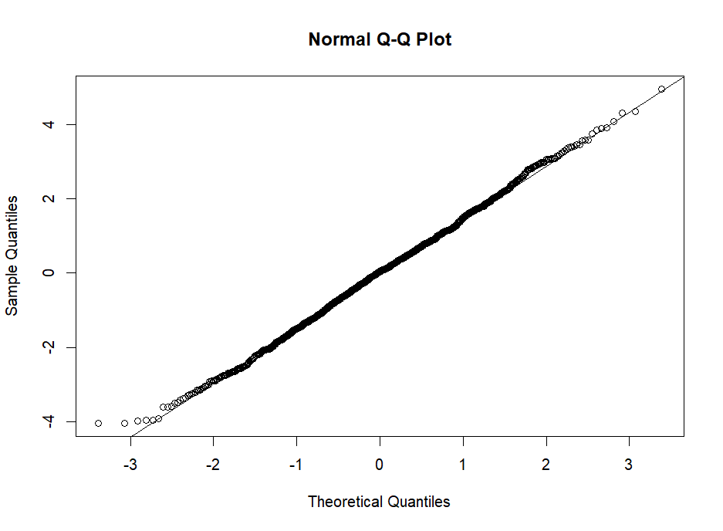

Fixed effects showed no significant association with time and sex.

|  |  |  |
| --- | --- | --- |
|  | **β (CI 95%)** | **P-value** |
| **Time** | 0.01 (-0.03 ; 0.05) | 0.64 |
| **Sex - Men** | 0.10 (-0.06 ; 0.25) | 0.22 |

The Cox model was run using the ESS score and clustered by patient. The sex variable was added as a covariate and the model was clustered by patient.

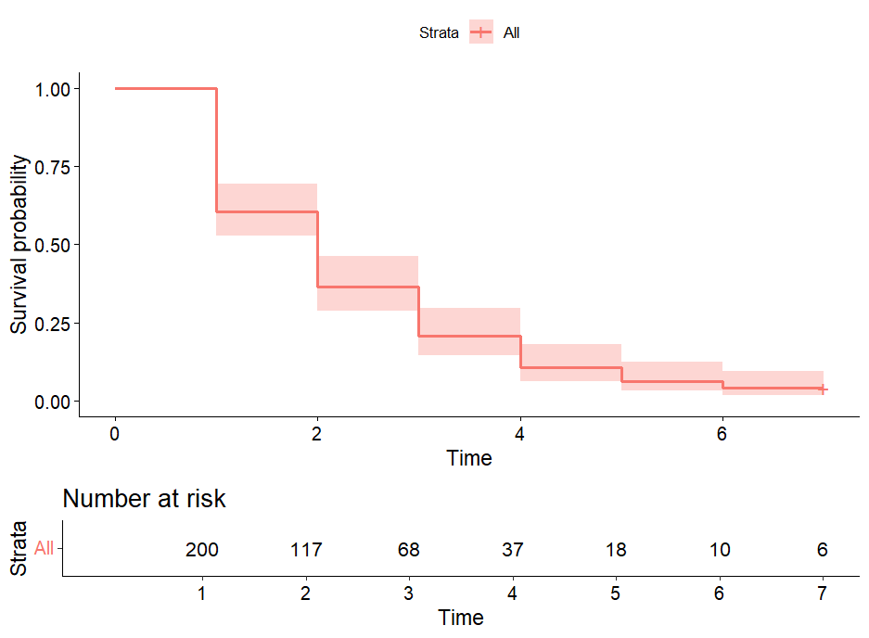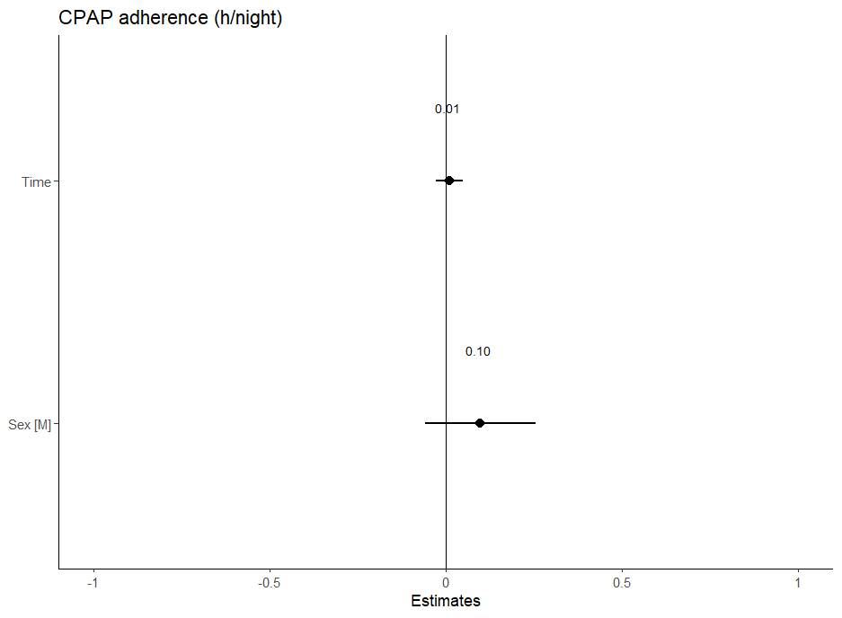The validation of the model was measured using the relative risk proportion test. The p-value of this test was 0.82 > 0.05, consequently we can assume the proportional hazards. However, the likelihood ratio (p-value = 0.4) and score tests (p-value = 0.4), the Wald (p-value = 0.4) and robust score tests (p-value = 0.4) indicated that the model is insufficient to describe the observed data, none of the predictor variables provide any information to help estimate the hazard in the regression model. According to the results, the sex did not significantly influence the survival curve (p-value = 0.42 > 0.05).

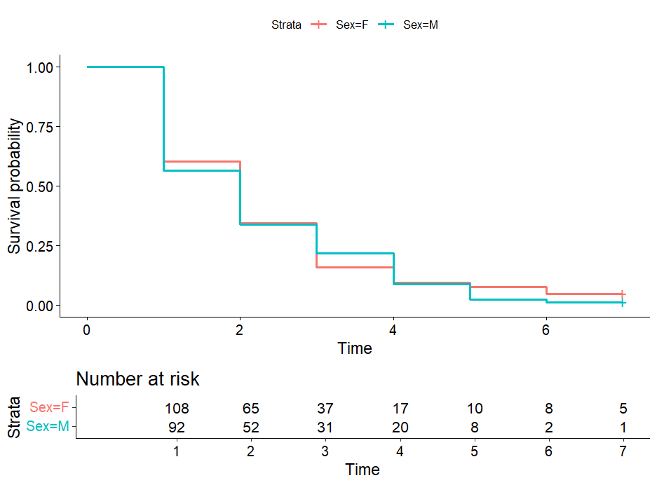

The joint model highlights significant association with sex and time for the longitudinal outcome (CPAP adherence). The joint model was validated by density, sampling behavior, mixing across chains and convergence graphs:

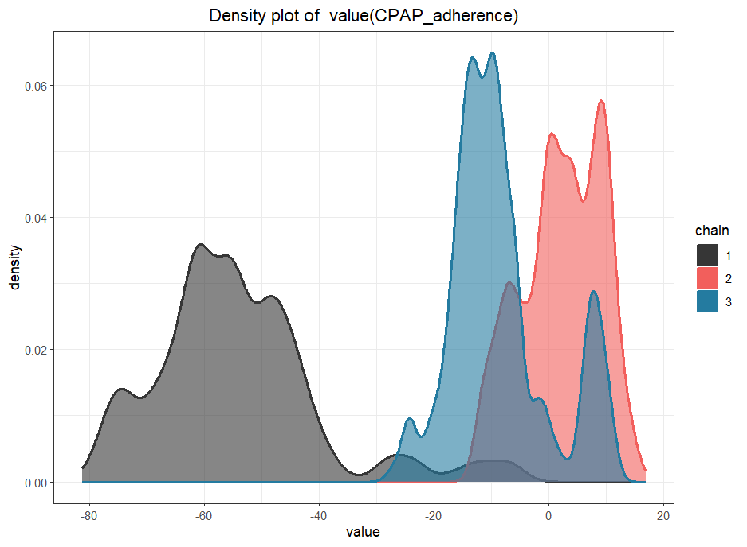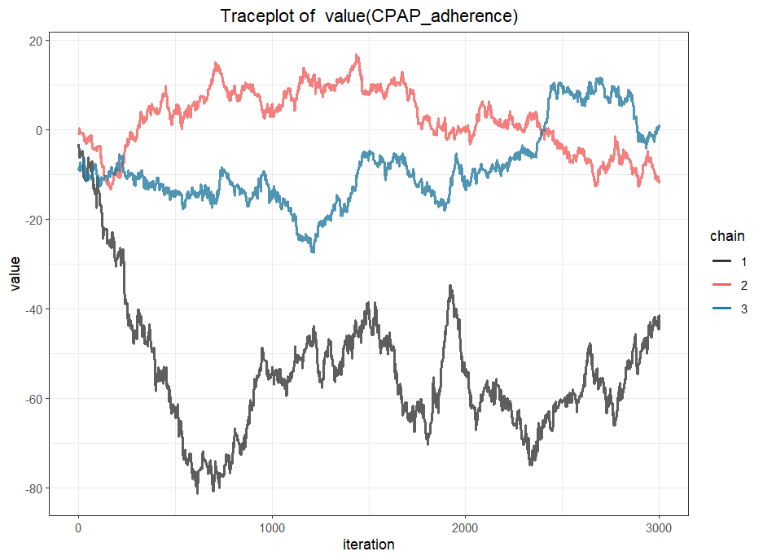

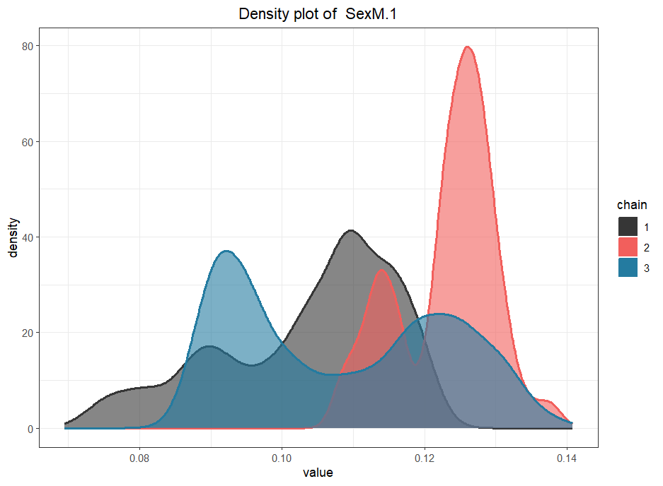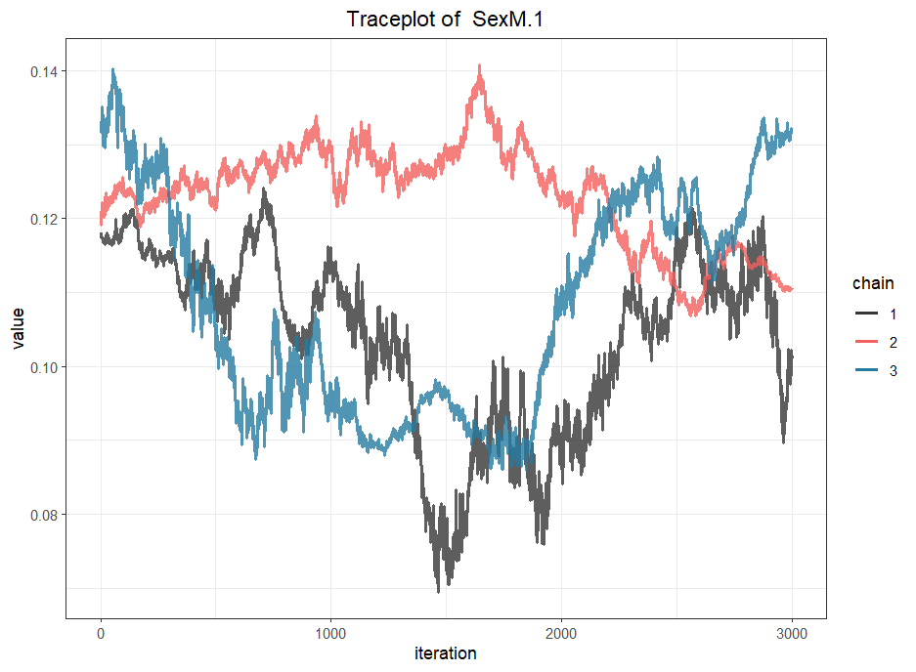

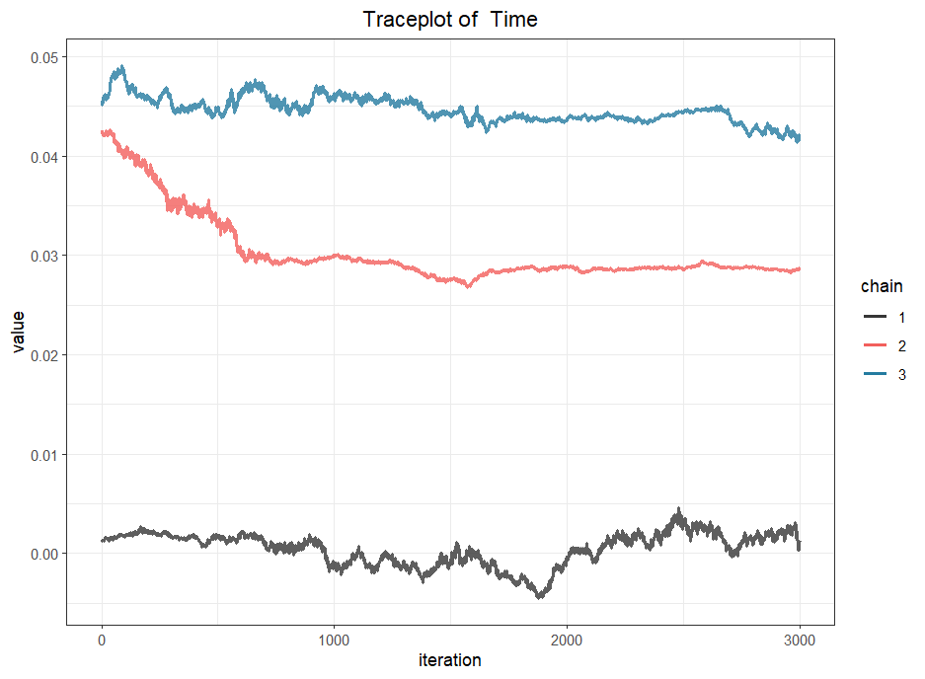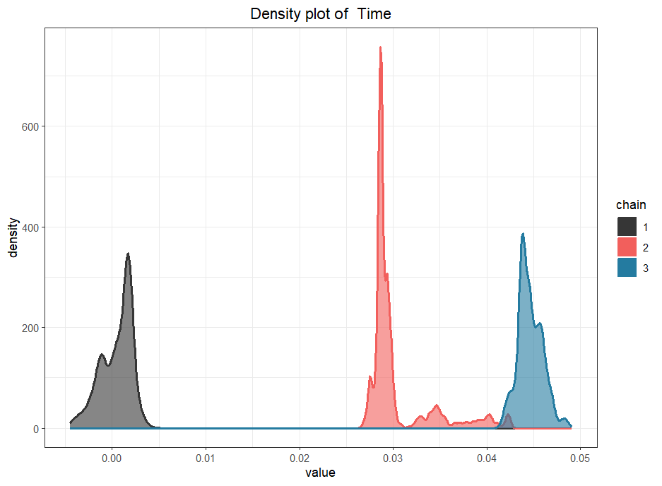

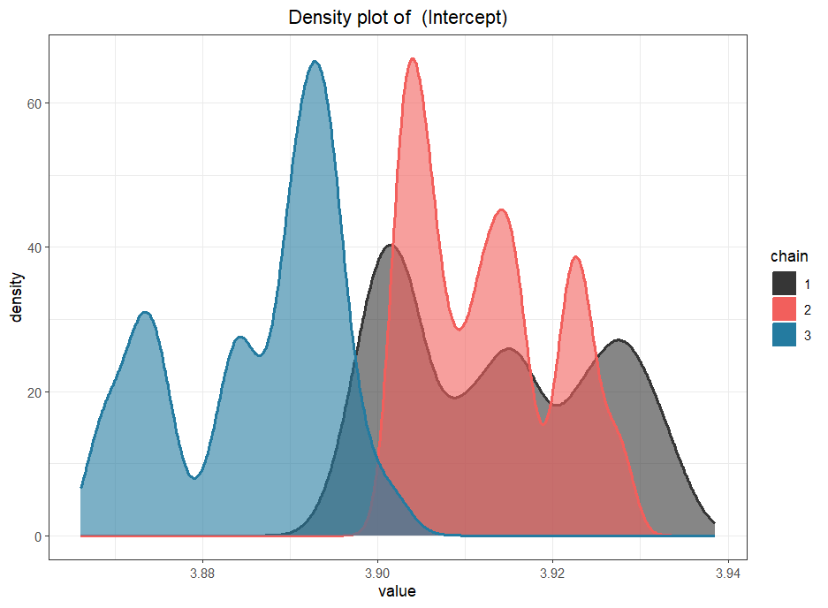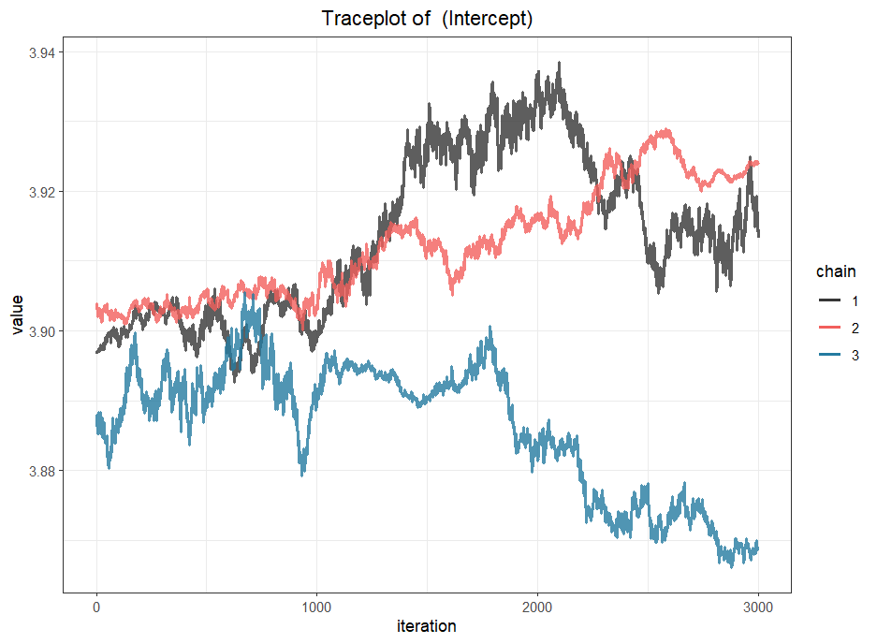The verification of the model showed not good observations for the CPAP adherence and the other parameters.

For example, the prediction of the cumulative risk for the patient 5 increased (risk to have ESS score < 10) from the 3th time points (cumulative risk around 0.00) to the 4th time points (cumulative risk around 0.58).

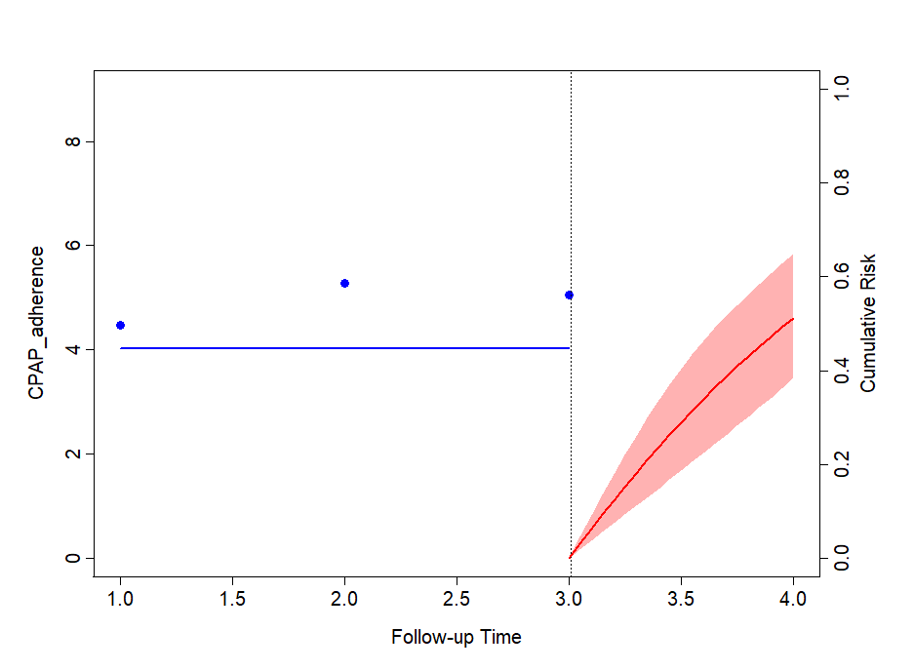

1. Hidden Markov model

One known categorical variable, e.g. in our analysis, CPAP adherence with 3 states and one hidden categorical variable with a known number of hidden states, e.g. 2 states: Adherent vs. Non-adherent were used. All time points but only one patient was included. We can repeat the model for each patient.

This model fitted EM algorithm and used the multinomial family for the categorial observations. The independence of observation variable from all covariates were added to the model. A seed was used for the reproducibility. A test for other number of hidden states can be applied and comparisons using BIC, AIC and loglikelihood criteria could be performed. However, the interpretation of hidden states must stay possible.

The initial state probabilities model was 1.0 for the 2nd state (Non-adherent). The transition probability matrix was 0.18 for the initial state of non-adherent group to the adherent group and 0.17 for the initial state of adherent to the non-adherent group. To stay in the non-adherent group, the probability was 0.82 and 0.83 to stay in the adherent group.

|  |  |  |
| --- | --- | --- |
|  | **Non-adherent** | **Adherent** |
| **Non-adherent** | 0.82 | 0.18 |
| **Adherent** | 0.17 | 0.83 |

The prediction of the patient’s state at each time point was predicted and plotted in the graph below.

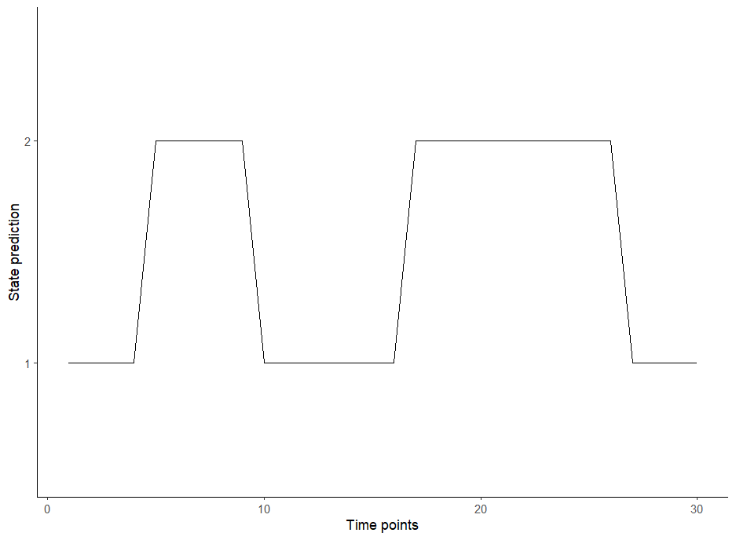

The states prediction included 50% of time points in the 1st state and 50% in the 2nd state.