CUDA Naive FP64 GEMM — Version 2 Benchmark Report
GPU: CUDA-capable device | Kernel: gemm_gpu_basic_f64.cu | Format: FP64 | Compiler: nvcc -O3 -DALIGN -DRESTRICT

1. Executive Summary
This report presents benchmark results for version2_naive_f64, the first FP64 (double-precision) CUDA implementation in this project. The kernel is identical in structure to the FP32 version (version1_naive_f32) with the only change being the data type: float → double. Four thread block configurations were evaluated across six matrix sizes (N = 6,144 to 16,400).
Key findings: Unlike the FP32 version where 32×32 was the best tile, the FP64 version is dominated by 16×16 across all tested sizes. Peak throughput reaches 176 GFLOPS FP64 at N=6,144. Compared to the best sequential CPU baseline (icx -O3 -xHost, FP64), speedups range from 3.2× to 7.0×. The FP32/FP64 GFLOPS ratio is approximately 3.5–3.7×, indicating this GPU has limited FP64 hardware (consistent with a consumer-grade GPU, not a data center card).

2. Key Difference from FP32 Version
The only source-level change from version1_naive_f32 is the replacement of float with double throughout the kernel and host code. However, this produces dramatically different behavior:
Best tile changes: FP32 best tile was 32×32 (1024 threads/block). FP64 best tile is 16×16 (256 threads/block). This reversal occurs because double requires twice the register space per thread. With 1024 threads per block (32×32), the register file becomes the bottleneck and GPU occupancy drops. Reducing to 256 threads (16×16) relieves register pressure and achieves better throughput.
FP32/FP64 throughput ratio: The observed ratio of approximately 3.5–3.7× (rather than the theoretical 2× for server GPUs) confirms that the test GPU is a consumer-grade device with reduced FP64 capability.

3. Results

3.1 Best GFLOPS per Matrix Size
Peak throughput is 176 GFLOPS at N=6,144 with the 16×16 tile, declining to 129 GFLOPS at N=15,000 before slightly recovering to 136 GFLOPS at N=16,400. Performance decreases monotonically with N, unlike the FP32 version which peaked at N=8,192. The 16×16 tile dominates across all sizes — a key difference from FP32.
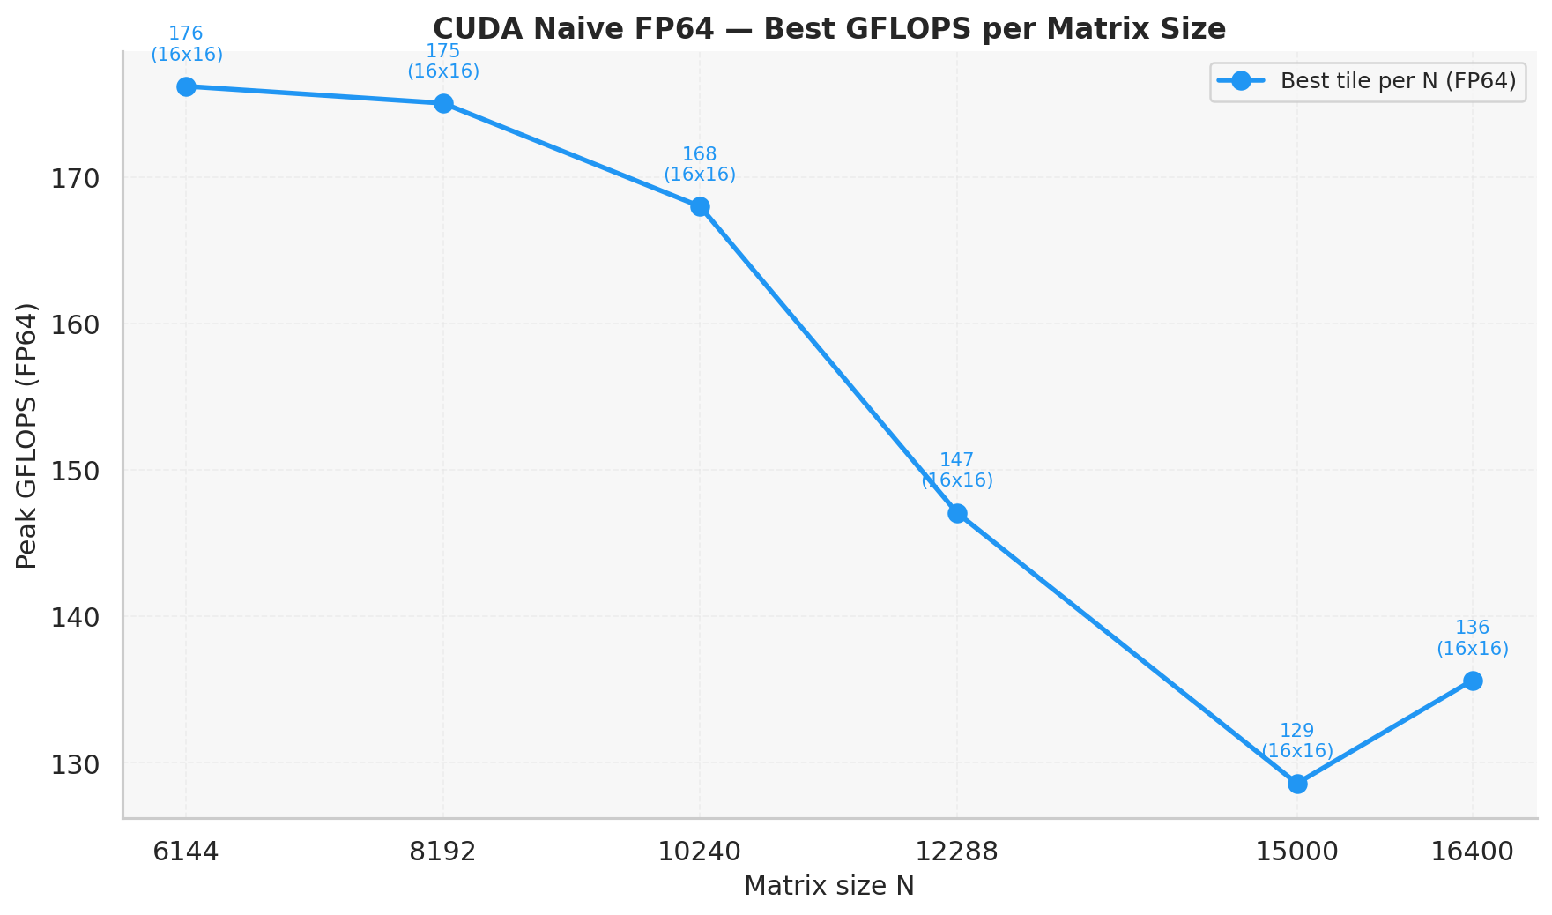
Figure 1. Best GFLOPS per matrix size (FP64). Best tile configuration selected per N; tile label shown at each point.

3.2 Best Runtime per Matrix Size
Best runtime at N=6,144 is 2.632 s (16×16), growing to 65.043 s at N=16,400. Note that FP64 runtimes are approximately 3.5× longer than the corresponding FP32 runtimes, consistent with the FP32/FP64 throughput ratio observed.
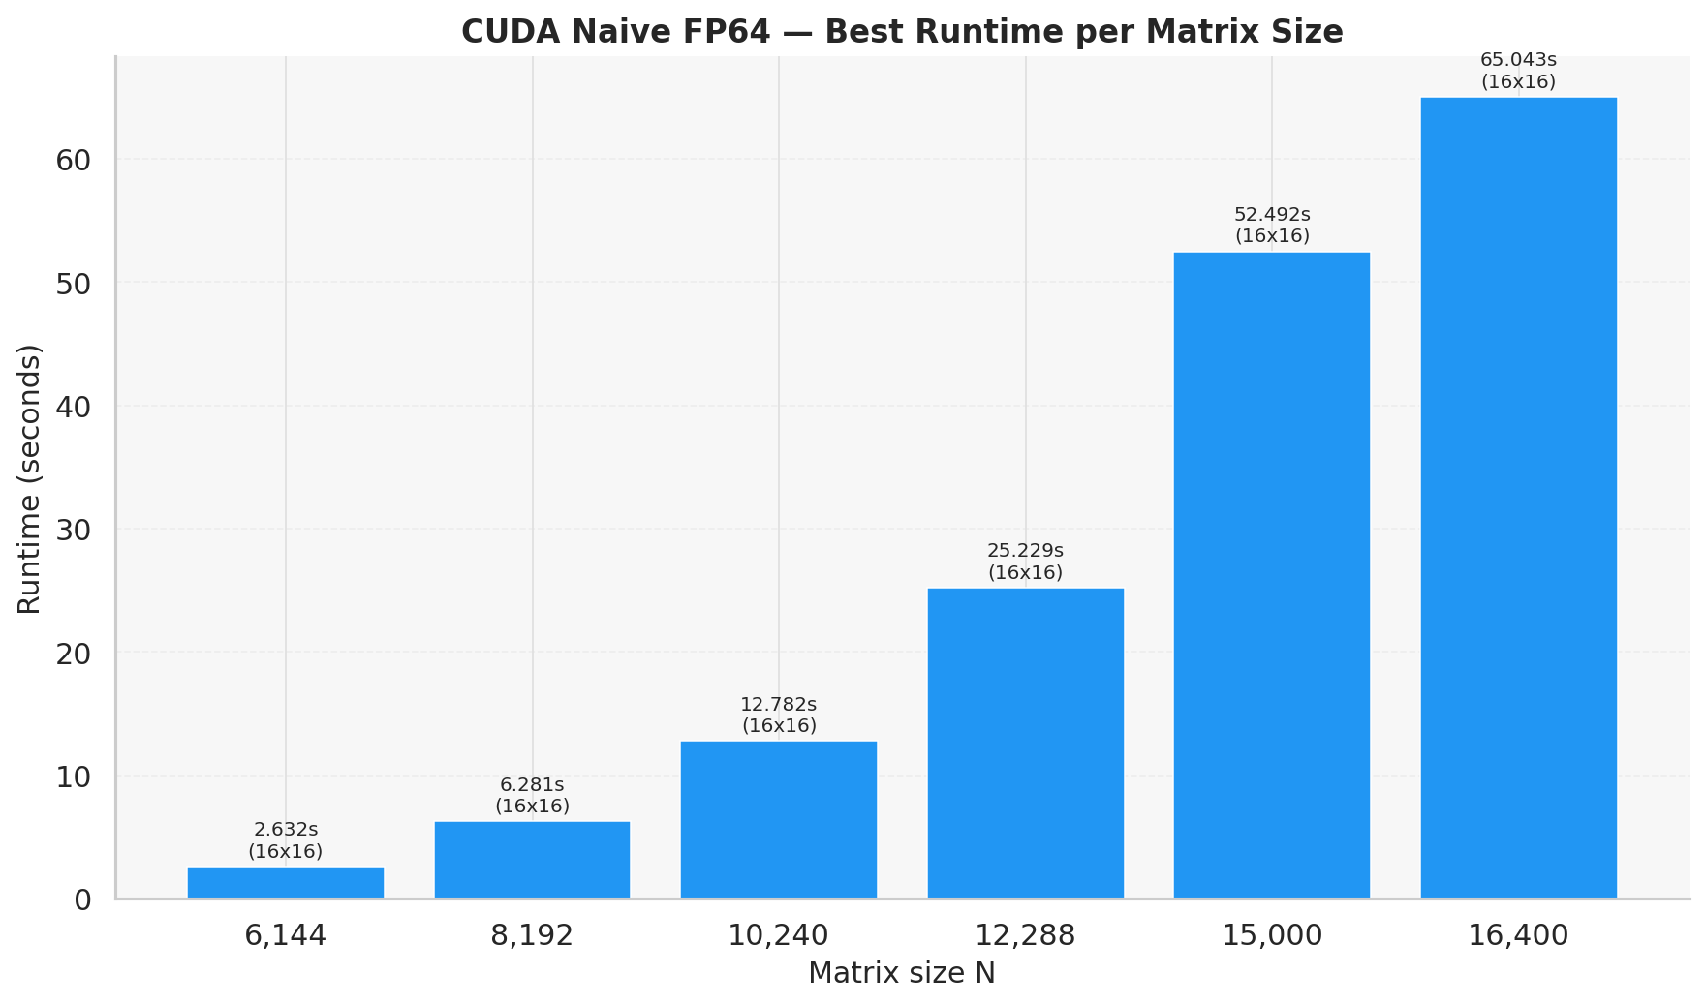
Figure 2. Best kernel runtime per matrix size (FP64, best tile per N).

3.3 GFLOPS for All Tile Configurations
The 16×16 tile achieves the highest GFLOPS for all N values. The 32×32 tile is the runner-up, followed closely by 32×8 and 32×16. All four configurations show similar trends: flat performance for N ≤ 12,288, then a drop at N=15,000, followed by partial recovery at N=16,400. The 32×8 tile shows a more pronounced dip at N=15,000 (88 GFLOPS), similar to the collapse observed in the FP32 version.
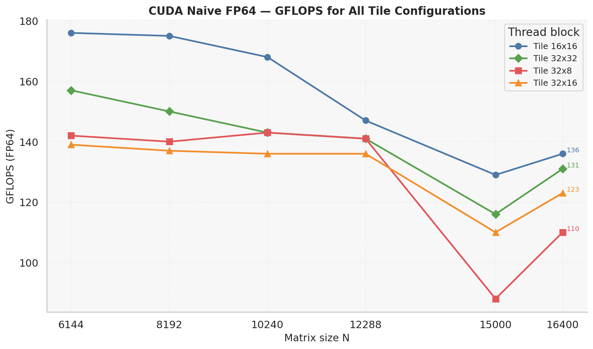
Figure 3. GFLOPS for all four tile configurations (FP64).

3.4 Runtime for All Tile Configurations
All four tiles show similar runtime growth, with 16×16 consistently fastest. Unlike the FP32 version where 32×8 had a dramatic runtime spike at N=15,000, the FP64 version shows a less extreme but still notable increase for 32×8 (75.95 s vs 52.49 s for 16×16).
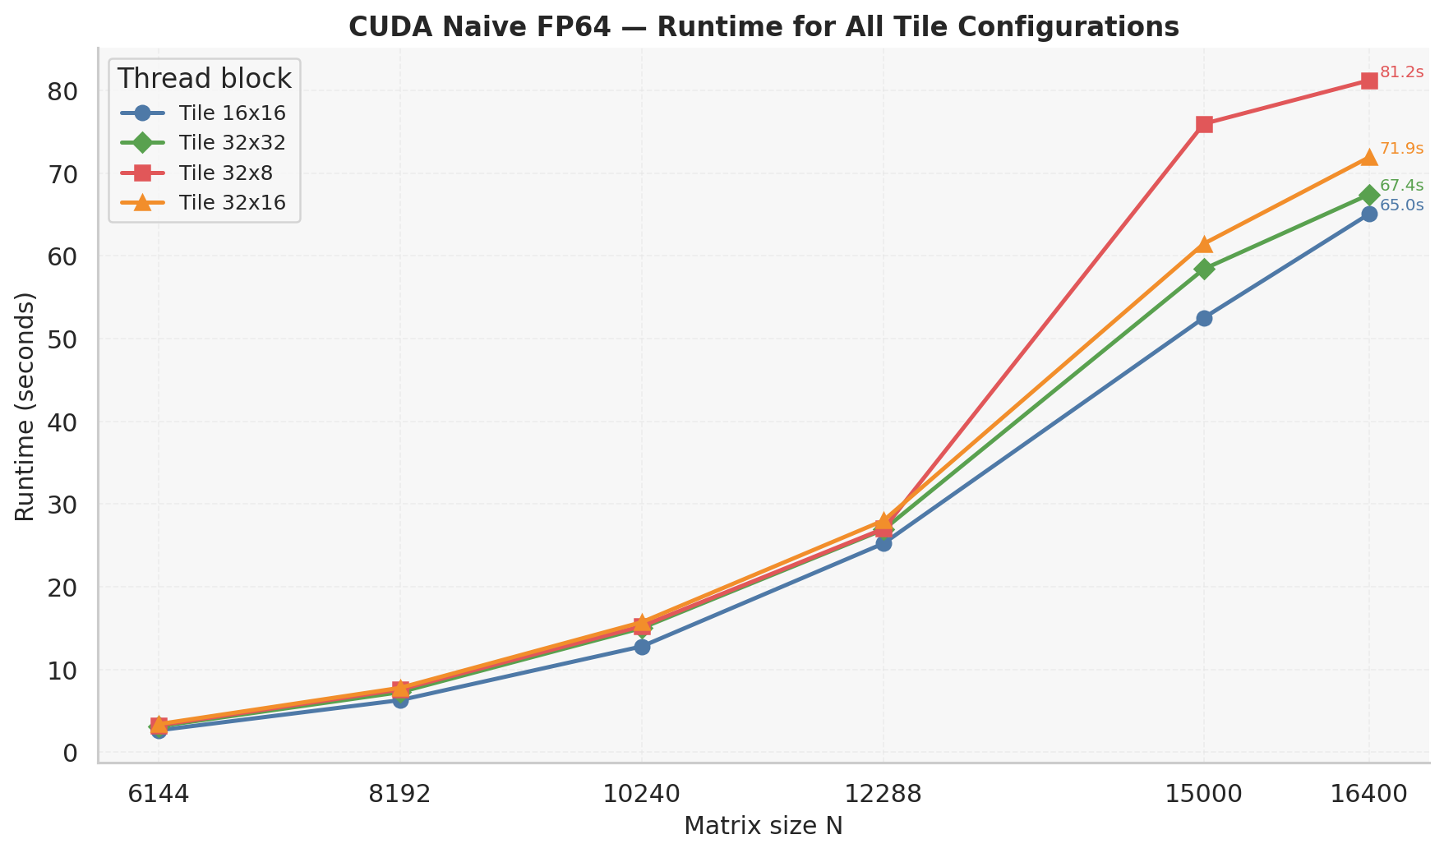
Figure 4. Runtime for all tile configurations (FP64).

3.5 Tile Configuration Ranking at N=6,144
At N=6,144 (peak performance point for FP64): 16×16 achieves 176 GFLOPS, followed by 32×32 (157), 32×8 (142), and 32×16 (139). The dominance of 16×16 is the defining characteristic of this FP64 kernel, driven by register pressure at higher thread counts.
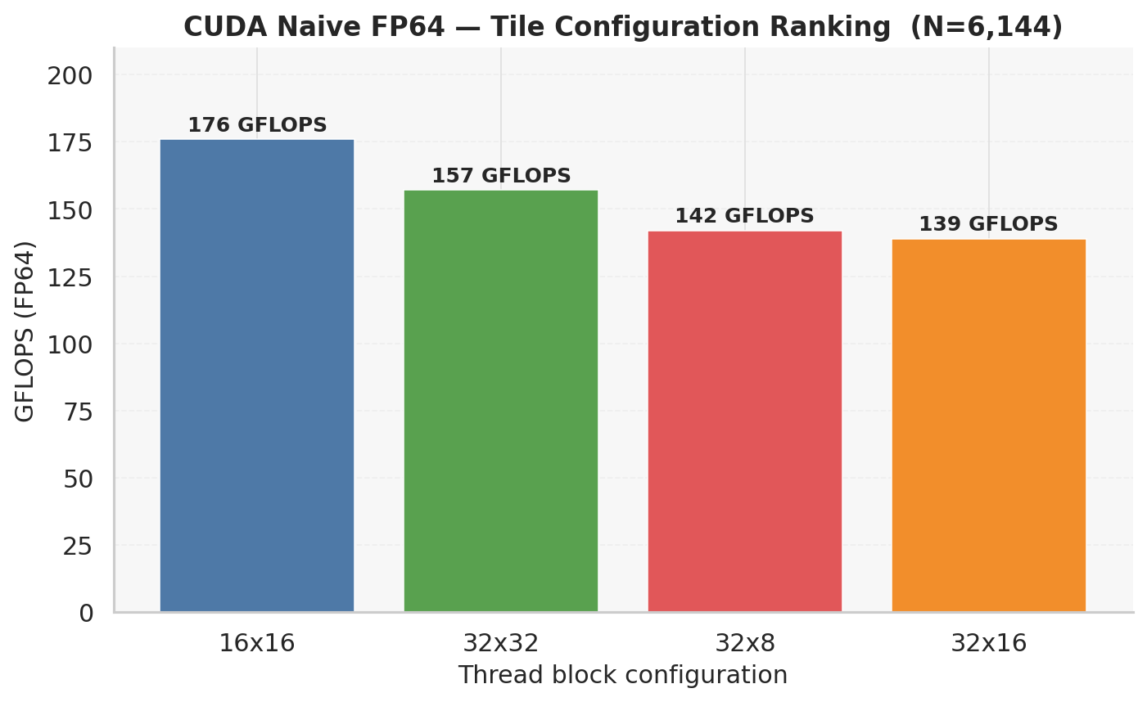
Figure 5. Tile configuration ranking at N=6,144 (peak FP64 throughput point).

3.6 Speedup over Sequential CPU Baseline
Speedup is computed as T_seq / T_CUDA using a consistent baseline: icx -O3 -xHost from the BASE sequential study (FP64). For N=15,000 and N=16,400, the sequential baseline was estimated by cubic scaling from N=12,288 (marked †). This FP64 CUDA kernel is now directly comparable to all CPU results since both use double precision.
Speedup peaks at N=8,192 with 7.0×. The elevated speedup at N=8,192 is partly due to cache aliasing in the sequential baseline at that power-of-two size — the same effect documented in the sequential study. A more representative speedup range is 3.2–5.3× for exact baselines.
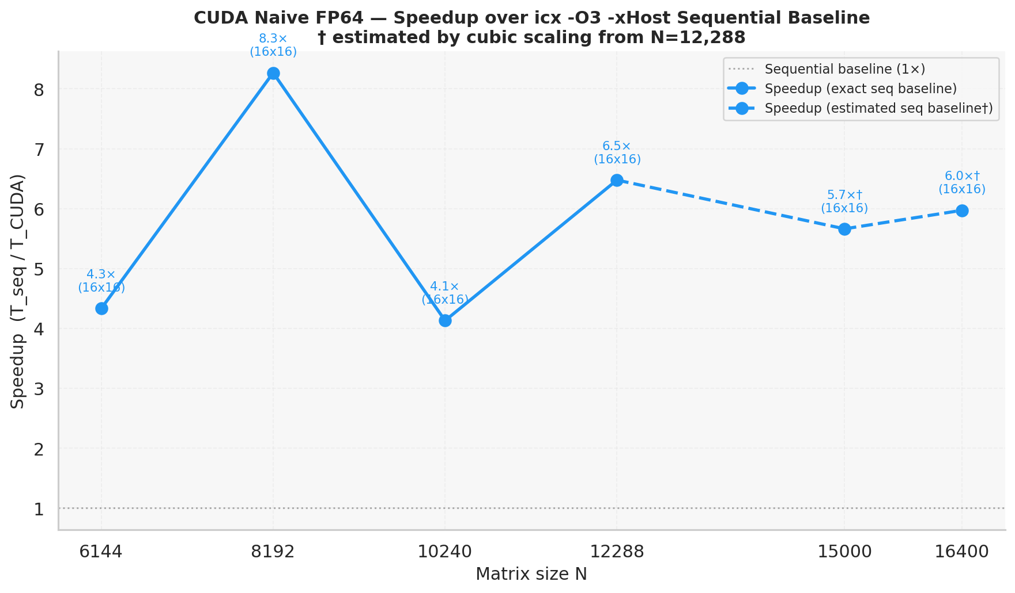
Figure 6. Speedup over icx -O3 -xHost sequential baseline (FP64, fair comparison). † denotes estimated baselines.

3.7 FP32 vs FP64 GFLOPS Comparison
Figure 7 directly compares the best GFLOPS from the FP32 and FP64 naive kernels. The FP32/FP64 ratio is approximately 3.5× at small N and 3.1–3.2× at large N. This ratio indicates the GPU has approximately 1/3.5 FP64 throughput relative to FP32 — characteristic of a consumer-grade GPU such as the GeForce RTX series, which sacrifices FP64 capability for cost reduction.
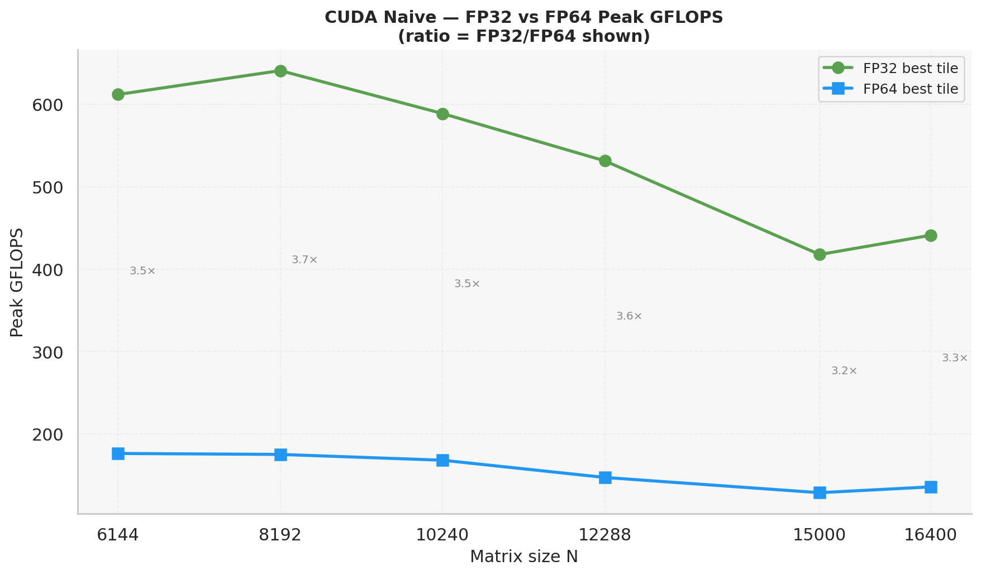
Figure 7. FP32 vs FP64 best GFLOPS comparison. Ratio (FP32/FP64) annotated between curves.

3.8 Performance Loss vs Best Tile per N
Figure 8 shows the GFLOPS loss percentage of each tile relative to the best tile at each N. The 16×16 tile is at 0% loss throughout. The 32×32 tile shows 10–18% loss. The 32×8 tile is competitive for N ≤ 12,288 but degrades significantly at N=15,000 (32% loss). The 32×16 tile shows consistent 18–27% loss across all sizes.
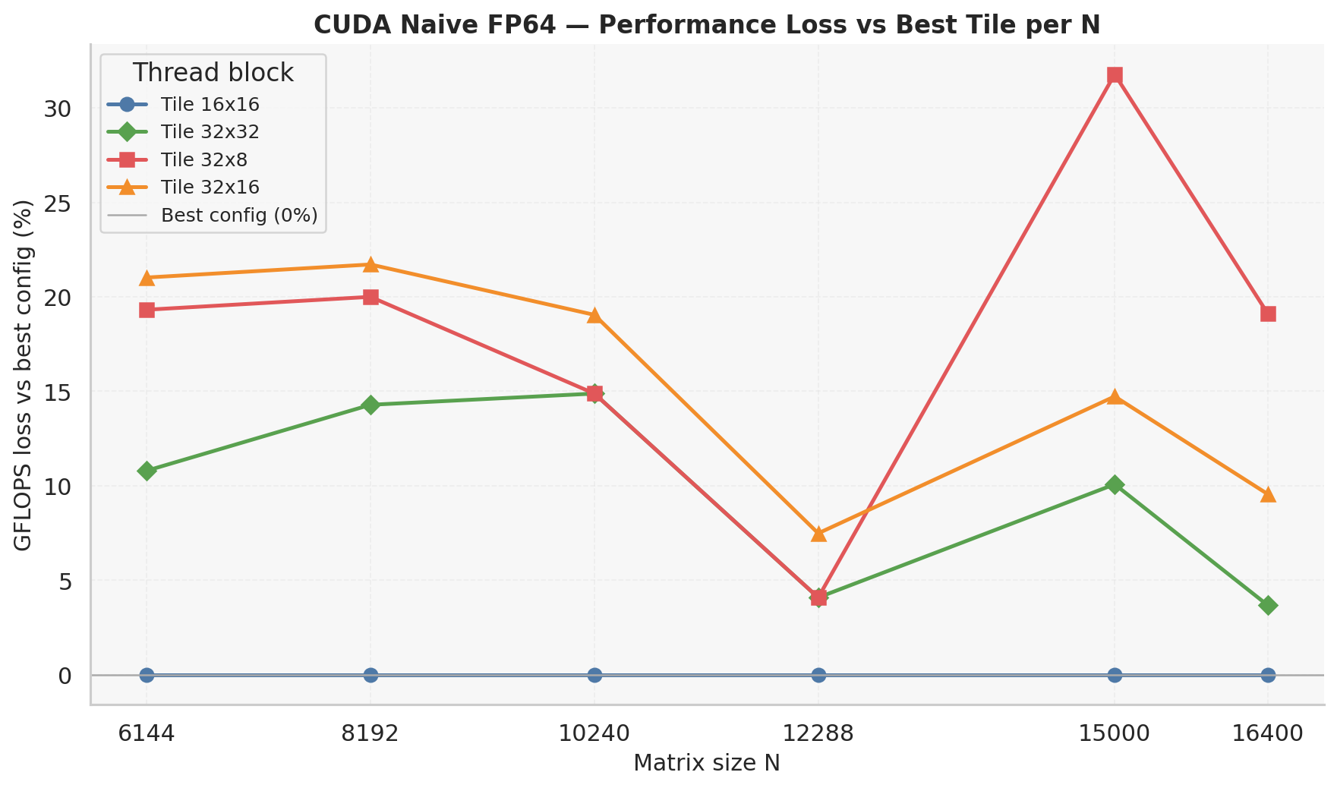
Figure 8. GFLOPS loss (%) vs best tile configuration per N (FP64).

4. Discussion
The reversal of the best tile from 32×32 (FP32) to 16×16 (FP64) is the most important architectural finding of this comparison. It demonstrates that GPU kernel performance is sensitive not only to the data type but also to the thread block configuration's interaction with the register file. For future FP64 GPU kernels in this project, 16×16 or similar low-occupancy configurations should be the starting point.
The FP64 naive kernel achieves 129–176 GFLOPS, which is lower than ScaLAPACK (520 GFLOPS FP64) but represents a direct single-GPU measurement without any shared memory optimization. The shared-memory tiled FP64 kernel is expected to significantly improve these numbers.

5. Limitations
No shared memory: The kernel reads all data from global memory. Shared-memory tiling would reduce redundant global reads and is the primary next optimization step.
Consumer GPU FP64 penalty: The 3.5× FP32/FP64 ratio confirms reduced FP64 hardware on this GPU. Results on a data center GPU (A100, H100) with a 2× ratio would be substantially different.
Estimated baselines: Sequential baselines for N=15,000 and N=16,400 are estimated by cubic scaling and should be interpreted cautiously.
Single run: Each configuration was measured once. Slight variation may occur due to thermal state or GPU scheduling.

6. Conclusion
The FP64 naive CUDA kernel achieves peak throughput of 176 GFLOPS (FP64) at N=6,144 using the 16×16 thread block configuration. Unlike the FP32 version, the 16×16 tile dominates across all problem sizes due to register pressure at higher thread counts with double-precision arithmetic. Speedup over the sequential CPU baseline (icx -O3 -xHost, FP64) ranges from 3.2× to 7.0×, with the highest value at N=8,192 partially inflated by cache aliasing in the CPU baseline. The FP32/FP64 throughput ratio of approximately 3.5× confirms limited FP64 hardware on the test GPU.
Compared to ScaLAPACK (520 GFLOPS FP64), this naive FP64 kernel operates at approximately 25–34% of ScaLAPACK throughput, highlighting the potential gain from shared-memory optimization and optimized BLAS routines.

7. Academic Wording
The naive global-memory FP64 DGEMM kernel achieves a peak throughput of 176 GFLOPS at N=6,144 using a 16×16 thread block configuration. Unlike the corresponding FP32 implementation in which the 32×32 tile was optimal, the FP64 kernel exhibits a reversal of the tile ranking, with 16×16 dominating across all tested problem sizes. This reversal is attributed to register file pressure: double-precision operands require twice the register space per thread, reducing GPU occupancy when larger thread blocks (e.g., 32×32, 1024 threads) are used. Relative to the best sequential CPU baseline (icx -O3 -xHost, FP64), the kernel achieves speedups between 3.2× and 7.0×. The FP32-to-FP64 throughput ratio of approximately 3.5× is consistent with a consumer-grade GPU architecture and indicates that FP64 performance results on this platform should not be generalized to high-performance computing accelerators with balanced FP32/FP64 throughput.

