STEPS TO CREATE AN INSTANCE WITH HORIZON DASHBOARD

Step 1: Access and login into Horizon Dashboard

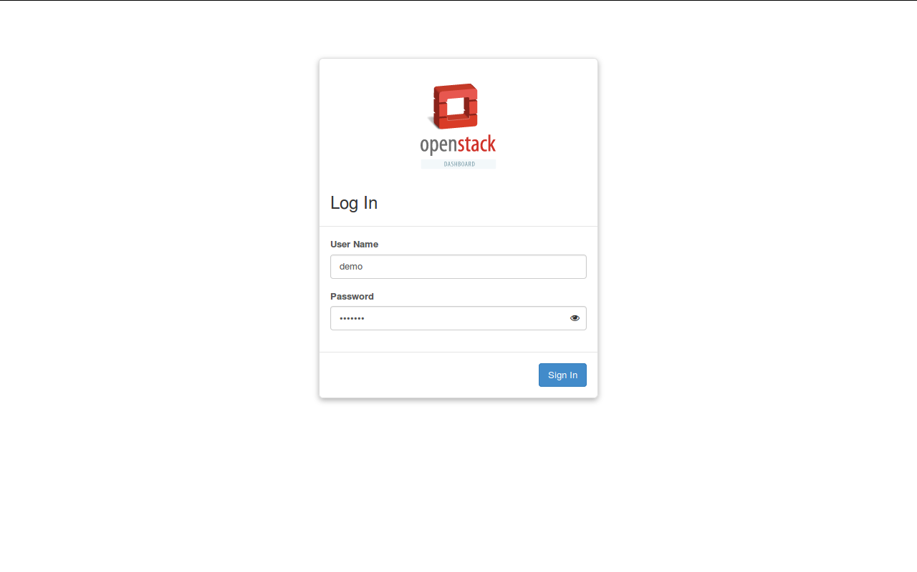
- Access URL Address in browser:
http://192.168.50.12/horizon
- Login with Openstack user account

Step 2: Launch an instance
Open page Project → Compute → Instances and then click button Launch Instance

In tab Details, fill out the required fields

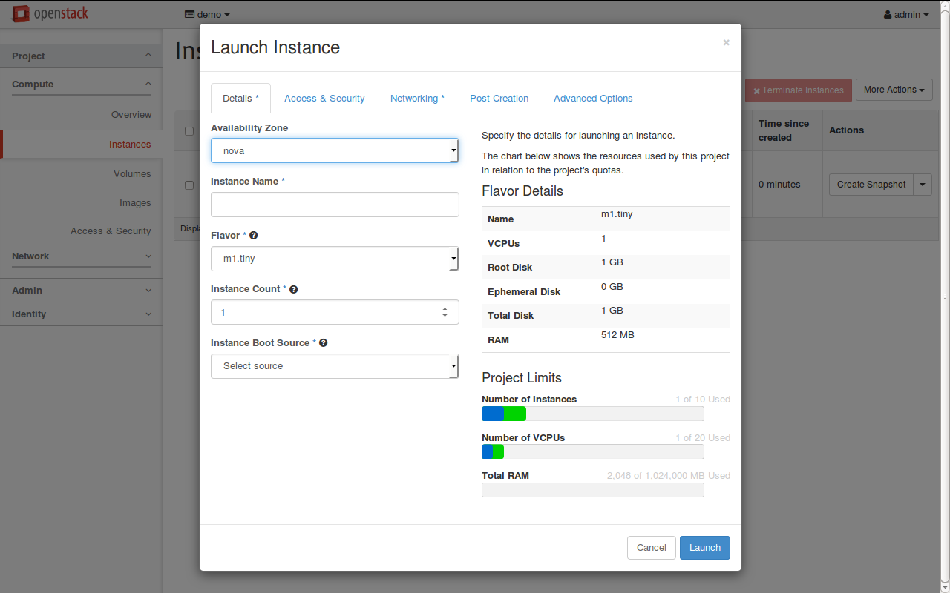
In tab Access & Security, select an imported keypair or import a new keypair to ssh to instance.
To import a new keypair:
- copy and paste in Public Key field the contents of the public key file in the machine which you want to ssh from. (The public key file default is /home/<username>/.ssh/id_rsa.pub)

- fill out the keypair name

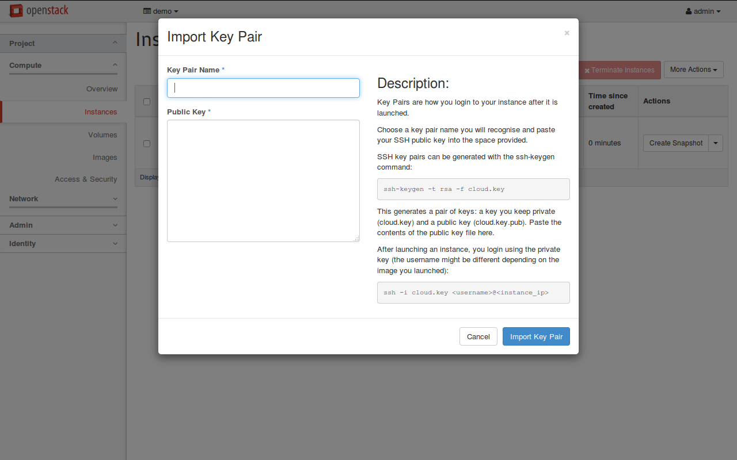

In tab Networking, selected network is your internal network.

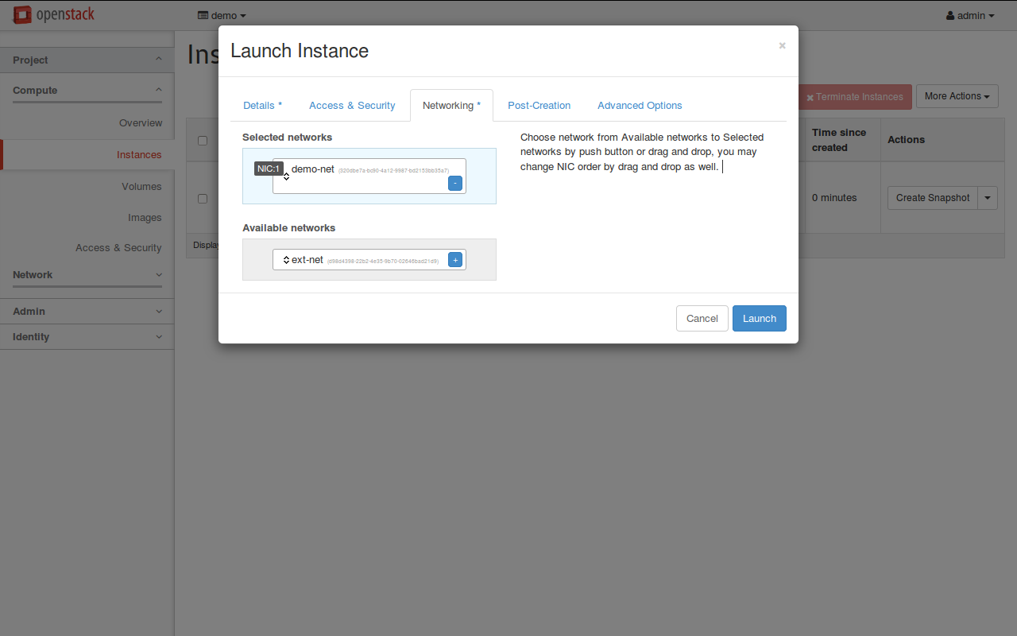
Step 3: Associate Floating IP
Select Associate Floating IP from Actions Column of the instance

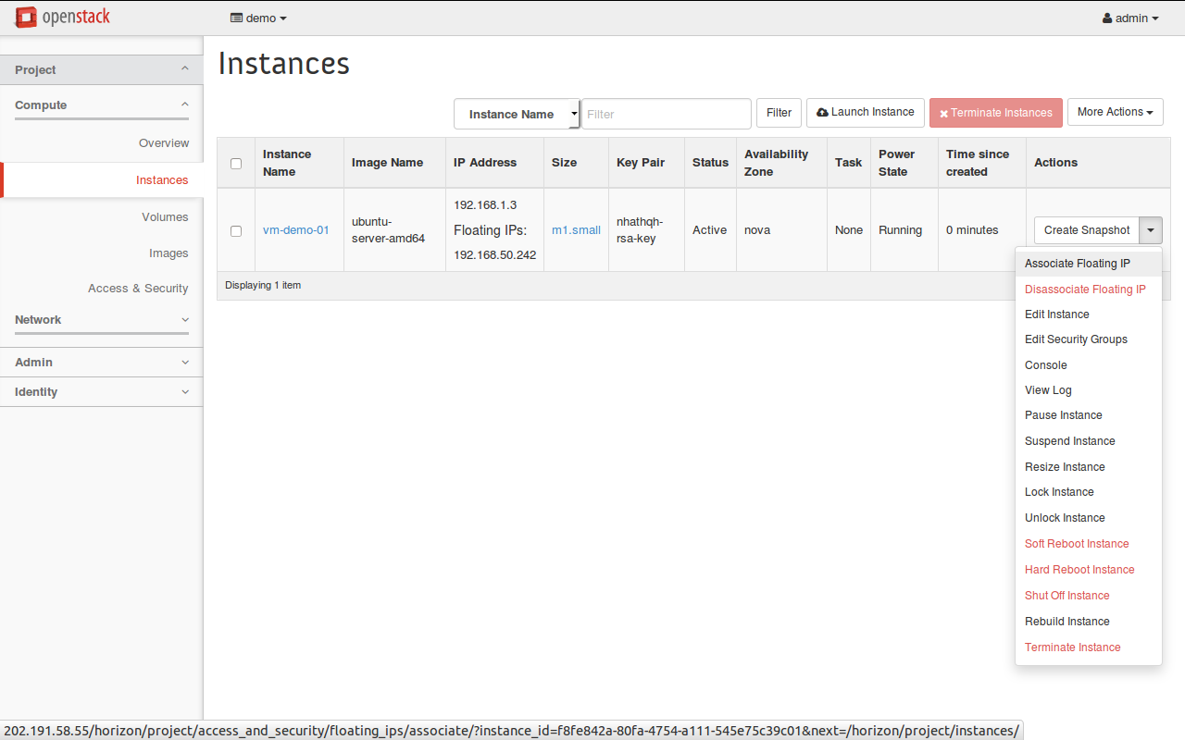
Click to (+) button

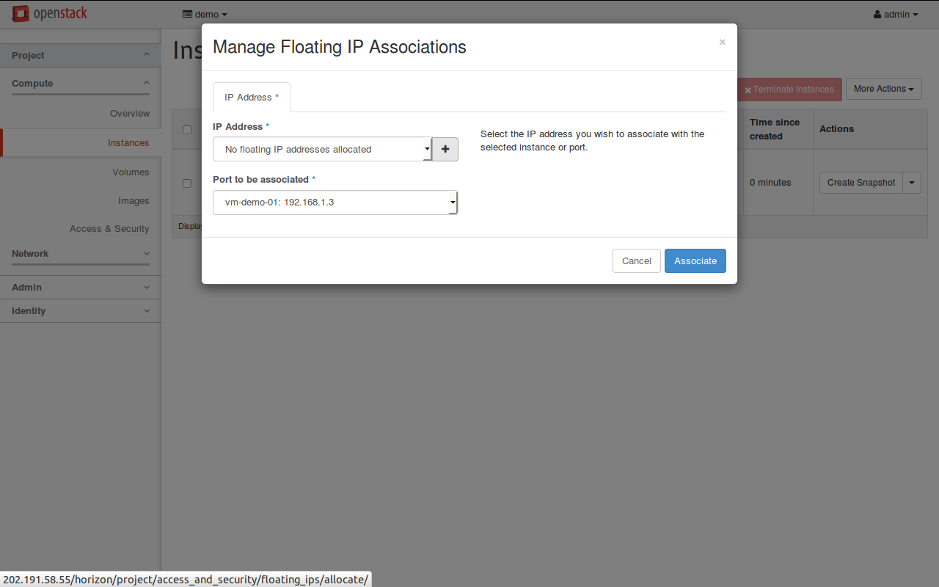

And select Pool as your external network to Allocate IP

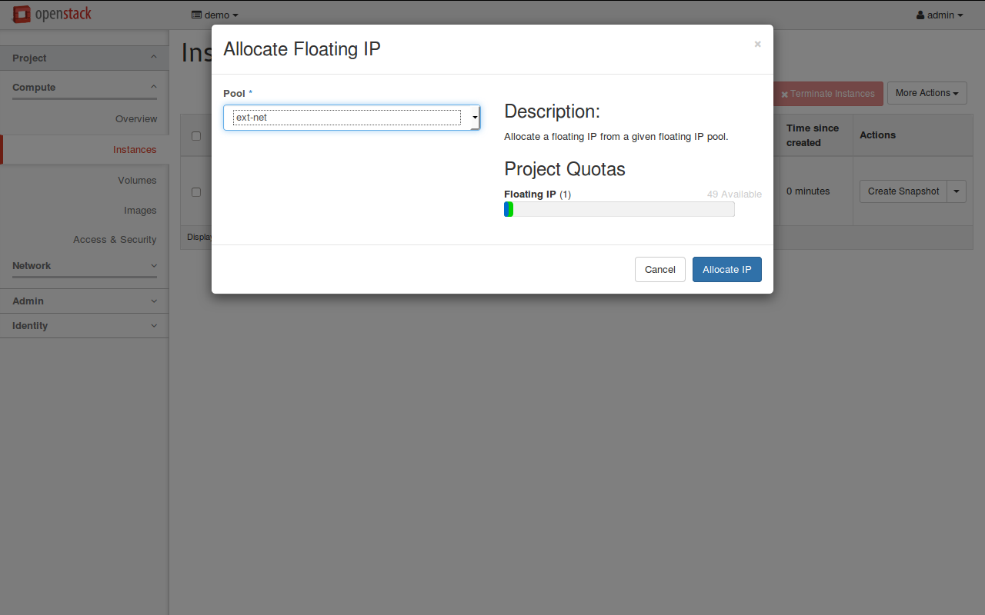

Step 4: SSH to your instance
You must point your private key suitable with you keypair which you chossed in step 2
With ubuntu image, the command line is:
ssh -i <your_private_key> ubuntu@<your_instance_IP>

