# TASK DECRIPTION

I need to add one web page in GEOCLOUD, which is used to select dataset and method for users.

In details:

1. Add one menu named “ Clustering Tool”

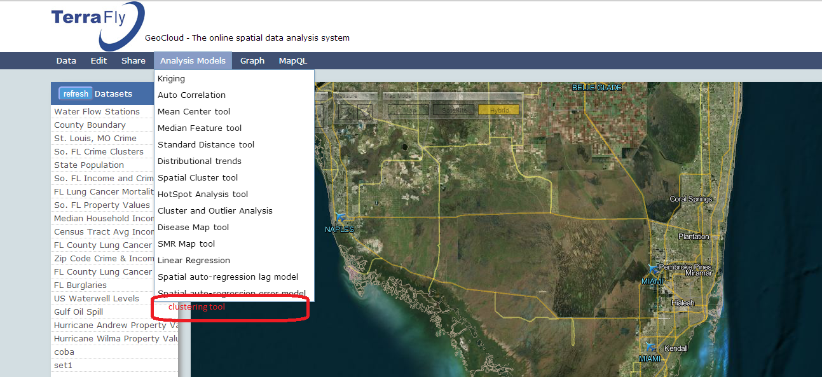

1. Click the menu to show one form page as below showing:

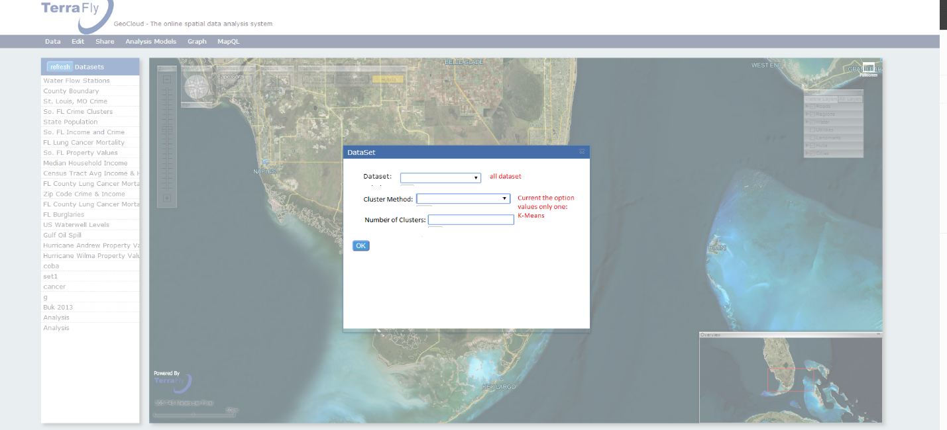

Note1: Dataset values equal to which of the dataset located main page left as the below showing:

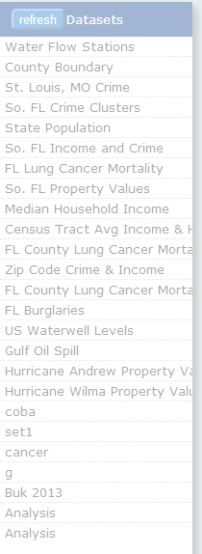

Note2: Cluster-Method values current only displaying one “K-Means”

Note3: Only when Cluster-Method option value is K-Means, the Number- of-Clusters input area is available.

1. Click the “OK” button after select the Dataset and Cluster-Method and Number-of- Clusters, then show the information like below:

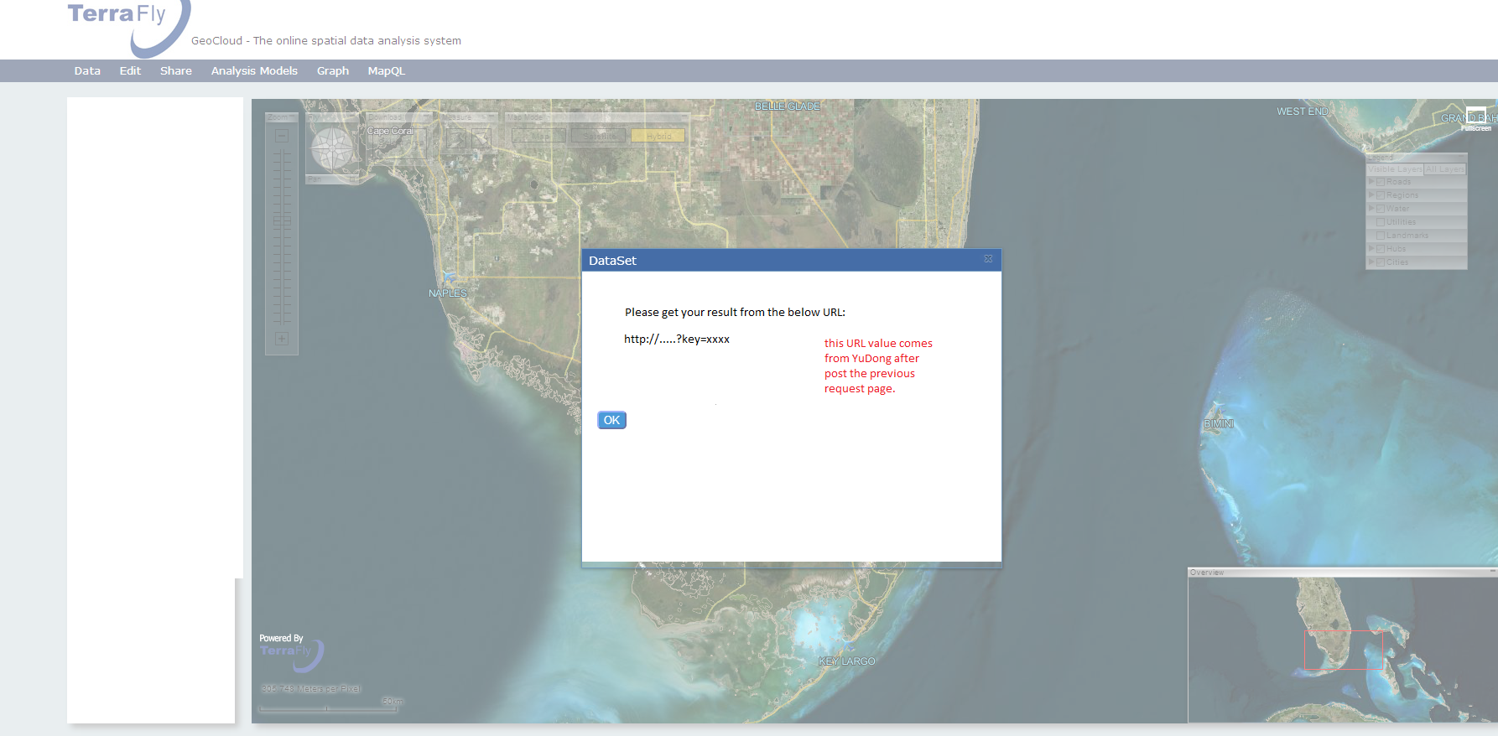

Note1: The URL value will be provided by YuDong after post the previous request page.

Note2: User can click the “Go” button to access the cluster result, then open one new web page to view the result.

# DESIGN DECRIPTION

## **2.1 Code Organization**

This page relative code is included in two files:

|  |  |  |
| --- | --- | --- |
| File | Directory | Note |
| index.html | ./ | Add one sub menu “Clustering Tool” on “Analysis Models” menu |
| DiseaseAnalysis.js | ./js/ | Main code here to create new page and add user’s actions |

## **2.2 Coding Main Point**

1. Functions Instruction included in “ DiseaseAnalysis.js”

|  |  |
| --- | --- |
| Function | Usage |
| selectClusteringTool | The code Entry; create new page and add actions for controls |
| getClusteringTool | to request one page to get the result url |
| handleClusteringTool | used to hide and show different controls after click the ok button |
| ClusterToolGetClusterMethod | add data items into dropdownlist control: cluster method |
| ClusterToolGetDataSets | ClusterToolGetDataSets is a function that makes an AJAX request to the backend  and passes the xml document to add data items into the dataset dropdownlist. |
| handleClusteringToolDataSets | add data items into the dataset dropdownlist control |

1. One agreement with YuDong is to post the option values with the parameters form like shown below:
2. method=kmeans
3. datasetId=…
4. noclusters=

such as: var url = "http://terranode-239/geocloud/newofflinejob.aspx?method=" + clustermethod + "&datasetid=" + datasetSelectId + "&noclusters=" + numclusters