S-Tree: A High Performance Spatial Search Tree
Research, Full Paper
Artyom Shaposhnikov, Naphtali Rishe, Ouri Wolfson and Evy Peralta
School of Computing and Information Sciences
Florida International University
University Park, Miami, FL 33199
http://HPDRC.FIU.edu

Abstract. This paper introduces a high performance spatial point indexing structure called S-Tree. S-Tree is a hybrid structure that uses the quad-tree style space decomposition and a hash table for searching. The performance of the data structure is mostly a hash table performance and is a better than O(log(N)), where N is the size of the tree. S-Tree has an easy to compute hashing function that improves the performance and reduces the index storage requirements by eliminating the need to store the quad-tree keys. S-Tree uses a hash table allowing it to start searching from an arbitrary level of the tree without traversing many levels close to the root or to the leaves of the tree as it is done in other algorithms. S-Tree is also very compact, allowing large spatial indexes to be stored in the main memory, and it is optimized for main-memory index residence.

1 Introduction

Spatio-temporal databases are becoming increasingly used as the number of mobile devices equipped with Global Positioning Systems (GPS) and Internet accesses grows. This will lead to proliferation of mobile internet applications such as internet vehicle tracking, stolen vehicle recovery systems, traffic monitoring, emergency response with high precision tracking, mobile real estate listings downloaded dynamically to users’ cell phones, mobile internet maps and cellular phone navigation systems, TerraFly [1] style dynamic navigation maps, and many others. As the number of devices grows, these applications will require extremely fast databases. Current relational database technology is limited to only a few thousands transactions per second (TPS). The problem is even more complicated because few databases have a built-in efficient support for multidimensional queries like “Given a location, find all objects nearby”.

This paper describes a new multidimensional point search structure based on a hybrid data structure that uses a quad-tree with a regular space decomposition and a hash table. A point quad-tree was first proposed in Finkel [6]. The point quad-tree is essentially a multidimensional binary search tree that divides the space into regions at the points being inserted into the tree. The order in which the points are being inserted into the tree affects the balance of the tree and the performance can degrade significantly for highly skewed data with many updates. Samet [2] proposed a region quad-tree that avoids the penalty associated with the insertion order by using a regular space decomposition. However, for highly skewed data, the tree becomes unbalanced and requires longer tree traversals in densely populated areas. It also uses an explicit tree structure based on pointers that make the update operations slower and have an associated storage penalty.

The algorithm proposed in this paper, called S-Tree, is a hybrid data structure that uses a combination of a hash table and a quad-tree multidimensional data structure that uses order preserving hashing which were proposed by Krigel [3] [4]. These structures however are inefficient for highly skewed non-uniformly distributed data, which unfortunately is the case in most applications dealing with urban areas.

Karlsson [5] proposed a new data structure, hQT*, that uses a combination of a quad-tree with a hash table and avoids long traversals by using mostly bottom–up traversals. However, hQT* may still need long tree traversals for highly skewed data distribution because the queries must proceed to the bottom (the highest existing level) of the tree even if the bottom is empty, to ensure that all relevant results are retrieved. The insertions from the bottom may also require long tree traversals for highly skewed data.
Bkd-tree [14] is a dynamic structure based on the K-D-B-tree [15] and on the logarithmic method for making a static structure dynamic. It maintains high space utilization by maintaining a set of static K-D-B-trees. Because of this Bkd-tree has to query all structures instead of just one.
Other, recently proposed efficient data structures for storing spatio-temporal data include: the 2-3 TR-Tree [9], SP-GiST [10], SV-Model [11], MV3R-Tree [12], and TPR*-Tree [13] and further analysis in [17]. These are mostly theoretical papers and while we can not directly compare the performance to the algorithms just described, we can consummate that S-tree provides hashing search and insert complexity while other all tree-based algorithms have log(N) complexity.

S-Tree further improves the performance for highly skewed data by storing small binary facts for the non-leaf quad-tree nodes that have non-empty children and utilizing an easy to compute formula for the keys of the quad-tree nodes, eliminating the need to store the keys. S-Tree allows the searches and updates to start from an arbitrary location in the tree, further improving the performance. Our approach to store the quad-tree nodes is more efficient and is based on hashed binary facts representing the quad-tree nodes. The tree traversals are done without pointers by utilizing a hash table. S-Tree uses a simple and easy to compute formula for the hashing keys of the quad-tree nodes (binary facts) and does not need store the quad-tree keys, reducing the expensive RAM storage requirements.

In most cases S-Tree provides hash table performance where operations require constant time that does not depend on the tree height. In fact, the only operation that typically needs to be performed for searching in S-Tree is a simple algebraic computation and a hash table lookup that requires only a few processor cycles. In the following sections we describe the algorithms and data structures for S-Trees and discuss a performance evaluation study of our implementation of S-Tree.

The remainder of this paper is organized as follows. Section 2 introduces the S-Tree cell numbering algorithm that we use to organize and address the S-Tree nodes. Section 3 introduces a storage structure for S-Tree using a hash table. In Section 4 we describe S-Tree algorithms. Finally, Section 5 describes our performance evaluation study of S-Tree.

2 S-Tree Cells

For simplicity we first consider a two-dimensional search algorithm. We assume that all objects have a pair of coordinates (X,) that belong to a region 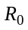 defined as:

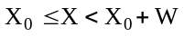 and 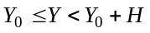 , (1)

where and are the region’s width and height respectively. In other words, defines the entire region of space that we are going to work with. X and Y can be any integer or real numbers; for example, and can be the longitude and latitude and can be a mapping of the entire Earth surface into a set of pairs and, where X ranges from -180 to 180 and Y ranges from -90 to 90.

An S-Tree consists of a number of standard-sized hyper-rectangles that belong to multiple levels in the S-Tree. Level 0 of the S-Tree starts with the rectangle defined by the expression (1). To optimize performance, the S-Tree uses standard-sized rectangles that can be randomly accessed at any level of the S-Tree without accessing the top S-Tree levels as it is done in most of the tree-searching algorithms. In addition to performance benefits, S-Tree does not need to store the bounding rectangle coordinates for each cell as they can be easily derived from the S-Tree cell number. This reduces the S-Tree storage requirements. In S-Tree we can assign an easily computed number to any standard-sized rectangle. We start by assigning the number 0 to the rectangle. The rectangle is then split into four equal sub-rectangles at the S-Tree level 1 as shown on Figure 1. At the level 2 S-Tree will contain 16 equal sub-rectangles. We call each rectangle in S-Tree a cell and assign an integer number to each cell as shown at the Figure 1.
5
6
7
8
12
16
20
9
13
17
10
11
15
18
19
14
0
1
2
3
4
Level 0
Level 1
Level 2

Figure 1: S-Tree Cell Numbering.

In general, a level L of an S-Tree contains 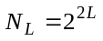 cells. As it is easy to see, the top leftmost cell numbers 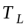 at each level L can be computed as the sum of a geometric progression and are given by expression (2):

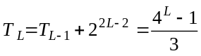 . (2)

At the level L of S-Tree the width 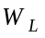and height 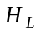 of an individual cell are:

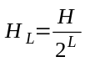
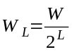 . (3)

Consider an arbitrary point P(X,Y) with coordinates X,Y that belongs to as defined by (1). At every level L, the point P(X,Y) will belong to a cell which is 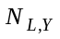cells below the topmost cell and 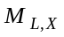 cells to the right from the leftmost cell:

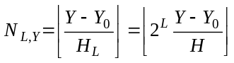 and 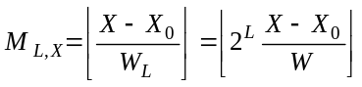 , (4)

where the square brackets 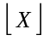 denote the real number truncation to the nearest integer smaller than or equal to the number inside the brackets.
As it is now easy to see from (2) and (4), the point P(X,Y) with coordinates X and Y belongs to a cell with number 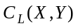at the level L:

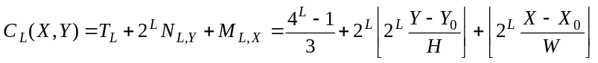 . (5)

We consider the expression (5) as the definition of a two-dimensional S-Tree cell. A point P(X,Y) belongs to the L-level cell determined by Expression (5). A cell 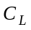 is a parent of 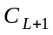 if any point of belongs to . We will also call the cell a child of if any point of also belongs to . An S-Tree cell may have up to four child cells at the level L+1.

The advantage of the cell numbering method in (5) is that it gives one of the most compact cell number representations. The maximum tree level achievable using (5) given a limited number of bits in an integer field is greater than in any other method. If the integer field used to store the cell numbers has 32 bits, the maximum level will be 32/2-1=15. We will reserve one bit to indicate if a cell represents a leaf cell in the tree. This means that each dimension of a smallest cell in a 32-bit S-Tree will be 32764 times smaller than same dimension of the total area covered by the S-Tree, i.e. in case of a two-dimensional S-Tree each leaf cell is one billionth the size of the entire area. For example, if we take the State of Florida that measures about 600 miles in length, the smallest cell will have the length of 30 meters.

3 S-Tree Storage Structure

The root node of the tree corresponds to the main rectangle and is created at the same time as the S-Tree. All objects are stored at the leaf nodes of the S-Tree. Non-leaf nodes in S-Tree serve as indirect pointers to non-empty leaf nodes. A number of objects that can be stored in single leaf S-Tree node is limited to a configurable parameter called MaxCell. When the number of objects exceeds MaxCell, as we add objects to a leaf S-Tree node, we create four child nodes and move all objects from the parent node to the child nodes. The parent node stores at most four pointers to non-empty child nodes. This split process is repeated until all leaf nodes contain less than MaxCell objects.

To facilitate quick insertions and queries, the tree nodes are organized into a single hash table that references binary (here the word binary refers to a binary relationship) facts of two types:

1. 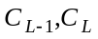, represents a fact that the cell at some level L is non-empty child of (and, therefore, the cell 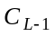 is not a leaf node).
2. 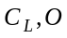, represents a fact that an object with identifier O belongs to a leaf node .

To physically distinguish facts of type 1 from type 2 facts, instead of cell numbers we use storage numbers 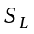 defined as:

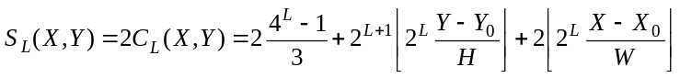 . (6)

Facts of type 1 use even numbers, odd numbers 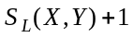 are used for facts of type 2 for the leaf nodes. So, the S-Tree hash table stores two types of facts:

1. 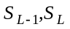, for non-leaf nodes
and
2. 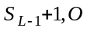, for the leaf nodes.

All binary facts are organized into a single hash table by the left component of the binary facts: 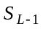 for non-leaf nodes and 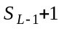 for the leaf nodes. The hash function can be chosen as:

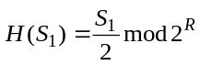 , (7)

where H is the hash function, S₁ is the S-Tree storage number given by (6), R is the hash table size.

4 Multidimensional S-Trees

If an application needs to store data in more than 2 dimensions, the following formulas can be used for 3 and 4 dimensional S-Tree cells:

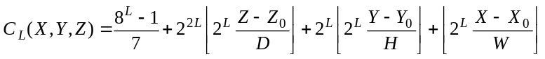 (5.1)

(5.2)

where D and I may be e.g. the depth and time interval correspondingly. The algorithms described in the next section work in any dimensions without changes.

5 S-Tree Operations

In this section we will consider the following operations with S-Tree: insertion, deletion and search. We will use two constants that will regulate S-Tree growth MaxCell and MinCell. MaxCell is the maximum and the minimum number of objects per single leaf S-Tree cell and MinCell is the minimum number of objects per single non-leaf cell.

5.1 S-Tree Insertion

The following algorithm describes the insertion algorithm for S-Tree.

Insert an object O(X,Y,ObjID) into S-Tree
0. . If the Level 0 is empty, choose L=0.
- Using Expression 6 and the hash table search, find the leaf cell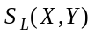 that should store the point (X,Y).
- Determine the number of objects N in the same cell .
- If N < MaxCell or L is a cell at the maximum tree level, insert the binary fact 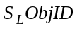 into the hash table. If N = 0, add the fact 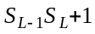 (a pointer from the upper level to the new leaf).
- If N ≥ MaxCell, move all facts from the level 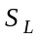to a set of its children cells 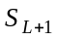 at the level L+1 and add facts 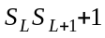 for the non-empty cells 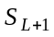 (add leaf pointers and grow S-Tree). Replace the fact 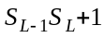 with the fact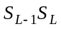 (replace the leaf pointer with non-leaf pointer). Let L := L+1 and repeat from the step 1.

Note that the last step requires knowledge of the coordinates X and Y for each object in order to be able to find the next level cell number. We assume that an object database or a simple array of object coordinates provides this information by the object IDs in the binary facts of the S-Tree, i.e. (X,Y)=Coordinates(ObjID).

5.2 S-Tree Deletion

S-Tree deletions are handled by using a reverse algorithm as below.

Delete the object O(X,Y,ObjID) from S-Tree
- Delete the fact (the cell can be identified either by an attribute of the object in an object database or direct searching in the S-Tree by the coordinates X, Y and the ObjID).
- Determine the number of objects N at the cell 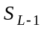of level L-1 that contains the cell .
- If N < MinCell, move all facts from the cells into (trim the S-Tree) and delete all pointers to the former leaf cells at the level L.

5.3 S-Tree Search

Given a rectangle 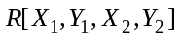, find all objects O(X,Y, ObjID) such that
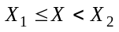 and 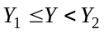.

The following describes the search algorithm for an S-Tree.

- Determine the maximum level L such that

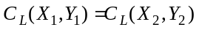 . (8)

Expression (8) is true when Expressions (9) are satisfied:

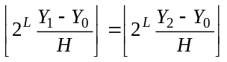 and 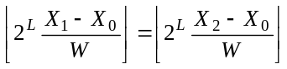 (9)

- Using a hash table, try to find a fact that starts with 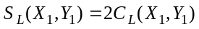 or 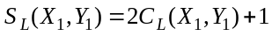. If the hash function is chosen as (7), this can be done in a single hash table lookup. If no facts found, this means that either the cell 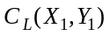 is below the tree leaf or the cell is empty. Find the largest smaller than L in step 1 such that the cell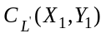 is not empty. If the fact starts with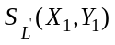 (an even number), the cell is empty and the search is done, otherwise let L=.

- Recursively traverse S-Tree from the cell to the leaf nodes, excluding the cells that lie outside the rectangle . For each object in the leaf cells, verify that the object belongs to and return it as a query result. In order to be able to exclude the cells that are outside the , we need to be able to compute the bounding rectangle 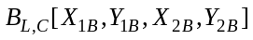of a cell C at level L from its cell number C. This is easy to do using Expressions (10):

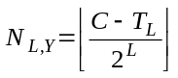
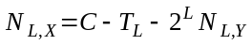
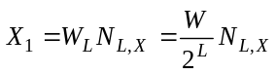
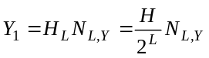 (10)
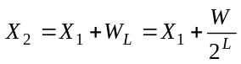
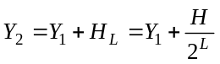 ,

where the 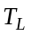 is given by (2). Note that Step 1 which can be done without accessing any S-Tree nodes, the S-Tree search performance does not depend on the tree depth and the size of S-Tree for sufficiently large sizes of S-Trees.

Although the description of the algorithm sounds complex, it is very easy to implement and each of the steps can be done highly efficiently in constant time.

6 Analysis

Since the S-Tree permits random access to any level, if the leaf level of S-Tree that stores the point being inserted or deleted is chosen correctly, the update performance of S-Tree would be equal to hash table performance, which does not depend on the size of the table and is constant. However, if the level L is chosen incorrectly, it would be either an empty descendant of a non-leaf level or a non-leaf level and would require tree traversals up or down correspondingly. In our implementation, we choose the level L to be the level of the previous update. This heuristic works well for both highly skewed and randomly distributed data and allows us to achieve a performance very close to that of a hash table in both cases.

7 Performance Evaluation

We have implemented a prototype of S-Tree. In our simulation study, the object coordinates were generated randomly within a rectangular area of space. The number of objects in our study varied from 10,000 to 10,000,000 objects. We define the average aerial density D of objects as the average number of objects per square mile. We varied D from 1 to 100 objects per square mile. The aerial density and the total number of objects determine the size of the area which is required to fit all objects. In our simulation we used a Pentium 4 PC with 1.8 GHz clock, 1 GB PC800 Rambus RAM, and Intel D850MD motherboard. We first measured the performance of S-Tree update insertions. Specifically, we measured the number of objects that we can insert into S-Tree per second. Figure 3 shows the performance of S-Tree depending on the size of S-Tree.

The performance varied insignificantly with the tree growth parameter MaxCell. In simulations, the S-Tree had the best performance when the MaxCell was 8. The performance of S-Tree with size of 10,000,000 objects is approximately 270,000 updates per second. Figure 2 shows that the performance of S-Tree insertions decreases approximately logarithmically with the size of S-Tree. The growth of performance between 300,000 and 1,000,000 can be attributed to the fact that S-Tree had more free space at the leaf cells on average at 300,000, so the insertions could proceed a bit faster.

Figure 3 shows the query performance of S-Tree. Our query was to find all objects within a randomly chosen rectangular square mile area in S-Tree with aerial density D = 10 and varied number of objects.

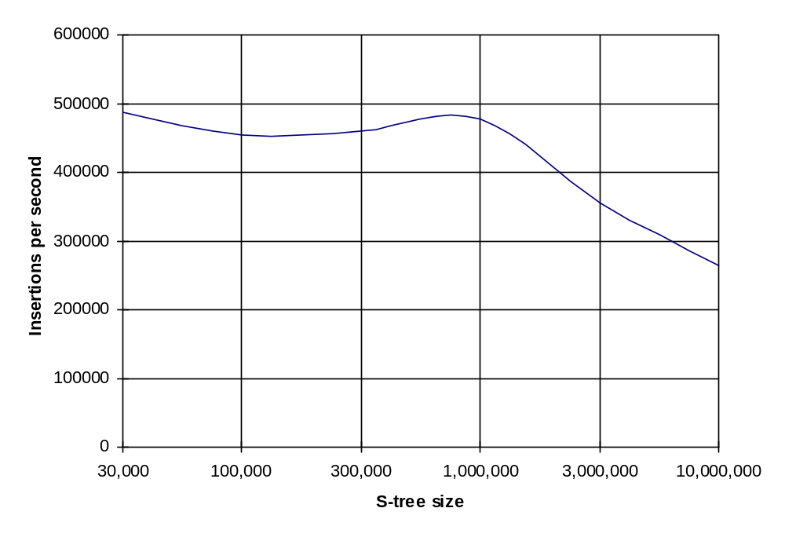
Figure 2: S-Tree Updates per Second

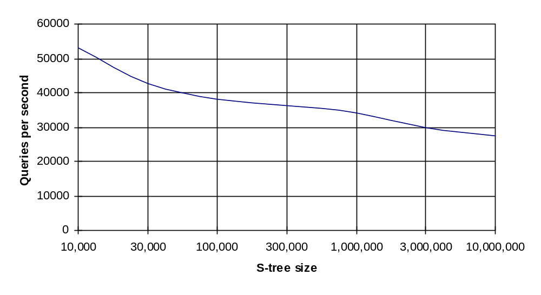
Figure 3: S-Tree Queries per Second

The performance of S-Tree with size of 10,000,000 objects was approximately 27,000 queries per second. The performance of S-Tree with 10,000 objects was approximately 53,000 queries per second. Figure 3 shows that the performance drop is better than logarithmic with the growth of S-Tree. This is easy to explain because Step 1 in the search algorithm (please refer to Section 5.3) essentially allows us to start the search from a node close to the leaf of the tree without traversing many of the root nodes in most cases. The size of the S-Tree with 10,000,000 objects including a small database that stored the object coordinates was approximately 295 MB.

Figures 4 and 5 show the performance of S-Tree relative to a freeware implementation of R+-Tree [7] by Knizhnik [8]. Figure 4 shows that S-Tree performance gap over R+-Tree grows linearly with the logarithm of the size of the database. Figure 5 shows that queries in S-Tree outperform R+-Tree by a large margin for large databases with over 500,000 objects.

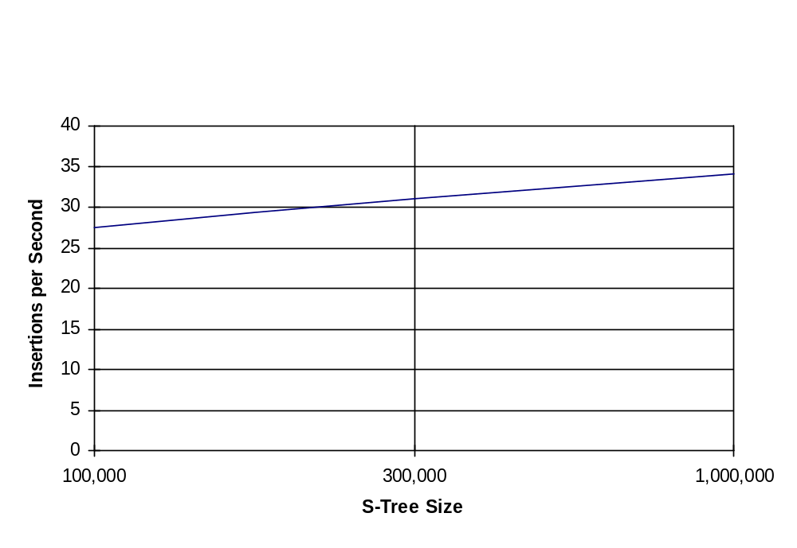
Figure 4: S-Tree Insertions per Second/R+-Tree Insertions per Second

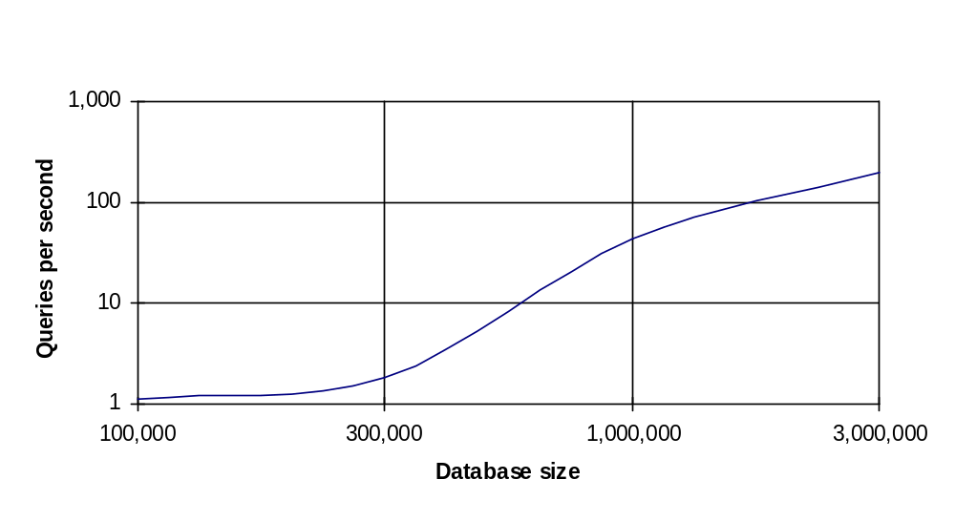
Figure 5: Queries per Second S-Tree/R+-Tree

8 Conclusion

S-Tree provides very efficient spatial point indexing. The performance of our data structure is mostly a hash table performance and is a better than O(log(N)), where N is the size of the tree. S-Tree uses an easy to compute hashing function to further improve the performance and reduce the index storage requirements by eliminating the need to store the quad tree keys.

9 References

- TerraFly. Internet: http://terrafly.fiu.edu
- H. Samet. The Quad-tree and Related Hierarchical Data Structures. ACM Computing Surveys, 16(2):187--260, June 1984.
- H.P. Krigel, B. Seeger: Multidimensional Order Preserving Linear Hashing with Parytial Expansions, International Conference on Database Theory, 203-220, Rome, 1986.
- H.P. Krigel, B. Seeger: PLOP-Hashing: A Grid File without Directory. In ICDE: Fourth International Conference on Data Engineering, pp 369-376, Los Angeles, California, 1988.
- Jonas S Karlsson: hQT*: A Scalable Distributed Data Structure for High Performance Spatial Access. Kluwer International Series In Engineering And Computer Science Series, pages 295 – 312, 2000.
- R.A. Finkel, J.L Bentley, Quad trees: A data structure for retrieval on composite keys, Acta Inform. 4 (1974) 1-9.
- Timos K. Sellis, Nick Roussopoulos, Christos Faloutsos: The R+-Tree: A Dynamic Index for Multi- Dimensional Objects. VLDB 1987: 507-518
- K. Knizhnik: “Generic Object Oriented Database System (GOODS)”. Internet: http://www.garret.ru/~knizhnik/goods/readme.htm#rtree
- M. Abdelguerfi, J. Givaudan, K. Shaw, and R. Ladner. The 2-3 TR-tree, A Trajectory-Oriented Index Structure for Fully Evolving Valid-time Spatio-temporal Datasets. In Proc. Of the ACM workshop on Adv. In Geographic Info. Sys., ACM GIS, pages 29-34, Nov. 2002.
- W.G. Aref and I. F. Ilyas. SP-GiST: An Extensible Database Index for Supporting Space Partitioning Trees. Journal of Intelligent Information Systems, JIIS, 17(2-3):215-240, 2001.
- H. D. Chon, D. Agrawal, and A. E. Abbadi. Storage and Retrieval of Moving Objects. In Mobile Data Management, pages 173-184, Jan. 2001.
- Y. Tao and D. Papadias. MV3R-Tree: A Spatio-Temporal Access Method for Timestamp and Interval Queries. In Proc. Of the Intl. Conf. on Very Large Data Bases, VLDB, pages 431-440, Sept. 2001.
- Y. Tao and D. Papadias, and J. Sun. The TPR*-Tree: An Optimized Spatio-temporal Access Method for Predictive Queries. In Proc. Of the Intl. Conf. on Very Large Data Bases, VLDB, pages 431-440, Sept. 2003.
- Octavian Procopiuc, Pankaj K. Agarwal, Lars Arge, Jeffrey Scott Vitter: Bkd-tree: A Dynamic Scalable kd-tree. Proceedings of the 8th International Symposium on Spatial and Temporal Databases (SSTD 2003), Santorini Island, Greece, July 2003.
- J.T Robinson. The K-D-B-tree: A search structure for large multidimensional dynamic indexes. In Proc. SIGMOD Int. Conf. On Management of Data, page 10-18, 1981.
- M. de Berg, J. Gudmundsson , M. Hammar , M. Overmars, On R-trees with low query complexity, Computational Geometry: Theory and Applications, v.24 n.3, p.179-195, April 2003.
- Ning An , Ji Jin , Anand Sivasubramaniam, Toward an Accurate Analysis of Range Queries on Spatial Data, IEEE Transactions on Knowledge and Data Engineering, v.15 n.2, p.305-323, February 2003.

This research was supported in part by NSF grants EIA-0320956, EIA-0220562, and HRD-0317692.

