SASHAS BENDER X PHASESPACE

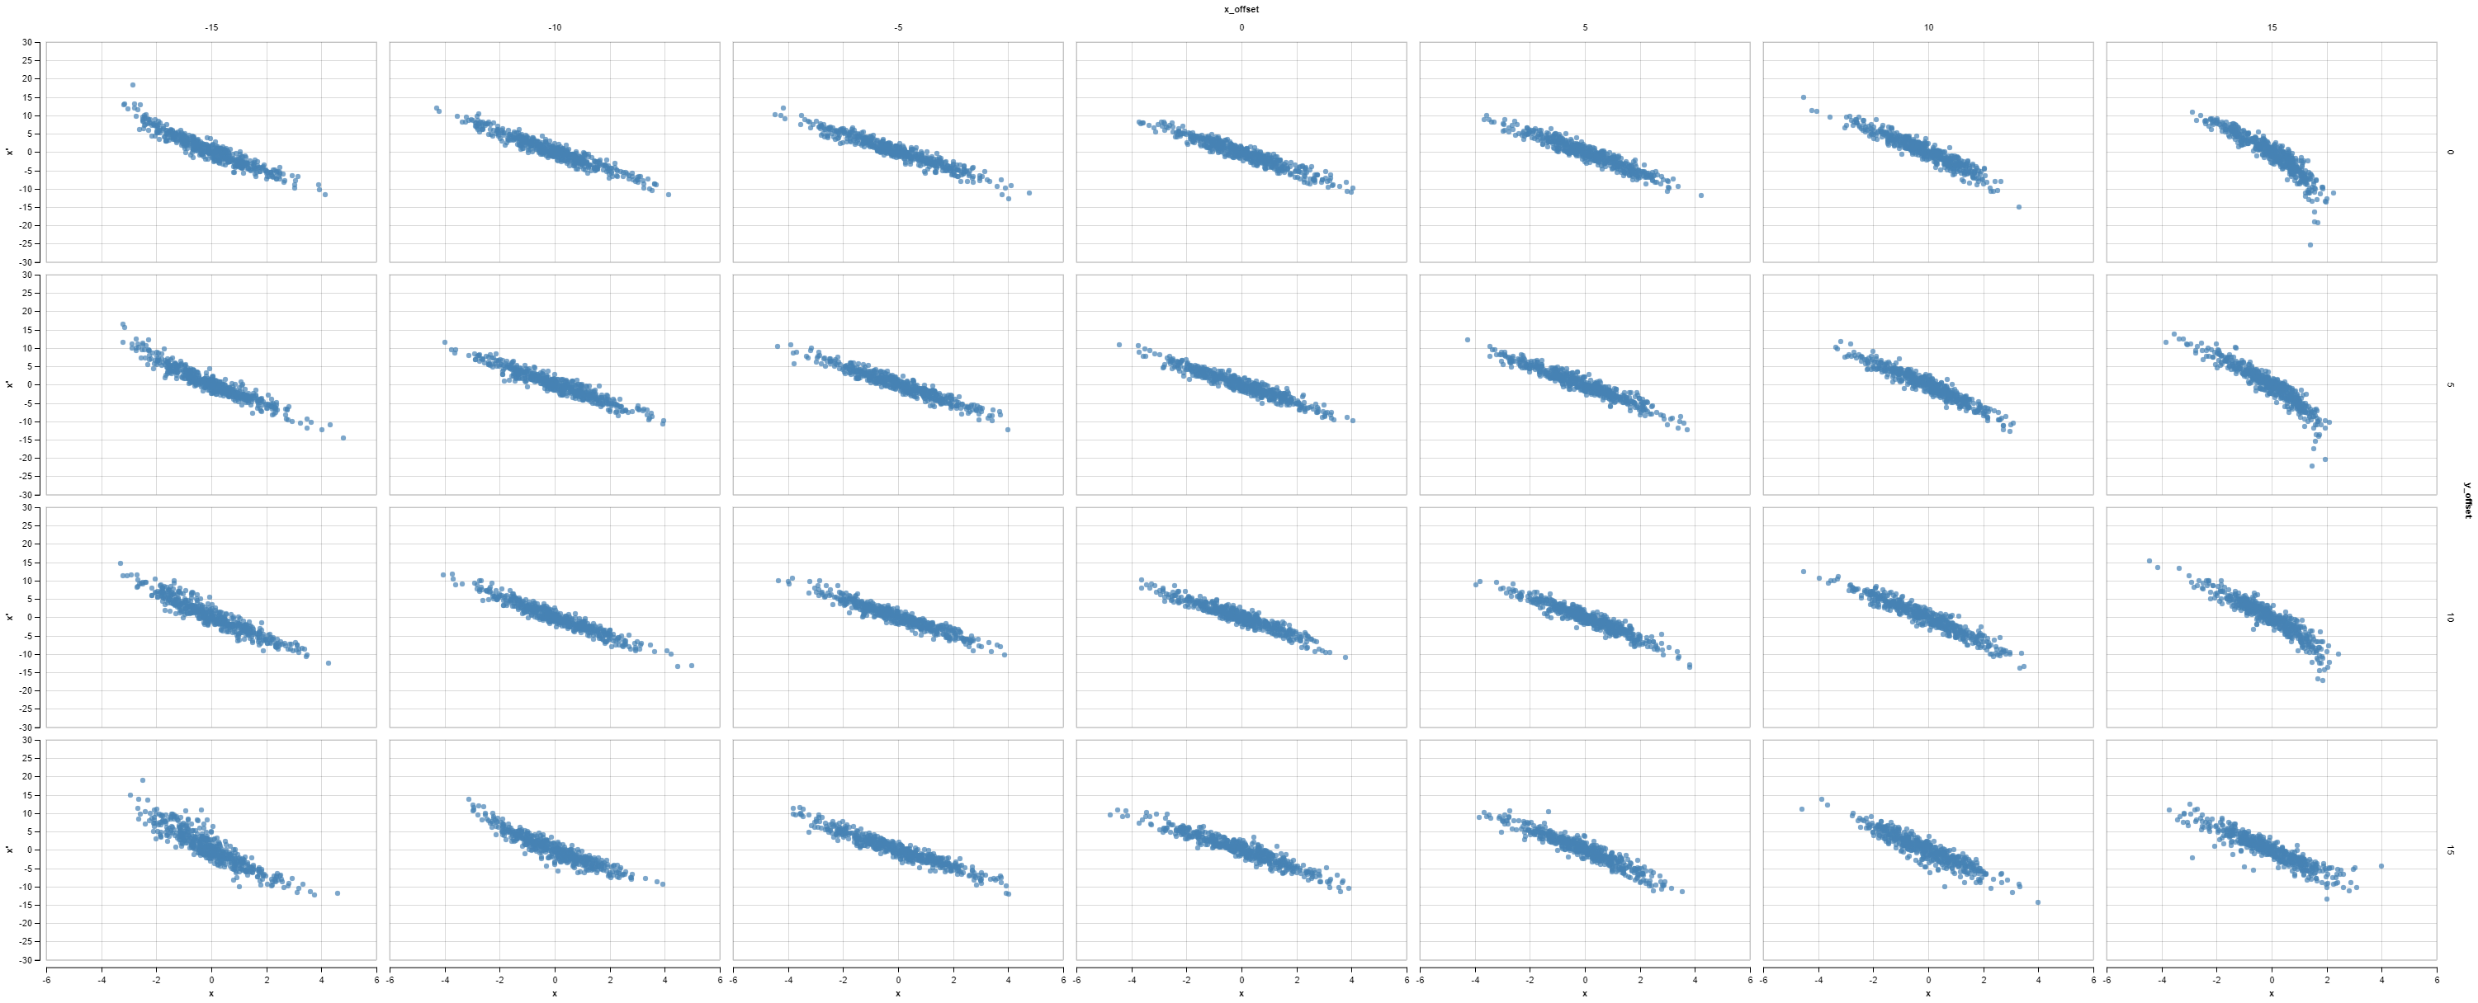

SASHAS BENDER Y PHASESPACE

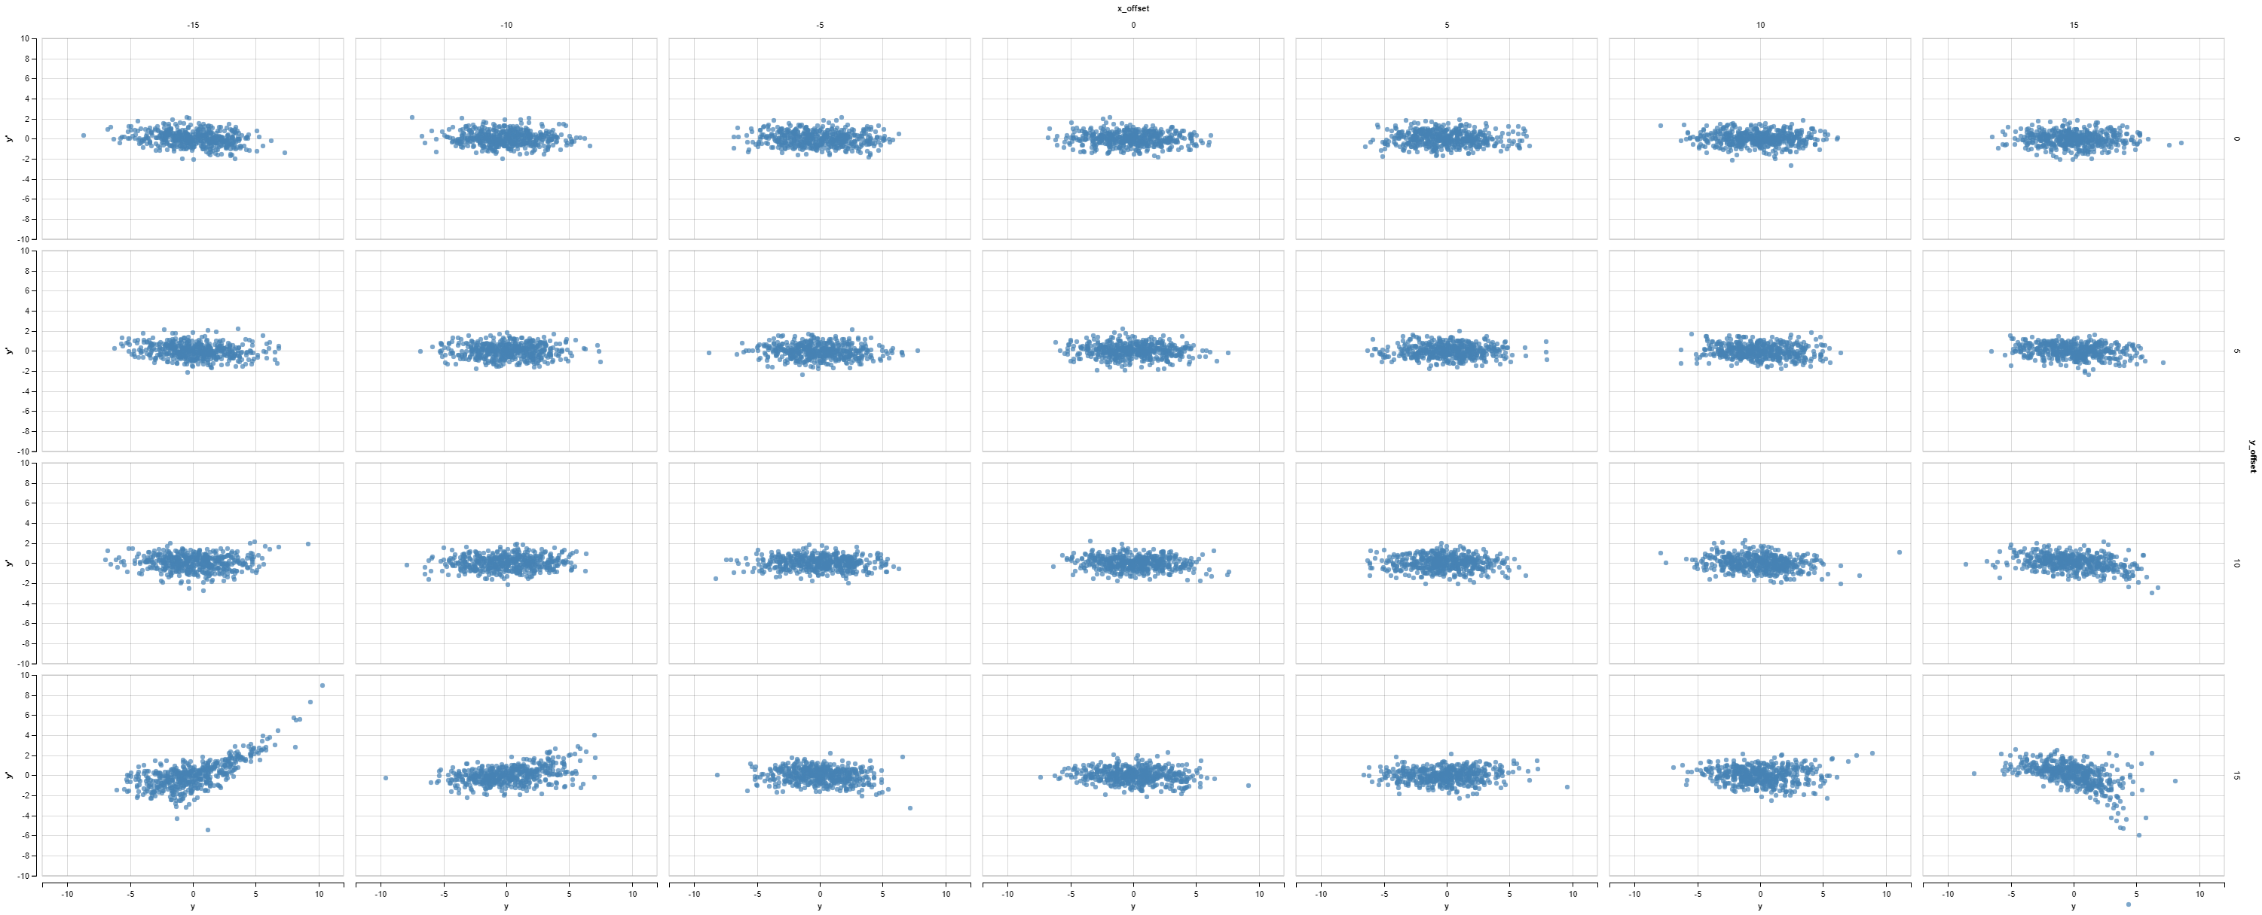

FLAT BENDER X PHASESPACE

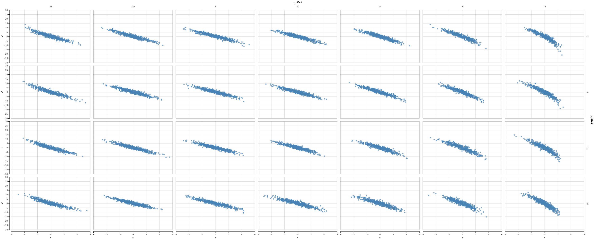

FLAT BENDER Y PHASESPACE

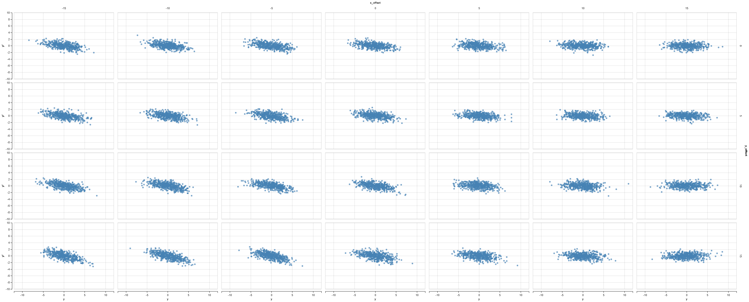

CYLINDRICAL BENDER X PHASESPACE

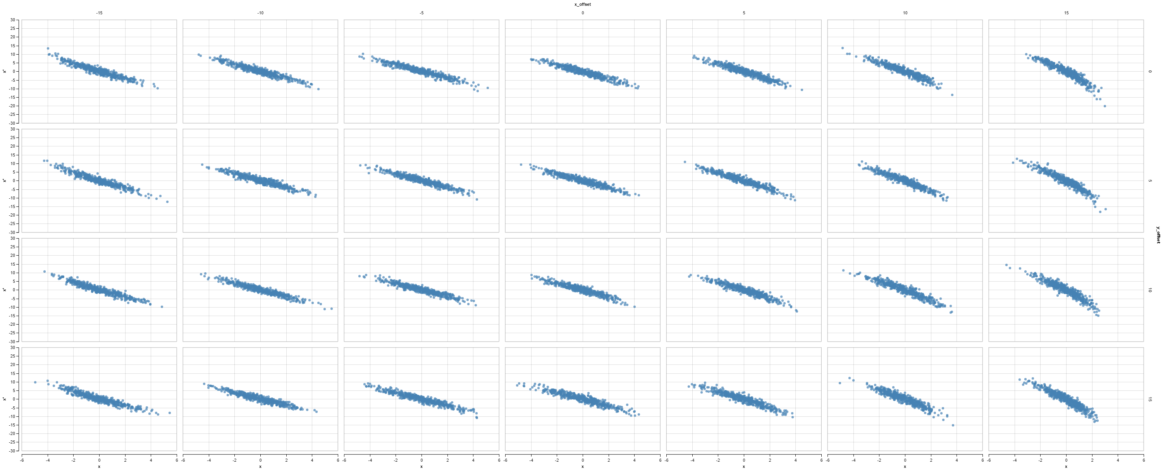

CYLINDRICAL BENDER Y PHASESPACE

