University of Waterloo
Faculty of Science

Improved Analytical Potential Functions for the Ground (X¹Σ_{g}⁺) States of Ca₂ and NaCs

University of Waterloo
Waterloo, Ontario

Prepared by
J. Tao
ID 20274180
2B Honours Biochemistry
January 24, 2010

268 Phillip Street.
Waterloo, Ontario
N2L 6G9

Jan. 7, 2010

Dr. J. Honek, Department Chair
Department of Chemistry
University of Waterloo
Waterloo, Ontario
N2L 3G1

Dear Dr. Honek.:
This report, entitled “Improved Analytical Potential Functions for the Ground X(¹Σ_{g}⁺) States of Ca₂ and NaCs” was prepared for my Fall 2009 work term report during my employment with Dr. Robert Le Roy at the University of Waterloo, who researches in the area of theoretical chemistry, specifically in the spectroscopy of small molecules and molecular clusters. This second report will be counted as my 2B work term report.
The purpose of this report is to demonstrate how recent extensions to the Morse/Long-Range potential function form has brought upon significant improvement to the accuracy and compactness to this form. This was done by performing Direct Potential Fits using this form to describe high resolution spectroscopic data sets for five different diatomic systems, two of which will be featured in this report. Another purpose of this report is to compare the improved MLR form with the original MLR form, as well as other successful potential function forms that have been used to describe the exact same data sets.
This report was written solely by me and has not received any previous academic credit at this or any other institution. I would like to thank Dr. Robert Le Roy for helpful discussion, proofreading, and feedback in regards to this report. I have received no other assistance.

Sincerely,

Jason Tao
ID # 20274180
Table of Contents
Summary………………………………………………………………………………………iii
1.0.0Introduction…………………………………………………………………………..…… 1
1.1.0 Potential Function Forms……………………………………………...………..2
1.1.1 Hannover Polynomial Potential (HPP)………………………...……….2
1.1.2 Spline Point-wise Potential (SPP)……………………………………….2
1.1.2 MLR form………………………………………………………..………3
2.0.0 Illustrative Applications………………………………………………………..……….6
2.1.0 Ca2 (X¹Σ_{g}⁺)………………………………………………………………...……..6
2.1.1 Experimental Data……………………………………………..………..6
2.1.2 Results and Discussion…………………………………………………..7
2.2.0 NaCs (X¹Σ⁺)………………………………………………………………………9
2.2.1 Experimental Data………………………………………………………9
2.2.2 Results and Discussion………………………………………………….9
3.0.0 Conclusions……………………………………………………………………………….11
4.0.0 Recommendations………………………………………………………………………..11
References……………………………………………………………………………………....12
Appendix A - Tables………………………………………………………………………...…13
Appendix B - Figures…………………………………………………………………………17

Summary
This report introduces recent extensions to the Morse/Long-Range(MLR) potential form, which allows for Direct Potential Fit analyses with higher quality of fit to spectroscopic data for diatomic molecules versus other published potential forms as well as a more realistic extrapolation behaviours.

One significant improvement was the addition of damping functions to control the short-range behaviour of the resulting potentials in order to have much more realistic extrapolation. The compactness of the MLR form was left intact as the damping function did not require any additional parameters.

This new potential model has been tested using five different diatomic systems and its effectiveness was compared with that of other well-established methods of representing potential energy curves, as well as with the original version of the MLR form
.
This improved MLR form was tested using high-resolution data collected for the ground-states for Ca₂, NaCs, NaRb, Rb₂, and MgH. For all systems analyzed, when using the same data sets that the improved MLR form is much more compact, robust, and portable, than any other potential that has been published to date. This report will present a critical analysis of the improved MLR form using the ground state Ca₂ and NaCs as examples.

1.0.0 Introduction
In recent years, there has much experimental work involving various electronic states of alkali and alkaline earth metal dimers, generating a vast amount of data. This has raised a need to efficiently represent this data in order to compactly summarize the results for each system in the form of an accurate potential energy curve.

The basic approach that has become increasingly more popular is that the fully quantum mechanical Direct Potential Fits (DPF), which compares transition energies found experimentally directly to those calculated by solving the effective radial Schrödinger equation:
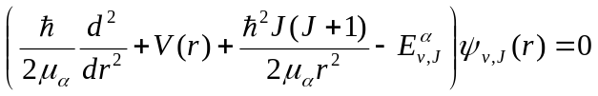

where V(r) is the parameterized potential energy function, μ_{α} is the reduced mass of the two atoms, and {E_{v,J}^{α}} are its eigenvalues.

The parameters in V(r) are determined and optimized in a non-linear least-squares fitting procedure to minimize the deviations to experimental data.

All calculations performed in this report were done using the program DPotFIT,¹ which allows for diatomic spectroscopic data to be fitted to a variety of potential forms, including the MLR. The program performs a DPF analysis outlined in the previous paragraph, with partial derivatives used in the nonlinear least-squares fitting procedure obtained using the Hellmann-Feynman theorem:
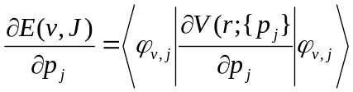

To provide plausible initial values as required for the nonlinear least-squares fits, companion program BetaFIT was used. BetaFIT accepts points of an existing potential function performs a linear least-squares-fit to a chosen potential form to generate rough estimates of the values for the fitted parameters to be used in DPotFIT.²

1.1.0 Potential Function Forms
Various potential function forms have been used in the past. In recent years, two types of potential function forms have been used very successfully to describe a variety of alkali/alkaline earth diatomic systems, these methods were used for a comparison to the improved MLR form.

1.1.1 Hannover Polynomial Potential (HPP)
The HPP has been used to accurately describe many different diatomic systems.³⁻⁹ in recent years. The potential well is defined by a finite polynomial series

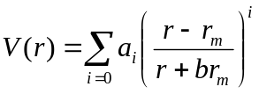

However, a major disadvantage of any polynomial form is that at extremely large or small values of r will cause the potential to behave unphysically. Thus, the potential is usually defined in three separate domains: short-range extrapolation region (V_{SR} (r)), the potential well, and the long-range extrapolation region (V_{LR} (r)). The extrapolation regions are connected at arbitrarily chosen distances an inner radial distance r_{i} and outer radial distance r_{o} while extra parameters are required to smoothly connect these sections in order to have both first and second derivatives continuous throughout the entire potential. This form has been used to obtain very accurate description of a number of diatomic systems; however, it requires a large number of parameters, often specified to many digits to attain suitable accuracy.

1.1.2 Spline Point-wise Potential (SPP)
This method was introduced by Pashov, and is described in detail in Ref. [10]. This method defines the potential energy function as a cubic spline passing through a set of evenly space points. The energy values of each point are treated as fitting parameters and are then fitted to experimental data. This method has shown to have accuracy comparable to the HPP while being somewhat more flexible and is currently the only potential form that is able to fit to irregular potentials such as double-minimum potentials.\cite{pash00} Unfortunately, this method has similar drawbacks as with the HPP, as the number of parameters required are even higher than the HPP. Also, the cubic spline cannot be used for sensible extrapolations, and as with the HPP, additional analytic functions are required to define the short- and long-range regions.
1.1.2 MLR form
What will be referred to as the “basic” MLR is that of its form when it was first introduced¹¹
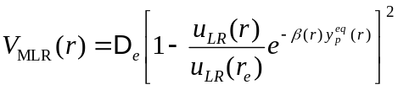

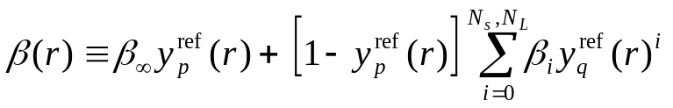where De is the dissociation energy, r_{e} is the equilibrium internuclear distance, and u_{LR}(r) specifies the limiting long-range behaviour, the exponential coefficient function β(r) is a slowly varying exponential coefficient function with the form

where β_{i} are fitted parameters. At long range, for the potential to adopt the correct behaviour of 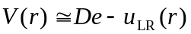 it is required that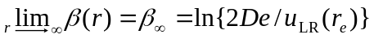. The upper limit of the sum N_{S} in the above equation is a relic from the original MLR form which is the polynomial at short distances (r < r_{e}), while N_{L} was the polynomial order at larger distances (r> r_{e}). In the basic MLR this separation was used to prevent inner-wall inflections because the behaviour in the short-range region is much more simplistic relative to the outer wall and does not need as many parameters to represent it. However, the new additions to the MLR form appear to have removed the need for this difference in polynomial order. Note that the variable y_{p}^{eq}(r), y_{p}^{ref}(r), and y_{q}^{ref}(r) appearing both the definition of V(r) and β(r) is the radial variable which is defined as:
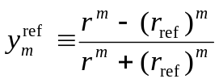

where m is either the interger of p or q and r_{ref} is the radial expansion centre.
When the MLR form was first introduced, the radial exponent q = p and r_{ref} = r_{e.} However in a recent paper, it was shown that allowing for the power of the radial variable inside the polynomial expansion of β(r) for q ≠ p and setting r_{ref} > r_{e} allowed for the most compact and accurate potentials when using the MLR form.¹²
The radial variable ranges from -1 to +1 and has a sigmoidal shape shown in Fig. 1. It is important that the values of the radial variable vary sufficiently within the data-region in order to show changes to the potential, the slower the radial variable varies the higher the values of β(r) are needed to show the changes in the potential. However, as the β(r) is defined by a polynomial expansion, the parameters β_{i} are highly correlated and if the β_{i} values are fitted using a radial variable that reaches its minimum/maximum well within the data-region the quality of fit will be poorer than optimum. This led to the idea of lowering the power of the radial variable in the polynomial expansion q < p which as seen on Fig 1 reduces the steepness of the radial variable, preventing it from reaching its minimum/maximum value within the data-region. The effect of setting the expansion centre r_{ref} > r_{e} is also shown on this figure as it moves the varying region of the radial variable further into the data-region.

The long-range function u_{LR}(r), which has traditionally been represented by sum of inverse powers
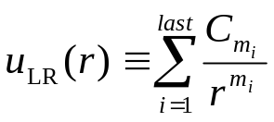
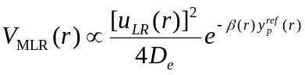In this study, the molecules dissociated into two neutral S-state atoms, thus the attractive forces are due to the dispersion constants C₆, C₈ and C₁₀.^{13,14} However due to square factor in the MLR definition of V(r), at very small r the MLR potential will be proportional to:

the factor of [uLR(r)]² would mean the potential would increase by 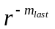 as r approaches 0.
Thus, when using the basic MLR with C₆, C₈, and C₁₀ the short-range potential will have r⁻²⁰ behaviour, which is completely unphysical as the interaction at short-range should be a Coulomb interaction (r⁻¹).

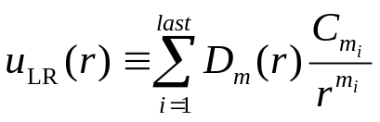To mitigate this problem, damping functions were introduced to u_{LR}(r) to change the form to

In this study, two damping functions were considered. First, a modified version of the Tang-Toennies damping function,¹⁵ which has the form
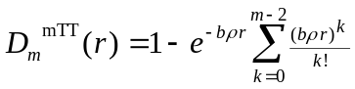

Where b is a numerical scaling factor, and ρ is a system dependent scaling factor for systems other than H₂, ρ was calculated using the scheme suggested in Ref. [16], for a any molecule AB
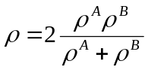

where ρ^{A}
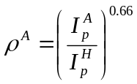

I_{p}^{A} is the ionization potential of atom A, and I_{p}^{H} is the ionization potential of atomic hydrogen.
The original Tang-Toennies form was unusable because of the fact that 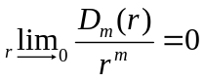 would cause the potential to go to zero as r approaches zero. The modification from the original Tang-Toennies form was by having sum in the definition of D_{m}^{mTT}(r) from k = 0-(m-2) instead of k = 0-m. This causes 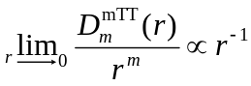, which due to the factor of [u_{LR}(r)]², potential will be proportional to r⁻², which while much better than r⁻²⁰ behaviour, is still not optimum.

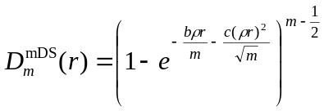The next damping function considered was that of a modified Douketis-Scoles form

Where b and c are numerical scaling factors, and ρ has the same definition it did in the modified Tang-Toonies form. The values of the numerical scaling factors were determined by fitting to the ab initio data for H₂ present by Kreek and Meath.¹⁷ First introduced in Ref [16], the original Douketis-Scoles form caused 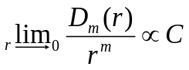 where C is some constant, however what is important about this form is that it can be modified (by the subtraction of ½ in the exponent) to have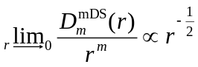 which causes to have V_{MLR} to have r⁻¹ behavior. The difference between r⁻² and r⁻¹and is quite significant, as shown in Fig 2, which shows a comparison short-range behaviour of the potential for the MLR using modified Tang-Toennies damping and modified Douketis-Scoles damping. It can be seen that the potential incorporating modified Douketis-Scoles damping has a much closer agreement with the ab initio data points. Thus, the rest of the study was carried out using only modified Douketis-Scoles damping.

As shown in Ref. [11], in order to ensure physical long-range extrapolation, it is necessary that the power p in the radial variable exponent have a value p ≥ m_{next} – m_{first}, where m_{next} is the next dispersion constant predicted by theory. This is because the leading term contribution to the potential at very large r is proportional to 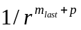 . For our applications for which u_{LR}(r) is defined by C₆, C₈ and C₁₀ forces p ≥ 5. However the power q does not have this requirement, allowing for q < p to be used in the radial variable inside the polynomial expansion, allowing for more of the radial variable to vary within the data region.

When reporting potential models using this new MLR form, the potentials will be abbreviated as
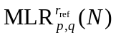while the basic MLR will be written as 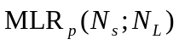.

2.0.0 Illustrative Applications
Using the current MLR, a variety of ground-state systems were analyzed, many trends were seen between the systems and only the analysis of the ground-state Ca₂ and NaCs will be presented. Unless otherwise stated, all energies are expressed in wavenumbers, and distances in Angstroms. The quality of fit to experimental data was measured using dimensionless root-mean-square deviation (DRMSD)



where y^{obs} is the value of the experimental data and y^{calc} is that value calculated by the model, and σ is that datum’s uncertainty.

2.1.0 Ca2 (X¹Σ_{g}⁺)

2.1.1 Experimental Data
The dataset used for the current analysis of this system is the same as what was used by Allard et al.,³ which combined their new experimental data for vibrational levels v> 35 up to v = 38 obtained using Filtered Laser Excitation, with the data from their previous work using Laser Induced Fluorescence.⁴ They fitted their data using both the HPP as well as the SPP, obtaining a DRMSD of 0.69 and 0.74 respectively. The HPP used a 20th order polynomial while the SPP used 50, both were connected to a long range extrapolation function involving C₆, C₈, and C₁₀. The HPP was also connected to a short-range extrapolation function, having r⁻⁻¹² character. Later, Le Roy and Henderson used the ‘basic’ MLR to fit the same data set, recommending an MLR₅(4;11). This treatment used only C₆ and C₈ from Moszynski et al.¹⁸ with C₈ fixed while C₆ was fitted. In entire data set used contained 3580 transitions, however transitions with (y_{calc}-y_{obs})/σ > 4. This led to the rejection of 10 lines, for which the average (y_{calc}-y_{obs})/σ was 12.9. The values for the dispersion constants were obtained from Mitroy and Zhang¹⁹, they are C₆ = 1.0550 x 10⁷ cm⁻¹ Ǻ⁶, C₈ = 3.0608 x 10⁸ cm⁻¹ Ǻ⁸ and C₁₀ = 8.3440 x 10⁹ cm⁻¹ Ǻ¹⁰. In this analysis, as with the previous MLR treatment, because the outermost turning-point was at a very large distance (~18.3Ǻ) the C₆ was fitted.

2.1.2 Results and Discussion
In search for the optimum fit, the value of p was varied between 5 and 6, q = 2-4 and N = 5-10 while r_{ref} was varied by 0.2 Ǻ from approximately 1.2 – 2.1r_{e}. The “optimum” fit was determined by the model with the highest quality of fit (minimum DRMSD) while behaving physically outside the data region, meaning that the potential contained no inflections in the inner and outer regions. A summary of results yielded by these fits can be seen in Fig 3 which displays the quality of fit, as well as the fitted values of various physical constants as a function of r_{ref}.
It can be seen that as N increases, r_{ref} becomes less important as the DRMSD plateaus at a minimum value over a wide range of r_{ref}; this is the case for the N = 8 potentials with q = 3. One thing to notice is that for potentials which have similar DRMSD have values for C₆, r_{e}, and D_{e} converge at reasonable values. However it can be seen that the fitted values for C₆ and D_{e} significantly deviate from the ideal values and have high associated uncertainty.

It is known that at large r that the potential takes the form of an inverse power series

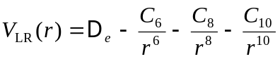

this equation can be rearranged such that:

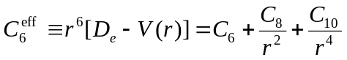

As r⁻² approaches zero, the C₆^{eff} plot should approach the y-intercept with a value of C₆ with a positive slope of C₈ and positive curvature due to the C_{10,} thus a plot of C₆^{eff} versus r⁻² can be used to detect unphysical long-range behavior. Figure 4 plots the C₆^{eff} versus r⁻² for each p, q, N with the best r_{ref}. It can be seen on this figure that all of the potentials, except the q = 2 potentials, exit the data-region with a slope of C₈ (the dotted line) and maintain this slope until the end, however the q = 2 potentials have inflects outside of the data-regions. Thus, while the q = 2 potentials have the highest quality of fit, are no longer considered on the grounds of unphysical behaviour as they exhibit negative curvature outside the data-region which should not be the case due to the positive value of the C₁₀.

This leaves the q = 3-4 potentials, while the q = 3 potentials have a lower average DRMSD than the q = 4, the q = 3 potentials plateau a minimum DRMSD at around 0.627, but it can be seen in the bottom section of Fig. 3 that a q = 4 potential dips slightly below this plateau. However, this only happens for the q = 4 with N > 8 potentials while N= 7-8 yielding very poor potentials at all r_{ref}. Therefore it was considered that the ‘best’ MLR_{5,4}(9) was fitting towards noise in the data and was discounted.

Within the remaining group of the MLR_{5,3} (6-8) the difference in DRMSD between best potentials were only 0.05%. This difference is hardly significant especially since it requires the addition of two additional fitting parameters. Therefore, the recommended model for this system is the MLR_{5,3}^{6.5}(6)

There has been many improvement to the model with the introduction of q and r_{ref .} The main improvement is that the exponent polynomial order of the new recommended MLR model is almost a factor of two smaller that the “basic” MLR model, while improving the quality of fit to the experimental data by approximately 2%. Also, the values of the β_{i} parameters are much smaller in magnitude and no longer increase by orders of magnitude and oscillate in sign, as does the old MLR₅(4;11) model, which the parameters’ magnitudes range from 0.2 – 800 and begin oscillating in sign at β₅ this shows inefficiency in the model as parts of the parameters are used to cancel the effect of the previous parameter.
The current MLR achieves a much better quality of fit than either of the HPP or the SPP, improving over either method by 9% and 15% respectively. The current MLR uses only 15 total parameters, which is less than half of the 31 parameters required by the model, and than a third of the 55 parameters required by the SPP. The MLR also has more realistic extrapolation as the short-range of the MLR has r⁻¹ behaviour while the HPP has r⁻¹² and for the SPP is not defined. Also, the long range of the HPP fits only C₆ and C₈, while C₁₀ was adjusted to ensure smooth connection to the intermediate region of the potential.
The value of the dissociation energy determined by present analysis is D_{e} = 1102.082 cm⁻¹ ± 0.007 cm⁻¹ which compares favourably with those obtained those of previous studies, the previous MLR treatment obtained 1102.076 cm⁻¹ ± 0.009 cm⁻¹ and those of the HPP and SPP, 1102.074 cm⁻¹ and 1102.060 cm⁻¹ (uncertainty not reported for either D_{e}), respectively.

2.2.0 NaCs (X¹Σ⁺)

2.2.1 Experimental Data
The present analysis uses the data set obtained by Docenko et al. in 2004⁶ supplemented with the more recent data obtained by the same group in 2006.⁸ The combined data set contained 6510 transitions with reached up to v’’ = 83, with data covering 99.96% of the depth of the potential well. Using the same de-weighting scheme as mentioned in the Ca₂ section, 25 lines were excluded from the fit, while 2 lines additional lines were excluded due to them belonging to bands with only a single line. The deviation of the de-weighted lines were very large, with the average (y_{calc}-y_{obs})/σ being 8.6. The dispersion constants used were obtained from Derevianko et al.^{20,21} with C₆ = 1.5550 x 10⁷ cm⁻¹ Ǻ⁶, C₈ = 4.890 x 10⁸ cm⁻¹ Ǻ⁸ and C₁₀ = 1.72 x 10⁹ Ǻ¹⁰.

2.2.2 Results and Discussion
The values of p and q were varied similarly to what was done with Ca₂. The range of N that gave good fits were those with N > 12, the values of r_{ref} were varied between 1.1-1.9r_{e.} When analyzing the long-range behaviour of the potential, due to C₆ being fixed, there is an additional constraint on the C₆^{eff} vs. r⁻² plot that allow, that is the lines must approach the specified value of C₆, with a slope of C₈ and positive curvature due to the C_{10.} Therefore the plots must approach the y-intercept from above and asymptotically to the C₈ slope line (the dotted line in fig 5.) because if the C₆^{eff} line crosses the C₈ slope line, then it must have inflection in order to fulfill the first three requirements. As was found for Ca_{2,} all q = 2 potentials (dashed and dot-dashed lines on Fig 5) behave unphysically, shown by the “bumps” outside of the data-region, again causing all q = 2 potentials to be discounted.

The summary of results for fits for NaCs is shown on Fig 6, which shows the same trends as the analogous plots for Ca₂.

The best potentials had a quality of fit around DRMSD = 0.597. Again, with all else being equal increasing q from 3 to 4 reduced the quality of fits of the potentials, with q = 3 potentials reaching the optimum quality of fit with N ≥ 14 while q = 4 required N ≥ 16. The difference between the DRMSD of the best N= 14 potential and the best N =15 potential was 0.0002% and when comparing to the N = 13 was 0.003%, which indicates that N = 14 is enough parameters to obtain the optimum fit. Thus the recommended model for this system is the MLR_{5,3}^{5.6}(14), whose parameters are listed in Tab. 1.

To illustrate the importance of damping, the damped recommended potentials were plotted along with the non-damped potentials with the same p, q, N, and the best associated r_{ref.} Shown on Fig 7, the short-range behaviour of non-damped potentials have slopes of approximately 20 on the log-log plot, while the damped potentials have a slope of approximately one, and the difference between non-damped and damped potentials being greater than 10¹⁵ wavenumbers at very small r. Another illustration of the effect of the addition of the D_{m}^{mDS}(r) is plotting the β(r) function, shown on Fig 8, for both Ca₂ and NaCs these functions are both slowly varying functions. However, for the non-damped potentials, at small r the β(r) functions have a huge drop, which is due to β(r) trying to compensate for the r⁻²⁰ behaviour inherent of the u_{LR}(r)² term

Significant improvements have been made over the “basic” MLR form. In addition to improving the quality of fit by 0.35% and reducing the number of total parameters from 27 to 12, the values of the β_{i} parameters behave much more sensibly. Table 2 which compares the parameters defining the original recommended MLR₄(3;20)²², with the current recommended MLR model. As seen in that table the values of the higher order β_{i} parameters for the “basic” MLR begin increasing in magnitude and oscillating in mathematical sign. This starts at β₇ = -1.02 x 10⁴ rising up to a magnitude of 1.66 x 10⁸ by β₁₂, this seems to be in huge excess as these parameters are used to define a function ranging between -5 and -0.4. The current MLR model is much more well behaved as the β_{i} parameters range in value from -5.4 to 3.4 in order to define a function ranging from -0.3 to 1.0.

The HPP⁸ model for NaCs involves a total of 43 parameters, with a polynomial expansion of order 29, both of these are around twice as many as the number of parameters required by current MLR, while the MLR has a 30% improvement in quality of fit over the HPP. Also the polynomial expansion coefficients of the HPP have magnitude on the order of 10⁴ - 10⁹ where pairs of coefficients alternate in mathematical sign, these coefficients are used to define the potential well with a De of ~5000 cm⁻¹.

The D_{e} obtained from present analysis was De = 4954.185 cm⁻¹ ± 0.009 cm⁻¹ which is close to the HPP’s value D_{e}= 4954.24 cm⁻¹ ± 0.10 cm⁻¹ ; however, it is much closer to their previous value\cite{d:doce04} D_{e} = 4954.187 cm⁻¹.

3.0.0 Conclusions
The recent extensions to the “basic” MLR form: q, r_{ref}, and D_{m}^{mDS}(r) have brought upon significant improvements to the potentials obtained using this form:
- Even at the cost of adding two additional parameters, r_{ref} and q, the number of β_{i} parameters required to obtain an optimal fit is generally more than two less than the basic MLR, thus making the extended MLR more compact and the β(r) function more sensible.
- The values of the β_{i} are much more well-behaved and the resulting β(r) function does not drop significantly at small r.
- The accuracy of the fit obtained using the extended MLR potential is much greater than those of other published potential forms.
- The representation of the potential using this form is much more compact than previously, as well as when compared to other potential forms.
- The short range extrapolation has been improved greatly with the introduction of damping functions changing the limiting short-range behaviour from r⁻²⁰ to r⁻¹. This improvement was brought about with no additional parameters.

4.0.0 Recommendations
This study only used ground states Ca₂, NaCs, NaRb, Rb₂, and MgH as a test of the improvement in the potential form. There has also been experimental data for the a³Σ⁺ states for NaCs, NaRb. Thus, to obtain a more complete analysis of the ¹S +¹S asymptote for these molecules, simultaneous fits can be performed to with both ground state as well as the corresponding triplet state that approaches the same asymptote.

While the current MLR form has achieved top-tier accuracy and compactness among potential function forms, it is still contains a polynomial expansion in the exponent coefficient function β(r), causing it to have similar drawbacks as the polynomial potential mentioned within the report, the HPP. These disadvantages include correlation between the parameters which cause inflexibility in the function of which the polynomial is used to define, thus the MLR form has difficulty fitting to irregular potentials such as double-minimum potentials. As mentioned in the introduction, the SPP is flexible enough to fit to these potentials, thus it may be possible to combine the advantages of both the MLR form, with the flexibility of the SPP by defining β(r) by a point-wise representation connected by a cubic spline, rather than a polynomial.

References
1. Le Roy, R. J. and J. Seto and Y. Huang. “DPotFit 1.2 : A Computer Program for fitting Diatomic Molecule Spectra to Potential Energy Functions,” University of Waterloo Chemical Physics Research Report CP-664 (2007); see http://leroy.uwaterloo.ca/programs/
2. Le Roy, R. J. “betaFIT 2.0 A Computer Program to Fit Potential Function Points to Selected Analytic Functions,” University of Waterloo Chemical Physics Research Report CP-665 (2009); see http://leroy.uwaterloo.ca/programs/
3. O. Allard, A. Pashov, H. Knöckel, and E. Tiemann. Phys. Rev. A 66, 042503:1 (2002)
4 O. Allard, C. Samuelis, A. Pashov, H. Knöckel, E. Tiemann, Eur. Phys. J D 26, 155 (2003)
5. O. Docenko, M. Tamanis, R. Ferber, A. Pashov, H. Knöckel, and E. Tiemann, Phys Rev A, 69, 042503 (2004)
6. O. Docenko, M. Tamanis, R. Ferber, A. Pashov, H. Knöckel, and E. Tiemann, Phys Rev. A Eur. Phys. J. D 31, 205 (2004)
7. A. Pashov, O. Docenko, M. Tamanis, R. Ferber, H. Knöckel, and E. Tiemann, Phys Rev. A 72, 062505 (2005)
8. O. Docenko, M. Tamanis, J. Zaharova, R. Ferber, A. Pashov, and E. Tiemann, J. Phys. B: At. Mol. Phys. 39, (2006)
9. A. Pashov,O. Docenko, M. Tamanis, R. Ferber, H. Knöckle and E. Tiemann, Phys. Rev. A 76, 022511 (2007)
10. A. Pashov, W. Jastrebski, P. Kowalczyk, Comp. Phys. Comm. 128, 622 (2000)
11. R. J. Le Roy and R. Henderson, Mol. Phys. 105, 663 (2007)
12. R. J. Le Roy, N. S. Dattani, J. A. Coxon, A. J. Ross, P. Crozet, and C. Linton, J. Chem. Phys. 131, 204309 (2009)
13.J. O. Hirschfelder, C. F. Curtiss, and R. Bird, Molecular Theory of Gases and Liquids (Wiley, New York, 1964)
14. J. Hirschfelder, and W. Meath, Intermolecular Forces, Adv. Chem. Phys. Vol. 12, edited by J. O. Hirschelder (Interscience, New York, 1967) Chap. 1, pp. 3-106
15. K. T. Tang and J. P. Toennies, J. Chem. Phys. 80, 3726 (1984)
16. C. Douketis, G. Scoles, S. Marchetti,M. Zen, and A. J. Thakkar, J. Chem. Phys. 76, 3057 (1982)
17. H. Kreek, Y. H. Pan, and W. J. Meath, Mol. Phys. 19, 513 (1970)
18. R. Moszinsky, G. Lach, M. Jaszuúski, and B. Bussery-Honavault. Phys. Rev. A. 68, 052706 (2003)
19. J. Mitroy and J.-Y. Zhang, J. Chem. Phys. 128, 134305 (2008)
20. A. Derevianko, J. F. Babb, and A. Dalgarno, Phys. Rev. A 63, 052704 (2001)
21.S. G. Porsev and A. Derevianko, J. Chem. Phys. 119, 844 (2003)
22 R. J. Le Roy and Y.-R. Wu (unpublished)

Appendix Tables and Figures
Table 1. The parameters defining the recommended models for the ground state of Ca2 and NaCs, energies in wavenumbers distances in Angstroms
 | Ca2 MLR_{5,3}^{6.5}(6) | NaCs MLR_{5,3}^{5.6}(14)
De | 1102.082(7) | 4954.185(9)
Re | 4.27782(2) | 3.850501(5)
C6/ 10⁷ | 1.053(15) | 4.89
C8 / 10⁸ | 3.0608 | 4.89
C10 / 10¹⁰ | 0.8344 | 1.72
{p,q} | {5,3} | {5,3}
r_{ref} | 6.5 | 5.6
β₀ | -0.2803492 | 0.0251877
β₁ | -.21863 | -0.7976514
β₂ | -0.00097 | -0.230931
β₃ | 0.1885 | 0.779433
β₄ | 0.1838 | 0.97705
β₅ | 0.345 | 1.00089
β₆ | 0.154 | 1.9725
β₇ | - | 3.3116
β₈ | - | 1.834
β₉ | - | -1.821
β₁₀ | - | -4.46
β₁₁ | - | -5.41
β₁₂ | - | -2.53
β₁₃ | - | 3.4
β₁₄ | - | 3.4
Table 2. A comparison of the recommended model using the original MLR form, MLR₄ (6;20) against the current recommended MLR_{5,3}^{5.6}(14) for NaCs (energy units are in wavenumbers and distances are in Angstroms)
 | MLR₄ (6;20) | MLR_{5,3}^{5.6}(14)
De | 4954.173(7) | 4954.185(9)
Re | 3.85050(1) | 3.850501(5)
C6 /10⁷ | 1.555 | 1.555
C8 /10⁸ | 4.89 | 4.89
C10 /10¹⁰ | --- | 1.72
{p,q} | {5,5} | {5,3}
r_{ref} | r_{e} | 5.6
β₀ | -2.22118251 | 0.0251877
β₁ | -1.0553251 | -0.7976514
β₂ | -1.546571 | -0.230931
β₃ | -1.0381 | 0.779433
β₄ | -1.51788 | 0.97705
β₅ | -1.3832 | 1.00089
β₆ | -1.0366 | 1.9725
β₇ | -1.0245815 x10⁴ | 3.3116
β₈ | -2.12731876 x 10⁵ | 1.834
β₉ | 2.10697812 x 10⁶ | -1.821
β₁₀ | -1.294743736 x 10⁷ | -4.46
β₁₁ | 5.45607365 x 10⁷ | -5.41
β₁₂ | -1.65596303 x 10⁸ | -2.53
β₁₃ | 3.7118274 x 10⁸ | 3.4
β₁₄ | -6.2084902x 10⁸ | 3.4
β₁₅ | 7.738898 x10⁸ | ---
β₁₆ | -7.09448 x 10⁸ | ---
β₁₇ | 4.64693 x 10⁸ | ---
β₁₈ | -2.0589 x 10⁸ | ---
β₁₉ | 5.53 x 10⁷ | ---
β₂₀ | -6.8 x 10⁶ | ---

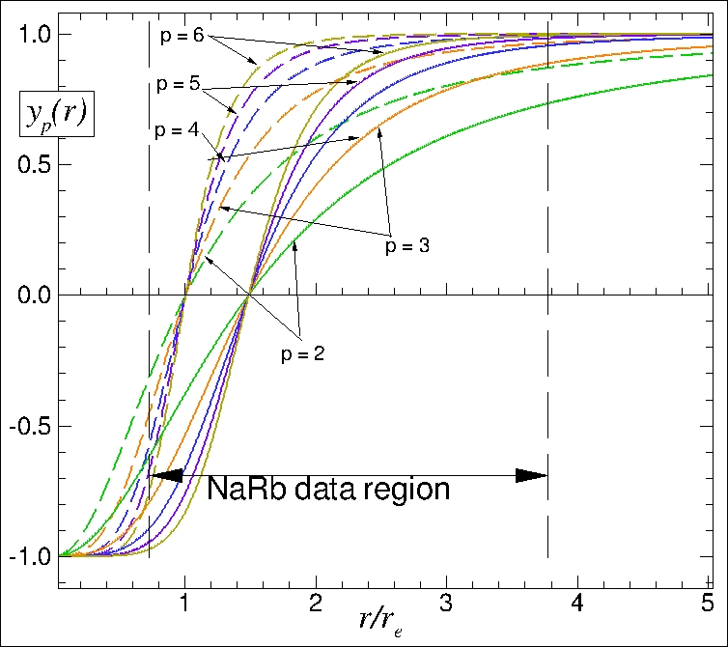

Figure 1. An example of the radial variable varying the value of p and r_{ref}

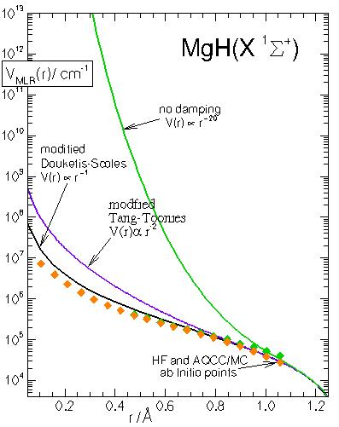

Figure 2. A comparison of the short-range behaviour of MLR potentials with no damping, modified Tang-Toennies damping and modified-Douketis-Scoles damping
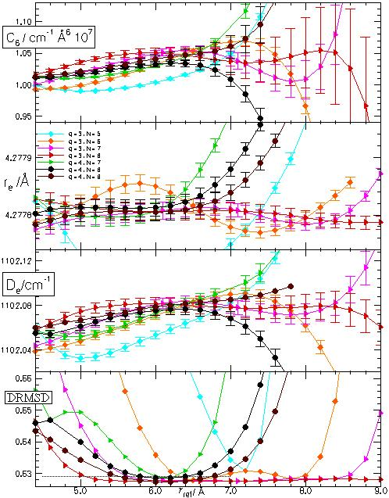
Figure 3. Summary of the DRMSD and fitted values for D_{e}, r_{e} and C₆ for Ca₂

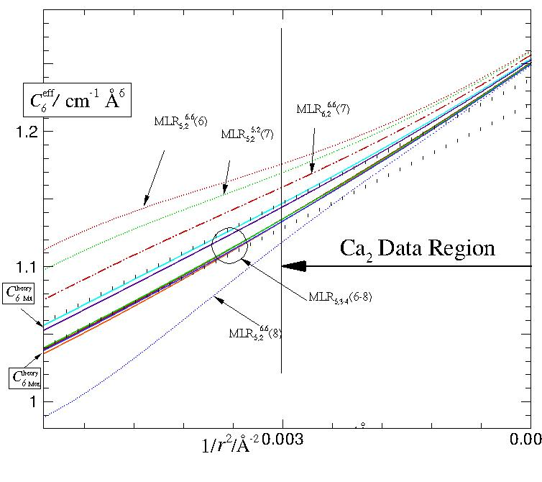
Figure 4. Long-range behaviour of MLR₅,q potentials for Ca₂ determined with C₆ as a free fitting parameter. The dotted lines have the theoretical slope [19] at the y-intercept.

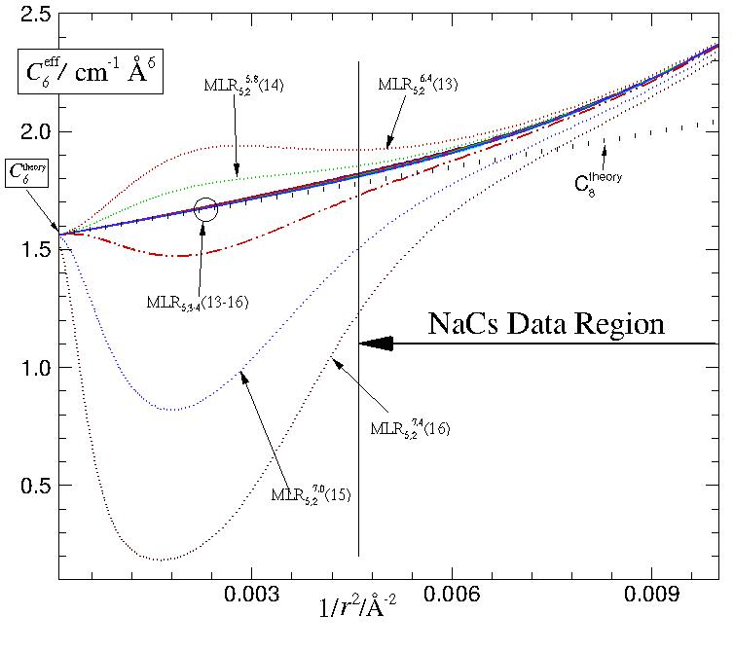
Figure 5. Long-range behaviour for MLR₅,q potentials for NaCs determined with all dispersion constants fixed at values from Ref. [20] and Ref. [21]

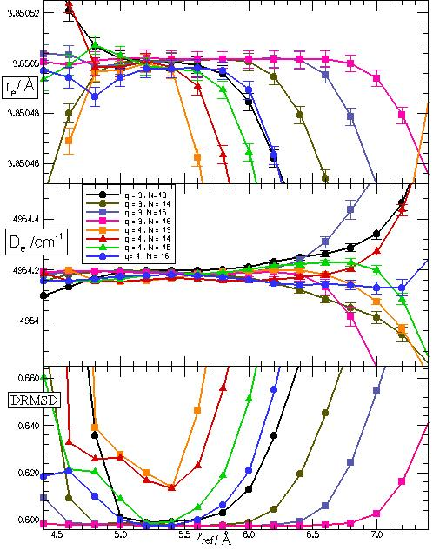
Figure 6. Summary of the DRMSD and fitted values for D_{e} and r_{e} for NaCs

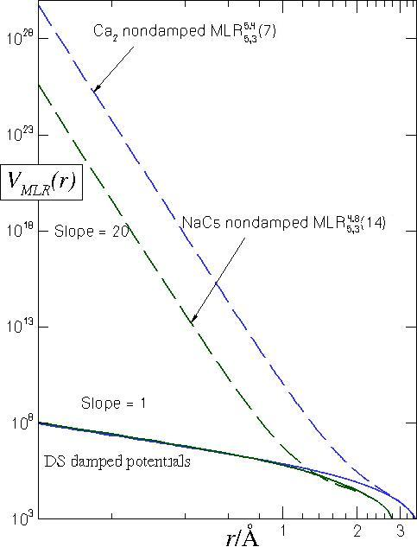
Figure 7. The comparison of the effect on the short-range region of the MLR with addition the D_{m}^{mDS}(r) versus the optimum MLR model with the same p, q, N without damping.

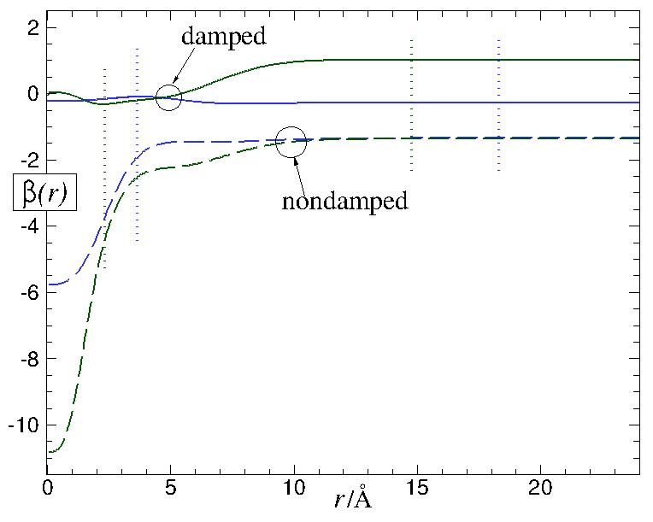

Figure 8. An illustration of the β(r) function for the recommended models Ca2 (blue lines) and NaCs(green lines). The dotted vertical lines indicate the end of data-region

