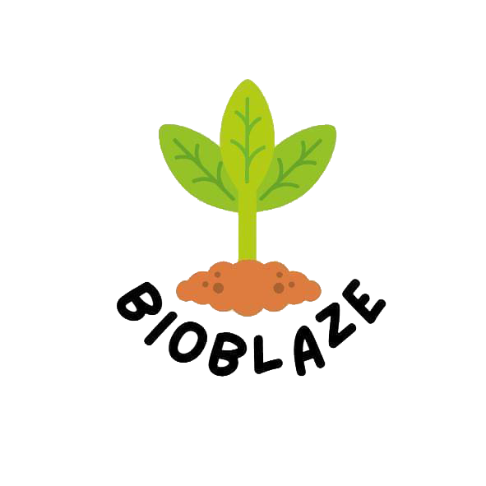

**Table of Content**

**1 The team of creators…………………………………………**

* 1. **Scrum trainer……………………………………….**
  2. **Front-end developers……………………………**
  3. **Desinger........................................**

**2 Goals of our project.................................**

* 1. **Advancing Robotics...........................**
  2. **Preserving the Past...........................**
  3. **Enhancing the Present.........................**
  4. **Shaping the Future..............................**
  5. **Collaboration and Partnerships................**
  6. **Education and Outreach.........................**

1. **Main stages of work..................................**

**3.1 The main activities..............................**

**3.2 Planning Stage.....................................**

**3.3 Design and Development.........................**

**3.4 Collaboration and project management........**

**3.5 Roles of authors and their performance.........**

**4.Summary................................................**

**1 The team of creators**

**1.1 Scrum trainer:** ***Hristo Rusev 9b***

* team leader
* coordinated the activities in the team
* determined the deadlines for the implementation of the tasks set by him
* was creating a virtual space on the "GitHub" platform

**1.2 Front-end developers: *Mitko Doychev and Gabriel Yanchev 9b***

* They were working on the graphic part of the application

**1.3 Designer: *Daniel Hristov 9b***

* defines the main design of the web page

**2 Goals of our project**

**2.1 Advancing Robotics**

* **Our primary goal at BIOT is to push the boundaries of robotics technology and lead the way in innovation. We strive to develop cutting-edge robotic solutions that can revolutionize various industries and improve the quality of human life.**

**2.2 Preserving the Past**

* **BIOT aims to honor and preserve the history of robotics by studying and documenting the significant advancements made in the field over the years. We recognize the importance of understanding the past to shape a better future for robotics.**

**2.3 Enhancing the Present**

* **BIOT is committed to creating robots that can assist humans in their daily lives and enhance productivity across different sectors. We aim to develop intelligent and reliable robotic systems that can perform tasks efficiently, safely, and seamlessly alongside humans.**

**2.4 Shaping the Future:**

* **BIOT envisions a future where robots play an integral role in transforming industries and society as a whole. We strive to be at the forefront of the next wave of robotics revolution, contributing to the development of advanced humanoid robots, robotic companions, and automation systems that will shape the future of work, healthcare, transportation, and more.**

**2.5 Collaboration and Partnerships:**

* **BIOT recognizes the importance of collaboration and partnerships to drive innovation and maximize the impact of our work. We actively seek out collaborations with academic institutions, industry leaders, and organizations that share our vision, fostering a collaborative ecosystem that propels the field of robotics forward.**

**2.6 Education and Outreach:**

* **BIOT is committed to raising awareness and promoting knowledge about robotics. By sharing our expertise and insights, we seek to inspire future generations to pursue careers in robotics and contribute to its advancement.**

**3 Main stages of work**

**3.1 The main activities**

**3.2 Planning Stage:**

* **We identified the goals and objectives of the website, focusing on how can AI help to the environment. We determined the target audience and tailored the content to them. We created a website structure including main pages, sections and navigation.**

**3.3 Design and Development:**

* **Our team designs the website layout, ensuring that it is visually appealing and user-friendly.**
* **We developed the website using appropriate web technologies and content management systems - Visual Studio Code.**
* **We created a visually appealing and consistent brand identity for the website.**
* **We designed a logo, chose appropriate color schemes and selected appropriate typography.**

**3.4 Collaboration and project management:**

* **We cordinated the efforts of content creators, designers, developers and our mentors.**
* **We facilitated effective communication and ensured timely completion of tasks.**
* **Our lead managed project schedules, timelines and resources to ensure a smooth workflow.**

**3.5 Roles of authors and their performance**

* **Designer:** **Daniel Hristov**
* **Created visually appealing layouts, graphics and visuals for the website. Responsible for researching and writing about robots past, present and future.**
* **Front-end developers: Mitko Doychev and Gabriel Yanchev**
* **We built the website using coding languages, implemented the necessary functionalities and ensured proper integration with content management systems.**
* **Scrum trainer: Hristo Rusev**
* **Coordinated the team, managed deadlines, allocated resources and ensured the successful completion of the website project.**

**4.** **Summary**