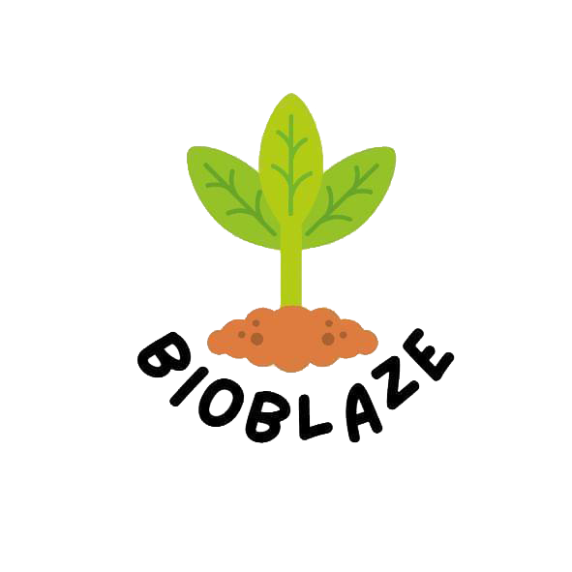

**Table of Content**

**1 The team of creators…………………………………………3**

* 1. **Scrum trainer……………………………………….3**
  2. **Front-end developers……………………………3**
  3. **Desinger........................................3**

1. **Goals of our project.................................4**
   1. **Raise Awareness ……………………………………….4**
   2. **Showcase Real-world Impact ……………………………4**
   3. **Promote Sustainable Practices........................................4**
   4. **Foster Innovation........................................4**
   5. **Community Engagement........................................4**

**Ethical Considerations........................................4**

**3 Main stages of work..................................5**

**3.1 The main activities..............................5**

**3.2 Planning Stage.....................................5**

**3.3 Design and Development.........................5**

**3.4 Collaboration and project management........5**

**3.5 Roles of authors and their performance.........6**

**4.Summary................................................****7**

**1 The team of creators**

**1.1 Scrum trainer:** ***Hristo Rusev 9b***

* team leader
* coordinated the activities in the team
* determined the deadlines for the implementation of the tasks set by him
* was creating a virtual space on the "GitHub" platform

**1.2 Front-end developers: *Gabriel Yanchev 9b and Mitko Doychev 9b***

* They were working on the graphic part of the application

**1.3 Designer: *Daniel Hristov 9b***

* defines the main design of the web page

**2 Goals of our project**

**2.1 Raise Awareness - Develop informative content, articles, and infographics highlighting the positive impact of AI on environmental conservation.**

**2.2 Showcase Real-world Impact - Feature case studies, success stories, and examples of ongoing projects that utilize AI for resource management, wildlife conservation, and energy efficiency.**

**2.3 Promote Sustainable Practices - Strategy: Provide practical insights, guides, and tools that showcase how AI can optimize energy consumption, reduce waste, and promote eco-friendly practices.**

**2.4 Foster Innovation - Regularly update the platform with the latest advancements, research, and emerging trends in the field of Green Tech, fostering a community of forward-thinking individuals.**

**2.5 Community Engagement - Establish forums, discussion boards, and interactive elements that facilitate knowledge-sharing, collaboration, and networking among users.**

**2.6 Ethical Considerations - Feature content discussing the ethical implications of AI in environmental contexts, encouraging a thoughtful and balanced approach to technological integration.**

1. **Main stages of work**

**3.1 The main activities**

**3.2 Planning Stage:**

* **In this site, we want to show you how artificial intelligence can help environmental problems. We determined the target audience and tailored the content to them. We created a website structure including main pages, sections and navigation.**

**3.3 Design and Development:**

* **Our team designs the website layout, ensuring that it is visually appealing and user-friendly.**
* **We developed the website using appropriate web technologies and content management systems - Visual Studio Code.**
* **We created a visually appealing and consistent brand identity for the website.**
* **We designed a logo, chose appropriate color schemes and selected appropriate typography.**

**3.4 Collaboration and project management:**

* **We coordinated the efforts of content creators, designers, developers and our mentors.**
* **We facilitated effective communication and ensured timely completion of tasks.**
* **Our lead managed project schedules, timelines and resources to ensure a smooth workflow.**

**3.5 Roles of authors and their performance**

* **Designer:** **Daniel Hristov**
* **Created visually appealing layouts, graphics and visuals for the website. Responsible for researching and writing about robots past, present and future.**
* **Front-end developers: Gabriel Yanchev and Mitko Doychev**
* **We built the website using coding languages, implemented the necessary functionalities and ensured proper integration with content management systems.**
* **Scrum trainer: Hristo Rusev**
* **Coordinated the team, managed deadlines, allocated resources and ensured the successful completion of the website project.**

**4.** **Summary**

**At BioBlaze, our mission is to inform and empower individuals, businesses, and policymakers about the transformative role of AI in addressing pressing environmental challenges. Through engaging articles, interactive tools, and real-world case studies, we showcase how AI is revolutionizing resource management, wildlife conservation, and energy optimization.**

**Our content goes beyond the theoretical, providing practical insights into the applications of AI that drive positive change. From monitoring air quality and protecting endangered species to optimizing energy consumption, BioBlaze demonstrates how AI can be a catalyst for meaningful environmental impact.**