2024 Paris Olympic Games

Post-Games Report

HPSNZ Strategy and Intelligence

2024/07/30

Contents

Report Logistics 1

Report Status 1

Reporting Errors 1

Data Cleaning 1

Considerations 1

historical to previous event 2

PHE Completion 2

Mental Health Screening 3

Tx 5

by discipline med/physio/massage 5

histoirical trends agross games 5

by sport- geom_col not facet wrapped? 5

by sex? 5

daily load games period 5

% team daily 5

Nature of Treatments n & % 6

injuries & treatments 6

illnesses & treatments 6

Section Four: Athlete Training Status Overview 6

Training Availability 7

Injury Burden 9

## Report Logistics

### Report Status

All analytics reports starts as a proof of concept. Once accepted as viable concept, it is refined in collaboration with subject matter experts, subject to ongoing bug fixes, rigorous error checking and formatting before a finalized and reliable report is obtained.

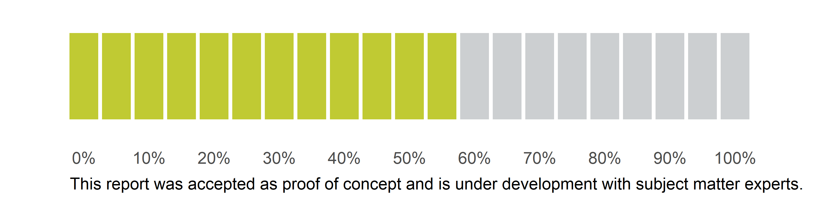

### Reporting Errors

For any errors or irregularities in your Report, please log a ticket detailing the error in as much detail as possible Intelligence Team ticket

### Data Cleaning

The primary data cleaning addressed:

* blank records.
* unique records when multiple records were entered on the same date.

### Considerations

Interpretation of data by Subject Matter Expert (SME)

* PHE related data by Director of Performance Health (e.g. NSO considerations, International Federation considerations, Major Games timing, overseas athletes, interim measures, etc.)

## historical to previous event

London, Rio, Tokyo, Glasgow, Brisbane

## PHE Completion

#### PHE Completion

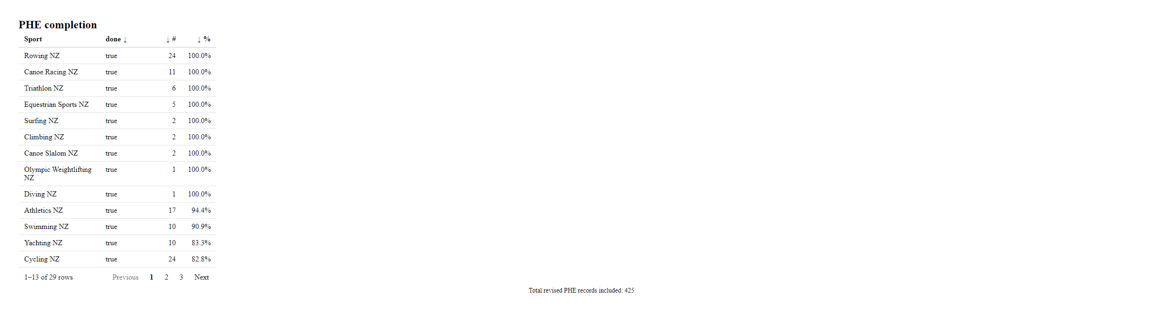

#### PHE Completion by Sport

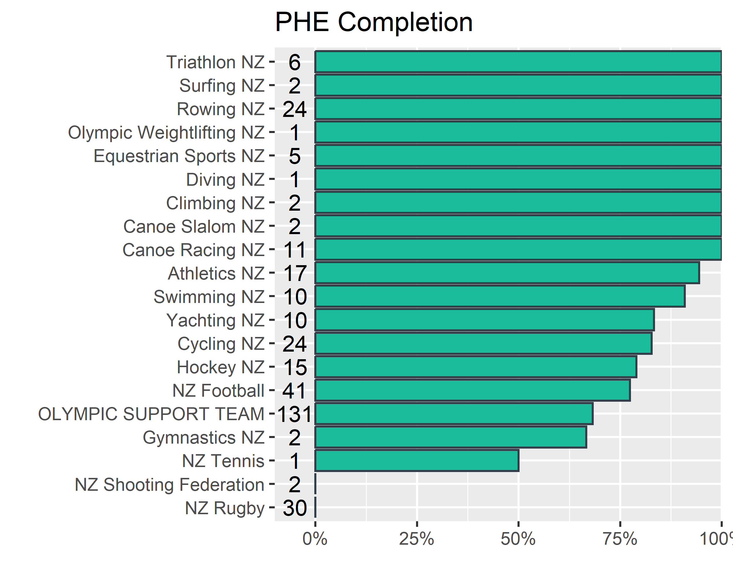

### Mental Health Screening

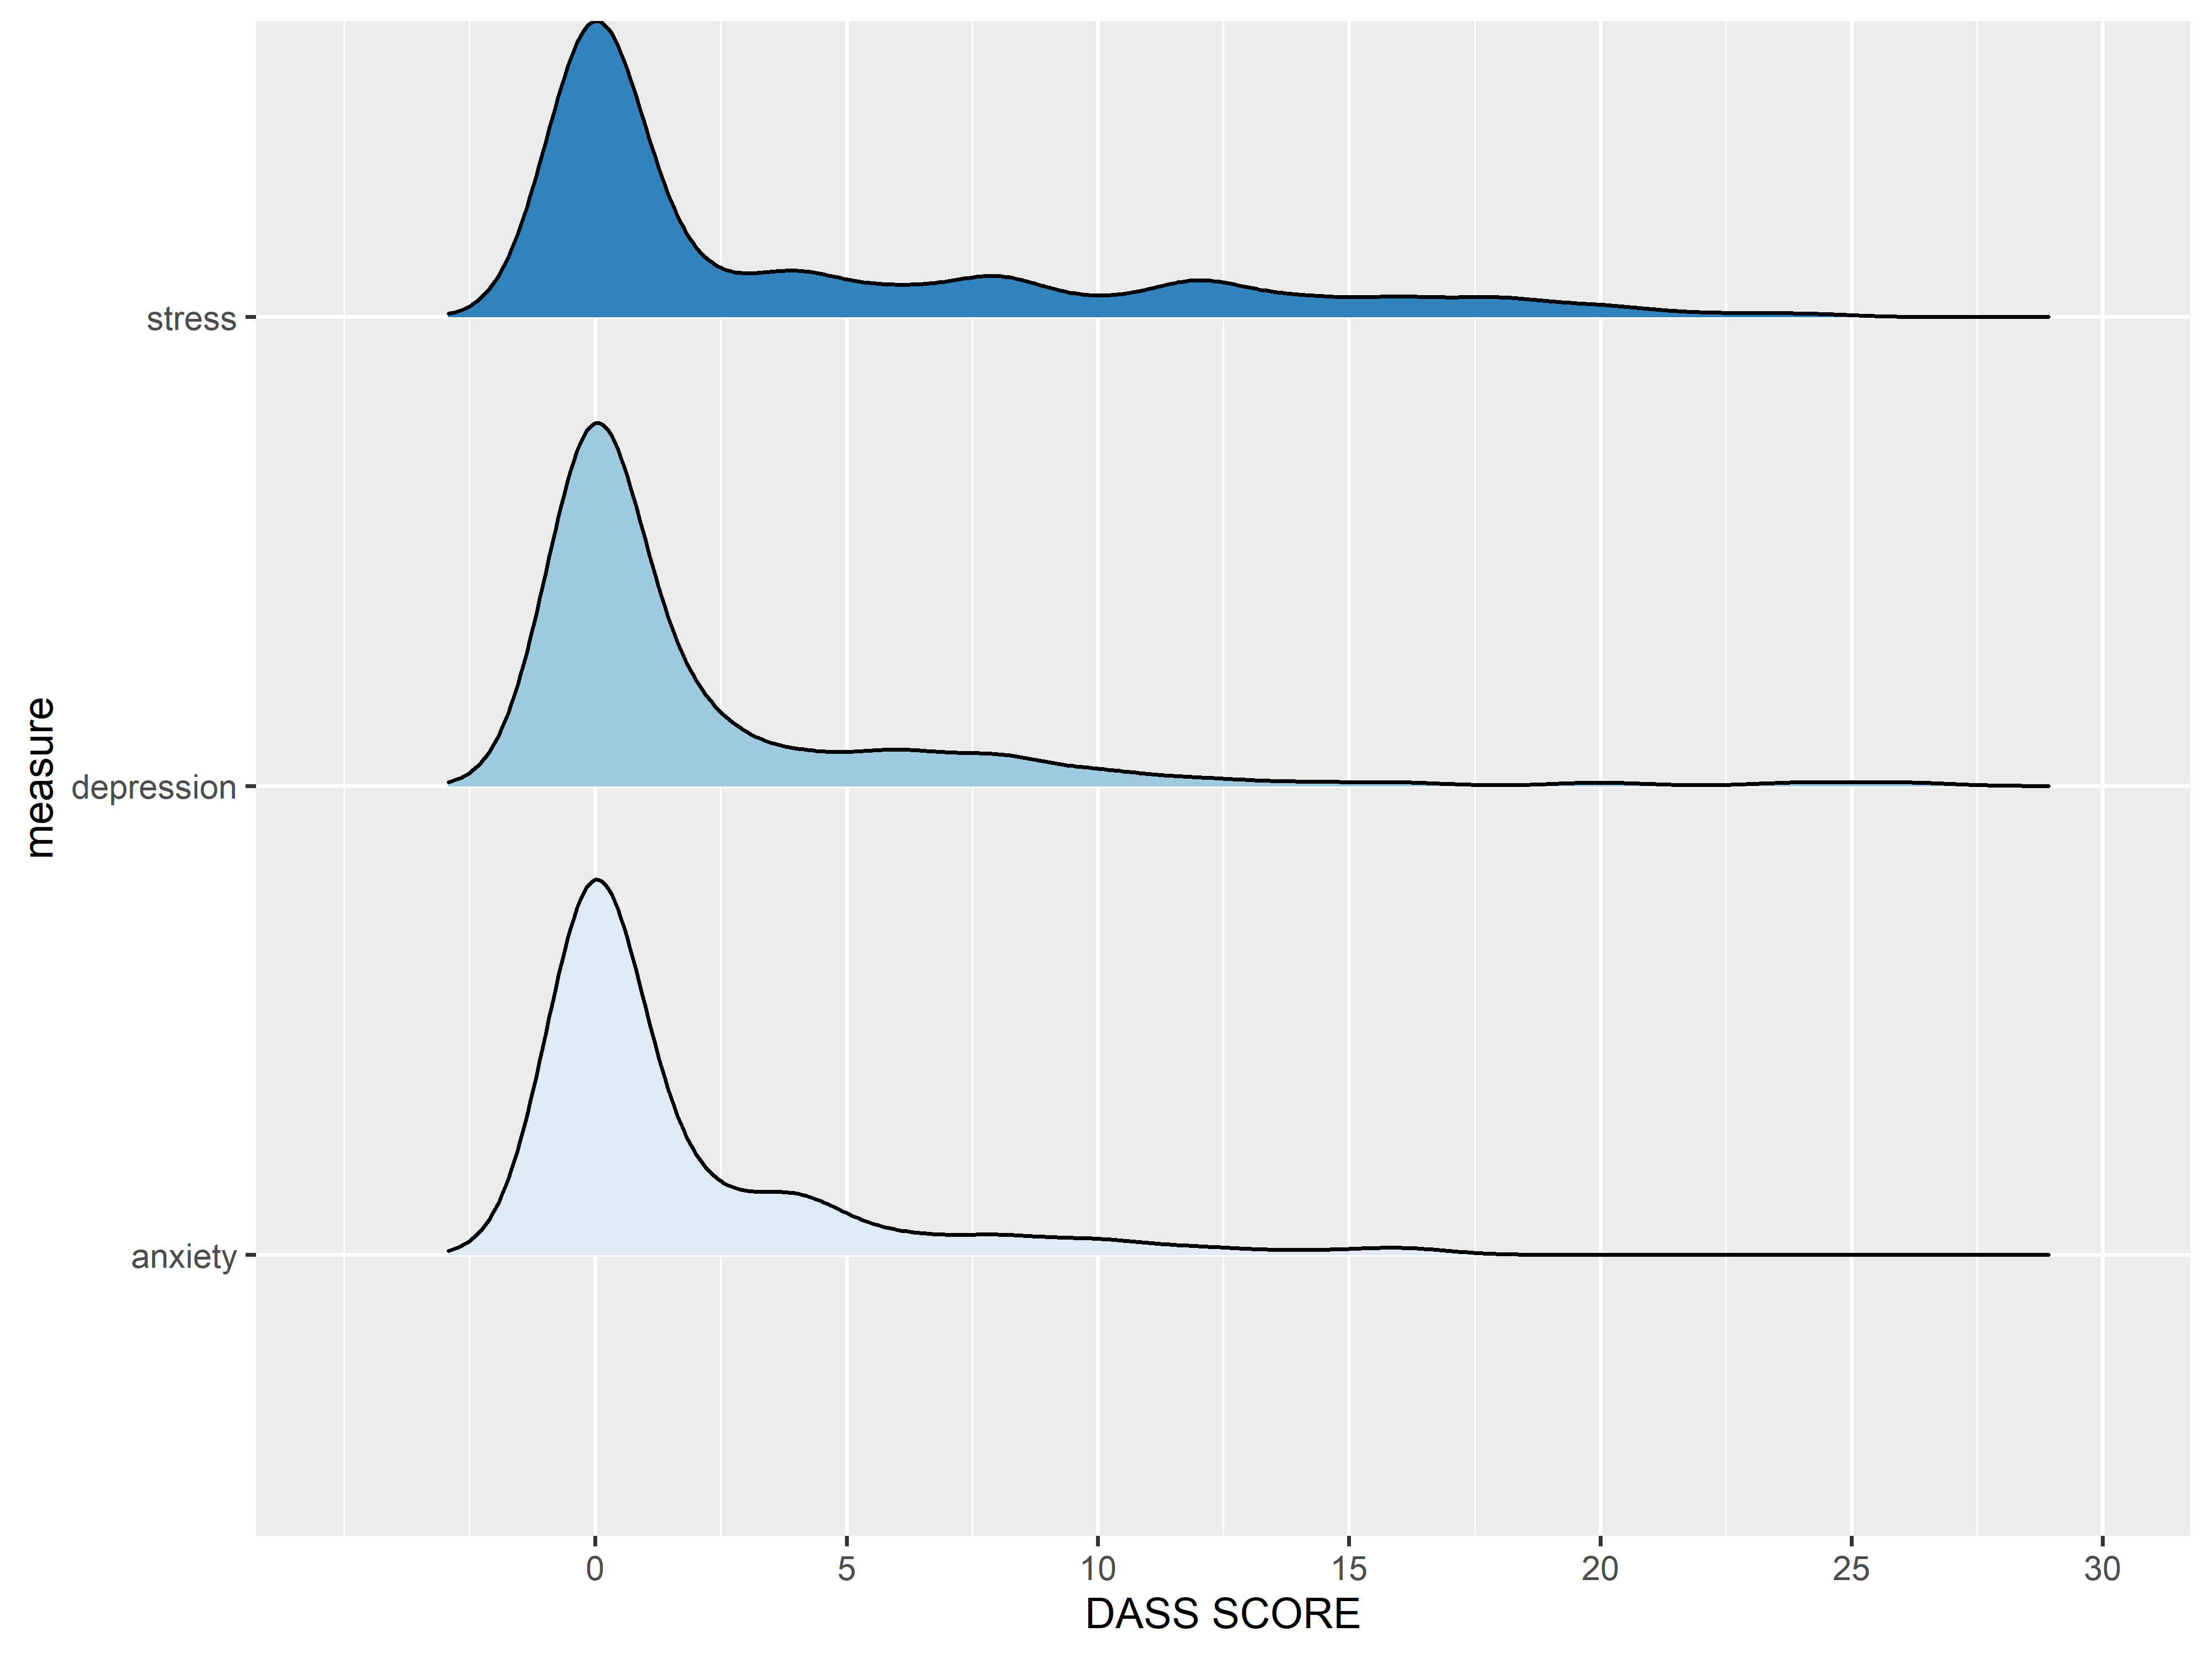

#### sample by deidentified nso (larger NSOs?)

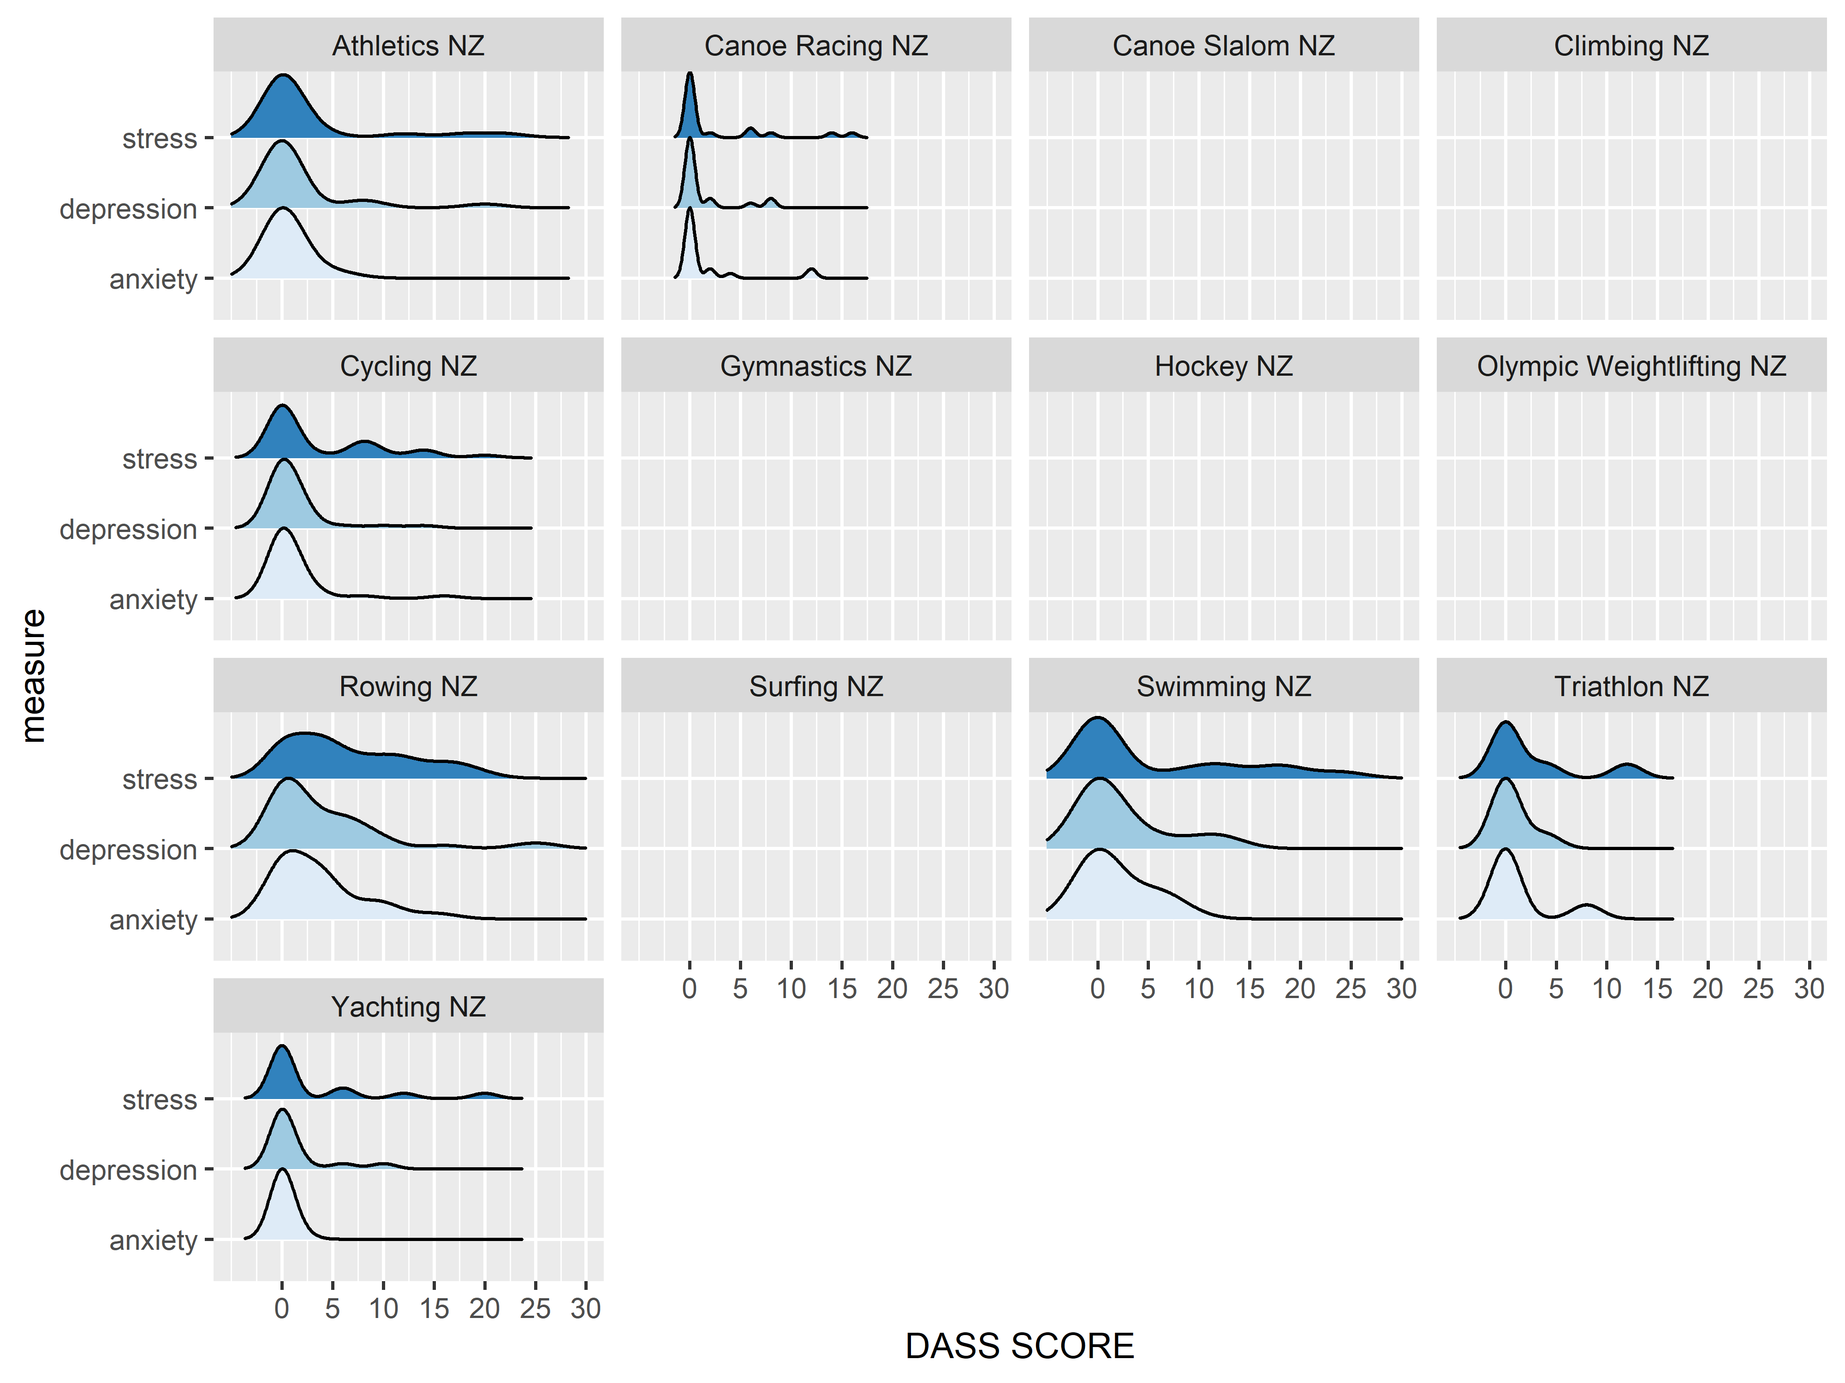

#### Mental Heath Scoring by sex

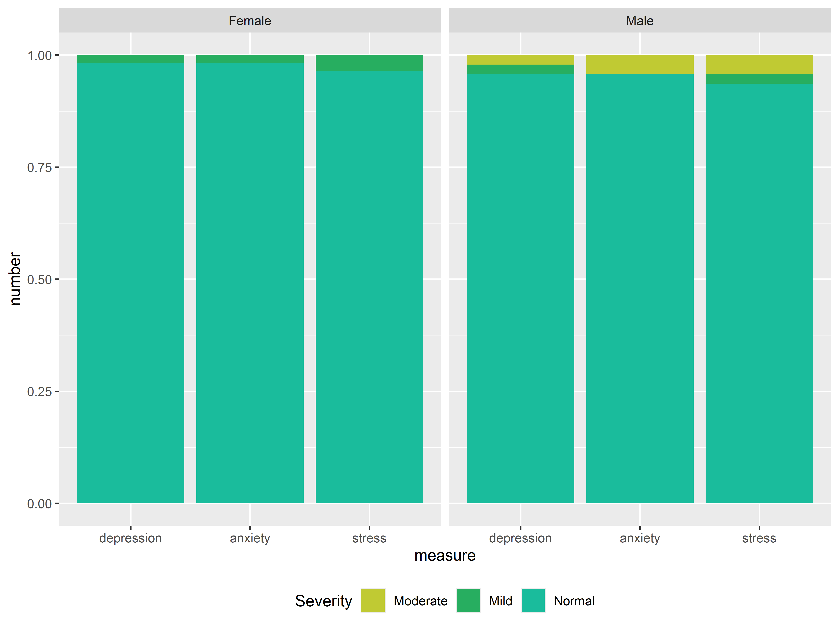

## Tx

### by discipline med/physio/massage

### histoirical trends agross games

### by sport- geom_col not facet wrapped?

### by sex?

### daily load games period

### % team daily

core vs NSO team n & %

## Nature of Treatments n & %

### injuries & treatments

### illnesses & treatments

#### infections

##### dermatological

##### respiratory

I’ve attached the Tokyo report of which P31-34 illustrate the data that we utilised. Reviewing this work from 2021, I think it would be nice to be able to present some of this data as cleanly and effectively as possible – I’m sure you’d agree some of the detail could probably be condensed, to make interpretation and impact more effective. Below is the DASS data as we presented it last time, which it would also be good to be able to reproduce.

I’ve also attached the 2016 report Pages 25-34 ish) , in which we broke things down into a little more detail – this was collected almost entirely manually and stored in excel. Interested in your thoughts on what information we can drag out from SB that was included in 2016 but lost in 2020 – if at all.

For obvious reasons, I’m particularly interested this year in the number of respiratory presentations, including infection (COVID may form some of these), asthma and other presentations. I will be pushing the coding of this with the team in particular as I want to understand its impact. Hence it would be good if we were able to look at the i) total number of respiratory consultations ii) the number of infections iii) including sex and sport as part of this, if there is actually enough data!

The other interesting element that would be good to report on, which we’ve never done before, is the outcomes of the PHE. At its most basic, how many were completed (which we’ve probably done most times), but more interestingly, working on a selection of elements that we may be interested in assessing (eg. women’s health; medications etc!). I’m not sure how easy or difficult this may be – noting that there will be a reasonable number (football, hockey) that will be done on PDF. This is a bit of a speculator.

Time is going to be very tight after the Games period and I’m very keen to have the report completed ASAP. The Games period for which we will be collecting data will be from the Village Opening on July 18, until Village Closure on August 12. In an ideal world, we’d be able to do an analysis of health team data immediately following that, as I have time on the plane home the following week to work through material and start to pull the report together.

## Section Four: Athlete Training Status Overview

The Health Related Issue (HRI) data provides an estimate of athlete availability and associated time loss associated with injuries to different body parts (i.e. ankle, elbow, arm, neck, lumbar spine, etc.).

* Time Loss refers to both being unavailable to compete
* Modified training applies to athletes with any training status other than **FULLY AVAILABLE**
* The body parts are drawn from the OSIICS codes *and* simplified by removing most adjectives (i.e. *anterior wrist* and *posterior wrist* are all simply **wrist**) and related body areas are grouped.
* The availability data reflects injuries treated in the HPSNZ clinic where the *injury status* was updated over reporting period. Pre-exising injuries that were not treated/updated in the reporting period are not included
* Only injuries resulting in an athlete no longer being **FULLY AVAILABLE** are reflected in these visual.
* All injuries with a status other than **FULLY AVAILABLE** regardless of being open, closed and resolved or closed and unresolved are reflected in these visual.

### Training Availability

An overview of which body part injuries are having the largest impact on training availability across a program

* NOTE: Significant training availability impact may be attributed to systemic injuries of a shorter duration accumulating across a large number of individuals, or non-systemic injuries with a longer duration across a smaller number of individuals

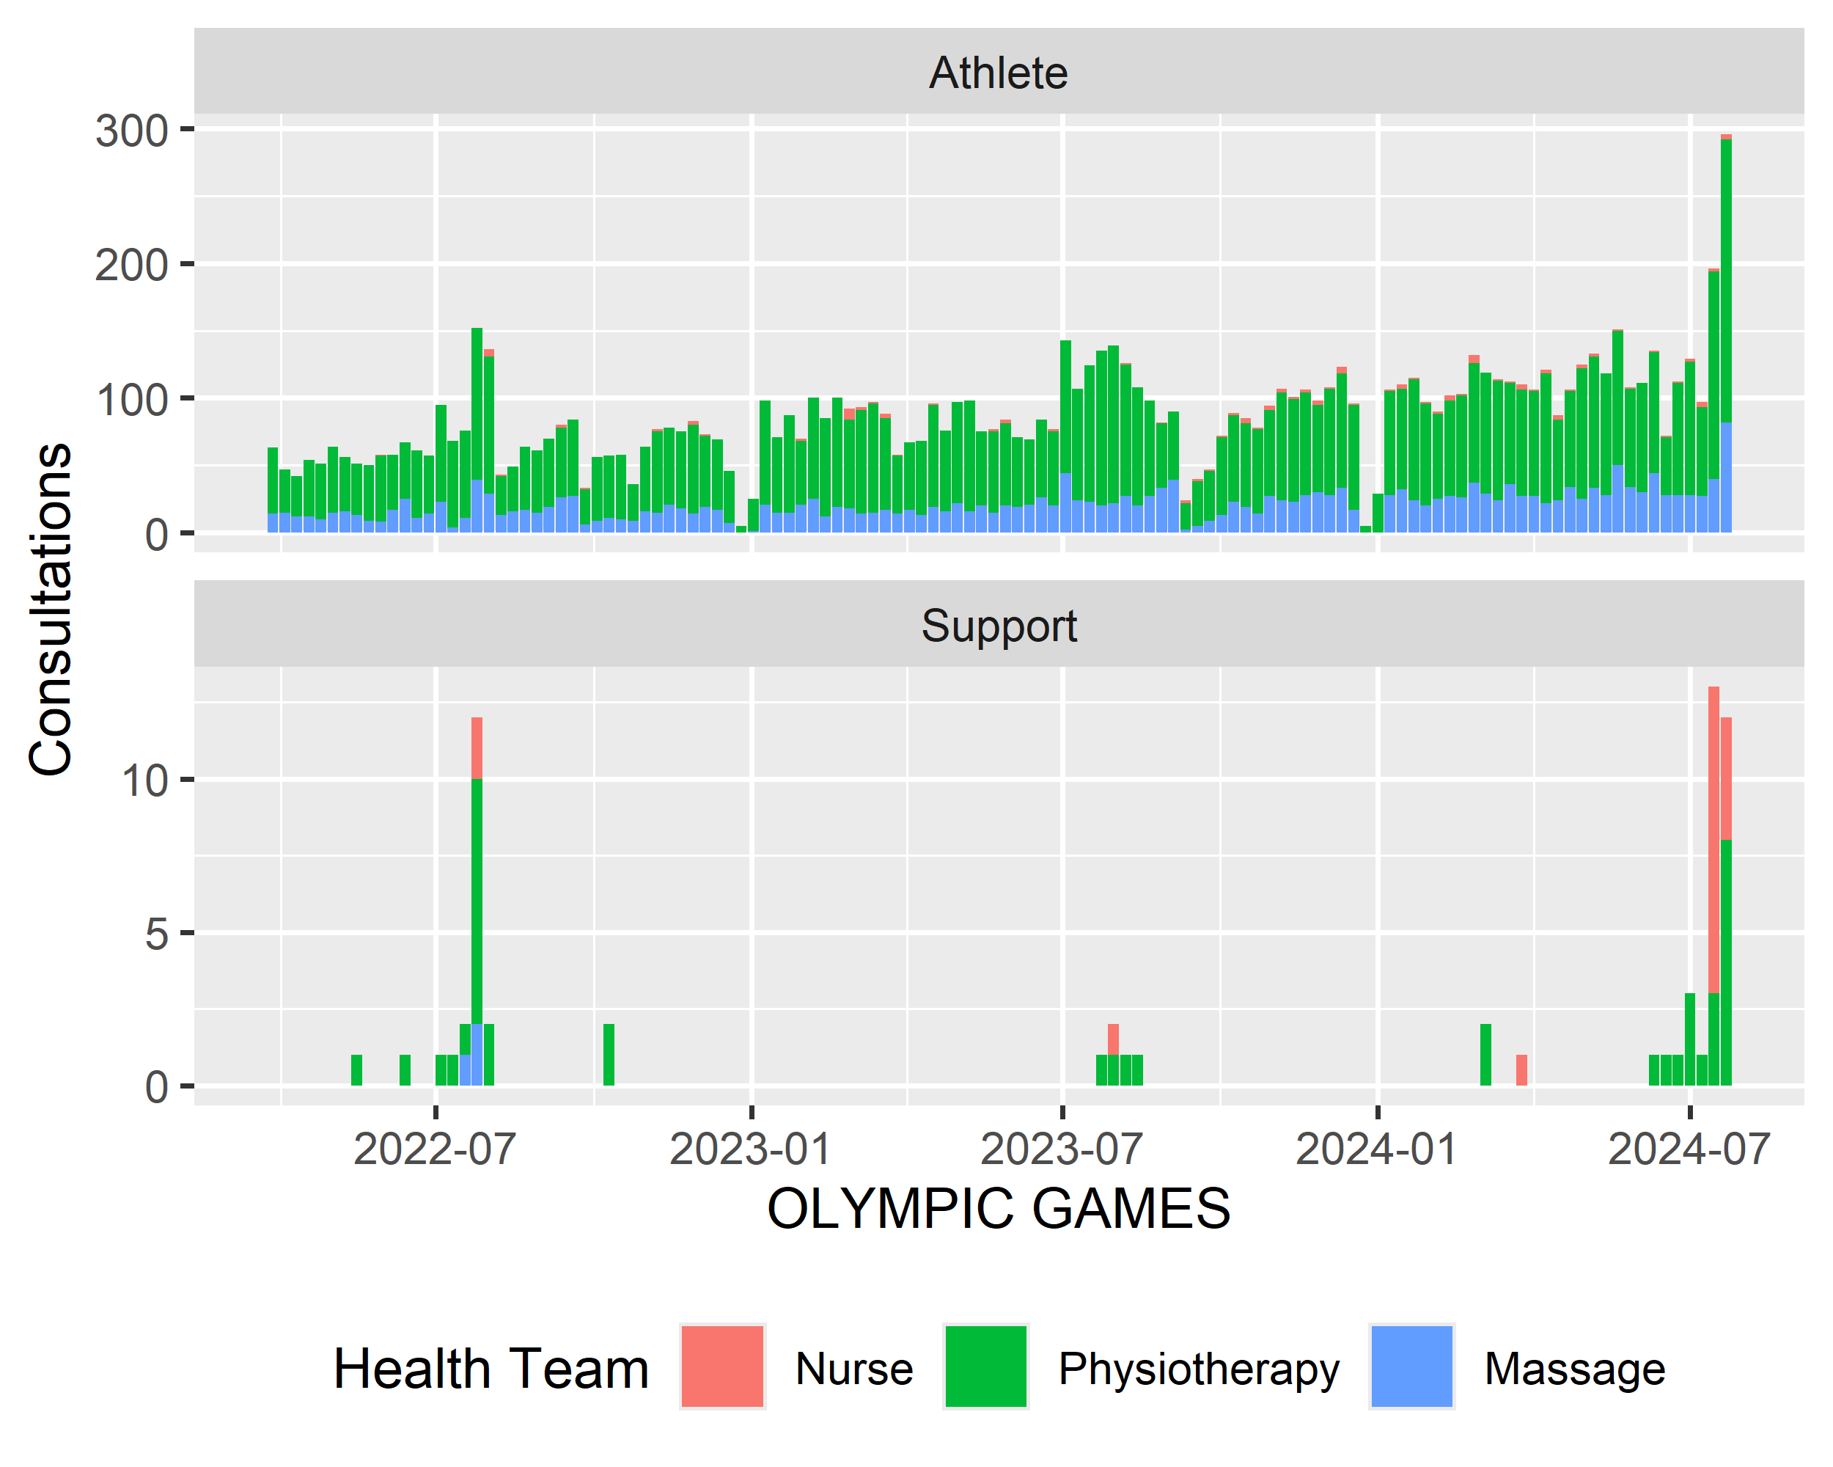

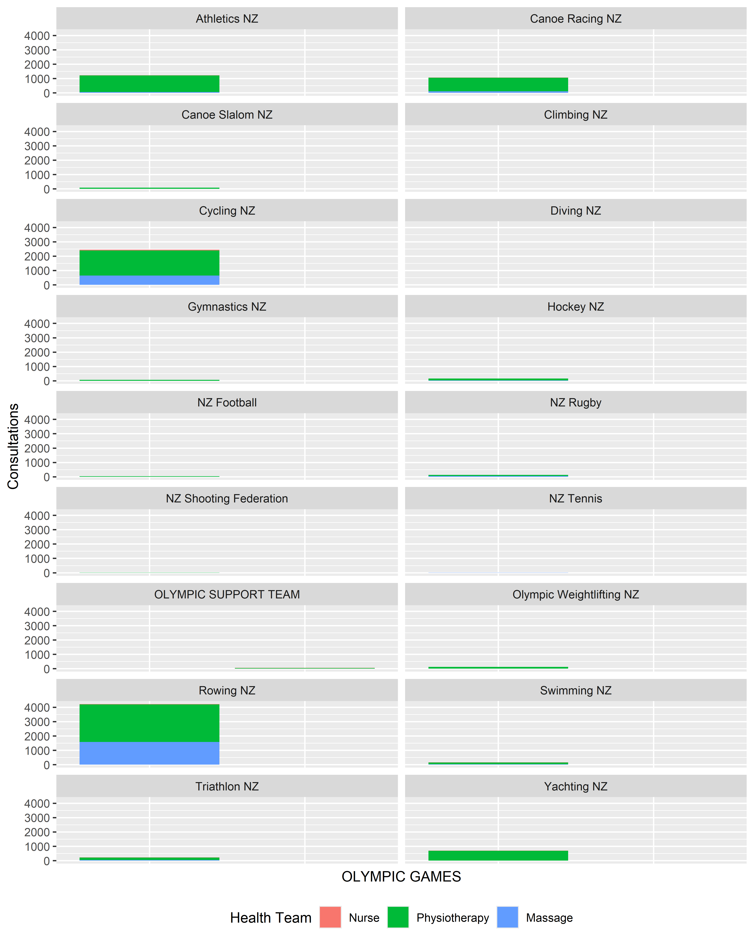

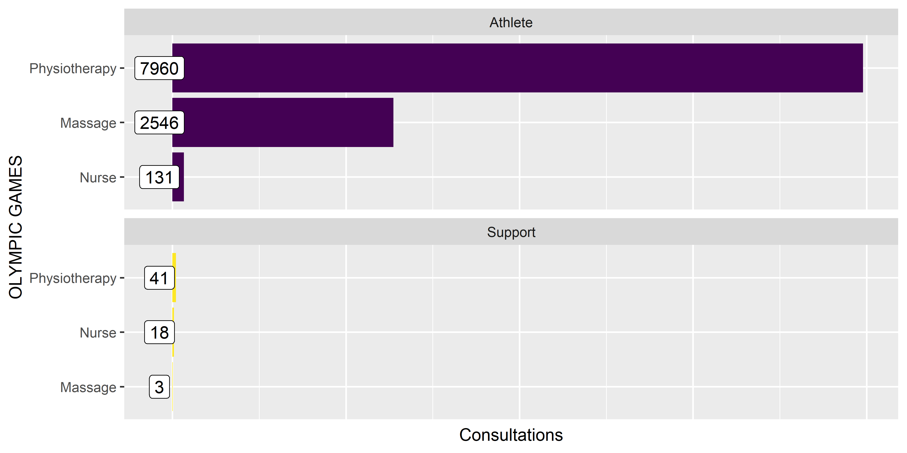

### Injury Burden

An overview of the burden for each injury where an athlete is unavailable to compete. Burden does take into account individual variation in recovery or initial severity.

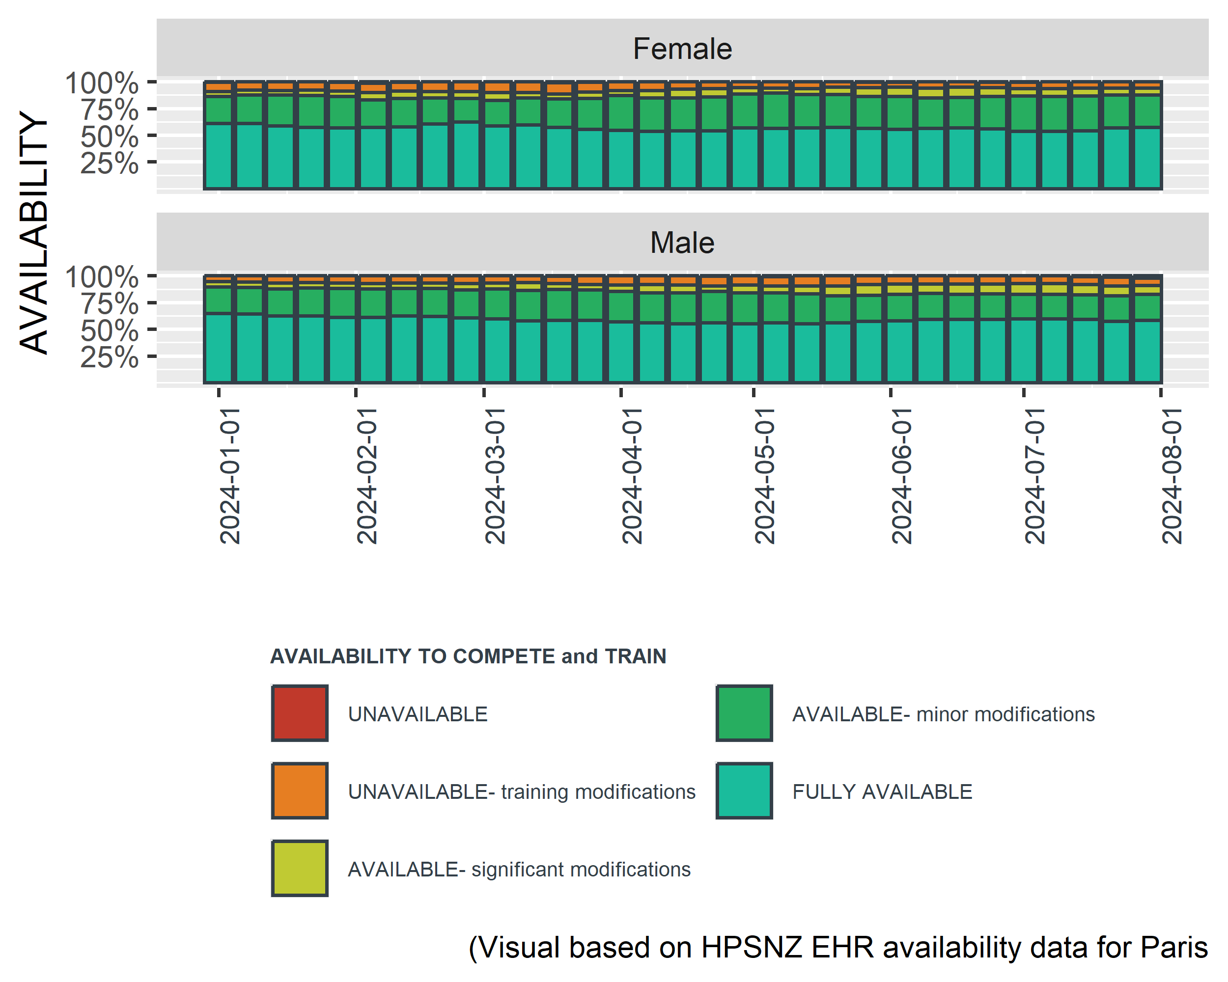

#### Availability by body part

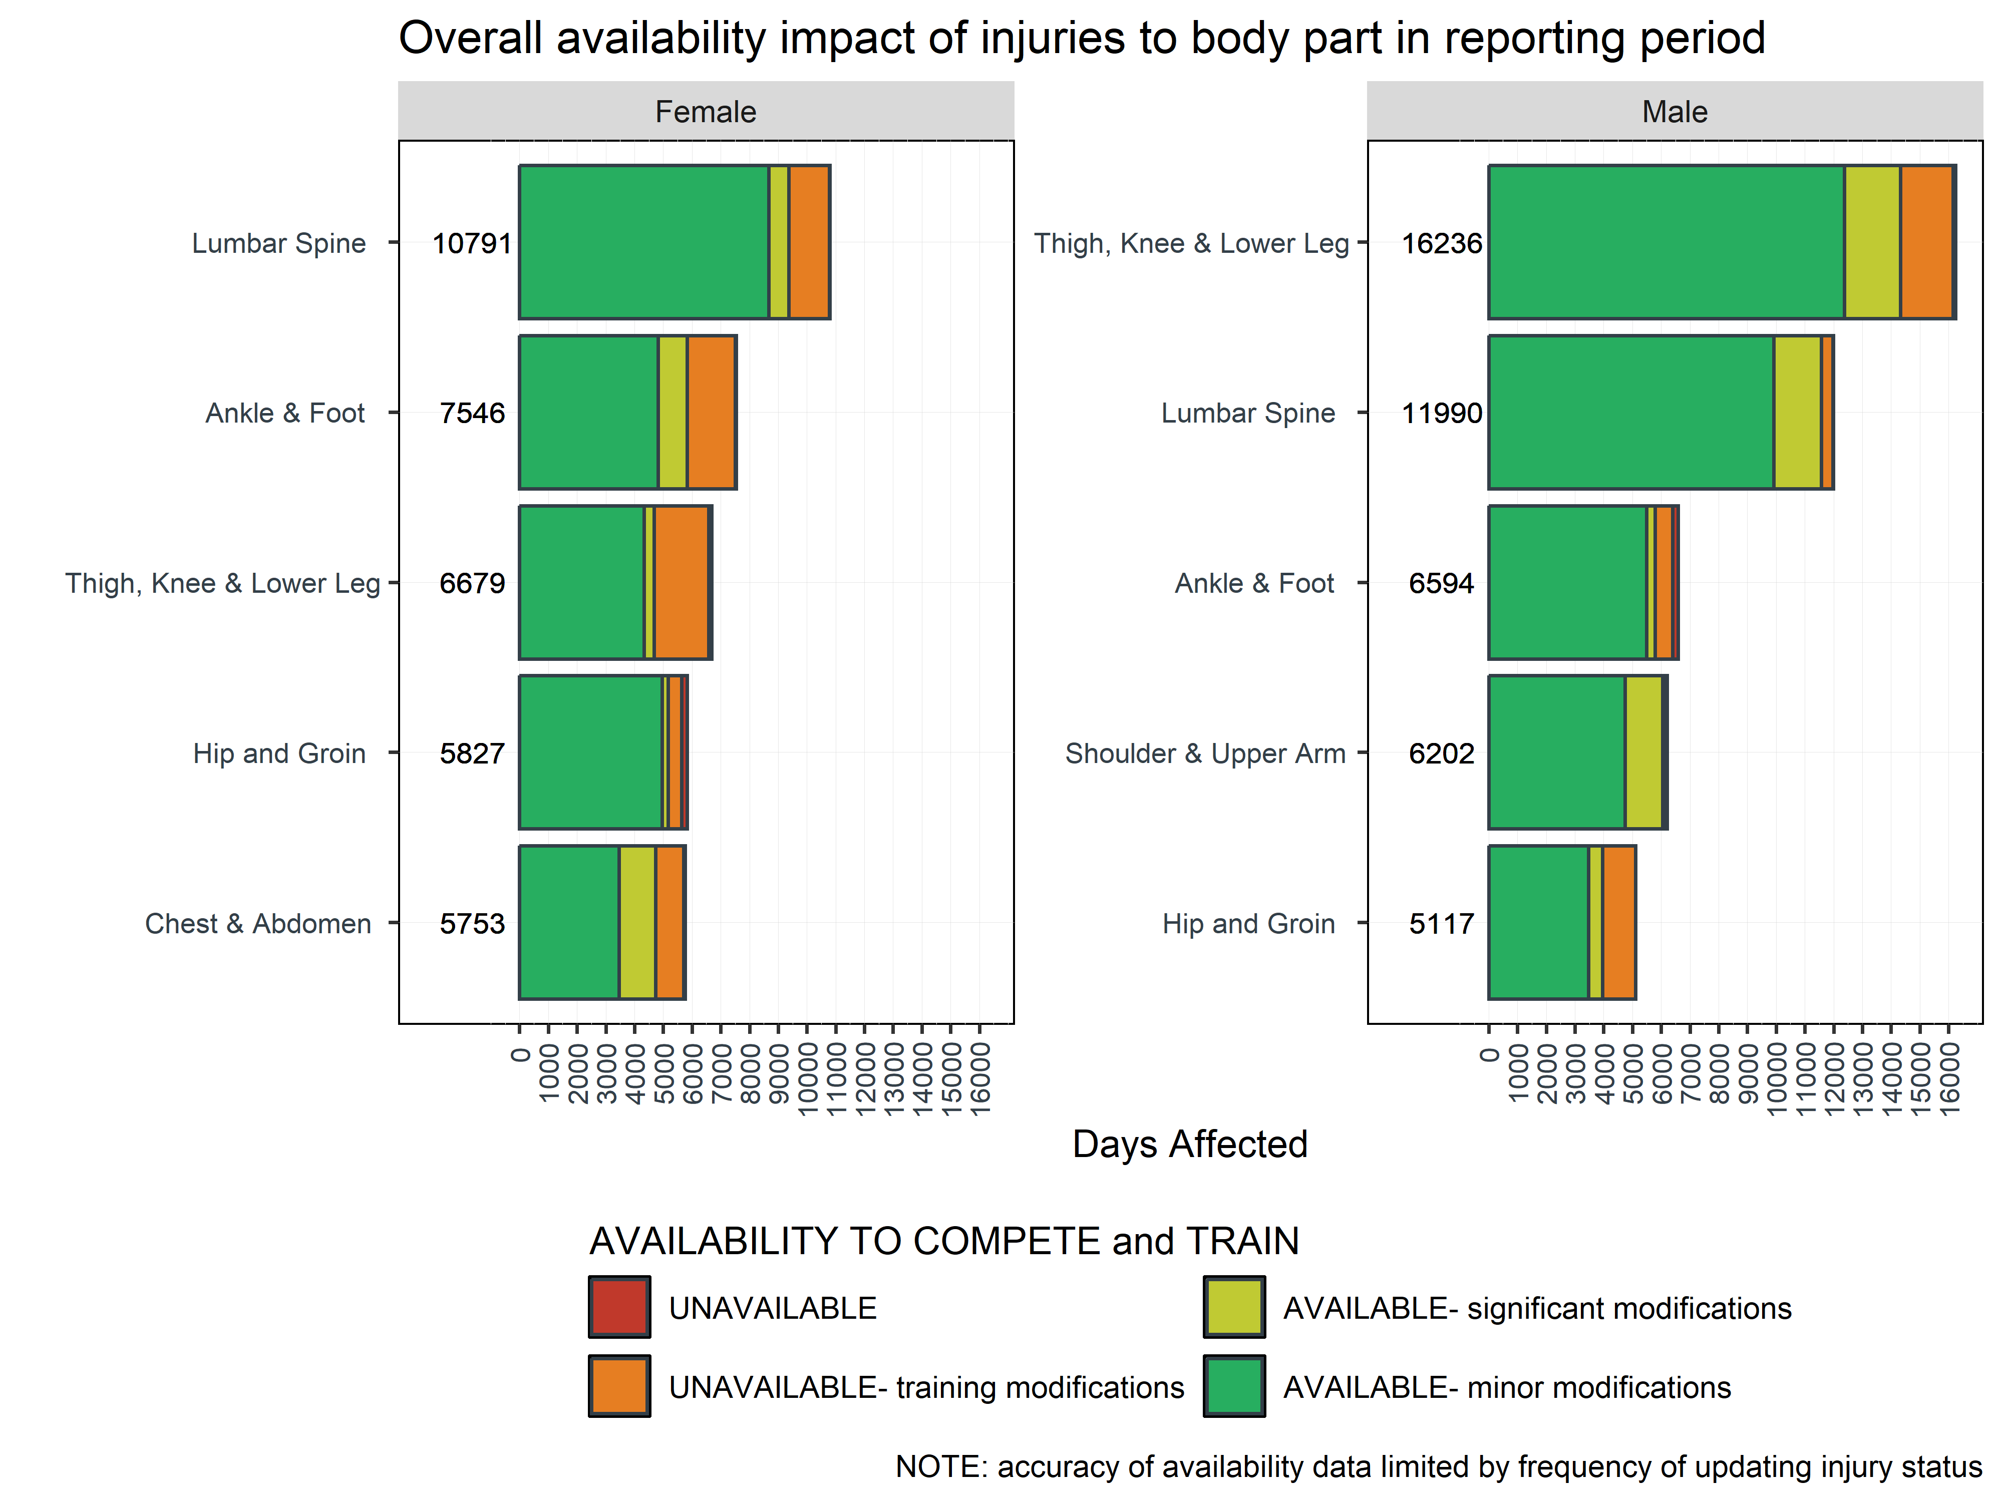

#### Burden by body part

