**Solution Roadmap:**

Here, As a participants of WIT Hackathon, We have created one app called­­­ Covid-19 Update using Flutter.

This App provides you latest Updated Covid-19 infected patients of India. We hope that it will be helpfull for all.

In future we will will add Global data and More Information related to prevention of this pandemic

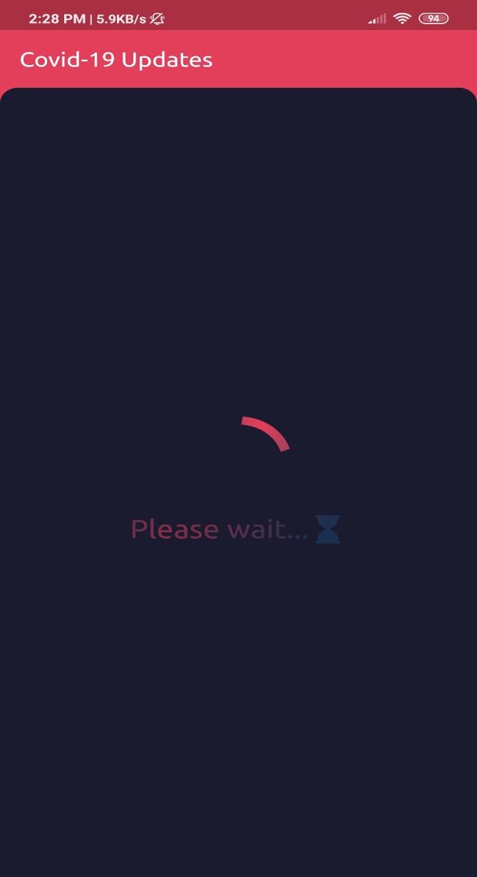

Img.(a) Img.(b)

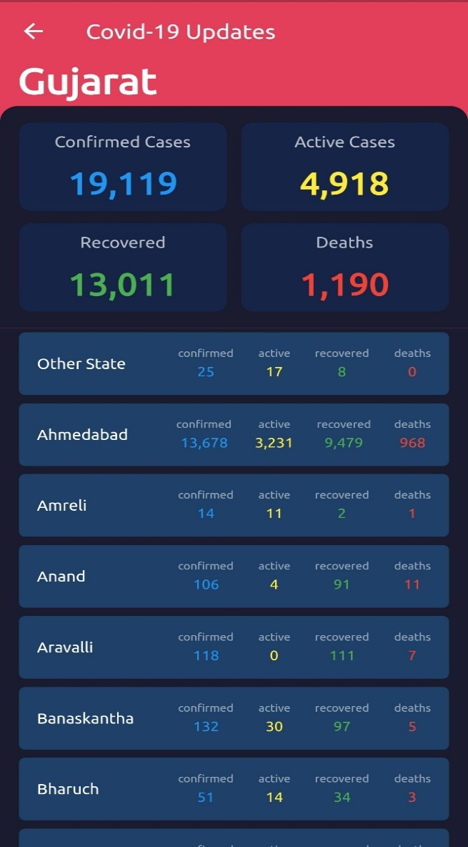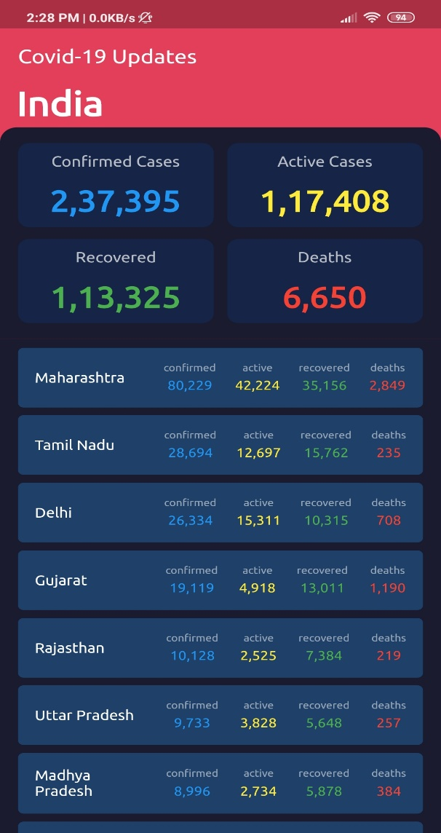

Img.(c) Img.(d)

* An app or solution available at fingertips which gives:

Img.(a) shows our Flutter App icon.

Img.(b) shows 2-5 seconds of loading icon.

Than Img.(c) & Img.(d) shows All direct information of updated numerical data related to covid 19 and related status state wise as well as district wise.

#STAY_SAFE ☺

---------- * ----------*------------