SignFlow — Administrator Guide
Running SignFlow for your organisation

The admin console gives you everything needed to run SignFlow. Sign in with an administrator account to see these modules. For the step-by-step rollout (creating teams and users), use the companion IT Onboarding Playbook.
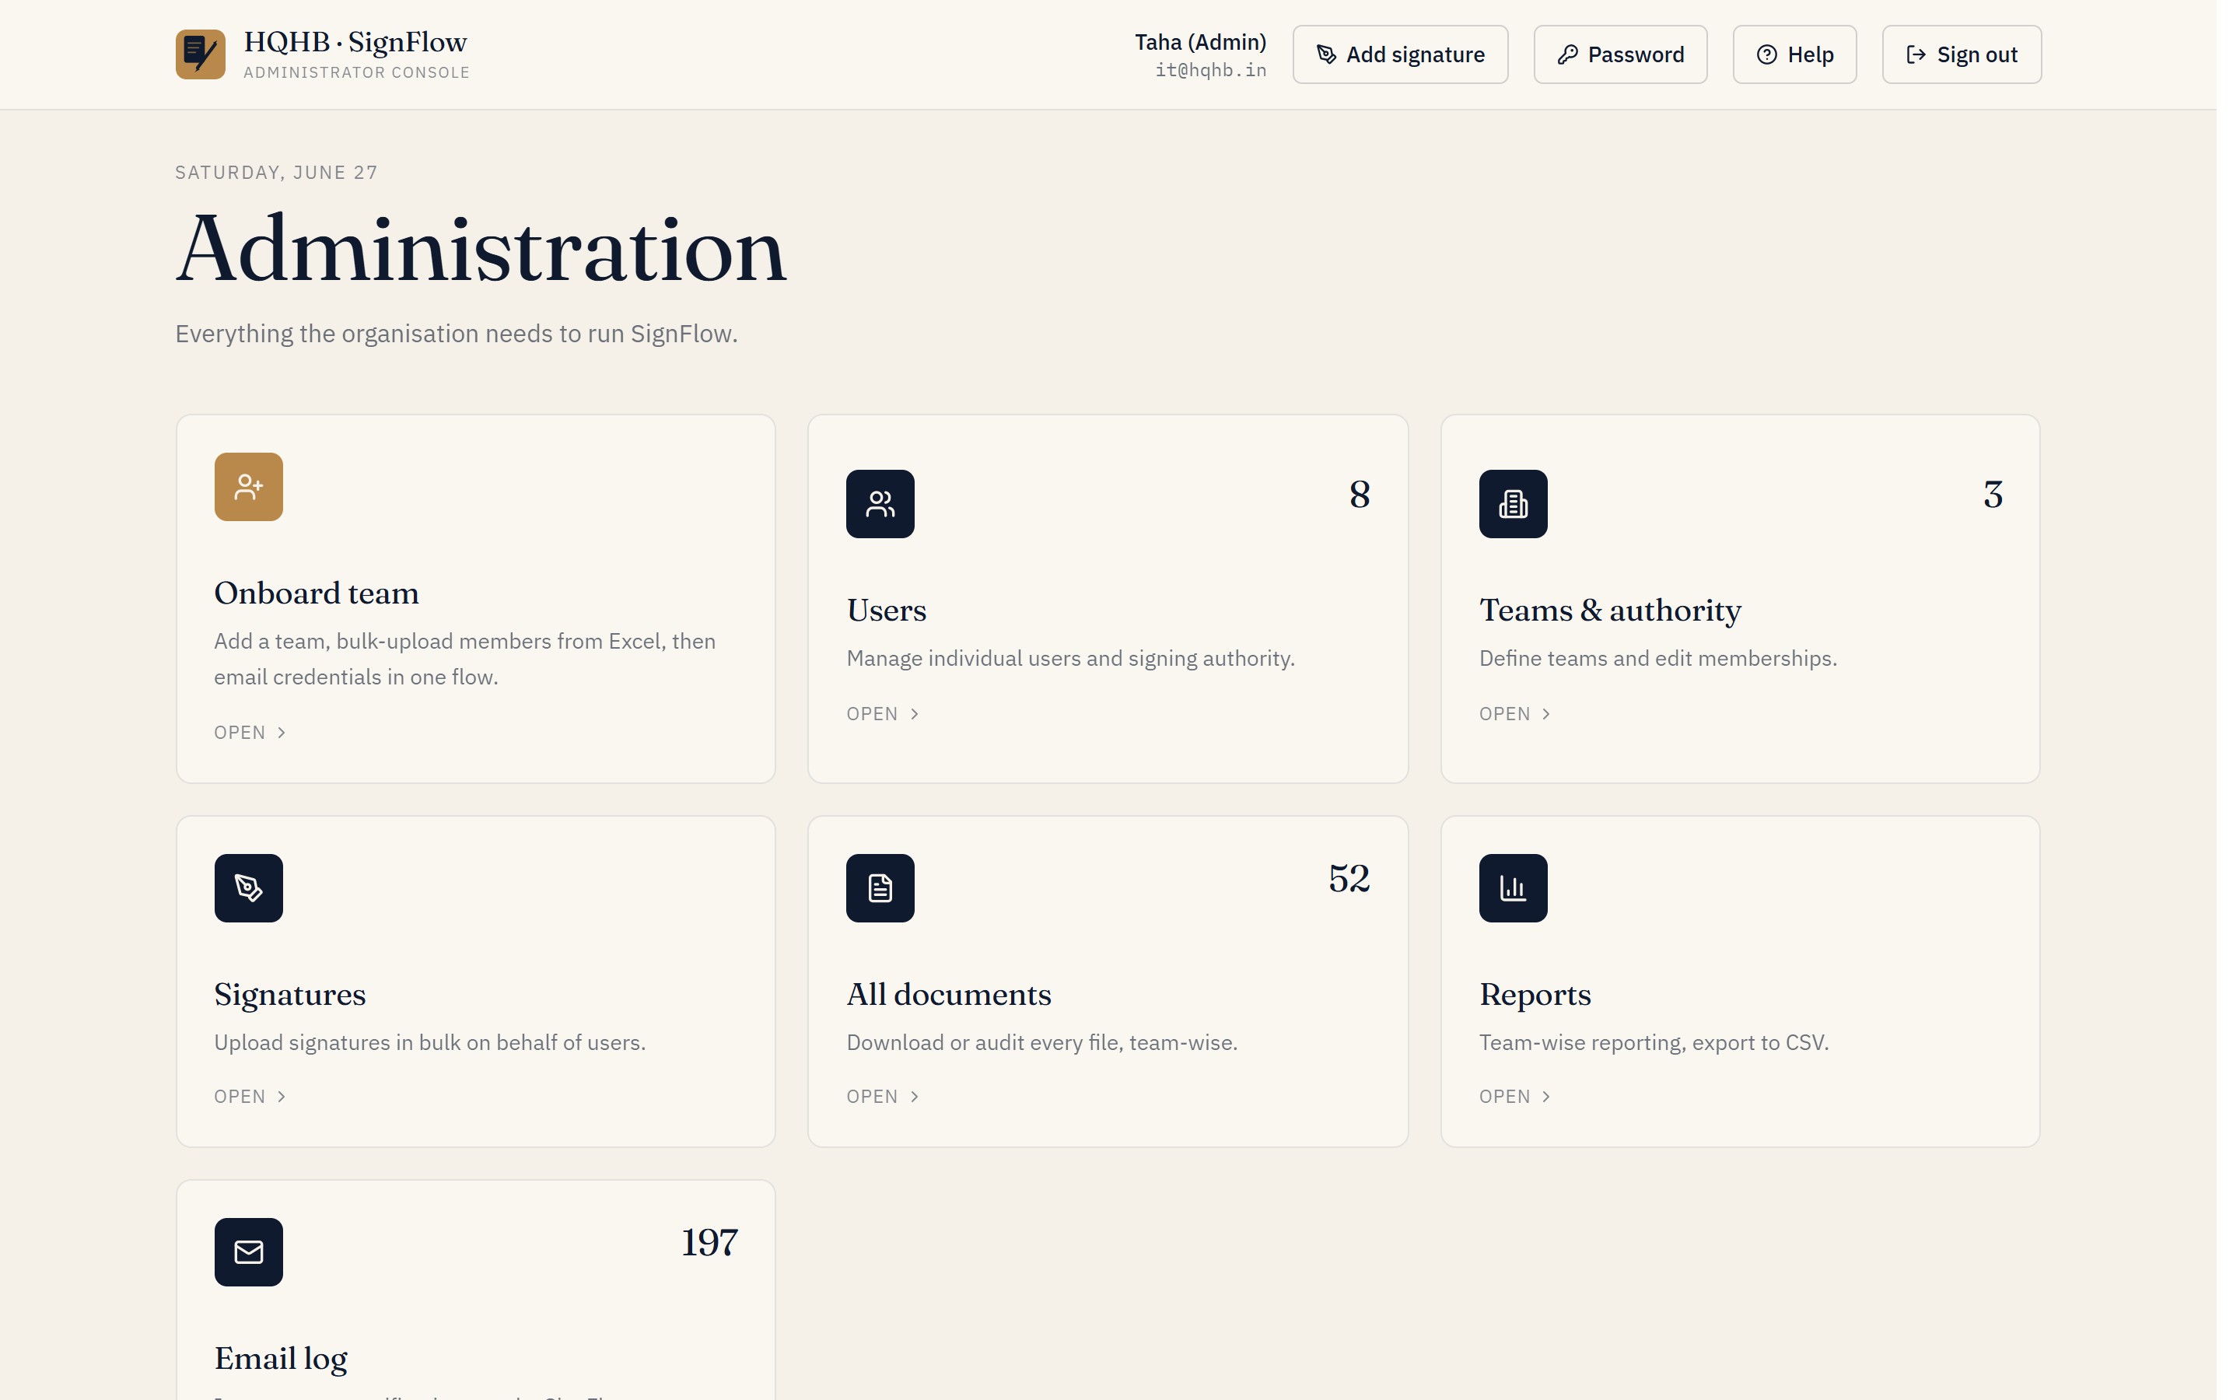
The Administrator console — every module in one place.

Users
- Add users individually (3-step wizard) or in bulk by department.
- Set each person’s role — Administrator / Requestor / Approver — and assign a team or signing authority.
- Delete users when needed: their name shows as “—” in past requests, but document history is preserved.

Registrations
If self-registration is enabled, people can request an account themselves from the login screen (Create an account). Each request lands in Admin → Registrations with a pending count.
- Review each request — the name, email, and the team and reporting manager they entered.
- Approve to create the account (as a Requestor) so they can sign in with the password they chose — then set their real role / team under Users.
- Reject, with an optional reason, if it isn’t a legitimate request.
- Until you approve them, a registrant cannot sign in — the approval is the gate.

Teams & authority
- Create or remove teams (business functions such as Finance, Operations, IT).
- View and edit who can sign for each team — this controls where requests are routed.

Signatures
- Upload a signature image on behalf of any user.
- Bulk-upload signatures by naming each file with the user’s email (e.g., jane@hqhb.in.png) — SignFlow matches them automatically.

All documents
- See every request across the company, filterable by status (All / Pending / Approved / Rejected).
- Download originals or signed copies for any audit.

Reports
- Team-wise totals — pending, approved, rejected.
- A top-approvers leaderboard.
- Full CSV export of the complete request history.

Email log
Audit every notification SignFlow has sent — invitations, approvals, reminders, and password resets — with delivery status.

Helping users with access
- Re-send an invite or reset a password from the Users page; a fresh temporary password is generated.
- Users can also self-serve via Forgot password? on the login screen.
Most day-to-day admin work is onboarding people. Keep the IT Onboarding Playbook handy for the first few weeks.

