SignFlow — Approver Guide
Reviewing and signing documents

Before you start
- Sign in at https://onesign.devhqhb.online/ and change your password.
- Register your signature (draw or upload) — it’s stamped onto documents when you approve.

Your home screen
You’ll see four areas: Pending approvals, Approved, Rejected, and Signing authority (the teams that have granted you the right to sign).
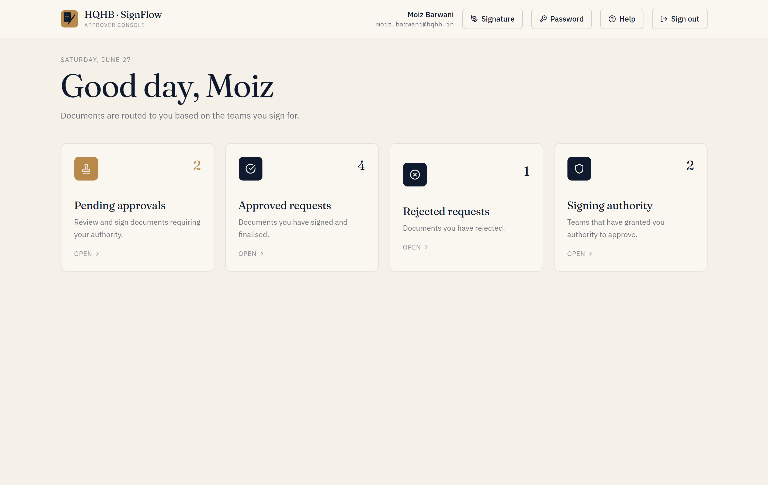
The Approver home — pending approvals, history, and your signing authority.

Review & sign
- Open a pending request and review the document.
- Check the workflow chain — who has already signed and who is next.
- If it’s your turn, your slot is highlighted “YOU SIGN HERE.” Click Approve & sign to stamp your signature, or Reject with a reason.
- If it’s not your turn yet, you’ll see “Awaiting signature from [Name]” and the document is view-only until it reaches you.
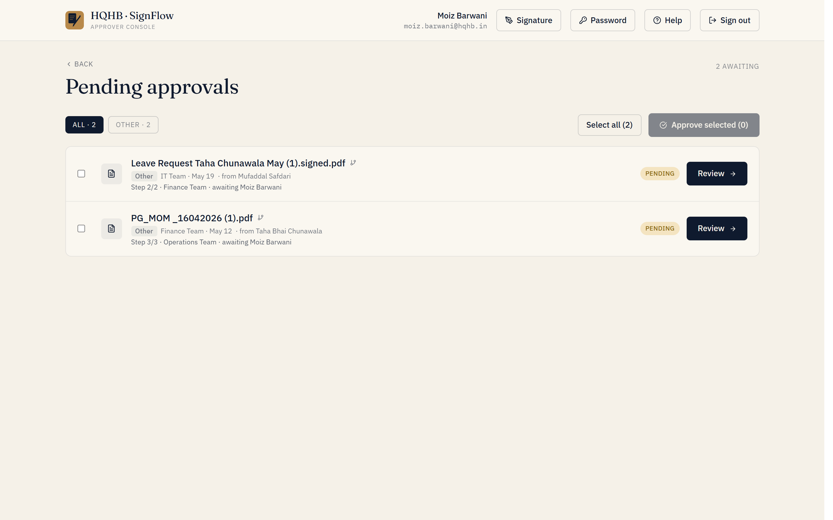
Open a pending request to review the document and sign when it is your turn.

The one-hour window
For standard (non-instant) approvals, you have one hour to withdraw your approval while the status shows “Approved · 1h window.” After the hour passes — or immediately, when Instant Approval was set — your signature is locked in.

When everyone has signed
Once all signers complete, the request is finalised: the requestor is emailed automatically and the signed PDF becomes downloadable. Every action is time-stamped for the audit trail.
Reject early if something is wrong — a clear reason helps the requestor fix and resubmit quickly.

