SignFlow — IT Onboarding Playbook
Set up teams, create users, and get everyone signed in

Step 0 — Create your teams first
SignFlow organises people into teams (business functions). Create these before adding users: Admin → Teams & authority → Add team (e.g., Finance, Operations, IT, HR, Management).
- Requestors are assigned to one team (their department).
- Approvers are granted signing authority over one or more teams.

The three roles
Role | What they do | Who gets it
Requestor | Submits documents for signature; downloads signed copies | Most staff
Approver | Reviews and signs documents routed to them | Managers, Finance, authorised signatories
Administrator | Full control of users, teams, signatures, reports | IT only

Details to capture from each user
Collect this for every person before creating accounts. It doubles as your bulk-import sheet.
Field | Required? | Notes
Full name | Yes | As it should appear on signatures and records
Work email | Yes | This is their login — must be unique
Role | Yes | Requestor / Approver / Administrator
Department (team) | Yes (Requestors) | Which business function they belong to
Signing authority | Yes (Approvers) | Which team(s) they may sign for
Signature image | Optional | They can register it themselves on first login

Creating users — two ways

A. By department, in bulk (recommended for rollout)
- Admin → Onboard team.
- Pick or create the team (department).
- Upload a spreadsheet of members — columns name, email (optional role; defaults to Requestor).
- Review the parsed rows; adjust each person’s role and tick signing authority where needed.
- Create the accounts — and email everyone their credentials in one click.
Everyone in the upload is auto-assigned to that team, so you don’t need team IDs. A CSV you can start from:
name,email,role
Jane Doe,jane.doe@hqhb.in,requestor
Moiz Khan,moiz.khan@hqhb.in,approver

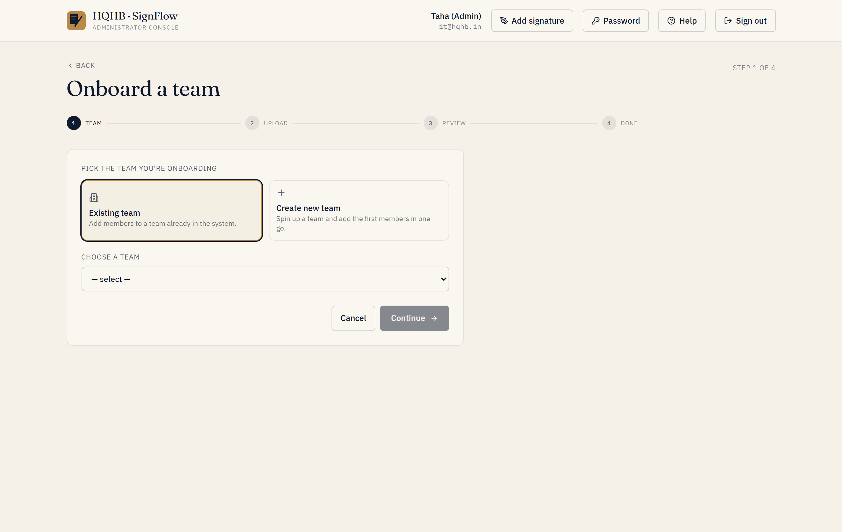
Onboard team — pick or create a team, then upload the member list.

B. One person at a time
- Admin → Users → Add user.
- Identity — Full name, Work email, Initial password (at least 6 characters; they change it later).
- Role & assignment — choose the role, then the department (Requestor) or tick signing-authority teams (Approver). Admins need no assignment.
- Confirm → Create user.
- Share the credentials — this path does not auto-email; send the user their email and temporary password.
Self-service alternative: let people request their own account from the login screen (Create an account). Each request appears in Admin → Registrations to approve or reject — handy for ad-hoc additions after the initial rollout. Approved registrants start as Requestors; adjust their role/team under Users.

What each user does on first login
- Go to https://onesign.devhqhb.online/
- Sign in with their email and temporary password.
- Change their password.
- Register their signature — draw it or upload an image (one-time).
- They’re ready to submit or sign documents.

Optional — pre-load signatures
Admin → Signatures → bulk-upload images named <email>.png (or .jpg). SignFlow matches each image to the user by email automatically, so they can skip the first-login signature step.

Suggested rollout order
- Create teams.
- Add the IT administrator account(s).
- Onboard each department in bulk — set approvers and signing authority as you go.
- (Optional) Pre-load signatures.
- Send the announcement email.
- Keep it@hqhb.in / taha.chunawala@hqhb.in ready for first-week questions.

