SignFlow Quick-Start
Get signing in three steps

- Sign in. Go to https://onesign.devhqhb.online/ and sign in with the email and temporary password from IT. Change your password when prompted.
- Register your signature. A one-time step — draw it with your mouse/finger or upload an image. (You can defer with “Sign out & do it later.”)
- Start using it — see your role below.
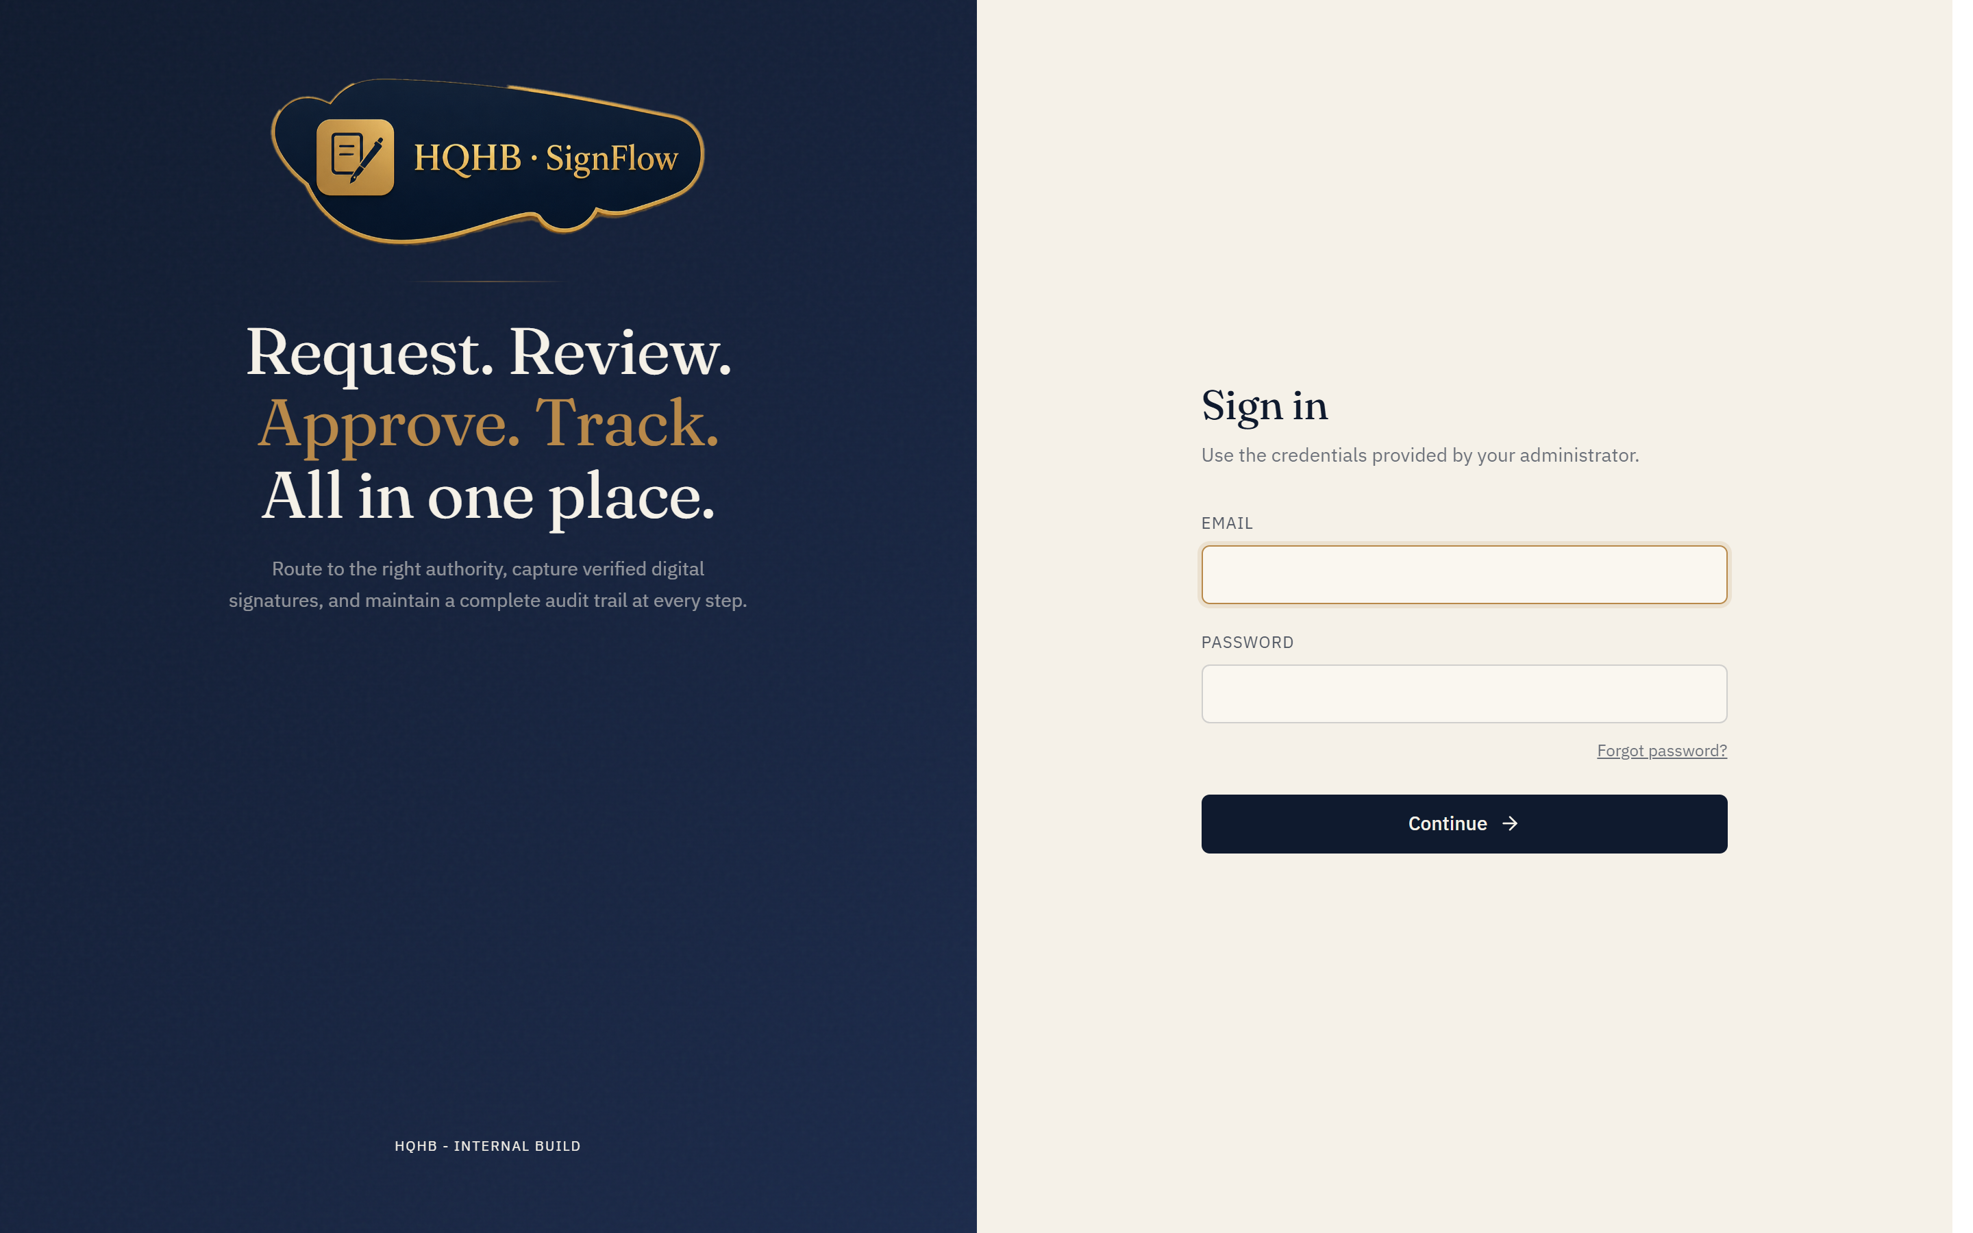
The SignFlow sign-in screen — https://onesign.devhqhb.online/

What you can do
Your role | What you do
Requestor | New request → upload a PDF/Excel → choose the approver(s) or send it to a specific person by email → place the signature box → submit. Track progress and download the signed file.
Approver | Open a pending request → review the document → Approve & sign (your signature is stamped on), or Reject with a reason.
Administrator | Manage users, teams, signatures, documents, and reports from the admin console.

No account yet? If self-registration is enabled, click Create an account on the sign-in screen, enter your details, and IT approves your request — then you sign in with the password you chose.
Need help? Email it@hqhb.in or taha.chunawala@hqhb.in.

