SignFlow — Requestor Guide
Submitting documents for signature

Before you start
- Sign in at https://onesign.devhqhb.online/ with your email and temporary password; change your password.
- Register your signature (draw or upload). This is required before your first request — you can defer it, but you’ll be asked again.
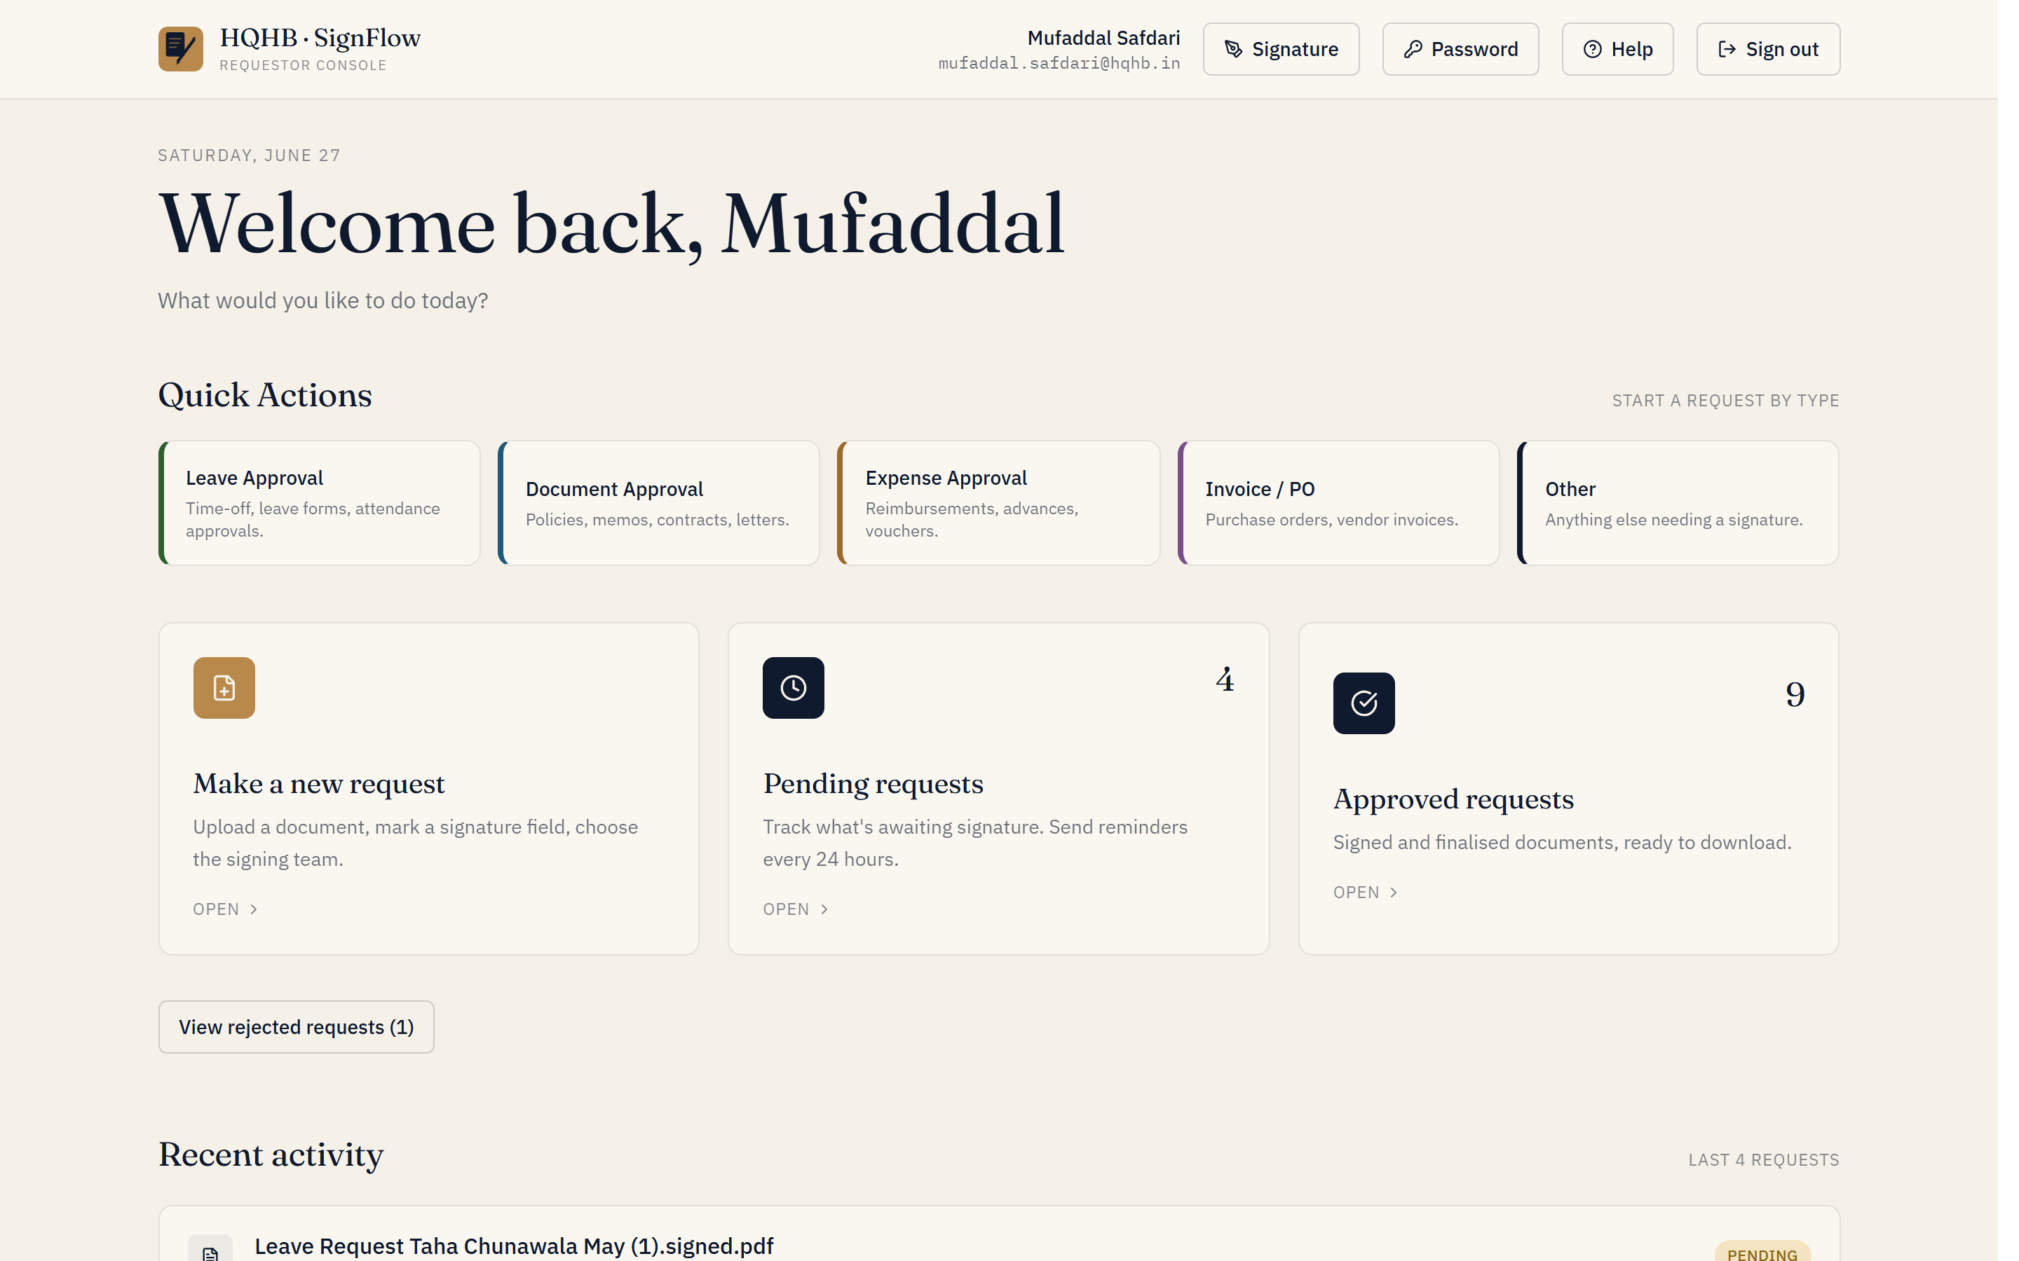
Your Requestor home — quick actions and your requests at a glance.

Make a new request
- Click New request and upload your document — a PDF or Excel file, up to 14 MB.
- Choose how it should be approved: Single approver (any approver from one team), Multi-step workflow (specific signers, in a set order), or Send to a specific person (request a signature from any individual by name or email).
- Optionally tick Instant approval to skip the one-hour cooling window.
- Place the signature box on the document and pick the team / signers (see below).
- Add an optional note and submit. Each signer is notified in turn.
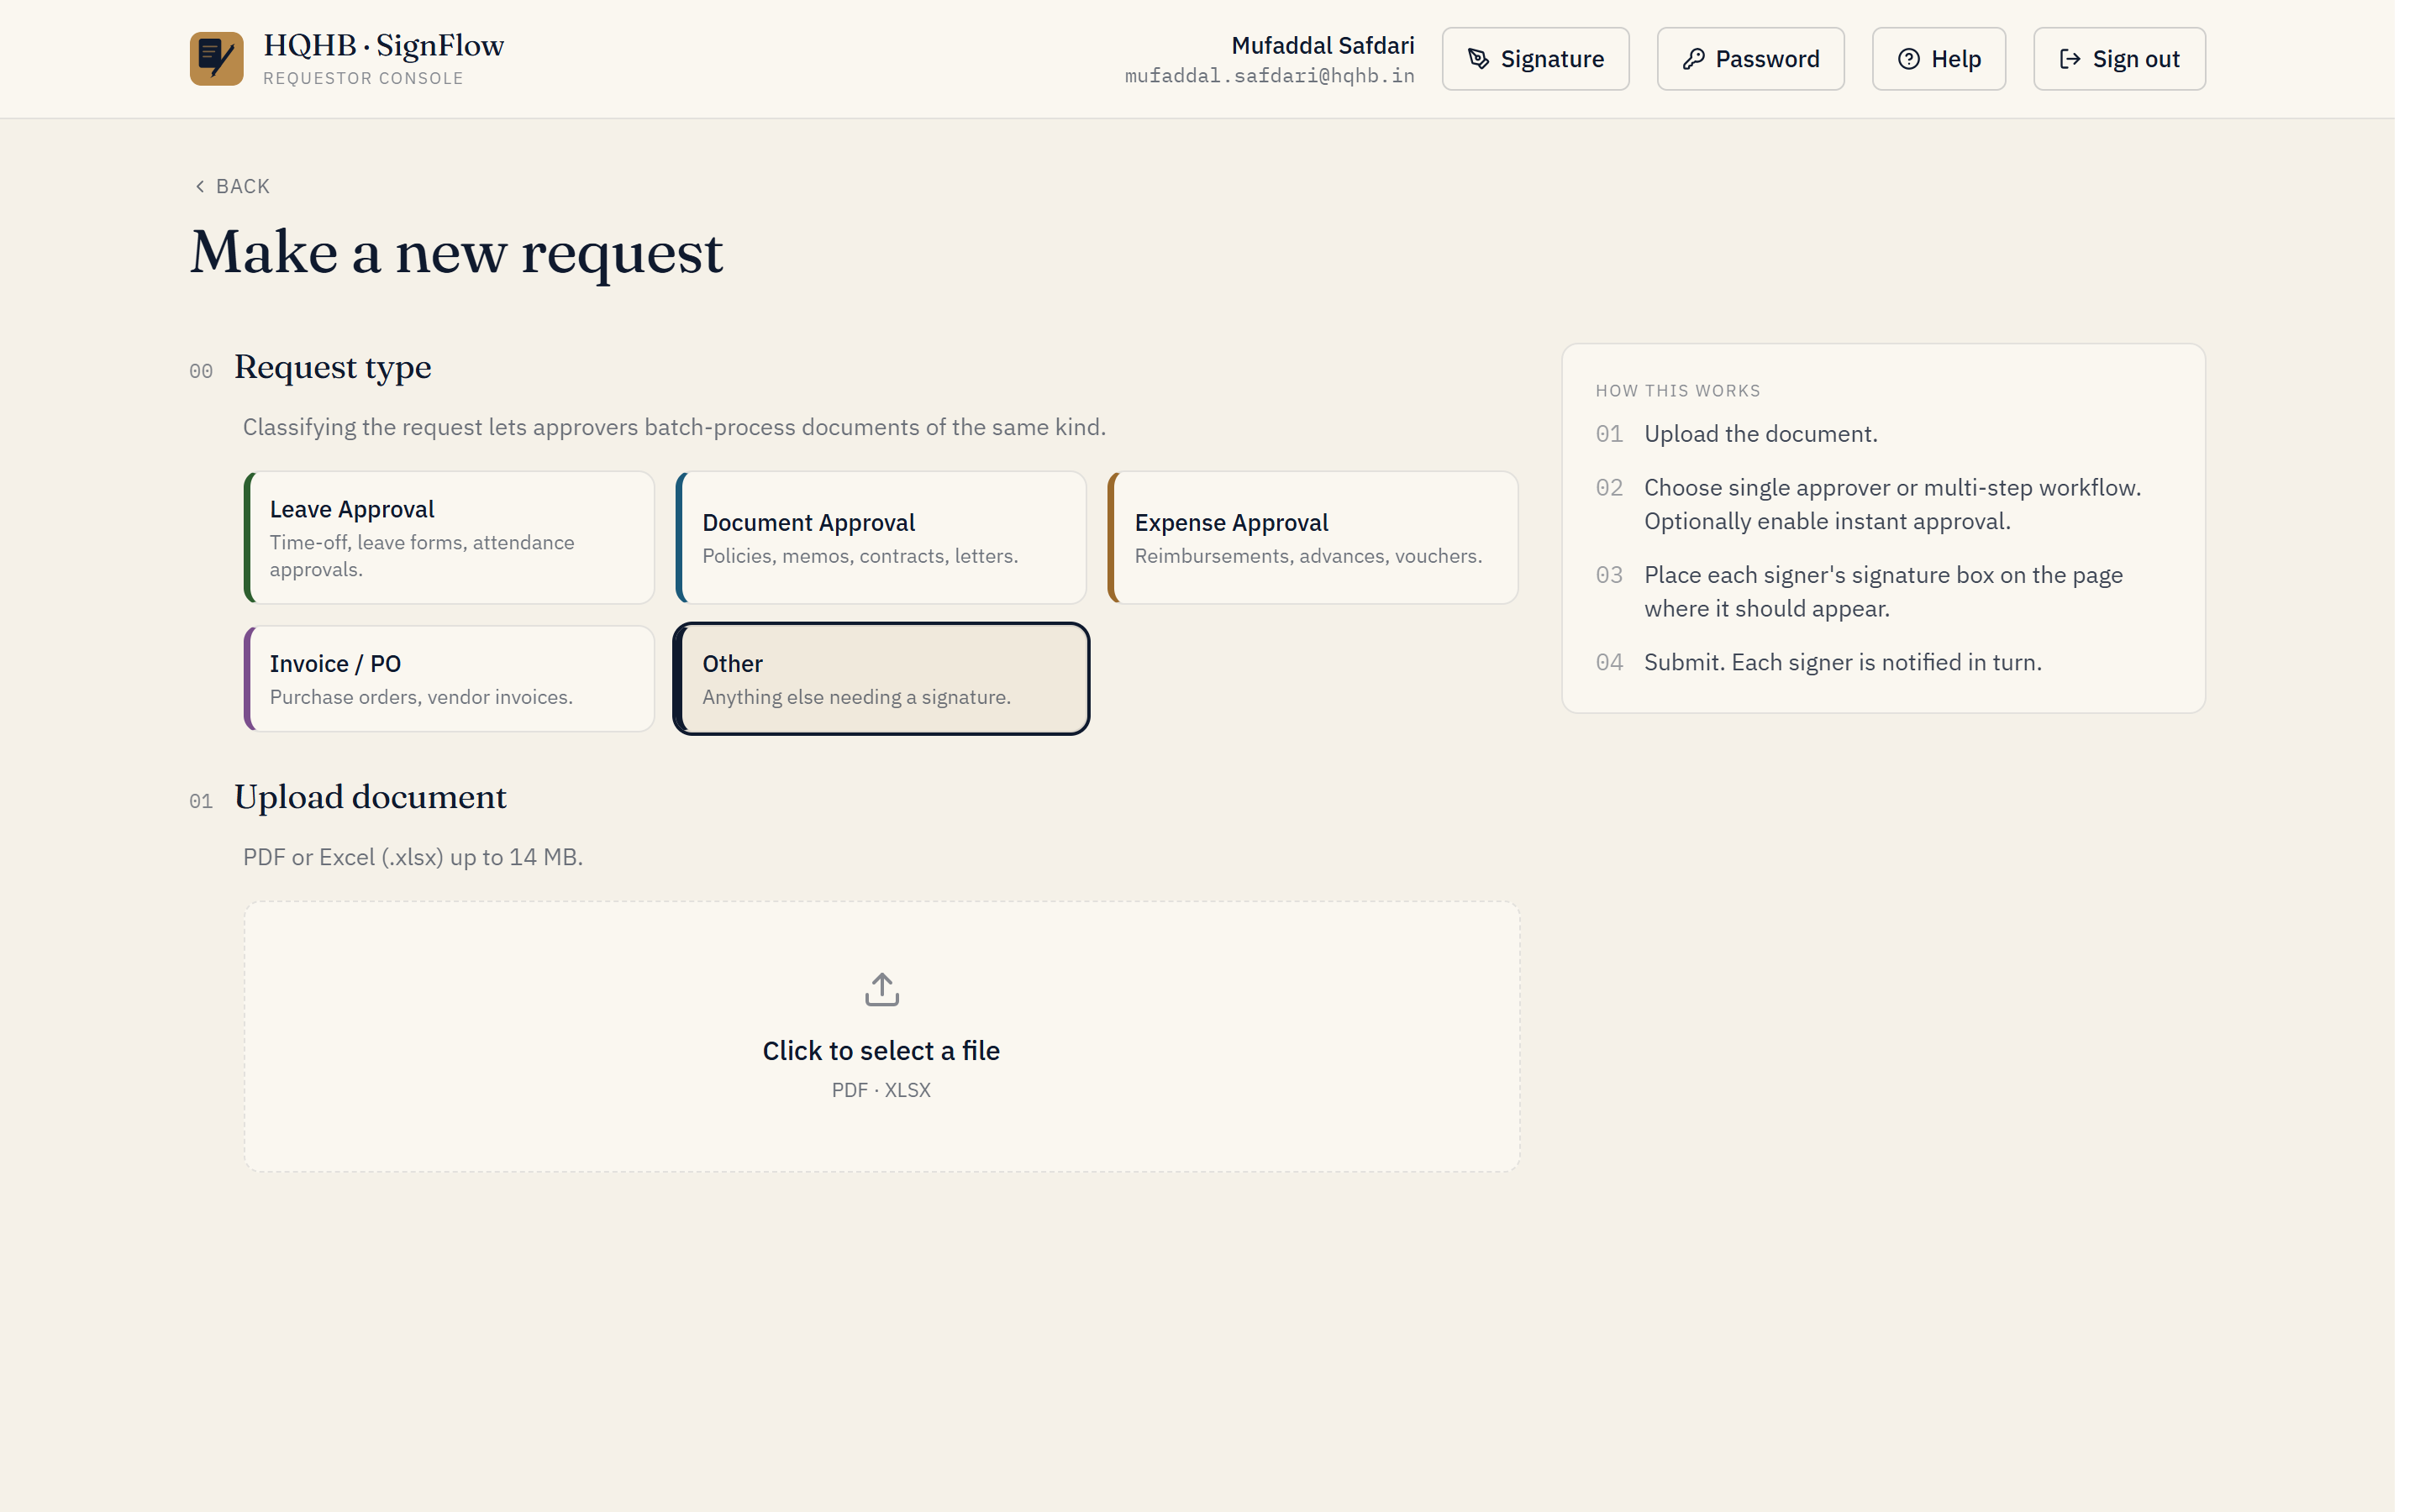
Starting a new request: choose a type, then upload your PDF or Excel.

Single-approver mode
- Click on the document where the signature should appear to drop one signature box.
- Pick the team — the request goes to any approver with authority for that team.

Multi-step workflow mode
- Add a step, pick the team, then Add signer.
- Click Place signature and drag a box on the relevant page for that signer.
- Repeat per signer / per step. Cross-team workflows are supported — signers are asked in order.

Send to a specific person
- Upload a PDF, then choose Send to a specific person (this mode is PDF-only).
- Search the directory by name or email and pick the person — this works for any user, regardless of team or role.
- If no one matches, they don’t have an account yet; ask them to register first (or have IT add them).
- Place their signature box on the page and submit. They’re notified and the document appears in their Awaiting your signature area.
Use this when you know exactly who should sign and they aren’t one of a team’s approvers — for example a colleague in another department.

Track your requests
- Pending — see exactly who the request is waiting on. You can send a reminder once every 24 hours.
- Approved — preview or download the signed file.
- Rejected — see the reason given, then correct and resubmit.

Signing a request someone sent you
If a colleague sends a document straight to you, it appears under Awaiting your signature on your home screen, with a count. Open it, review the document, and Review & sign — exactly like an approver. You’ll need a registered signature; if you don’t have one yet, you’ll be prompted to add it first.
Tip: name your files clearly before uploading — the file name is what approvers and the audit log show.

