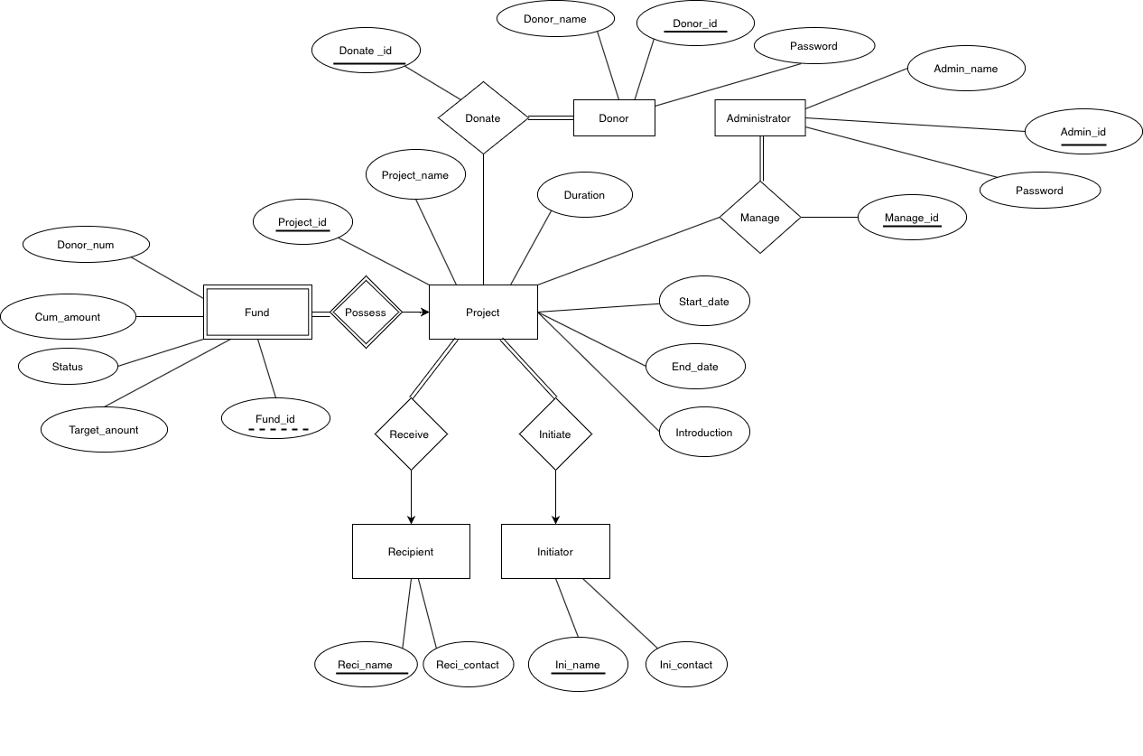

When we designed the database, we made several assumptions.

1. One donor can only donate several times for each project.
2. Each administrator is able to manage all the projects, but he cannot donate.
3. One project has exactly one recipient and one initiator.
4. Each project corresponds to one fund. However, one fund can be possessed by several projects.

According to definition, a relation schema R is in Boyce-Codd Normal Form (BCNF) if for all functional dependencies in F + of the form α→β where α ⊆ R and β ⊆ R, at least one of the conditions holds:

(1) α → β is trivial

(2) α is a superkey for R

We find the functional dependencies all meet these two requirements. For a schema, the id or name or two ids together determine all other attributes. For example, as a superkey for Project, *Project_id* determines *Projection_name*, *Start_date, End_date* and *Introduction*. For weak entity Fund, Fund_id and Project_id together determine *Donor_num*, *Cum_amount*, *Target_amount* and *Status*. In Recipient entity, superkey *Recipient_name* determines *Contact_details*. Therefore, we can say that our relation schemas are perfectly in BCNF, and such normal forms completely eliminate the possibility of redundancies, which means our database is a perfectly non-redundant design.