**Software Quality Assurance and Testing Technology Assignment 2**

**White Box Testing**

**Q1: White Box Testing**

Here is a part of program code shown in Table.1

1. Please draw the control flow graph of the following code and provide the cyclomatic complexity V(G) of the control flow graph;
2. Please provide the Basis Path set of the control flow graph;
3. Please provide an example of Basis Path combination (Pass or Fail) for detecting possible error;
4. Please provide the All-du-paths (ADUP) of the code (all the variables should be included);

**Table 1: Part of Program Code**

1 public List<List<Integer>> permuteUnique(int[] nums)

2 {

3 ArrayList<List<Integer>> rst = new ArrayList<List<Integer>>();

4 if (nums == null) {

5 return rst;

6 }

7 if (nums.length == 0){

8 rst.add(new ArrayList<Integer>());

9 return rst;

10 }

11 Arrays.sort(nums);

12 ArrayList<Integer> list = new ArrayList<Integer>();

13 int[] visited = new int[nums.length];

14 for (int i = 0; i < visited.length; i++) {

15 visited[i] = 0;

16 }

17 helper(rst, list, visited, nums);

18 return rst;

19 }

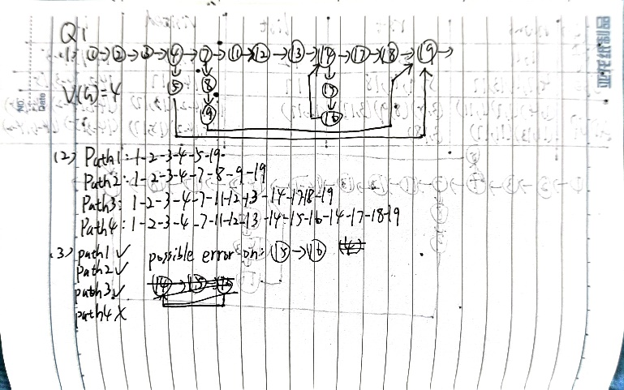

**Q2: White Box Testing**

Here is a part of program code shown in Table.2

1. Please draw the control flow graph of the following code and provide the cyclomatic complexity V(G) of the control flow graph;
2. Please provide the Basis Path set of the control flow graph;
3. Please provide an example of Basis Path combination (Pass or Fail) for detecting possible error;
4. Please provide the All-du-paths (ADUP) of the code (all the variables should be included);

**Table 2: Part of Program Code**

1 public static void bubbleSort(int[] array)

2 {

3 int tmp;

4 boolean flag = false;

5 for(int i = array.length-1;i >= 0;i--)

6 {

7 for(int j=0;j<i;j++)

8 {

9 if(array[j]>array[j+1])

10 {

11 tmp = array[j];

12 array[j] = array[j+1];

13 array[j+1] = tmp;

14 flag = true;

15 }

16 }

17 if(!flag) break;

18 }

19 }

