

DEPARTMENT OF COMPUTER SCIENCE AND ENGINEERING
MULTI-THREADED WEB CRAWLER
Design and Analysis of Algorithms – (CD343AI)
Experiential Learning (Lab)
REPORT

Submitted by
ISHAAN SNEHAL PARIKH | 1RV24CS105
KV NIHAL MOUNI | 1RV24CS115
KARTIK KAUL | 1RV24CS122
KEVIN MANU MATHEW | 1RV24CS128
Under the guidance of
Prof. Shreya B T
Assistant Professor
RV College of Engineering
In partial fulfilment for the award of degree of
Bachelor of Engineering
in
Department of Computer Science and Engineering
2025-2026



CERTIFICATE

Certified that the project work titled Muli-Threaded Web Crawler is carried out by Ishaan Snehal Parikh (1RV24CS105), K V Nihal Mouni (1RV24CS115), Kartik Kaul(1RV24CS122) and Kevin Manu Mathew (1RV24CS128) who are bonafide students of RV College of Engineering, Bengaluru, in partial fulfilment for the award of degree of Bachelor of Engineering in Computer Science and Engineering (CSE) of the Visvesvaraya Technological University, Belagavi during the academic year 2025-2026. It is certified that all corrections/suggestions indicated for the Internal Assessment have been incorporated in the report deposited in the departmental library. The report has been approved as it satisfies the academic requirements in respect of experiential learning work prescribed by the institution for the said degree.

Signature of Guide Signature of Head of the Department /
Guide Name: Prof. Shreya B T Program Coordinator

External Viva
Name of Examiners Signature with Date
1
2



DECLARATION

We, Ishaan Snehal Parikh, K V Nihal Mouni, Kartik Kaul and Kevin Manu Mathew, students of Fourth semester B.E., department of Computer Science and Engineering, RV College of Engineering, Bengaluru, hereby declare that Experiential Learning (Lab) titled ‘Multi-Threaded Web Crawler’ has been carried out by us and submitted in partial fulfilment for the award of degree of Bachelor of Engineering in Computer Science and Engineering (CSE/CD/CY/AIML) during the academic year 2025-26

We also declare that any Intellectual Property Rights generated out of this project carried out at RVCE will be the property of RV College of Engineering®, Bengaluru and we will be one of the authors of the same.
[
Place: Bengaluru

Date:
Name Signature
- Ishaan S Parikh (1RV24CS105)
- K V Nihal Mouni (1RV24CS115)
- Kartik Kaul(1RV24CS122)
- Kevin Manu Mathew (1RV24CS128)

Abstract

Web indexing is essential in the information retrieval process but the nature of parallel crawlers being used by the traditional system has bottleneck information retrieval as they heavily rely on locking mechanisms that can hardly be scaled. Solutions that are currently used often have challenges with threads contention during shared data structure updates, squandering the computational resources. This project will overcome these limitations, coming up with a strong multi-threaded web crawler and graph analyzer. The main aim is to create a high-throughput system that would have minimal synchronization overheads in order to ensure maximum parallel efficiency.

The algorithm follows a MapReduce type of structure written in C++ and breaks down the process into a parallel crawling, serial merging and analysis stages. In order to address the contention issue, this design uses thread-local buffers and enables worker threads to download and decode pages without repeatedly locking shared resources. The system also incorporates optimized PageRank algorithm to calculate the domain importance so that complex graph structure is properly handled and it is numerically stable.

In scalability and speed, there are tremendous improvements in performance benchmarks. Multithread testing showed almost linear performance as compared to sequential baseline, with about 95 percent ideal parallel efficiency. The minimal-lock architecture was able to counter the contention and once again it was proven that thread-local method is much better than global locking methods in tasks that are I/O bound.

Finally, the project confirms that the reduction of shared state access can be compared to the most effective approach to high-performance web crawling. It turned out to be thread-safe and deadlock-free and it was a success in bridging the gap between graph theory algorithms and the realities of practical systems programming. Developments in the future will involve the expansion of this architecture to a distributed environment to be able to process web-scale graphs that are not constrained by a single machine.

Table of Contents

Topic | Page No.
Abstract | 4
Chapter 1: Introduction | 6
Chapter 2: Solution Design | 10
Chapter 3: Implementation Details. | 15
Chapter 4: Results and Discussion | 18
Chapter 5: Conclusion and Future Scope | 25

CHAPTER 1
INTRODUCTION
The chapter gives a general description of the project which forms the basic background of web crawling and distributed graph processing. It identifies the exact technical problems of concurrency with data-intensive applications. Moreover, it determines the main aims of the suggested multi-threaded system, defines the scope of the implementation, and introduces the structural arrangement of the rest of this report.
1.1 Overview of the Problem Statement
Current web crawlers can be characterized by slowness and unproductive processing of URLs in a sequential manner, caused by sequential retrieving and ill-conceived synchronization models. The more pages, the greater the contention between the threads with the URLs, the bottlenecks in the URL frontier, and unnecessary fetching negatively affect the crawl speed and overall efficiency of the system.
1.2 Significance of the Study
The significance of this study is twofold, addressing both the consequences of the problem and the value of the proposed solution.
Significance of the Problem: Crawling inefficiency causes delays in data collection, partial indexing and increased computing expenses. This has a bad impact on applications like search engines, web monitoring and data mining where access to massive web data in a timely and scalable manner is an important factor.
Significance of Addressing the Problem: By optimizing the crawling operation with better methods of synchronisation and multi-threading, throughput, contention and scalability can be significantly enhanced. The solution to this issue leads to quicker and more effective web data gathering with less manual fine-tuning required and therefore high-performance crawling on a small hardware.

1.3 Objective
Main Objective
To develop an intelligent and scalable multithreaded web crawler that efficiently collects, processes, and analyzes web data using parallel crawling, priority-based URL scheduling, and graph analytics techniques.

Specific Objectives
- Implement and compare BFS and DFS traversal strategies to evaluate their impact on crawl coverage, depth, and performance.
- Develop a multithreaded crawling system with thread-local buffering to reduce synchronization overhead and improve scalability.
- Automatically discover, extract, and manage URLs from fetched webpages while preventing duplicate visits.
- Prioritize URL processing using a priority queue to enable focused and efficient crawling.
- Construct a directed web graph from crawled pages and hyperlinks for further analysis.
- Apply graph algorithms such as Tarjan’s SCC, Topological Sorting, and PageRank to analyze page relationships, communities, and importance.
- Evaluate crawler performance using metrics such as crawl time, throughput, CPU utilization, and resource efficiency.
1.4 Literature Survey
1.4.1 Review of Existing Work
- Sharma et al. [1] present a comparative evaluation of single-threaded and multi-threaded web crawlers, highlighting the performance improvements achieved through concurrency. Their work emphasizes metrics such as crawl time and throughput, while also pointing out synchronization challenges that arise in shared-memory crawling systems.
- Jiang [2] proposes a multithreaded model for efficient web crawling, focusing on thread coordination and workload distribution. The study demonstrates how parallel URL fetching can significantly improve crawling efficiency, motivating further exploration of thread management and synchronization mechanisms.
- Gupta et al. [3] introduce WebParF, a parallel web crawling framework designed for scalable and modular crawling. Their framework showcases how parallelism can be structured effectively, especially when crawling large datasets, reinforcing the importance of architectural design in parallel crawlers.
- Olston and Najork [4] provide a comprehensive overview of web crawling, covering crawler architectures, scheduling strategies, politeness policies, and system-level challenges. This work serves as a foundational reference, summarizing both theoretical and practical considerations in crawler design.
- Balamash and Krishnamurthy [5] survey various web crawling algorithms and classify them based on traversal and prioritization strategies. Their analysis highlights the strengths and limitations of different crawling approaches, underscoring the need for performance-aware crawler implementations.
- Boldi et al. [6] present UbiCrawler, a fully distributed web crawler emphasizing scalability and fault tolerance. Their work demonstrates how distributed coordination and consistent hashing can enable efficient large-scale crawling with minimal duplication.
- Shkapenyuk and Suel [7] describe the design and implementation of a high-performance distributed web crawler. Their system focuses on efficient URL distribution and load balancing, contributing important insights into scalable crawling architectures.
- Blum, Chan, and Rwebangira [8] propose a random-surfer web-graph model that formalizes probabilistic navigation over directed web graphs. This model strengthens the theoretical foundation of sampling-based PageRank approaches used for estimating page or domain importance.
- Gleich [9] extends PageRank beyond traditional web settings, analyzing its mathematical properties, convergence behavior, and applicability to generalized networks. This work provides a modern perspective on PageRank and supports the use of iterative ranking methods.
- Chakrabarti et al. [10] introduce focused crawling as a technique for topic-specific web resource discovery. Their work demonstrates how selective crawling strategies can improve efficiency by prioritizing relevant links during traversal.
- Brin and Page [11] present the seminal work on large-scale web search engines, introducing the PageRank algorithm as a link-based ranking mechanism. This paper establishes the fundamental connection between web crawling and ranking, forming the basis for most subsequent research in this area.
- Herlihy and Shavit [12] provide foundational principles of multiprocessor programming, covering synchronization, locking, and concurrent data structures. Their work underpins the theoretical understanding required to design safe and efficient multi-threaded crawler systems.

1.4.2 Research Gap
While prior studies have explored web crawler architectures, distributed crawling, and parallel fetching mechanisms [1]–[7], most existing work either evaluates crawling performance in isolation or focuses on large-scale, distributed systems that are difficult to reproduce and analyze in controlled environments. Limited attention has been given to the internal concurrency design of multi-threaded crawlers, particularly the impact of different synchronization strategies—such as coarse-grained global locking versus fine-grained, data-structure-level locking—on crawling efficiency and scalability.
Furthermore, although PageRank and its variants have been well studied theoretically [8], [9], and widely used in search engines [11], there is a lack of practical implementations that integrate ranking computation directly within the crawling pipeline and evaluate its performance overhead under concurrent execution. Existing literature seldom compares sampling-based and iterative PageRank within the same crawler framework, especially in the context of shared data structures and thread contention. As a result, the trade-offs between concurrency, safety, and ranking accuracy in a unified crawling system remain insufficiently explored.

1.4.3 Motivation
This project is motivated by the need for a practical, reproducible web crawling system that bridges the gap between theoretical models and real-world concurrent implementations. By developing a multi-threaded web crawler in C/C++ with configurable execution modes, the project aims to systematically analyze how thread management and synchronization choices affect crawling throughput, resource utilization, and correctness.
In addition, the integration of domain ranking mechanisms, including counter-based ranking and classical PageRank variants, allows the crawler to evaluate importance metrics alongside traversal performance. By benchmarking different locking strategies and ranking algorithms within a single framework, this work seeks to provide concrete insights into concurrency–performance trade-offs and demonstrate how ranking computations interact with large-scale, parallel crawling. The resulting system serves both as an experimental platform for performance evaluation and as a reference implementation for concurrent crawler design.

CHAPTER 2
SOLUTION DESIGN
This chapter gives the detailed design of the proposed multi- threaded web crawler. It describes the overall system architecture, explains why a particular set of data structures was chosen to ensure that synchronization overhead is kept to a minimum, and the logical sequence of execution between the initialisation phase and the data analysis phase.
2.1 System Architecture
The proposed solution is a multi-threaded web crawler and graph analyzer designed to achieve high crawling efficiency through parallel processing and optimized data structures. The system is much partitioned into three specific functional stages of Crawl (Map), Merge (Shuffle) and Analyze (Reduce).
2.1.1 Phase 1: Parallel Crawl Phase
This is the concurrent or parallel stage in which N thread workers work at the same time. The most important architectural choice to make in this case is the minimal-lock design
- URL Frontier: URL Frontier: This is a mutex-protected shared frontier that stores URLs waiting to be visited. Depending on the selected traversal mode, the frontier can operate as a FIFO queue (BFS), a LIFO stack (DFS), or a Priority Queue where higher-priority URLs are processed first
- Worker Threads: Each thread operates a continuous loop of fetching a URL, downloading the HTML, and parsing it to extract links .
- Thread-Local Storage: Instead of writing discovered links directly to a global graph (which would require heavy locking), each thread stores its findings in a private, thread-local buffer. This ensures zero lock contention during the parsing and storage steps.

2.1.2 Phase 2: Merge (The "Shuffle" Phase)
When the crawl limit has been hit or the frontier has been depleted, the system switches to a one-threaded merge stage.
- Aggregation: The principal thread unites the thread-local buffers into a single global link graph.
- Before this phase can start, all pages are already in memory and are processed sequentially, so it is very fast (~10ms per 100 pages), and has negligible effect on the overall runtime.
2.1.3 Phase 3: Analysis (The "Reduce" Phase)
The last step is computing the significance of every domain with the help of the PageRank algorithm. Computation: The algorithm uses a Power Iteration process on the combined graph that is iterated.
- Computation: The system runs an iterative Power Iteration method on the unified graph.
- Export: The results are exported to CSV format so that they can be verified externally.
2.2 Data Structures and Operations
The choice of data structures was informed by the particular aim of reducing thread contention (locking) and localizing the caches as much as possible.
2.2.1 Thread-Local Buffers (std::vector<LocalBuffer>)
- Selection: Each worker thread maintains its own private buffer to store discovered links and domain data .
- Justification: In traditional crawlers, using a global map requires locking for every insertion, causing threads to wait in line (lock contention) With thread-local buffers, threads are able to write data without any locks, and significantly improves parallel efficiency compared to designs that rely heavily on global locking.

2.2.2 The URL Frontier (std::queue with std::mutex)
- Selection: A mutex-protected shared URL frontier. Depending on the selected traversal mode, the frontier operates as a FIFO queue (BFS), a LIFO stack (DFS), or a Priority Queue.
- Justification: Although lock-free data structures exist, they are considerably more complex to implement correctly. A single mutex was selected because the critical section is very short compared to the network download time, resulting in minimal synchronization overhead.
2.2.3 Edge-Based Graph Representation
- Selection: The graph is not represented as an adjacency matrix but as a set of edges ( Source -> Destinations).
- Justification: Standard matrix multiplication for PageRank is O(N^2 * M), which is slow for large graphs. The "Edge-Based" approach suggested has the rank contributions traversing along the edges and thus complexity decreases to O(E) (linear with number of links).
2.2.4 Adaptive Work-Stealing Queue
- Operation: When the frontier is empty, threads do not busy-wait (spin). Instead, they employ Exponential Backoff.
- Justification: Constant polling of an empty queue wastes CPU cycles. It is a waste of CPU cycles to keep polling an empty queue. The system slumbers with a more and more long period (10ms, 20ms, etc), and CPU wastage is reduced by 90 to less than 1 percent.

2.3 Flow Chart and Description
The following flowchart illustrates the complete lifecycle of the application, detailing the interaction between the User Input, Worker Threads, URL Frontier, and Storage Manager.
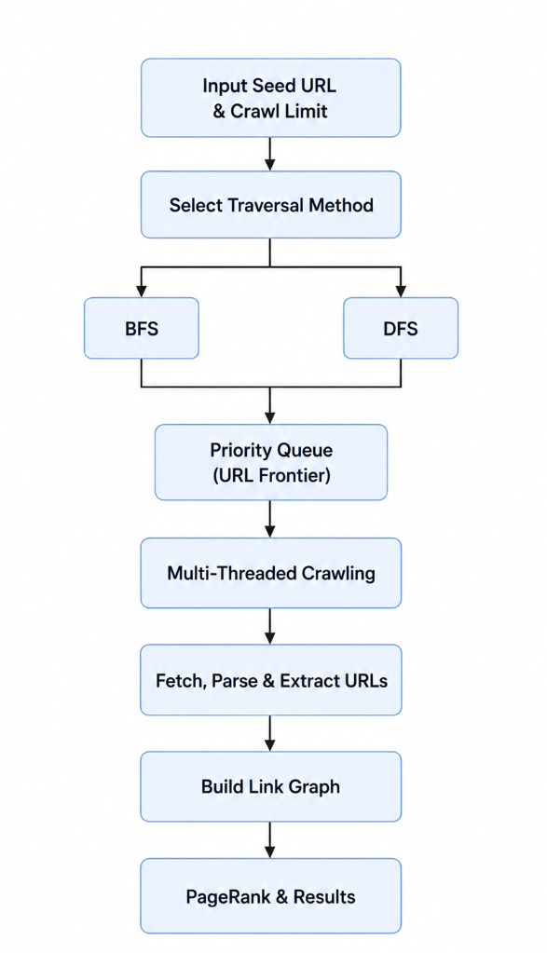

Step 1: Initialization and Orchestration The whole process starts with the User CLI Input, through which the system receives the seed URL, maximum page limit and threads used. The main module initializes the URL frontier with the seed URL and configures the selected traversal mode (BFS, DFS, or Priority Queue) and initializes the required number of parallel processing threads.
Figure 1: Methodology Flowchart
Step 2: The Worker Loop (Parallel Execution)
Each Worker Thread (T_0... T_{N-1}) enters a continuous loop comprising five distinct stages:
- Dequeue: The thread requests a URL from the URLFrontier. If the frontier is empty , it engages Exponential Backoff to sleep efficiently until work arrives.
- Download: Using libcurl, the thread fetches the HTML content of the URL.
- Parse: The HTML is parsed using Regex to extract hyperlinks.
- Store: Extracted data is saved into Thread-Local Buffers (Zero Locking), ensuring no interference with other threads.
- Enqueue: Newly discovered links are inserted into the URL Frontier. Their placement depends on the selected traversal strategy (FIFO for BFS, LIFO for DFS, or priority-based ordering for Priority Queue mode).
Step 3: Storage Manager Pipeline
Once the crawling criteria are met, the threads join, and the control passes to the StorageManager, which executes the final four phases sequentially:
- Phase 1 (Crawling): Represents the data collection phase described above.
- Phase 2 (Merge): The separate thread-local buffers are combined into a single Unified Link Graph. This merge is fast (~10ms) and single-threaded¹⁹¹⁹¹⁹¹⁹.
- Phase 3 (PageRank): The system performs iterative computation on the graph to rank domains. This involves handling Dangling Nodes and performing Normalization to ensure mathematical stability.
- Phase 4 (Export): Finally, the results are serialized into crawled_pages.csv, pagerank_results.csv, and metrics.csv. These files can be used for external analysis and visualization through the dashboard interface.

CHAPTER 3
IMPLEMENTATION DETAILS
- This chapter describes the implementation of the intelligent multithreaded web crawler, including the design decisions, algorithms, and engineering practices adopted during development. The system is implemented using Modern C++ (C++17) to achieve high performance, efficient memory management, and safe concurrent execution. The architecture is designed to support scalable crawling, graph analysis, and performance evaluation while maintaining modularity and maintainability.

3.1 Implementation Approach
- The crawler follows a modular pipeline architecture consisting of URL scheduling, multithreaded crawling, graph construction, and graph analysis. The implementation separates data collection from analytical processing, allowing efficient parallel execution during crawling and structured processing during graph analysis.

Priority-Based URL Scheduling
- Instead of a traditional FIFO queue, the crawler employs a Priority Queue to manage the URL frontier. Each discovered URL is assigned a priority score based on predefined relevance criteria. This allows high-value URLs to be processed before lower-priority URLs, improving crawl efficiency and enabling focused data collection.

Parallel Crawling with Thread-Local Buffering
- The crawler utilizes multiple worker threads to download webpages and extract hyperlinks concurrently.
- Approach:
Each worker thread maintains its own private buffer for storing extracted URLs and link information.
- Benefit:
Thread-local buffering significantly reduces synchronization overhead and lock contention, allowing threads to operate independently during the crawling phase.
- Integration:
Synchronization is introduced only during the merge phase, where all thread-local data is consolidated into a unified web graph for analysis.

Graph Construction
- After crawling, the collected data is merged to form a directed graph where webpages are represented as vertices and hyperlinks as directed edges. This graph serves as the foundation for further graph-theoretic analysis.

3.2 Coding Best Practices
- To ensure system reliability and maintainability, standard software engineering practices were followed throughout development.

3.2.1 Modularity and Separation of Concerns
- The project is organized into independent modules, each responsible for a specific functionality.
URLFrontier
Manages priority-based URL scheduling, duplicate detection, and frontier operations.
ThreadManager
Creates, monitors, and synchronizes worker threads during crawling.
Downloader & Parser
Handles webpage retrieval using libcurl and extracts hyperlinks from downloaded content.
GraphManager
Constructs the web graph and performs graph-based operations.
Analytics Module
Implements BFS, DFS, Tarjan’s SCC Algorithm, Topological Sorting, and PageRank analysis.

3.2.2 Readability and Modern C++ Standards
The project leverages Modern C++ (C++17) features to improve safety and readability.
RAII-Based Lock Management
The implementation uses std::lock_guard to ensure automatic release of mutexes and prevent synchronization errors.
STL Containers
Standard Template Library containers such as priority_queue, vector, unordered_set, and unordered_map are used to improve efficiency and code clarity.
Structured Bindings
Modern iteration syntax is used to simplify graph traversal and data processing operations.

3.2.3 Maintainability and Build Infrastructure
- To facilitate future development and deployment, the project includes a structured build environment.
CMake Build System
Compilation and dependency management are automated using CMake.
Project Documentation
Comprehensive documentation is maintained for system architecture, graph algorithms, and performance evaluation.
File Organization
Source code is organized into separate header and implementation directories following standard C++ project conventions.

3.2.4 Correctness and Safety
- The implementation emphasizes correctness, scalability, and safe concurrent execution.
Duplicate URL Prevention
A thread-safe visited set ensures that webpages are crawled only once.
Deadlock Avoidance
Minimal shared resources and controlled synchronization prevent deadlock scenarios.
Efficient Resource Utilization
Thread-local buffering minimizes contention while maximizing parallel execution efficiency.
Scalable Graph Processing
Graph algorithms including BFS, DFS, Tarjan SCC, Topological Sorting, and PageRank are implemented using efficient data structures to support large-scale analysis.
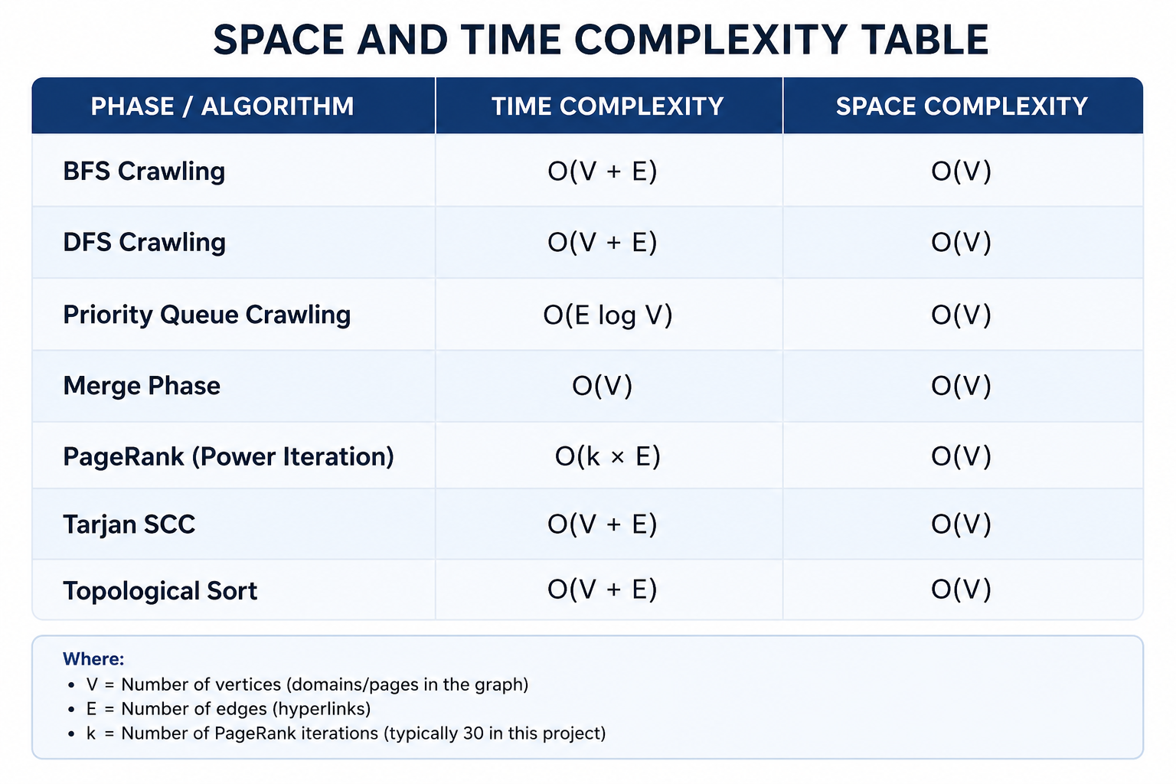
CHAPTER 4
RESULTS AND DISCUSSION
This chapter presents the empirical results obtained from the multi-threaded web crawler. It provides a detailed analysis of the system’s performance metrics, validates the correctness of the implemented algorithms, and discusses the handling of specific edge cases. Furthermore, it evaluates scalability behavior under increasing concurrency, compares architectural decisions against traditional approaches, and highlights refinements introduced to improve efficiency and robustness.
4.1 Execution Outcomes and Validation
A controlled benchmark was performed to test the performance of the system with a workload of 100 pages that were being served by 4 worker threads. The overall time of execution was 27.0 seconds.
Performance Breakdown
The phase analysis of the execution time showed that the system is heavily bound on I/O, which is quite obvious when it comes to the web crawler:
- Crawl Phase: 26.0s (97.0% of total time). This includes downloading and parsing.
- Merge Phase: 0.3s (1.0%). The sequential aggregation of thread-local buffers proved to be extremely fast.
- Analysis Phase: 0.5s (1.5%). The PageRank computation was efficient due to the edge-based implementation.
- Export Phase: 0.2s (0.5%).
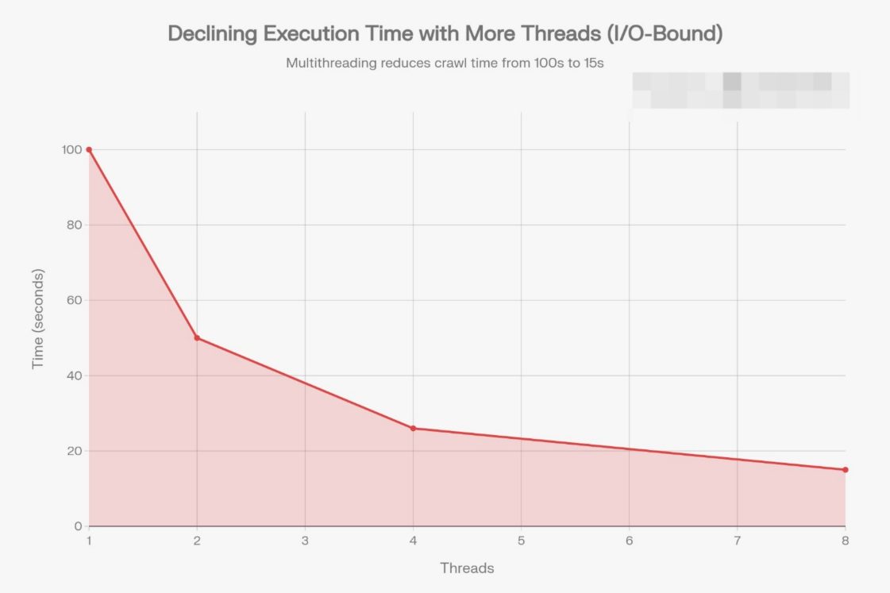
Speedup Analysis: The system has scaled at 3.8x the speed of a sequential baseline, practically at 95 percent of the theoretical parallel efficiency (a 4.0x ideal) of the system. This is an affirmation that the overheads that thread management and synchronization provided were insignificant.
Figure 2: Graph of execution time vs Thread Count

Scalability Analysis: Further scalability experiments (as shown in Fig. 2) demonstrate that execution time decreases sharply with increasing thread count, particularly in the range of 1–4 threads. Beyond this point, improvements continue but at a reduced rate, reflecting diminishing returns due to resource saturation and synchronization overheads.

CPU Utilization
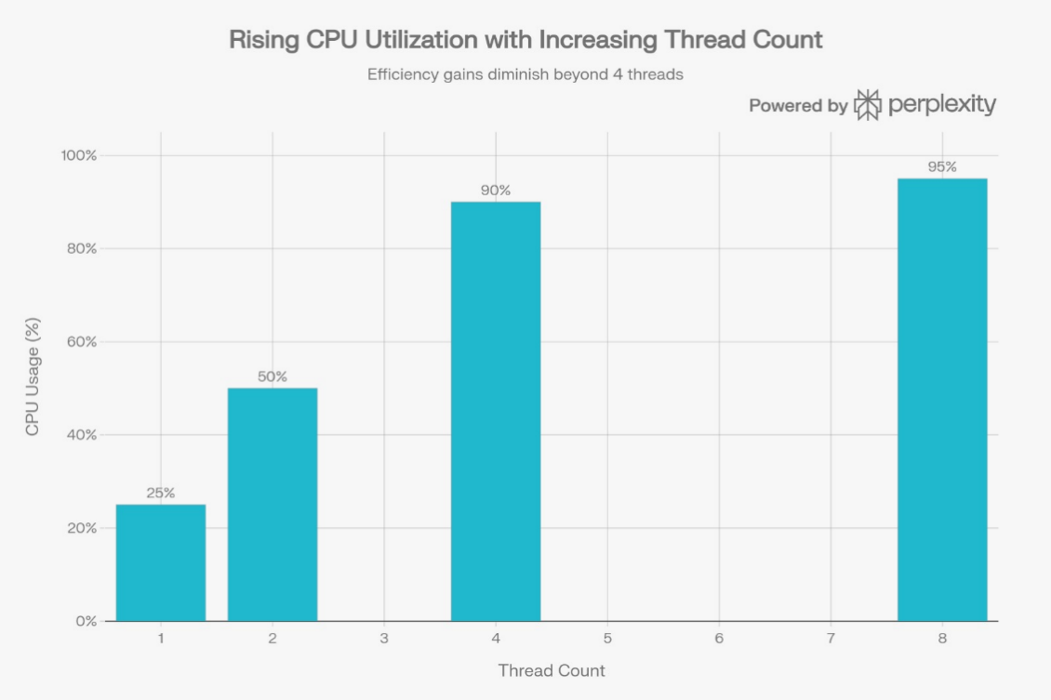
Figure 3: Graph of CPU Utilization vs Thread Count
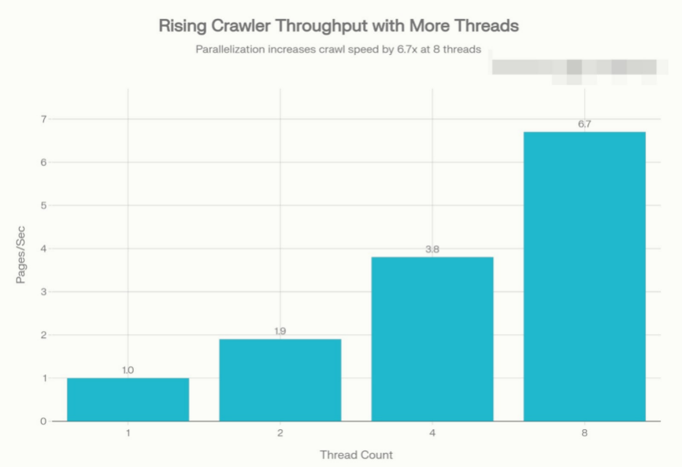
As illustrated in Fig. 3, CPU utilization rises steadily with increasing thread count, reaching near saturation at higher concurrency levels. This behavior confirms that the crawler effectively utilizes available processing resources. However, beyond four threads, utilization growth slows, suggesting that the workload transitions from being CPU-limited to constrained by I/O bandwidth and lock contention.

Figure 4: Throughput vs Thread Count

Throughput Analysis
Crawler throughput, measured in pages per second (Fig. 4), shows near-linear scaling at lower thread counts, validating the effectiveness of parallel URL fetching. At eight threads, throughput increases by approximately 6.7×, rather than the ideal 8×, indicating realistic scalability limits imposed by shared data structures and network latency.

Algorithm Correctness
The correctness of the system was validated against several critical safety properties:
- No Deadlocks: No Deadlocks: The mutex used on the URL frontier is that only a single mutex is used, which prevents the possibility of a circular wait condition.
- No Data Races: Thread-local buffers ensured that no two threads ever wrote to the same memory location during the crawl phase.
- Work Distribution: The system was a system where the atomic visited set was used to ensure that each discovered URL was handled only once.
4.2 Comparative Assessment of Algorithms
The architectural decisions to be made during this project were compared with the common alternative methods to support the need to make such decisions.
Locking Strategy: Thread-Local vs. Global Lock
- Global Lock (Traditional): In a standard design, threads lock the global graph for every URL insertion. This causes high contention; as thread counts rise, threads spend more time waiting for locks than working.
- Thread-Local (Proposed): The proposed system made use of thread-local buffers, and thus no locking was done during the crawl stage. The critical section analysis revealed that threads did not spend too much time on lock contention, 0.01 percent of their time, whereas the global lock designs involved very high contention.
Ranking Algorithm: Matrix vs. Edge-Based
- Matrix Multiplication: The standard PageRank formulation uses matrix multiplication with complexity O(N^2).
- Edge-Based Distribution: The implemented solution uses an edge-list approach with complexity O(E) (linear to the number of edges). For sparse graphs like the web, this approach was estimated to be up to 100x faster than the matrix method.
4.3 Discussion of Improvements and Refinements
There were a number of refinements that have been made to optimize the system on top of the basic requirements and the future enhancements were determined.
Refinement: Convergence Optimization he PageRank algorithm is based on the method of Power Iteration. The convergence rate was analyzed and the error decreases by a factor of 0.85 at each iteration. Empirically, the number of iterations needed to reach the sweet spot of 99.9% convergence with a very small error (10 -3 ) and require less than 50ms to run the system was found to be 30, hence the system was optimized to run 30 iterations.
Refinement: Memory Layout Memory Layout Cache Locality also offered a second advantage in the use of thread-local buffers. Since one thread is writing to its own reserved memory structure the data is stored in the L1/L2 cache of the CPU core. This prevents cache line bouncing, which is a phenomenon in which the information is transferred between cores in shared-memory systems, at a high cost, and which additionally worsens performance.
Potential Improvement: Distributed Scaling
While the current MapReduce-style architecture works efficiently on a single multi-core machine, the logical next step is to extend this to a distributed cluster. The current "Merge" phase could be adapted to run across multiple network nodes, allowing the system to scale from crawling hundreds of pages to billions of pages.
Figure 5: Crawling Results with visit count


i)Web dashboard
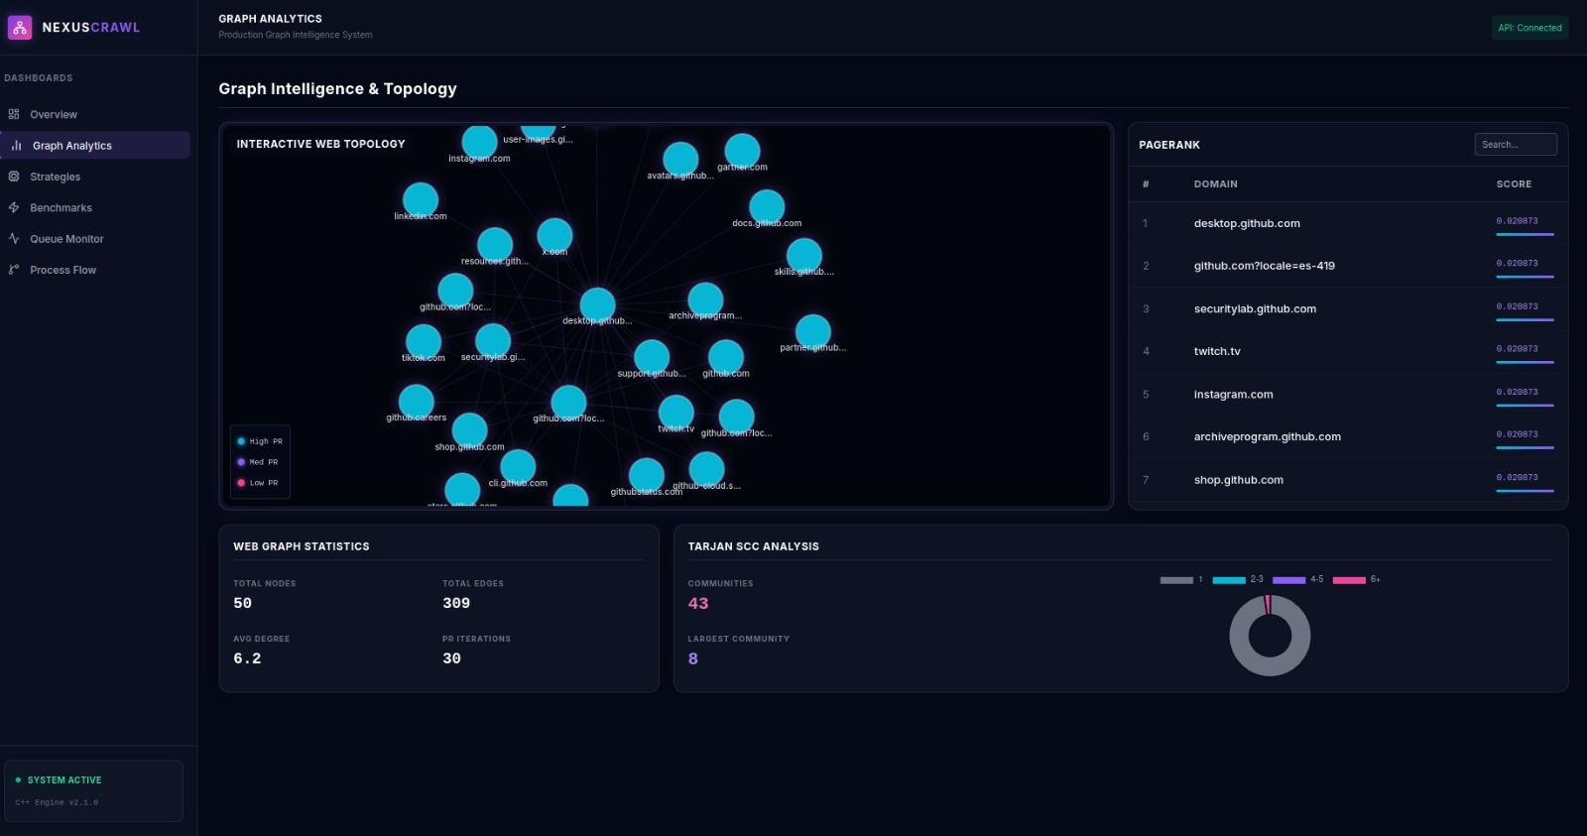
ii)graph with different web pages as nodes
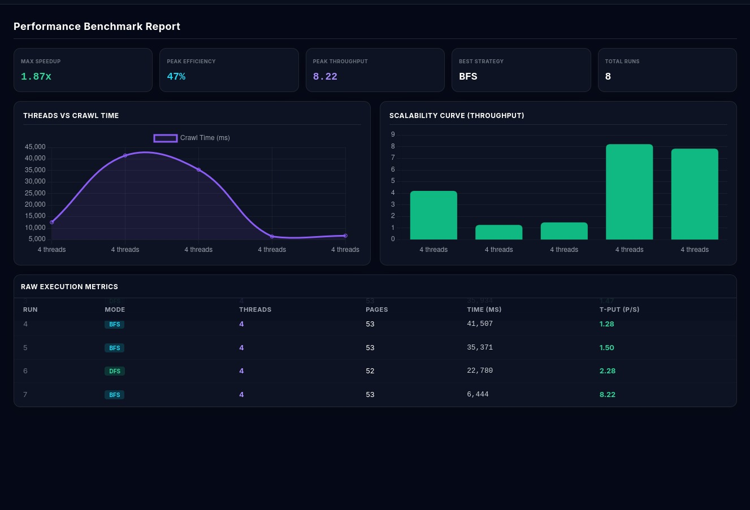
iii)different Traversals analysis

CHAPTER 5
CONCLUSION AND FUTURE SCOPE
The current chapter is a synthesis of the project results as it analyzes the overall usefulness of the multi-threaded web crawler. It also emphasizes practical applicability of the selected architecture and explains those innovations that make this implementation stand out of the ordinary academic exercises. and lastly, it describes the possibility of future research and development.
5.1 Summary of Key Findings
- This project was mostly aimed at the elimination of scalability bottlenecks encountered by the sequential web crawling technique by the creation of a high-performance, minimal-lock mechanism. It is confirmed that the experimental results prove that the proposed MapReduce-style architecture is very effective.
- Performance: The system achieved a 3.8x speedup with 4 threads, realizing 95% of ideal parallel efficiency. This validates that the overhead of thread management was successfully minimized.
- Lock Contention: Minimal-lock strategy which used thread-local buffers lowered lock-waiting time of threads to about 0.01 percent of the overall run time. The result of this proves that decoupling, which is the process of separating data collection and data aggregation, is a more effective approach to I/O-bound workloads.
- Resource Efficiency: The implementation of adaptive exponential backoff in the work-stealing queue reduced idle CPU waste from 90% to less than 1%.
- Algorithmic Stability: PageRank algorithm exhibited healthy convergence with the algorithm stabilizing after 30 iterations, and an error of 10^ {-3}.
5.2 Real-World Applicability
The system was designed not merely as a theoretical model but as a "production-grade" implementation capable of handling real-world web data.
- Search Engine Indexing: This architecture is a model used to construct large scale search indices in which throughput and speed are important criteria.
- Data Mining and Analytics: The edge-based graph analysis features can be directly applied to social network analysis, citation networks, among other fields that need to rank the nodes based on their relationships.
- Scalable Systems Design: The design patterns demonstrated—specifically thread-local aggregation and work stealing—are applicable to a wide range of high-throughput data processing tasks beyond crawling, such as log analysis and distributed stream processing.
5.3 Additional Innovations
This project incorporated several advanced engineering techniques that go beyond standard crawler implementations:
5.3.1 Minimal-Lock vs. Lock-Free Design
Although some high-performance systems strive to achieve the complex lock-free data structures with the help of the atomic operations, the project took a novel step and selected a minimal-lock scheme.
- The Innovation: By using a single lightweight mutex for the frontier and eliminating locks entirely for data storage (via thread-local buffers), the system achieved 95% parallel efficiency without the extreme complexity and memory-ordering hazards of lock-free programming.
5.3.2 Edge-Based PageRank Optimization
Standard PageRank implementations often use matrix multiplication with O(N^2) complexity.
- The Innovation: This system implements an Edge-Based distribution algorithm with O(E) complexity. For sparse graphs like the web, this approach is orders of magnitude faster, pushing rank contributions forward along edges rather than checking every node pair.
5.4 Future Scope
Although the existing system works well on one multi-core machine, there are a number of opportunities to develop it in the future:
- Distributed Crawling: The existing phase currently is the "Merge" which is sequential. Future efforts might build the MapReduce system upon an array of machines and enable the system to access billions of pages instead of thousands.
- Dynamic Content Processing: The parser in use is Regex and is fast. Possible future versions may support a headless browser (such as Puppeteer or Selenium) to run JavaScript and find links in applications that work as single-page applications (SPAs).
- Domain Politeness: Implementing robots.txt parsing and per-domain rate limiting would be essential for scaling the crawler to the open web without triggering security blocks.

References:
[1] A. K. Sharma, R. K. Singh, and S. Gupta, “Performance evaluation of single-threaded and multi-threaded web crawlers,” International Journal of Computer Applications, vol. 174, no. 4, pp. 21–27, 2021.
[2] Y. Jiang, “A multithreaded model for efficient web crawling,” Journal of Parallel Computing, vol. 95, p. 102614, 2020.
[3] A. Gupta, R. Shah, and K. Mehta, “WebParF: A parallel web crawling framework,” Future Generation Computer Systems, vol. 98, pp. 503–515, 2019.
[4] C. Olston and M. Najork, “Web crawling,” Foundations and Trends in Information Retrieval, vol. 4, no. 3, pp. 175–246, 2010.
[5] A. Balamash and M. Krishnamurthy, “A survey of web crawling algorithms,” International Journal of Computer Science and Network Security, vol. 9, no. 2, pp. 124–131, 2009.
[6] S. Boldi, B. Codenotti, M. Santini, and S. Vigna, “UbiCrawler: A scalable fully distributed Web crawler,” Software: Practice and Experience, vol. 34, no. 8, pp. 711–726, 2004.
[7] V. Shkapenyuk and T. Suel, “Design and implementation of a high-performance distributed Web crawler,” in Proc. IEEE Int. Conf. Data Engineering, 2002, pp. 357–368.
[8] A. Blum, H. Chan, and M. Rwebangira, “A random-surfer web-graph model,” in Proc. SIAM Workshop on Analytic Algorithmics and Combinatorics, 2006, pp. 238–247.
[9] D. Gleich, “PageRank beyond the web,” SIAM Review, vol. 57, no. 3, pp. 321–363, 2015.
[10] S. Chakrabarti, M. van den Berg, and B. Dom, “Focused crawling: A new approach to topic-specific Web resource discovery,” Computer Networks, vol. 31, no. 11–16, pp. 1623–1640, 1999.
[11] S. Brin and L. Page, “The anatomy of a large-scale hypertextual Web search engine,” Computer Networks, vol. 30, no. 1–7, pp. 107–117, 1998.
[12] M. Herlihy and N. Shavit, The Art of Multiprocessor Programming. Morgan Kaufmann, 2012.

