**COMP 1531 Group Project**

**Team Name: Segmentation-fault**

**Zhang Yiwei Z5100640**

**Renhao Huang z5111342**

**Contribution is 50% for each team member**

**Summary of project:**

Front-End Part: Yiwei Zhang

Back-End Part: Renhao Huang

Contributions:(most of)

1. html files (htmls, css) are by Yiwei Zhang
2. python files are written by Renhao Huang
3. Debug: together
4. Idea: together

**User-stories:**

1. **Epic Story**: As an authorized user, I should be able to register events online so that I can save time

**US1**: As a user, I should be able to login successfully with a correct user-name and password so that I can access to the system securely

Acceptance Criteria:

1. The login page should include the username and password form
2. Invalid username and password should be informed
3. No access to other pages are allowed if not log in.
4. The user must provide both user-name and password.

**Effort**: 5 user story points, where each point = 1 hour

**Priority**: 1(High)

**US2**: As a user, I should be able to view the open events by categories so that I can check the events conveniently

Acceptance Criteria

1. All the events that meet the requirement should be listed (registered events, posted events, etc.)
2. Two category names should be displayed on the page.
3. Each event should be displayed under their category names.
4. If there is no available event, no event will be listed.
5. The seminar will not be display if it has no available session.

**Effort**: 2 user story points  
**Priority**:3(middle)

**US3**: As a user, I should be able to view the events descriptions before registering so that I can be familiar with events

Acceptance Criteria:

1. Each event displayed on the page should have a link to the description page
2. When the user clicks the events links, the descriptions of corresponding events (include name, type, date, location) should be displayed
3. Each description page should display the details of only one event

**Effort**: 2 user story points

**Priority**:2(middle-high)

**US4**: As a user, I should be able to select and register courses or seminars(sessions) so that the admin will know I will participate in

Acceptance Criteria:

1. The webpage should provide the register button
2. The register button will be disabled if the event is closed
3. A confirmation should be displayed on screen after registration
4. A corresponding fee (with or without early bird discount) will be displayed in the confirmation.
5. The user cannot register the event for which he is the convener.
6. The user can register single or multiple session in the seminar.

Effort: 2 user story points

Priority: 3

**US5**: As a user, I want to view my registered events so that I can know which events I have registered

Acceptance Criteria:

1. The dashboard should have a link for “registered events”
2. All the registered events should be listed in the page.
3. If user did not register any events, no event should be displayed.
4. A notification should be given to the user if the event was closed before the scheduled date (i.e. cancelled).

Effort: 2 user story points

Priority:3

**US6**: As a user, I want to cancel my registration up so that I can spare a position for those who want to attend

1. A button for deregister after registration should be provided in the description page
2. The number of attendees that shows in the detail page should be decreased.
3. After deregistering, register button should be abled.
4. The button for deregister should be disabled after the de-registration window

Effort: 1

Priority:4 (middle-low)

**US7**: As a guest, I want to sign up so that I will have the permission to access into the Event Management System webpages.

Acceptance Criteria:

1. A button for guest signing up will be displayed on log in page.
2. The system will display a guest user registration form that requests the user to provide E-mail as username, password, and user real name
3. The authentication details should be saved and return a confirmation.
4. The username must include “@” to be regarded as ‘email’
5. The user real name cannot include space at front or in the end
6. The guest user can login with their email as username and password afterwards

Effort: 2 user story points

Priority:3

2. **Epic Story**: As a staff, I can update events so that all users can decide which events to register

**US8**: As a staff, I can post the new events on EMS so that all users can know fresh events

Acceptance Criteria:

1. Dashboard should provide links to two different types of event
2. The website should provide a page includes the form with events details
3. The events details should include all attribution and descriptions
4. The post page should not allow user to leave the blank input
5. User cannot post an event with same title
6. The start date should be earlier than end date (include open period and early bird period)
7. There is no negative capacitor accepted
8. The staff can return to the dashboard from the post events page
9. When posted one events, the webpage should redirect to dashboard page to show the posted events.

Effort: 4 user story points

Priority:1(high)

**US9**: As a staff, I can view the attendees so that I can know who will attend the events

Acceptance Criterial:

1. Each event in the dashboard should have a link to the description page
2. The event descriptions table should have a place lists all attendees’ name
3. If no attendees, the place should be empty, but name of the place should still exist
4. Each session in a seminar will show its attendance.

Effort: 2 user story points

Priority:3(middle)

**US10**: As a staff, I can cancel or close events I posted so that other users can know whether they can register

1. The events description pages should have a button to change the status to “cancel” before the start day
2. The events description pages should change the button function to change the status to “closed” after the event completes
3. If the user changes the status, the button should be disabled so they cannot change back
4. If the event is during the start day and close day, the button should be disabled

Effort: 2 user story points

Priority:5(low)

US11: As a staff, I can add the sessions for a seminar so that user can choose to attend different session they interest.

1. A button for add sessions should be displayed in detail page of a seminar
2. A form should be provided to input details
3. No blank input accepted
4. The new session cannot have the same title as another session under the same seminar
5. The speaker name should not start with space or end with space
6. The capacity should not tolerate negative value
7. A back button should exist to return to the detail page of the seminar

User-stories 1-8 are chosen for the iteration 1.

**Velocity Chart:**

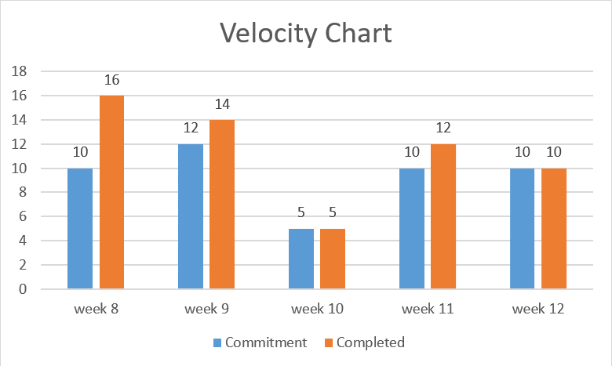

TIP: Here 1 use story points=1 hour

**Meetings:**

4/11 week6:

Start at 2pm and end at 2.45pm

1. After the discussion with the group member, we decided to meet every Wednesday 2-3

PM after the lab.

1. During our first meeting on week 6, we decided every one’s responsibilities for the

Iteration 1 Design Deliverables on week 7. Renhao Huang will finish the Epic Stories and

break them into user stories. Yiwei Zhang will finish the UML class diagram and summary

the meeting.

1. We had done the draft of user-stories and CRC cards during the meeting.
2. We talked about the velocity chart.

4/18 week7:

Start at 2pm and end at 2.50pm

1. We finished our class diagram and user stories and discuss them with the tutor in the lab.
2. We modified our class diagram and user stories base on the suggestions given by the

tutor.

1. We finished our velocity chart and posted it at the end of the user stories.
2. We talked about the format of the website, the first page should be the login page and

then transfer the user to the main page and show different materials to different kind of

users (student or stuff).

1. We decided Yiwei Zhang will do the front-end part and Renhao Huang will do the back-end part.

4/25 week8:

4/25 is public holiday so this is an online meeting.

Start at 7pm and end at 7.40pm

1. We finished US 1, 2, 3 and 7 and all of them are tested separately.
2. We talked about the bugs we found when we finished the above US.
3. We discussed the advantages and disadvantages of using database system in our project and decided to use the database system.

5/2 week9:

Start at 2pm and end at 3.10pm

1. The separate pages for registered events and posted events are cancelled.
2. We finished US 4, 5, 6 and 8 and all of them are tested separately.
3. The EMS main page is cancelled and everything will display om the Dashboard.
4. We re-read the Preliminary Requirements and decide to add some new features.
5. Add a new feature that is the seminar events can add sessions and the seminar without sessions will not appear on the "open events".
6. Add a new feature that is the users cannot cancel their registration up after the de-registration window.
7. Add a new feature that is events can only be cancelled up to 24 hours before the scheduled date.

5/9 week10

Start at 2pm and end at 2.10pm

1. There is nothing important to discuss this week.
2. The demo 1 is successful and we are waiting for the Iteration 2.

5/16 week11

Start at 2pm and end at 3.10pm

1. We talked about the Iteration 2 and some features had already been finished previously (e.g. “A status of remaining seats left for an event”)
2. We wrote some simple pytest cases and we will finish all the pytest by the next meeting.
3. The guest needs to provide the real name when he signs up for distinguishing the speaker.
4. We added the error messages if users provide a negative event period and early bird period.

5/23 week12

Start at 2pm and end at 2.50 pm

1. All the pytest were done and our project passed all the test.
2. We added the confirmation message for the users if the registered events are cancelled.
3. The final version of the project is finished and the code will be submitted after the final debug this weekend.

**Test user-name and password:**

Staff:

User-name: aaa password: aaa

Student:

User-name: bbb password: bbb

**Reflection:**

We learned a lot about the software engineering during this project.

1. We know how to learn a new programming language by ourselves.
2. An introduction on how to use Database in a project.
3. We know how to write test cases for a project.
4. We experienced the process of selling the project after we finish it.

**Some possible improvement if we had to re-implement this application:**

1. We can add a new feature to allow users to modify the events they posted.
2. We can add an event summary before the event is posted. It can make sure the user is satisfied with everything they typed.
3. We can improve the user interface design so that user will feel more comfortable while visiting.