**There are two parts to the task. You need to complete both using Microsoft Excel.**

**Part 1**

As a data analysis intern, you are provided with a general store transaction dataset. You are supposed to do the following operations.

* Draw a Pivot table to get the different types of outlets and their counts
* Draw a Pivot table to get the total sales for different outlets
* Draw a Pivot table to find out the total sales of different item types in different outlet types
* In the third Pivot table, filter out (remove) low-fat products
* Add slicers for item fat and item type in the last Pivot table

Dataset: [General_store_dataset.xlsx](https://docs.google.com/spreadsheets/d/1tCGKSbCRXgh8ElkvC_7iNJeMw53atXiP/edit?usp=sharing&ouid=106115340208586563833&rtpof=true&sd=true)

We have data of product sales in the 'Dataset' sheet. Below are your tasks

1 Draw a Pivot table to get the different types of outlets and their counts

2 Draw a Pivot table to get the total sales for different outlets

3 Draw a Pivot table to find out the total sales of different item types in different outlet types

4 In the third Pivot table, filter out (remove) low fat products

5 Add slicers for item fat and item type in the last Pivot table

**Part 2**

Create the financial dashboard:

As a data analysis intern, you are provided with the Profit and Loss statement of a company for the year 2020.

1. Create a line graph for profit and profit margin for different years.
2. Column chart for historical revenue.
3. Pie chart for expense breakup
4. Main expenditure item Target vs achieved
5. Create chats of other metrics you feel are important.

This is what your dashboard should look like:

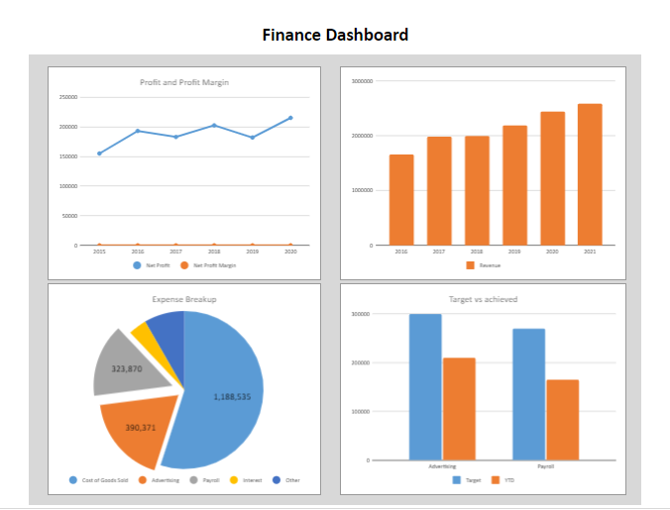

If you want to analyze data further you may do that.

Dataset

<https://docs.google.com/spreadsheets/d/1PHoXC4VvkghGKLZtvCknkYfUt85232Lj/edit?usp=sharing&ouid=106115340208586563833&rtpof=true&sd=true>

Regardless of whether you decide to do this problem statement or not, you must click on the “Mark Complete” button below.