PLS Document

Hogeschool Rotterdam

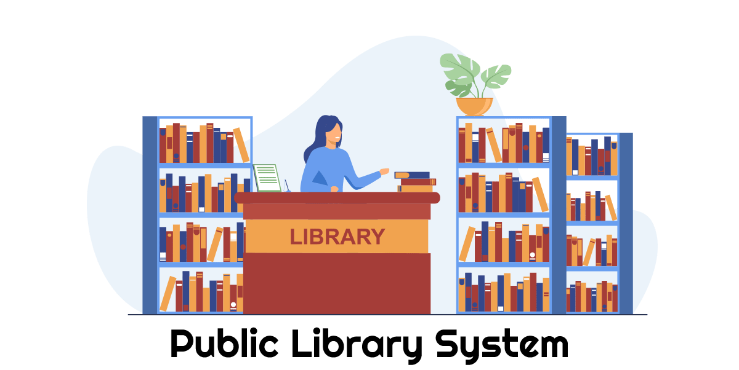

Table of Contents

Document information 1

Document version 1

Authors 1

Software requirements specifications 2

Introduction 2

Purpose 2

Intended use 2

Scope 2

Functional requirements 3

Class diagram 7

Class diagram 7

Catalog 7

Description 7

Book 7

Description 7

Book item 7

Description 7

Loan item 7

Description 7

Person 7

Description 7

Library admin 7

Description 7

Member 8

Description 8

Use Case diagrams 9

Member use case 9

Admin use case 10

User manual 11

# Document information

## Document version

|  |  |  |
| --- | --- | --- |
| Version | Date | Notes |
| 1.0 | 10-03-2023 | Document creation |
| 1.1 | 11-03-2023 | Add diagrams |
| 1.2 | 15-03-2023 | Modified based on feedback |
| 1.3 | 24-03-2023 | Updated diagrams to better reflect requirements |
| 1.4 | 26-03-2023 | Added User manual chapter |
|  |  |  |

## Authors

|  |  |
| --- | --- |
| Name | Student number |
| Jeremey Sas | 1028294 |
| Michael Heerkens | 1028285 |
| Tobias Roessingh | 1042623 |

# Software requirements specifications

## Introduction

### Purpose

The purpose of the Public Library System (PLS) is to manage the inventory of a library through a console application.

### Intended use

The system is supposed to be used by either members or employees of the library. It is intended to be used as an inventory management system.

### Scope

Members of the system (Customers of the library) are able to search for books and check if they are available. When a book is available the member is able to loan the book and can loan the book for a maximum of 30 days and can’t loan more than three books at once.

The library Admin can manage the library inventory, manage its members and loan books to specific members. This user is also privileged to create backups of the system and restore them from a valid backup file.

## Functional requirements

The functional requirements are divided in four categories based on the priority, these priorities are set following the MoSCoW method.

Must have requirements are required for base functionality of the system and must be in the end product.

Should have requirements are required for the system functionalities but are dependent on the requirements of the Must have requirements.

Could have requirements are not mandatory for the system functionalities. These requirements will be added to the system if the time allows for these requirements

Won’t have requirements are not mandatory for the system and will not be in this implementation of the system. These requirements can be added in a later project to improve ease of use, user interface and speed improvements.

|  |  |  |  |  |  |
| --- | --- | --- | --- | --- | --- |
| ID | Requirement | Priority | Relations | Type | |
| 1 | View members list | Must | 2, 39 | | F, A |
| Description | An administrator needs to be able to view the list of members | | | | |
| 2 | Member management | Must | 1, 42 | | F, A |
| Description | An administrator needs to be able to add, edit and delete members from and to the system | | | | |
| 3 | Check loaned items | Must |  | | F, A |
| Description | An administrator needs to be able to check the currently loaned items per member | | | | |
| 4 | View catalog | Must | 5, 22, 28, 40 | | F, A, M |
| Description | A user (Admin and Member) needs to be able to view the catalog (list of books) | | | | |
| 5 | Catalog management | Must | 4, 43 | | F, A |
| Description | An administrator needs to be able to add, edit and delete books from and to the catalog | | | | |
| 6 | View book items | Must | 7, 9, 24, 28, 41 | | F, A, M |
| Description | A user (Admin and Member) needs to be able to view the list of book items in the system | | | | |
| 7 | Book item management | Must | 6, 25 | | F, A |
| Description | An administrator needs to be able to add new book items to the system | | | | |
| 8 | System back-up | Must |  | | F, A, S |
| Description | An administrator needs to be able to make a back-up of the system in JSON format | | | | |
| 9 | Loan book item | Must | 6, 26 | | F, M, L |
| Description | A member needs to be able to loan an available book item | | | | |
| 10 | User logon | Must |  | | F, A, M, S |
| Description | All users need to be able to logon to the system, without login there are no functionalities available | | | | |
| 11 | Check mandatory files | Must | 34 | | F, S |
| Description | On startup the system will check all required data files | | | | |
| 12 | Functionality before logon | Must |  | | NF, A, M |
| Description | Before the logon the only two options for a user to choose from is ‘Login’ or ‘Exit’ | | | | |
| 13 | Book item copies | Must |  | | NF, S |
| Description | Each book item has three copies | | | | |
| 14 | Book search | Must |  | | NF, S |
| Description | A title or author are required when searching for books in the system | | | | |
| 15 | Back-up formatting | Must |  | | NF, S |
| Description | A back-up file name contains the current date and serial number to distinguish multiple back-ups | | | | |
| 16 | Data saving | Must |  | | NF, S, FM |
| Description | All data is saved after each transaction in the system | | | | |
| 17 | Duplicates | Must |  | | NF, S, FM |
| Description | The system must prevent duplicate entities that are being created | | | | |
| 18 | Username formatting | Must |  | | NF, S, M |
| Description | A member username must contain lowercase formatting | | | | |
| 19 | Defining members | Must |  | | NF, S, M, A |
| Description | The username and password of a member are defined by the library administrator | | | | |
| 20 | Navigation | Must |  | | NF, S |
| Description | The system navigation will be chosen by digits | | | | |
| 21 | Import members | Should |  | | F, A, M, FM |
| Description | An administrator needs to be able to import members via CSV file | | | | |
| 22 | Search books | Should | 4, 33 | | F, A |
| Description | An administrator needs to be able to search books in the catalog | | | | |
| 23 | Import books | Should |  | | F, A, FM |
| Description | An administrator needs to be able to import books from a JSON file | | | | |
| 24 | Search book items | Should | 6, 33 | | F, A |
| Description | An administrator needs to be able to search a book item in the system | | | | |
| 25 | Check availability | Should | 7 | | F, A |
| Description | An administrator needs to be able to check availability of a book item in the system | | | | |
| 26 | Lend book item | Should | 9 | | F, A, L |
| Description | An administrator needs to be able to lend a book item to a member | | | | |
| 27 | Restore system | Should |  | | F, A, S, FM |
| Description | An administrator needs to be able to restore the system via a back-up | | | | |
| 28 | Search book | Should | 4, 33 | | F, M |
| Description | A member needs to be able to search for a book in the catalog | | | | |
| 29 | Search book item | Should | 6, 33 | | F, M |
| Description | A member needs to be able to search book item in the system | | | | |
| 30 | Return loaned item | Should |  | | F, M, L |
| Description | A member needs to be able to return loaned item(s) | | | | |
| 31 | Application interface | Should |  | | F, S |
| Description | The main interface in console application | | | | |
| 32 | Admin credentials | Should |  | | F, A, S |
| Description | Admin credentials are hardcoded | | | | |
| 33 | Partial filters | Should | 22, 24, 28, 29 | | F, S |
| Description | Filters need to accept partial parameters | | | | |
| 34 | File availability | Should | 11, 35 | | F, S, FM |
| Description | Only when the required data file is available, it will be loaded into the system | | | | |
| 35 | File creation | Should | 34 | | F, S, FM |
| Description | The system creates new data files when the required data files are not available | | | | |
| 36 | Loan limit | Should | 37, 38 | | NF, S, M, L |
| Description | A member can only loan a book for a maximum of 30 days | | | | |
| 37 | Loan maximum | Should | 36, 38 | | NF, S, M, L |
| Description | A member can loan a maximum of three books simultaneously | | | | |
| 38 | Loan one book | Should | 36, 37 | | NF, S, M, L |
| Description | A member can only loan one book item of its multiple copies | | | | |
| 39 | Filter members list | Could | 1 | | F, S, A |
| Description | The system needs to be able to filter the list of members | | | | |
| 40 | Filter catalog | Could | 4 | | F, S, A, M |
| Description | The system needs to be able to filter the catalog | | | | |
| 41 | Filter book items | Could | 6 | | F, S, A, M |
| Description | The system needs to be able to filter the book items | | | | |
| 42 | Export members | Could | 2 | | F, S, A, FM |
| Description | The administrator can export the list of members to CSV file | | | | |
| 43 | Export books | Could | 5 | | F, S, A, FM |
| Description | The administrator can export the list of books to JSON file | | | | |
| 44 | Graphical interface | Won’t |  | | NF, S |
| Description | The system will not have any fancy interfaces and mouse pointer actions, for this version it will just be a command-line application | | | | |
| 45 | Location management | Won’t |  | | F, S |
| Description | The system cannot manage location of the library system, there will always be one location, the catalog of the system it is running on | | | | |

|  |  |
| --- | --- |
| Type Legend | |
| F | Functional |
| NF | Non-Functional |
| A | Administrative |
| M | Members |
| S | System |
| L | Loaning |
| FM | File management |

# Class diagram

## Class diagram

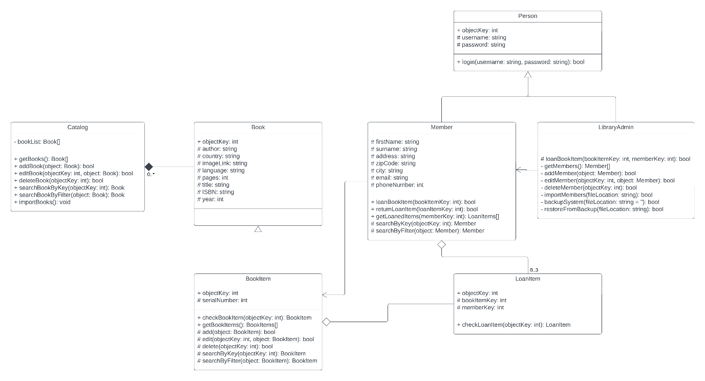

## Catalog

### Description

The catalog contains a list of all the books available at the library. This object contains all the information used to manage the inventory of books at the library.

## Book

### Description

The book contains all base information of a book item, like genre, title and author. This is also the object used to fill the catalog. This is a definition item and cannot be used as physical item.

## Book item

### Description

The book item is the physical object of a book. This can be used to loan to members of the library system.

## Loan item

### Description

The loan item will describe a connection between a member and the book item that has been loaned to the member.

## Person

### Description

This is a base for both the Library Admin and the Member. This will contain basic information used in the derived objects.

## Library admin

### Description

This is the administrator of the public library system. This user has a higher privilege level and can manage the system.

## Member

### Description

A member can loan book items, search for books and return loaned items. This user is created for customers of the library.

# Use Case diagrams

### Member use case

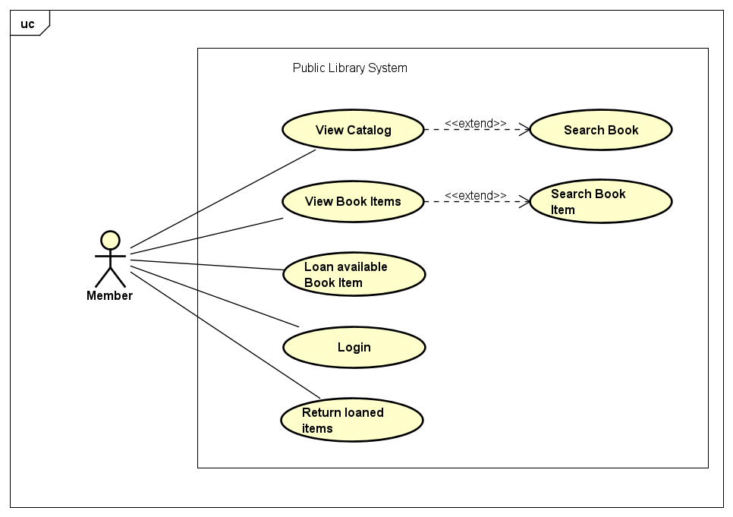

### Admin use case

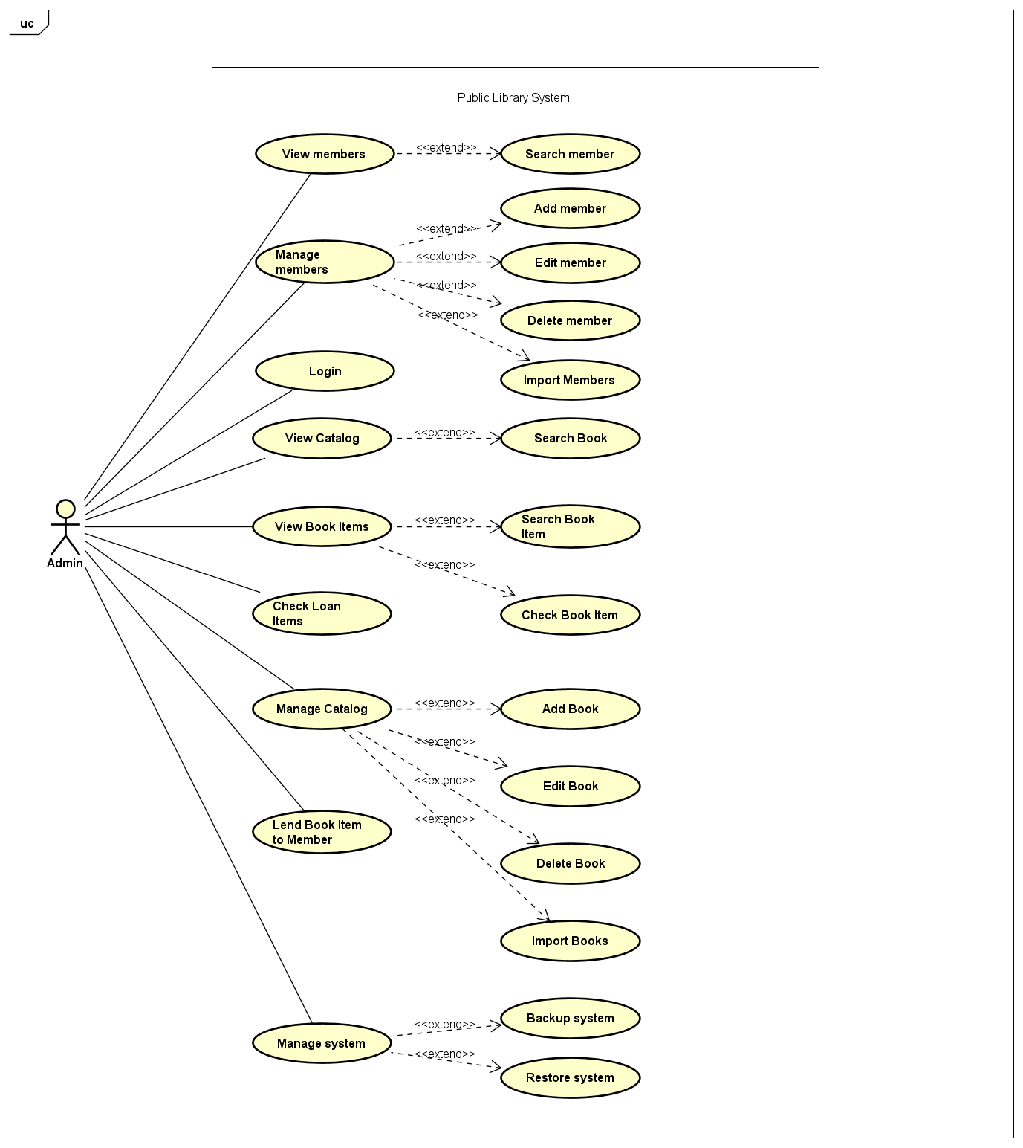

# User manual