**CSU33081 Assignment 2 Multiple Choice Answers**

Please enter your answers (A – E)

Q 1 Answer: C

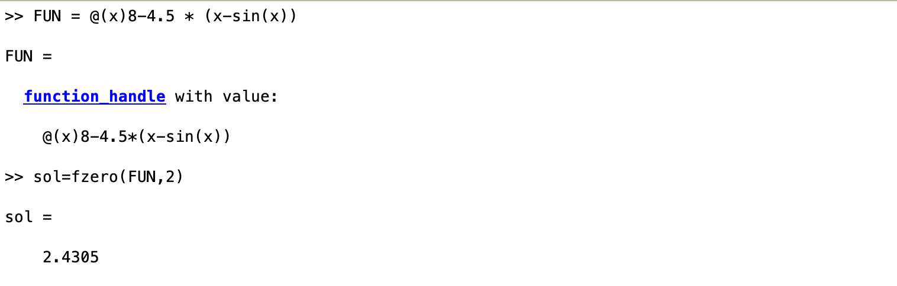

Q2 Answer: A



Q3 Answer: A

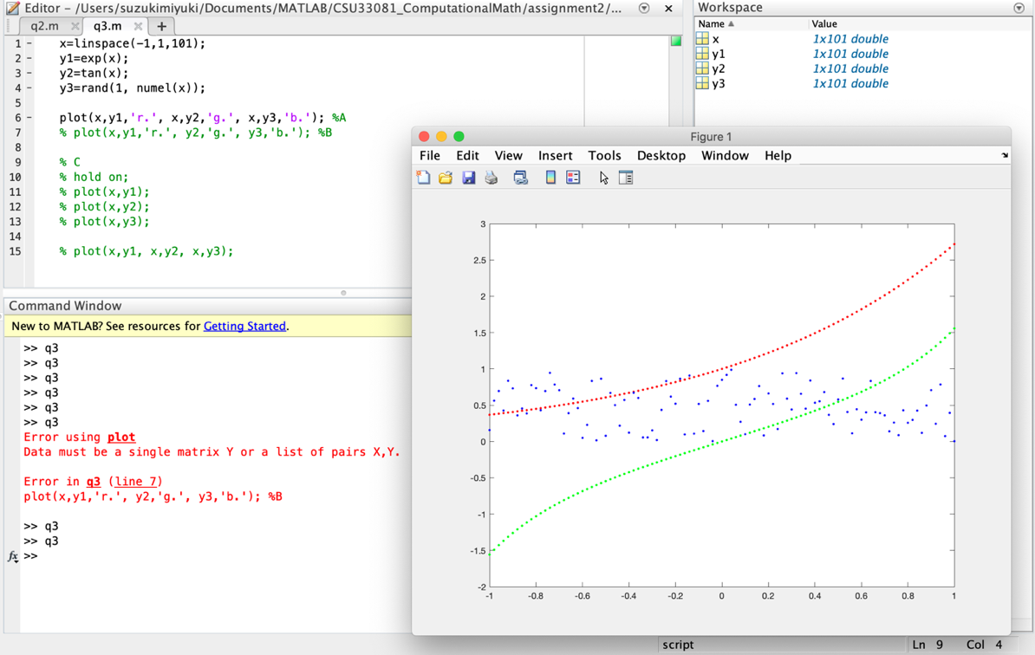

Q 4 Answer: C

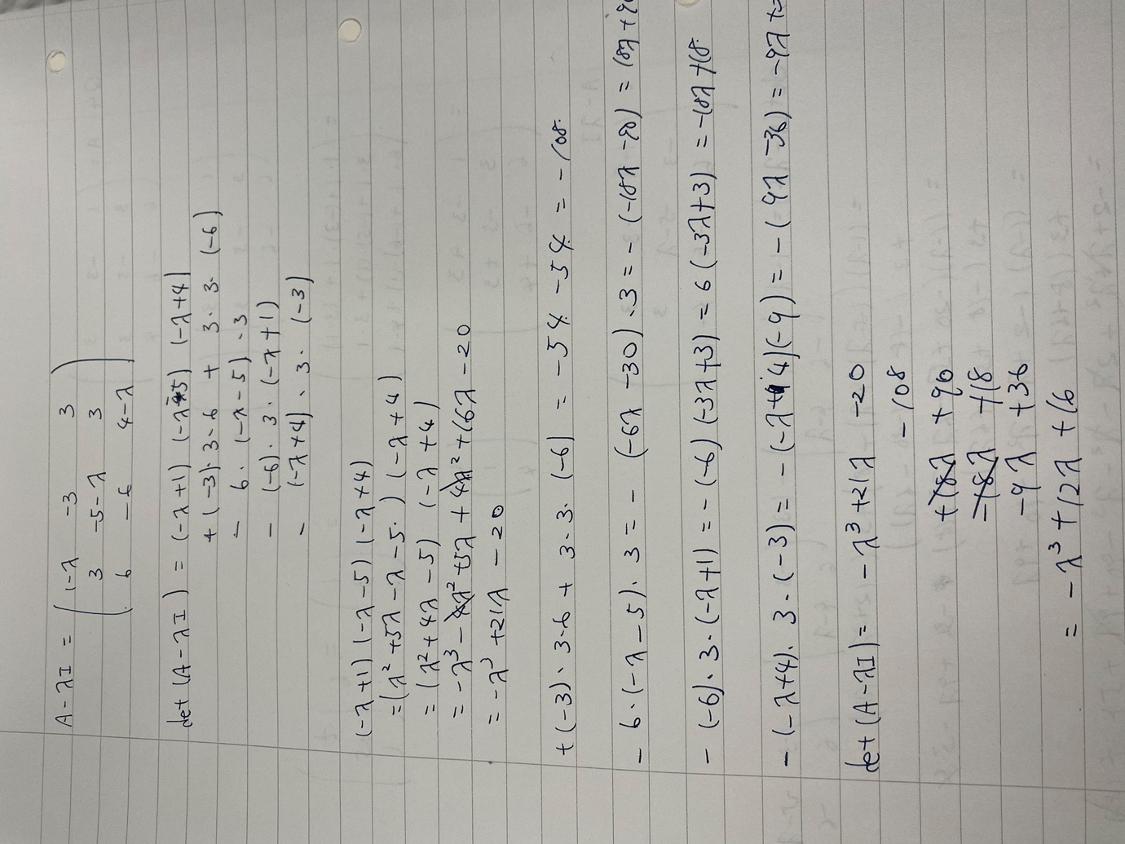

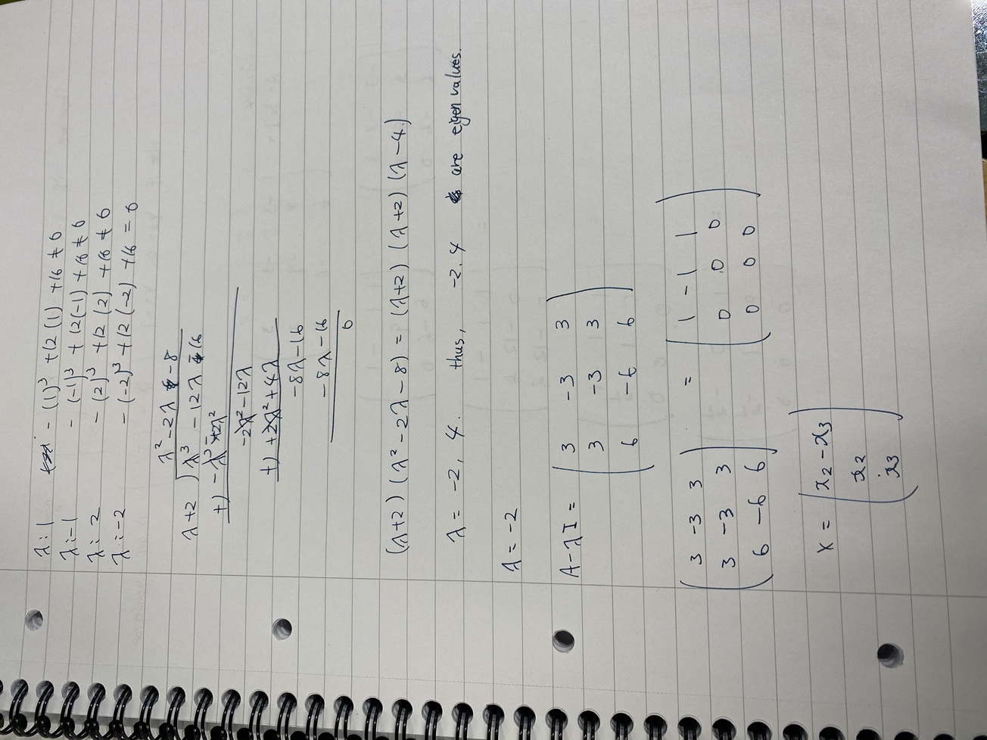

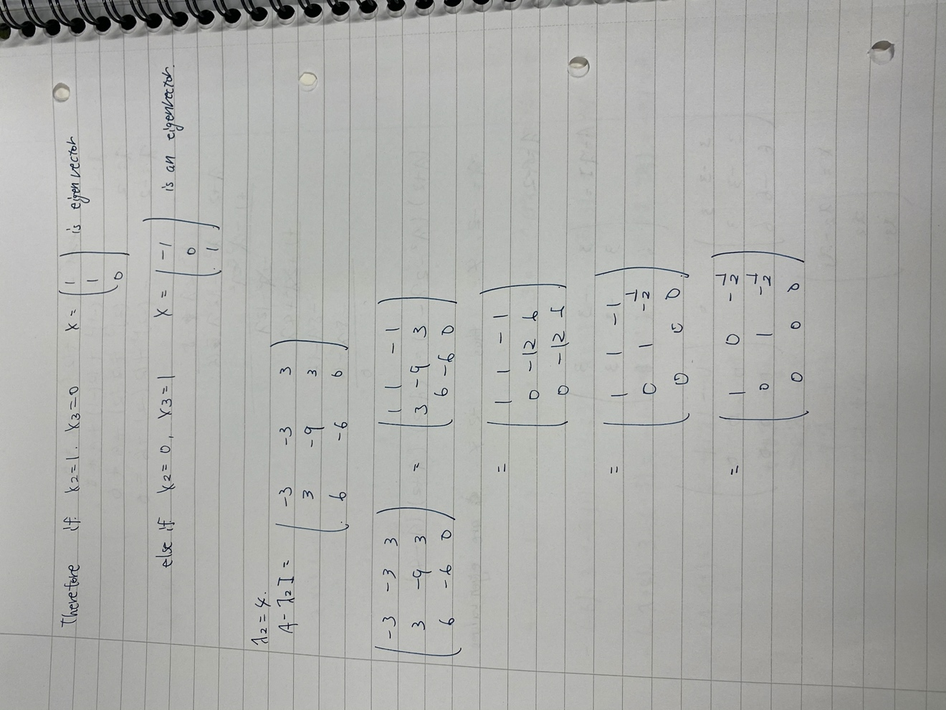

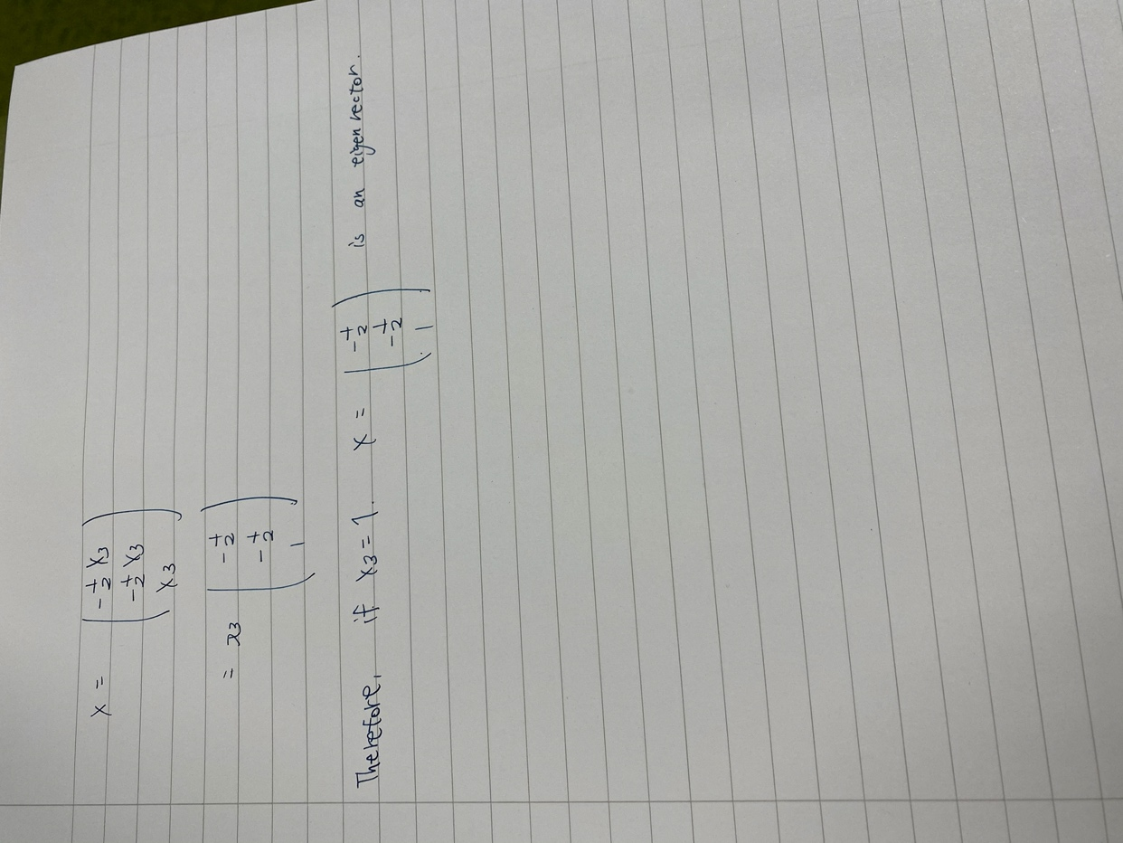

Q 5 Answer: E

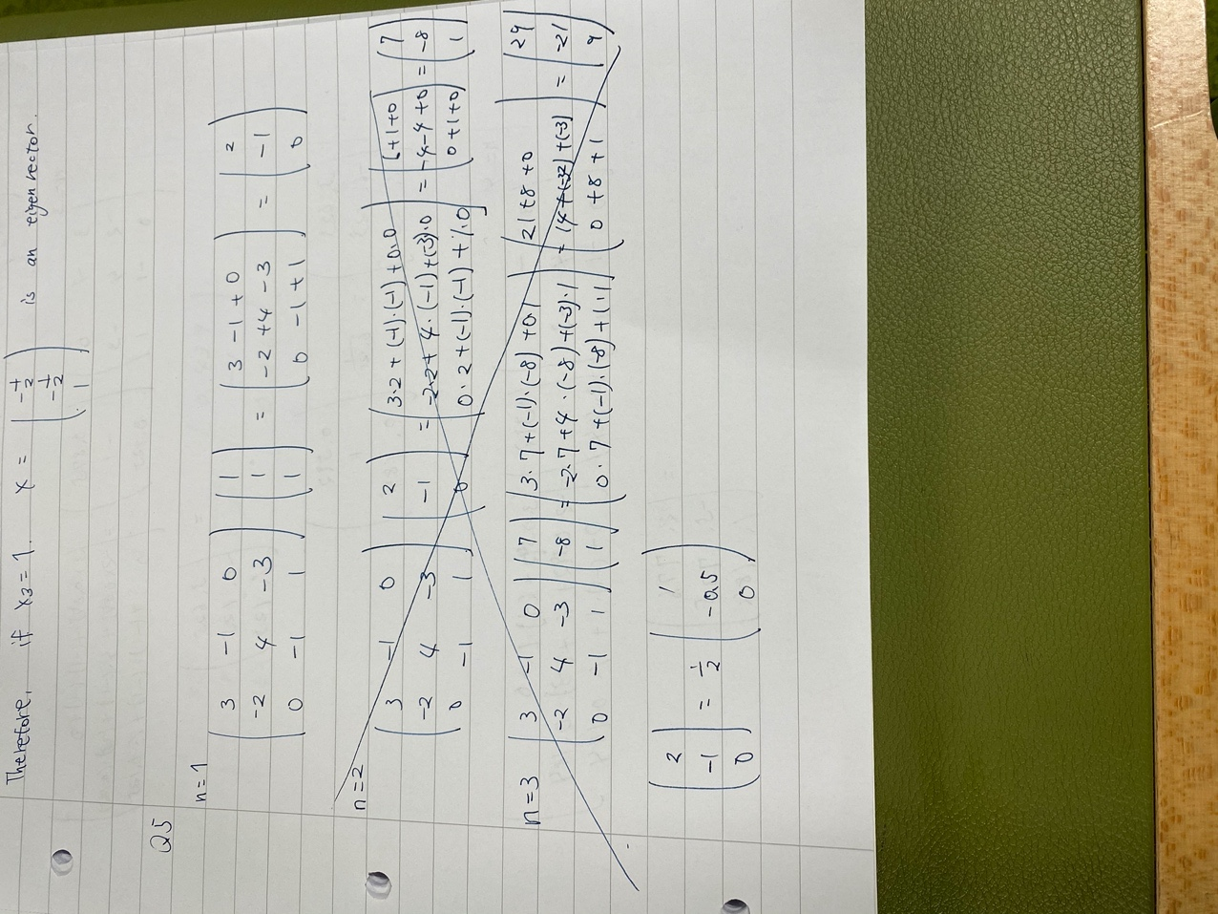

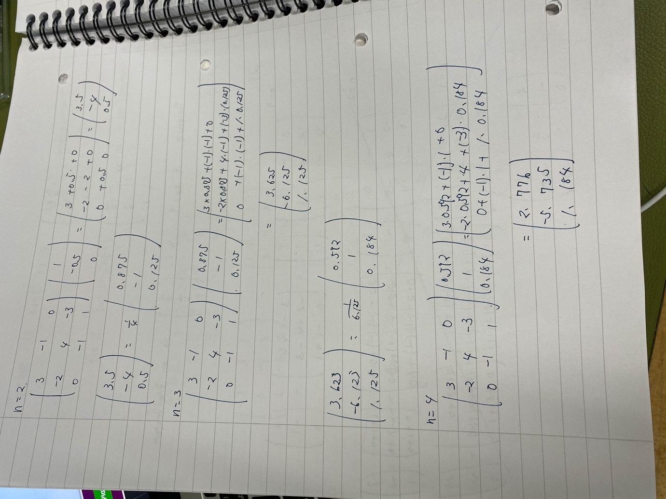

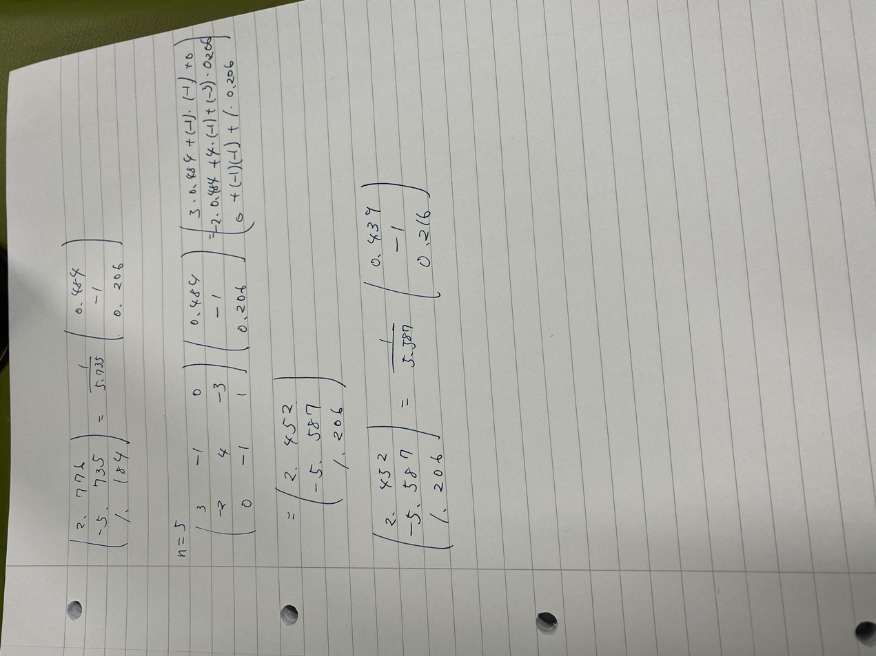

Q 6 Answer: B

Sx = 700

Sy = 1860

Sxy = 118600

Sxx = 44200

N= 12

A1 = NSxy -SxSy/NSxx – (Sx)^2

=12*118600 – 700*1860/12*44200-700^2

= 3

A0 = SxxSy -SxySx/NSxx – (Sx)^2

=44200*1860 – 118600*700/12*44200-700^2

=-20

Y=3x-20

1. Y = 3(35)-20 = 85
2. Y = 3(85)-20 = 235
3. Y = 3(100)-20 = 280

Q 7 Answer: D

S(Pi*e*^0.1315i) = 1.15* *e*^0.1315*0.32 + 1.10* *e*^0.1315*0.64 + 1.05* *e*^0.1315*1.28 + 0.95* *e*^0.1315*1.60 = 4.704

S(*e*^0.263*i) = *e*^0.263*0.32 + *e*^0.263*0.64 + *e*^0.263*1.28 + *e*^0.263*1.60 = 5.173

K1 = 4.704/5.173 = 0.9093

P(sea_level) = 0.9093 * e^-0.1315*0 = 0.9093

P(top) = 0.9093 * 1/1000 = 0.0009093

e^-0.1315*a = 0.0009093/0.9093

a = ln(0.001)/-0.01315 = 52.53

Therefore, the anwer is D

Q 8 Answer: C

P2(x) = Y(x) = (x-x2)/(x1-x2) * y1 + (x-x1)/(x2-x1) * y2

=(x-15)/(0-15) * 22 + (x-0)/(15-0) * 24

f(x) = 2/15*x + 22

f(16) = 2/15* 16 + 22 = 24.13

Y(16) =((16-15)/(0-15) * 22) + ((16-0)/(15-0) * 24)

=24.1333

a2*x1^2 + a1*x1 + a0 = y0

a2*x2^2 + a1*x2 + a0 = y2

a2*x3^2 + a1*x3 + a0 = y3

a2*15^2 + a1*15 + a0 = 24

a2*18^2 + a1*18 + a0 = 37

a2*22^2 + a1*22 + a0 = 25

a2 = -22/21

a1 = 817/21

a0 = -2267/7

f(x) = (-22/21)*x^2 + (817/21)*x + (-2267/7)

f(16) = (-22/21)*16^2 + (817/21)*16 + (-2267/7) = 30.42857

Therefore, the answer is C.

Q 9 Answer: E

P3(x) = Y(x) = y0L0(x) + y1L1(x) + y2L2(x) + y3L3(x) + y4L4(x)

L0(x) = (x-0.5) (x-1.0) (x-1.5) (x-2.0)/ (0.0-0.5) (0.0-1.0) (0.0-1.5) (0.0-2.0)

L1(x) = (x-0.0) (x-1.0) (x-1.5) (x-2.0)/ (0.5-0.0) (0.5-1.0) (0.5-1.5) (0.5-2.0)

L2(x) = (x-0.0) (x-0.5) (x-1.5) (x-2.0)/ (1.0-0.0) (1.0-0.5) (1.0-1.5) (1.0-2.0)

L3(x) = (x-0.0) (x-0.5) (x-1.0) (x-2.0)/ (1.5-0.0) (1.5-0.5) (1.5-1.0) (1.5-2.0)

L4(x) = (x-0.0) (x-0.5) (x-1.0) (x-1.5)/ (2.0-0.0) (2.0-0.5) (2.0-1.0) (2.0-1.5)

Therefore, Y(x) = 0.00((x-0.5) (x-1.0) (x-1.5) (x-2.0)/ (0.0-0.5) (0.0-1.0) (0.0-1.5) (0.0-2.0))

+19.32((x-0.0) (x-1.0) (x-1.5) (x-2.0)/ (0.5-0.0) (0.5-1.0) (0.5-1.5) (0.5-2.0))

+90.62((x-0.0) (x-0.5) (x-1.5) (x-2.0)/ (1.0-0.0) (1.0-0.5) (1.0-1.5) (1.0-2.0))

+175.71((x-0.0) (x-0.5) (x-1.0) (x-2.0)/ (1.5-0.0) (1.5-0.5) (1.5-1.0) (1.5-2.0))

+407.11((x-0.0) (x-0.5) (x-1.0) (x-1.5)/ (2.0-0.0) (2.0-0.5) (2.0-1.0) (2.0-1.5))

Y(2.5) = 0.00((2.5-0.5) (2.5-1.0) (2.5-1.5) (2.5-2.0)/ (0.0-0.5) (0.0-1.0) (0.0-1.5) (0.0-2.0))

+19.32((2.5-0.0) (2.5-1.0) (2.5-1.5) (2.5-2.0)/ (0.5-0.0) (0.5-1.0) (0.5-1.5) (0.5-2.0))

+90.62((2.5-0.0) (2.5-0.5) (2.5-1.5) (2.5-2.0)/ (1.0-0.0) (1.0-0.5) (1.0-1.5) (1.0-2.0))

+175.71((2.5-0.0) (2.5-0.5) (2.5-1.0) (2.5-2.0)/ (1.5-0.0) (1.5-0.5) (1.5-1.0) (1.5-2.0))

+407.11((2.5-0.0) (2.5-0.5) (2.5-1.0) (2.5-1.5)/ (2.0-0.0) (2.0-0.5) (2.0-1.0) (2.0-1.5))

=1037.478125

Therefore, the answer is E.

Q 10 Answer: E

P3(x) = Y(x) = y0L0(x) + y1L1(x) + y2L2(x) + y3L3(x) + y4L4(x)

f(x) = √x

f(x0) =f(2) = √2

f(x1) =f(3) = √3

f(x2) =f(7) = √7

x y

2 √2

√3-√2/3-2 = 0.317837

3 √3

0.18274-0.317837/7-2 = -0.0270194

√7-√3/7-2 = 0.18274

7 √7

y(x) = √2 + 0.317837(x-2) + (-0.0270194)(x-2)(x-3)

y(2.5) = √2 + 0.317837(2.5-2) + (-0.0270194)(2.5-2)(2.5-3)

= 1.579886912

Therefore, the answer is E.