## Research Guidelines for Help Page

The first step to good design is research. The following document outlines potential research areas and tips to help you get started on the Help Page design.

### Competitive Analysis

Competitive analysis for UX design provides insights into the design solutions of similar platforms. By studying the details of finished platforms, you will gain a firm foundation for your design process and build a stronger experience. Below is a short template to get you started.

**Define Product Goals**

What is the purpose of the Help page?

* Being able to let users find the answers to their questions and provide guidelines to users. Let users know where to find help when they are facing challenges.

What do you want users to think and feel when they visit the Help page?

* They want to find the question that they have in their mind; possibly seeking for guidelines of certain functions or general confusion/questions.

What do you hope to achieve from a competitive analysis? Outline three specific design goals.

1. Clean and concise designs
2. Easy to find their questions
3. Informative

**Outline Competitors**

Name two to three competitors to explore.

* 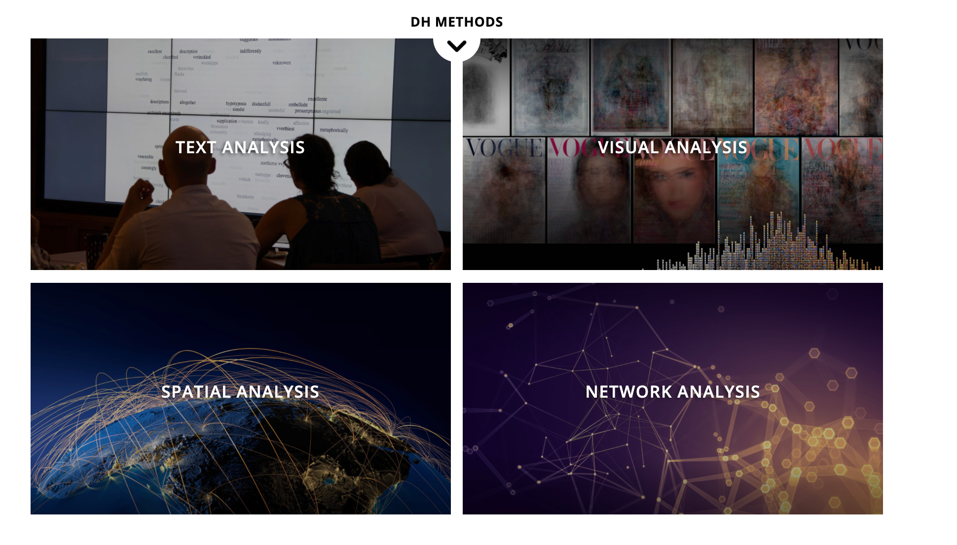
* 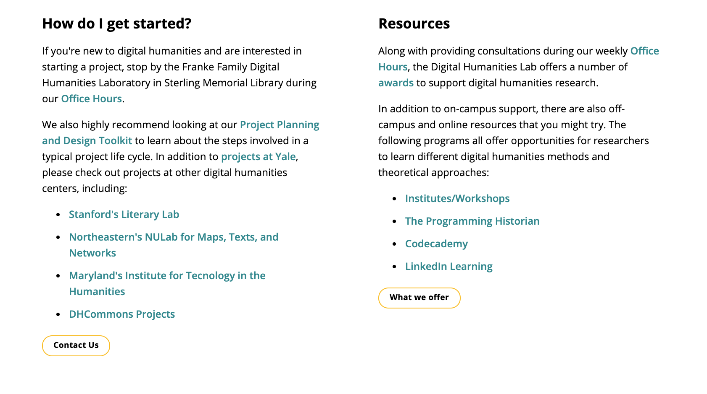

| Competitor | What makes them relevant? |
| --- | --- |
| [Product A] [Microsoft’s FAQs section](https://www.microsoft.com/en-gb/software-download/faq) | Clear page design with questions under specific subjects. |
| [Product B][Pinterest’s Help Center](https://help.pinterest.com/en) | Page designed with letting users to enter their questions and have instructions below for help on topics. |
| [Optional: Product C] [Nintendo FAQ page](https://www.nintendo.com/switch/faq/) | Similar design to windows. Simple to navigate and easy to read. Also has the function of being able to search questions. |

**Analyze Designs**

Create a comparison chart of product features. The comparison criteria should include features and UI elements that would be the most important for your users. (e.g.; filters, sorting, images, ease of use, etc). Fill in at least five UX/UI criteria and one development (criteria e.g.; responsiveness), then evaluate each product on a scale of 0-5 (0: N/A, 1: bad, 2: poor, 3: ok, 4: good, 5: great). Tally the results to get a usability score for each product at the end.

| **UX/UI** | [Product A] | [Product B] | [Optional: Product C] |
| --- | --- | --- | --- |
| Ease of use | 5 | 4 | 5 |
| Informative | 2 | 4 | 5 |
| Images | 2 | 5 | 5 |
| Clear directions | 5 | 4 | 4 |
|  |  |  |  |
| **Dev** | -- | -- | -- |
| Responsiveness | 3 | 1 | 4 |
| **Usability Score** | 17 | 18 | 23 |

Now, compare and contrast each product. What are the similarities and differences? What are the strengths and weaknesses?

Microsoft: Pros: Clear page design with Cons: Does not really have a search bar for questions. When you type in a question in the search bar, the web just directly changes to their website.

Pinterest: Pros: Great design on search bar. Cons: Taking very long for the website to find the answer to users’ questions.

Nintendo: Pros: Search bar includes frequently asked questions and relative stuff comes out as you type in the search bar. Many information included. Cons: Page design isn’t the clearest.



*Double click the venn diagram to edit it

|  | Strengths | Weaknesses |
| --- | --- | --- |
| [Product A] Microsoft | Clickable question bars. Clear to users on how to use the FAQ page. | Not the best visual design. No images, no search bar, cannot display too much information |
| [Product B] Nintendo | Nice image design, clear categories with good directions, search bar | Not a straightforward way for users to find the question that they have in mind |
| [Optional: Product C] Pinterest | Search bar design to let users browse questions, aesthetic design | Not suitable for a small collection of questions, |

**Summarize Findings**

Use this section to summarize your findings and discuss how you will apply them to your design.

I think being able to have the function of searching so it is easier for users to locate and having a clear page design can better improve users’ experiences.

### Fieldwork

Fieldwork consists of interviewing and interacting with potential users. This process will allow you to accumulate direct feedback and insights for your design.

**Before Prototyping**

It is important to measure the efficacy of your design process before focusing on the design itself. To do this, you should outline several design thinking questions that are relevant to the Help page. For example, what is the best format for receiving instructions: written or video? How do you make navigation less stressful? And so on.

**After Prototyping**

Once you have answered those questions, evaluated your wireframe against them, and created a prototype, you can begin interviewing users. It is important to standardize your testing methods. All users should be given the same prompt and problem. For example, you can ask them to navigate the Help page to find a specific piece of information. You should also allow them to freely explore your design with no goal. This way you have both structured and unstructured insights. User interviews can be conversational and unregimented, but it is useful to follow up with a survey to collect detailed information. Furthermore, you should consider asking them to provide numerical ratings for certain design features - the same way you rated other products during competitive analysis. There are several user survey examples online that you can look at for inspiration. Another powerful tool is to screen record as they interact with the prototype so you can reference the recording alongside survey results later.

### 

## Portal Design Protocol (ignore this -- work in progress)