Global Unicorn Tracker - Q2 2026
Late-Stage Company Research | As of June 30, 2026
Primary basis: PitchBook deal-level unicorn tracker (1,743 active companies / $8.23 trillion aggregate post-money valuation). The Morningstar PitchBook Unicorn 20 daily valuations and the Unicorn Monitor are used only where flagged, for the three-way valuation comparison of the largest companies and for the vertical index returns, and their figures are not combined with the primary-tracker totals. Secondary-market prices are from the Unicorn Monitor secondary dataset, marked as of June 22, 2026; SpaceX and Cerebras, public since June and May, are carried at public market values. AIBQ/PBQ scores are from the hand-scored panel as of June 30, 2026; the 301-company US AI extension is from the US AI/ML hand-scored workbook.

Key takeaways
- The five largest rounds took $87.1 billion, 62% of Q2's sized deal value, and Anthropic's $65 billion Series H alone was 16.4% of first-half financing. Quarterly deal value fell to $144.9 billion from Q1's record $251.3 billion.
- AI holds $5.08 trillion, 61.7% of unicorn value on 40.3% of the companies, and added more value in six months than the whole universe gained. Meanwhile 47.6% of unicorns have not raised in more than two years.
- Business quality and price disagree where the money is. Valuation explains about 15% of the variation in AIBQ/PBQ scores, and the secondary market prices Anthropic, the most valuable private company, 22% below its model valuation, with 11 of the 18 private names trading below model.
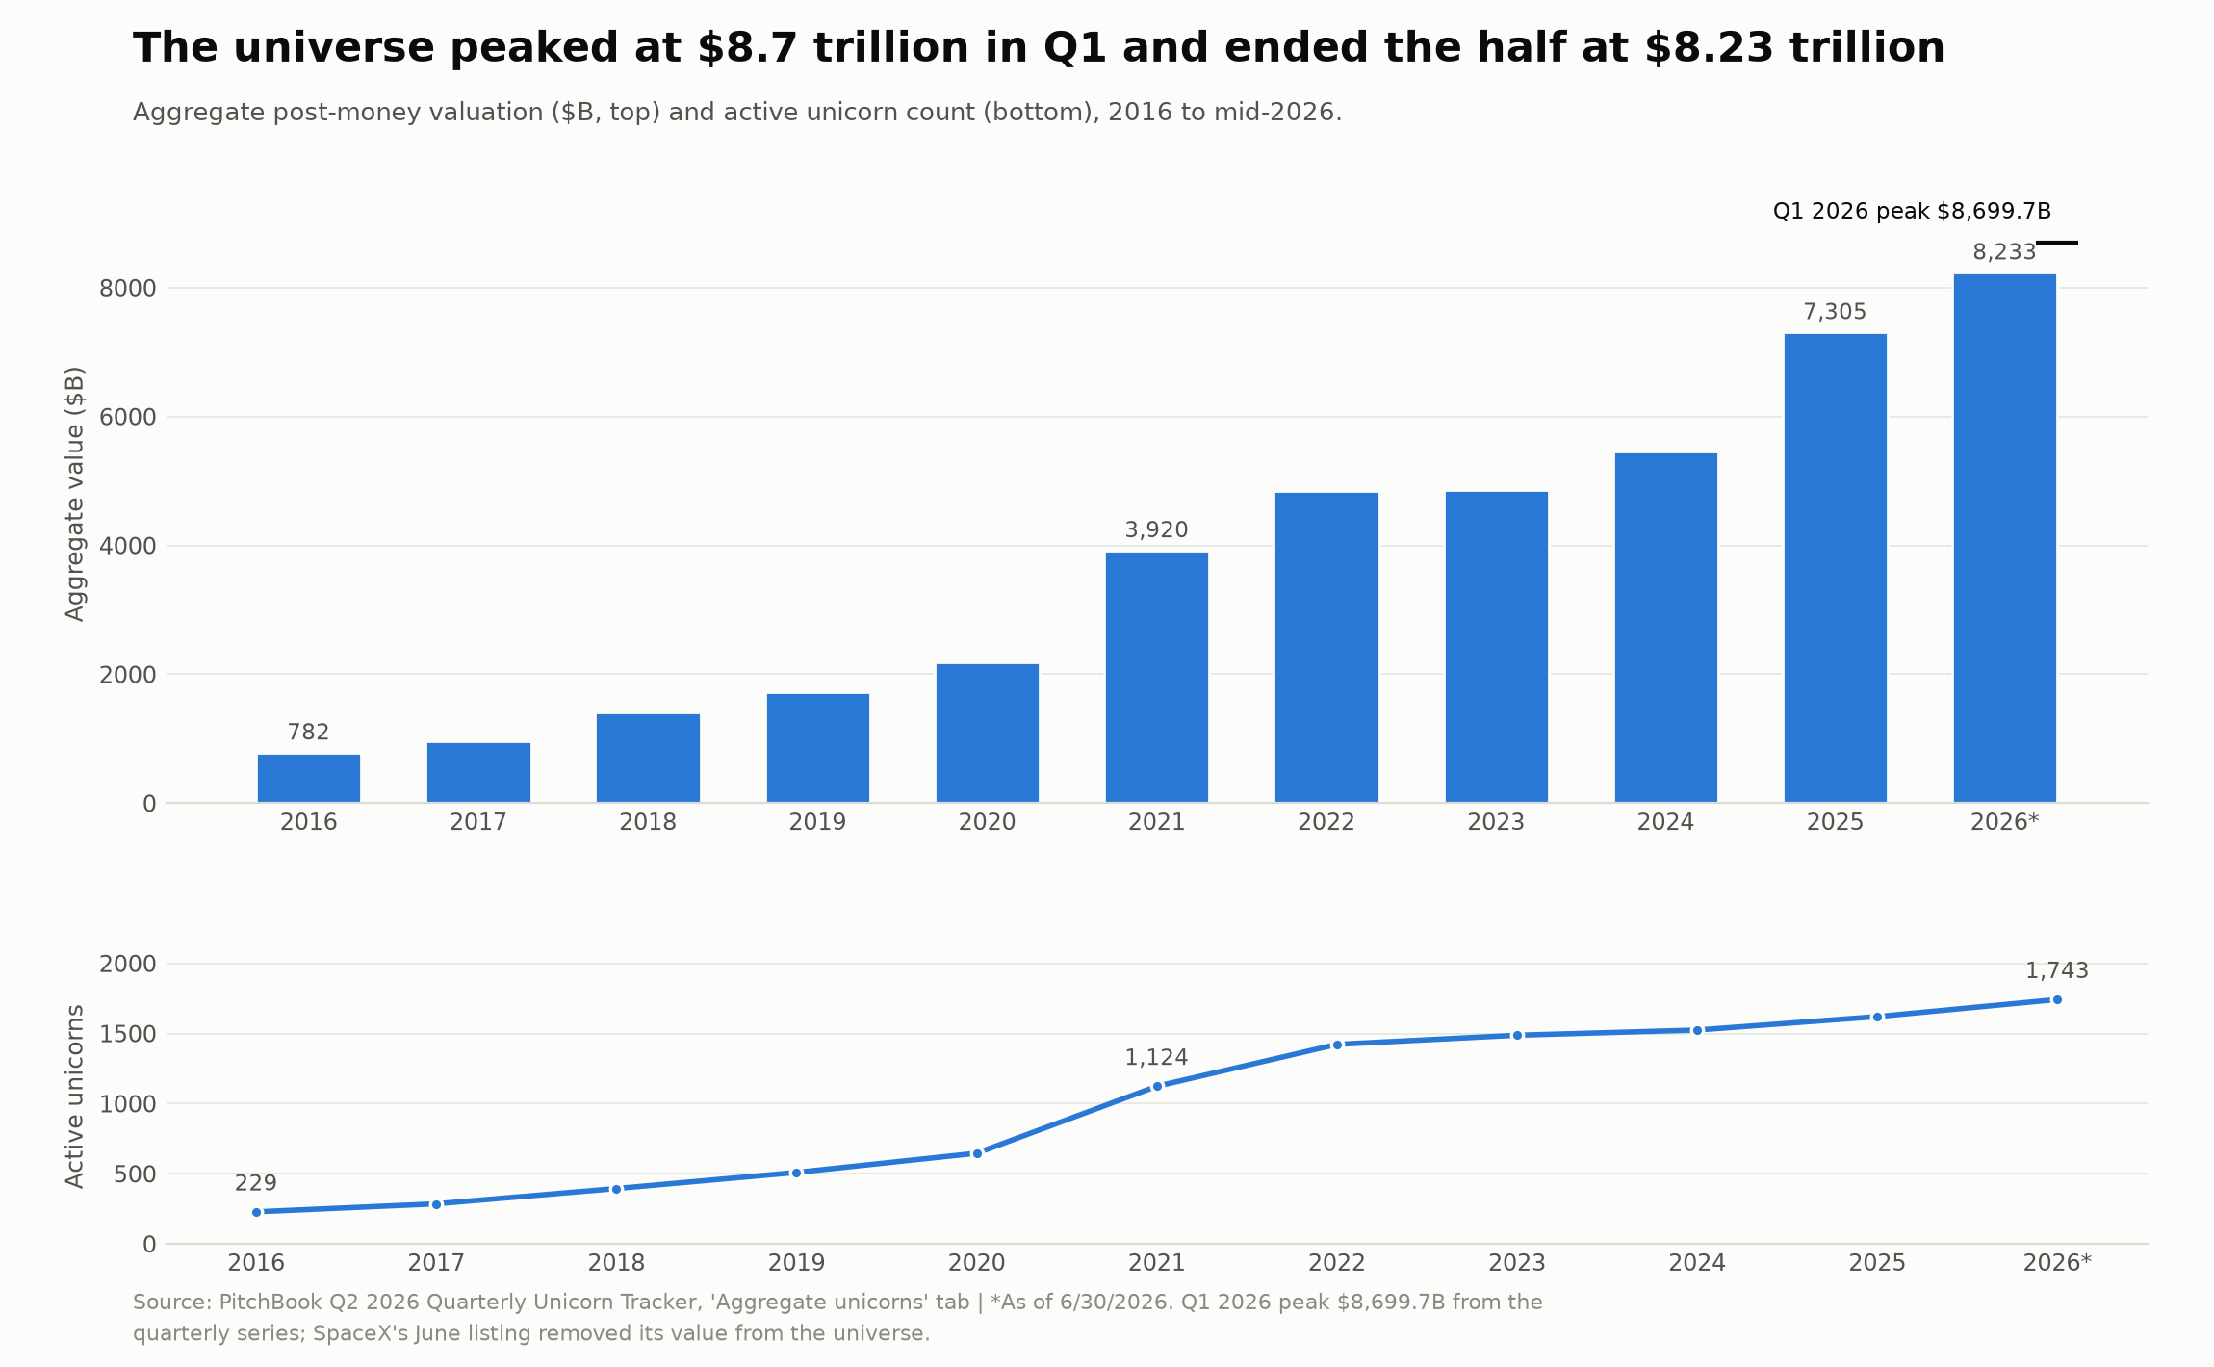

Market overview

Five financings defined the quarter's primary market
The five largest rounds raised $87.1 billion between them, and Anthropic alone accounted for $65 billion, raising into a $965 billion post-money valuation. That one financing was 5.4 times the next-largest round, Prometheus at $12 billion into a $41 billion valuation, and 16.4% of all first-half unicorn financing. Anduril ($5 billion into a $61 billion valuation), ByteDance ($3 billion into $370 billion), and Isomorphic Labs ($2.1 billion) completed the five, four of them artificial intelligence businesses. Below them, financing sizes fall under $2 billion by the sixth company and under $1 billion shortly after, so the ten largest rounds absorbed 68.9% of the quarter's $139.5 billion in sized financing value and the twenty-five largest 78.5%. Quarterly deal value fell to $144.9 billion from Q1's record $251.3 billion, and the concentration deepened even as the total shrank. Late-stage capital is concentrating into a small number of frontier labs that set the reference valuations others raise against. A strong first half in financing describes five companies, not 1,700.
The same concentration runs through who writes the checks. Syndicates of six or more investors made up 60.9% of 2026 rounds with disclosed participation, near the 2021 peak of 64.0%, so the rounds that occur are more crowded than before. Investor participation by count has not recovered alongside the dollars. It peaked at 2,892 in Q3 2021, bottomed at 895 in Q4 2023, recovered to 1,415 in Q1 2026, then fell back to 995 in Q2, even as financing value stayed high. Sequoia Capital has participated in 491 unicorn financings since 2016, Tiger Global 472, Andreessen Horowitz 454, Accel 382, and Coatue 344. Investor concentration mirrors company concentration.
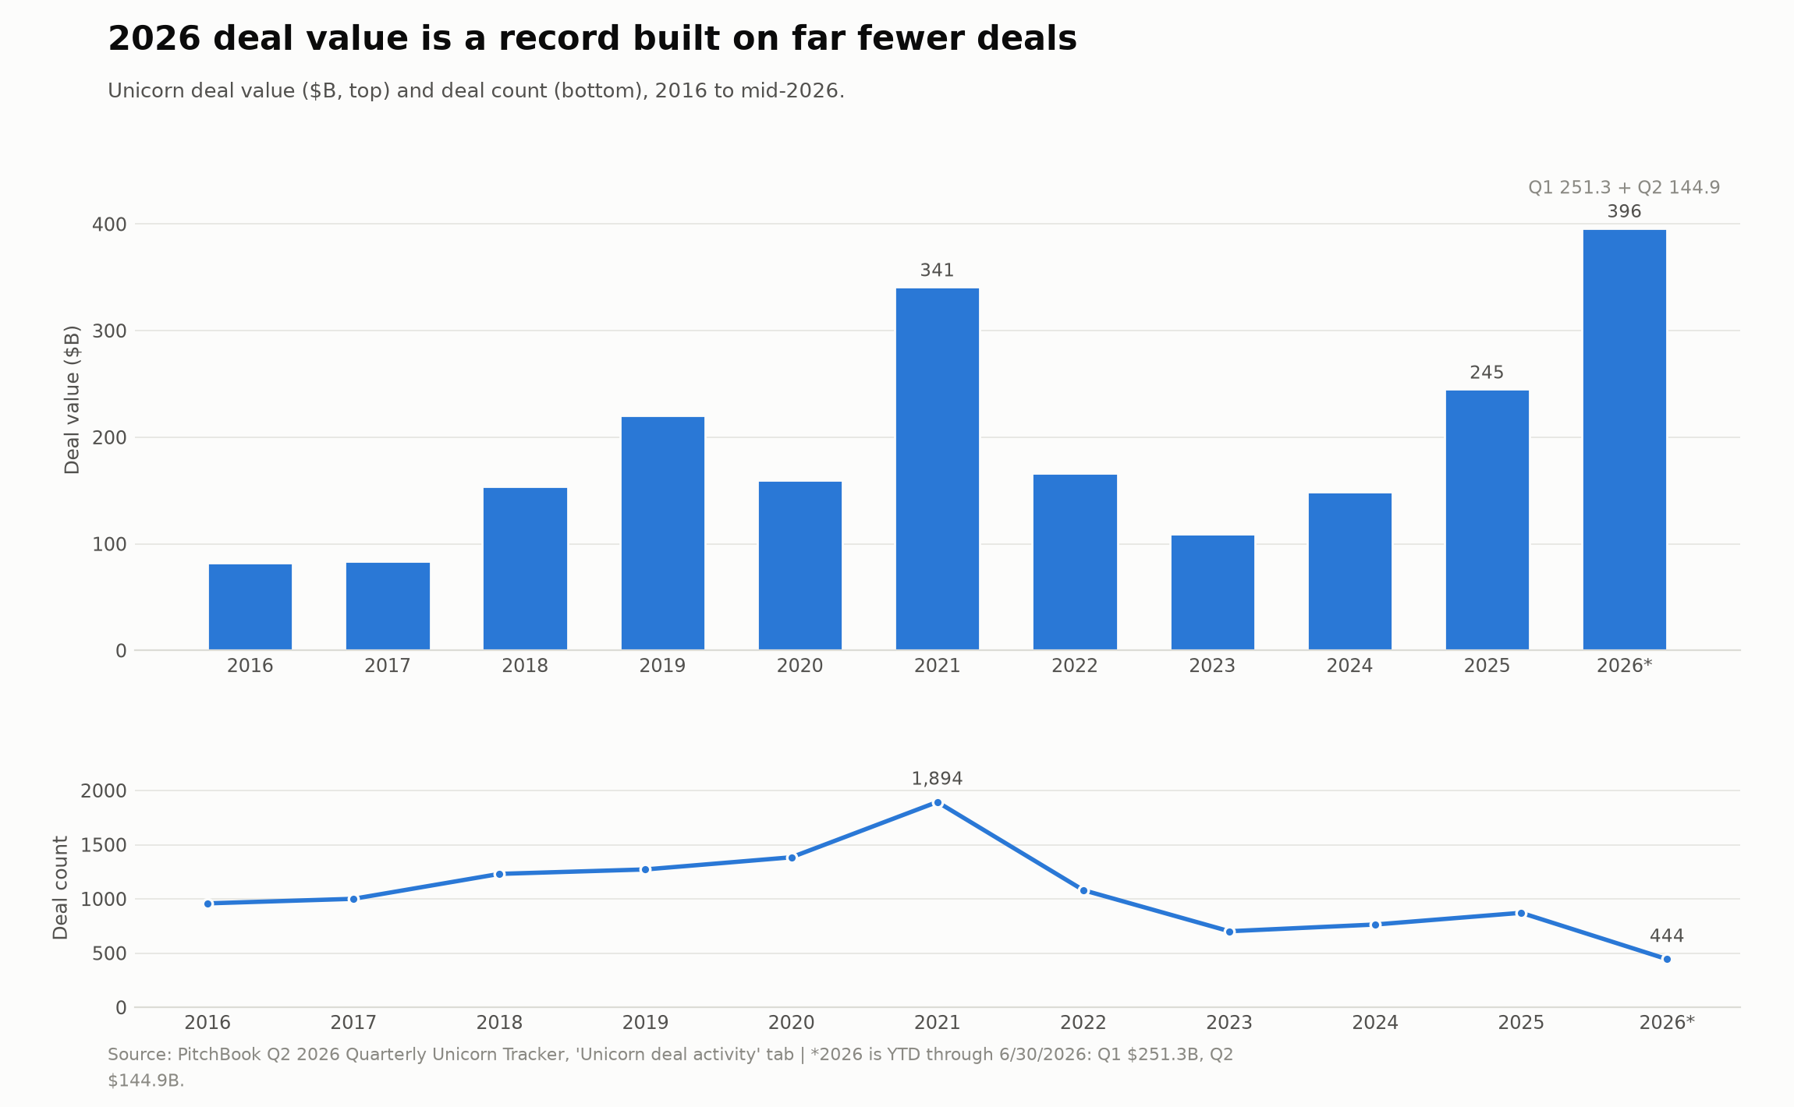

The largest valuations carry the widest gap to where shares actually trade
Each of the twenty companies in the Morningstar PitchBook Unicorn 20 can be valued three ways: a daily, model-derived valuation published by Morningstar; the post-money valuation of the last completed primary financing; and an implied valuation from secondary-market transactions, the price at which shares change hands. The index excludes some large private names, xAI and Waymo among them, which carry no model or secondary pricing. Across eighteen companies with a priced round, model-derived valuations sit 15.2% above last-round valuations. The gap is expected, since the model updates daily while the last-round valuation stays fixed until the next financing.
The secondary market diverges exactly where the capital sits. Among the eighteen names that remain private, shares in 11 trade below their model-derived valuations, and the largest position carries the widest discount. Anthropic changes hands 22% below its $1.27 trillion model valuation, a gap of about $282 billion, set after a May financing that ran ahead of a secondary market that has yet to reprice. That gap will be settled by the company's next financing or listing. SpaceX, public since June 11, is the control case: pre-listing secondary prints implied a discount of roughly a third, and the opening of public trading erased it, with shares closing day one near $2.11 trillion against a $2.03 trillion model valuation. Further down the list the pattern reverses. Applied Intuition, Anysphere, Anduril, and Revolut all trade 16-36% above their last round, so their recorded valuations understate what buyers will pay. At the bottom, all three measures have fallen together at Ripple, Epic Games, and Kraken.
Valuation reliability, the agreement among independent estimates, runs inversely to position size. The least corroborated valuations belong to the companies most likely to dominate a late-stage portfolio, so a portfolio carried at model values holds its largest private position 22% above what buyers are currently paying, and the overstatement grows with the size of the position.

The median and the average describe two different markets
Among unicorns that raised in the first half of 2026, the median financing priced at a $2.0 billion post-money valuation while the average was $18.19 billion. That 9.1-to-1 gap was 3.1-to-1 in 2025 and 2.8-to-1 in 2024. These are financing-cohort figures, not universe averages, and the widening is a composition effect: the cohort that raised this half includes the giants, so a handful of rounds pulls the average an order of magnitude above the median. The universe-wide numbers carry the same skew at smaller scale, a median active unicorn near $1.7 billion against a $4.7 billion implied average on the $8.23 trillion aggregate. Financing sizes are skewed the same way, with a $200 million median against a $1.14 billion average, the widest separation in eleven years. The aggregate grew because roughly a dozen valuations were rewritten upward while the middle of the distribution stood still. An institution benchmarking to the aggregate is tracking the twelve largest companies and crediting their revaluation to the asset class as a whole, when the median portfolio bears little resemblance to the index it is judged against.
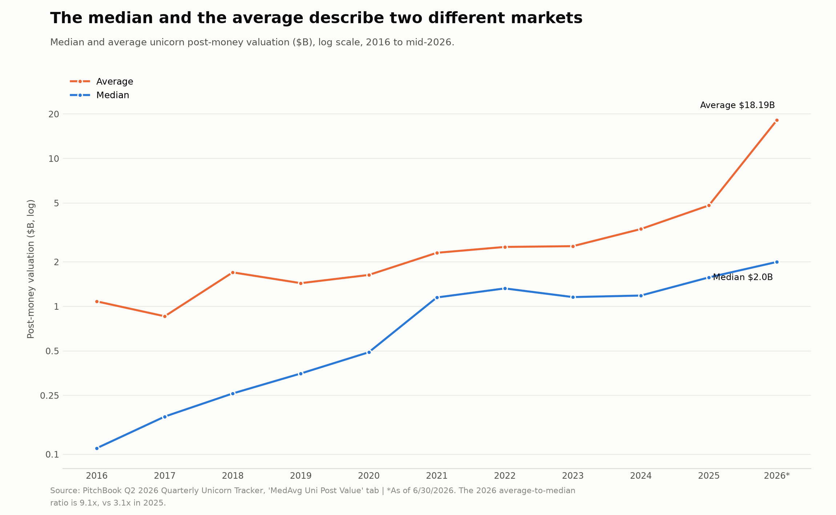

Companies that raised were repriced upward quickly
Among the companies that actually raised, terms were strong. The median valuation step-up, the ratio of a new round's post-money valuation to the prior round's, reached 2.20 times in the first half of 2026, up from 2.05 in 2025. Only the 2021 peak of 2.64 stands higher. The median interval between financings compressed to 0.98 years from 1.21 years in 2025 and 1.45 years in 2024. Down rounds have nearly vanished, with six in the first half of 2026 worth $3.85 billion, against 31 in all of 2025 and 34 in 2024. The steepest revaluations came from small companies rather than the leaders: Hark at 151 times its prior round, Blitzy and SendCutSend at 30 times, each valued below $7 billion, while the giants gained in dollars at modest multiples. Velocity lives at the small end of the market, where a single financing can revalue a company several times over, and the value sits at the large end. Every figure describes only companies that raised, which is well under half the universe, and the untested majority is where the market's real risk sits.
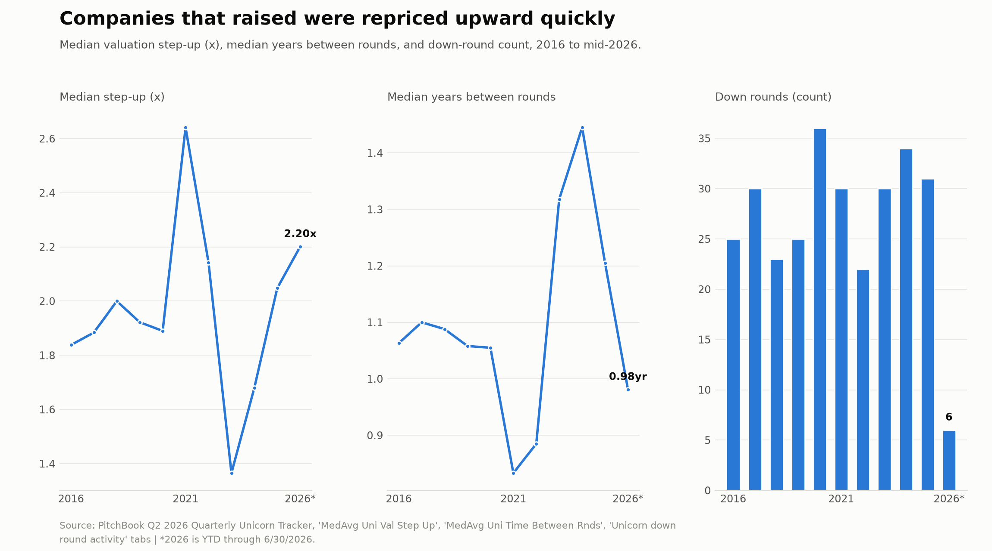

AI holds three-fifths of the universe's value on two-fifths of its companies
AI companies number 702 of the 1,743 unicorns, 40.3% by count, yet account for $5.08 trillion of the $8.23 trillion in value, 61.7% of the total. The twenty-one-point gap between those two shares measures how much larger the average AI company is, and it keeps widening. AI value rose from $3.49 trillion at the end of 2025 to $5.08 trillion by mid-2026, up 45.6% in six months. AI accounted for 109 of the 178 companies newly crossing the billion-dollar threshold.
With artificial intelligence at three-fifths of value and three-fifths of new formation, an allocation to late-stage venture is a concentrated bet on one theme. A program built without an explicit view on AI is still long AI, at a weight that now exceeds what most diversified mandates would knowingly hold.
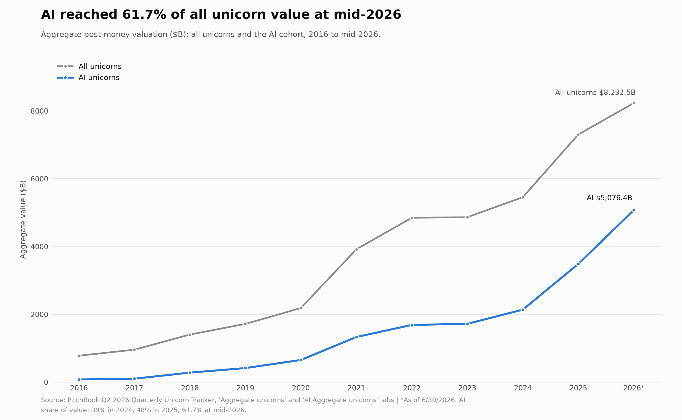

The public-listing window reopened, but one company is most of it
Exit value in the first half of 2026 reached $2.1 trillion across 50 exits, with a single event accounting for four-fifths of it. SpaceX's listing alone was $1.7 trillion; excluding it, exit value was $420.7 billion, the strongest year since 2021 but far below the headline. Public listings drove 85% of exit value, and after three years of few listings, SpaceX, Cerebras ($34 billion), and Quantinuum ($14 billion) all listed in the quarter. The listing was large enough to shrink the universe itself: the aggregate peaked at $8.7 trillion in the first quarter and ended the half at $8.23 trillion, because SpaceX's departure removed more value than the rest of the market added. After a first-quarter dip in median time to exit, driven by AI-native companies exiting young, the half-year median settled at 8.47 years, near the 9.17-year peak of 2025, so the companies reaching liquidity now are older vintages rather than recent 2023 and 2024 formations. The 2026 total reflects one large listing and an aged backlog clearing.
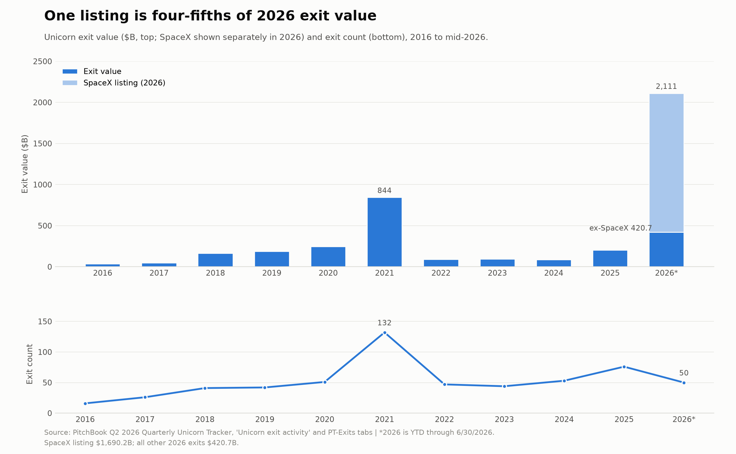

Verticals

SaaS and AI tower over every other category
SaaS leads at $6.44 trillion across 968 companies, with AI close behind at $6.02 trillion across 865, and FinTech a distant third at $2.02 trillion across 436. The next tier is far smaller: SpaceTech $1.87 trillion, Mobility $0.83 trillion, Cloud Infrastructure $0.74 trillion, HealthTech $0.45 trillion. The two leaders hold roughly $12.5 trillion between them. Tags overlap, so these totals sum to about 1.5 times the universe by value and cannot be added together, and much of the apparent breadth is the same companies counted twice under SaaS and AI. The AI tag at 865 companies is also broader than the curated 702-company AI cohort cited elsewhere in this report, because tags are nonexclusive. SpaceTech shows how a category can be a single company: its $1.87 trillion across 34 names still carries SpaceX at its final private valuation because the tag table is a snapshot that does not roll up to the aggregate, and excluding it the vertical holds roughly $0.18 trillion.

The investable universe is far narrower than the company count implies
The count of 1,743 overstates the number of large, recently valued companies. The ten largest hold about $2.9 trillion, 35% of the total, while the median active unicorn is about $1.7 billion, so most of the universe sits far below the names that carry it. Only about a third of unicorns, 614 companies, have raised within the past twelve months. The rest are priced off older financings. Geography and theme narrow it further, with 54% domiciled in the United States and 40% classified as AI. Size, recency, and required liquidity together leave a small subset of the total count, weighted toward US software and AI.

The largest verticals are not where value is created fastest
On first-half 2026 medians, AI recorded a relative velocity of value creation, the ratio of new valuation created to capital invested, of 1.84 times alongside a 2.35 times step-up across 249 financings, with SaaS at 1.42 and 2.18 across 176 financings. The highest velocity sits in smaller categories: robotics and drones at 2.03 times, and CleanTech at 3.30 with a 2.77 step-up. Crypto fell from 2.62 to 1.11. Cybersecurity at 0.66 and e-commerce at 0.38 are the lowest, both below 1.0, even as they raised at higher valuations (step-ups of 1.74 and 2.13 times), so each dollar invested created less than a dollar of new valuation.
The three-year vertical indexes show the same order. Stated as annualized returns, AI returned 58.1% a year, or 302.6% cumulative, enterprise SaaS 34.2%, and cybersecurity 22.2%, the only categories to beat the Morningstar Global TME public technology benchmark of 19.6% a year, or 72.4% cumulative, over the three-year window ended June 30. AI compounded at about three times the public rate, while FinTech, third by value, returned 12.9% and trailed. These returns are based on infrequently updated valuations, which suppress measured volatility, so the low volatility of the private indexes reflects infrequent revaluation rather than stability.

AI is the source of both the return and the risk
AI is both the driver of the market's growth and its largest concentration of value. It added $1.59 trillion in a half-year when the whole universe gained $0.93 trillion, so the rest of the market contracted around it, through both repricing and the departure of SpaceX to the public market. It now represents 61.7% of value, four of the five largest rounds, and 61% of new company formation. Because AI valuations move together and dominate the index, a repricing in a few frontier names moves the aggregate. A 25% reduction in AI valuations would remove roughly $1.27 trillion, which is 15.4% of all private-technology value. That is the bet. The companies that produced the gain are the same ones the secondary market values below their model valuations. The exposure that drove the aggregate up carries the widest downside and sits in too large a share of the universe to be diversified away within it.

The 2021 cohort is the base rate for today's AI class
Of 634 unicorns minted in 2021, five years on 470 remain active (74%), 102 have exited (16%), and 62 have failed (10%). Of the 62 that failed, 34 fell below the billion-dollar threshold while private, 15 fell at exit through a listing or sale below unicorn status, and 13 went bankrupt. Three-quarters remain illiquid five years after formation, consistent with a median time to exit of 8.47 years. Today's 702 AI unicorns are a cohort of the same size at an earlier stage. If they age as the 2021 vintage did, roughly a quarter would impair and three-quarters would remain illiquid into the next decade. AI valuations are more correlated and concentrated than 2021's, so those outcomes would be more tightly linked. The ten-year funds that financed the 2021 vintage mature between 2028 and 2031, the period over which those untested valuations resolve through markdown, sale, or wind-down.

Business quality and valuations

What the AIBQ and PBQ scores measure
The AI business quality (AIBQ) and private business quality (PBQ) framework scores the twenty Unicorn 20 constituents on five weighted dimensions of the business underneath the valuation: revenue quality (25%), capital efficiency (20%), governance optionality (20%), moat durability (20%), and either compute independence or strategic velocity (15%), depending on the business type. Eight companies built on their own AI models are scored as AIBQ, and for them, compute independence measures how much of their compute they control, because compute is the input that decides whether these businesses can keep operating. The other twelve are scored as PBQ and measured on speed of execution instead. Each composite sorts the company into one of four tiers, from Elite at 8.0 and above to Distressed below 4.5, with wide confidence bands because private disclosure is thin. Scores are re-baselined under a revised methodology and are not comparable to the Q1 prints. All inputs are capped at June 30; events after quarter-end, including Databricks' July financing, are excluded.

The scores against primary valuations
The primary market and the scores disagree about the same twenty companies. The disagreement is largest where the money is. Valuation explains about 15% of the variation in quality scores, a directional read on a sample of twenty. Databricks and Stripe are the only companies to reach the Elite tier, and they are valued at $134 billion and $159 billion. Anthropic scores 7.22 and ranks seventh despite being the most valuable private company in the world at $965 billion, while OpenAI scores 6.30 and ranks fifteenth at $852 billion. A late-stage round prices scarcity and expected scale, and the giants earn their valuations on exactly those grounds. The framework scores what a growth round tends to look past, which is where the giants lose points, since they rent the compute they depend on, run thin margins after model costs, and in OpenAI's case carry an unfinished conversion from nonprofit control. Expressed as price per point of quality, the disagreement becomes concrete. A point of quality costs about $2.2 billion at Applied Intuition and $134 billion at Anthropic, a sixty-fold premium for a lower score.
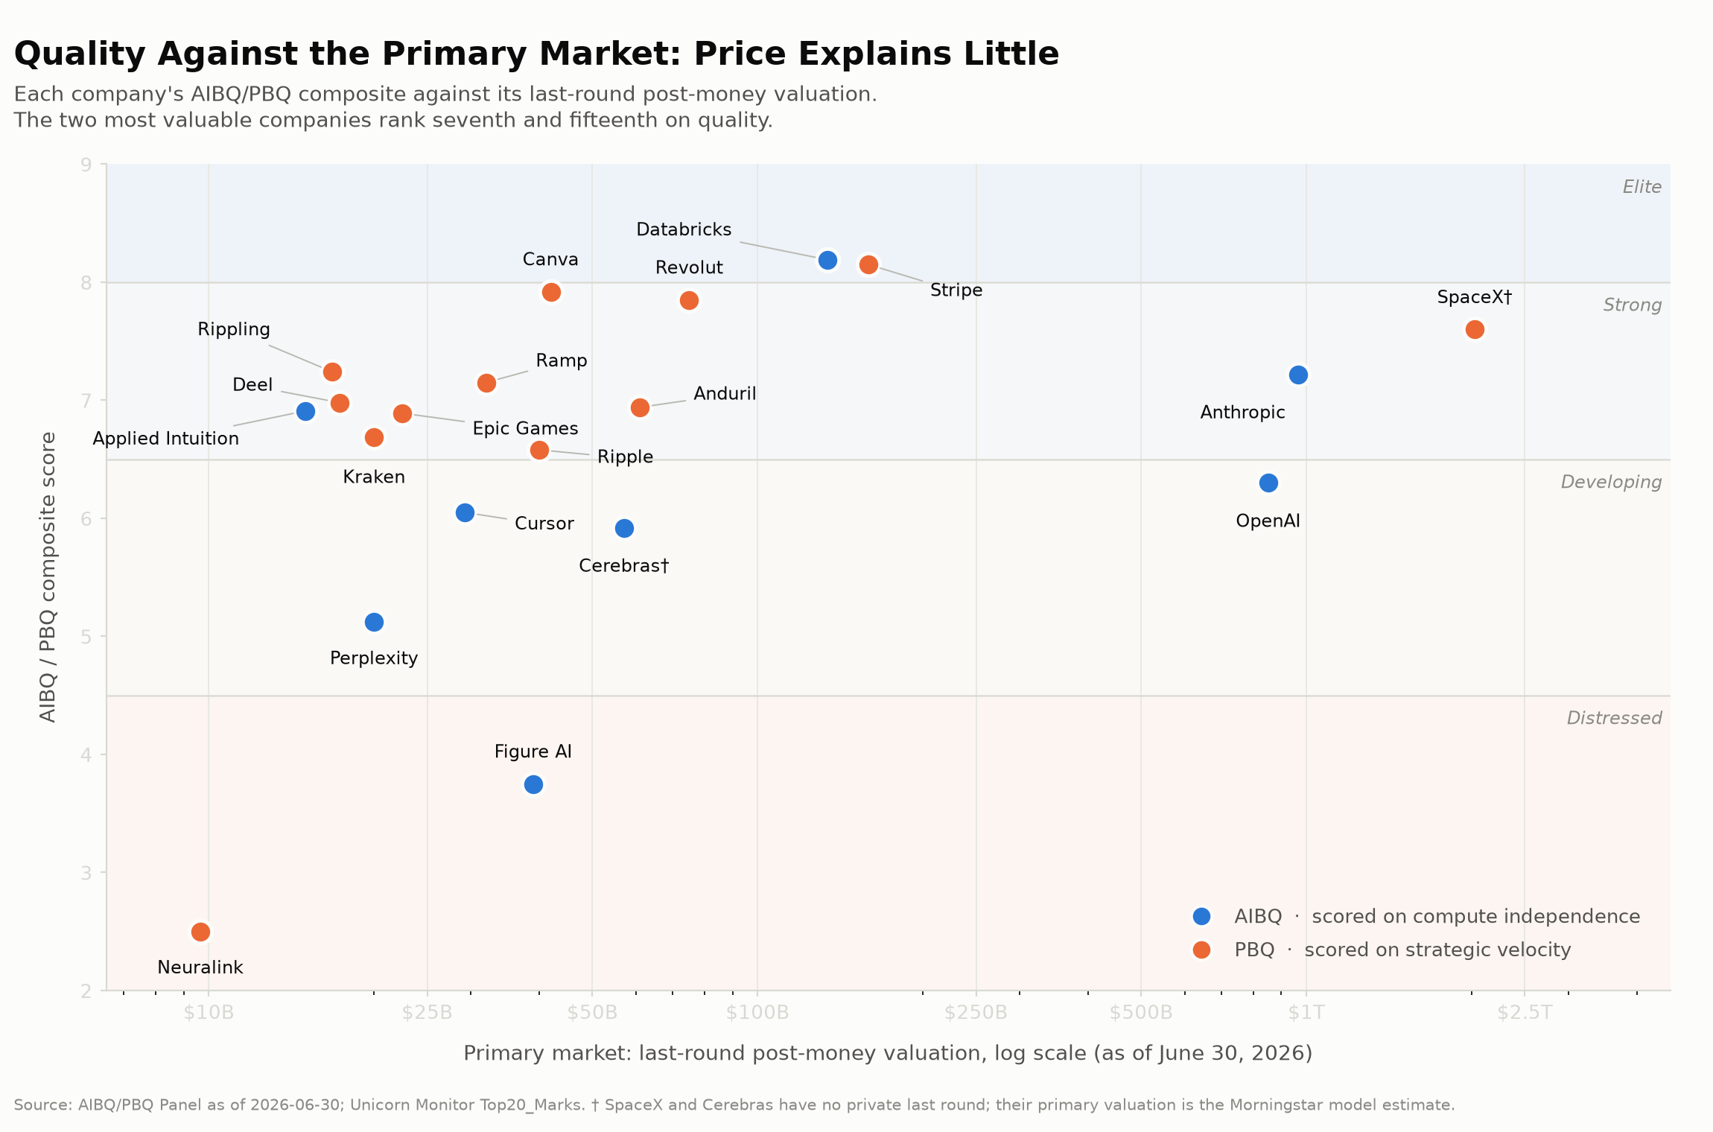

The scores against the secondary market
The secondary market, compared to the primary market, aligns more closely with the framework's reading. Of the eighteen private names, eleven trade above their last round and seven below. Excluding Neuralink, whose premium is a stale-round artifact, the ten trading above average 7.4 on quality, while the seven trading below average 6.0. That alignment makes sense because a secondary purchaser gets no board seat and no new information rights, so the price rests on what can be observed about the business today, which is close to what the framework scores. Two departures from the pattern are informative. Anthropic and OpenAI trade at 22% and 9% below their model valuations despite mid-tier scores, suggesting secondary buyers are already discounting the compute dependence and governance questions that the primary market has not yet priced. And the two Distressed names have the least price discovery of all. Figure AI, scored 3.75, trades 23% below its round, and Neuralink, scored 2.50, has no meaningful secondary depth beneath a model valuation sitting 441% above its last financing. Across the twenty, the weaker the business scores, the fewer independent prices exist to test its valuation. The whole tape is thin: closed secondary volume across the twenty names was $562 million in Q2, down from $1.33 billion in Q1, against positions marked in the trillions. Extending the framework across 301 US AI companies, each hand-scored on the same rubric and calibrated to the twenty verified composites, with lower confidence on sparsely disclosed names, shows how thin quality runs below the leaders: the median composite sits at 4.55, just above the 4.5 Distressed boundary, only five companies reach Strong or better, and 140 of the 301 score Distressed. The quality question is not the top of the AI market. It is everything underneath it.
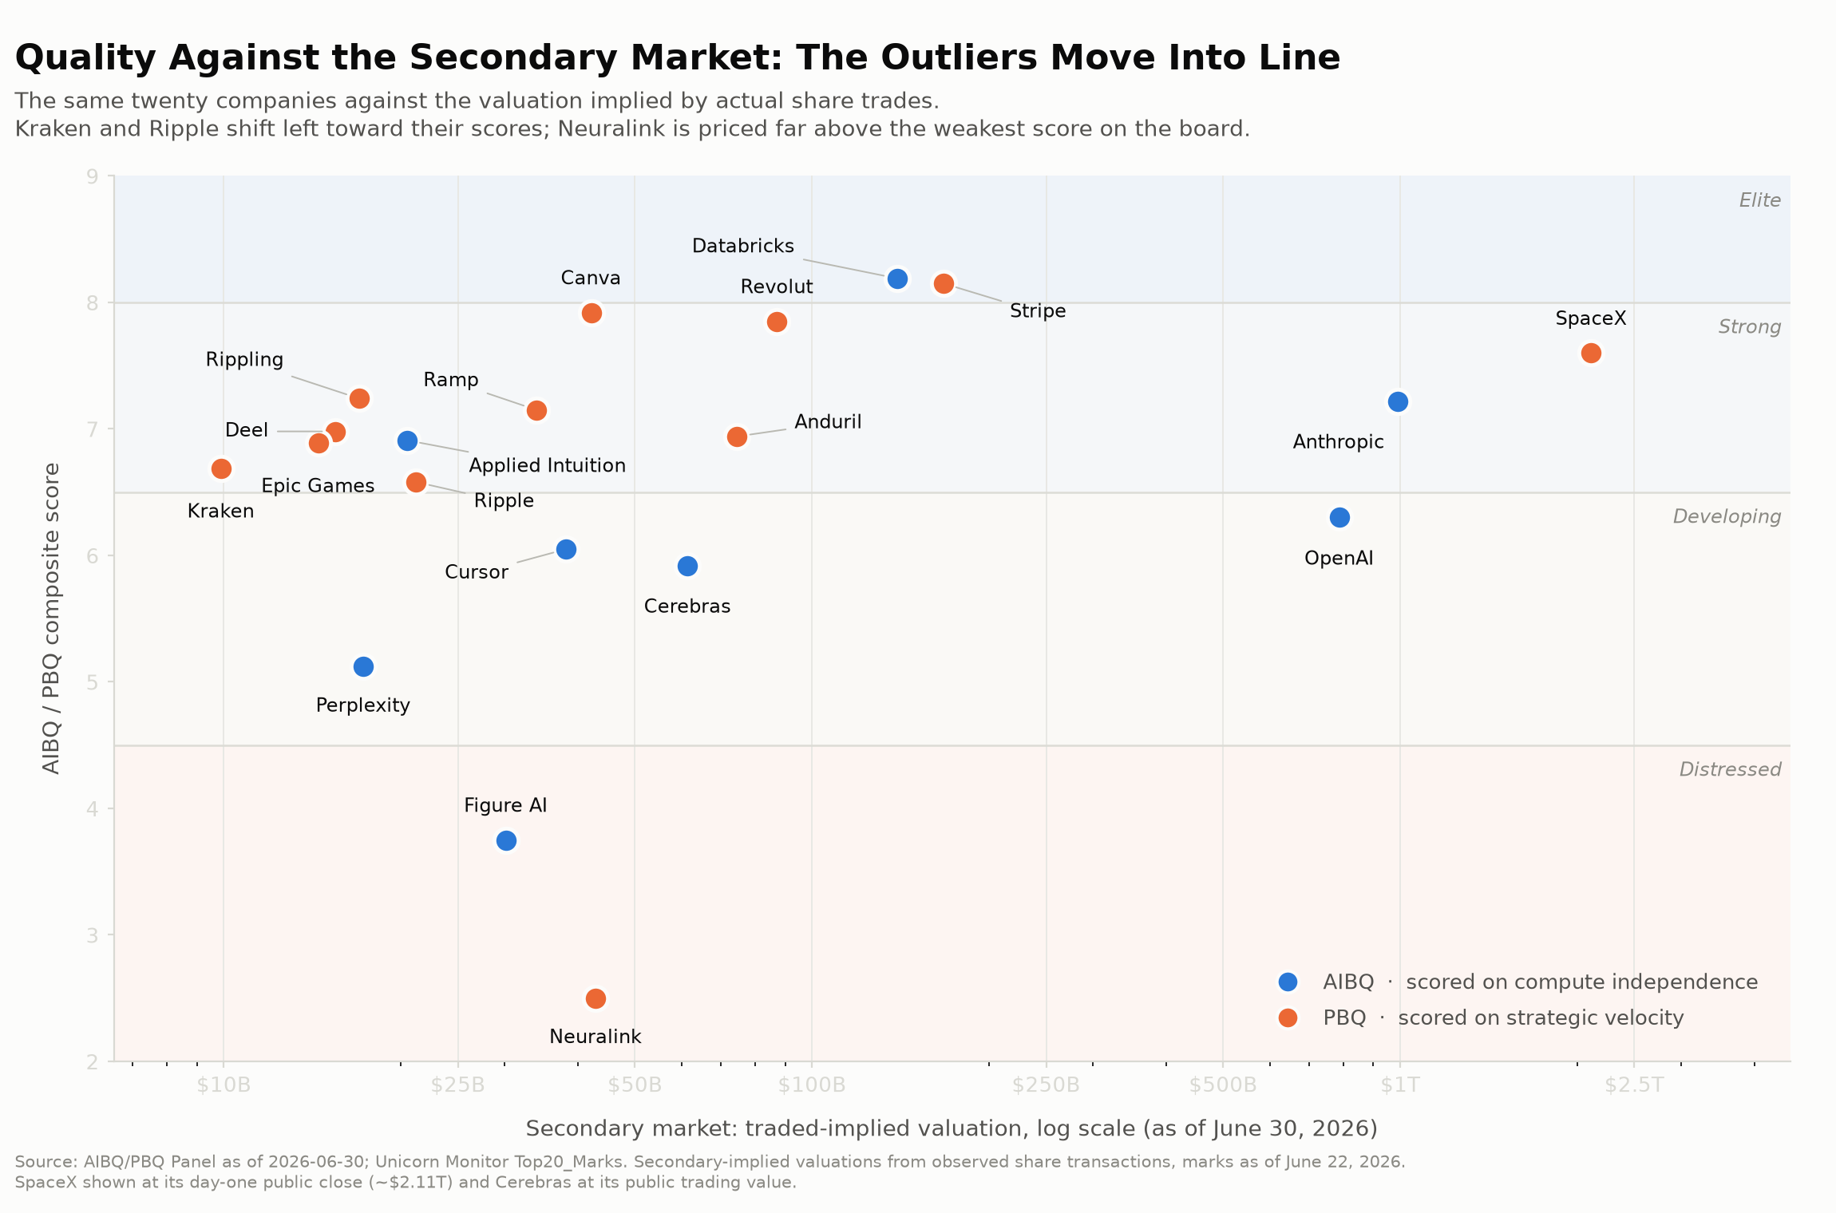
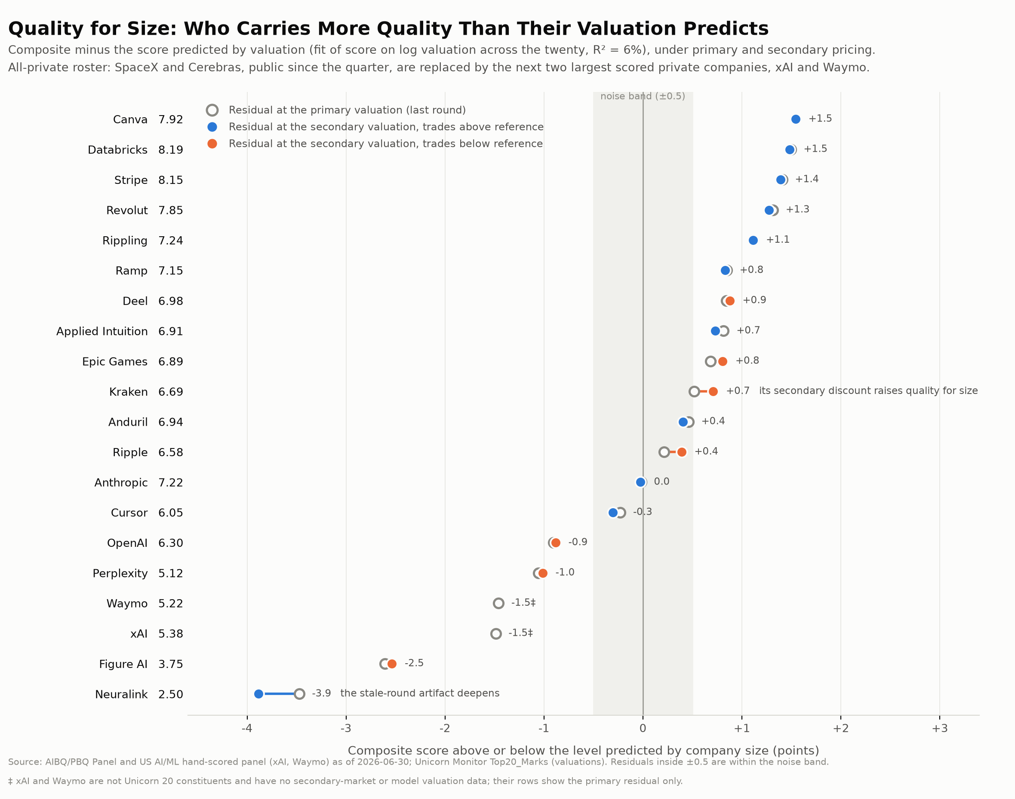
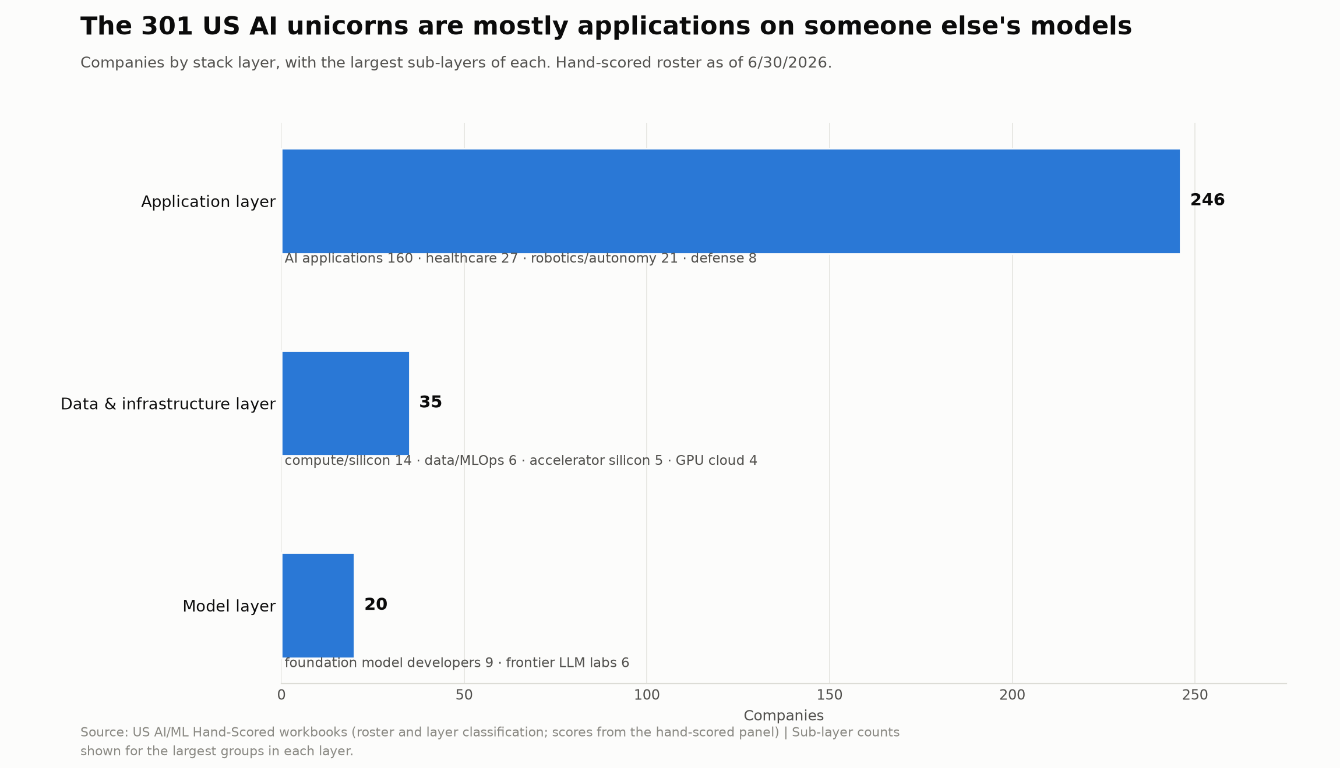

Valuations and fallen unicorns

Valuations are current at the top and grow stale quickly below it
Anthropic ($965 billion) and OpenAI ($852 billion) together hold $1.82 trillion, 22% of the $8.23 trillion universe, and both carry recent valuations, Anthropic from May 2026 and OpenAI from March 2026, as does ByteDance (May 2026). Below these leaders, valuations age fast. Ant Group, seventh by value, still carries a financing from August 2020, and SHEIN carries one from January 2024. Measured from actual latest-financing dates, 47.6% of unicorns have not raised in more than 24 months and 37.1% in more than 36 months. Close to half of the $8.23 trillion rests on valuations no financing has retested in two years or more. The universe divides into a small frontier of recently priced companies and a large interior of dated valuations whose repricing risk never appears in the aggregate. Blending recently priced companies with hundreds priced years ago produces a single number that hides the difference, and the total should be split into tested and untested dollars.

Value created per dollar invested has recovered above its pre-boom level
The median relative velocity of value creation rose to 1.42 times in the first half of 2026 from 0.93 in 2025 and a low of 0.23 in 2023, above its pre-boom baseline of roughly 0.73, with the 2.20 median step-up and 0.98-year interval pointing in the same direction. Velocity above 1.0 means each dollar raised created more than a dollar of new valuation, a reversal from 2023, when financings diluted holders more than they built value. The 2.73 average against the 1.42 median carries the same skew as the valuations themselves. Value creation concentrates in a few names, and the measure counts only companies that have raised.
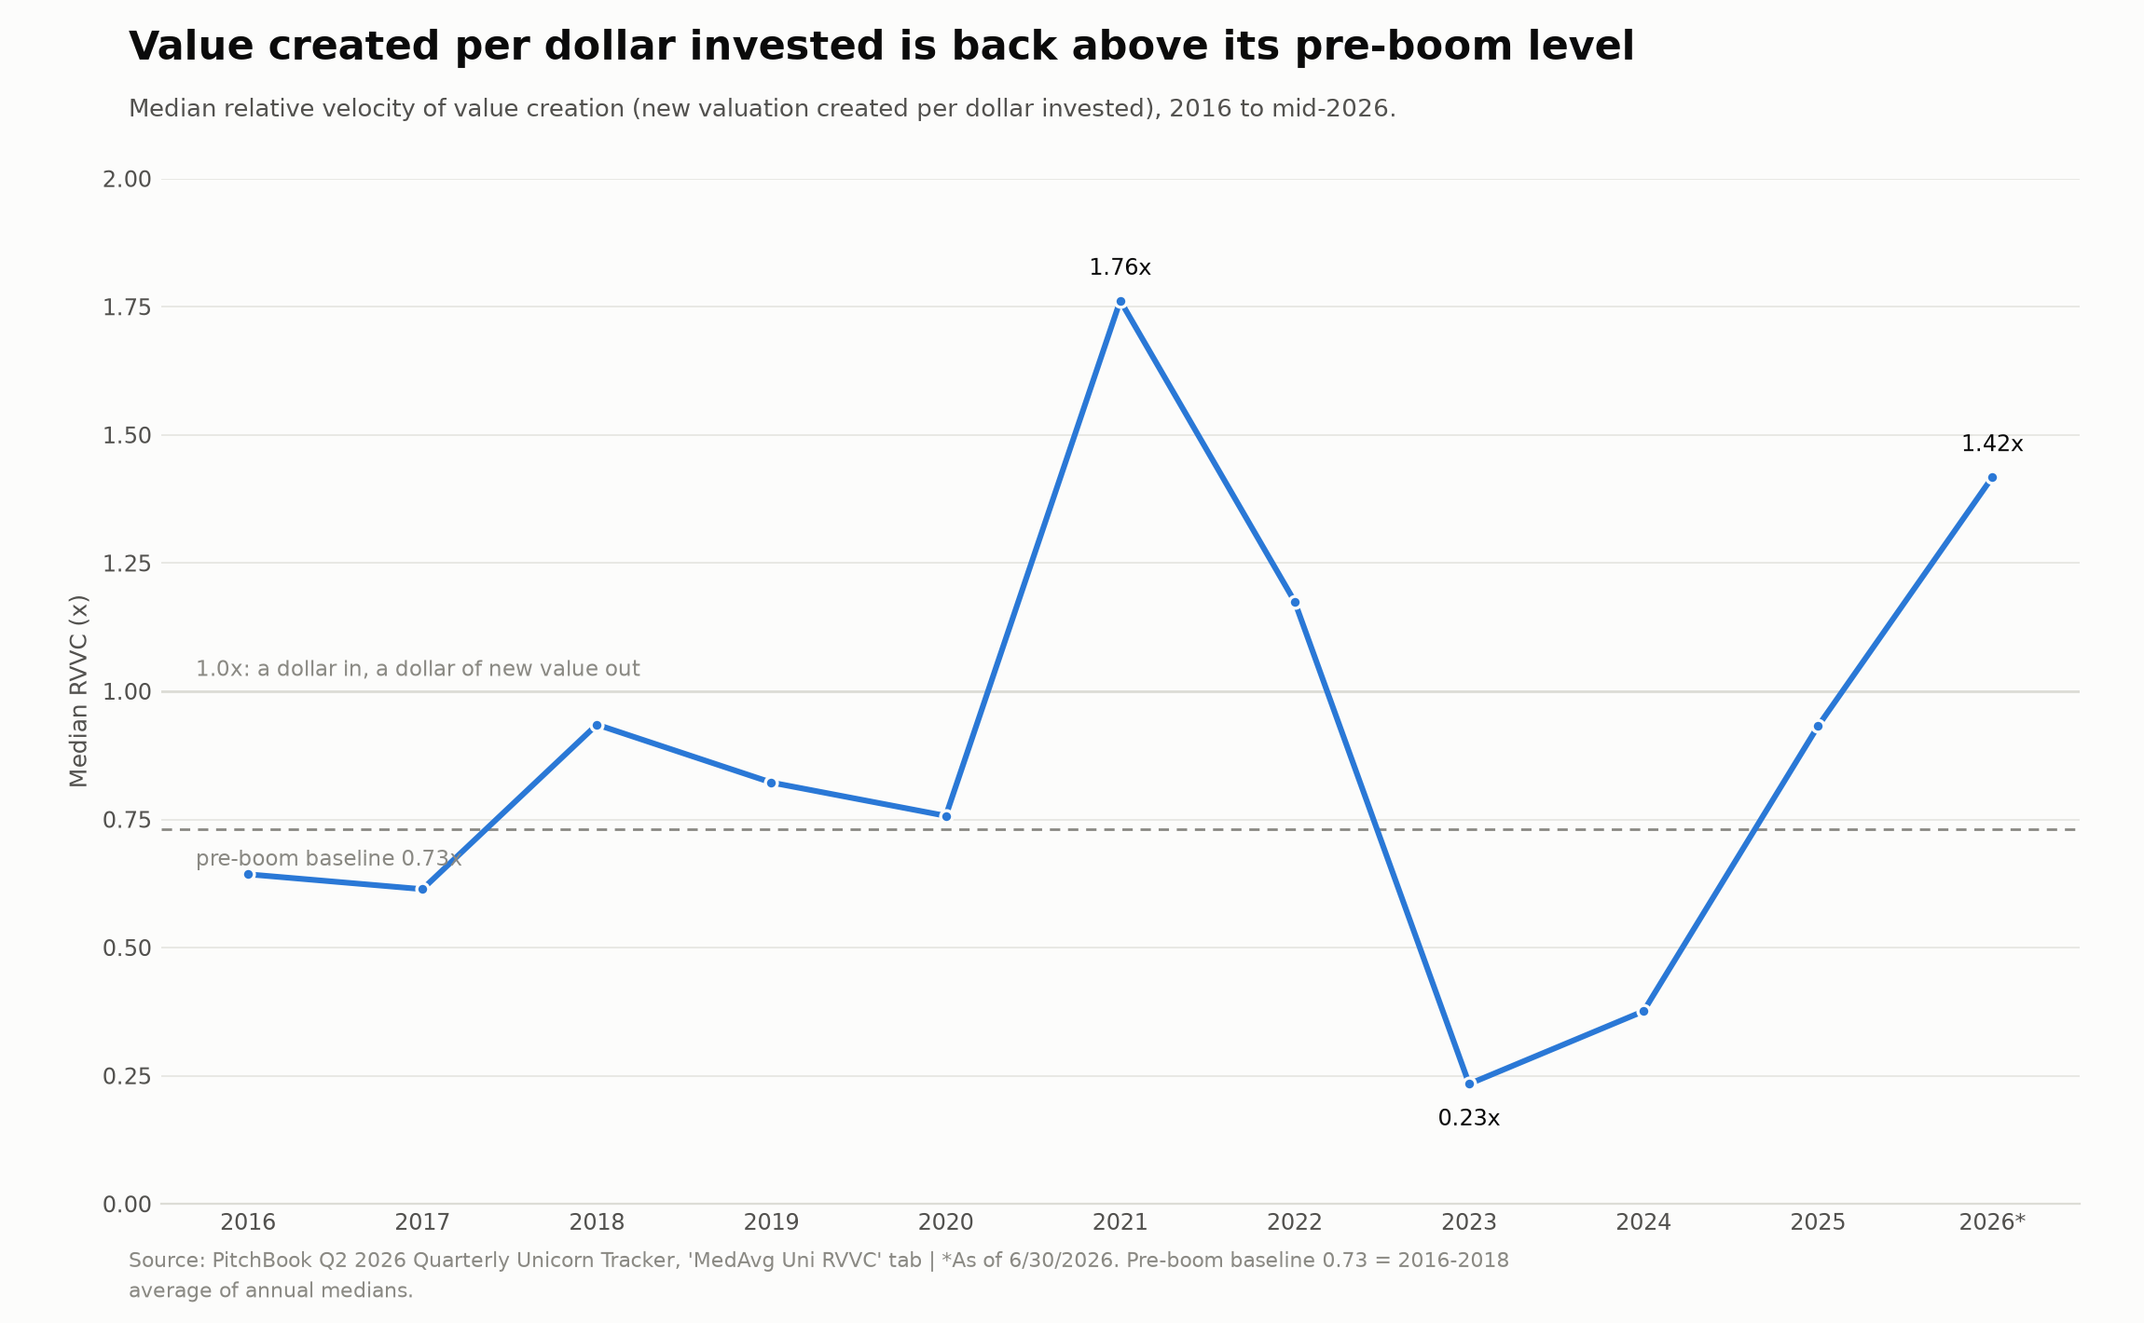

The rate of new failures has fallen while the untested population has grown
A total of 245 unicorns have fallen below the billion-dollar threshold to date, and new failures have nearly stopped. The count rose from the 175 reported in Q1 through a rebuild of the curated list, which now includes pre-2016 falls and 63 companies with no recorded down round, not through new failures. There have been six down rounds in the first half of 2026 worth $3.85 billion, against a peak of 34 in 2024. Failures are severe when they occur, at a median failing valuation of $524.5 million and a median decline of 67% from the prior peak. The 2021 cohort's 15 companies that fell at exit are counted as exits in standard exit statistics even though this report's cohort accounting classes them as failures, so headline exit tallies overstate successful outcomes. A company is also recognized as failing only when it raises at a lower valuation, and 47.6% of the universe has not raised in more than two years, so the count describes companies that raised rather than the dormant majority.

What to watch
The $8.23 trillion is real, concentrated, and largely untested. Two companies hold 22% of it, the five largest financings took 62% of the quarter's sized deal value, and 47.6% of all valuations have gone more than two years without a financing to confirm them. The valuations that are current, at the top, are the ones the secondary market prices furthest below the model, led by Anthropic at 22%. The governing fact is AI, which added more value in six months than the entire universe gained and now holds three-fifths of all private-technology value on two-fifths of the companies.
The figure to track is not the aggregate, which will keep climbing on a dozen AI valuations, but the share of value resting on the frontier of recently tested valuations against the interior of dated ones. The event that will move it is the next set of frontier financings. SpaceX has already met its test, listing in June at a public value roughly in line with its model valuation. Anthropic and OpenAI have not. Should Anthropic's expected listing or OpenAI's next round clear below the model rather than above it, the repricing will not stay contained to a single company.
The market that emerges is five companies deep at the top and 1,700 wide beneath, and the space between those two numbers is where the next three years happen.

