INITIATION OF COVERAGE
Databricks, Inc.
Where the Models End and the Business Begins
The highest-quality business in the Frontier Five, at the lowest quality-adjusted price. The IPO is the event that forces the market to reconcile the two.
AIBQ RATING  8.81 / ELITE  Highest in the Frontier Five; only Elite score in the cohort | RECOMMENDATION  CORE HOLDING  8% allocation; conflict disclosed on page 2 | QUALITY-ADJUSTED PRICE  $15.2B / AIBQ POINT  Cheapest in cohort vs $118B (Anthropic), $188B (OpenAI)

Snapshot (all figures re-verified July 10, 2026)
Metric | Value | As of / source | Tier
Last completed mark | $134B (held flat, two closes) | Series L; Dec 2025 / Feb 9, 2026; company + PitchBook | T2
Rumored round (not adopted) | $165-175B, in talks, unclosed | The Information, Jun 9, 2026; PB note Jul 7, 2026 | T3
Revenue run-rate | $6.9B, +80% YoY, accelerating | Company via CNBC, Jun 16, 2026 | T2
Gross margin | 74% (from >80%), guided lower | Company disclosures, Jun 16, 2026 | T2
Free cash flow | Positive (TTM and FY2025) | Company, Feb 9, 2026 | T2
Net revenue retention | >140% | Company, Feb 9, 2026 | T2
Run-rate multiple | 19.4x ($134B / $6.9B) | Derived | calc
Capital efficiency (equity-only) | 0.34x ($6.9B / ~$20.2B) | PitchBook 21-deal record, Jul 2026 | T2
Lifetime capital | ~$29.5B (~$20.2B equity + ~$9.3B debt) | PitchBook entity 59199-40 | T2
IPO status | No S-1; 2026 ruled out; 2027 earliest | EDGAR Jul 10, 2026 (T1); Bloomberg TV, Jun 4, 2026 | T1/T2
Author: Harrison Rolfes, Senior Research Director | July 10, 2026 | Single-name institutional initiation note. Prepared for institutional-investor and venture-capital recipients.

Disclosure and Basis of Preparation
CONFLICT OF INTEREST DISCLOSURE
Databricks, Inc. is a position in the author's managed book, held as a core allocation of 8% of portfolio value. The author therefore has a direct economic interest in the conclusions of this note. This is not a footnote consideration: readers should weight every judgment herein with that interest in mind. The position was established prior to the preparation of this note and no transaction in Databricks securities has been made, and none will be made, within five trading days of this note's distribution.

This note initiates coverage of Databricks, Inc. for an institutional-investor and venture-capital audience. It is prepared as of July 10, 2026, on a canonical data pack designated v3.4 (compiled July 7 to 9, 2026), with every load-bearing figure re-verified against live primary sources on July 10, 2026. Where a figure could not be independently re-verified, it is labeled as such in the text. Where a company-announced figure and a media figure disagree, both are stated with their dates; we adopt the higher-tier source and do not average.

Figure provenance and tiering
Every material figure in this note carries a dated source assigned to one of three tiers. T1 denotes audited or regulatory sources (SEC EDGAR filings, exchange data). T2 denotes company-announced figures (Databricks press releases, executive statements to named outlets). T3 denotes media or single-source reporting (The Information, aggregated coverage). Databricks is private and publishes no audited financials; the reader should hold in mind that even its T2 figures are self-reported and would be restated in an S-1 under GAAP discipline. Estimates are labeled as estimates. Figures that may be stale carry their as-of dates. Appendix B tables every load-bearing claim with its source, date, and tier.

Embargo discipline
The correlation coefficient linking business quality to valuation across our coverage cohort is embargoed and appears nowhere in this document, in text or in chart form. The only cleared public expression of the quality-valuation relationship is the dollar-per-AIBQ-point spread, presented as a ranked bar (Figure 1). No chart in this note plots quality scores against valuations, and no chart carries a fitted line from which the embargoed statistic could be reconstructed.

Valuation basis
The base-case valuation anchors on the last completed financing mark of $134 billion (Series L, first close announced December 2025, additional close February 9, 2026; T2, company press releases and PitchBook deal record 313367-68T). The reported financing discussions at $165 to 175 billion (T3: The Information, June 9, 2026) remained unclosed as of July 10, 2026 and are excluded from the base case under our do-not-adopt rule for unclosed or rumored financings. They are analyzed, at length, in Section 10. Capital-efficiency calculations use an equity-only denominator; debt is excluded from that ratio by methodological ruling and informs the compute-independence and risk assessments instead (Appendix A).
This document is research, not investment advice. Databricks securities are not publicly traded; private-market access is restricted, illiquid, and unsuitable for investors who cannot bear total loss and indefinite holding periods. Figures for private peers are negotiated marks, not market prices.

Executive Summary and Investment Thesis
The most expensive assets in private technology are the least proven businesses, and the cheapest is the best one. That is the paradox this note is built around. Databricks scores 8.81 on our AI Business Quality framework, the highest composite in the Frontier Five and the cohort's only Elite rating, and at its $134 billion mark it costs $15.2 billion per point of measured quality. Anthropic costs $118 billion per point. OpenAI costs $188 billion. xAI, on our estimate of its implied value inside the newly listed SpaceX, costs roughly $345 billion. The buyer of Databricks pays the least, by an order of magnitude, per unit of the thing an investor is supposed to be buying.
This is where the models end and the business begins. The frontier labs are call options on artificial general intelligence, priced accordingly. Databricks is a cash-generative enterprise franchise: $6.9 billion of run-rate revenue growing more than 80% year over year (T2: CNBC, June 16, 2026), gross margin of 74% (T2, same disclosure), free-cash-flow positive on a trailing-twelve-month basis (T2: company, February 9, 2026), and net revenue retention above 140%. It is being priced, per unit of quality, as if it were the least proven asset in the room. The IPO, guided by the CEO to 2027 at the earliest (T2: Bloomberg Television, June 4, 2026), is the event that forces the market to reconcile the two.

The three legs
- Quality that survives scrutiny. Growth above 80% at $6.9 billion scale is not a small-base artifact; it is the fastest growth of any software company near this size, against CrowdStrike at 26% and Shopify at 34% (T3: Tunguz, June 2026). The growth is accelerating: +50% in September 2025, +55% in December, +65% in February 2026, +80% in June (Figure 2). Margin, cash generation, and retention all clear institutional bars simultaneously, which is precisely what the AIBQ efficiency gate tests.
- Growth funded from within. Databricks has raised roughly $20.2 billion of equity in its lifetime and converted it into $6.9 billion of run-rate revenue, a capital efficiency of 0.34x, against roughly 0.14x at OpenAI and 0.07x at xAI (desk estimates). Only Anthropic, at an estimated 0.38x, is comparable. Unlike the labs, Databricks generates cash rather than consuming it: the last raise was taken flat at $134 billion across two closes because the company did not need to reprice itself to fund operations.
- The price. At $15.2 billion per AIBQ point, the market charges less for Databricks quality than for any other asset in the cohort (Figure 1). Growth-adjusted against its nearest public comp, the discount repeats: Databricks trades at 0.24x forward revenue multiple per point of growth versus Snowflake at 0.49x (Figure 3). Two independent yardsticks, private and public, say the same thing.

The honest counter
Part of the spread is rational. Some of the labs' premium is genuine option value on AGI outcomes that Databricks does not offer; if frontier models compound into something discontinuous, no data platform participates in that tail. Part of the spread is structural: the labs re-mark upward on every raise because they must raise continuously, while Databricks held its mark flat precisely because it did not need money, so the comparison partly reflects liquidity mechanics rather than mispricing. And category confusion cuts both ways: the market may be paying up for model companies not by error but because it believes platform economics are more contestable than they look. We take these seriously and answer them in Sections 11 and 14. The short version: option value explains a premium, not an 8x-to-23x per-point premium over a business growing 80% with positive free cash flow, and the flat mark is itself evidence of the discipline the labs cannot afford.

Rating and recommendation
AIBQ 8.81, Elite band, down from 8.92 on exactly two drivers: gross-margin compression from above 80% toward the 70% efficiency-gate floor, and removal of a 0.5-point governance imminence premium that was tied to an H2 2026 S-1 no longer expected. The rumored raise is not a rating driver in either direction. Recommendation: Core Holding at an 8% allocation (disclosed conflict, page 2). Base-case value of $155 to 190 billion on a twelve-month view, reached by letting growth do the work against the $134 billion anchor, not by adopting the rumored round.

What would change our mind
- A gross-margin print below 70% at the next disclosure (expected roughly September to October 2026) breaks the efficiency gate, forces a mechanical re-score, and removes the Elite band. This is the single line that changes the rating.
- Growth decelerating through 50% while margin is still compressing would convert the acceleration story into a peak-quarter story and compress the base case toward the bear range of $115 to 130 billion.
- An OpenAI or Anthropic listing that prices poorly and closes the IPO window into 2028 extends the private holding period and weakens the convergence mechanism, though it does not impair the business.
- Hyperscaler behavior that turns co-opetition into margin capture, for example punitive egress or preferential first-party bundling, would attack the compute-independence dimension where the company is already weakest (CI 8.0).
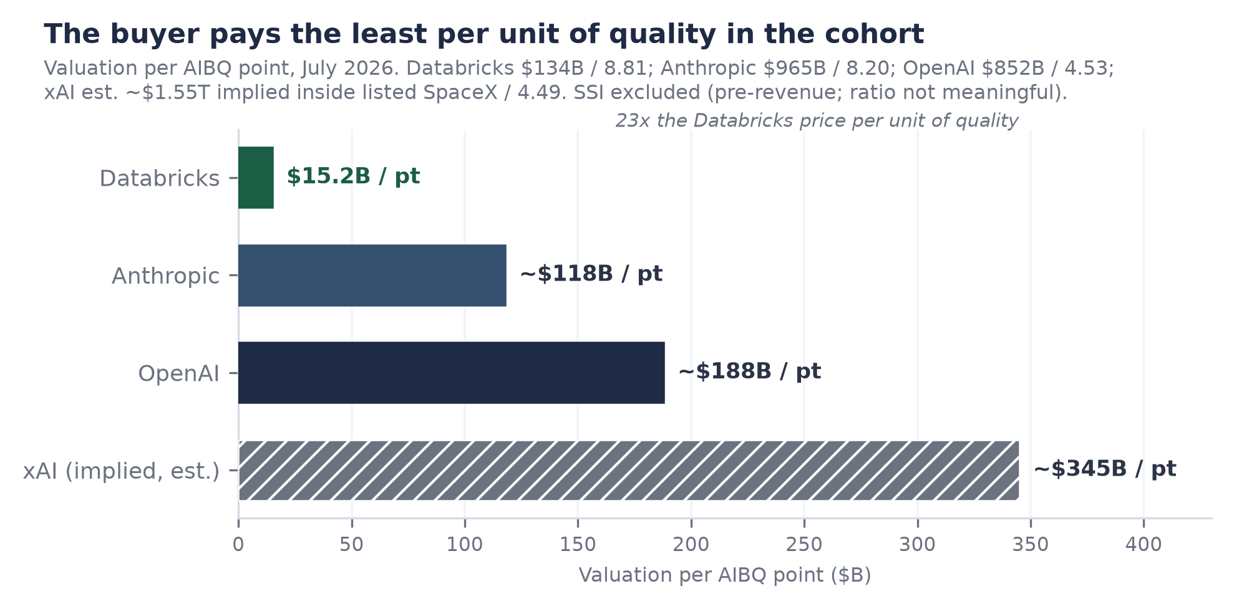
Figure 1. Valuation per AIBQ point across the Frontier Five, July 2026. Sources: marks per company announcements and PitchBook (T2); xAI implied value is a desk estimate inside listed SpaceX (T3/est.); AIBQ scores are this desk's framework. SSI (~$30-32B / 2.30) excluded as pre-revenue. The embargoed quality-valuation coefficient is not derivable from this ranked bar.

The AIBQ Rating: Full Breakdown
AIBQ scores durable business quality, deliberately independent of valuation, across five weighted dimensions on a 0-to-10 scale, less a contextual risk adjustment (CRA). Databricks composites to 8.81 with a CRA of zero: the only Elite rating in the Frontier Five, and the highest composite this desk has assigned. The full methodology, band definitions, and the equity-only capital-efficiency ruling are in Appendix A. This section decomposes all 24 sub-scores, because the rating is the analytical spine of the note and the reader is entitled to see every joint in it.
AIBQ composite reconciliation
Dimension | Weight | Score | Contribution
Capital Efficiency (CE) | 20% | 8.9 | 1.780
Revenue Quality (RQ) | 25% | 9.0 | 2.250
Compute Independence (CI) | 15% | 8.0 | 1.200
Governance Optionality (GO) | 20% | 8.9 | 1.780
Moat and Defensibility (MD) | 20% | 9.0 | 1.800
Weighted sum | 100% |  | 8.810
Contextual Risk Adjustment (CRA) |  |  | 0.000
Composite |  |  | 8.81 (Elite)
Source: desk AIBQ framework, July 2026 re-score. Reconciles exactly: 8.9(.20) + 9.0(.25) + 8.0(.15) + 8.9(.20) + 9.0(.20) = 8.81.

Capital Efficiency: 8.9 (weight 20%)
CE asks one question: how much durable revenue does a dollar of equity buy? Databricks is stage-gated S5 (late stage), where the bar is hardest: at S5 the framework demands the efficiency gate be met in full, meaning positive free cash flow, growth above 40%, and gross margin above 70% simultaneously. Databricks clears all three, with the margin leg now the binding one: 74% against the 70% floor leaves a cushion of roughly four points, worth about $280 million of annualized gross profit at the current run-rate. That cushion, and the company's own guidance that margins will decline further on agentic compute (T2: Ghodsi, June 16, 2026), is why CE is 8.9 and not higher, and why the next quarterly print is the single most important data point in this note.
CE sub-scores (5)
Sub-score | Score | Basis (dated)
Revenue per equity dollar | 9.0 | 0.34x run-rate per lifetime equity dollar ($6.9B / ~$20.2B), Jul 2026; best-in-cohort save Anthropic
FCF status and trajectory | 9.1 | FCF-positive TTM and FY2025 (T2: company, Feb 9, 2026); labs are deeply FCF-negative
Cost of incremental growth | 8.5 | Growth accelerating while equity base static since Feb 2026; but agentic COGS rising (T2: Jun 16, 2026)
Dilution discipline | 9.0 | Mark held flat at $134B across two closes (Dec 2025, Feb 2026); raised for flexibility, not survival
Stage-gate compliance (S5) | 8.9 | Gate met on all three legs; margin leg cushion ~4 pts and guided lower
Simple average 8.9. Denominator is equity-only ($20.2B) by AIBQ ruling; the ~$9.3B of debt is assessed under CI and risk instead.

Revenue Quality: 9.0 (weight 25%)
RQ carries the largest weight in the framework because it is the best predictor of which growth stories become durable franchises. Databricks posts the strongest RQ this desk has scored. The core mechanism is structural: consumption billing on compute and storage means expansion is a property of customer workloads, not of sales-force heroics. When a customer's agents generate more queries, revenue rises without a renewal negotiation. Net revenue retention above 140% (T2: company, February 9, 2026) at a base of more than 20,000 organizations, with more than 800 customers above $1 million a year and more than 70 above $10 million, is a distribution of expansion, not a handful of whales. We flag that these operating metrics are as of February 2026 and are five months old at publication; the September-October disclosure should refresh them.
RQ sub-scores (5)
Sub-score | Score | Basis (dated)
Net revenue retention | 9.4 | >140% (T2: Feb 9, 2026); top decile at this scale, mechanical under consumption billing
Billing-model quality | 9.2 | Consumption-based on compute and storage; expansion is a product property, not a sales artifact
Customer diversification | 8.7 | >20,000 orgs; >60% of Fortune 500; 800+ at $1M+, 70+ at $10M+ (T2: Feb 9, 2026)
Scale-adjusted growth durability | 9.3 | +80% at $6.9B, accelerating four consecutive prints (T2: Sep 2025 to Jun 2026)
Mix genuineness | 8.4 | AI line ($1.7B) is incremental usage on the same platform, not relabeled core; but agent-driven usage is young (T2: Jun 16, 2026)
Simple average 9.0. Consumption revenue is lower-visibility than subscription in downturns; scored within mix genuineness and durability.

Compute Independence: 8.0 (weight 15%)
CI is the honest notch in the radar (Figure 4) and the dimension a skeptic should attack first. Databricks does not own hyperscale infrastructure; it rides AWS, Azure, and Google Cloud, pays their list economics, and competes with their first-party analytics services while depending on their capacity. Three mitigants keep the score at 8.0 rather than lower. First, multi-cloud is real at Databricks in a way it is not for most vendors: workloads are portable across all three hyperscalers, which converts suppliers into bidders. Second, the debt structure (roughly $9.3 billion across the January 2025 $5.25 billion facility, the January 2026 $1.8 billion addition, and the $2.0 billion Series L tranche) exists substantially to pre-fund compute commitments without burning equity, a deliberate hedge we credit here rather than in CE. Third, the MosaicML lineage gives Databricks genuine training and inference engineering of its own, so its AI unit economics are not purely a pass-through of someone else's GPU pricing. The offset is the new agentic cost curve: agents generating more queries is revenue, but at 74% and falling gross margin it is also the clearest evidence that compute cost is a live constraint.
CI sub-scores (4)
Sub-score | Score | Basis (dated)
Infrastructure ownership and leverage | 7.2 | No owned hyperscale capacity; rents from three competitors-suppliers
Supplier diversification | 8.8 | True multi-cloud portability across AWS, Azure, GCP converts dependence into a bid process
Unit-cost trajectory | 7.4 | GM 74%, down from >80%, guided lower on agentic compute (T2: Jun 16, 2026)
Strategic hedges | 8.6 | ~$9.3B debt capacity ring-fenced for compute; Mosaic-derived infra IP; stake in Rao hardware venture (T3: Bloomberg, Sep 12, 2025)
Simple average 8.0. The CI-CE boundary is where the debt lives: it does not dilute the CE denominator, but it is scored here as both hedge and obligation.

Governance Optionality: 8.9 (weight 20%)
GO measures whether the company can access public markets on its own timetable, and whether its governance would survive the scrutiny. Databricks scores 8.9, down from an effective 9.4 in the prior score: we have removed the 0.5-point imminence premium that was tied to an H2 2026 S-1, because no S-1 is on file (T1: EDGAR, CIK 1587468, checked July 10, 2026; Form D filings only) and the CEO has ruled 2026 out (T2: Bloomberg Television, June 4, 2026). What remains is still exceptional: audited-grade internal reporting implied by quarterly public run-rate disclosures, a board and investor register (Insight, Fidelity, J.P. Morgan Growth Equity, Microsoft and roughly 44 others in the last close alone; T2/PB, February 9, 2026) that already resembles a public registry, and, critically, the luxury of choosing its window. Waiting is a governance strength when free cash flow means the company never has to file into a bad tape.
GO sub-scores (5)
Sub-score | Score | Basis (dated)
Board and investor structure | 8.8 | Crossover-heavy register (Fidelity, Insight, JPM Growth, Microsoft; T2/PB Feb 2026); founder-led with institutional depth
Reporting and audit readiness | 9.2 | Quarterly public run-rate cadence since 2025; FCF disclosed on TTM and FY basis (T2)
Control and alignment | 8.4 | Founder control tempered by 148 active investors (PB, Jul 2026); no exotic instruments disclosed
Disclosure cadence | 9.3 | Four dated public prints in ten months; conflicts rare and explainable
Listing optionality | 8.8 | Can list at will; chooses not to; imminence premium (0.5) removed on 2027-earliest guidance (T2: Jun 4, 2026)
Simple average 8.9. Prediction markets price 'no IPO by end-2027' at 0.54 (T3: 24/7 Wall St, Jul 7, 2026); optionality, not imminence, is what we score.

Moat and Defensibility: 9.0 (weight 20%)
MD is where the lakehouse architecture pays its rent. The moat is data gravity: once petabyte-scale data lands in Delta Lake under Unity Catalog governance, with lineage, permissions, and ML lifecycle (MLflow) attached, the cost of moving is not the storage bill, it is re-certifying every downstream pipeline, model, and compliance attestation. The paradox that makes this durable is that Databricks built it on open formats. Delta Lake is open source; in principle a customer can walk. In practice openness removed the adoption objection that kills proprietary platforms, and the switching cost migrated up the stack into governance and workflow, where it is stickier. Each new layer (SQL warehousing, model serving, Lakebase, Agent Bricks) deepens the dependency of the layer below it. Nineteen-odd acquisitions (estimate, aggregated from company disclosures) have been absorbed without a visible integration failure, MosaicML being the proof case: bought for roughly $1.3 billion in 2023 (T3: Bloomberg), it now anchors a $1.7 billion revenue line (T2: June 16, 2026).
MD sub-scores (5)
Sub-score | Score | Basis (dated)
Data gravity and switching costs | 9.5 | Petabyte-scale estates under Unity Catalog governance; migration cost is re-certification, not storage
Open-format paradox | 8.9 | Open Delta/Iceberg posture removes adoption friction; lock-in migrates to governance layer
Ecosystem breadth | 9.0 | >20,000 orgs, >60% of Fortune 500 (T2: Feb 2026); 46 offices; ~9,000 employees (PB, Jun 2026)
Acquisition integration record | 8.8 | ~19 deals (est.); MosaicML to $1.7B AI line; Neon to Lakebase; Tabular to format detente
Category definition power | 8.8 | Coined and owns 'lakehouse'; competitors now advertise in its vocabulary
Simple average 9.0. Hyperscaler co-opetition is deliberately scored under CI, not MD; the moat question is customer exit cost, not supplier power.

The delta from 8.92, and the band
The prior composite was 8.92. Two drivers, and only two, account for the 0.11-point decline. First, CE moved from 8.95 to 8.9 as the gross-margin band tightened: 74% and guided lower is a different fact pattern from the stable low-80s the prior score rested on. Second, GO moved from 9.4 to 8.9 with the removal of the 0.5 imminence premium tied to an S-1 that is no longer expected in H2 2026. The rumored $165 to 175 billion raise is not a driver of the score in either direction: AIBQ is constructed independent of valuation, and a rumor is not a business fact. Reconciliation: prior 8.95(.20) + 9.0(.25) + 8.0(.15) + 9.4(.20) + 9.0(.20) = 8.92; current 8.9(.20) + 9.0(.25) + 8.0(.15) + 8.9(.20) + 9.0(.20) = 8.81.
Band placement: 8.81 sits in the Elite band (8.50 and above). Anthropic at 8.20 is Strong. OpenAI at 4.53 and xAI at 4.49 sit in the Developing band, scores dominated by revenue-quality and capital-efficiency deficits rather than by any doubt about their research. SSI at 2.30 is Distressed on business dimensions for the uncomplicated reason that it is pre-revenue by design. The per-point ladder in Figure 1 prices these scores; the peer radar in Figure 4 shapes them.
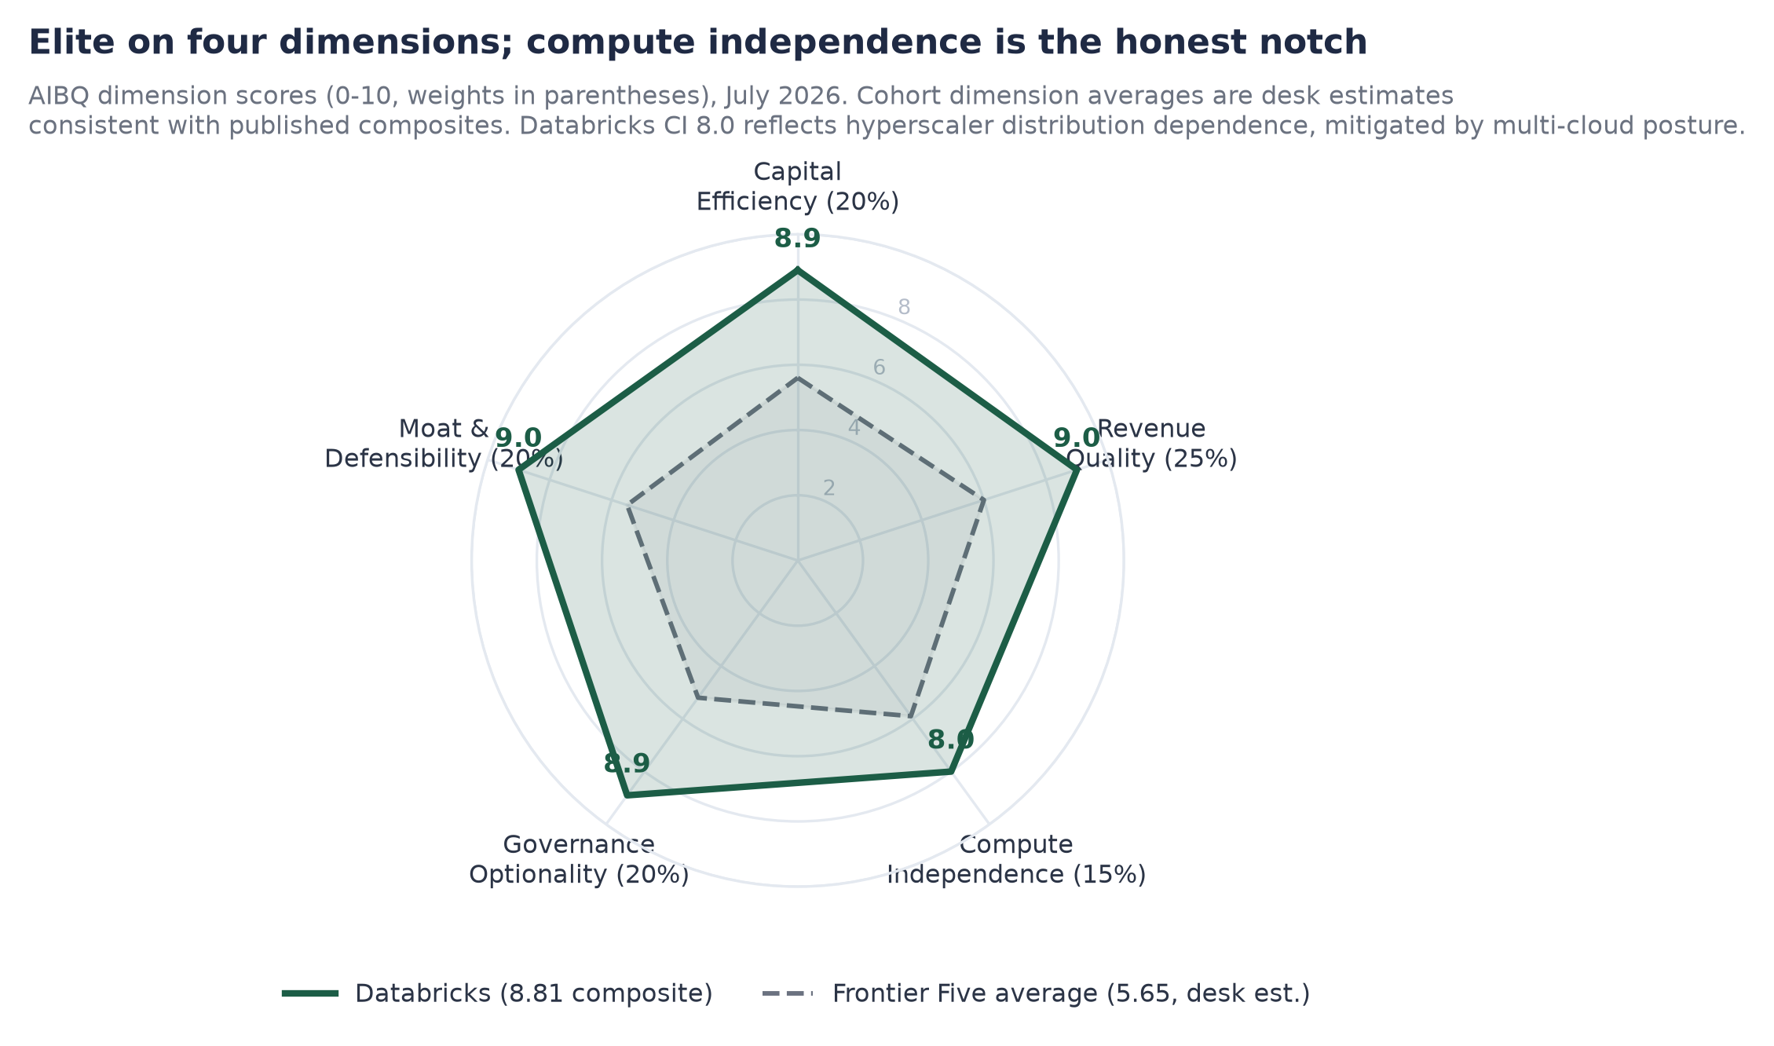
Figure 4. AIBQ dimension scores, Databricks versus Frontier Five average, July 2026. Cohort dimension averages are desk estimates consistent with published composites (8.81 / 8.20 / 4.53 / 4.49 / 2.30). Source: desk AIBQ framework.

Business Model and the Lakehouse
Databricks sells one architectural idea, executed for thirteen years: the warehouse and the lake should be the same system. Before the lakehouse, enterprises ran two estates, a data warehouse for structured analytics (expensive, governed, SQL) and a data lake for everything else (cheap, ungoverned, ML-friendly), and paid an integration tax to shuttle data between them. The lakehouse collapses the two: open-format storage (Delta Lake) with warehouse-grade governance (Unity Catalog) and native machine-learning lifecycle (MLflow) on top. Founded in 2013 out of the UC Berkeley AMPLab by the creators of Apache Spark, headquartered in San Francisco with 46 additional offices and roughly 9,000 employees (PB, June 2026), the company has ridden that one idea from research project to $6.9 billion of run-rate revenue.
The billing model is the underappreciated half of the machine. Databricks charges for consumption, metered in compute units and storage, not for seats or licenses. That single design choice produces most of the revenue quality documented in Section 4. Expansion requires no renewal event: when a customer's data volume grows, or its analysts run more queries, or, increasingly, its AI agents run queries by themselves, revenue expands mechanically. Net revenue retention above 140% (T2: February 9, 2026) is not a sales achievement, it is a property of the product meeting a secular trend in data volume. The same choice cuts the other way, and we do not hide it: consumption revenue has less downturn visibility than subscription revenue, because customers can throttle usage without breaching a contract. In 2022-23 this hurt consumption names across the industry. The offset today is that the marginal workload is AI, and no enterprise is throttling AI in 2026.
Land-and-expand is therefore a property of the architecture, not a sales artifact. The land is often a single team's Spark or SQL workload. The expand is gravitational: data lands in Delta Lake, governance attaches in Unity Catalog, downstream teams build on what is already governed, and each new product layer (warehousing, model serving, agents, operational databases) monetizes the same estate again. More than 60% of the Fortune 500 is somewhere on that curve, with the deep end (70+ customers above $10 million a year; T2: February 2026) demonstrating where the rest of the base is headed. The forward implication is the one that matters for valuation: as long as data volumes and AI workloads compound, the installed base is a pre-sold pipeline, which is why we treat Databricks' growth as structurally persistent rather than cyclically fortunate.

Products and Services Deep Dive
The product surface is best read as four strata, each deepening the dependency on the one below. The foundational layer creates the gravity; analytics monetizes it against the warehouse incumbents; the AI layer monetizes it against the model era; and the newest agentic and security surface aims to make the platform the operating substrate for autonomous software. Revenue attribution, where disclosed: AI products roughly $1.7 billion run-rate and Databricks SQL roughly $1.5 billion (both T2: June 16, 2026, CNBC and Bloomberg respectively), implying a residual core platform of roughly $3.7 billion. Figure 9 (Section 7) charts the mix.
Product surface, by stratum
Stratum | Products | Function and evidence (dated)
Foundational | Delta Lake, Unity Catalog, MLflow | Open-format storage, governance and lineage, ML lifecycle. The gravity layer; not separately monetized, universally attached.
Analytics | Databricks SQL | Warehouse workloads on lakehouse storage; ~$1.5B run-rate, doubled YoY (T2: Bloomberg, Jun 16, 2026). The head-to-head Snowflake layer.
AI platform | Model serving, vector search, Mosaic training and inference | ~$1.7B run-rate, largest and fastest line, from ~$1.0B Dec 2025 and $1.4B Feb 2026 (T2/T3).
Agentic and operational | Lakebase, Agent Bricks, Genie / Genie One / Ontology, Lakeflow | Serverless Postgres for agents (thousands of customers in first six months, revenue growing ~2x the warehousing product's pace at equivalent stage; T2: Feb 9, 2026); production agent tooling; natural-language access.
Security and real-time | Lakewatch (agentic SIEM, Mar 2026), Panther (announced Jun 16, 2026, clearance pending), CustomerLake, real-time engine (Reyden), Omnigent | Security lakehouse build-out via third security acquisition; CDP and streaming surface (T2/T3, product-stage figures largely undisclosed).
Sources as noted per row; strata are the author's organization. Undisclosed lines carry no revenue attribution.
Three observations carry analytical weight. First, Databricks SQL doubling to $1.5 billion (T2: Bloomberg, June 16, 2026) means the newest major assault on Snowflake's core is also one of the fastest-growing large product lines in software; Ghodsi attributes the growth partly to workload switching, which, if accurate, is share capture rather than market growth. Second, Lakebase is the one to watch for 2027: built on the Neon acquisition (2025, ~$1 billion reported, T3), it is an operational Postgres designed for agents to create and use databases programmatically, and the company reports it compounding at roughly twice the adoption pace DBSQL managed at the same age (T2: February 9, 2026). If agents become the dominant database customers, Databricks has pre-positioned the product they will provision. Third, the security push (Antimatter, SiftD.ai, then Panther, announced June 16, 2026 with terms undisclosed; Panther last privately marked at $1.4 billion in 2021, which is a reference point and not a purchase price) extends the same play into the SIEM market: security telemetry is the largest data volume in most enterprises, and pulling it into the lakehouse both grows consumption and deepens exit costs. That Anthropic is among Panther's customers (T2: company release) is a small but telling read on where AI-native buyers already sit.
The roadmap logic is consistent and, from a moat perspective, slightly ruthless: every new layer is priced in consumption, lands on data already resident, and makes the layer below harder to leave. The forward implication is that product-count expansion functions as retention insurance; even if any single layer loses its head-to-head, the estate stays.

AI Focus: Where the Models End and the Business Begins
Is Databricks an AI company or a data company? The honest answer is that it is a data-and-AI platform whose AI line is genuine incremental revenue on a profitable core, and the distinction matters for how it should be valued. The AI products line, at roughly $1.7 billion annualized, is now the largest single product line and the fastest-growing: roughly $1.0 billion in December 2025, $1.4 billion in February 2026, $1.7 billion in June (T2/T3 ladder; CNBC June 16, Tunguz June 2026). That is about 25% of total revenue, added in barely three years from the MosaicML acquisition, and it is growing faster than the corporate 80%.
Positioning in the AI stack is the crux. Databricks does not compete with the frontier labs on model capability, and stopped pretending to after DBRX; the Mosaic lineage now feeds training, fine-tuning, serving, and evaluation infrastructure for whatever model the customer prefers, including the labs' own via API. Against the hyperscalers, Databricks occupies the governed-data layer they cannot easily replicate across each other's clouds: an enterprise running on all three clouds can have one catalog, one lineage graph, one agent platform. The strategic wager of the agentic surface (Agent Bricks for production agents, Genie and Ontology for natural-language access, Lakebase for agent-native storage, Lakewatch and Panther for agent-driven security operations) is that the durable profit pool of the AI era is not the model, it is the substrate where enterprise agents read, write, and are governed. Every credible competitor for that substrate either lacks the data estate (labs), lacks cross-cloud neutrality (hyperscalers), or lacks the AI-native tooling (legacy warehouses).
The cost of the wager is visible in the gross margin, and we treat it as the price of the prize rather than a defect: agents generate far more queries per human decision than humans do ('the agents are generating way more queries'; T2: Ghodsi, June 16, 2026), and serving that load compresses margin from above 80% to 74%, guided lower. The bull case is operating leverage on a much larger revenue base; the bear case is that agentic workloads permanently carry warehouse-era revenue at inference-era margins. The 70% gate (Section 8, Figure 5) is where we adjudicate that argument with data instead of adjectives.
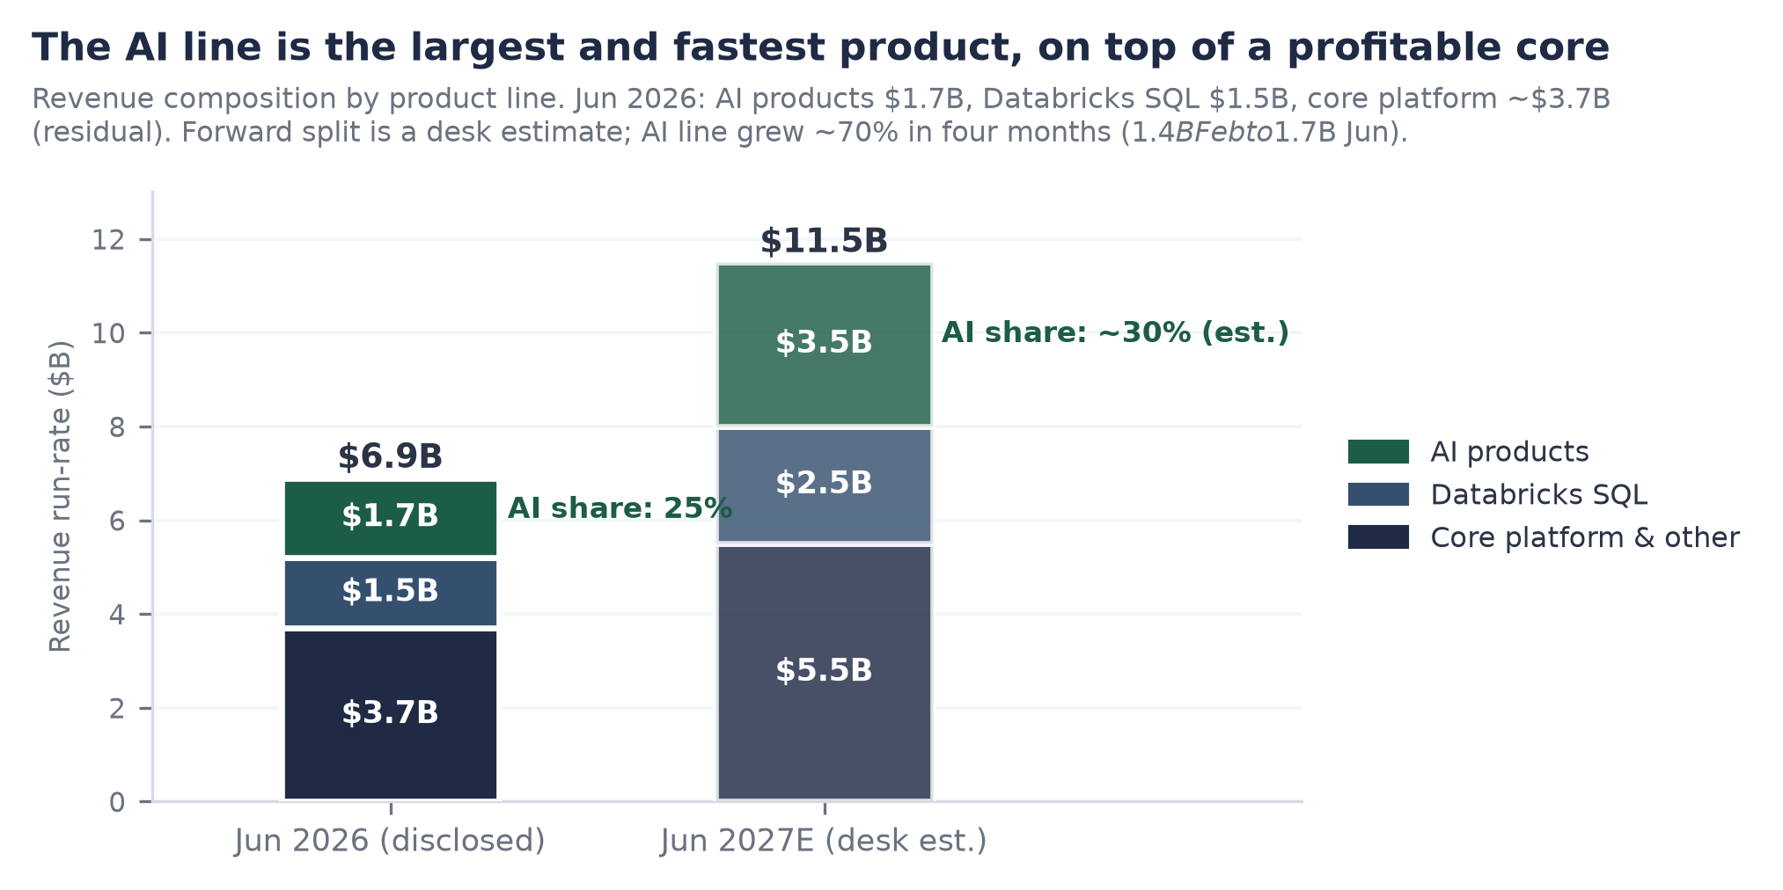
Figure 9. Revenue composition by product line, June 2026 disclosed versus June 2027 desk estimate. Sources: AI line $1.7B (T2: CNBC, Jun 16, 2026); DBSQL $1.5B (T2: Bloomberg, Jun 16, 2026); core is the residual; forward split is a desk estimate.

Financials

Revenue: the acceleration is the story
Databricks disclosed a $6.9 billion annualized revenue run-rate growing more than 80% year over year on June 16, 2026 (T2: CNBC, from the Data + AI Summit analyst session). The level is remarkable; the second derivative is the thesis. Four consecutive public prints show growth accelerating at scale: $4.0 billion at +50% (September 2025), $4.8 billion at +55% (December 2025), $5.4 billion at +65% (February 9, 2026), $6.9 billion at +80% (June 2026), all company-announced (Figure 2). Software companies at multi-billion scale decelerate; this one added thirty points of growth rate in nine months while nearly doubling its base. The proximate drivers are attributable: the AI line compounding fastest, DBSQL doubling on workload switching, and consumption billing translating customer agent adoption directly into metered revenue.
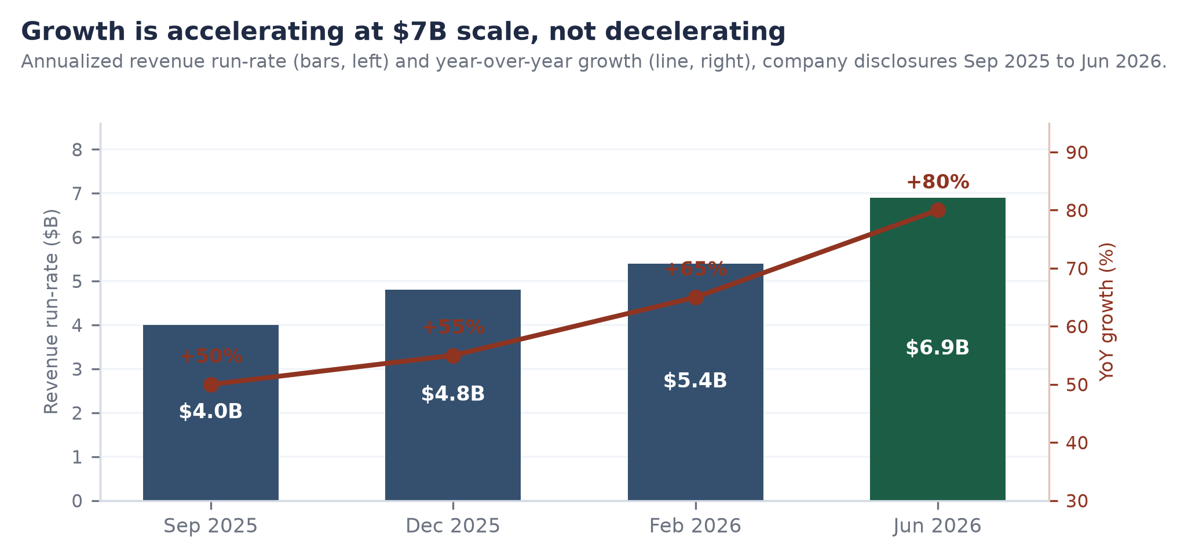
Figure 2. Revenue run-rate and year-over-year growth, September 2025 to June 2026. Sources: company press releases (Sep 2025, Dec 2025, Feb 2026, T2) and CNBC from company disclosure (Jun 16, 2026, T2).
Forward build: we model graceful deceleration, not extrapolation of the acceleration. Base case: roughly $11.5 billion run-rate by mid-2027 (about +67%), roughly $16 billion in 2028, low-to-mid $20 billions by 2030, an unusually visible path given >140% NRR arithmetic alone sustains mid-40s growth before any new logo lands. A note of discipline on sources: PitchBook carries $6.9 billion labeled as TTM for a fiscal window ending December 2026 (PB financials field, retrieved July 10, 2026), which is a forward-window projection, not trailing actuals; we therefore use only the dated company prints above as run-rate evidence, per our cross-reference rule.

Margins: 74%, and the gate at 70
Gross margin is 74%, down from above 80%, and management has guided it lower as agentic compute grows in the mix (T2: June 16, 2026 disclosures). At $6.9 billion of run-rate, each point of gross margin is roughly $69 million of annualized gross profit, so the compression from the low 80s has already surrendered on the order of $400 to 500 million a year; this is a real cost, incurred deliberately, to own the agentic workload. The AIBQ efficiency gate sits at 70%: a print below that level breaks the gate, forces a re-score, and would in our judgment also reprice the private mark, because it would recast the AI line from high-quality software revenue toward pass-through inference resale. The cushion is roughly four points. Watch the September-October 2026 disclosure before anything else in this note (Figure 5). Our base case holds margin in the 71 to 74% band through 2027 as serving efficiency (Mosaic lineage) and pricing actions offset mix; we assign meaningful but minority probability, roughly a third, to a print in the 70-71% range that survives the gate while thinning the cushion to nothing.
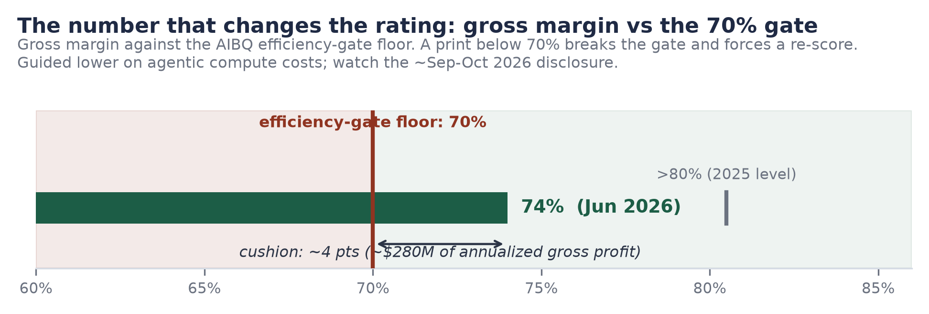
Figure 5. Gross margin versus the 70% efficiency-gate floor. Sources: margin 74%, prior >80%, guided lower (T2: company disclosures via CNBC/MLQ, Jun 16, 2026); gate definition per desk AIBQ framework (Appendix A).

Free cash flow: the differentiator
Databricks is free-cash-flow positive on both a trailing-twelve-month and a fiscal-2025 basis (T2: company, February 9, 2026; magnitude undisclosed). Against the Frontier Five this is the dividing line: the labs consume capital as a condition of existence, Databricks generates it as a byproduct of operations. The practical consequences compound quietly. The company raises when terms are attractive rather than when the treasury demands it (the flat $134 billion mark across two closes is the visible evidence); it funds compute commitments with debt priced against cash flows rather than equity priced against hope; and it can wait out a shut IPO window indefinitely. We flag the disclosure asymmetry honestly: FCF magnitude, GAAP operating loss, and stock-compensation load are all undisclosed and will only surface in an S-1. Positive FCF with heavy SBC is a weaker fact than it appears; we score what is disclosed and note what is not.

Unit economics and cohorts
Operating metrics (as of February 9, 2026 disclosure, five months old at publication)
Metric | Value | Read
Net revenue retention | >140% | Expansion alone sustains ~40%+ growth; consumption billing makes it mechanical
Organizations | >20,000 | Breadth: the base is a distribution, not a whale list
Fortune 500 penetration | >60% | Enterprise standard status; remaining 40% is pipeline, not TAM ceiling
Customers >$1M/yr | >800 | Up from 'more than 650' in stale mid-2025 coverage (T3); depth of the paid base
Customers >$10M/yr | >70 | The $10M+ tier is where lakehouse consolidation economics show first
Gross retention | Undisclosed | We assume a mid-90s floor typical of governed data platforms; flagged as assumption
Source: Databricks press release, Feb 9, 2026 (T2), except as noted. Next refresh expected ~Sep-Oct 2026.
The cohort math is the quiet engine of the valuation section: with >140% NRR, the June 2026 customer base alone reaches roughly $9.7 billion of run-rate by June 2027 with zero new logos. New business, DBSQL switching, and Lakebase attach are all additive to that floor. This is what 'letting growth do the work' means mechanically in Section 14.

Capital Structure and Capital Efficiency
Databricks has raised approximately $29.5 billion in its lifetime (PB total-raised, retrieved July 10, 2026: $29,515.7 million across a 21-deal record), decomposing into roughly $20.2 billion of equity and $9.3 billion of debt. The decomposition matters because the AIBQ capital-efficiency ratio is computed on the equity denominator only: CE = $6.9 billion run-rate / $20.2 billion lifetime equity = 0.34x. The ruling is deliberate. Debt raised against a cash-generative business to pre-fund compute is a financing choice, not a claim on the equity engine's efficiency; it belongs in the compute-independence and risk assessments, where we duly count it as both hedge and obligation. Two figures carried in older internal versions ($33.1 billion and roughly $38 billion of total capital) had no clean deal-record basis and are retired; they appear here only so the reader knows why they appear nowhere else.
The financing ladder (completed deals; PitchBook deal records, retrieved Jul 10, 2026)
Date | Round / instrument | Size ($M) | Class
Sep 2013 | Series A | 13.9 | Equity
Jun 2014 | Series B | 33.4 | Equity
Dec 2016 | Series C (3rd round) | 60.0 | Equity
Sep 2018 | Series D | 140.0 | Equity
Jan 2019 | Series E | 250.0 | Equity
Oct 2019 | Series F | 400.0 | Equity
Feb 2021 | Series G | 1,000.0 | Equity
Aug 2021 | Series H | 1,600.0 | Equity
Nov 2023 | Series I | 684.6 | Equity
Dec 2024 | Series J (incl. ~$170M embedded debt) | 10,230.0 | Equity + debt
Jan 2025 | Credit facility (JPMorgan-led) | 5,250.0 | Debt
Sep 2025 | Series K | 1,000.0 | Equity
Dec 2025 | Debt refinancing | 53.7 | Debt
Jan 2026 | Debt addition (JPMorgan, Citi enter) | 1,800.0 | Debt
Feb 2026 | Series L (two closes; $5,000 equity + $2,000 debt) | 7,000.0 | Equity + debt
 | Lifetime total (excl. 5 secondaries) | ~29,516 | ~$20.2B equity / ~$9.3B debt
Source: PitchBook entity 59199-40, 21-deal record incl. 5 secondary transactions not itemized above (T2). Series L: first close >$4B announced Dec 2025 at $134B (company, T2); Feb 9, 2026 close per PB deal 313367-68T, $5B equity led by Insight, J.P. Morgan Growth Equity, Fidelity, with Microsoft and ~44 others, plus $2B loan. Round-count note: the rumored next raise is the 13th equity round; PitchBook's deal count runs higher because debt deals and secondaries are tracked separately.
The cross-cohort comparison is the point of the exercise. On desk estimates from reported cumulative raises and run-rates, Anthropic converts equity to revenue at roughly 0.38x, Databricks at 0.34x, OpenAI at roughly 0.14x, xAI at roughly 0.07x (Figure 6). Two members of the cohort compound capital; the rest consume it. And the Databricks figure understates the gap in one respect: it is the only member of the four whose marginal growth requires no new equity at all, because the business self-funds. From here forward, the CE ratio improves automatically as the numerator compounds against a static denominator; on the base-case revenue path the ratio passes 0.55x by mid-2027 without a dollar raised. The labs' ratios, by construction, cannot do that while training costs scale.
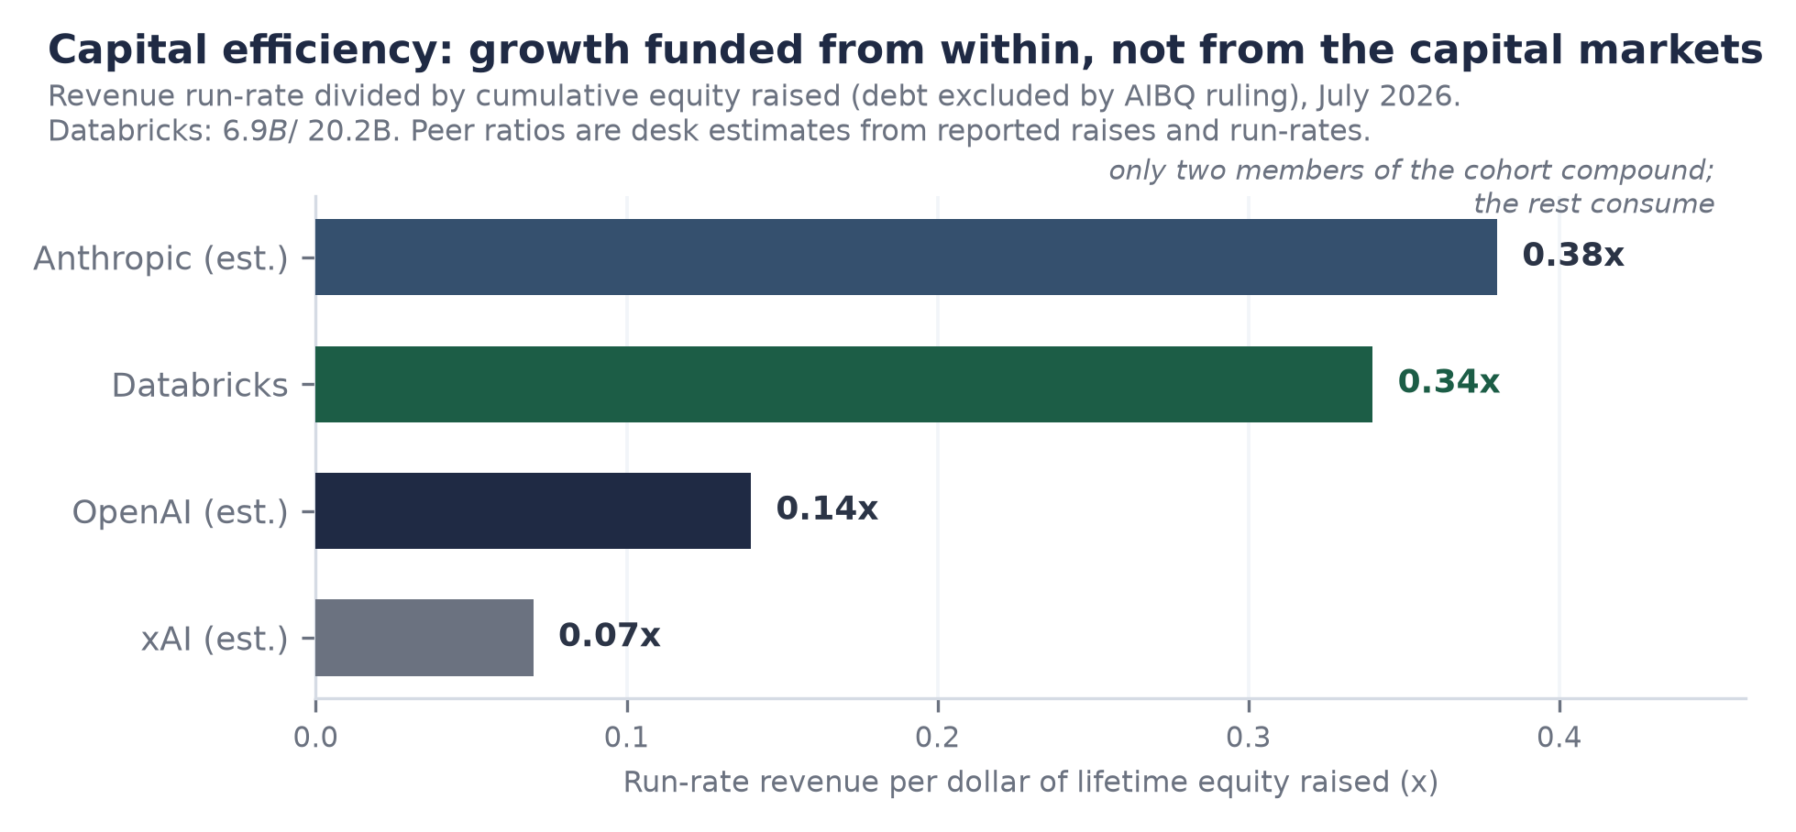
Figure 6. Capital efficiency across the Frontier Five: run-rate revenue per dollar of lifetime equity, July 2026. Databricks computed from disclosures (T2/PB); peers are desk estimates from reported raises and run-rates (est.). Debt excluded from denominators by AIBQ ruling.
The debt book deserves its own honest paragraph. Roughly $9.3 billion of obligations at a private company is unusual, and it is collateralized, ultimately, against continued hypergrowth. We are comfortable for three reasons: the ladder is termed out and syndicate-broadening (JPMorgan-led 2025, Citi entering January 2026), the borrower is FCF-positive, and the use of proceeds (compute pre-funding, Series L liquidity structuring) substitutes directly for equity that would otherwise have diluted holders at the same moment the mark was being held flat. But the risk assessment in Section 15 carries it at full weight: in a downside where growth halves and margin breaks the gate, leverage converts a disappointment into a hard problem.

The Upcoming Raise: Analyzed, Not Adopted
What is reported: Databricks has discussed raising a round that would value it between $165 and 175 billion, first reported by The Information on June 9, 2026, echoed by Reuters the same day (T3). Follow-on reporting indicated the round could formally kick off within a month of that report, with terms still being finalized and even the treatment of new capital in the headline valuation unsettled (T3: Benzinga, Economic Times syndication, June 9). As of this note's July 10 verification, PitchBook carries the deal as Rumor/Speculation with an estimated $170 billion post-money (PB financing note dated July 7, 2026), and no close has been reported by any outlet. Status: in talks, unclosed. Under our do-not-adopt rule it contributes nothing to the base-case mark, which remains $134 billion.

The step-up math, and what the round is for
The rumored range implies a 23 to 31% step-up over the February 2026 mark, five to seven months later. If it closes, it would perform the three classic functions of a late pre-IPO round: set a reference mark for eventual listing conversations, provide employee and early-investor liquidity after thirteen years of private tenure (the deal record already shows five secondary transactions; PB, July 2026), and let crossover institutions build position before a prospectus exists. Note the distinction the coverage often blurs: a completed primary round at $170 billion would be a negotiated institutional mark; secondary-market chatter in the meantime is a sentiment reading from a thin market, and we weight it accordingly, which is to say barely.

The observation that reframes the rumor
Here is the analytically important part, and the reason this section exists rather than a disclaimer sentence. Our fundamentals-driven base case (Section 14) reaches $155 to 190 billion on a twelve-month view with no reference whatsoever to the rumor: it is simply the February anchor plus a year of disclosed-trajectory growth at a de-rated multiple. The rumored range sits inside that corridor. Read properly, then, $165 to 175 billion is not an inflated current mark, it is a fair forward mark: the price at which new money would be buying roughly the business we expect to exist in mid-2027, at roughly today's quality-adjusted discount. That is also precisely why it must not be adopted as a current anchor: adopting it would double-count the year of growth that justifies it. The discipline and the analysis point the same direction. If the round closes at or above the range, the correct update is to our conviction in the demand curve for the eventual listing, not to our estimate of present value; if it closes below, or dies, that is a genuinely bearish data point about crossover appetite and we would revisit the multiple, not the business quality.

Competitive Position and the Moat

Snowflake: the comparison, done properly
The Snowflake comparison is usually done lazily (two logos, one 'data war' headline) and the lazy version misses the finding. Done properly: Snowflake carries an enterprise value of roughly $89 billion (market capitalization ~$91 billion on July 7, 2026, less estimated net cash) against forward product-revenue guidance of $5.84 billion for FY2027, raised on May 27, 2026 from $5.66 billion, implying 31% growth (T1: 8-K; Q1 actuals ran ~30-34%). That is roughly 15.3x forward product revenue. Databricks at $134 billion against $6.9 billion is 19.4x, a higher headline multiple. But the buyer is not buying a multiple, the buyer is buying growth, and per point of growth purchased the ranking inverts: Databricks costs 0.24x per growth point, Snowflake 0.49x (Figure 3). Growth-adjusted, Databricks is roughly half the price of its own best public comparable. Meanwhile the operational scoreboard has already flipped: Databricks passed Snowflake in revenue during 2026, and the gap, roughly $490 million in March, was roughly $1.6 billion by June (T3: Tunguz, June 2026), with Databricks' warehousing product, Snowflake's home turf, doubling year over year to $1.5 billion (T2: Bloomberg, June 16, 2026).
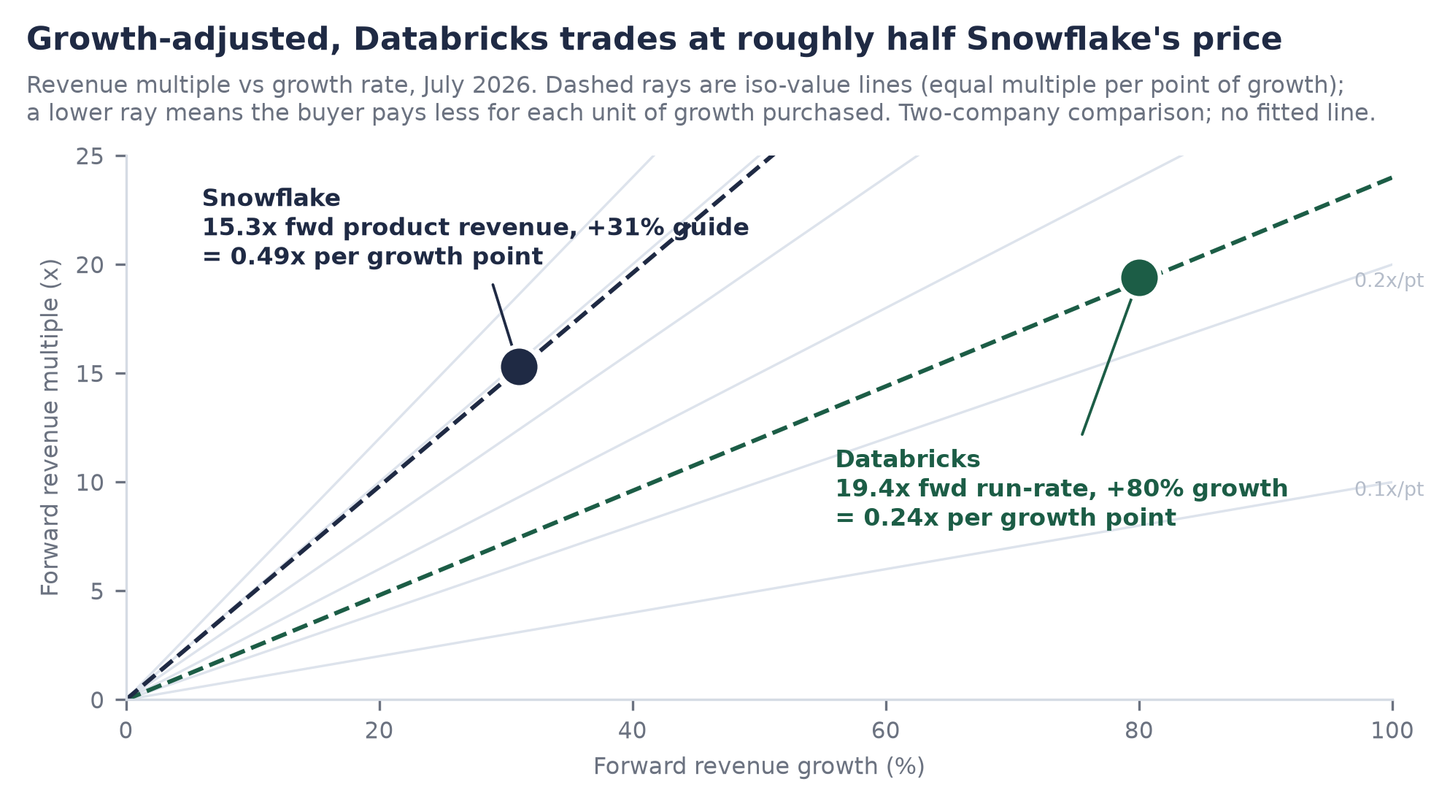
Figure 3. Growth-adjusted multiples: Databricks (19.4x / +80%) versus Snowflake (15.3x / +31% FY27 guide). Sources: Databricks per company disclosures (T2, Jun 16, 2026) and Feb 2026 mark; Snowflake per 8-K of May 27, 2026 (T1) and market data of Jul 7, 2026. Iso-value rays indicate equal price per growth point; no fitted line is shown.
Two fair rebuttals, answered. First, Snowflake's 31% is public-market audited guidance and Databricks' 80% is self-reported; some haircut is warranted, though four independent dated prints in ten months constrain how large a haircut is plausible. Second, growth-adjusted multiples flatter the faster grower only while growth persists; that is true, and it is why the durability analysis of Sections 5 and 8 (consumption mechanics, >140% NRR, cohort floor) is the load-bearing wall of the whole note, not the multiple arithmetic.

The hyperscalers: co-opetition priced into the score
AWS, Azure, and Google Cloud are simultaneously Databricks' distribution channels, suppliers, and competitors, and this triple role is the single largest structural risk to the franchise, which is why compute independence scores 8.0 while everything else scores near 9. The bear mechanics are obvious: each hyperscaler sells first-party analytics (Redshift, Fabric/Synapse, BigQuery), controls the marketplace rails Databricks sells through, and prices the compute beneath it. The mitigants are equally concrete. Neutrality is a product feature the hyperscalers cannot copy: none of them will ever be the governance layer across the other two, and enterprises are structurally multi-cloud. Microsoft's participation in the Series L close (PB deal record, February 9, 2026) is the tell that partnership economics currently dominate predation economics: the hyperscalers monetize every Databricks workload through the compute beneath it, and an ecosystem partner driving consumption is worth more to them than a first-party product with single-cloud reach. That equilibrium is stable while Databricks drives more hyperscaler revenue than it displaces, which at current AI workload growth is not close to binding.

Data gravity: the durable moat
Strip the noise and the moat is one sentence: it costs an enterprise almost nothing to bring data to Databricks and a great deal to take it away, and the asymmetry deepens with every layer adopted. The open-format strategy makes this politically sustainable inside customer organizations (no vendor-lock objection at adoption time) while the switching cost quietly migrates up into Unity Catalog governance, lineage, compliance attestation, and now agent workflows, where re-platforming means re-certifying everything an auditor ever signed. Competitors can match features; nobody has demonstrated they can dissolve an installed governance layer. That, more than any single product, is what an acquirer of this note's thesis is buying.

Market Implications and Category
Databricks sits at the intersection of two spend pools that are converging: the data platform market (warehousing, lakes, streaming, governance), a pool we estimate at $150 billion-plus annually growing low-teens (desk estimate), and AI infrastructure, the most violent capital cycle in technology history, with hyperscaler capex alone running in the hundreds of billions annually in 2026. The lakehouse thesis is that the second pool does not bypass the first but lands on top of it: models and agents are only as useful as the governed data beneath them, so every dollar of enterprise AI ambition drags a data-platform dollar behind it. Databricks' acceleration while margin compresses is precisely what that convergence looks like from inside the P&L: AI workloads arriving faster than pricing and efficiency can absorb them.
The category read-through runs in both directions. Today, public data-platform names are priced off Snowflake's 31%-growth reality; a Databricks listing would insert an 80%-growth, FCF-positive datapoint at the top of the comp table and force a repricing of what 'best in category' is worth, likely dragging the whole complex upward, Snowflake included, in the way that best-of-breed listings historically re-anchor their categories. Until then, the read-through runs the other way and is a genuine risk to the thesis: Databricks' eventual public multiple will be set partly off Snowflake's, and Snowflake has halved from its highs into mid-2026 before recovering (T3: TIKR, July 2026). We size that risk in Section 14 by de-rating the base-case multiple to 14-16x rather than assuming today's 19.4x survives contact with a public order book. For private-market allocators, the more actionable implication is the per-point ladder itself: if the quality-cheapest asset in the cohort re-rates toward even a fraction of the labs' per-point pricing upon listing, the convergence gain accrues to pre-IPO holders; the labs' per-point pricing, by contrast, requires AGI-grade outcomes to defend.

The IPO as the Convergence Event
The thesis needs a mechanism, and the mechanism is the listing. Private marks are negotiated among consenting institutions; the per-point spread between Databricks and the labs can persist indefinitely in that regime because nothing arbitrages it. A public order book is the arbitrage. On listing day, Databricks stops being priced against the private AI complex and starts being priced against software fundamentals, where 80% growth, 74% margin, positive FCF, and >140% NRR have well-understood, generous public precedents. Convergence does not require the labs to fall; it requires Databricks to be re-based against assets it dominates on fundamentals.
Timing: 2026 is ruled out by the CEO in terms that leave no ambiguity ('a terrible year to go public'; T2: Bloomberg Television, June 4, 2026), 2027 is the earliest, no S-1 is on file (T1: EDGAR CIK 1587468, verified July 10, 2026, Form D filings only), and prediction markets price 'no IPO by end-2027' at 0.54 (T3: 24/7 Wall St, July 7, 2026), i.e., a coin flip skewed slightly long. We read the waiting as strength, not evasion: an FCF-positive company choosing its window is exercising the governance optionality we score at 8.9, and every quarter of waiting compounds the eventual entry point at 80% growth. The next raise, if it closes, buys another year of that optionality.
Sequencing is the real risk, and 2026 has already run the experiment at both ends. The absorption wall (Figure 10): the AI mega-listing wave totals roughly $3.9 trillion of listing value against a US IPO market that absorbed only $44 to 47 billion of proceeds in all of 2025 (T2: Deloitte, EY). The first brick has cleared: SpaceX, carrying xAI after their February 2026 all-stock merger, listed in late June 2026 at a $1.77 trillion valuation and has rallied roughly 23% since (T3, July 2026), proof that the wall is scalable for a scarce, iconic asset. OpenAI and Anthropic have reportedly filed IPO paperwork (T3: Reuters/CNA syndication, June 9, 2026), targeting roughly $1 trillion and $965 billion respectively, with potential combined primary raises across the wave in the $240 billion range, more than five times a normal year's entire issuance. If those two price well, Databricks lists into a validated category with the cleanest financial profile of the wave and the smallest ask (it may need essentially no primary capital at all). If they price poorly or exhaust the demand pool, the window shuts into 2028, and Databricks' capacity to wait, uniquely in the cohort, is the hedge. Either way the labs go first and take the experiment risk; Databricks gets to price off their result. We would rather hold the asset that chooses than the assets that must.
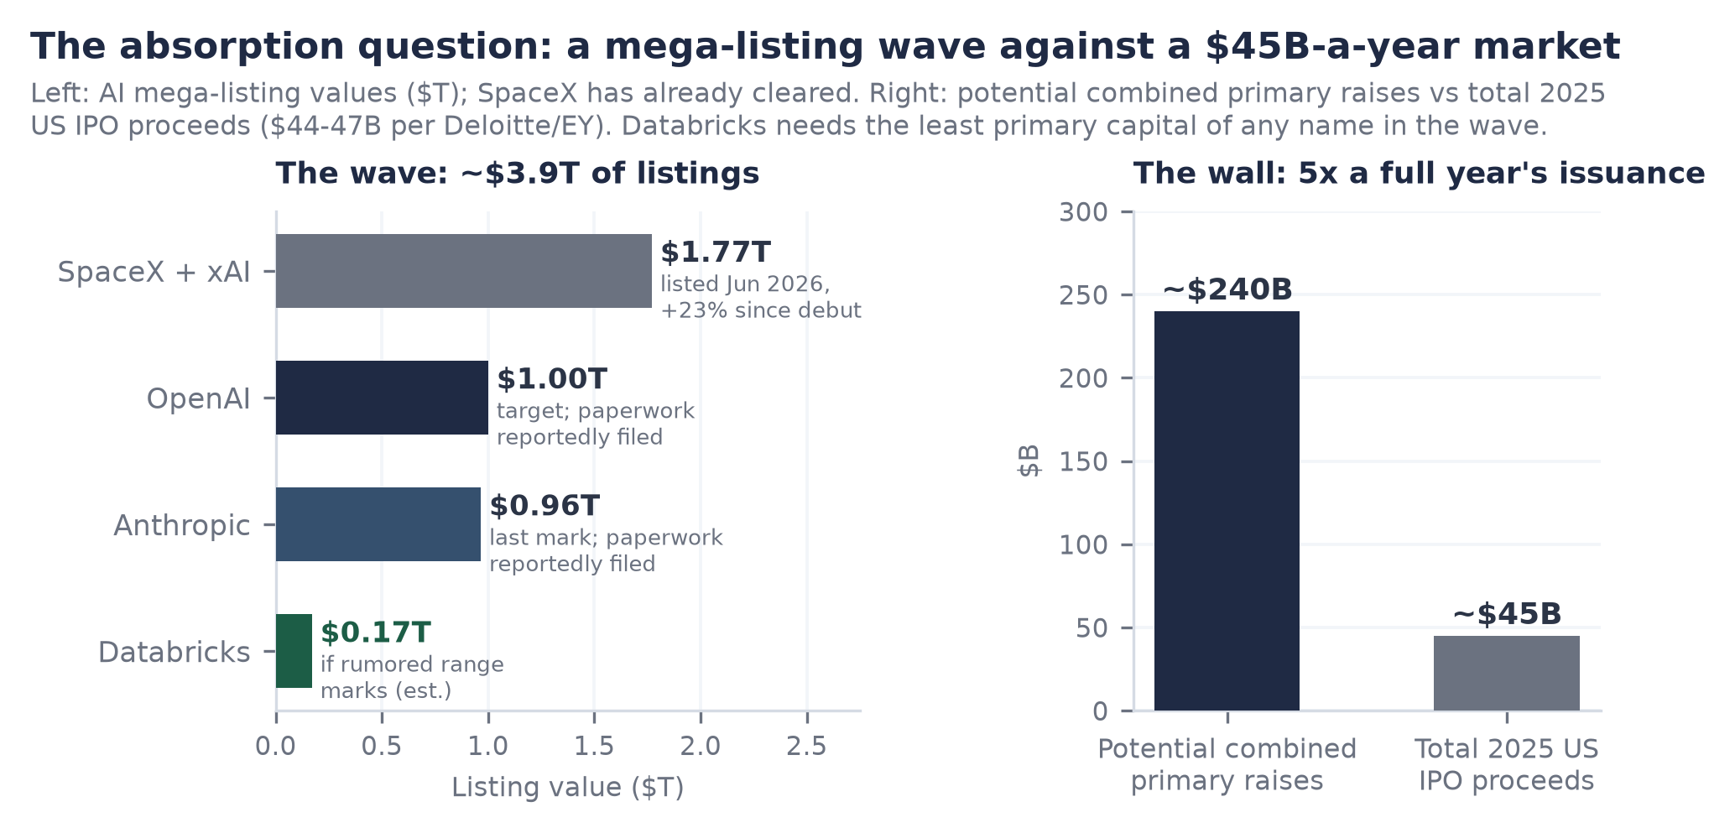
Figure 10. The absorption question: AI mega-listing values versus 2025 US IPO issuance. Sources: SpaceX listing and performance (T3, Jun-Jul 2026); OpenAI target and Anthropic mark (T2/T3, Mar-May 2026); raise estimates (T3, desk aggregation); 2025 US IPO proceeds $44-47B (Deloitte, EY, T2).

Valuation and Scenarios
Three independent lenses, one discipline: the base case anchors on the completed $134 billion mark and lets disclosed growth do the work; the rumored round appears only as a reference line. First lens, quality-adjusted: at $15.2 billion per AIBQ point Databricks is the cheapest quality in the cohort by 7.8x against the nearest lab (Figure 1); this lens sets direction, not a target. Second lens, growth-adjusted comps: at 0.24x per growth point against Snowflake's 0.49x, parity pricing on Snowflake's growth-adjusted multiple would imply roughly $270 billion today; we treat that as an upper bound illustration, not a target, because a private mark should discount the public comp, not match it. Third lens, forward fundamentals, which is where the target lives: mid-2027 run-rate of roughly $11.5 billion (graceful deceleration from +80% to the mid-60s) at 14 to 16x run-rate, a deliberate de-rate from today's 19.4x toward what a public order book pays for hypergrowth data platforms, yields $161 to 184 billion; widening for execution variance gives the base corridor of $155 to 190 billion (Figures 7 and 8).
Scenario architecture (12-month view, anchored on $134B; rumor not adopted)
Scenario | Run-rate path | Multiple | Value | What has to be true
Bear | Growth halves to ~40-50%; GM prints <70%, gate breaks | 11-12.5x on ~$10.4B | $115-130B | Agentic margin drag is structural; consumption throttling returns; rating re-scored out of Elite
Base | ~$11.5B by mid-2027 (+65-70%); GM holds 71-74% | 14-16x | $155-190B | Disclosed trajectory persists with graceful deceleration; gate holds; window opens 2027
Bull | ~$12.5B+; GM stabilizes; DBSQL and Lakebase compound | 16.5-19x | $205-240B+ | Acceleration proves durable; listing re-anchors category; scarcity premium on cleanest AI-wave asset
Desk estimates, July 10, 2026. Reference lines: $134B completed mark (T2, Feb 9, 2026); $165-175B rumored range (T3, The Information, Jun 9, 2026; unclosed, not adopted).
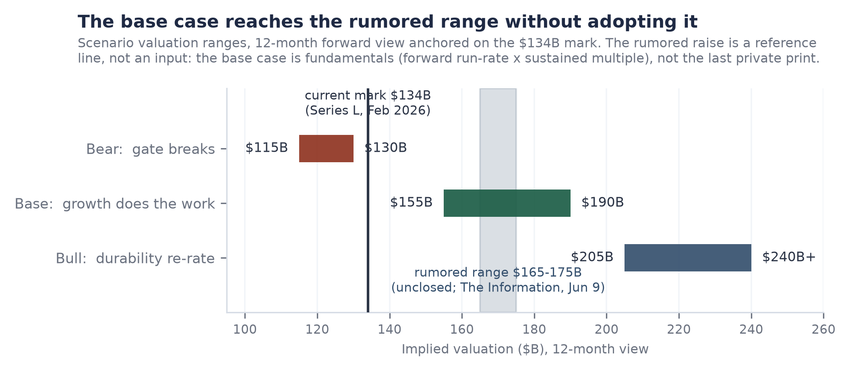
Figure 7. Valuation football field, 12-month view. The base case reaches the rumored range on fundamentals alone; the rumor is a reference line, not an input. Sources: as tabled above.
The sensitivity grid (Figure 8) makes the machinery inspectable: value is forward run-rate times multiple, and the base intersection ($11.5 billion at 14 to 16x) sits comfortably above the current mark even after a five-point multiple de-rate. Read the bear column honestly: at $9.5 billion (growth halving) and 12x, the implied $114 billion sits 15% below the current mark, which is what the position risks if the margin gate breaks and growth decelerates simultaneously. Read the discipline the other way too: today's 19.4x on the base-case run-rate would imply roughly $223 billion, and we are deliberately not underwriting today's private multiple surviving the listing. The margin of safety is not the multiple; it is the per-point spread and the cohort-worst price for cohort-best quality.
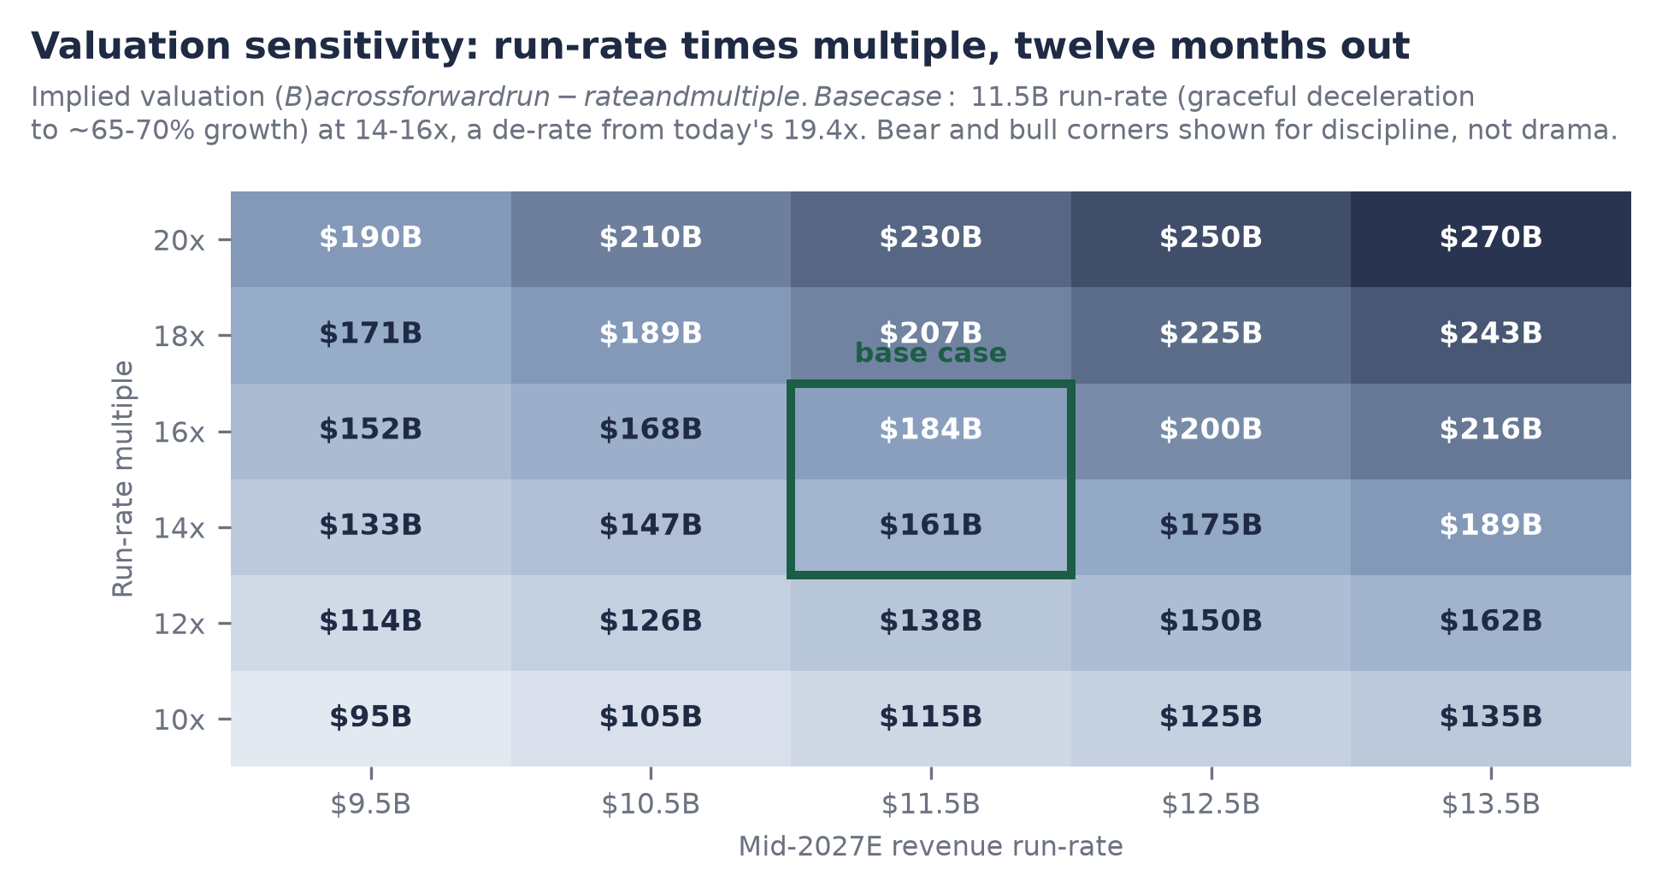
Figure 8. Sensitivity: implied valuation across mid-2027E run-rate and multiple, base intersection highlighted. Desk estimates, July 10, 2026.

Risks and What Would Change Our Mind
One line changes the rating: a gross-margin print below 70%. Everything else in this section is sized, dated, and survivable; that one is mechanical. The risks below are ranked by expected impact on the thesis, not by likelihood of headlines.
Risk register, ranked
# | Risk | Mechanism and evidence (dated) | Trigger / watch item
1 | Gross-margin gate break (first order) | GM 74%, down from >80%, guided lower on agentic compute (T2: Jun 16, 2026). Below 70% breaks the AIBQ efficiency gate, forces re-score out of Elite, and recasts the AI line toward inference resale economics. Each point is ~$69M of annualized gross profit. | Next disclosure, ~Sep-Oct 2026. Cushion: ~4 points.
2 | Growth deceleration | The thesis leans on acceleration at scale (Figure 2). A fall through ~50% while margin compresses converts the story to a peaked one; consumption billing cuts both ways in downturns (usage throttles without contract breach, as the 2022-23 cycle showed industry-wide). | Sequential run-rate prints; NRR refresh; $10M+ tier count.
3 | Absorption / IPO-window risk | ~$3.9T of AI listings vs a $44-47B 2025 issuance market (T2: Deloitte/EY). OpenAI and Anthropic reportedly filed (T3: Jun 9, 2026) and go first; a failed mega-listing shuts the window into 2028. Mitigant: FCF means waiting is costless; SpaceX's June 2026 listing (+23%) says the wall is scalable. | OpenAI/Anthropic pricing and aftermarket; window state H1 2027.
4 | Hyperscaler absorption | AWS/Azure/GCP are supplier, channel, and competitor at once (CI 8.0, the cohort-visible notch). Predation via egress pricing, marketplace terms, or first-party bundling attacks the margin and the moat simultaneously. Mitigant: multi-cloud neutrality is structurally uncopyable by any single hyperscaler; Microsoft invested in the Feb 2026 close (PB). | Cloud marketplace term changes; Fabric/BigQuery win rates in $10M+ accounts.
5 | Leverage in a downside | ~$9.3B of debt (PB ladder, Jul 2026) is benign against 80% growth and positive FCF; against a broken gate and halved growth it converts disappointment into balance-sheet pressure. | Covenant disclosures in any S-1; further debt additions.
6 | Secondary-vs-primary mark confusion | Headline valuations from thin secondary trading or unclosed rounds (the $165-175B talks; T3, unclosed as of Jul 10) can anchor expectations the fundamentals must then chase. Our do-not-adopt rule exists for this reason. | Close/repricing/death of the rumored round.
7 | Key-person and AI-leadership depth | AI chief Naveen Rao departed Sep 12, 2025 to found a hardware startup, retaining an advisory role, with Databricks investing (T3: Bloomberg). Ten months on, the AI line accelerated from ~$1.0B to $1.7B post-departure, which empirically retires most of the concern; residual watch on Mosaic-lineage retention. | Senior AI-org attrition; DBRX-successor cadence.
Ranking and sizing are the author's. Items 1 and 2 are thesis-level; 3 through 7 are path-level.
What would make us add: a gross-margin print at or above 73% alongside a run-rate at or above $8 billion in the autumn disclosure would confirm the agentic cost curve is being managed and the acceleration is intact, at which point the bear leg of the football field loses most of its probability mass. What would make us exit entirely, beyond the gate: evidence that DBSQL growth is discount-bought rather than switching-driven, or a hyperscaler term change that demonstrates the neutrality moat is rentable after all.

Management and Governance
Databricks is that rarity, a founder-led company at $134 billion where the founding team is still intact at the top: CEO Ali Ghodsi and co-founder and executive chairman Ion Stoica (PB, July 2026) lead a bench drawn from the original Berkeley AMPLab group that created Apache Spark. The management quality shows less in the biography than in three observable behaviors. First, disclosure discipline: four dated public financial prints in ten months, each with consistent metric definitions, a cadence indistinguishable from a public company's and the basis of our GO reporting-readiness sub-score of 9.2. Second, capital discipline: holding the $134 billion mark flat across two closes rather than chasing a headline step-up, and financing compute with debt rather than dilution. Third, timing discipline: ruling out a 2026 listing in public, unhedged language (T2: Bloomberg Television, June 4, 2026) while competitors filed, a decision that costs prestige and preserves optionality.
Governance readiness (GO 8.9) rests on the crossover-heavy register documented in Section 9 (Fidelity, Insight, J.P. Morgan Growth Equity, Microsoft, and roughly 44 others in the final close alone; 148 active investors in total per PitchBook, July 2026), audit-grade internal reporting implied by the disclosure cadence, and the absence of disclosed exotic control instruments. What an S-1 would still have to answer: stock-compensation load, GAAP operating economics beneath the FCF line, and the precise founder-control structure, none of which are visible from outside and all of which we have flagged rather than assumed.
The Naveen Rao departure deserves its proper size, no more. The architect of the AI line left in September 2025 to build AI hardware; Databricks kept him as an advisor and invested in the venture (T3: Bloomberg, September 12, 2025). In the ten months since, the AI products line grew from roughly $1.0 billion to $1.7 billion and the company shipped its broadest agentic product slate to date (June 2026 summit). The empirical verdict is that the AI organization survived its founder-figure's exit; the residual risk is bench depth in a market where every lab is hiring, and we carry it as a watch item, not a discount.

Recommendation and Positioning
Core Holding. The author's managed book carries Databricks at an 8% core allocation (conflict disclosed on page 2), and this note's analysis supports maintaining that position in full. The rating is AIBQ 8.81, Elite, the cohort's best business at the cohort's lowest quality-adjusted price, with a defined convergence mechanism (the 2027-window listing) and a defined disqualifier (the 70% margin gate).
- Entry discipline: accumulation is rational at or below the $134B completed mark, and defensible up to ~$150B, the level at which the buyer starts paying today for growth the base case books over the coming year. Do not chase a closed round at $165-175B: at that price the forward return compresses toward the bull-case dependency.
- Exit discipline: a GM print below 70% exits the position mechanically alongside the rating; growth through 50% with margin still compressing halves the position. Neither trigger has fired.
- Sizing logic: 8% reflects conviction bounded by illiquidity and single-disclosure risk (the September-October print). The margin of safety is the per-point spread: at $15.2B per point against $118B for the nearest lab, the market must be catastrophically wrong about business quality, not merely optimistic about models, for this to be the expensive asset in the cohort.
- Horizon: the position is underwritten to the listing plus one lock-up cycle, roughly 2027-28, with the private optionality (FCF, debt capacity) funding indefinite patience if the window shuts.
Conviction: high on the business, moderate on the path. The business case survives every stress in this note except the margin gate; the path case (window timing, sequencing behind the labs) is genuinely uncertain and is why the position is 8% and not 15%. We are paid to hold exactly this asymmetry: a franchise priced below its quality with a dated, checkable list of things that would prove us wrong.

Appendix A: The AIBQ Framework
AIBQ (AI Business Quality) scores durable business quality independent of valuation. Five dimensions, each 0 to 10, weighted and summed, less a contextual risk adjustment (CRA): Composite = 0.20 CE + 0.25 RQ + 0.15 CI + 0.20 GO + 0.20 MD, minus CRA. Revenue Quality carries the largest weight because, in our coverage history, it best predicts which growth stories survive the transition to durable franchise. Twenty-four sub-scores (5 CE, 5 RQ, 4 CI, 5 GO, 5 MD) average simply within each dimension; the full Databricks decomposition is in Section 4.
Dimensions, weights, and the question each answers
Dimension | Weight | The question
Capital Efficiency (CE) | 20% | How much durable revenue does a dollar of equity buy, and does the business self-fund?
Revenue Quality (RQ) | 25% | Is the revenue diversified, retained, expanding mechanically, and honestly attributed?
Compute Independence (CI) | 15% | Who controls the cost curve and capacity the business runs on?
Governance Optionality (GO) | 20% | Can the company access public markets on its own timetable, and would its governance survive the scrutiny?
Moat and Defensibility (MD) | 20% | What does it cost the customer to leave, and is that cost rising?
Desk framework. CRA captures contextual risks not natively held by the dimensions; Databricks carries CRA 0 in the current score.

Stage gates and the efficiency gate
CE is stage-gated S1 through S5 so that seed-stage burn is not scored against late-stage discipline. Databricks is S5 (late stage), where the efficiency gate applies in full and is a hard rule: positive free cash flow AND growth above 40% AND gross margin above 70%, simultaneously. A gross-margin print below 70% breaks the gate and forces a re-score regardless of the other legs. This is the mechanical link between the next earnings print and the rating, dramatized in Figure 5. At 74% and declining, the cushion is roughly four points.

Bands
Band definitions and cohort placement
Band | Range | Cohort members (Jul 2026)
Elite | 8.50 - 10.00 | Databricks (8.81)
Strong | 7.00 - 8.49 | Anthropic (8.20)
Developing | 4.50 - 6.99 | OpenAI (4.53), xAI (4.49)
Distressed | < 4.50 | SSI (2.30; pre-revenue by design)
Desk framework. Lab scores are dominated by capital-efficiency and revenue-quality deficits, not by research capability, which AIBQ does not score.

The capital-efficiency ruling
CE denominators are equity-only. Debt is excluded because it makes claims on cash flows, not on the equity engine whose efficiency the ratio measures; folding it in would penalize precisely the financing structure (termed debt against a cash-generative base) that late-stage discipline should reward. Debt is instead assessed in CI (as a compute hedge) and in the risk register (as an obligation). Applied to Databricks: $6.9B / $20.2B = 0.34x; the ~$9.3B of debt appears in CI sub-score 4 and risk item 5, at full weight in both.

The per-point expression and the embargo
The relationship between AIBQ scores and market valuations across the cohort is summarized publicly only as dollars of valuation per composite point, presented as a ranked bar (Figure 1). The underlying correlation coefficient is embargoed and is not disclosed, plotted, or derivable from any exhibit in this note; no exhibit pairs scores with valuations in a form that supports reconstruction. Per-point figures are computed on last completed marks (rumored rounds excluded) and on implied-value estimates only where labeled.

Appendix B: Sources and Tiering
Tiering: T1 = audited or regulatory; T2 = company-announced; T3 = media or single-source. Conflicts are frozen and stated, not averaged; the higher tier is adopted. All sources re-verified live on July 10, 2026. The quality-valuation correlation coefficient is embargoed and appears nowhere in this note; the per-point ladder is its only cleared public expression.
Load-bearing claims, sourced and dated
Claim | Value | Source, date | Tier
Revenue run-rate / growth | $6.9B / >80% YoY | CNBC from company disclosure, Jun 16, 2026 (Data + AI Summit) | T2
Run-rate ladder | $4.0B/+50% Sep 25; $4.8B/+55% Dec 25; $5.4B/+65% Feb 9, 26 | Databricks press releases | T2
Gross margin | 74%, prior >80%, guided lower | Company disclosure via CNBC/MLQ, Jun 16, 2026 | T2
Free cash flow | Positive, TTM and FY2025 (magnitude undisclosed) | Databricks press release, Feb 9, 2026 | T2
NRR / customers | >140%; >20,000 orgs; >60% F500; 800+ >$1M; 70+ >$10M | Databricks press release, Feb 9, 2026 (5 months old at publication) | T2
Current mark | $134B, held flat across closes | Company (Dec 2025); PB deal 313367-68T, Feb 9, 2026 ($5B equity + $2B debt) | T2
Lifetime capital | $29.5B total: ~$20.2B equity, ~$9.3B debt, 21-deal record | PitchBook entity 59199-40, retrieved Jul 10, 2026 | T2
Rumored raise | $165-175B, in talks, UNCLOSED as of Jul 10 | The Information, Jun 9, 2026; Reuters echo; PB note Jul 7, 2026 | T3
S-1 status | None on file; Form D filings only | SEC EDGAR CIK 1587468, verified Jul 10, 2026 | T1
IPO timing | 2026 ruled out ('terrible year'); 2027 earliest | Ali Ghodsi, Bloomberg Television, Jun 4, 2026 | T2
IPO odds | 'No IPO by end-2027' priced at 0.54 | Prediction markets via 24/7 Wall St, Jul 7, 2026 | T3
AI products line | $1.7B run-rate (from $1.4B Feb, ~$1.0B Dec) | CNBC Jun 16, 2026; company Feb 9, 2026; Tunguz Jun 2026 | T2/T3
Databricks SQL | $1.5B run-rate, doubled YoY | Bloomberg, Jun 16, 2026 | T2
Lakebase pace | Thousands of customers in 6 months; ~2x DW-product pace at stage | Databricks press release, Feb 9, 2026 | T2
Panther acquisition | Announced Jun 16, 2026; terms undisclosed; last mark $1.4B (2021); 3rd security deal; clearance pending | Company release; Benzinga; SiliconANGLE | T2/T3
Naveen Rao departure | Sep 12, 2025; advisory role; DB investing in his startup | Bloomberg | T3
Snowflake comp | Mkt cap ~$91B Jul 7; EV ~$89B (est.); FY27 product guide $5.84B/+31% (May 27, 2026) | 8-K (T1); market data (T2); EV net-cash adj. is an estimate | T1/T2/est.
Anthropic mark | $965B (Series H, $65B); reported run-rate ~$47B | CNBC, May 28, 2026 | T2
OpenAI mark | $852B after $122B round | Media reports, late Mar 2026 | T2/T3
SpaceX/xAI | Merger completed Feb 2026; listed late Jun 2026 at $1.77T; ~+23% since; xAI slice est. ~$1.4-1.7T basis | Media reports Jun-Jul 2026; implied slice is a desk estimate | T3/est.
2025 US IPO proceeds | $47.4B (EY) / ~$44B (Deloitte); ~$45B used | EY, Deloitte 2025 reviews | T2
Peer CE ratios | Anthropic ~0.38x; OpenAI ~0.14x; xAI ~0.07x | Desk estimates from reported raises and run-rates | est.
AIBQ scores | 8.81 / 8.20 / 4.53 / 4.49 / 2.30; sub-scores per Section 4 | Desk framework (proprietary; not externally verifiable) | desk
Employees / footprint | ~9,000; HQ SF + 46 offices | PitchBook, as of Jun 9, 2026 | T2
Acquisition count | ~19 to date (MosaicML 2023 pivotal; Neon 2025; Tabular 2024; Panther 2026) | Aggregated company disclosures and press; count is an estimate | T3/est.
Retired figures not used anywhere in this note: $33.1B and ~$38B lifetime-capital variants (no clean deal-record basis). PitchBook's $6.9B revenue field is labeled TTM 4Q2026 (window ending Dec 31, 2026) and is treated as a forward projection, not a run-rate source, per the cross-reference rule.
End of note. Prepared by Harrison Rolfes, Senior Research Director, July 10, 2026. Confidential: for institutional recipients only; not for redistribution. Not investment advice.

