COMPANY UPDATE
Databricks, Inc.
The Appraisal Moves: Reading the $188 Billion Term Sheet
What the signed but unclosed Coatue round changes about the July thesis, what it cannot change until it closes, and the three dated numbers that decide the next quarter of this coverage. Built from the company tracker; every load-bearing figure re-verified on the run date.
BUSINESS QUALITY (AIBQ)  8.81 / ELITE  Unchanged at the July 2026 re-score; the cohort's only Elite rating | COMPLETED MARK  $134B · 19.4x  Series L, Feb 9, 2026; anchors the base case until the close | ANNOUNCED BID  $188B · 27.2x  Term sheet Jul 17, 2026, Coatue lead; adopted only on completion

Snapshot (figures re-verified August 10, 2026)
Metric | Value | Source, date
Announced round | $188B post; ~$3B size (press); Coatue lead; unclosed | Company announcement, Jul 17, 2026; PitchBook note, Aug 7, 2026
Completed mark | $134B (Series L, held flat across two closes) | Company + PitchBook deal record, Feb 9, 2026
Revenue run-rate | $6.9B, +80% YoY, fourth consecutive accelerating print | Company disclosure, Jun 16, 2026
Gross margin | 74%, guided lower; four points above the 70% gate | Company disclosure, Jun 16, 2026
Lifetime capital | ~$29.5B (~$20.2B equity + ~$9.3B debt) | PitchBook 21-deal record, Jul 2026
Active investors | 152, from 148 at the July pack | PitchBook profile, Aug 10, 2026
Employees | 9,000 | PitchBook, Jun 9, 2026
Listing status | No S-1 on file; 2026 ruled out; 2027 earliest | SEC EDGAR, Jul 10, 2026; company, Jun 4, 2026
Quality-adjusted price | $15.2B/pt at the completed mark; ~$21.3B/pt announced (est.) | Derived, Aug 10, 2026
Prepared by Harrison Rolfes, Senior Research Director | August 10, 2026 | Companion: live tracker digest, same date.

Contents
The Signal: A Higher Bid, Signed but Not Settled | 3
The Ledger Moves: What Changed and What Did Not | 5
The Thesis Check: Confirmed, Extended, or Contradicted | 7
The Verdict and the Watch List | 9
Appendix: The Fact Sheet | 10

Exhibits
Figure 1. The valuation ladder: three completed marks and the announced bid
Figure 2. The acceleration: run-rate and growth, four prints
Figure 3. The per-point ladder at both marks

The Signal: A Higher Bid, Signed but Not Settled
The rumor has become a term sheet, and the price went up on the way. On July 17 Databricks announced a signed term sheet for a strategic funding round at a $188 billion post-money valuation, led by existing investor Coatue with participation from new and existing backers (company announcement, July 17, 2026). The company has not disclosed the size; press reports place it near $3 billion (press reports, July 17, 2026). The money is explicitly not in hand: the company expects the round to close later this summer, and the deal record carries it as announced and in progress, the thirteenth equity round (PitchBook financing note, August 7, 2026).
This is the July coverage's open question, resolved upward. The initiation note carried the reported $165 to 175 billion talks under the standing rule that unclosed financings are analyzed, never adopted, and the tracker held that line while the talks firmed. The signed term sheet lands $13 billion above the top of the talked range and 40% above the $134 billion completed mark set five months earlier (derived from the two marks). The size tells the same story the February round told: roughly $3 billion against February's $7.0 billion raise is a company building dry powder on its own schedule, raising because it wants to, not because it must (PitchBook deal record, February 9, 2026).
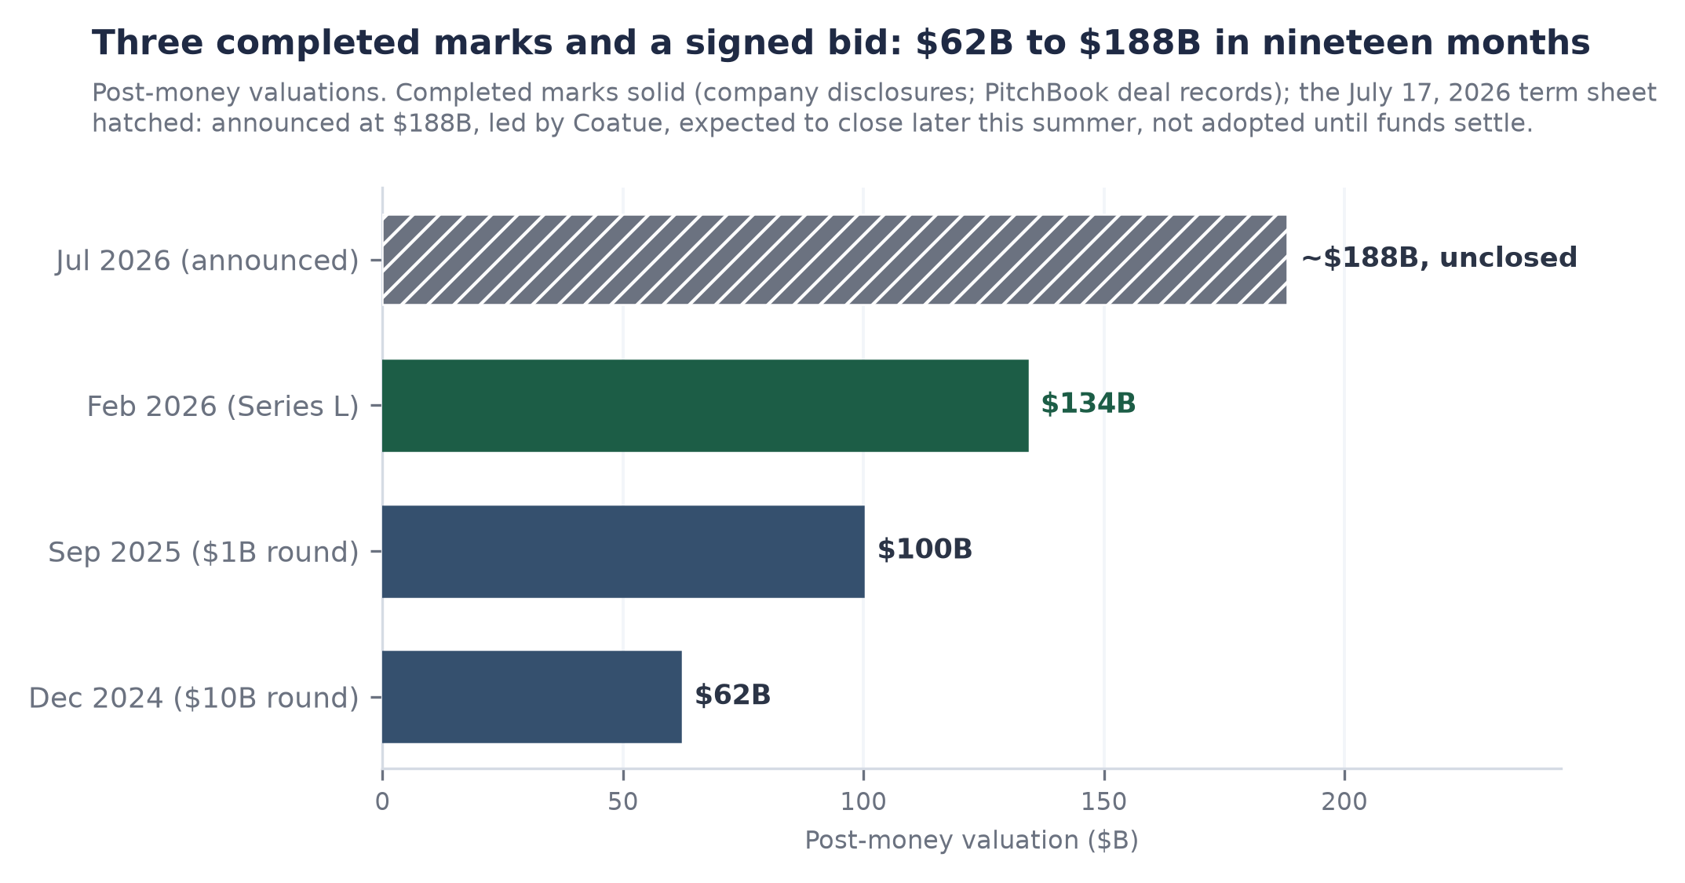
Figure 1. Post-money valuation marks, December 2024 to July 2026. Completed marks solid (company disclosures; PitchBook deal records); the July 17, 2026 term sheet hatched: signed at $188B, unclosed, not adopted in the base case until funds settle.
What happened is a price signal; what it means is a re-rate of the same engine. Nothing in the operating record moved with the announcement: the last dated print remains $6.9 billion of run-rate growing +80% YoY (company disclosure, June 16, 2026), gross margin remains 74% and guided lower, and the next scheduled disclosure is the September to October window. The bid moved, the business did not. At the completed mark the run-rate multiple is 19.4x; at the announced mark it is 27.2x on the identical June print (derived). The September print therefore decides which of those numbers the buyer actually paid.
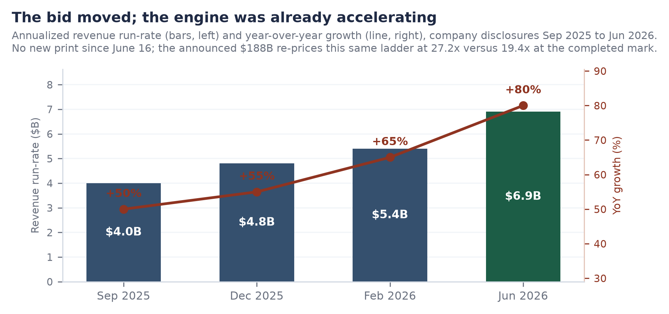
Figure 2. Annualized revenue run-rate (bars, left axis) and year-over-year growth (line, right axis), company disclosures September 2025 to June 2026. No new print since June 16; the announced bid re-prices this same ladder.
The implication cuts two ways. For the base case, discipline holds: the $134 billion completed mark anchors valuation work until funds settle, and every figure in this note that depends on the mark is stated at both levels where the difference matters. For the forward view, the signal tier upgraded: a speculative range sourced to press became a company-confirmed price with a named lead. The watch item is no longer whether a round happens; it is whether the close lands on schedule, and what the first post-money print shows.

The Ledger Moves: What Changed and What Did Not
Four fields moved between the July 10 verification pack and this run's live pull. The financing signal upgraded from rumor to announced term sheet at $188 billion, as covered above. The active investor count rose from 148 to 152 (PitchBook profile, August 10, 2026). The deal-record detail on the February Series L was revised: the final close is now described as $5 billion of equity led by Insight, J.P. Morgan Growth Equity, and Fidelity with Microsoft and 48 other investors participating, against roughly 44 in the July pack, and the note states the $129 billion pre-money explicitly (PitchBook financing note, August 7, 2026). And the company named where the new capital goes: Genie, the business-data assistant suite introduced in March, Unity AI Gateway, and Lakebase, the database built for AI agents (company announcement via press reports, July 17, 2026).
The list of what did not change is load-bearing. The run-rate ladder still ends at the June print: $6.9 billion, +80% YoY, the fourth consecutive accelerating disclosure (company disclosure, June 16, 2026). Gross margin remains 74%, guided lower on agent-driven compute. Headcount remains 9,000 (PitchBook, June 9, 2026). Free cash flow remains positive on the February bases with no newer print (company, February 9, 2026). No S-1 has appeared; the last registry check found Form D filings only (SEC EDGAR, July 10, 2026). And the tracker re-verified the standing trap: the PitchBook revenue field still reads $6,900M labeled TTM 4Q2026 with a December 2026 period end, a forward-window figure that this desk does not use as a run-rate source.
One scheduled gap is flagged rather than absorbed: the operating metrics beneath the revenue line, retention above 140%, more than 20,000 organizations, 800 plus customers above $1 million, are February 2026 vintage and now sit past their refresh window. The September to October disclosure is the scheduled fix; until then those figures carry their dates visibly wherever they appear. The tables below are generated directly from the tracker at build time.
Derived metrics (computed this run)
Metric | Value | Basis
Run-rate multiple | 19.4 | $134B / $6.9B run-rate (as of 2026-06-16)
Capital efficiency (CE, equity-only) | 0.34 | $6.9B run-rate / $20.2B EQUITY-ONLY (Ruling 1)
Valuation per AIBQ point ($B) | 15.2 | $134B / 8.81 AIBQ
Derived by the tracker at build time; inputs carry their own tiers.
Tracked ladders
Series | First print | Latest print | Direction | Prints
Run-rate ladder ($B) | 4 (2025-09-30) | 6.9 (2026-06-16) | accelerating | 4
YoY growth ladder (%) | 50 (2025-09-30) | 80 (2026-06-16) | accelerating | 4
Gross margin ladder (%) | 80 (2025-12-31) | 74 (2026-06-16) | falling | 2

Changed since prior snapshot (2026-07-10.json to 2026-08-10.json)
Field | Prior | Current
identity.business_status | None | Generating Revenue; Privately Held (backing);...
identity.founded | None | 2013
valuation.pb_last_known_valuation_bn | None | 188
valuation.rumored_round | $165-175B in talks, unclosed | Term sheet signed for a strategic round at $1...
valuation.valuation_ladder_bn | 0 item(s) | +3 new: [62, 100, 134]
financing.active_investors | 148 | 152
financing.series_l_participants_note | None | Series L $5B equity led by Insight, J.P. Morg...
financing.series_l_pre_money_bn | None | 129
financials.pb_ttm_field_note | PitchBook revenue $6,900M labeled TTM 4Q2026 ... | PitchBook revenue field still $6,900M TTM 4Q2...
products.ai_capital_focus | None | New capital earmarked for AI capabilities: Ge...
competition.private_valuation_rank | None | Trails only Anthropic, OpenAI, Tether, ByteDa...
events.stream | 4 item(s) | +1 new: ['Term sheet signed: strategic round ...

Stale facts (decay-class breach; refreshed or flagged before use)
Field | Value | As of (age, class)
valuation.pb_last_known_valuation_bn | 188 | 2026-07-16 (25d, VOLATILE)
financials.fcf_status | Positive, TTM and FY2025 bases; magnitude und... | 2026-02-09 (182d, QUARTERLY)
products.lakebase | Thousands of customers in first six months; r... | 2026-02-09 (182d, QUARTERLY)
customers.nrr_pct | >140% | 2026-02-09 (182d, QUARTERLY)
customers.orgs | 20000 | 2026-02-09 (182d, QUARTERLY)
customers.customers_1m_plus | 800 | 2026-02-09 (182d, QUARTERLY)
customers.customers_10m_plus | 70 | 2026-02-09 (182d, QUARTERLY)
customers.fortune500_pct | >60% | 2026-02-09 (182d, QUARTERLY)
competition.snowflake_mkt_cap_bn | 91.1 | 2026-07-07 (34d, VOLATILE)
competition.private_valuation_rank | Trails only Anthropic, OpenAI, Tether, ByteDa... | 2026-07-17 (24d, VOLATILE)
ipo_status.s1_status | No S-1 on file; Form D / D/A only (latest 202... | 2026-07-10 (31d, VOLATILE)
ipo_status.window | 2026 publicly ruled out by CEO; 2027 earliest | 2026-06-04 (67d, VOLATILE)
ipo_status.prediction_market | 'No Databricks IPO by Dec 31, 2027' priced 0.54 | 2026-07-07 (34d, VOLATILE)

The Thesis Check: Confirmed, Extended, or Contradicted
The July initiation rested on three legs: the strongest business quality score this framework has issued (8.81, Elite, July 2026 re-score), the cheapest price per unit of quality in the cohort, and a do-not-adopt stance on the rumored round paired with the read that the talks themselves were a forward signal of demand. The term sheet confirms the third leg and extends it: the signal did not merely survive, it firmed at a price above the talked range, with a named lead and a company announcement in place of sourced whispers.
The quality-adjusted price survives the higher bid. At the completed mark the market pays $15.2 billion per point of business quality; at the announced mark it would pay roughly $21.3 billion per point (est., derived). Both numbers sit on the cohort floor by a wide margin: the nearest neighbor pays about $118 billion per point and the top of the ladder sits near $188 billion per point on marks confirmed in mid-July (internal framework on PitchBook-confirmed marks, July 2026; derived). Even granting the full re-rate, the buyer at $188 billion still pays roughly a fifth of the cohort's next-cheapest price per unit of quality. Figure 3 restates the ladder at both marks.
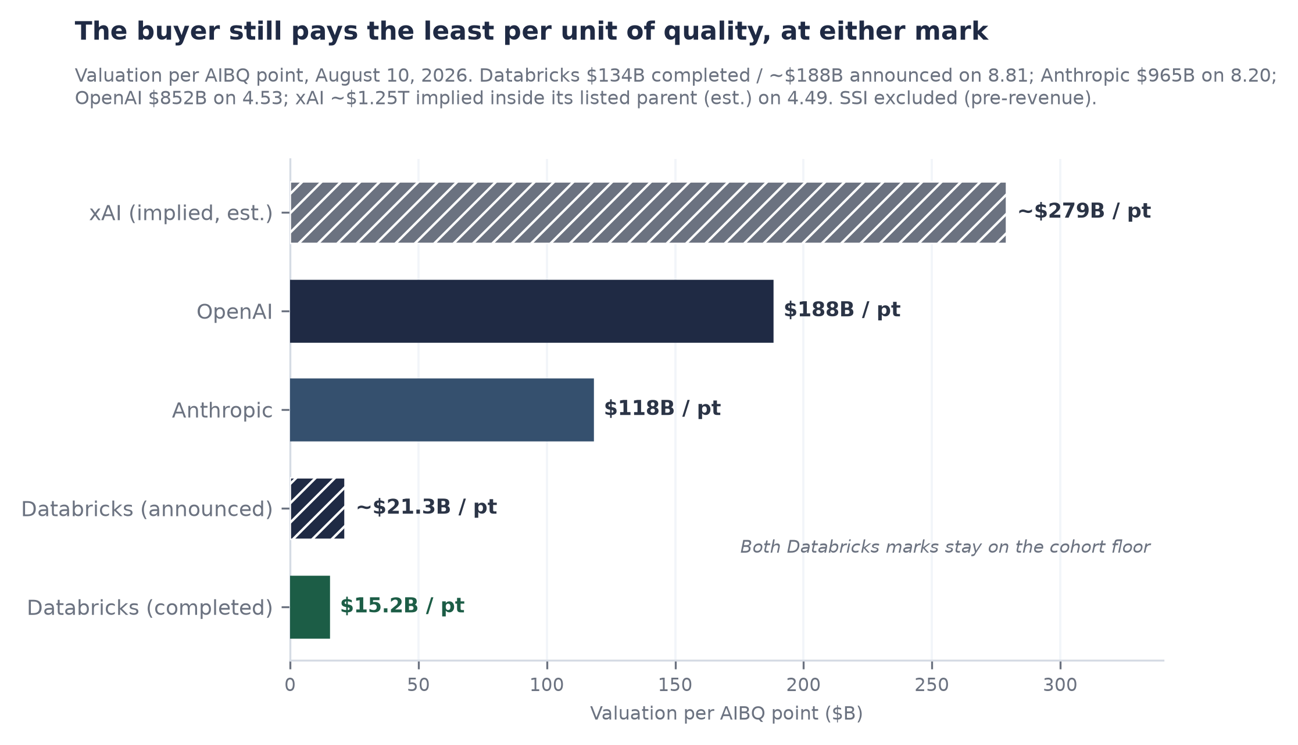
Figure 3. Valuation per AIBQ point, August 10, 2026. Databricks shown at both the completed and the announced mark; peer marks as confirmed mid-July 2026; xAI implied inside its listed parent (est.). SSI excluded (pre-revenue). The per-point spread is the only cleared expression of the quality-valuation relationship.
Growth adjustment tells the same story. At 27.2x on $6.9 billion growing +80%, the announced mark prices each point of growth at 0.34x; the listed comparable trades near 15.3x its guided forward product revenue growing +31%, or 0.49x per point (comparable company 8-K, May 27, 2026; derived). The February conclusion, that Databricks is the cheaper growth-adjusted asset, holds at the higher bid. Capital efficiency is the one line that moves against the thesis on close: funds received would lift lifetime equity from roughly $20.2 billion toward $23.2 billion, diluting CE from 0.34x toward 0.30x unless the September print raises the numerator first (derived, equity-only basis). That is a measurement note, not a crack: a company choosing dilution at 40% above its last mark, in a round it does not need, is exercising exactly the capital character the CE dimension scores.
Trigger review: the round trigger from the initiation fired on July 17, and it fired in the direction the report did not predict, firming at a higher price rather than closing or lapsing at the talked range. The margin-gate trigger remains armed and is unchanged by any of this: 74% against the 70% floor, a four-point cushion, guided lower, with the September to October print as the test. The S-1 trigger remains armed with nothing on file at the last registry check. A new trigger is armed today: the close itself, expected before the end of summer, which on completion adopts $188 billion as the mark and re-runs the appraisal.

The Verdict and the Watch List
The position is unchanged in method and upgraded in signal. The base case anchors on the $134 billion completed mark until the Coatue round settles; the $188 billion term sheet is treated as the market's confirmed forward bid on an engine whose last four prints accelerated from +50% to +80% at $7 billion scale. On close, the mark is adopted, the run-rate multiple moves to 27.2x on the June print, and the appraisal re-runs with the new equity in the denominator. Nothing in the announcement weakens the quality thesis; the announcement exists because of it.
Three dated numbers decide the next quarter of this coverage. First, the close: the company expects funds later this summer, and a completed deal record is the adoption event (company announcement, July 17, 2026). Second, the September to October print: gross margin against the 70% efficiency gate with a four-point cushion, the run-rate against the $6.9 billion June level, and the scheduled refresh of the February operating metrics. Third, the registry: any S-1 at the company's filing index re-rates the listing window immediately (last verified clean, SEC EDGAR, July 10, 2026).
The watch list, dated
Trigger | Window | On firing
Coatue round close at $188B | By end of summer 2026 (company guidance) | Adopt the mark; multiple to 27.2x on the June print; CE re-based toward 0.30x
Quarterly disclosure: margin vs the 70% gate; run-rate; metrics refresh | September to October 2026 (pattern of prior prints) | Gate breach forces a re-score regardless of the round; fresh NRR and customer counts replace February vintage
S-1 registration statement | Registry checked at every run; none on file July 10, 2026 | Listing window re-rates; governance optionality re-scores
Sources as cited in text; trigger states maintained in the company tracker.
The falsifier is unchanged and singular: a gross-margin print below 70% breaks the efficiency gate and forces a re-score of the quality thesis regardless of what the round does. Everything else in this note is a re-rate of price against a business whose published trajectory is still accelerating; that one number is the only print that would change what the business is.

Appendix: The Fact Sheet
Generated from the canonical company store at build time. Every row carries its source, as-of date, and tier; estimates are tilded and labeled; disputed values would appear with both figures under the freeze-on-conflict rule.
Identity & Status
Metric | Value | Source, date (tier)
Name | Databricks, Inc. | validation pack, July 10, 2026, 2026-07-10 (T2)
Pb entity id | 59199-40 | PitchBook profile, 2026-07-09 (T2)
Hq | San Francisco (+46 offices) | PitchBook, 2026-06-09 (T2)
Ceo | Ali Ghodsi | validation pack, July 10, 2026, 2026-07-10 (T2)
Sector | AI-PLAT (lakehouse / data + AI platform) | validation pack, July 10, 2026, 2026-07-10 (T2)
Founded | 2013 | PitchBook profile, 2026-08-10 (T2)
Business status | Generating Revenue; Privately Held (backing); Venture Capital-Backed | PitchBook profile, 2026-08-10 (T2)

Valuation & Marks
Metric | Value | Source, date (tier)
Post money ($b) | 134 | Series L, company PR Dec 2025 + PitchBook deal 313367-68T, 2026-02-09 (T2)
Rumored round | Term sheet signed for a strategic round at $188B post, led by Coatue with new and existing investors; ~$3B size (press); company expects close later this summer; funds NOT in hand as of Aug 10 | company announcement Jul 17, 2026 + PitchBook financing note Aug 7, 2026 (deal 334745-56T, Announced/In Progress); size per press reports, 2026-08-10 (T2) [do-not-adopt]
Pb last known valuation ($b) | 188 | PitchBook Last Known Valuation field, deal 334745-56T (Announced/In Progress), 2026-07-16 (T2) [do-not-adopt]
Valuation ladder ($b) | 62 | press reports of the $10B round, 2024-12-15 (T3)
Valuation ladder ($b) | 100 | press reports of the $1B round, 2025-09-30 (T3)
Valuation ladder ($b) | 134 | company PR + PitchBook deal 313367-68T, 2026-02-09 (T2)

Capital Raised & Deals
Metric | Value | Source, date (tier)
Total raised ($b) | 29.5 | PitchBook Total Raised $29,515.7M, 21 tracked deals, 2026-07-10 (T2)
Equity raised ($b) | ~20.2 (est.) | PitchBook 21-deal decomposition, 12 completed equity rounds A-L, 2026-07-10 (T2) [est.]
Debt raised ($b) | ~9.3 (est.) | PitchBook deal records: 4 debt deals + embedded, 2026-07-10 (T2) [est.]
Last completed deal | Series L $7.0B ($5.0B equity led by Insight/JPM Growth/Fidelity + Microsoft and ~44 others, $2.0B debt) | PitchBook deal 313367-68T + company PR, 2026-02-09 (T2)
Active investors | 152 | PitchBook profile, 2026-08-10 (T2)
Series l pre money ($b) | 129 | PitchBook financing note, 2026-08-07 (T2)
Series l participants note | Series L $5B equity led by Insight, J.P. Morgan Growth Equity, Fidelity; Microsoft + 48 other investors; $2B loan from undisclosed lenders | PitchBook financing note, 2026-08-07 (T2)

Financials
Metric | Value | Source, date (tier)
Run-rate ladder ($B) | 4 | company PR, 2025-09-30 (T2)
Run-rate ladder ($B) | 4.8 | company PR, 2025-12-31 (T2)
Run-rate ladder ($B) | 5.4 | company PR, 2026-02-09 (T2)
Run-rate ladder ($B) | 6.9 | company disclosure (analyst session), 2026-06-16 (T2)
YoY growth ladder (%) | 50 | company PR, 2025-09-30 (T2)
YoY growth ladder (%) | 55 | company PR, 2025-12-31 (T2)
YoY growth ladder (%) | 65 | company PR, 2026-02-09 (T2)
YoY growth ladder (%) | 80 | company disclosure, 2026-06-16 (T2)
Gross margin ladder (%) | ~80 (est.) | company (prior level, 'above 80%'), 2025-12-31 (T2) [est.]
Gross margin ladder (%) | 74 | company disclosure; guided to decline further on agent-driven compute, 2026-06-16 (T2)
Fcf status | Positive, TTM and FY2025 bases; magnitude undisclosed | company PR, 2026-02-09 (T2)
PitchBook TTM field (trap note) | PitchBook revenue field still $6,900M TTM 4Q2026 (period end 2026-12-31) = forward-window projection, NOT run-rate. Ruling 4 holds; not adopted. | PitchBook profile, re-verified this pull, 2026-08-10 (T2)

Employees
Metric | Value | Source, date (tier)
Employees | 9000 | PitchBook, 2026-06-09 (T2)

Products & Revenue Lines
Metric | Value | Source, date (tier)
Ai products run rate ($b) | 1.7 | company disclosure, 2026-06-16 (T2)
Dbsql run rate ($b) | 1.5 | press reports of company disclosure, 2026-06-16 (T2)
Lakebase | Thousands of customers in first six months; revenue growing at 2x the DW product's pace at equivalent stage | company PR, 2026-02-09 (T2)
Ai capital focus | New capital earmarked for AI capabilities: Genie (business-data assistant suite, debuted Mar 2026), Unity AI Gateway, Lakebase (database for AI agents) | company announcement via press reports, 2026-07-17 (T2)

Customers & Retention
Metric | Value | Source, date (tier)
Net revenue retention | >140% | company PR, 2026-02-09 (T2)
Orgs | 20000 | company PR, 2026-02-09 (T2)
Customers 1m plus | 800 | company PR, 2026-02-09 (T2)
Customers 10m plus | 70 | company PR, 2026-02-09 (T2)
Fortune500 (%) | >60% | company PR, 2026-02-09 (T2)

Competitive Position
Metric | Value | Source, date (tier)
Snowflake mkt cap ($b) | 91.1 | market data aggregators, 2026-07-07 (T3)
Snowflake fwd product rev ($b) | 5.84 | Snowflake 8-K, Q1 FY27 guide, +31%, 2026-05-27 (T1)
Vs snowflake | ~Databricks revenue has overtaken Snowflake; gap ~$1.6B and widening (est.) | third-party analyst data, 2026-06-30 (T3) [est.]
Private valuation rank | ~Trails only Anthropic, OpenAI, Tether, ByteDance among private companies at the announced $188B (est.) | PitchBook data via PitchBook news, 2026-07-17 (T2) [est.]

M&A / Acquisitions
Metric | Value | Source, date (tier)
Acquisitions count | ~19 (est.) | aggregated company disclosures + press, 2026-07-10 (T3) [est.]
Latest | Panther (security, 3rd security deal; terms undisclosed; $1.4B is Panther's 2021 mark, not a price) | company announcement + press, 2026-06-16 (T2)

IPO / Listing Status
Metric | Value | Source, date (tier)
S1 status | No S-1 on file; Form D / D/A only (latest 2025-12-31) | SEC EDGAR submissions API, CIK 0001587468, 2026-07-10 (T1)
Window | 2026 publicly ruled out by CEO; 2027 earliest | company (CEO television interview), 2026-06-04 (T2)
Prediction market | ~'No Databricks IPO by Dec 31, 2027' priced 0.54 (est.) | prediction-market aggregator, 2026-07-07 (T3) [est.]

Internal Scores (AIBQ)
Metric | Value | Source, date (tier)
Aibq composite | 8.81 | internal re-score (this desk), 2026-07-10 (T2)
Aibq dimensions | CE 8.9 · RQ 9.0 · CI 8.0 · GO 8.9 · MD 9.0 · CRA 0.0 | internal re-score (this desk), 2026-07-10 (T2)

Disclosures and Method
Method. This update was produced by the desk's report engine: the company tracker pulled the live PitchBook profile and news record on August 10, 2026, merged them into the canonical company store under freeze-on-conflict rules, recomputed derived metrics, and generated the tracker tables in Section 2 directly from the store at build time. Prose sections were composed against the measured house style profile and the company-update template; every load-bearing figure carries a source of kind and date in text. Source tiers follow the house convention: T1 regulatory filings, T2 company announcements and PitchBook records, T3 press reports, with estimates labeled at the point of use.
Standing constraints. Unclosed financings, including the July 17 term sheet, never anchor the base case; they are analyzed as forward signals. Capital-efficiency denominators are equity-only. PitchBook TTM revenue fields are forward-window projections and are not used as run-rate sources. The quality-valuation coefficient is embargoed; the per-point spread is its only cleared expression.
This document is not investment advice. Figures dated before August 10, 2026 are the latest available disclosures as of the run date; stale operating metrics are flagged with their vintage in Section 2.

