AN INSTITUTIONAL DEEP DIVE
Databricks, Inc.
Brick by Brick: Understanding the Business
What each layer of the $134 billion company is, what it earns, what it means now, and what it implies next. With a seven-year three-statement operating model (companion workbook).
BUSINESS QUALITY (AIBQ)  8.81 / ELITE  Highest in the Frontier Five; the cohort's only Elite rating | QUALITY-ADJUSTED PRICE  $15.2B / POINT  Cheapest in cohort vs ~$118B (Anthropic) and ~$188B (OpenAI) per point | MODEL BASE CASE  $155-190B  12-month view, anchored on the $134B mark; reported round not adopted

Snapshot (all figures re-verified July 10, 2026)
Metric | Value | Source, date
Last completed mark | $134B (held flat across two closes) | Series L; company, Dec 2025; PitchBook deal record, Feb 9, 2026
Reported round (not adopted) | $165-175B, in talks, unclosed | Press reports, Jun 9, 2026; PitchBook note, Jul 7, 2026
Revenue run-rate | $6.9B, +80% YoY, accelerating | Company disclosure, Jun 16, 2026
Gross margin | 74% (from >80%), guided lower | Company disclosure, Jun 16, 2026
Free cash flow | Positive (TTM and FY2025; magnitude undisclosed) | Company, Feb 9, 2026
Net revenue retention | >140% | Company, Feb 9, 2026
Customers | 20,000+ orgs; 800+ >$1M/yr; 70+ >$10M/yr; >60% of Fortune 500 | Company, Feb 9, 2026
Lifetime capital | ~$29.5B (~$20.2B equity + ~$9.3B debt) | PitchBook 21-deal record, Jul 2026
Run-rate multiple | 19.4x ($134B / $6.9B) | Derived
Listing status | No S-1 on file; 2026 ruled out; 2027 earliest | SEC EDGAR, Jul 10, 2026; company, Jun 4, 2026
Prepared by Harrison Rolfes, Senior Research Director | July 10, 2026 | Companion workbook: Databricks_Operating_Model_Jul2026.xlsx.

Contents
Executive Summary: The House That Data Built | 3
The Foundation: What Databricks Is | 5
The Bricks: Products and Services, Layer by Layer | 6
The Mortar: How the Money Is Made | 9
The Builders: Customers and What They Do | 11
The Neighborhood: Competition on Three Fronts | 13
The Blueprint: Strategy, Read Through Actions | 15
The Ledger: The Financial Picture | 19
The Appraisal: What the Business Is Worth | 23
The Stress Test: What Would Change the Answer | 28
The Verdict | 30

Exhibits
Figure 1. The per-point ladder: valuation per unit of quality | 4
Figure 2. Revenue composition by product line | 6
Figure 3. The valuation ladder: six marks in five years | 17
Figure 4. The absorption wall: listings vs issuance capacity | 18
Figure 5. The acceleration: run-rate and growth, four prints | 19
Figure 6. Gross margin vs the 70% efficiency gate | 20
Figure 7. Capital efficiency across the Frontier Five | 21
Figure 8. AIBQ dimension radar vs cohort average | 24
Figure 9. Growth-adjusted multiples vs Snowflake | 25
Figure 10. Valuation football field, 12-month view | 26
Figure 11. Sensitivity: run-rate by multiple | 27

Executive Summary: The House That Data Built
Databricks is best understood the way it was built: brick by brick. Underneath the $134 billion mark sits a thirteen-year sequence of deliberate constructions, an open storage format that became an industry standard, a governance layer that turned openness into lock-in, a billing model that turns customer growth into revenue without a renewal meeting, an AI product line built from an acquisition into the company's largest business, and a capital structure engineered so the company never has to raise money it does not want. This report takes the building apart layer by layer: what each piece is, what it does for the economics, what it means today, and what it implies for the next three years.
The headline facts, all re-verified as of July 10, 2026: revenue run-rate of $6.9 billion growing more than 80% year over year and accelerating (company disclosure, June 16, 2026); gross margin of 74%, down from above 80% and guided lower on agent-driven compute (same disclosure); free cash flow positive on trailing-twelve-month and fiscal-2025 bases (company, February 9, 2026); net revenue retention above 140% across more than 20,000 customer organizations including over 60% of the Fortune 500 (company, February 9, 2026); roughly $20.2 billion of lifetime equity raised against roughly $9.3 billion of debt (PitchBook deal records, July 2026); no S-1 on file (SEC EDGAR, verified July 10, 2026) and a 2027-at-the-earliest listing posture.
The valuation carries a paradox worth the whole report. On our AI Business Quality framework Databricks scores 8.81, the highest composite in the Frontier Five cohort and its only Elite rating, yet at $134 billion the market pays just $15.2 billion per point of measured quality, against roughly $118 billion per point for Anthropic, $188 billion for OpenAI, and an estimated $345 billion for xAI inside the newly listed SpaceX (Figure 1). The cheapest quality in the cohort is attached to its most complete business. Understanding why that gap exists, and what closes it, requires understanding the business brick by brick, which is precisely what the market has not yet been forced to do. A public listing forces it; the company has earned the right to choose when.
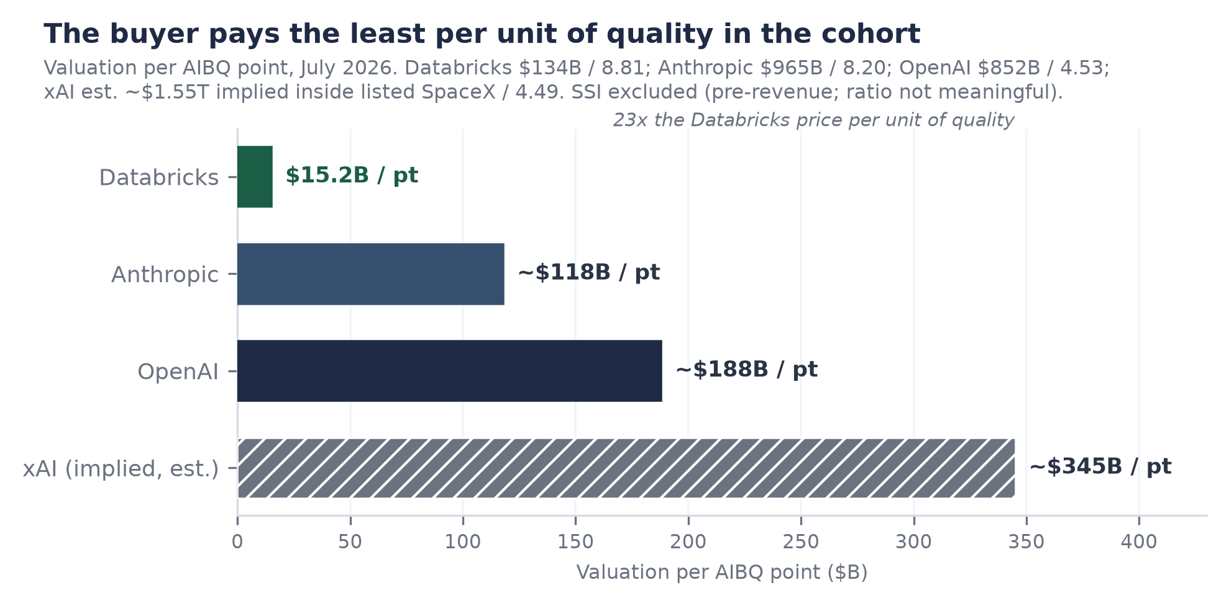
Figure 1. Valuation per AIBQ point across the Frontier Five, July 2026. Marks per company announcements and PitchBook; xAI implied value inside listed SpaceX is an estimate. SSI excluded (pre-revenue). The quality-valuation correlation is embargoed; this ranked bar is its only cleared expression and the coefficient is not derivable from it.

How the report is laid
- The Foundation: what Databricks is, where it came from, and what the lakehouse actually solves.
- The Bricks: every product layer, what it is, what it earns, and how each one deepens the one below.
- The Mortar: the consumption billing machine, unit pricing, and why expansion is a property of the product.
- The Builders: who the customers are, what they build on the platform, and where the revenue concentrates.
- The Blueprint: strategy read through actions, acquisitions, partnerships, capital structure, and the listing posture.
- The Ledger: the financial picture, and a seven-year three-statement operating model (companion workbook).
- The Appraisal: what the business is worth under a quality framework, comparables, and scenarios.
- The Stress Test and The Verdict: what would change the answer, and where we come out.

The Foundation: What Databricks Is

What it is
Databricks is a data and AI platform company, founded in 2013 in San Francisco by the University of California, Berkeley researchers who created Apache Spark, the open-source engine that became the standard for large-scale data processing. The company commercialized Spark, then spent a decade building an integrated platform on one architectural conviction: that the data warehouse (structured, governed, expensive, built for SQL analytics) and the data lake (cheap, flexible, ungoverned, built for machine learning) should be a single system. It named that system the lakehouse, and the name stuck to the entire category. Today the company employs roughly 9,000 people across 47 offices (PitchBook, June 2026), serves more than 20,000 customer organizations, and runs at $6.9 billion of annualized revenue.

What the analysis says
The founding insight matters because it targeted a tax every large enterprise was paying. Before the lakehouse, a typical Fortune 500 company ran two parallel data estates and a brigade of pipelines shuttling data between them: the warehouse for the finance and BI teams, the lake for the data scientists, and endless copies in between. Each copy cost storage, engineering time, and, most expensively, trust, because two systems answering the same question differently is worse than one system answering slowly. Databricks' bet was that open formats plus warehouse-grade governance could collapse the two estates into one. The bet took a decade to pay because governance, not storage, was the hard part; it is paying now because AI made the tax intolerable. A machine-learning model, and today an AI agent, is only as good as the data it can reach and trust, so every enterprise AI ambition forces the consolidation Databricks was already selling.

What it means now
The current implication is visible in the numbers: growth is accelerating at a scale where software companies normally decelerate, from +50% in September 2025 to +80% in June 2026 (company press releases and disclosures). That acceleration is the AI wave landing on an architecture positioned exactly beneath it. It is also visible in the competitive map: the company that owns the governed data layer gets first call on every new workload type that needs governed data, which is why Databricks' newest products (agents, operational databases, security analytics) reach meaningful revenue in quarters rather than years.

What it means next
Forward, the foundation implies durability more than it implies any single product's success. Data has gravity: once petabytes sit in one governed estate, with lineage, permissions, and audit history attached, the cost of leaving is not a migration bill, it is re-certifying everything a regulator or auditor ever signed off. Each layer described in the next section raises that exit cost. The investment question is therefore less whether any given Databricks product wins its niche, and more whether the estate itself keeps compounding. Every disclosed metric says it is.

The Bricks: Products and Services, Layer by Layer
Databricks' product surface is a stack of five strata, and the ordering is not cosmetic: each layer monetizes the data pulled in by the one beneath it and makes that layer harder to leave. Revenue attribution, where disclosed: AI products at roughly $1.7 billion annualized and Databricks SQL at roughly $1.5 billion (both company disclosures, June 16, 2026), implying a core platform residual of roughly $3.7 billion. Figure 2 shows the mix and its forward path.
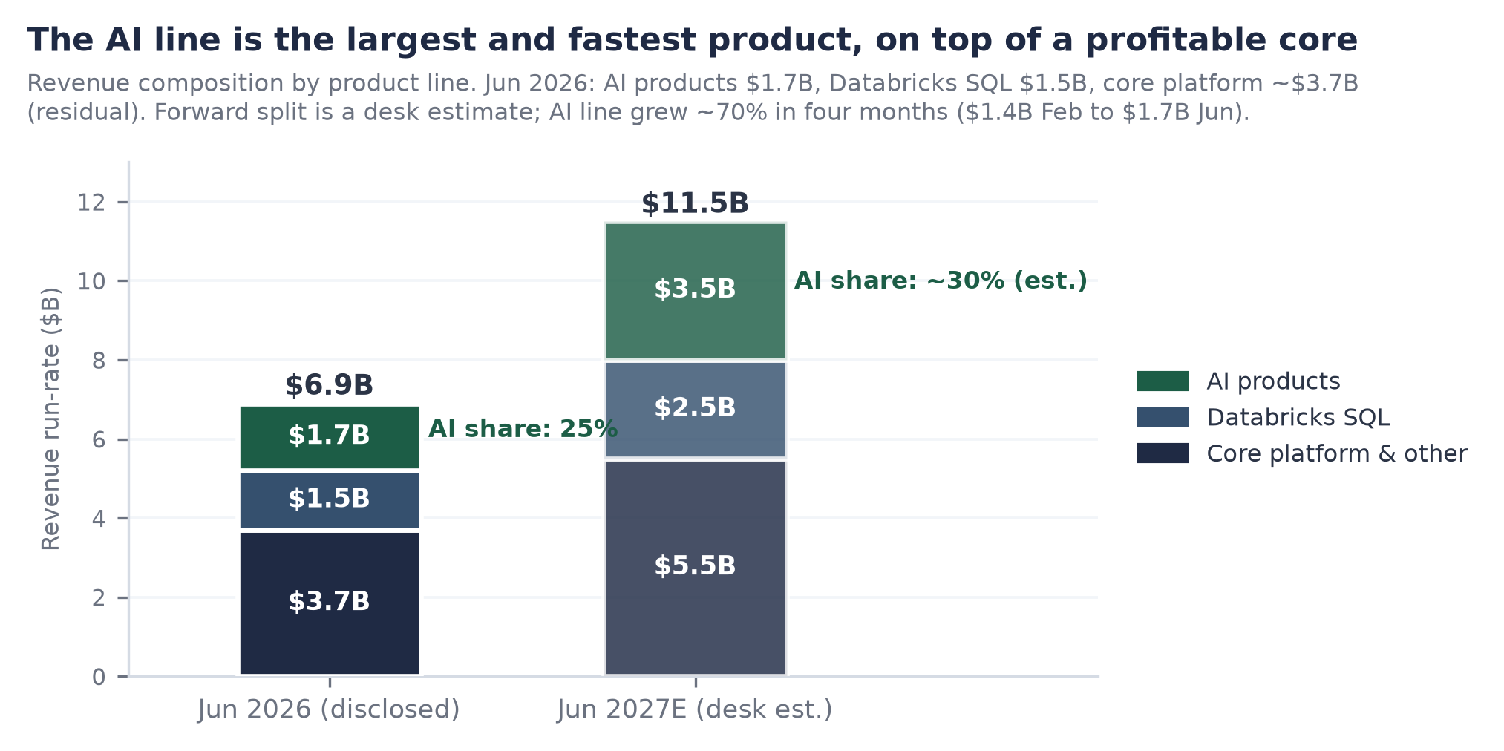
Figure 2. Revenue composition by product line, June 2026 disclosed versus June 2027 estimate. AI products $1.7B and Databricks SQL $1.5B per company disclosures (Jun 16, 2026); core platform is the residual; the forward split is an estimate.

Layer 1: the foundational trio (Delta Lake, Unity Catalog, MLflow)
What it is: Delta Lake is the open-source storage format that gives cheap object storage the transactional reliability of a database; Unity Catalog is the governance layer that tracks what data exists, who may touch it, and where every derived table came from; MLflow manages the lifecycle of machine-learning models from experiment to production. None of the three is sold as a line item. Analysis: this layer is the moat, not the monetization. Open-sourcing Delta Lake looked like giving away the crown jewels; in practice it removed the vendor-lock objection that kills platform adoption, while the real switching cost migrated up into Unity Catalog, which cannot be swapped out without re-certifying every downstream pipeline, model, and access policy. Current implication: adoption friction at the bottom of the stack is near zero, which is why more than 20,000 organizations are on the platform. Forward implication: every product Databricks ships lands on data that is already governed, which compresses each new product's time to revenue; Unity Catalog is quietly becoming the system of record for enterprise data permissions, a position with utility-like persistence.

Layer 2: Databricks SQL, the warehouse assault ($1.5B, doubling)
What it is: a SQL data warehouse that runs directly on lakehouse storage, sold against Snowflake, Amazon Redshift, Google BigQuery, and Microsoft Fabric. Analysis: DBSQL reached a $1.5 billion run-rate and doubled year over year (company disclosure, June 16, 2026), making it one of the fastest-growing large product lines in software. Management attributes much of the growth to workload migration from incumbent warehouses; at this scale that is share capture, not market drift. The strategic point is that warehousing is the incumbent category's home turf: winning here converts the largest existing enterprise data budget into lakehouse consumption. Current implication: Databricks passed Snowflake in total revenue during 2026, and the gap widened from roughly $0.5 billion in March to roughly $1.6 billion by June (derived from both companies' disclosures). Forward implication: the modeled path has DBSQL sustaining roughly 22 to 24% of revenue as the platform grows, which means the warehouse line alone would approach $6 billion by fiscal 2031, a business the size of Snowflake's entire current guide, running as one product among five.

Layer 3: the AI platform ($1.7B, the largest and fastest line)
What it is: model training and fine-tuning infrastructure (from the 2023 MosaicML acquisition), model serving, vector search, and evaluation tooling; the layer where enterprises build and run their own AI on their own data. Analysis: the trajectory is the story: roughly $1.0 billion annualized in September 2025, $1.4 billion in February 2026, $1.7 billion by June 2026 (company disclosures), about 25% of total revenue and growing faster than the corporate 80%. Two design choices make this line durable rather than fashionable. First, it is model-agnostic: after concluding it would not win a frontier-model race, Databricks repositioned to serve whatever model the customer prefers, including the frontier labs' own models natively (see the partnerships in The Blueprint). Second, it is metered in the same consumption unit as everything else, so AI adoption is platform expansion, not a separate purchase. Current implication: the AI line is genuine incremental revenue on a profitable core, not relabeled analytics. Forward implication: it is also the margin question. Serving AI workloads is compute-heavy, and management has said plainly that agents generating queries at machine speed will press gross margin lower. The AI line is simultaneously the growth engine and the reason the margin gate in The Ledger is the single most important watch item.

Layer 4: the agentic surface (Agent Bricks, Genie, Lakebase, Lakeflow)
What it is: the newest stratum, aimed at AI agents as the next class of platform user. Agent Bricks is a framework for building and operating production agents against governed data. Genie, with its Genie One and Ontology extensions, provides natural-language access so business users, and increasingly agents, can query the estate conversationally. Lakebase, built on the 2025 Neon acquisition, is a serverless Postgres database designed to be provisioned programmatically by agents. Lakeflow handles data movement. Analysis: the wager is that the durable profit pool of the AI era is not the model but the substrate where agents read, write, and are governed. Lakebase is the leading indicator: the company reports thousands of customers within six months of launch and revenue compounding at roughly twice the pace its own warehousing product managed at the same age (company, February 9, 2026). Current implication: agent workloads are already moving the P&L in both directions, adding consumption revenue while compressing gross margin. Forward implication: if agents become the dominant creators of database workloads, Databricks has pre-positioned the product they will provision; the modeled AI-plus-agentic share of revenue rising from 25% toward 30% by fiscal 2031 rests substantially on this layer maturing.

Layer 5: security and real-time (Lakewatch, Panther, CustomerLake, Reyden)
What it is: a security lakehouse push built through three acquisitions (Antimatter, SiftD.ai, and Panther, the last announced June 16, 2026 with terms undisclosed and regulatory clearance pending), an agentic security-operations product (Lakewatch, March 2026), a customer-data platform (CustomerLake), and a real-time engine (Reyden). Analysis: security telemetry is the largest data volume most enterprises generate, and the incumbent SIEM vendors charge by ingestion, which makes them structurally expensive at exactly the moment data volumes explode. Pulling security data into the lakehouse both grows consumption and attacks a large adjacent budget. Panther, last privately marked at $1.4 billion in 2021 (a reference point, not a purchase price), brings detection content and a customer base that already includes AI-native buyers. Current implication: none of these lines has disclosed revenue; they are options, not earnings. Forward implication: the security estate is the most credible candidate to become product line number four at billion-dollar scale, because it recycles the exact playbook that built DBSQL and the AI line: land on data gravity, price in consumption units, let the platform's governance be the differentiator.

What the stack means as a whole
Read vertically, the five layers describe a company that has industrialized a single motion: identify a large data-adjacent budget, build or buy a product that serves it from the governed estate, price it in the platform's consumption unit, and let gravity do the selling. The pattern has now worked twice at billion-dollar scale (DBSQL, AI) and is being run again twice (agents, security). That repeatability, more than any single product, is what a buyer of the company at $134 billion is underwriting.

The Mortar: How the Money Is Made

What it is
Databricks sells compute by the unit. The billing atom is the Databricks Unit (DBU), a normalized measure of processing capacity consumed per hour, with a price per DBU that varies by workload type, cloud, region, and tier. Customers either pay on demand or, far more commonly at enterprise scale, sign multi-year committed-use contracts: a prepaid pool of spend, drawn down as consumption occurs, at discounts that deepen with commitment size. Storage is billed by the underlying cloud provider; Databricks monetizes the compute and the software intelligence wrapped around it. There are no seats, no per-user licenses, and, in the traditional sense, no renewals: there is a commitment, a drawdown, and a bigger commitment.
The price list, in one view (AWS, US regions, Premium tier; public price lists, retrieved July 2026)
Workload (SKU) | Rate per DBU | What it meters
Jobs Light compute | ~$0.07 | Basic scheduled pipelines
Jobs compute | ~$0.15 | Production data engineering and ETL
All-purpose compute | ~$0.55 | Interactive analytics and notebooks
SQL Serverless | ~$0.70 | Warehouse queries, infrastructure bundled
Model serving | ~$0.08 | AI inference endpoints (scales with tokens/requests)
Rates vary by cloud, region, and tier; Europe runs ~20-30% higher. The 10x span between the cheapest and richest SKU is the mix-shift engine: as customers move up the stack from pipelines to interactive AI, revenue per unit of underlying compute rises.

What the analysis says
Three properties of this design do most of the work in the company's economics. First, expansion is mechanical. When a customer's data volume grows, when its analysts run more queries, and now when its AI agents run queries by themselves at machine speed, the meter turns without a salesperson in the room. Net revenue retention above 140% (company, February 9, 2026) is not a sales accomplishment; it is the billing model meeting the secular growth of data and AI workloads. Second, the committed-use structure converts consumption into visibility. Prepaid commitments sit on the balance sheet as deferred revenue and drain predictably; in the companion model, deferred revenue roughly doubles to about $2.0 billion by fiscal 2027 on the modeled path, funding growth with customers' own cash. Third, procurement friction is unusually low because Databricks sells through the cloud marketplaces: a Fortune 500 company can buy Databricks against its existing AWS, Azure, or Google Cloud spending commitment, which turns three trillion-dollar vendors' pre-negotiated budgets into Databricks' sales channel.

What it means now
The current implication is the quality of the revenue, and it shows up in three disclosed numbers read together: growth above 80%, NRR above 140%, and free cash flow positive. Subscription software can show any two of those; showing all three at once is the signature of consumption billing on top of a workload that customers cannot stop growing. It also carries an honest cost: consumption revenue has less downside protection than subscriptions, because customers can throttle usage without breaching a contract, as the industry learned painfully in the 2022-23 optimization cycle. The offset today is that the marginal workload is AI, and no enterprise in 2026 is optimizing its AI usage downward.

What it means next
Forward, the mortar sets the shape of the model. Because expansion is a product property, the arithmetic floor under growth is high: at NRR above 140%, the June 2026 installed base alone would reach roughly $9.7 billion of run-rate by June 2027 before a single new logo signs. Because the meter prices AI workloads in the same unit as everything else, the AI wave arrives as expansion revenue at enterprise-software margins rather than as a new low-margin business line, though the margin pressure from agent-driven query volume is real and is treated at length in The Ledger. And because commitments prepay, growth strengthens rather than strains the balance sheet, which is why the company can be simultaneously hypergrowth and self-funding, the combination that separates it from every frontier lab it is compared against.

The Builders: Customers and What They Do

What it is
The customer base is a pyramid of more than 20,000 organizations (company, February 9, 2026): a broad self-serve and departmental tail, a professional class of more than 800 customers spending over $1 million a year, and an apex of more than 70 customers spending over $10 million a year, with more than 60% of the Fortune 500 somewhere on the platform. Consumption economics make the pyramid dynamic by design: today's $200 thousand departmental workload is tomorrow's $2 million platform standard, and the disclosed tiers are snapshots of customers in transit between them.
What the customers actually build (company-published case studies)
Customer | What they run on Databricks | Why it matters
Comcast | Voice-remote intelligence: petabyte-scale telemetry from video and voice applications, processed for instant response and viewer analytics | Consumer-scale streaming workload; reported ~10x reduction in compute cost after consolidating on the platform
Shell | Predictive operations: more than 3 terabytes of real-time sensor data daily across energy infrastructure | Industrial IoT at scale; the lakehouse as the operational nervous system, not just analytics
Rivian | Vehicle telemetry and battery/charge prediction models; a cybersecurity lakehouse migrated in under three months | One customer, three strata: core platform, ML, and the security push, adopted in sequence
HSBC | Customer analytics and personalization across retail banking | Regulated-industry proof: governance (Unity Catalog) is the purchase criterion, not an afterthought
Fortune 500 broadly | >60% penetration; use cases from fraud detection to genomics to supply-chain optimization | The platform is horizontal; vertical depth comes from the data, which the customer already owns
Company-published case studies and disclosures, retrieved July 2026. Case-study metrics are company-reported.

What the analysis says
Two structural facts stand out from the base. First, concentration is meaningful but healthy: on the cohort arithmetic in the companion model, the roughly 70 largest customers at an average of roughly $30 million each account for about 30% of revenue, and the 800-plus million-dollar class for well over half; yet no single customer is disclosed or reputed to be material alone, and the tail of 20,000 organizations is a pipeline, not a rounding error. Second, the expansion motion is visible in the tiers themselves: the million-dollar class grew from the mid-hundreds to more than 800 in roughly a year (company disclosures), and the Rivian pattern, core platform first, then ML, then security, is the template the newest product layers are designed to repeat. The customer stories also explain the moat better than any architecture diagram: when a bank's regulatory reporting, a carmaker's battery models, and a media company's viewer experience all run on the same governed estate, the platform is no longer a vendor, it is infrastructure.

What it means now, and next
Now: the depth of the paid base is why revenue quality survives scrutiny. Expansion within existing customers alone sustains roughly 40%-plus growth before new business, which is the arithmetic backbone of the near-term forecast. Next: the pyramid's top tier is the leading indicator to watch. The modeled path takes the $10 million-plus class from roughly 70 customers toward 200 by fiscal 2031, at rising average spend, as AI agents move from pilots to production inside exactly these accounts; the disclosed count at the next update (expected around September-October 2026) will say whether that migration is on schedule. The risk symmetric to the opportunity: these are the same accounts where consumption throttling would appear first in a downturn, which is why the tier counts are a better early-warning system than the headline run-rate.

The Neighborhood: Competition on Three Fronts
Databricks fights on three fronts simultaneously, against different opponents with different weapons, and the state of each front explains a different part of the numbers.

Front one: the warehouse incumbents (winning, measurably)
What it is: the head-to-head against Snowflake and, secondarily, the legacy warehouse estates migrating to the cloud. Analysis: this is the only front with a public scoreboard, and it has flipped. Databricks passed Snowflake in absolute revenue during 2026; the gap ran roughly $0.5 billion in March and roughly $1.6 billion by June (derived from both companies' disclosures), and it is compounding, because Databricks is growing at 80% against Snowflake's guided 31%. The sharpest datapoint is DBSQL doubling to $1.5 billion inside Snowflake's core category, with management attributing the growth to workload migration. The 2024 Tabular acquisition mattered strategically here: by hiring the founders of Apache Iceberg, Snowflake's preferred open format, Databricks ended the format war and removed the last technical excuse not to consolidate on the lakehouse. Current implication: the competitive narrative that framed the two as peers is roughly two years stale; they are now different sizes growing at different speeds. Forward implication: Snowflake remains the price-setter for how public markets value the category, which matters enormously in The Appraisal, but it is no longer the constraint on Databricks' growth.

Front two: the hyperscalers (a stable, watchable truce)
What it is: Amazon, Microsoft, and Google are simultaneously Databricks' infrastructure suppliers, its distribution channel, its largest competitors (Redshift, Fabric, BigQuery), and, since Microsoft's participation in the February 2026 financing close (PitchBook), its investors. Analysis: the bear case writes itself, three trillion-dollar vendors controlling the compute beneath the platform and the marketplaces it sells through. The reason it has not happened is arithmetic: every Databricks workload monetizes hyperscaler compute underneath, so an ecosystem partner that drives consumption across all three clouds is worth more to each of them than a first-party product that only wins on its own cloud. Neutrality is also the one feature none of them can copy: no hyperscaler will ever be the trusted governance layer across its two rivals, and large enterprises are structurally multi-cloud. Current implication: the truce is profitable for everyone and priced into the quality score as its one visible notch (compute independence, 8.0 of 10). Forward implication: this is the front to monitor rather than the front to fear; the tell would be marketplace term changes or egress pricing aimed at cross-cloud platforms, which would show up in the $10 million-plus account win rates before it showed up anywhere else.

Front three: the AI labs (settled by treaty, for now)
What it is: the possibility that foundation-model companies capture the enterprise AI budget directly, making the data platform a commodity beneath them. Analysis: 2025-26 settled this front in Databricks' favor, at least for this cycle, and the evidence is the labs' own signatures: a multi-year OpenAI partnership with frontier models native on the platform, a five-year Anthropic alliance with Claude available across all three clouds through the platform's own interfaces (company announcements, 2025). The labs concluded that enterprises buy AI where their data is governed, not the reverse. Current implication: Databricks collects a distribution position on frontier intelligence without bearing frontier training costs, the inverse of the labs' economics. Forward implication: the treaty holds while no single model wins outright; a decisive frontier-capability breakaway would concentrate bargaining power in one lab and reopen the front. Model plurality is, quietly, a Databricks asset.

The moat, stated once
Across all three fronts the durable defense is the same: it costs an enterprise almost nothing to bring data onto the platform and a great deal to take it away, and the asymmetry deepens with every layer adopted. Open formats keep the front door frictionless; Unity Catalog governance, lineage, compliance attestation, and now agent workflows make the back door progressively more expensive, because leaving means re-certifying everything an auditor ever signed. Competitors can match any feature; none has demonstrated it can dissolve an installed governance layer. That is the moat a buyer of the company is underwriting, and it is why the competitive question in this report is not whether Databricks survives its neighborhood but what its neighborhood is worth.

The Blueprint: Strategy, Read Through Actions
Strategy documents are cheap; wire transfers are not. This section reads Databricks' strategy through what it has actually paid for, signed, and declined to do: roughly nineteen acquisitions, a set of partnerships that would have been unthinkable three years ago, a debt structure built for a compute war, and a listing it keeps refusing to rush.

Acquisitions: buying the next brick, every time
The deals that built the stack
Deal | When / consideration | What it became
MosaicML | 2023; ~$1.3B | The AI platform layer: training, fine-tuning, serving. Now inside the company's largest product line ($1.7B run-rate, Jun 2026)
Tabular | 2024; reported >$1B | Detente in the format war: brought the Apache Iceberg founders in-house, making the lakehouse format-neutral and removing the last architectural adoption objection
Neon | 2025; reported ~$1B | Became Lakebase, the serverless Postgres for AI agents; thousands of customers within six months (company, Feb 9, 2026)
Antimatter, SiftD.ai, Panther | 2024-2026; Panther announced Jun 16, 2026, terms undisclosed, clearance pending | The security lakehouse: detection content, data security, and an agentic SOC surface (with Lakewatch, Mar 2026)
~14 smaller deals | 2019-2026; mostly undisclosed | Tuck-ins for connectors, governance, and talent; no visible integration failure across the program
Company announcements and PitchBook, retrieved July 2026. Consideration figures are as reported at announcement; several were substantially stock.
The pattern deserves more credit than any single deal. Each major acquisition bought the seed of the next product layer roughly eighteen months before the market priced that layer as essential: Mosaic before enterprise AI training was a category, Neon before agent-provisioned databases existed as a phrase, Panther as agentic security operations is forming. The forward implication is that the M&A program is a leading indicator of the roadmap; the current security concentration (three of the last several deals) says clearly where management believes the next billion-dollar line sits.

Partnerships: the labs sell through the platform now
The alliance map
Partner | Deal | What it means
OpenAI | Multi-year partnership incl. a ~$100M commitment; frontier models made natively available on the platform and inside Agent Bricks (announced Sep 2025) | The largest AI lab distributing through Databricks' governed estate rather than around it
Anthropic | Five-year alliance; Claude models native across all three clouds via SQL and model endpoints (announced Mar 2025) | Model-agnosticism made real: the customer chooses the model, the platform keeps the workload
Palantir | Strategic product partnership joining Palantir's operational AI layer with the lakehouse (announced Mar 2025) | Reach into defense and regulated operations where Databricks sells less directly
SAP | SAP Business Data Cloud ships with Databricks embedded (2025) | The world's largest ERP estate flows toward the lakehouse by default
Microsoft, AWS, Google | First-party Azure Databricks; marketplace distribution on all three clouds; Microsoft participated in the Feb 2026 Series L close (PitchBook) | The hyperscalers are simultaneously supplier, channel, competitor, and now investor
Company announcements, 2025-2026; PitchBook deal record for the Series L close.
The analytical point: in 2023 the plausible bear case was that the frontier labs would commoditize Databricks from above while the hyperscalers squeezed it from below. The 2025-26 alliance map shows the opposite settlement. The labs concluded that the enterprise buys AI where its data is governed, and signed distribution into the platform; the deepest-pocketed hyperscaler wrote a check into the equity. Both are revealed-preference statements about where the durable position in the stack sits. The forward implication is a tailwind with a dependency: model partnerships make Databricks the neutral marketplace for frontier intelligence, but neutrality only stays valuable while no single model wins outright.

The capital blueprint: equity for ownership, debt for compute, flat marks by choice
The financing history is a strategy document in itself (Figure 3). Six marks in five years, from $28 billion (February 2021) to $134 billion (December 2025 and February 2026), each cleared by fundamentals that had roughly caught up with the prior mark. The composition matters more than the levels: roughly $20.2 billion of lifetime equity, over half of it in one round (the $10.2 billion Series J, December 2024) raised substantially to fund employee liquidity rather than operations, and roughly $9.3 billion of debt assembled between January 2025 and February 2026 (PitchBook deal records) to pre-fund compute commitments without dilution. A company that is free-cash-flow positive does not need either; it raised both to control its own timeline. The tell is the Series L: $134 billion held flat across two closes, a company declining a headline step-up it could have had, because it did not need the money enough to negotiate for vanity.
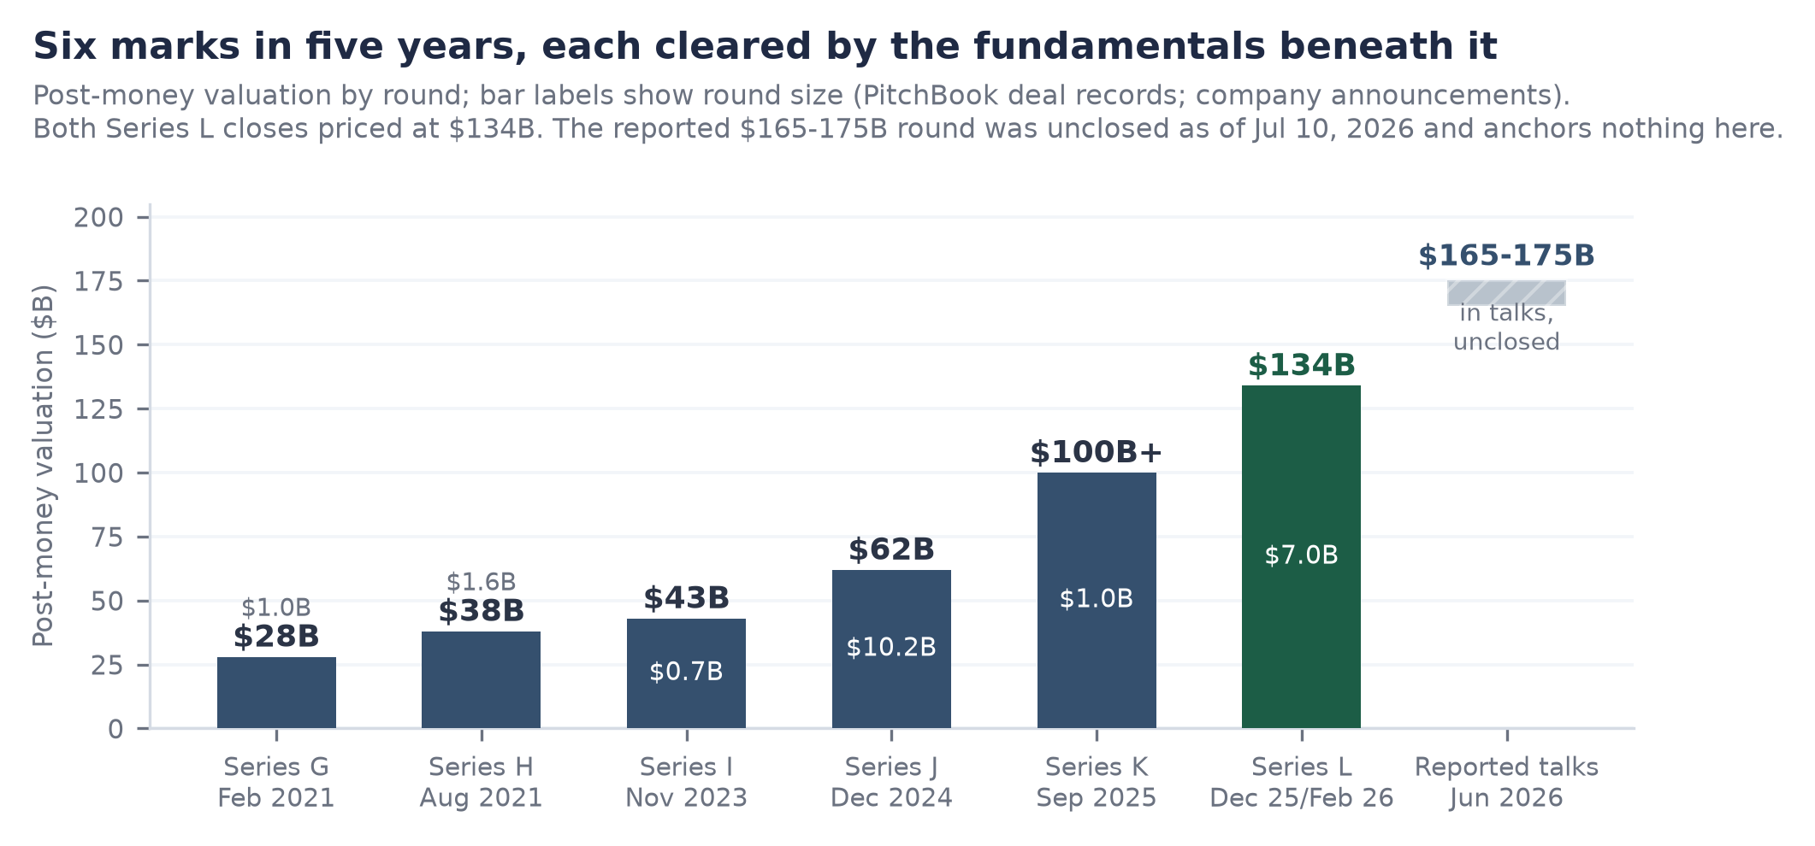
Figure 3. Post-money valuation by round, Series G through L, with the reported June 2026 talks shown as unclosed. Sources: company announcements; PitchBook deal records.

The unclosed round: analyzed, not adopted
Press reports of June 9, 2026 describe discussions of a new round at $165 to 175 billion, a 23 to 31% step-up, with terms unsettled; PitchBook carried it as rumor with an estimated $170 billion post-money as of July 7, and no close had been reported as of July 10. Discipline first: an unclosed round anchors nothing in this report; every valuation statement here rests on the completed $134 billion mark. Analysis second, because the rumor is informative even while unadopted: the fundamentals-based valuation work in The Appraisal reaches $155 to 190 billion on a twelve-month view without referencing the round at all. Read against that, $165 to 175 billion is not an inflated present mark but a fair forward one, the price of the business a year from now bought today. If it closes in range, it confirms crossover demand for the eventual listing; if it dies or prices below, that is a genuine signal about appetite, and the multiple assumptions here would deserve revisiting. Either way the base case does not move, which is the point of the discipline.

The listing posture: waiting as strategy
No S-1 is on file (SEC EDGAR, CIK 1587468, verified July 10, 2026); the chief executive has publicly ruled out 2026 and pointed to 2027 at the earliest; prediction markets price no listing by end-2027 as a slight favorite. Meanwhile the two largest AI labs have reportedly filed paperwork, and the SpaceX listing (June 2026, $1.77 trillion, trading up roughly 23% since) has already tested the market's capacity for mega-scale AI paper (Figure 4). The strategic read: Databricks is the only name in the wave that can wait indefinitely, because it generates cash, and the only one that needs essentially no primary capital from a listing. Letting OpenAI and Anthropic price first outsources the experiment risk and hands Databricks a calibrated demand curve to price against. Waiting is not hesitancy here; it is the cheapest option the company owns.
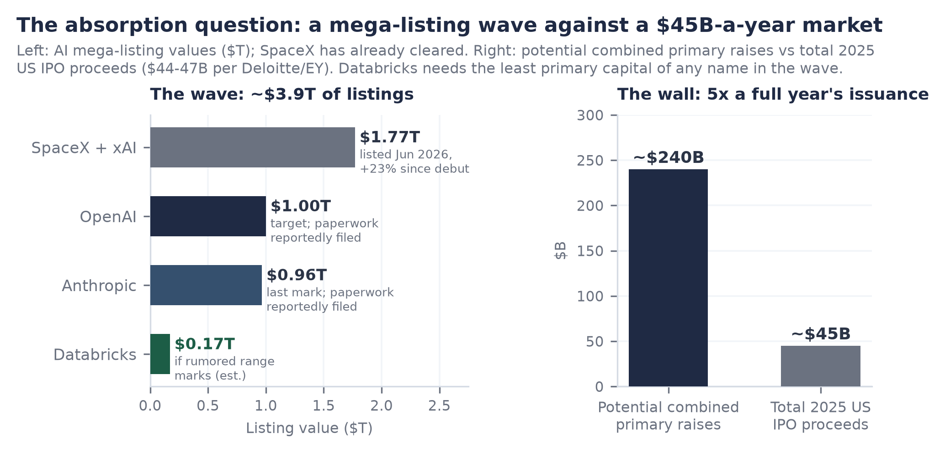
Figure 4. The AI mega-listing wave against the 2025 US IPO market (~$44-47B of proceeds, per major audit-firm annual reviews). SpaceX has already cleared; Databricks needs the least primary capital of any name in the queue.

The Ledger: The Financial Picture
Databricks publishes no financial statements, but it has published enough, four dated run-rate prints in ten months, a margin level and direction, retention, tier counts, and a complete financing record, to constrain a serious model. This section presents the disclosed skeleton and the seven-year three-statement model built on it; the full workbook (Inputs, Model, Valuation, with every assumption sourced) accompanies this report.

Revenue: acceleration at scale
What is disclosed: $4.0 billion annualized at +50% (September 2025), $4.8 billion at +55% (December 2025), $5.4 billion at +65% (February 9, 2026), $6.9 billion at +80% (June 16, 2026), all company statements (Figure 5). Four consecutive prints of accelerating growth while the base nearly doubled is behavior essentially without precedent at this scale; the drivers, decomposed in The Bricks, are the AI line compounding fastest, DBSQL doubling on workload migration, and the consumption meter converting agent adoption into revenue in real time. The model translates the ladder into fiscal years (ending January 31): roughly $2.6 billion in FY2025 and $4.1 billion in FY2026 as calibrated estimates, then a base case that deliberately decelerates, +77% in FY2027 to +24% by FY2031, landing at roughly $25 billion of revenue, consistent with a low-to-mid $20 billions run-rate entering calendar 2030. Nothing in the base case extrapolates the acceleration; it only asks the deceleration to be graceful, which retention above 140% alone nearly guarantees arithmetically.
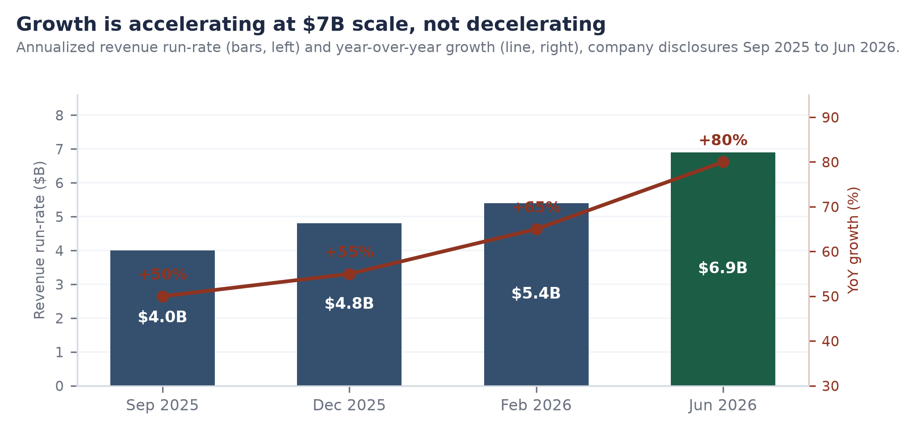
Figure 5. Revenue run-rate and year-over-year growth, September 2025 to June 2026, per company disclosures. The rising growth line at rising scale is the core financial fact of the company.

Margins: 74%, guided lower, gated at 70
Gross margin is 74%, down from above 80%, and management has been unusually direct that agent-driven query volume will press it further. At the current run-rate each margin point is roughly $69 million of annualized gross profit, so the glide from the low 80s has already surrendered several hundred million dollars a year, a price paid deliberately to own the agentic workload while it forms. The quality framework in The Appraisal imposes a hard floor: a print below 70% breaks the efficiency gate and forces a re-score, and would recast the AI line from software revenue toward pass-through compute resale (Figure 6). The cushion is roughly four points. The base case holds margin in the 72.5 to 74% band through the forecast on serving efficiency and price/mix; the worst case in the model breaks the gate in FY2028 and is priced accordingly in the scenarios. The next disclosure, expected around September-October 2026, is the single most important data point for the thesis.
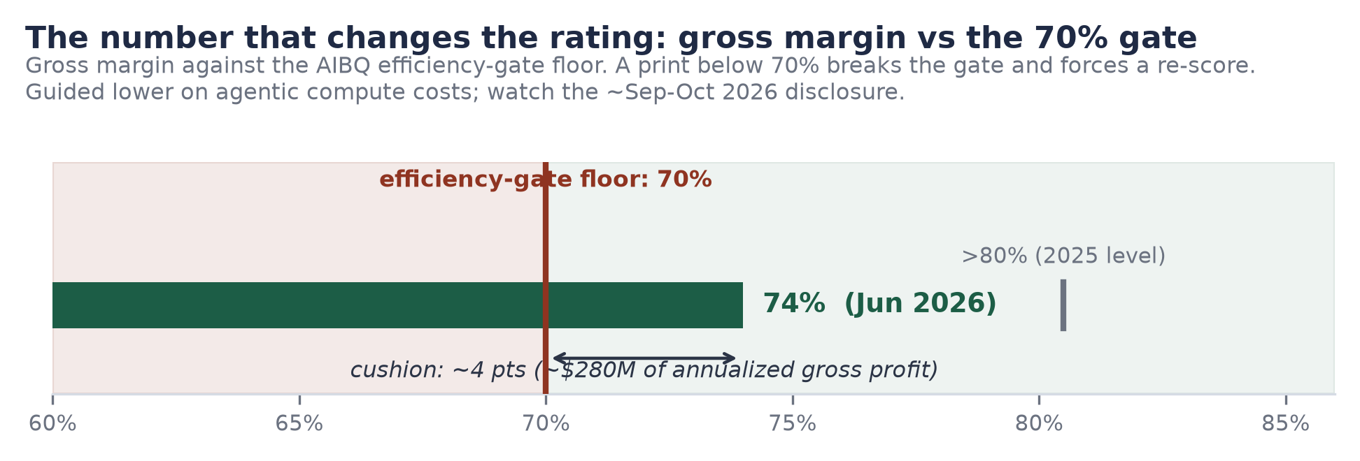
Figure 6. Gross margin (74%, June 2026, company disclosure) against the 70% efficiency-gate floor, with the prior >80% level marked.

Cash: the self-funding hypergrowth machine
The company states it is free-cash-flow positive on trailing-twelve-month and fiscal-2025 bases without giving magnitude (February 9, 2026). The model's estimate of what that understates: consumption prepayments mean customers fund growth in advance, so modeled free cash flow runs roughly $0.8 billion in FY2026 rising toward $6.7 billion by FY2031 at margins in the high teens to mid twenties, even while GAAP operating income only turns positive around FY2028 under the weight of stock compensation. Three balance-sheet consequences follow (all modeled, all labeled estimates in the workbook): cash of roughly $14 to 15 billion through the mid-forecast even after funding employee tenders and acquisitions; deferred revenue doubling to roughly $2 billion by FY2027 as commitments prepay; and debt steady at roughly $9.3 billion, comfortably serviced at a modeled ~$630 million of annual interest against gross profit two orders of magnitude larger by the forecast's end. Figure 7 places the resulting capital efficiency in its cohort: only Databricks and Anthropic convert equity into revenue at better than a third of a dollar per dollar raised, and only Databricks does it while generating cash.
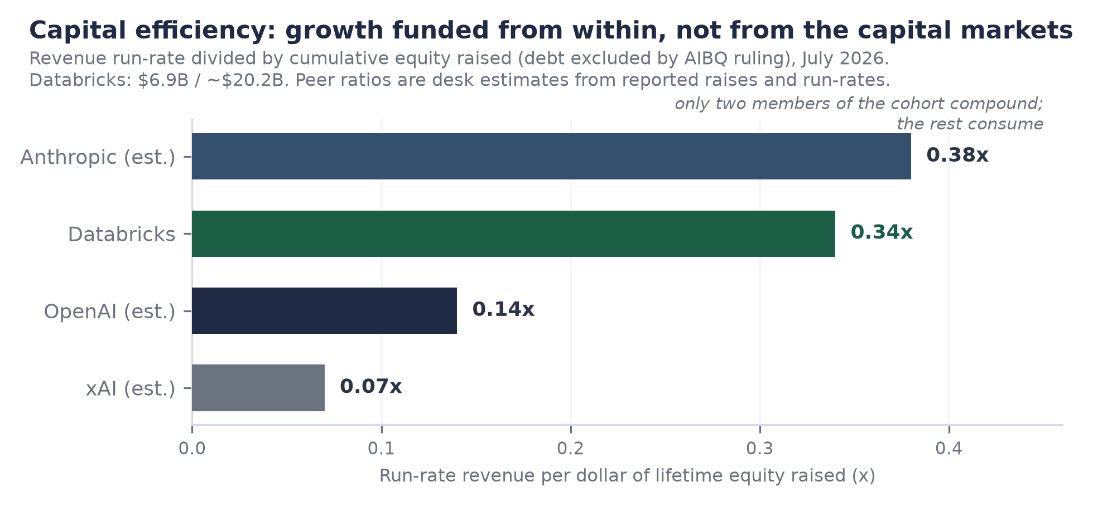
Figure 7. Run-rate revenue per dollar of lifetime equity raised, July 2026. Databricks from disclosures and PitchBook; peers are estimates from reported raises and run-rates. Debt excluded from all denominators.

The model on one page
Base case summary (USD millions; FY ends Jan 31; FY25A/FY26A calibrated estimates; companion workbook: Databricks_Operating_Model_Jul2026.xlsx)
 | FY25A | FY26A | FY27E | FY28E | FY29E | FY30E | FY31E
Revenue | 2,550 | 4,050 | 7,168 | 11,254 | 15,756 | 20,483 | 25,399
Growth | 59% | 59% | 77% | 57% | 40% | 30% | 24%
Gross margin | 80.0% | 78.0% | 73.5% | 72.5% | 73.0% | 73.5% | 74.0%
EBIT (GAAP est., incl. SBC) | (255) | (223) | (179) | 169 | 1,024 | 2,253 | 3,810
Net income | (195) | (152) | (55) | 106 | 900 | 1,860 | 3,231
Free cash flow | 244 | 801 | 1,442 | 2,187 | 3,510 | 4,884 | 6,675
FCF margin | 9.6% | 19.8% | 20.1% | 19.4% | 22.3% | 23.8% | 26.3%
Cash (closing) | 10,924 | 15,379 | 14,321 | 14,508 | 16,019 | 18,903 | 23,578
Debt (closing) | 5,420 | 7,274 | 9,274 | 9,274 | 9,274 | 9,274 | 9,274
Model output, base case. Only the run-rate ladder, margin level/direction, FCF sign, retention, tier counts, and financing events are disclosed; every other line is an estimate with its source and logic stated in the workbook's Inputs sheet. Balance sheet balances in all years (check row in workbook).
How to read it: the disclosed facts pin the corners (revenue path, margin level and direction, FCF sign, the financing ladder), and the model fills the interior with sourced assumptions rather than hopes. The load-bearing estimates are three: sales efficiency improving as consumption expansion substitutes for sales headcount; stock compensation heavy now (an estimated low-20s percent of revenue, consistent with the scale of the company's employee tender programs) and declining; and working capital remaining a source of cash because commitments prepay. Flip any one and the earnings dates move; none of the three changes the direction. The scenario switch in the workbook flexes growth and gross margin to the Best and Worst paths shown in The Appraisal.

The Appraisal: What the Business Is Worth
Valuation here proceeds in three passes, from quality to comparables to scenarios, and one rule binds all three: the base case anchors on the completed $134 billion mark (February 9, 2026) and lets the disclosed growth do the work. The reported $165 to 175 billion round remained unclosed as of July 10, 2026 and appears only as a reference line.

First pass: quality, measured
Our AI Business Quality (AIBQ) framework scores durable business quality independent of valuation: five dimensions on a 0-to-10 scale, weighted and summed, less any contextual risk adjustment. Revenue Quality carries the heaviest weight because, across our coverage, it best predicts which growth stories become durable franchises. One hard rule matters most here: at late stage, the framework's efficiency gate requires positive free cash flow, growth above 40%, and gross margin above 70% simultaneously; a print below 70% breaks the gate and forces a re-score regardless of everything else. Bands: Elite (8.50+), Strong (7.00-8.49), Developing (4.50-6.99), Distressed (below 4.50).
AIBQ scorecard: Databricks 8.81, Elite (the cohort's only Elite rating)
Dimension | Weight | Score | The one-line case
Capital Efficiency | 20% | 8.9 | 0.34x run-rate per lifetime equity dollar; FCF positive; mark held flat by choice. Gate cushion ~4 margin points is what keeps this below 9
Revenue Quality | 25% | 9.0 | >140% NRR, mechanical under consumption billing; 20,000+ orgs; four accelerating prints; AI line is genuine incremental usage
Compute Independence | 15% | 8.0 | The honest notch: rents compute from three competitors. Mitigants: true multi-cloud portability, ~$9.3B debt ring-fenced for compute, Mosaic-derived serving efficiency
Governance Optionality | 20% | 8.9 | Public-company disclosure cadence while private; crossover register; can list at will and chooses not to (2026 ruled out; no S-1 on file)
Moat & Defensibility | 20% | 9.0 | Data gravity under Unity Catalog governance; open formats removed adoption friction while switching cost migrated up the stack; ~19 acquisitions absorbed cleanly
Composite (less CRA of 0) | 100% | 8.81 | = 8.9(.20) + 9.0(.25) + 8.0(.15) + 8.9(.20) + 9.0(.20). Down from 8.92 on exactly two drivers: margin-band tightening and removal of a 0.5 listing-imminence premium; the unclosed round moved nothing
AIBQ framework, July 2026 re-score. Cohort composites: Anthropic 8.20 (Strong); OpenAI 4.53 and xAI 4.49 (Developing); SSI 2.30 (Distressed, pre-revenue by design). Lab scores reflect capital-efficiency and revenue-quality deficits, not research capability, which the framework does not score.
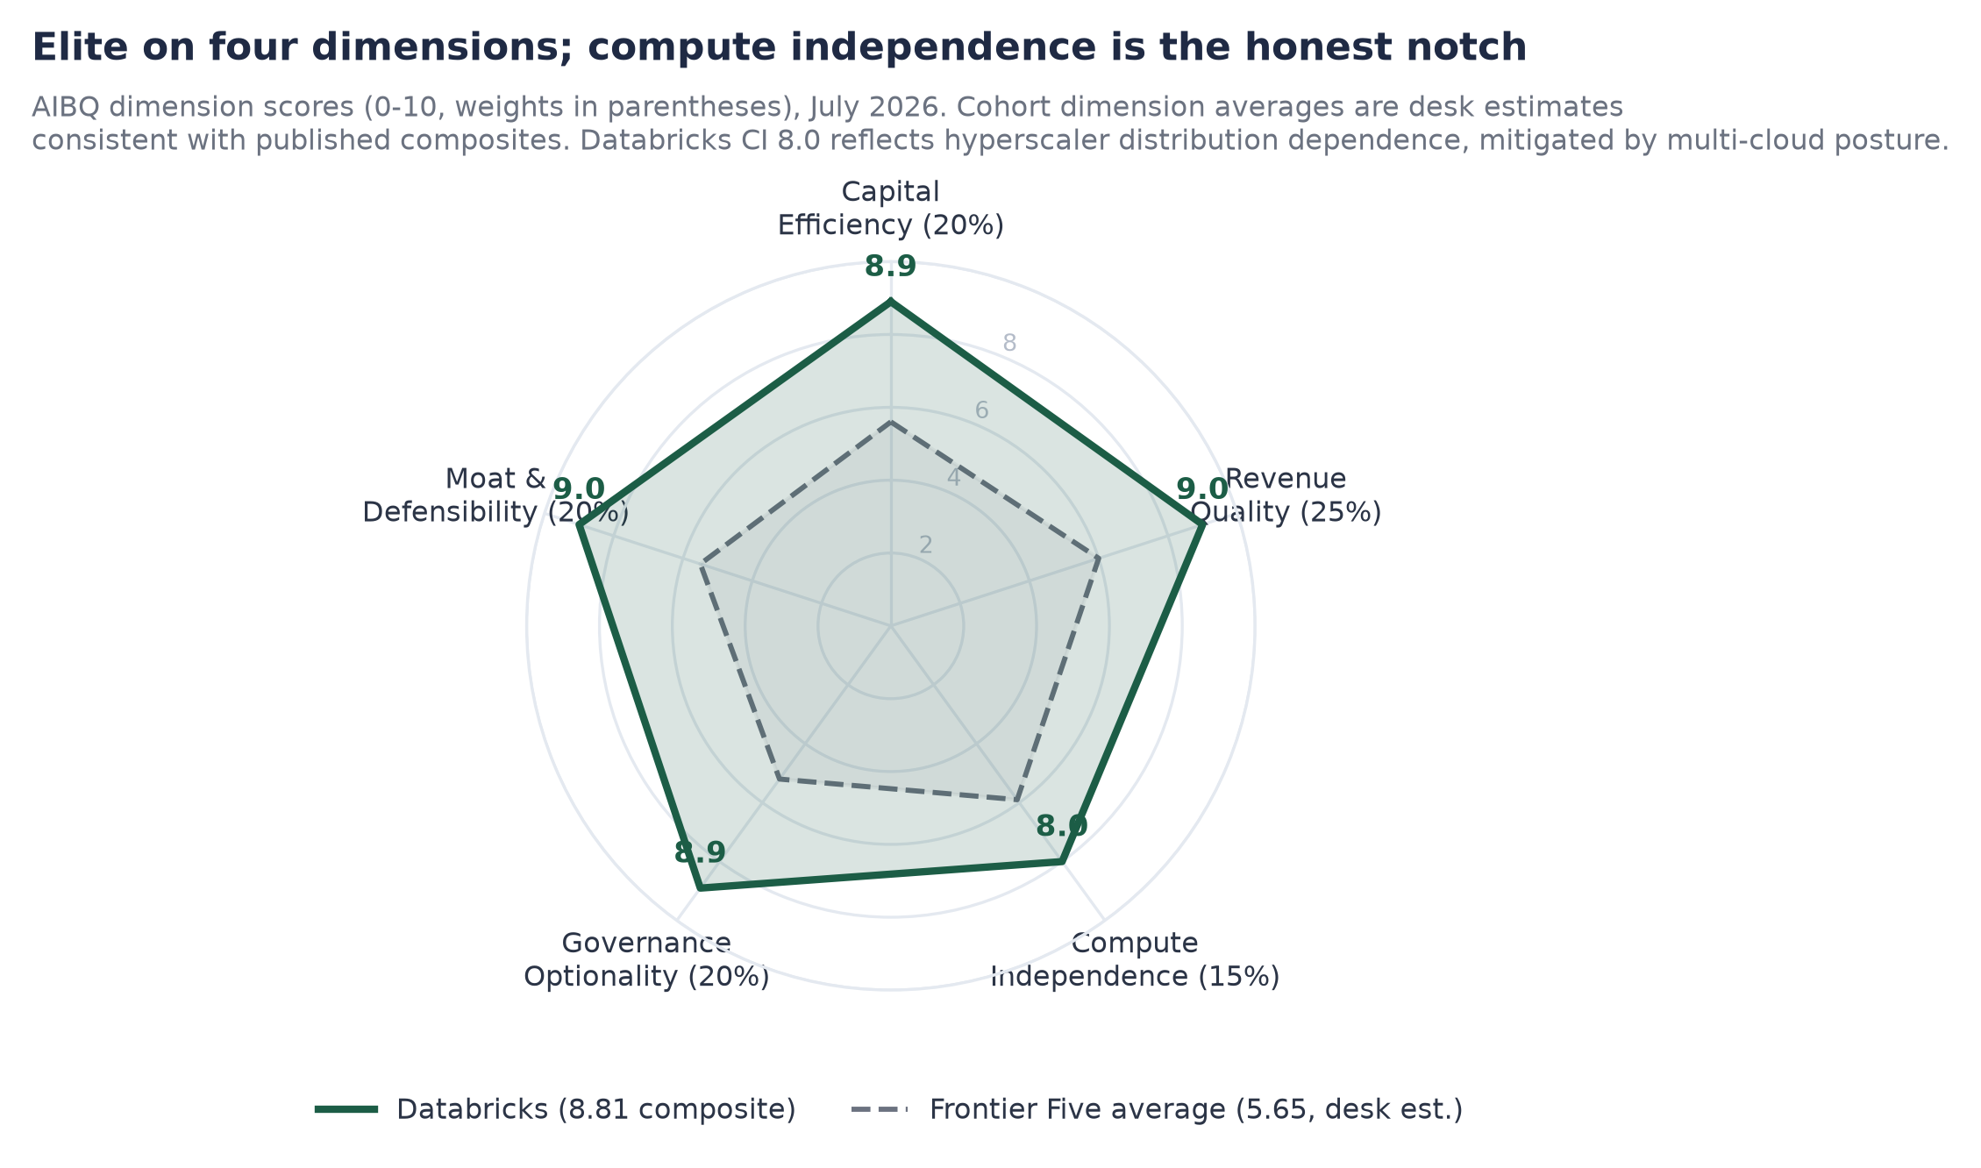
Figure 8. AIBQ dimension scores, Databricks against the Frontier Five average (cohort dimension averages are estimates consistent with published composites). The compute-independence notch is the honest weakness; everything else scores near the top of the scale.
Priced against that quality, the paradox from the Executive Summary sharpens: $15.2 billion per AIBQ point for the cohort's only Elite business, against $118 billion (Anthropic), $188 billion (OpenAI), and roughly $345 billion estimated (xAI). Part of the spread is rational, and the honest version of the counterargument deserves stating: the labs carry genuine option value on artificial general intelligence that no data platform participates in, and their marks re-rate upward mechanically because they must raise continuously while Databricks held its mark flat precisely because it needed nothing. But option value explains a premium, not an 8-to-23-fold premium per unit of quality over a business growing 80% with positive free cash flow. The residual is category confusion, and category confusion is exactly what a public listing prices out.

Second pass: comparables, growth-adjusted
The only clean public comparable is Snowflake: enterprise value roughly $89 billion (market capitalization ~$91 billion on July 7, 2026, less estimated net cash) against a raised FY2027 product-revenue guide of $5.84 billion, implying 31% growth (regulatory filing, May 27, 2026) at roughly 15.3x forward product revenue. Databricks at $134 billion on $6.9 billion is 19.4x, a higher sticker. But a buyer is buying growth, not a multiple, and per point of growth the ranking inverts: 0.24x per growth point for Databricks against 0.49x for Snowflake (Figure 9). Growth-adjusted, the private company trades at roughly half the price of its own best public comp, while outgrowing it nearly threefold and having already passed it in absolute revenue. Two fair objections and their answers: Snowflake's guide is audited and Databricks' prints are self-reported, which earns a haircut but not a halving, four dated disclosures in ten months constrain the exaggeration hypothesis; and growth-adjusted multiples flatter fast growers only while growth persists, which is why the durability case built across The Mortar and The Builders, not this arithmetic, is the report's load-bearing wall.
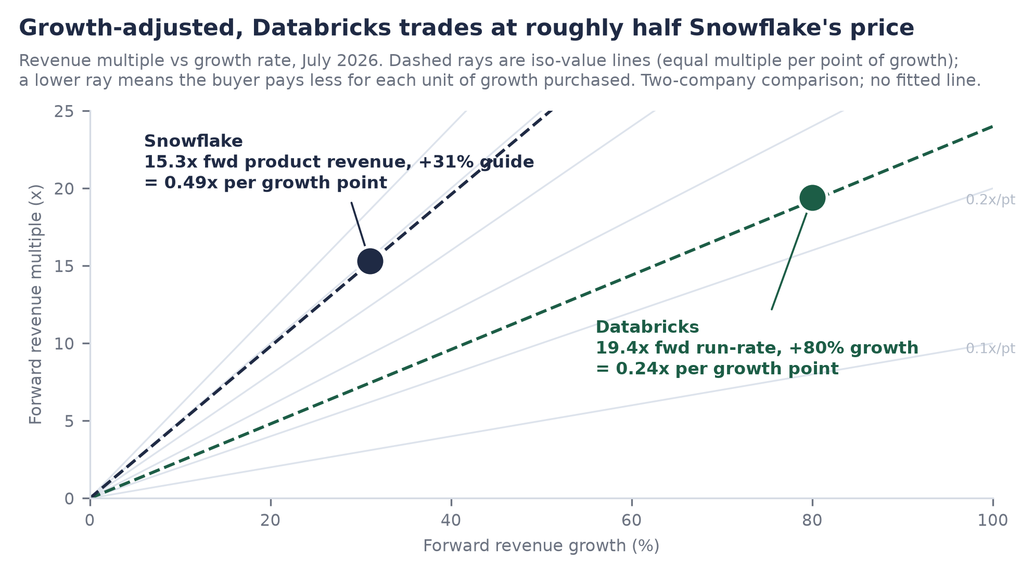
Figure 9. Growth-adjusted multiples: Databricks (19.4x forward run-rate, +80%) versus Snowflake (15.3x forward product revenue, +31% guide). Iso-value rays mark equal price per point of growth; no fitted line is shown or implied.

Third pass: scenarios, anchored and gated
Twelve-month scenario architecture (anchored on $134B; the unclosed round is not an input)
Scenario | Operating path (workbook switch) | Multiple | Value | What has to be true
Bear | Growth halves toward 40-50%; margin breaks the 70% gate (Worst path: 69.5% FY28E) | 11-12.5x on ~$10.4B | $115-130B | Agentic margin drag proves structural; consumption throttling returns; quality re-scored out of Elite
Base | ~$11.5B run-rate by mid-2027 (+65-70%); margin holds 72.5-74% | 14-16x | $155-190B | Graceful deceleration; gate holds; listing window opens 2027
Bull | ~$12.5B+; margin stabilizes; DBSQL and Lakebase compound; listing re-anchors the category | 16.5-19x | $205-240B+ | Acceleration proves durable; scarcity premium on the cleanest asset in the AI listing wave
Estimates, July 10, 2026. Reference lines: $134B completed mark (Feb 9, 2026); $165-175B reported range (unclosed, press reports of Jun 9, 2026). Base multiple is a deliberate de-rate from today's 19.4x toward public hypergrowth-platform pricing.
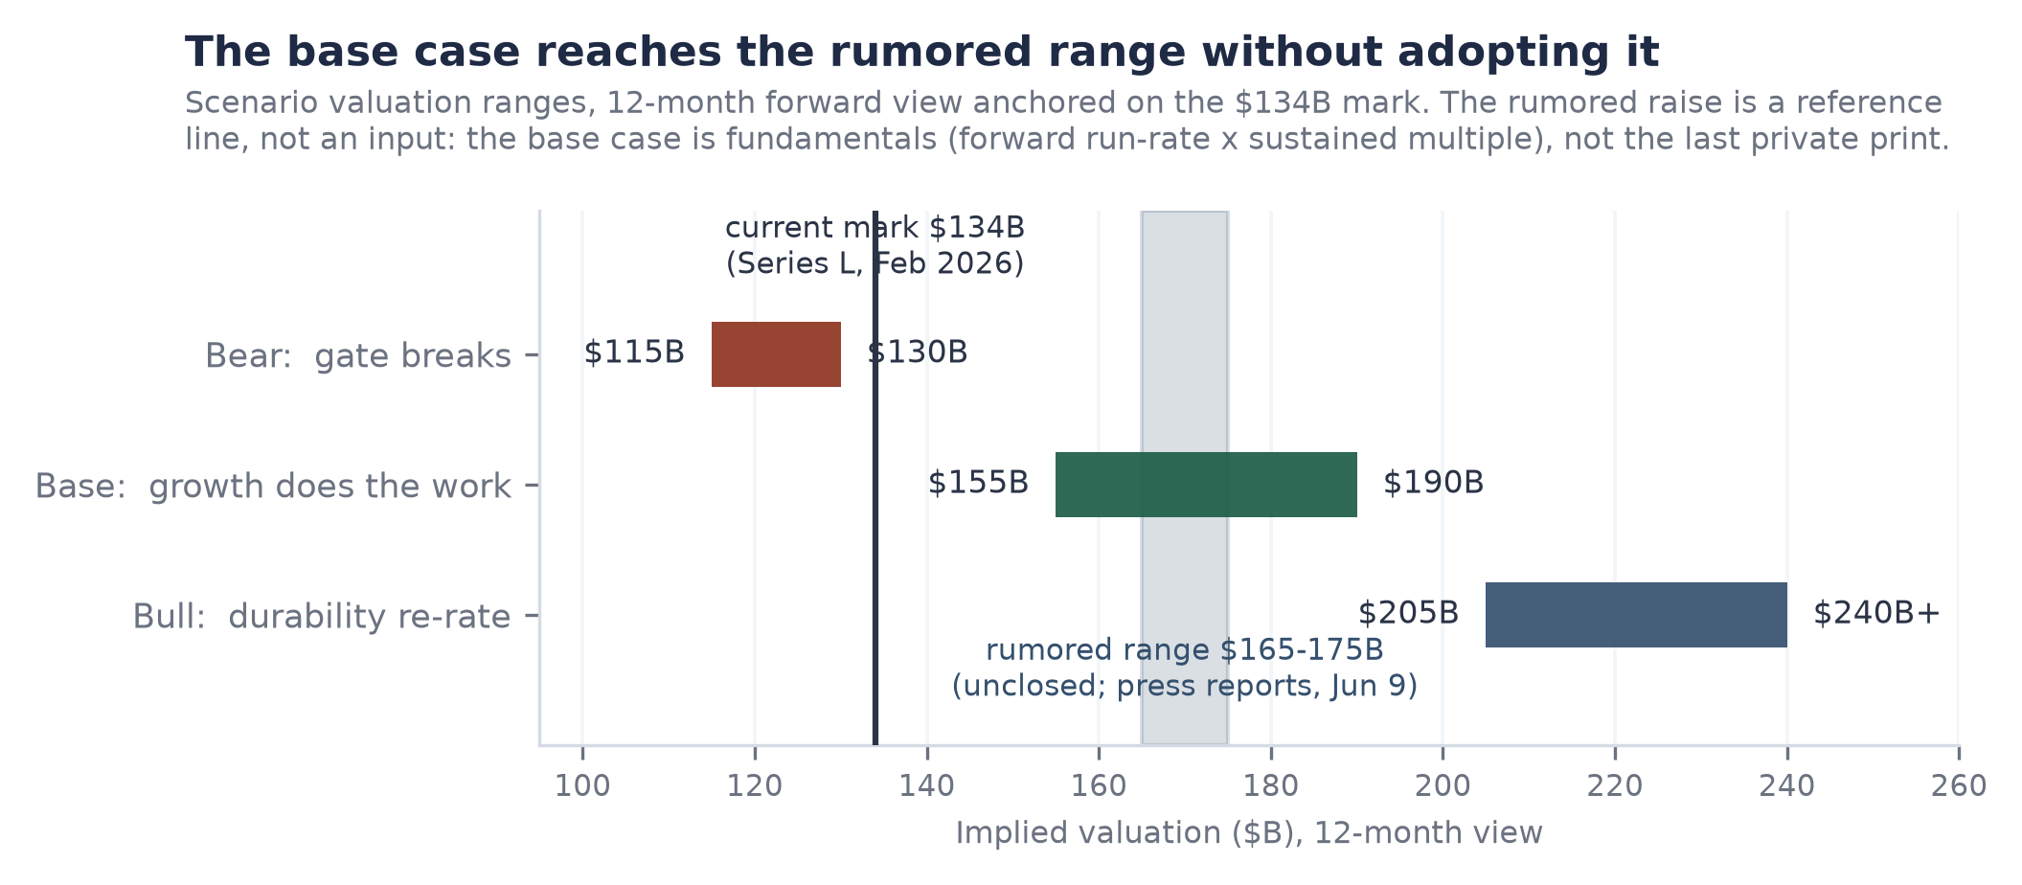
Figure 10. Scenario ranges on a twelve-month view. The base case reaches the reported range on fundamentals alone, which reframes the rumor as a fair forward mark rather than an inflated current one, and is precisely why it must not be adopted as a present anchor: doing so would double-count the year of growth that justifies it.
The sensitivity grid (Figure 11) exposes the machinery: value is forward run-rate times multiple, nothing else. Read it honestly in both directions. At $9.5 billion and 12x, the bear corner sits about 15% below the current mark; that is the real drawdown if margin breaks and growth halves together. At today's 19.4x on the base-case run-rate the grid reads roughly $223 billion, and the base case deliberately does not underwrite today's private multiple surviving a public order book. The margin of safety is not the multiple; it is quality bought at the cohort's lowest per-point price, with a mechanical gate that tells you when the thesis is wrong.
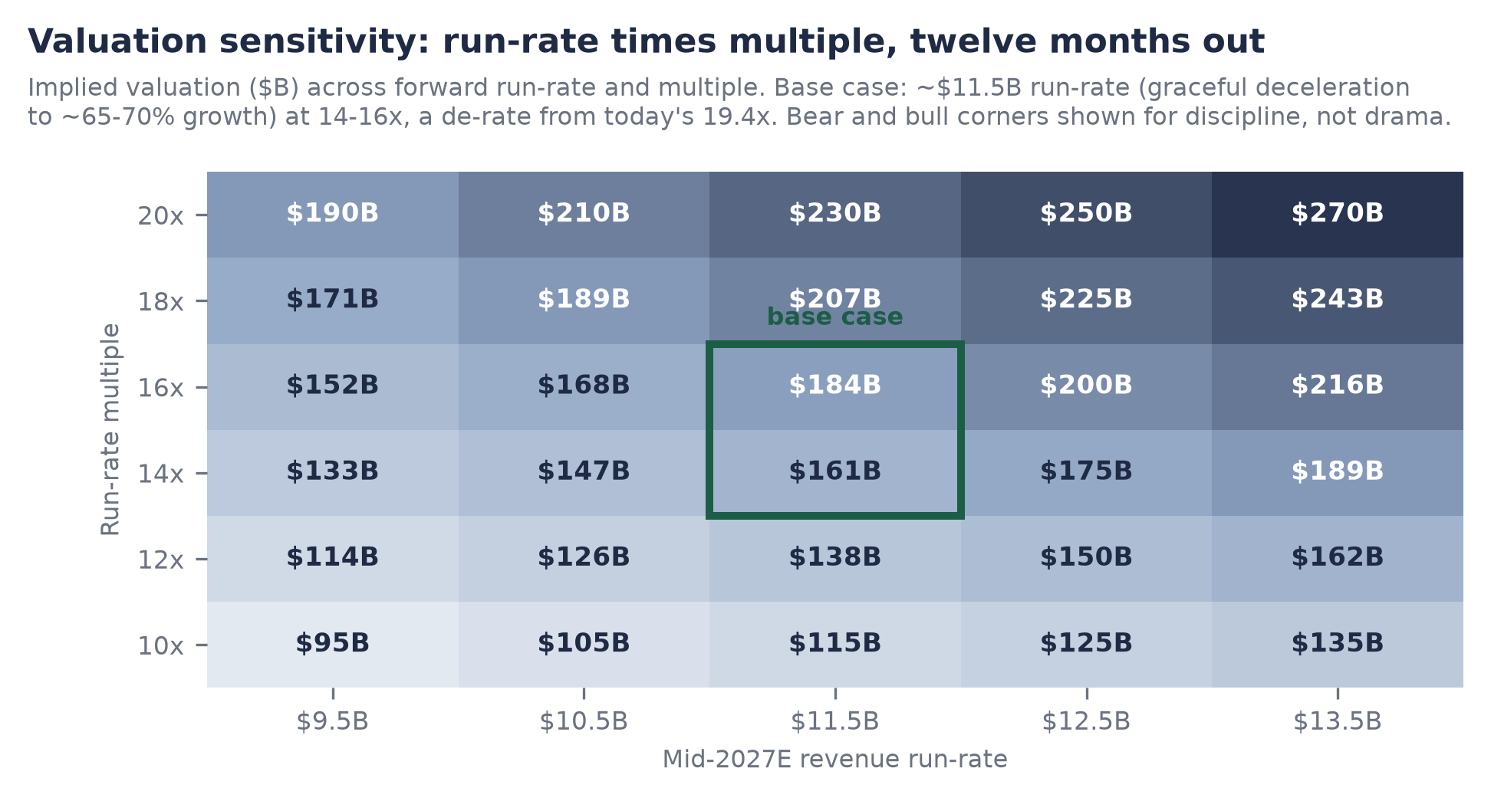
Figure 11. Implied valuation across mid-2027 run-rate and multiple; base intersection highlighted. The same grid is live in the companion workbook's Valuation sheet.

The Stress Test: What Would Change the Answer
One line changes the rating mechanically: a gross-margin print below 70%. Everything else on this list is sized and survivable. Risks ranked by expected impact on the thesis, not by headline likelihood.
Risk register
# | Risk | Mechanism | Watch item
1 | Margin gate break | GM 74% and guided lower on agent compute (company, Jun 16, 2026). Below 70%, the efficiency gate breaks, the Elite rating re-scores, and the AI line reads as compute resale. Each point is ~$69M of annualized gross profit | The ~Sep-Oct 2026 disclosure; cushion ~4 points
2 | Growth deceleration | The thesis leans on acceleration at scale. A fall through ~50% while margin compresses turns the story peaked; consumption billing cuts both ways when customers optimize, as 2022-23 showed industry-wide | Sequential run-rate prints; NRR refresh; $10M+ tier count
3 | Listing-window sequencing | OpenAI and Anthropic reportedly filed first and will price first; a failed mega-listing shuts the window into 2028. Mitigant: FCF makes waiting costless, and the SpaceX listing (up ~23% since June) says the wall is scalable | Lab IPO pricing and aftermarket, H1 2027
4 | Hyperscaler squeeze | Supplier, channel, competitor, and now investor at once; predation via egress pricing, marketplace terms, or bundling attacks margin and moat together. Mitigant: neutrality across three clouds is structurally uncopyable by any one of them | Marketplace term changes; first-party warehouse win rates in $10M+ accounts
5 | Leverage in a downside | ~$9.3B of debt is benign against 80% growth and positive FCF; against a broken gate and halved growth it turns disappointment into balance-sheet pressure | Any new debt; covenant detail in an eventual S-1
6 | Mark confusion | Unclosed rounds and thin secondary trading can anchor expectations the fundamentals then have to chase; this report's do-not-adopt rule exists for that reason | Close, repricing, or death of the $165-175B talks
7 | AI leadership depth | The AI line's founding leader departed September 2025 to a hardware venture (advisory role retained; company invested). Since then the AI line grew from ~$1.0B to $1.7B, which empirically retires most of the concern | Senior AI-organization attrition; agent-product cadence
Ranking and sizing are judgments; items 1 and 2 are thesis-level, the rest are path-level.
What would strengthen the case: a margin print at or above 73% alongside a run-rate at or above $8 billion this autumn would confirm the agentic cost curve is being managed while the acceleration holds, and would retire most of the bear scenario's probability. What would end it, beyond the gate: evidence that DBSQL growth is bought with discounts rather than won on workload migration, or a hyperscaler term change proving the neutrality moat is rentable after all.

The Verdict
Brick by brick, the building holds. The foundation (an architecture that turned a universal enterprise tax into a platform), the bricks (five product layers, two already at billion-dollar scale, two more running the same proven play), the mortar (a billing model that converts customers' own growth into revenue and their prepayments into balance-sheet strength), the builders (a 20,000-organization pyramid whose top seventy accounts fund the platform's next act), and a blueprint (buy the next layer early, sign the labs as tenants, borrow for compute, never raise on need) together describe the most complete business in private technology.
The appraisal says the market has not paid for that completeness. At $134 billion, Databricks costs $15.2 billion per point of measured quality against $118 to 345 billion for the labs it is filed next to; growth-adjusted, it costs half its own public comparable. The base case reaches $155 to 190 billion within twelve months on nothing more heroic than graceful deceleration and a de-rated multiple, and the reported next round, unclosed and unadopted here, happens to sit inside that corridor, which says sophisticated buyers are converging on the same arithmetic. The one number that breaks the case is published roughly quarterly and currently reads 74 against a floor of 70. Watch the autumn print, watch the $10 million tier count, and treat the eventual listing not as the risk but as the mechanism: the event that forces the market to underwrite the business brick by brick, the way this report just did.
This report is for informational purposes only and is not investment advice. Databricks securities are unlisted and illiquid; private-market figures are negotiated marks, not market prices; all non-disclosed financial figures herein are estimates and are labeled as such. Quality-valuation correlation statistics are embargoed; the per-point spread is their only expression here. Prepared July 10, 2026.

