Q3 2026 Anthropic is winning on value, not price
Frontier AI's token trap, where the priciest tokens do the cheapest work
Data filepath: R&E - Thematic Research\Frontier AI\Price Wars Jul2026
Chart as-of date: July 10, 2026
Chart geography: US
Research type: Emerging Tech
Access level: Public (Full report on N&A + platform)
Chart count: 6
Table count: 2
Credits
Harrison Rolfes, Senior Research Analyst
Published on July 17, 2026
Contents
Key takeaways
1. What you are buying: the technology behind a token price
2. The unit of account: value per token
3. Margin mechanics: who can subsidize, and is this a war?
4. The barbell and the squeezed middle
5. Market implications
6. Consumer implications
7. The surface decides
8. The verdict: best model, best value
What would change the call
References

Landing page
CHART: Mythos 5, the priciest sticker on the sheet at $50, runs near-cheapest, while the cheapest sticker, Muse Spark, runs dearest. Cost per completed enterprise task at a fixed quality bar: the near-top sticker finishes the work for less than half what the cheapest model on the sheet costs to run.
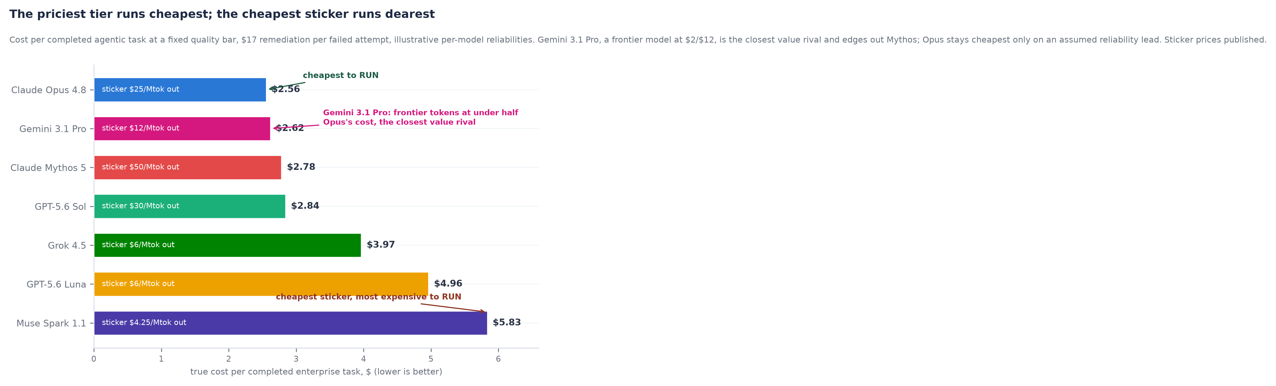
The market is pricing tokens. It should be pricing work.
Frontier token prices collapsed in July, and the coverage has the story backwards. Buyers do not purchase tokens; they purchase completed tasks, and once you price the work rather than the tokens, the ranking inverts. The near-priciest model on the sheet becomes the cheapest to run, and the models winning the price-cut headlines become the most expensive way to get an agentic job done. The best model for the money is Claude Opus 4.8, but Google's Gemini 3.1 Pro, a frontier model at a fraction of the price, closes the gap to a whisker. This note shows why, and it argues that the price war is a trap that hands the buyer the appearance of savings and the real cost of failure.
Report picks
AI Compute and Power: The Buildout Is a Scarcity Trade (forthcoming)
Enterprise Agents: Who Owns the Seat (forthcoming)
Method: figures are drawn from published price lists and PitchBook company data. Vendor performance claims are treated skeptically, and where we introduce an estimate or an assumption we say so in the sentence.

Key takeaways
- The best model for the money is Claude Opus 4.8, priced near the top of the sheet. At a fixed quality bar it finishes a representative enterprise agentic task for about $2.56, while the cheapest model finishes the same task for about $5.83, more than twice the completed work per dollar.
- The price war is a trap. A cheaper model that fails more often costs more per completed task once you count the human time each failure consumes, so every sticker cut can raise the true cost of the work. The buyers celebrating the cuts pay for the failures.
- This is a segmentation event dressed as a price war. Meta prices Muse Spark near zero to commoditize a market it need not profit from, and only Meta can. OpenAI and Anthropic defend premium tiers; xAI is a forced participant.
- Grok is the loudest capability story and the weakest position. xAI's mid-July Grok 4.5 refresh, which it says adds native agentic tool use and a real-time X and Starlink feed no rival can match, makes Grok the best value on paper. It is still the worst place to build, on a segment losing more than six billion a year with no enterprise surface to sell into.
- The war is subsidized, not won. Floor prices sit below serving cost, and the roughly three-and-a-half-trillion-dollar private-credit market funds the gap, deferring a solvency question straight into Anthropic's October S-1.

1. What you are buying: the technology behind a token price
Every claim here reduces to one unit: a model reads and writes in tokens, each roughly three to four characters, and a provider charges separately for the input it reads and the output it writes, per million.
Output is priced far above input, and the gap is physics rather than a margin choice. Opus charges five times more to write than to read, Sol and Luna six. Reading a prompt happens in one parallel pass, the prefill; writing happens one token at a time, and each token demands a full forward pass that reads the entire model and the growing conversation memory out of high-bandwidth memory. Generation is therefore sequential and bound by memory bandwidth, expensive and serial where reading is cheap. The binding constraint on output cost is the same scarce high-bandwidth memory the buildout is fighting over, so the price sheet and the compute thesis are one story.
Two consequences follow. Utilization sets the real cost: providers batch requests so one expensive read of the weights serves many, and a cut not paid for by better hardware or utilization comes out of margin, so a lower number is either better economics or a subsidy, indistinguishable on a sheet. A long context is not free either: conversation memory grows with it in that same scarce memory, so Muse Spark's million-token window is costly to use at scale.
The step that reframes the competition is that enterprise work is agentic. An agent plans, calls a tool, reads the result, replans, and repeats dozens of times, each pass re-reading a growing context, and consumption multiplies every time it fails and retries. The per-token price therefore says almost nothing about what a task costs, because the loop and its failure rate dominate the sticker.
CHART: The pricing ladder, from the free tier to the premium anchor. Published prices span more than tenfold, from Muse Spark at $4.25 to Mythos 5 at $50, and the free tier makes the full spread unbounded: two crowded ends, a hollow middle.
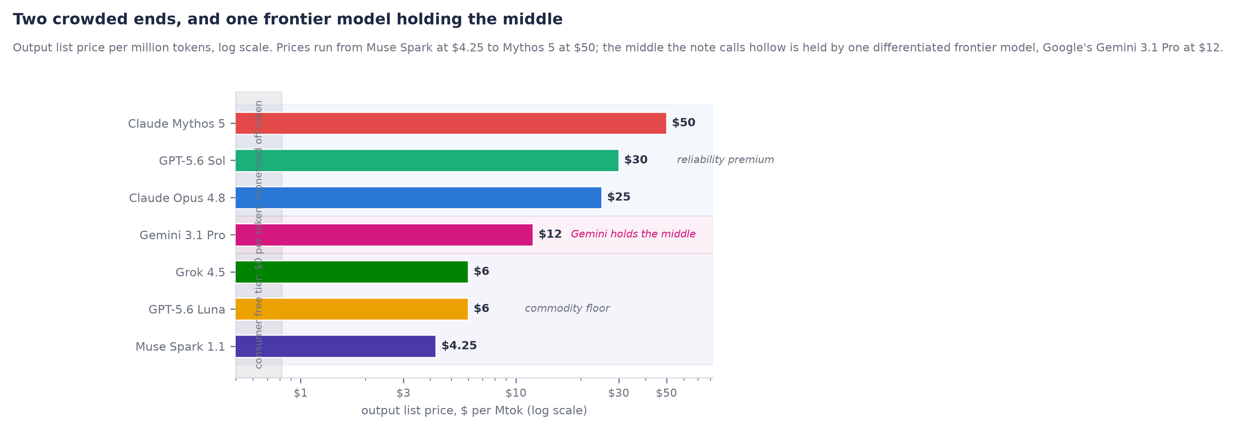

2. The unit of account: value per token
Buyers do not want cheap tokens; they want the most completed work per dollar. The correct unit is the cost per completed task. Cost per completed task = (tokens in x price in + tokens out x price out) x expected attempts to succeed at a fixed quality bar. A model that succeeds with probability p needs on average one divided by p attempts, so one at a quarter of the price that needs three tries is not cheaper. That estimate treats retries as independent; in production, failures are correlated, since a model that misreads a task tends to miss it again, so the geometric figure flatters the cheap tier and the premium's true edge is wider than the table below. Take a representative agentic task of sixty thousand input and twelve thousand output tokens per attempt.
TABLE: Cost per completed task at list prices, sixty thousand in and twelve thousand out per attempt. On raw token arithmetic the cheap tier wins almost mechanically; value per token is decided by reliability, not by the sticker.
Model | $/Mtok in | $/Mtok out | Cost per attempt | Per task, p = 90% | Per task, p = 75% | Per task, p = 65%
Claude Opus 4.8 | $5.00 | $25.00 | $0.60 | $0.67 | $0.80 | $0.92
Gemini 3.1 Pro | $2.00 | $12.00 | $0.26 | $0.29 | $0.35 | $0.41
GPT-5.6 Sol | $5.00 | $30.00 | $0.66 | $0.73 | $0.88 | $1.02
GPT-5.6 Luna | $1.00 | $6.00 | $0.13 | $0.15 | $0.18 | $0.20
Grok 4.5 | $2.00 | $6.00 | $0.19 | $0.21 | $0.26 | $0.30
Muse Spark 1.1 | $1.25 | $4.25 | $0.13 | $0.14 | $0.17 | $0.19
Claude Mythos 5 | $10.00 | $50.00 | $1.20 | $1.33 | $1.60 | $1.85

Prices are published list prices, including Claude Mythos 5 at $10/$50 and Google's frontier Gemini 3.1 Pro at $2/$12. Per-task figures are our arithmetic.
On tokens alone the cheap tier wins almost mechanically, because Opus at sixty cents an attempt only beats Muse Spark at about thirteen cents if it succeeds nearly five times as often, and no frontier gap is that wide. That is exactly where the token-only view fails, because a failed agentic attempt is not free: it burns reviewer time, breaks the automation downstream, and erodes trust in the seat. The cost of a failure is not one number: it is near zero for failure-tolerant work like drafting and internal search, and hundreds of dollars for a wrong answer that reaches a customer or a regulator, and that spread is not noise, it is the reason the market segments. Assign a conservative seventeen dollars to each failed attempt, about ten minutes of a fully loaded operator, and the ranking inverts. Opus succeeding nine times in ten finishes the task for about $2.56; Muse Spark succeeding three times in four finishes it for about $5.83, more than twice as much despite tokens at a quarter of the price. The cheapest model on the sheet is the most expensive to run, and the near-priciest is the cheapest. That inversion is the thesis of this note. It is also why a lower sticker often produces a larger bill: a cheaper token invites longer contexts and more agent loops, and the failures it hides are billed to the buyer in labor, not tokens. The same arithmetic reaches the top of the sheet: Mythos 5, at twice Opus's price, still runs near-cheapest, the priciest sticker on the sheet finishing among the cheapest to run. It also produces the note's real challenger. Gemini 3.1 Pro is a frontier model at two and twelve dollars, under half Opus's per-attempt cost, and it finishes the reference task for about $2.62 against Opus's $2.56. Opus keeps the crown by a hair, and only because we assume Anthropic is the more reliable; if Google matches it, Gemini is the cheapest way to finish real work.
The conclusion does not rest on the seventeen-dollar figure; solve for the failure cost at which the premium breaks even: at a fifteen-point reliability edge it pays once a failure costs more than about $2.24, at ten points more than $3.67, at five points more than $7.93. Only if failure is free does the cheap tier win, and in production it never is. The premium is defensible whenever mistakes are expensive, which is the reliability-gated work where most enterprise value sits, so value per token belongs to whoever pairs the highest reliability with a defensible price, not the lowest number.
CHART: Fully loaded cost per completed task versus per-attempt success rate. The curves cross near eighty-five to ninety percent, below which the sticker dominates and above which reliability does.
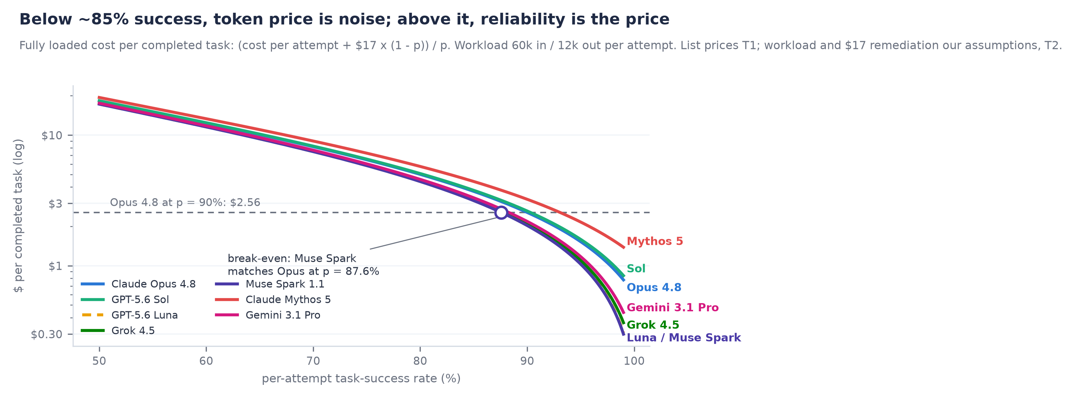
CHART: Break-even failure cost versus reliability edge. Above the curve the premium is cheaper, and the curve sits at a few dollars across the realistic range.
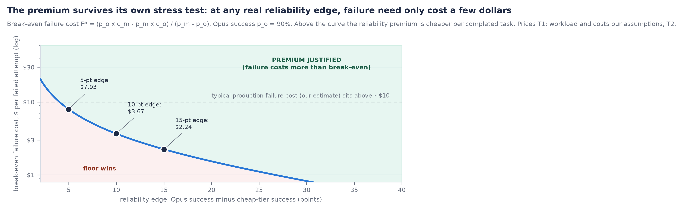
If independent, non-vendor evaluations that measure cost per completed task rather than price per token show the cheap tier matching premium success within two points at scale by September 30, 2026, the thesis of this note breaks.

3. Margin mechanics: who can subsidize, and is this a war?
A four-to-five-times output cut destroys model-layer margin. We estimate a frontier model serves at roughly six to eight dollars per million output tokens. At twenty-five dollars that is about a seventy percent gross margin; at the four-to-six-dollar floor it is negative, roughly minus seventeen percent at six and minus sixty-five at four and a quarter. A four-times cut in one generation outruns the two-to-three-times serving-cost decline each generation delivers, so the gap is subsidy, and who can pay it decides the war.
Meta is a structural price warrior, because it does not need model margin: pricing Muse Spark near or below cost drives the complement toward zero while Meta monetizes the surface, the ad load, and its own silicon, durable because an ad engine funds it, not external capital. Commoditizing a market you need not profit from is not winning it.
xAI is the capability story that does not fix the economics. The mid-July Grok 4.5 refresh, which the company says adds native computer use, multimodal input, and a real-time feed from X and Starlink that no rival can replicate, is a genuine jump that makes Grok the value leader on paper. It changes nothing: the AI segment turns about $2B of revenue against a FY25 operating loss we estimate north of six billion, and xAI is now a SpaceX operating subsidiary following the $250B February acquisition, so the losses ride the SpaceX and Starlink cross-flow, a balance-sheet decision, not a business model, and a better cheap model does not close a six-billion-dollar loss.
OpenAI is running segmentation, not a race to zero, and the tell is that Sol lists above Opus on output. Luna harvests price-sensitive volume while Sol defends the premium, and with roughly twenty-five billion in net revenue, about nine hundred million weekly users, and Codex above one and a half million, OpenAI needs the premium because its rich multiple and thin capital efficiency cannot ride six-dollar output.
Anthropic defends a two-tier premium and declines to chase. Opus holds at five and twenty-five, and Claude Mythos 5 sits above it as a limited-availability flagship priced at ten and fifty, exactly twice Opus on output. On PitchBook's marks Anthropic carries a $965B valuation on forty-seven billion of gross run-rate revenue, the best capital efficiency among the labs, and a first quarterly operating profit near $559M, though that figure excludes stock compensation and rides a SpaceX ramp discount, flattering the steady state. The strategy: hold list price, extend the premium upward, and prove enterprises keep buying it.
Google is the player this war should fear most, because it can fight on both fronts at once. Gemini 3.1 Pro is a frontier model at two and twelve dollars, funded like Meta's Muse from an advertising engine, distributed like ChatGPT through Search, Workspace, Android, and Cloud, and served on Google's own TPUs, which give it the best cost structure here with no third-party silicon tax. The tell is that Anthropic's own $34.5B June chip-bond raise is earmarked for Alphabet-developed TPUs, so even the premium defender buys its silicon from Google. Meta commoditizes to sell ads but has no frontier model; Google can commoditize and still field one, a stronger hand than any pure premium defender or price warrior alone.
CHART: Implied model-layer gross margin versus output list price. A margin barbell: every price below roughly eight dollars is gross-margin negative and the floor is sold below cost, while Mythos 5 at fifty dollars earns about eighty-six percent.
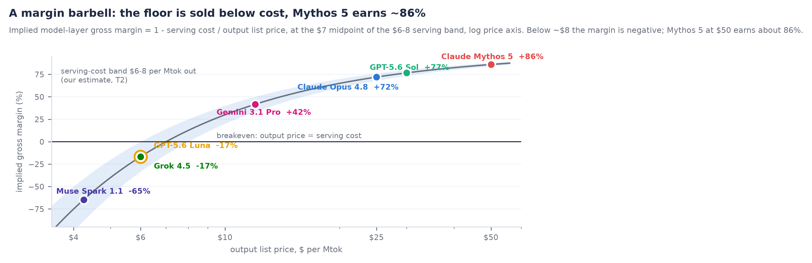
This is a segmentation play at the top and a real price war only at the floor. Two of the four defend premium tiers, Anthropic pushes the premium upward with Mythos, Meta commoditizes a complement, and xAI follows price without the economics. On our estimate, a slight majority of enterprise agentic dollars flow to reliability-gated work where the premium is defensible, and the rest to failure-tolerant work that carries most of the volume. The two ends split volume and value in opposite directions, the value end Anthropic's.
If Anthropic or OpenAI cuts flagship output pricing by fifteen percent or more before August 31, 2026, the segmentation read fails and this becomes a war note. We think Anthropic holds, and put the probability near seventy percent.

4. The barbell and the squeezed middle
Repricing events rarely kill the top or bottom of a market; they hollow out the middle. The vulnerable layer is undifferentiated mid-tier access, neither the cheapest useful inference nor the most reliable premium surface. It reprices to commodity within quarters, because Luna and Muse Spark now define good enough at the floor while Opus and Mythos set a reliability bar the middle cannot clear. Capital and revenue drain to the ends. One name complicates this: Gemini 3.1 Pro sits in the middle the note calls hollow, but it is a differentiated frontier model, not the undifferentiated mid-tier that dies. A frontier model at a mid price is not the squeezed middle; it is the strongest value position on the sheet.
The losers have names. Model resellers and gateways earned the spread between list price and enterprise inertia, and that spread has gone negative now that the floor undercuts their markup. Legacy vertical software sold a workflow moat by the seat, and that umbrella collapses the moment an agent that finishes the same task for a few dollars runs the workflow itself. The commodity model tier and the seat-priced software middle are one trade: capacity charging more than it costs to replace.
The test: if a well-known reseller or gateway reprices to a thin usage-based margin, shuts down, or sells below its last private mark by December 31, 2026, the squeeze is confirmed.

5. Market implications
Cheaper inference is accretive to buyers and the application layer and dilutive to the model layer, because every dollar cut from output pricing lands with whoever owns the workflow, not the lab that cut it. A valuation dislocation follows: Anthropic trades near 20.5 times revenue, $965B on $47B of gross run-rate, against OpenAI's 34, $852B on $25B, so the market pays more for the weaker position; if the thesis survives the S-1 that gap is the trade.
The buildout is insulated. High-bandwidth memory, wafer fabrication equipment, data-center power, cooling, and permitted baseload are priced on capacity scarcity, not model margin, the same memory-bandwidth wall that sets output pricing. A model-layer price war does not cancel compute demand; at the volumes the cheap tier chases, it raises it. The complex faces a financing shock, not a pricing one.
CHART: Model-layer economics versus buildout economics. The layer cutting prices is the one losing money, and the layer selling scarcity is not in the war.
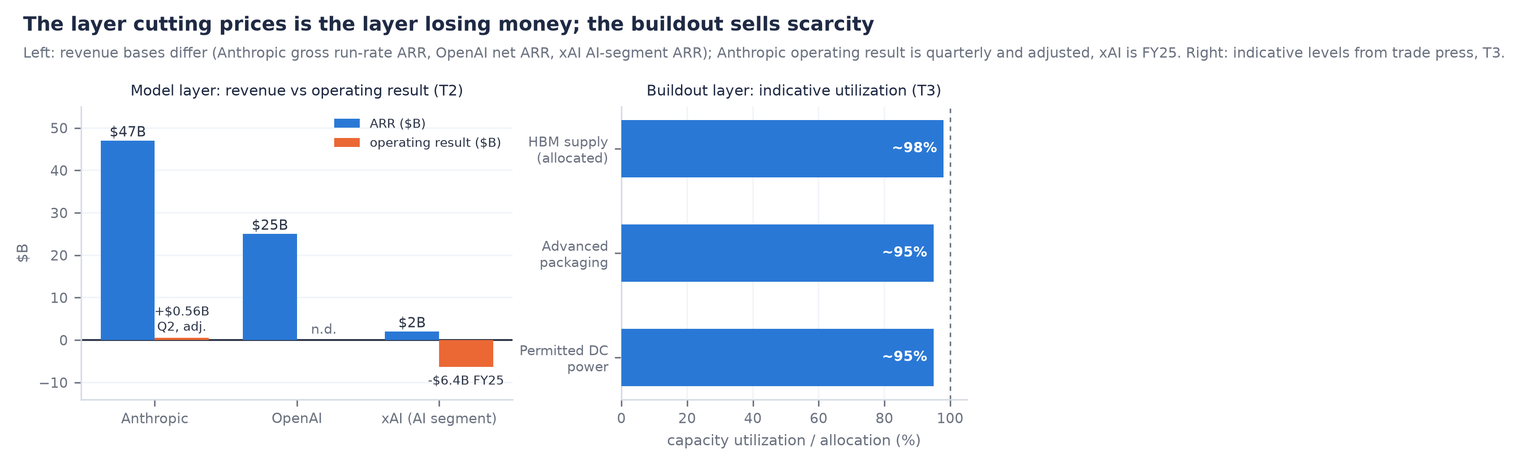
Financing makes the war possible: the roughly three-and-a-half-trillion-dollar private-credit market is the marginal source of AI capital, and labs price below serving cost because debt funds the gap. Anthropic's $34.5B June chip-bond stack, earmarked for Alphabet-developed TPUs, is the template; xAI's cross-subsidy, now folded inside SpaceX, is the same in a corporate wrapper. A war paid for by credit ends when the credit reprices, not when a margin breaks, so the covenant is the market's appetite for negative-margin token sales, tying the price war to the coming IPO.
The IPO is the pressure test. OpenAI's own September filing front-runs it, but Anthropic's October S-1 is the one that forces open what private markets have never seen: model-layer gross margin, mix, and any enterprise attach. Filing at a $965B mark while a rival prices comparable-claim inference at a quarter of the rate is the hardest setup and cleanest validation at once: hold price and attach through the window and the best-value thesis is proven under live fire. The gross-margin page, not any benchmark, is the filing's most repriced disclosure.
If an AI-exposed private-credit vehicle discloses markdowns or tighter terms on chip-backed paper by January 31, 2027, the financing-fragility read is confirmed; a second large chip-bond stack pricing at or inside June's terms would refute it.

6. Consumer implications
Consumers almost never pay per token: a flat subscription near twenty dollars a month, attention and data on an ad-funded free tier (Meta's model), or nothing visible when AI is folded into a subscription they hold. Cheaper inference makes the free tier good enough, so capability inflates there while willingness to pay compresses above it, the mirror of the enterprise story: enterprises pay for reliability they can measure, consumers will not for quality they cannot perceive. Distribution decides this one, because a user will not switch assistants over a difference they cannot feel.
If a consumer provider materially raises free-tier capability or discloses paid conversion or ARPU under pressure by November 30, 2026, the pass-through is visible; we expect free-tier expansion first.

7. The surface decides
The war looks like a pricing table but is settled on the desktop and the phone. OpenAI's ChatGPT Work and Codex superapp and Anthropic's Claude Cowork compete for the enterprise-agent seat, the permissioned surface through which agents touch company systems, and whoever owns it owns task routing. That is where the best-value argument becomes a moat: the surface owner routes silently, sending the high-stakes step to Opus or Mythos and the trivial one to the floor, capturing both ends of the barbell. Google is a third front, folding Gemini into Workspace and Search, but the enterprise-agent seat, the permissioned surface where high-stakes work runs, is still contested between OpenAI and Anthropic. This is why Grok's refresh does not win: a better cheap model with a unique data feed is still only a model, and xAI owns no seat to route it through and no cash to outlast the incumbents. Cheap tokens win benchmarks and spot volume, which churn on the next price sheet; seat reliability, admin tooling, and audit trails cannot be re-procured quarterly. The seat, not the sticker, is the moat.
If the first disclosed enterprise-agent seat or attach metric arrives by September 30, 2026, the surface thesis becomes measurable. Trivial seat counts at both OpenAI and Anthropic would mean the surface war is earlier than we think.

8. The verdict: best model, best value
Judge the labs on the axes that compound, and the answer is not close.
TABLE: Competitive scorecard on the four axes that decide the war. Anthropic leads on value pricing, model, and economics; OpenAI only on distribution; Meta owns the floor; xAI has capability without the economics to keep it.
Lab | Pricing for value | Model | Moat | Unit economics | Verdict
Anthropic | Best value: cheapest per completed task | Opus 4.8, best value; Mythos 5, best model | Reliability, the Cowork seat, a defended premium | Best capital efficiency; first quarterly profit | Winner
OpenAI | Split: Sol premium, Luna at the floor | Strong and broad | Distribution: roughly 900M weekly users | Rich multiple on thin efficiency | Closest rival
Google | Frontier value: Gemini 3.1 Pro at $2/$12 | Strong frontier: Gemini Pro and Flash | Search, Workspace, Cloud, and its own TPUs | Best cost structure; ad and cloud funded | Dark horse
Meta | Cheapest sticker, dearest per completed task | Reported strong agent | Ad engine and owned surfaces | No model margin needed | Owns the floor
xAI | Value leader on paper only | Grok 4.5 refresh: agentic, real-time data | Real-time X and Starlink feed; no seat | Loss north of six billion a year | Broken economics

The scorecard is our assessment; the Meta and xAI model claims are the vendors' own.
Anthropic owns both ends of the value frontier, and the distinction matters. The best model outright is Claude Mythos 5, the limited-availability flagship above Opus on capability and, at ten and fifty, exactly twice Opus. At the top of the risk curve, where a mistake costs the most, its reliability edge earns that premium, and once the edge over Opus reaches about three points Mythos is also the cheapest way to finish the work. The best value on the market is Claude Opus 4.8, which finishes a representative task for about $2.56 despite a near-top sticker, though Google's Gemini 3.1 Pro is now within a whisker. Either way, the company is Anthropic.
Is Opus really best, or an artifact of our reliability assumption? Against Sol the answer is airtight: Opus wins at every equal level of reliability, because Sol prices output higher, so Sol takes the crown only by being materially more reliable, which nothing suggests. Against Google it is not airtight, and this is the note's real soft joint. Gemini 3.1 Pro's tokens cost under half Opus's, so at equal reliability Gemini is cheaper, and Opus holds the value crown only if Anthropic's reliability edge over Google clears about two points, a thinner and more contestable claim than the rest, because Google's frontier model is genuinely frontier. Against the failure-tolerant cheap tier Opus still wins on a small edge. The controversial part is not the pick but what it says about the market: the companies winning the price-cut headlines sell the worst value, and the value crown is now a photo finish between Anthropic and Google.

What would change the call
The verdict breaks if OpenAI turns its distribution lead into the enterprise seat before Anthropic locks it, or if Anthropic cuts flagship pricing and concedes the value argument it must sell. The segmentation read breaks if agents self-correct cheaply, collapsing the cost of failure and the premium with it, or if Meta or a capability-rich xAI builds a credible enterprise surface. The value call breaks if Google's reliability matches Anthropic's, which would hand Gemini 3.1 Pro the value crown outright and its TPU cost structure the durability to keep it. We watch six dated markers: Anthropic's flagship pricing by August 31, the first enterprise-agent seat or attach metric by September 30, the first consumer free-tier or ARPU signal by November 30, chip-backed private-credit terms through 2027, whether Anthropic's $34.5B chip-bond converts into delivered Alphabet TPU capacity by December 31, 2026, which would confirm that Google's own silicon underwrites even its closest rival and hardens the cost-structure edge behind the value call, and above all Anthropic's October S-1, whose gross-margin page converts most of this note from argument into fact.

References
- Published API price lists, accessed July 2026: Anthropic (platform.claude.com) for Claude Opus 4.8 at $5/$25 and Claude Mythos 5 at $10/$50; OpenAI (developers.openai.com) for GPT-5.6 Sol at $5/$30 and Luna at $1/$6; xAI (docs.x.ai) for Grok 4.5 at $2/$6 up to 200k context; and Google (ai.google.dev) for Gemini 3.1 Pro at $2/$12 up to 200k context. Meta Muse Spark 1.1 at $1.25/$4.25 is from Meta's list. The OpenAI, xAI, and Meta figures already in the note were verified unchanged.
- Meta's July 2026 announcement of Muse Spark 1.1, including the agent-reasoning and million-token-context claims, which are the vendor's own.
- xAI's mid-July Grok 4.5 capability refresh, including native computer use, multimodal input, a real-time X and Starlink data path, and a frontier-parity reasoning claim, which are the vendor's own.
- PitchBook company data: Anthropic at a $965B mark on $47B of gross run-rate revenue with a first quarterly operating profit near $559M; OpenAI at $852B on about $25B of net ARR with about 900M weekly users; xAI, now a SpaceX operating subsidiary after its $250B February 2026 acquisition, turning about $2B of revenue against a FY25 operating loss we estimate above $6B.
- Reporting on Anthropic's $34.5B June 2026 chip-bond financing, earmarked for Alphabet-developed (Google) TPUs, and on the roughly $3.5T market in AI-linked private credit.
- Background on transformer inference economics, consistent with public research on inference pricing and token-cost deflation: prefill versus decode, memory-bandwidth-bound generation, growing conversation memory, batching, an output-to-input price ratio of roughly three to eight times across real models, and roughly order-of-magnitude annual token-price decline. Used as context, and no scenario figure rests on it.
- Company product disclosures for OpenAI ChatGPT Work and Codex and for Anthropic Claude Cowork. Consumer subscription price points are our reading of the prevailing market.

