Q3 2026 Databricks: Reading the $188 Billion Term Sheet
A signed bid 40% above the last mark, and the accelerating engine underneath it
Data filepath: R&E - Thematic Research\Emerging Tech\Databricks\Q3_2026_Vertical_Note
Chart as-of date: August 10, 2026
Chart geography: US
Research type (Core/Quant, Emerging Tech, Industry): Emerging Tech
Access level: Client only (Platform only, no preview on N&A)

Chart count: 3
Table count: 0

Credits
HARRISON ROLFES Senior Research Director
Published on August 11, 2026

Contents
Key takeaways
The term sheet: signed at $188 billion, unclosed
The engine under the bid: four accelerating prints
Pricing the quality: both marks stay on the cohort floor
References

Landing page
CHART: The buyer still pays the least per unit of quality, at either mark
Valuation per AIBQ point across the frontier cohort, with Databricks shown at both its completed $134 billion mark and the announced $188 billion term sheet.
Databricks signs at $188 billion, and the quality math survives the re-rate
Databricks' rumored round resolved upward into a signed, Coatue-led term sheet at $188 billion, 40% above February's completed mark, with the close expected later this summer. The operating ladder beneath the bid is still accelerating at $7 billion scale, and even at the higher price the company remains the cohort's cheapest asset per unit of business quality.

Report picks
Databricks: Brick by Brick (July 2026 initiation)
Databricks Company Update: The Appraisal Moves (August 2026)

Key takeaways
- Databricks signed a term sheet on July 17 for a strategic round at a $188 billion post-money valuation, led by existing investor Coatue; press reports place the size near $3 billion, and the company expects the close later this summer (company announcement, July 17, 2026).
- The bid lands 40% above the $134 billion completed February mark and $13 billion above the top of the previously reported $165 to 175 billion range; funds are not in hand, so the completed mark still anchors valuation work until the close (PitchBook financing note, August 7, 2026).
- The operating record did not move with the announcement: the last print remains $6.9 billion of annualized revenue growing +80% YoY, the fourth consecutive accelerating disclosure, with gross margin at 74% and guided lower (company disclosure, June 16, 2026).
- At $188 billion the run-rate multiple is 27.2x versus 19.4x at the completed mark, and the quality-adjusted price stays on the cohort floor at either level; the round close and the September to October disclosure window decide which number holds (derived).

The term sheet: signed at $188 billion, unclosed
Databricks announced on July 17 that it has signed a term sheet for a strategic funding round at a $188 billion post-money valuation, led by existing investor Coatue with participation from new and existing backers (company announcement, July 17, 2026). The company did not disclose the size; press reports place it near $3 billion. The money is not in hand: the close is expected later this summer, and the deal record carries the round as announced and in progress, the thirteenth equity round (PitchBook financing note, August 7, 2026).
The signed price resolves the July talks upward: $13 billion above the top of the reported $165 to 175 billion range and 40% above the $134 billion completed mark set in February (derived). Under the standing rule that unclosed financings never anchor a base case, $134 billion remains the working mark until funds settle, and the term sheet is treated as the market's confirmed forward bid. A round near $3 billion against February's $7.0 billion raise reads as balance-sheet building on the company's own schedule rather than operational need; the company has said the capital goes to AI capabilities including Genie, Unity AI Gateway, and Lakebase (company announcement via press reports, July 17, 2026).
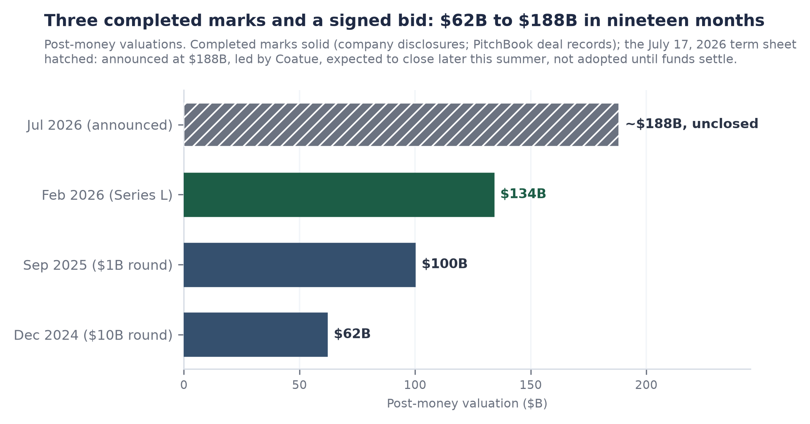
Post-money marks, December 2024 to July 2026. Completed marks solid; the July 17, 2026 term sheet hatched: announced at $188B, unclosed, not adopted until funds settle.

The engine under the bid: four accelerating prints
Nothing in the operating record moved with the announcement. The last dated print is $6.9 billion of annualized revenue growing +80% YoY (company disclosure, June 16, 2026), the fourth consecutive accelerating print in a ladder that runs $4.0 billion, $4.8 billion, $5.4 billion, $6.9 billion across ten months of dated disclosures. Gross margin stands at 74%, down from above 80% and guided lower on agent-driven compute; free cash flow remains positive on trailing and fiscal 2025 bases with no newer print (company, February 9, 2026). Headcount stands at 9,000 (PitchBook, June 9, 2026).
The next scheduled read is the September to October disclosure window, and it carries three tests at once: the run-rate against the June level, the gross margin against the 70% efficiency floor where the cushion is four points, and the refresh of February-vintage operating metrics, retention above 140% and more than 20,000 organizations among them. Until that window, those metrics are cited only with their February dates visible.
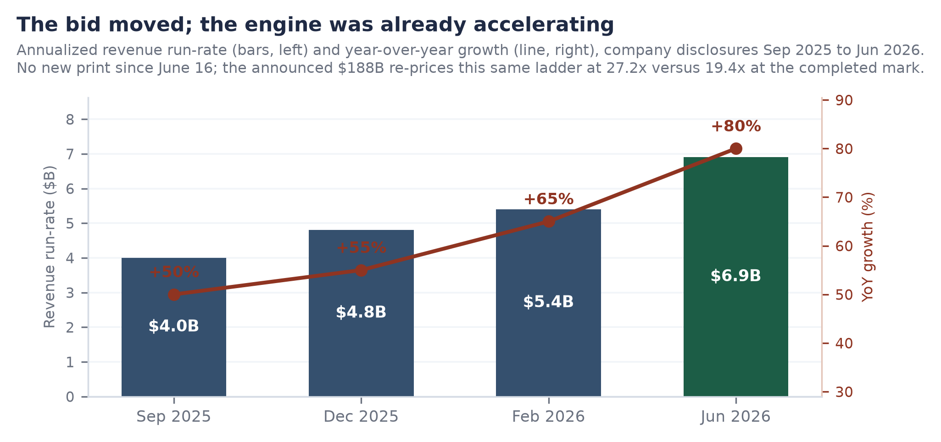
Annualized revenue run-rate (bars) and year-over-year growth (line), company disclosures September 2025 to June 2026. No new print since June 16.

Pricing the quality: both marks stay on the cohort floor
At the completed mark the run-rate multiple is 19.4x; at the announced mark it is 27.2x on the identical June print (derived). Growth adjustment keeps the comparison favorable at either level: 27.2x against +80% growth prices each point of growth at 0.34x, versus roughly 0.49x for the closest listed comparable trading near 15.3x its guided +31% forward product revenue (comparable company 8-K, May 27, 2026; derived).
On the desk's quality framework, the announced price pays roughly $21.3 billion per point of business quality against $15.2 billion at the completed mark (est., derived); the cohort's next-cheapest asset pays about $118 billion per point, the top of the ladder near $188 billion, and the listed parent's implied AI segment about $279 billion (est.). Even granting the full re-rate, the buyer pays roughly a fifth of the cohort's next-cheapest quality-adjusted price. The watch list into the fall: the close itself, expected before the end of summer; the September to October print, where a gross margin below 70% would force a quality re-score regardless of the round; and the registry, where no S-1 was on file at the last verification (SEC EDGAR, July 10, 2026).
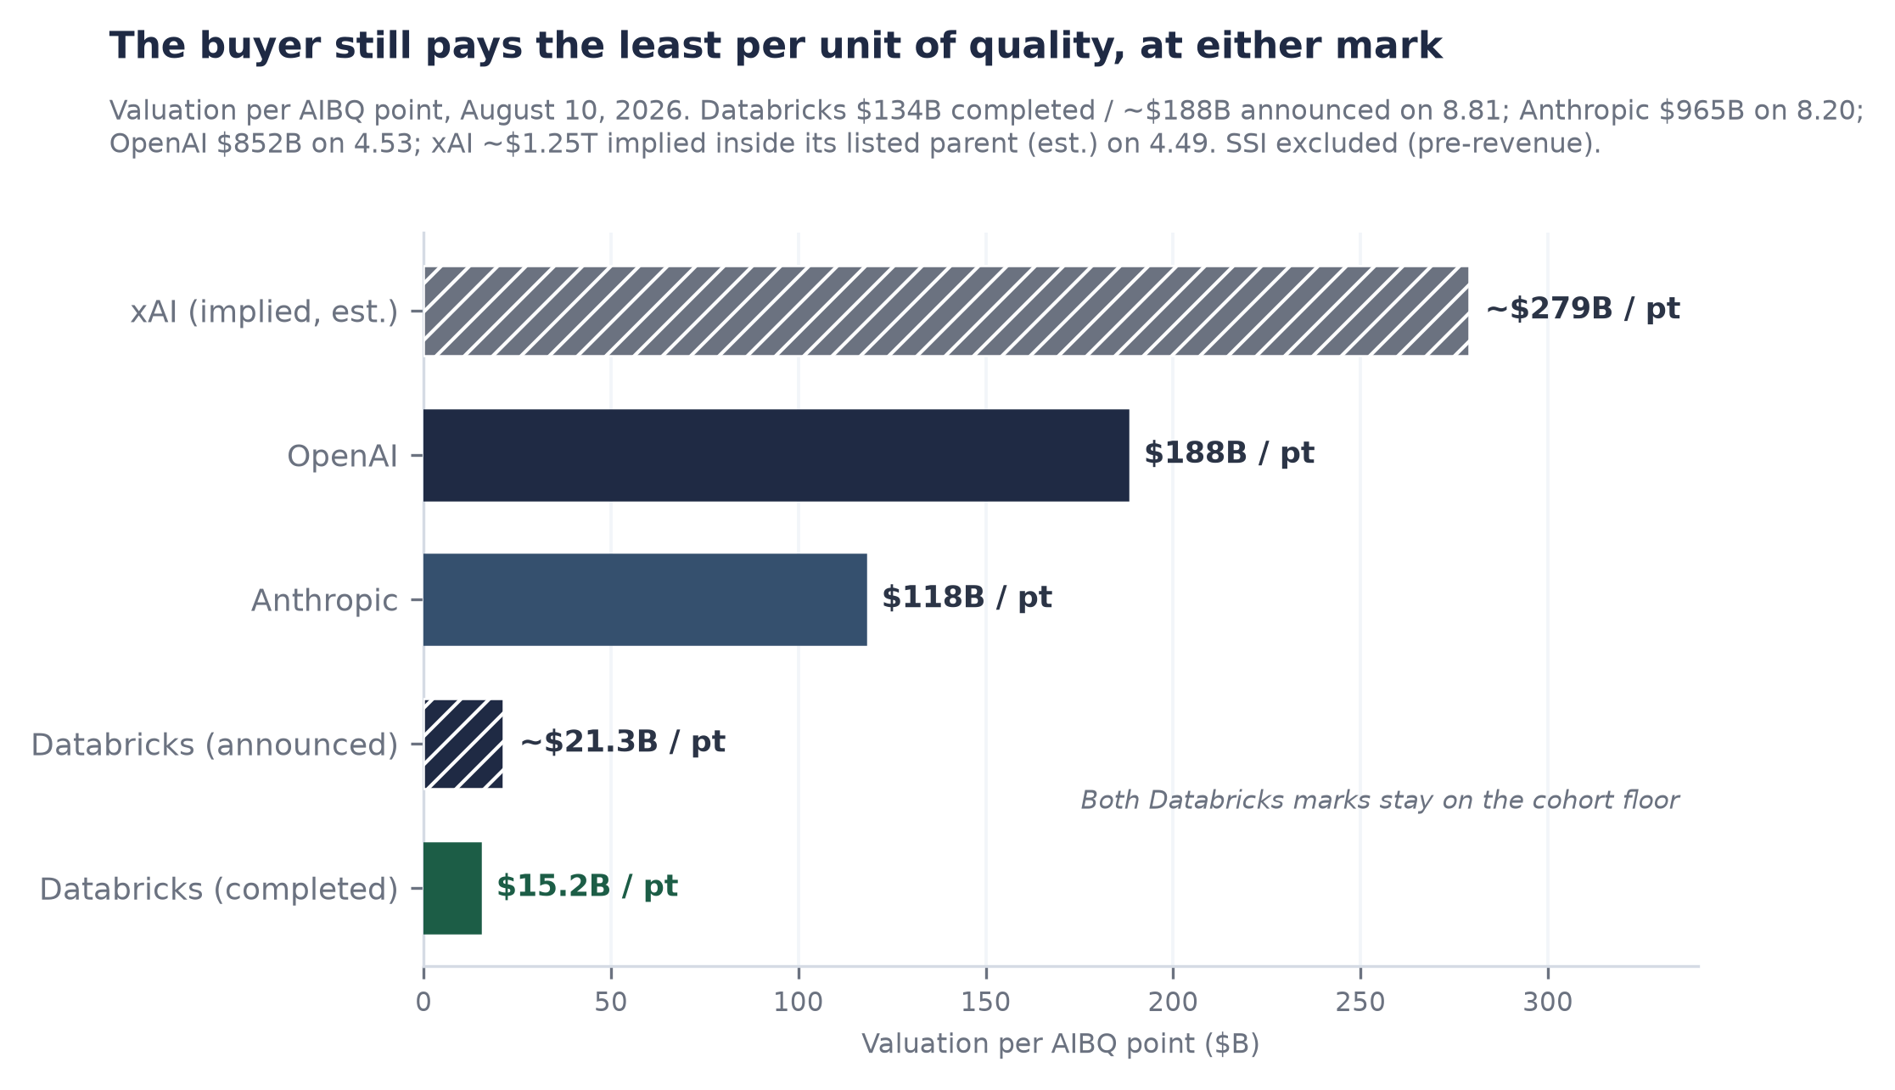
Valuation per AIBQ point, August 10, 2026. Databricks shown at completed and announced marks; xAI implied inside its listed parent (est.); SSI excluded (pre-revenue).

References
1. Databricks signs term sheet at $188B, Coatue lead (Reuters syndication), July 17, 2026. https://www.dealstreetasia.com/stories/coatue-led-funding-round-to-value-databricks-at-188b-489409/
2. Databricks hits $188B valuation (TechCrunch), July 17, 2026. https://techcrunch.com/2026/07/17/databricks-hits-188b-valuation-extending-its-run-as-ais-favorite-second-act/
3. Coatue-led $3B investment at $188B (WSJ, via Reuters/CNA), July 16-17, 2026. https://www.channelnewsasia.com/business/databricks-valued-188-billion-after-coatue-led-investment-wsj-reports-6259931
4. PitchBook News: Databricks' 40% valuation bump looks 'almost quaint' next to Anthropic, July 17, 2026. https://my.pitchbook.com/news-center/pb208542455521588824
5. PitchBook company profile 59199-40 (last updated August 10, 2026) and financing note, August 7, 2026. https://my.pitchbook.com/profile/59199-40/company/profile
6. Databricks company announcement: Series L final close and operating metrics, February 9, 2026.
7. Databricks Data + AI Summit analyst-session disclosures ($6.9B run-rate, +80% YoY, 74% gross margin), June 16, 2026.
8. SEC EDGAR submissions API, CIK 0001587468 (no registration statement on file), verified July 10, 2026. https://data.sec.gov/submissions/CIK0001587468.json

